**Solution Concept for Hiring Test**

1. **Introduction :**

The simplest and most obvious choice is to get solution which contains Cassandra, Spark with a highly available Spark Master, and many more components bundled up. AWS has good features and components to implement great solution for this task .

I will explain how to build , install and configure their solution :

1. **Solution Architecture :**

We have a lot of scenarios for executing the task , I will explain two scenario from point of my view

1. First Scenario :

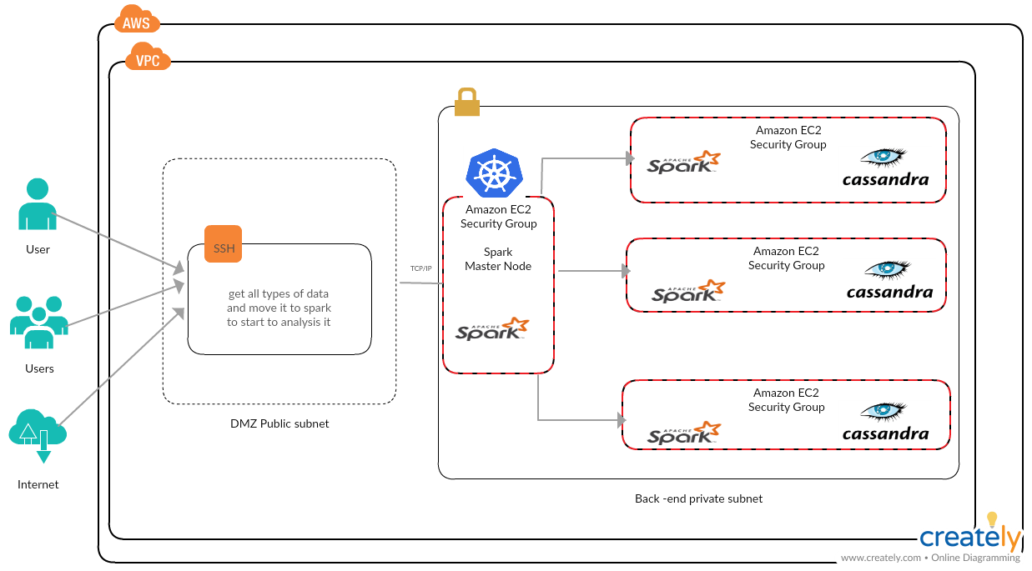

1. Second Scenario

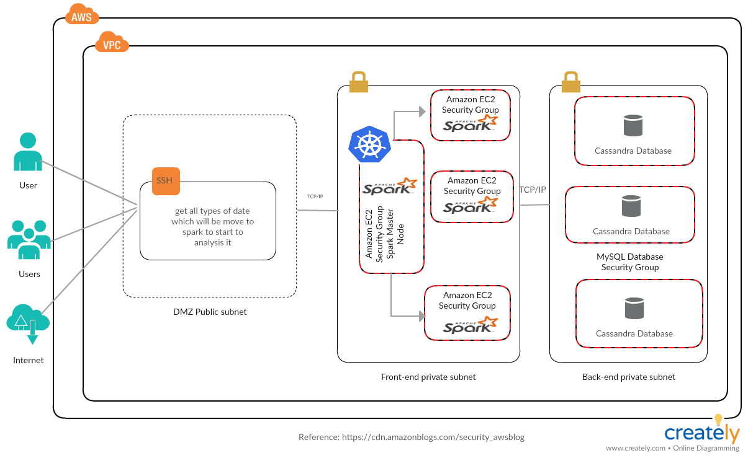

B.1 - Back end for cassandra databases :

