1. Go to Cpanel and Create folder for deployment  
   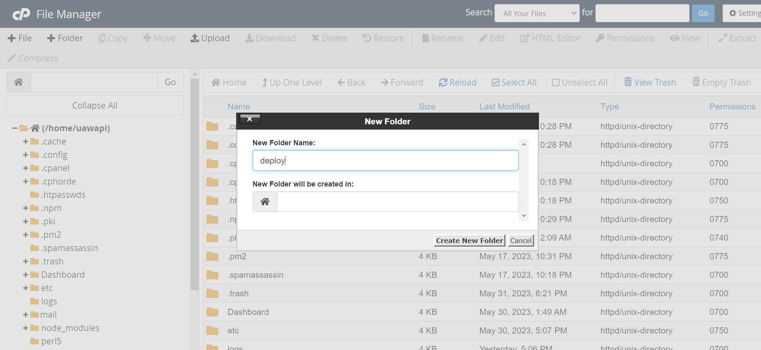
2. Go to Cpanel and Git Version Control

