Technical Analysis

* Fundamentals offer only an understanding of value
* Technical are the observation of how investors are allocating money
* Trends reflect sentiment
* Reflects activity
* Tools to help investors measure risk / reward
* Create a point of action to act for:
  + Entry strategy
  + Stop loss
  + Profit taking
  + Averaging down

# Foundations

## Type of Charts

Use 4 daily values Open, Close, Low and High

* Line chart
* Mountain charts
* Step charts
* Bar charts
* Candle Charts

## Trendlines

* Common identifiers of primary trends
* Common identifiers of shifts in momentum
* Observations as to the magnitude and speed of a move

## Support & Resistance

* Price level that trigger investor buying/selling
* Is most likely attributed to psychology as investors earmark previous highs and lows of markets as mental highwater marks
* Often previous resistance, (when broken) becomes a new support level
* Support:
  + Previous lows act as a new accumulation point for investors that regretted not buying at the level previously.
  + A break of a support level often is an indication of assertive distribution and a hallmark of downtrends
* Resistance:
  + Previous highs act as a level for investors to sell positions
  + Often investors that regretted not selling at the level previously

# Patterns and Gaps

## Patterns

* Reversal Patterns
  + Head and Shoulder
  + Inverted Head and Shoulder
  + Double Top
  + Double Bottom
* Continuation Patterns
  + Wedges
  + Flats
  + Horizontal Triangles
  + Ascending/Descending Triangles

## Price Gaps

* Upside gaps occur when the market opens higher than the previous days high
* Downside gaps occur when the market opens lower than the previous days low
* Differentiating gaps based on our method
* There are different types of gaps
  + Common. Gaps
  + Run Away Gaps
  + Reversal Gaps (Exhaustion Gaps)
  + Break Away Gap Bullish
  + Break Away Gap Bearish

# Technical Overlays (Moving Averages)

* Smooth out price fluctuations to identify trend direction.
* Simple Moving Average (SMA or MA)
  + Trade Signals
  + Different periods
  + Applying to intraday charts
* Weighted Moving Average (WMA)
* Exponential Moving Average (EMA)

## Weighted Moving Average

* Apply weighting to make the more recent changes more responsive
* Multiplying each price point by a weighting

## Exponential Moving Average (EMA)

* Faster Trend Indicator
* Apply weighting
* Weighting decreases at an exponential rate
* EMA reacts faster to price changes than SMA
  + If the current price is above the EMA, it confirms an uptrend → Possible Buy
  + If the current price is below the EMA, it confirms a downtrend → Possible Sell
* Example:
  + If **price > EMA(10)** → Trend is bullish → Consider buying.
  + If **price < EMA(10)** → Trend is bearish → Consider selling.

## Moving Average Cross Overs

* Two moving averages of different periods
* Smooths out many false start signals

## Moving Average Envelopes

* Trend following indicator
* Identify overbought and oversold conditions
  + Most price action will be contained by the envelope
  + Price outside envelope indicates overbought/oversold condition
* An envelope is a band that is fixed percent away from a moving average
* Volatility is an important consideration when setting envelops
* A stock index likely to have lower volatility
* A high beta growth stock likely to have higher volatility
* The envelope needs to be adjusted

# Technical Indicators

Indicators are just mathematical interpretations of price action.

|  |  |
| --- | --- |
| Indicator | Purpose |
| RSI (14) | Measures momentum (overbought/oversold conditions). |
| SMA (5, 20, 50) | Tracks short-term, mid-term, and long-term trends. |
| EMA (9, 21, 50) | Reacts faster to price changes for trading signals. |
| Bollinger Bands (20,2) | Identifies volatility and potential breakouts. |
| ATR (14) | Measures volatility for stop-loss strategies. |
| Stochastic Oscillator | Similar to RSI but more sensitive. |
| MACD (12, 26, 9) | Detects trend direction and strength. |

## Relative Strength Index (RSI)

RSI is a **momentum oscillator** that measures the speed and change of price movements. This data could be used in a trading strategy to:

* **Identify Overbought and Oversold Conditions**:
  + The RSI value ranges from **0 to 100**:
    - If the RSI value were below 30 (oversold), it might indicate a potential **buying opportunity**.
    - If the RSI value were above 70 (overbought), it might indicate a potential **selling opportunity**.
    - **RSI between 30 and 70**: The stock is considered **neutral**.
* **Confirm Trends**:
  + RSI measures the **strength** of price movements, indicating whether the stock is gaining or losing momentum.
    - If the RSI is consistently above 50, it confirms a **bullish trend**.
    - If the RSI is consistently below 50, it confirms a **bearish trend**.
* **Divergence Analysis**:
  + If the stock price is making **higher highs** but the RSI is making **lower highs**, it could indicate a **bearish divergence** (potential reversal to the downside).
  + If the stock price is making **lower lows** but the RSI is making **higher lows**, it could indicate a **bullish divergence** (potential reversal to the upside).

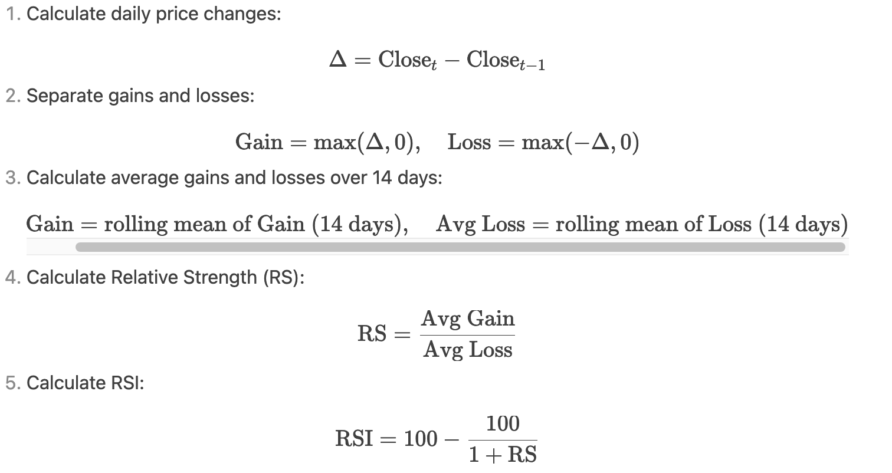

* RSI measures how overbought or oversold a stock is.
  + Example:
    - If **RSI is 80**, the stock is overbought → **May start dropping** → Consider selling.
    - If **RSI is 20**, the stock is oversold → **May start rising** → Consider buying.
  + RSC Settings
    - 9 and 14 period are most common default settings
    - 5 period used for rapid signals
    - 21, 30 and 50 period slow the signals (identify major extremes rather than swing trade signals)

Simple Moving Average (SMA)  
The Simple Moving Average (SMA) is a technical indicator used to smooth out price data and identify trends. It is calculated by taking the arithmetic mean of the stock's closing prices over a specific number of periods.

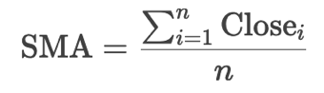

Where:

* Close= Closing price at period ii.
* n = Number of periods (in this case, 50).

This data could be used in a trading strategy to:

* **Identify Trends**:
  + If the price is consistently **above the SMA**, it indicates an uptrend (bullish **trend)**.
  + If the price is consistently **below the SMA**, it indicates a downtrend (**bearish trend)**.
* **Generate Buy/Sell Signals**:
  + A **buy signal** might be generated when the price crosses **above the SMA**.
  + A **sell signal** might be generated when the price crosses **below the SMA**.
* **Support and Resistance**:
  + The SMA can act as **dynamic support** in an uptrend or **dynamic resistance** in a downtrend.

## Exponential Moving Average (EMA)

The EMA is a type of moving average that gives more weight to recent prices, making it more responsive to new information compared to the Simple Moving Average (SMA). The Exponential Moving Average (EMA) is a technical indicator used to smooth out price data and identify trends. Unlike the Simple Moving Average (SMA), which gives equal weight to all data points, the EMA assigns more weight to recent prices. This makes the EMA more responsive to recent price changes.

The EMA is calculated using the following:

* Step 1: Calculate the Smoothing Factor (α)

The smoothing factor (α) determines the weight given to the most recent price. It is calculated as:

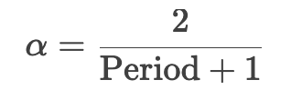

* Step 2: Calculate the Initial EMA

For the first calculation, the EMA is typically set to the Simple Moving Average (SMA) of the first n periods, where n is the specified period (e.g., 50).

* Step 3: Calculate the EMA for Subsequent Periods

For each subsequent period, the EMA is calculated as:

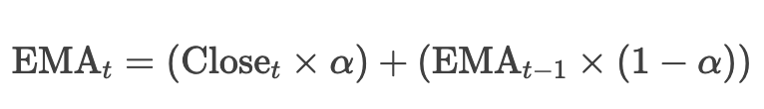

The EMA is used to:

* **Identify Trends**:
  + If the price is consistently **above the EMA**, it indicates a **bullish trend**.
  + If the price is consistently **below the EMA**, it indicates a **bearish trend**.
* **Generate Buy/Sell Signals**:
  + A **buy signal** might be generated when the price crosses **above the EMA**.
  + A **sell signal** might be generated when the price crosses **below the EMA**.
* **Crossover Strategy**:
  + A **Golden Cross** occurs when a shorter-term EMA (e.g., 20-day) crosses above a longer-term EMA (e.g., 50-day), signaling a potential **buy** opportunity.
  + A **Death Cross** occurs when a shorter-term EMA crosses below a longer-term EMA, signaling a potential **sell** opportunity.
* **Act as Dynamic Support/Resistance**:
  + In an uptrend, the EMA can act as **dynamic support**.
  + In a downtrend, the EMA can act as **dynamic resistance**.

## Bollinger Bands

Bollinger Bands are a **technical analysis tool** used to measure volatility and identify potential overbought or oversold conditions in the market. They consist of three lines:

* **Middle Band**: A simple moving average (SMA) of the stock's price over the specified period.

*Middle Band= SMA*

* **Upper Band**: The middle band plus two standard deviations.

*Upper Band=Moving Average+(2×Standard Deviation)*

* **Lower Band**: The middle band minus two standard deviations.

*Lower Band=Moving Average−(2×Standard Deviation*

This data could be used in a trading strategy to:

* **Identify Overbought/Oversold Conditions**:
  + If the price is near the **upper band**, it might be a signal to **sell** or **short** the stock.
  + If the price is near the **lower band**, it might be a signal to **buy** the stock.
* **Measure Volatility**:
  + The distance between the upper and lower bands indicates the **volatility** of the stock. Wider bands suggest higher volatility, while narrower bands suggest lower volatility.
* **Confirm Trends**:
  + If the price consistently stays near the upper band, it could indicate a **strong uptrend**.
  + If the price consistently stays near the lower band, it could indicate a **strong downtrend**.

## Stochastics

The Stochastic Oscillator is a momentum indicator that compares the closing price of a stock to its price range over a specific period. The value ranges from **0 to 100**:

* **Above 80**: The stock is considered **overbought** (potentially overvalued).
* **Below 20**: The stock is considered **oversold** (potentially undervalued).
* **Between 20 and 80**: The stock is considered **neutral**.

The **Stochastic Oscillator** is a **momentum indicator** used to:

* **Identify Overbought and Oversold Conditions**:
  + Helps traders determine when a stock might be overvalued (overbought) or undervalued (oversold).
  + This can signal potential **reversals** in price direction.
* **Measure Momentum**:
  + The Stochastic Oscillator measures the **strength** of price movements, indicating whether the stock is gaining or losing momentum.
* **Generate Buy/Sell Signals**:
  + A buy signal might be generated when the Stochastic Oscillator crosses above 20 (exits oversold territory).
  + A sell signal might be generated when the Stochastic Oscillator crosses below 80 (exits overbought territory).
* **Confirm Trends**:
  + The Stochastic Oscillator can be used to confirm the strength of a trend. For example, in an uptrend, the Stochastic Oscillator tends to stay above 50, and in a downtrend, it tends to stay below 50.

The Stochastic Oscillator is calculated using the following formula:

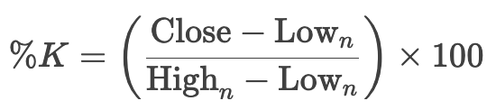

The **%D** line (signal line) is a moving average of %K, typically calculated over 3 periods.

Where:

* Close = Current closing price.
* Low​ = Lowest price over the last n periods.
* High​ = Highest price over the last n periods.
* The most common period for the Stochastic Oscillator is 14, but it can be adjusted based on the trader's preference:
  + **Shorter Periods (e.g., 5 or 9)**: More sensitive to price changes, suitable for short-term trading.
  + **Longer Periods (e.g., 20 or 21)**: Smoother and less sensitive, suitable for long-term trading.

Trading Strategy:

* **Buy Signal**:
  + If the Stochastic Oscillator crosses above 20 (exits oversold territory), it might be a signal to **buy** the stock.
* **Sell Signal**:
  + If the Stochastic Oscillator crosses below 80 (exits overbought territory), it might be a signal to **sell** the stock.
* **Trend Confirmation**:
  + If the Stochastic Oscillator is consistently above 50, it confirms a **bullish trend**.
  + If the Stochastic Oscillator is consistently below 50, it confirms a **bearish trend**.

## Average True Range (ATR)

The Average True Range (ATR) is a volatility indicator used to measure the degree of price movement in a stock or other financial instrument. It does not indicate the direction of the price movement but rather the volatility or range of price movement.

The ATR is calculated using the following steps:

* Step 1: Calculate the True Range (TR)

The True Range is the greatest of the following:

* + Current High - Current Low
  + Absolute Value of Current High - Previous Close
  + Absolute Value of Current Low - Previous Close



* Step 2: Calculate the ATR

The ATR is the **average of the True Ranges** over the specified period.

* + For the first calculation, the ATR is typically set to the **Simple Moving Average (SMA)** of the first n True Ranges, where n is the specified period (e.g., 14).
  + For subsequent calculations, the ATR is calculated using an **exponential moving average (EMA)**:

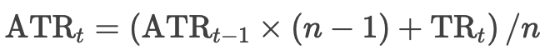

The ATR is used to:

* **Measure Volatility**:
  + Helps traders understand the level of volatility in the market.
  + A higher ATR indicates a more volatile market, while a lower ATR indicates a less volatile market.
* **Set Stop-Loss and Take-Profit Levels**:
  + Traders often use the ATR to set **stop-loss** and **take-profit** levels based on the current volatility.
  + For example, a stop-loss might be set at 2 × ATR below the entry price.
* **Identify Breakouts**:
  + A sudden increase in ATR can indicate a potential **breakout** or **trend reversal**.
* **Adjust Position Sizing**:
  + Traders may adjust their position size based on the ATR to account for changes in volatility.

## Moving Average Convergence/Divergence (MACD)

The MACD is a momentum indicator for Identifying trends and potential buy/sell signals. It is a lagging indicator, meaning it reacts to past price movements rather than predicting future ones. It consists of two moving averages (usually 12-day EMA and 26-day EMA) and a signal line (9-day EMA of MACD).

It is often used in conjunction with other indicators (e.g., RSI, Bollinger Bands) to confirm signals and improve accuracy.

The MACD is calculated using the following steps:

* Calculate the 12-day exponential moving average: EMA12
* Calculate the 26-day exponential moving average: EMA26
* MACD Line:

MACD = EMA12 - EMA26

The MACD line is calculated as the difference between two exponential moving averages (EMAs)

* Signal Line:

Signal = EMA9(MACD)

The Signal line is a 9-period EMA of the MACD line. It is a smoothed version of the MACD line, used to generate trading signals:

* + When MACD crosses above the Signal Line → Bullish signal (buy)
  + When MACD crosses below the Signal Line → Bearish signal (sell)

The MACD is used to:

* Identify Trends:
  + Measure the difference between the two moving averages.
  + It shows the relationship between two EMAs (12-period and 26-period), helping traders to identify the direction and strength of a trend.
* Generate Cross Over (Buy/Sell) Signals:
  + A **bullish crossover** (MACD line crosses above the Signal line) is a potential **buy signal**.
  + A **bearish crossover** (MACD line crosses below the Signal line) is a potential **sell signal**.
* **Measure Momentum**:
  + The distance between the MACD line and the Signal line indicates the strength of the momentum.
* **Identify Divergences**:
  + A **bullish divergence** occurs when the price makes a lower low, but the MACD makes a higher low, signaling a potential reversal to the upside.
  + A **bearish divergence** occurs when the price makes a higher high, but the MACD makes a lower high, signaling a potential reversal to the downside.
* It consists of two moving averages (usually 12-day EMA and 26-day EMA) and a signal line (9-day EMA of MACD).

# **Trading Plans**

Each indicator works best when combined with others to reduce false signals

* Objective Statement
  + Important to define your objective
  + Like a fund manager, you are giving yourself a mandate
* Personal Assessment
  + Goals; e.g. I want to retire soon.
  + Time to dedicate
  + Mental and emotional obstacles
  + Resources
  + Organization
* Risk and Money Management
  + Sizing your investments / trades
  + Stop losses or criteria for existing trades
  + Changing your position size (dollar cost averaging or cutting position size)
  + Profit taking strategies
* Execution Strategy
  + Macro or fundamental criteria for an investment
  + Technical criteria that is met for acting
  + Defining the criteria for existing the investment
    - To lock in profits (outright selling or rebalancing weighting)
    - To cut the loss (outright selling or reducing position sizing)
  + Defining criteria for dollar cost averaging
* Results Review
  + Maintaining an investing / trading history
  + Maintaining a trade log with notes
  + Focusing on assessing larger trading strategy vs individual trades

# RSI and MACD

#### **Buy Signal**

🔹 RSI < 30 (oversold)  
🔹 MACD line crosses above the signal line (bullish crossover)  
🔹 **Price is above 50-day MA** (uptrend confirmation)

#### **Sell Signal**

🔹 RSI > 70 (overbought)  
🔹 MACD line crosses below the signal line (bearish crossover)  
🔹 **Price is below 50-day MA** (downtrend confirmation)

#### **Exit Conditions (Stop-Loss & Take-Profit)**

🔸 Stop-Loss: **5% below entry price** (to limit risk)  
🔸 Take-Profit: **10% above entry price** (to lock in gains

### **Combining Indicators for Trading Strategies**

| **Indicator** | **Purpose** | **Signal Example** |
| --- | --- | --- |
| **MACD** | Trend identification | MACD crosses above Signal Line (Buy) |
| **Bollinger Bands** | Volatility & Overbought/Oversold | Price touches lower band (Buy) |
| **Stochastic Oscillator** | Momentum & Reversals | %K crosses above %D in oversold area (Buy) |

✅ **BUY Signal:**

* RSI < 30 (Oversold)
* MACD Line > Signal Line (Bullish Crossover)
* Close price crosses above EMA 21 (Uptrend)
* Volume confirms (Higher than average)

✅ **SELL Signal:**

* RSI > 70 (Overbought)
* MACD Line < Signal Line (Bearish Crossover)
* Close price crosses below EMA 21 (Downtrend)
* Volume confirms (Higher than average)

✅ **SMA smooths out price data by averaging past prices**

* **Golden Cross** ✨ → **Short-term SMA (e.g., 50-day) crosses above Long-term SMA (e.g., 200-day)**  
  🔹 **Bullish signal → Buy**
* **Death Cross** 💀 → **Short-term SMA crosses below Long-term SMA**  
  🔹 **Bearish signal → Sell**

💡 **Example:**

* If **SMA(50) crosses above SMA(200)** → Strong **Buy** signal.
* If **SMA(50) crosses below SMA(200)** → Strong **Sell** signal.

These indicators are often used together to make informed trading decisions.

* **SMA_5** and **EMA_5**: Help identify short-term trends.
* **RSI_14**: Helps identify overbought or oversold conditions.
* **MACD** and **Signal Line**: Help identify momentum and potential buy/sell signals.

As an example, If you see:

* **MACD > Signal Line**: Indicates bullish momentum (potential buy signal).
* **RSI_14 > 70**: Indicates overbought conditions (potential sell signal).
* **SMA_5 > EMA_5**: Indicates a strong upward trend.

Many traders **combine multiple indicators** for better accuracy:

✅ **RSI < 30 + Price above EMA(10) + Golden Cross** → Strong **Buy Signal**  
✅ **RSI > 70 + Price below EMA(10) + Death Cross** → Strong **Sell Signal**

**1. SMA_5 and EMA_5: Identifying Trends**

* **SMA_5** and **EMA_5** are used to identify short-term trends in the price of a stock or asset.
* **Golden Cross**: When the **SMA_5** crosses above the **EMA_5**, it indicates a potential **upward trend** (bullish signal).
* **Death Cross**: When the **SMA_5** crosses below the **EMA_5**, it indicates a potential **downward trend** (bearish signal).

**3. MACD and Signal_Line: Identifying Momentum**

* **MACD** and **Signal_Line** are used to identify momentum and potential buy/sell signals.
  + **Bullish Signal**: When the **MACD** line crosses **above** the **Signal_Line**, it indicates **bullish momentum** (potential buy signal).
  + **Bearish Signal**: When the **MACD** line crosses **below** the **Signal_Line**, it indicates **bearish momentum** (potential sell signal).

• **Objective:**

* Are we looking for short-term trades (days/weeks) or longer-term positions (months)?
* Do we want a high-frequency strategy (many trades) or a lower-frequency one (fewer, but higher-confidence trades)?

• **Indicators to Use:**

* RSI, MACD, Bollinger Bands, EMAs, or others?
* Should we combine multiple indicators for confirmation?

• **Entry Conditions (When to Buy):**

* Should we buy when RSI is oversold (<30) and MACD has a bullish crossover?
* Should we buy when the price is above a certain EMA (e.g., 50-day EMA) for trend confirmation?

• **Exit Conditions (When to Sell):**

* Should we sell when RSI is overbought (>70)?
* Should we sell when MACD turns bearish?
* Should we use a stop-loss (e.g., 5-10% below entry price) and a take-profit level?

• **Risk Management:**

* Should we risk a fixed percentage of our portfolio per trade (e.g., 2%)?
* Should we avoid trading during certain market conditions (e.g., high volatility, earnings reports)?

TrendPulse Application

### ****Phase 1: Backend Enhancements (FastAPI)****

1. **Refactor API Endpoints**
   * Improve structure and consistency
   * Standardize response formats
2. **Enhance Error Handling & Validation**
   * Implement robust input validation
   * Improve logging and exception handling
3. **Optimize Data Processing**
   * Improve efficiency in RSI calculation
   * Introduce caching mechanisms for frequent data queries

### ****Phase 2: Trading Signals & Strategy Improvement****

1. **Enhance RSI-based Trading Signals**
   * Fine-tune threshold levels for better accuracy
   * Add smoothing techniques to reduce noise
2. **Introduce Additional Indicators**
   * Moving Averages (SMA/EMA)
   * MACD (Moving Average Convergence Divergence)
3. **Backtesting & Simulation**
   * Develop a module to test trading strategies on historical data
   * Compare results of different strategies

### ****Phase 3: Frontend Development (React)****

1. **Build Initial UI Components**
   * Implement a dashboard for visualizing RSI trends
   * Add tables for displaying stock data
2. **Enhance User Experience**
   * Add interactivity (hover effects, filters, and sorting)
   * Implement dark mode
3. **API Integration**
   * Connect frontend to FastAPI backend
   * Ensure real-time data updates

### ****Phase 4: Deployment & Expansion****

1. **Deploy Backend on Server**
   * Choose a hosting solution (local or cloud)
   * Set up environment variables and security configurations
2. **Deploy Frontend**
   * Use a platform like Vercel or Netlify
   * Optimize for performance
3. **Future Expansion**
   * Mobile App (React Native)
   * AI-enhanced predictions