
Payroll Application
Group Project
Regine Benton, Leah Boalich, Madi Hauptmann | 12/1/25 | SDEV268

IMPORTANT OVERVIEW
As our company continues to expand, we have identified a need to streamline our
payroll process due to the current manual system causing delays in meeting payroll
deadlines. We understand that navigating the required calculations can be complex, but
we are committed to addressing this challenge.
Introducing a new automated payroll system will eliminate errors in the payroll process
and ensure timely paycheck distribution. This software will be tailored to meet our
business needs and accounting workflow, ultimately saving time for our HR team. You
have been selected as our designer and developer for our new program. Your
responsibilities will involve showcasing competence in procedural and object-oriented
programming principles, exploring recursion to understand different algorithms, creating
programming, and testing software incorporating various design patterns. Please
ensure your project incorporates security measures to protect the data being gathered.
In your role as the developer, you will need to design user interfaces using JAVA,
establish the necessary databases for the application, and establish the necessary
connections between the interfaces and databases.
Enclosed are the business requirements for the payroll system prepared by the HR
department. Each section contains prompts for you to confirm your comprehension or
raise questions. A comprehensive listing of the review materials can be found under the
Resources / Payroll Project. You have eight weeks to complete the project and have it
ready for use.
Thank you for your commitment and hard work in developing and executing our new
payroll software to improve our business operations.

Sincerely,
Ralph Robertson
President
Owl Innovate or Owl Code It

Table of Contents
IMPORTANT OVERVIEW 1
Payroll Program Development Design & Planning 6
Required Documentation 6
1. System Overview 6
Software 6
Hardware 6
1.2 System Architecture 6
1.3 Data Structures 6
Core Data Structures 6
1.4 Structure Architecture Documentation 8
UML Case Diagram 9
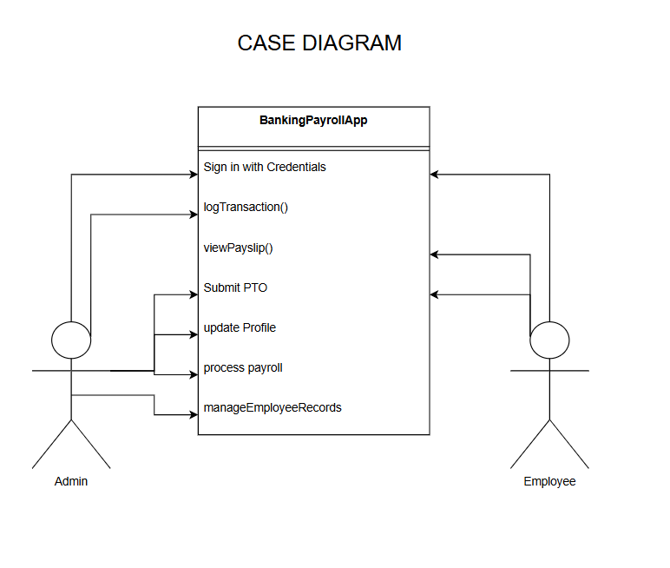Actors: 9
1.4 Use of Java Standard Libraries 11
2. Database Structure Documentation 11
3. Algorithm Documentation 11
Functional Requirements 12
1.5 Non-Functional Requirements 12
1.6 Technical Documentation 12
2. Testing Procedures 12
2.1 Test Plan 12
1. Required Test Areas 13
3. Security Measures 13
3.1 Access Control 13
3.2 Password Security 13
3.2 SQL Protection 13
3.3 Storage Standards 13
3.4 Data Privacy 13
4. Menu, Employee Screen, Salary Screen, Employee Time Entry Screen 14
4.1 Main Menu (Admin Only) 14
4.2 Employee Screen 14
4.3 Salary Screen 14
4.4 Employee Time Entry Screen 15
5. Admin Options & Calculating Payroll 15
5.1 Payroll Calculation Workflow 15
6. Your Final Submission Should Include 16
7. Final Project Grading 16
UML Diagrams 16
Architecture 17
3-Layer Structure 17
Design Patterns Used 18
SCREEN SHOTS OF RUNNING PROGRAM 19
USER INSTRUCTIONS 19

IMPORTANT OVERVIEW
As our company continues to expand, we have identified a need to streamline our
payroll process due to the current manual system causing delays in meeting payroll
deadlines. We understand that navigating the required calculations can be complex, but
we are committed to addressing this challenge.
Introducing a new automated payroll system will eliminate errors in the payroll process
and ensure timely paycheck distribution. This software will be tailored to meet our
business needs and accounting workflow, ultimately saving time for our HR team. You
have been selected as our designer and developer for our new program. Your
responsibilities will involve showcasing competence in procedural and object-oriented
programming principles, exploring recursion to understand different algorithms, creating
programming, and testing software incorporating various design patterns. Please
ensure your project incorporates security measures to protect the data being gathered.
In your role as the developer, you will need to design user interfaces using JAVA,
establish the necessary databases for the application, and establish the necessary
connections between the interfaces and databases.
Enclosed are the business requirements for the payroll system prepared by the HR
department. Each section contains prompts for you to confirm your comprehension or
raise questions. A comprehensive listing of the review materials can be found under the
Resources / Payroll Project. You have eight weeks to complete the project and have it
ready for use.
Thank you for your commitment and hard work in developing and executing our new
payroll software to improve our business operations.

Sincerely,
Ralph Robertson
President
ABC Company

Payroll Program Development Design & Planning

Required Documentation
This section outlines all documentation required for design, development, and delivery of the payroll system.

1. System Overview
The Bank Payroll Application is designed to manage employees records, calculate salaries, track hours, and allow administrators to run payroll securely and efficienty. The system includes roles for Admin and Employee, with Admin performing management operations and Employees submitting time entries.

Software
- Java 17+ (or the course required JDK)
- JavaFX (for GUI)’
- MySQL 8.x (server)
- JDBC driver for MySQL (mysql-connector-java)
- Build: Maven or Gradle
- Git + GitHub repository (public or private with instructor access)

Hardware
- Development workstation with JDK and MySQL installed
- Staging server for integration testing

1.2 System Architecture
- Architecture Type : 3-Layer Architecture (Presentation -> Controller-> DatabaseModel)
- Design Patterns Used:
  - MVC – clean separation of UI , logic, and data
  - DAP – consistent database access structure
  - Observer Pattern – PayrollCalculator observes Employee and TimeEntry changes
  - Singleton –Database connection
- Programming Language Java
- Database: MySQL

1.3 Data Structures

Core Data Structures
Purpose | Structure | Example
Employee directory | ArrayList<Employee> | Add/Edit/Delete employee
Time entry for week | ArrayList<TimeEntry> | Store 7-da time logs

Payroll records | ArrayList<PayrollRecord> | Weekly payroll
Tax tables | hashMap<String, Double> | (« federal », « medicare », »Social Security »,state)
Quick lookup by ID | HashMap<Integer,Emoloyee> | Dins employee instantly

1.4 Structure Architecture Documentation
Include diagrams and explanations for
- Class Diagram: Employee, Admin, User, PayrollService, EmployeeRepository, SalaryCalculator, TimeEntry, AuthenticationService, MenuController, EmployeeController, TimeController.
- UML Use -Case Diagram: Run Payroll, Add Employee, Edit Employee, Submit Time Entry, View Salary, Admin Options, Login.
- UML Sequence Diagrams
  - “Run Payroll”
  - “Submit Hours”
  - “Add Employee”
- Description of actors: Employee, Payroll Administrator, System Admin
- Description of major classes: Employee, Department, PayrollCalculator, TimeEntry, DatabaseManager, AdminToolsm, etc.

UML Case Diagram

Actors:
- Employee
- Admin
Use Cases:
- Login
- Manage Employee Records
- Manage Salary
- Enter Time
- Approve Payroll
- Generate Reports
Classes:
- Admin
- Employee
- Salary
- TimeEntry
- PayrollCalculator(Observer)
- EmployeeController
- EmployeeDAP
- SalaryDAO
- TimeEtnryDAO
- DatabaseConnection (Singleton)
- ReportGenerator
Relationships: 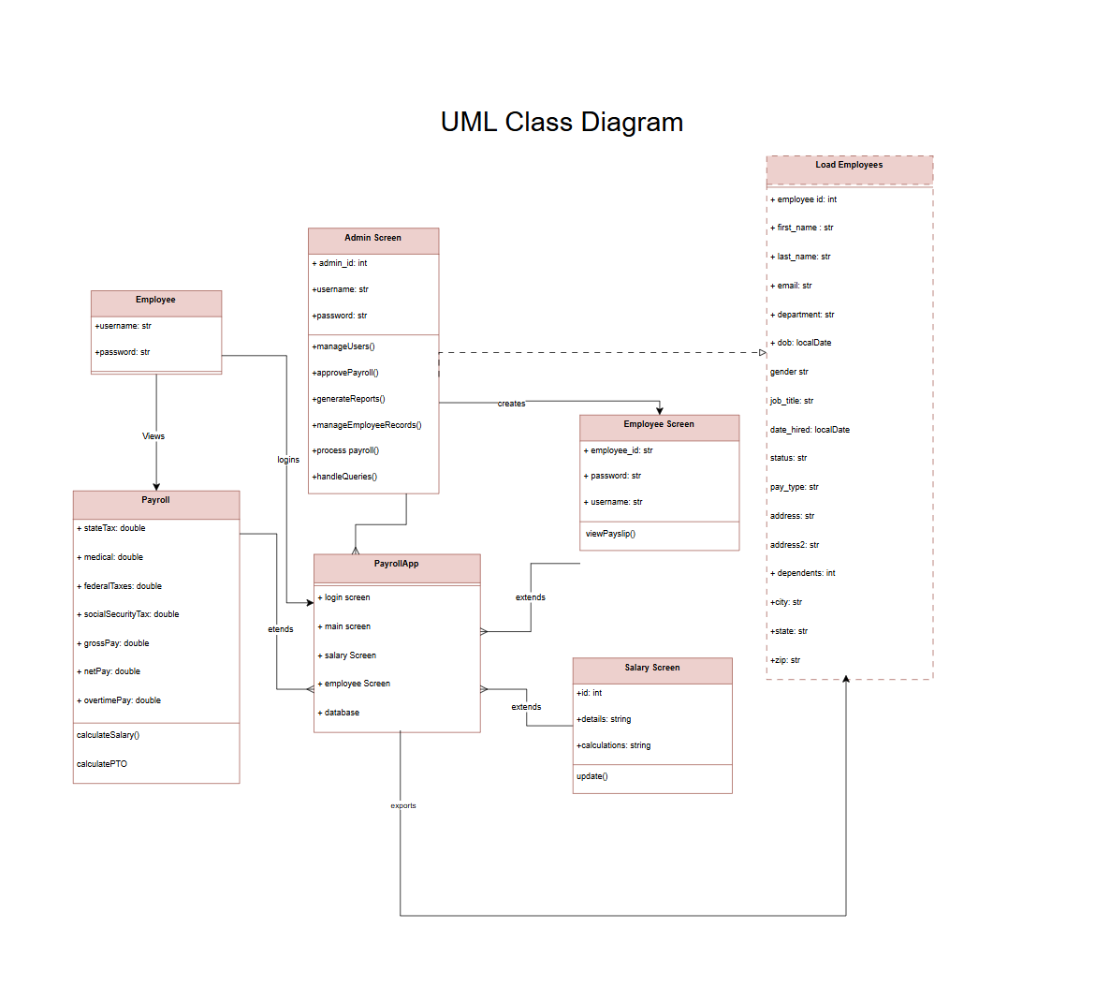
Controllers -> DAO (association)
DAOs -> DatabaseConnection (dependency)
PayrollCalculator -> subjects (Observer relationship)
Employee, Salary, Time Entry -> PayrollCalculator (observable subjects)

1.4 Use of Java Standard Libraries
The project must demonstrate use of core Java libraries
Key Libraries
- Java.util.* (ArrayList, HashMap, Observer, Observable)
- Java.time.* (LocalDate, Duration)
- Java.sql* (JDBC MySQL connection)
- Java.io.* (report file creation)
- Java.text.* (currency formatting)
- IntelliJ
- MongoDB Java Driver (JAR files)
Rationale
- Efficiency and reliability
- Reduces custom code
- Meets course requirement
- Promotes industry-standard practices

2. Database Structure Documentation
- A relational table or pseudo-database storing information for at least 12 employees
- Required tables/objects:
  - Employee (ID, name, departmentID, job title, payType, rate, etc.)
  - Departmemt (ID, departmentName)
  - TimeEntry (employeeID, date, hoursWorked)
  - Deductions (tax rates, benefit rates)
- Departments should be an attribute, not its own instance because an employee belongs to a department (one-to-many).
A department does not need its own behaviors or methods, so an attribute or simple reference table is only necessary.

3. Algorithm Documentation
- Explanation of how overtime is calculated
- Explanation of paycheck formula
- Use of Java Standard Libraries (ArrayList, HashMap, LocalDate, Collections)
- Explanation of where recursion or sorting alogrithms are used
- Justification for any additional data structures (lists, maps, queues)

Functional Requirements
- The system must allow the Admin to add, edit, or remove employees.
- Employees must be able to submit time entries.
- Payroll must calculate salary via hourly or annual rates.
- Summaries and reports must be displayed clearly.
- User authentication must protect sensitive data.

1.5 Non-Functional Requirements
- Secure data handling.
- Efficient retrieval and updating of employee records.
- Accurate salary calculations.
- Easy-to-use interface navigation.

1.6 Technical Documentation
Explain variable storage, data validation, calculation methods, business rules, controller actions, and error handling strategies.

2. Testing Procedures

2.1 Test Plan
- List of all features to be tested
- Expected results
- Pass/fail criteria

Test Case ID | Feature tested | input | expected output | actual output | pass/fail | notes
tc-01 | Login | Valid credentials | User logged in | Pass | __
tc-02 | Add Employee | Employee data | Employee saved | N/A | __
TC-03 | Submit Hours | 40 hours | Hours saved | N/A | __
TC-04 | Calculate Payroll | Weekly payroll | Correct total | N/A | Check rounding

1. Required Test Areas
- Employee creation
- Time entry addition and deletion
- Calculating payroll
- Handling invalid values
- Admin operations
- Reort generations
- Saving the final payroll file

3. Security Measures

3.1 Access Control
- Admin-only screens locked behind login
- Employees may only access their own time entry

3.2 Password Security
- Passwords hashed (SHA-256 or bcrypt recommended)
- Never stored as plain text

3.2 SQL Protection
- Prepared statements
- Input validation
- Parameterized queries

3.3 Storage Standards
- Variables storing sensitive information must npt remain in memory longer than needed.
- Use encrypted storage where applicable.

3.4 Data Privacy
- Only minimum required data displayed
- Employee SSN is not stored or used

4. Menu, Employee Screen, Salary Screen, Employee Time Entry Screen

4.1 Main Menu (Admin Only)
Screens in the payroll system are implemented using JavaFX layout components. The login, Employee, and Salary pages use VBox and Hbox controls inside a BorderPane root layout. Each page is represented by its own Java class.
- Employee Management
- Salary Management
- Time Entry Management
- Payroll Calculation
- Reports
- Logout

4.2 Employee Screen
Admin-only
Features include:
- Add /Edit/Delete employee
- Required fields with validation
- Age validation (less than or equal to 18)
- Gender selection
- Status (active/terminated)
- Email validation
- Address entry
- Employee picture upload

4.3 Salary Screen
Admin-only
Displays:
- Department
- Job Title
- Hire Date
- Salary Type (Hourly/Salary)
- Base Salary
- Medical Coverage
- Number of Dependents
Validations:
- Base salary > 0
- Dependents > or equivalent to 0
- Medical coverage required

4.4 Employee Time Entry Screen
Accessible by:
- Employee (only edit until payroll submitted)
- Admin (override capability)
Rules:
- Salary employees only enter PTO
- Salary automatically loads 8 hours Mon-Fri
- Hourly employees enter daily hours
- Overtime:
  - 8 hours/day = time and a half
  - Saturday = time and a half
- Medical:
  - Single= $50
  - Family = $100
- Dependent stipend = $45 each
- Display all taxes:
  - State: 3.15%
  - Federal: 7.65%
  - Social Security: 6.2% (each)
  - Medicare: 1.45% (each)

5. Admin Options & Calculating Payroll

5.1 Payroll Calculation Workflow
Admin-only:
- Lock employee time entry
- Calculate:
  - Gross pay
  - Deductions
  - Taxes
  - Net pay
- Generate:
  - HR Sign-Off Report
  - Payroll File
- Store payroll record
Pretax Rule
Medical + dependent stipends are deducted before applying taxes.

6. Your Final Submission Should Include
- Fully written report
- Comprehensive UML Class Diagram
- Use Case Diagram
- Optional Sequence Diagrams
- Menu Flow Diagram
- Testing Log
- Security explanations
- Fully commented source code
- Screenshots of the application running
- Summary of results
- Reflection section describing what was learned

7. Final Project Grading
Component | Points | Description
Functional Application + Final Payroll Report | 300 | Java code, database, correct payroll output, meets all requirements
Project Plan & Technical Documentation | 100 | Algorithms, coding standards, security, use of libraries
Testing Procedures | 50 | Complete test cases + documented results
UML Use Case Diagram | 25 | Actors, use cases, clarity of relationship
User Documentation + GitHub Organization | 25 | Clear user guide + structured GitHub repo

UML Diagrams
Show Actors (Admin, Employee) and interactions with the system.


Architecture
The technical design is made up in a 3 layer Structure.

3-Layer Structure

Layer 1—Domain Layer (Entities)
- Employee
- Admin
- TimeEntry
- PayrollRecord

Layer 2—Service Layer (Business Logic)
- PayrollCalculator <<Subject>>
- OvertimeCalculator
- MedicalCalculator
- TaxCalculator
- DependentStipendCalculator

Layer 3 –Application Layer (Use Cases/ Controllers)
- EmployeeController
- AdminController

UI Layer Presentation (Observers)
- EmployeeScreen(Observer)
- AdminScreen(Observer)
- PayrollObserver(interface)

Design Patterns Used
- MVC (Model-View-Controller) –separates UI, logic, and data
- Observer Pattern – screens are notified of data changes
- DAP Pattern –database access handling
- Singleton (optional) –database connection instance

Domain Entities
- Employee
- Admin
- TimeEntry

Business Logic/ Services
- PayrollCalculator
- OvertimeCalculator
- MedicalCalculator
- TaxCalculator
- DependentStipendCalculator

Data Access
- EmployeeDAO
- TimeEntryDAO
- PayrollDAO
- DatabaseConnection(Singleton)

UI (Observer Pattern)
- EmployeeScreen(Observer)
- AdminScreen(Observer)
- PayrollScreen
- LoginScreen

Observers / Subjects
- EmployeeController (Subject)
- AdminController (Subject)

8-Week TIME LINE
Dependencies | Estimated Time (hours) | Person
System structure | 4-6 | Madi Hauptmann
The basic GUI components like windows, buttons, and text fields | 3 weeks | Leah Boalich
Backend | 4 weeks | Madi Hauptmann
Authentication, database schema | 10-15 | Madi Hauptmann & Leah Boalich
Authentication, file storage | 10-20 | Madi Hauptmann & Leah Boalich
Documentations | 8 weeks | Regine Benton
Database/ schema for entries | 5-10 | Regine Benton
Auth and CRUD basics | 10-15 | Madi & Leah Hauptmann
Finish the testing | 5-10 | Regine Benton

SCREEN SHOTS OF RUNNING PROGRAM

USER INSTRUCTIONS

ADMIN DEMO

For New Admin Members, Create An Account to edit Employee Infofmation. Please click Register once credentials are entered.
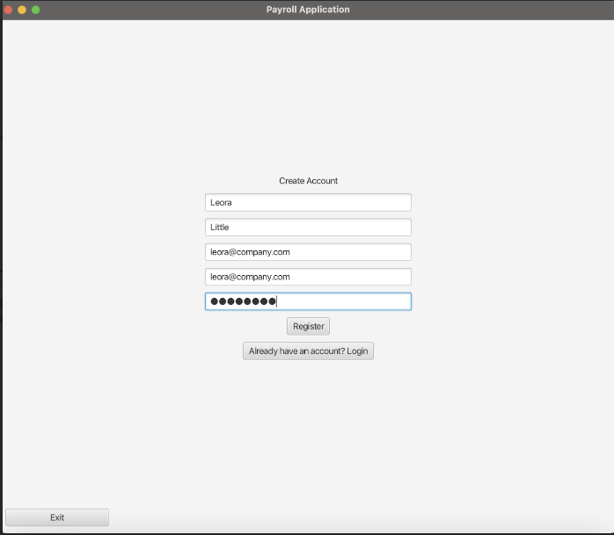
You will be asked to log in. Please resubmit your credentials.
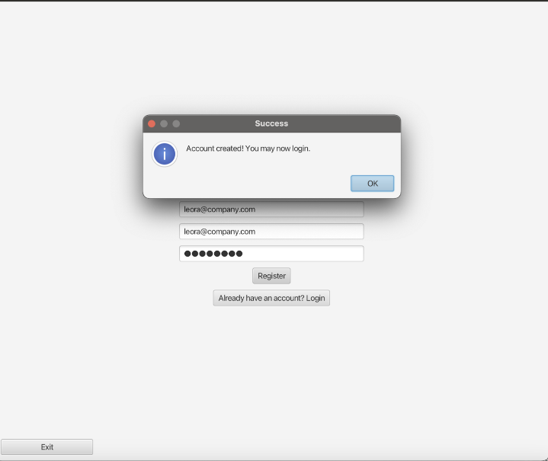
Once you are signed in, you will be directed to the front page. The front page offers many features like seeing the “Employee Demographics”, “Salary data”, “Timecards”, “Payroll” and “Application Information”. Here you may choose any of the following to complete a task. Would you like a Demo to edit an Employee’s Profile (Y,N)?
You submitted Yes! Welcome to the Payroll Application. We will assist you in working on the application.
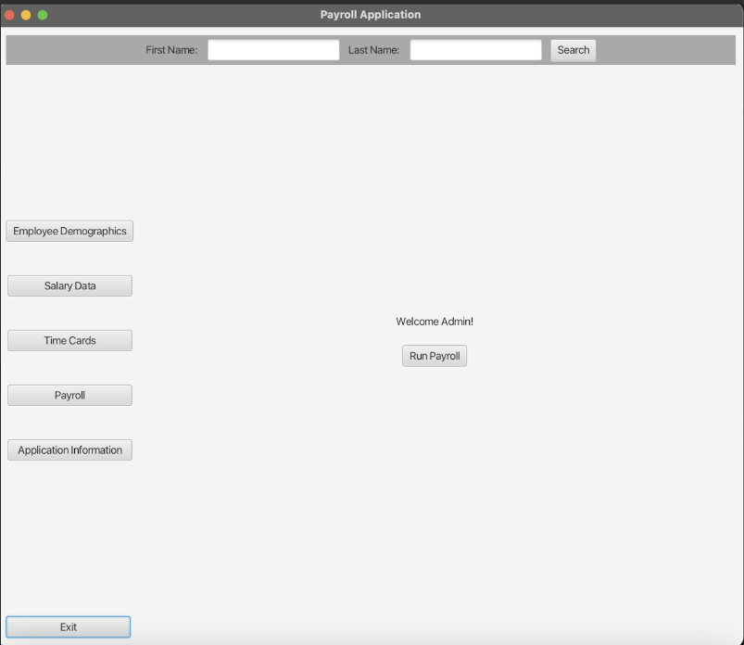

Click the arrow down to bring down a menu list and click the accurate hours the employee has completed throughout the week. Once you are completed, click “Save” or you can exit the screen.
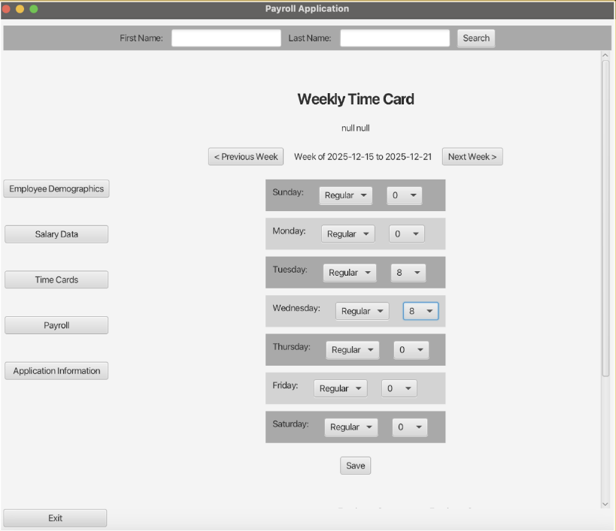

Once you have successfully completed the timesheet, go to the salary data located on the left of the page. When you are finished entering the Employee’s information, click “Calculate Payroll” An employee report will be made once you successfully complete this step in the Payroll application.
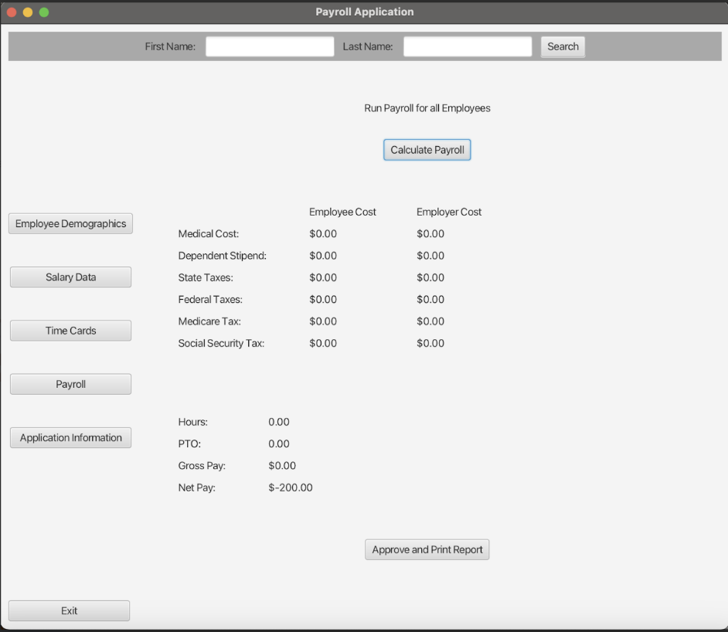

In the salary data window, information about each employee is saved here. You may make changes, “Update” or click “Exit” at any time.
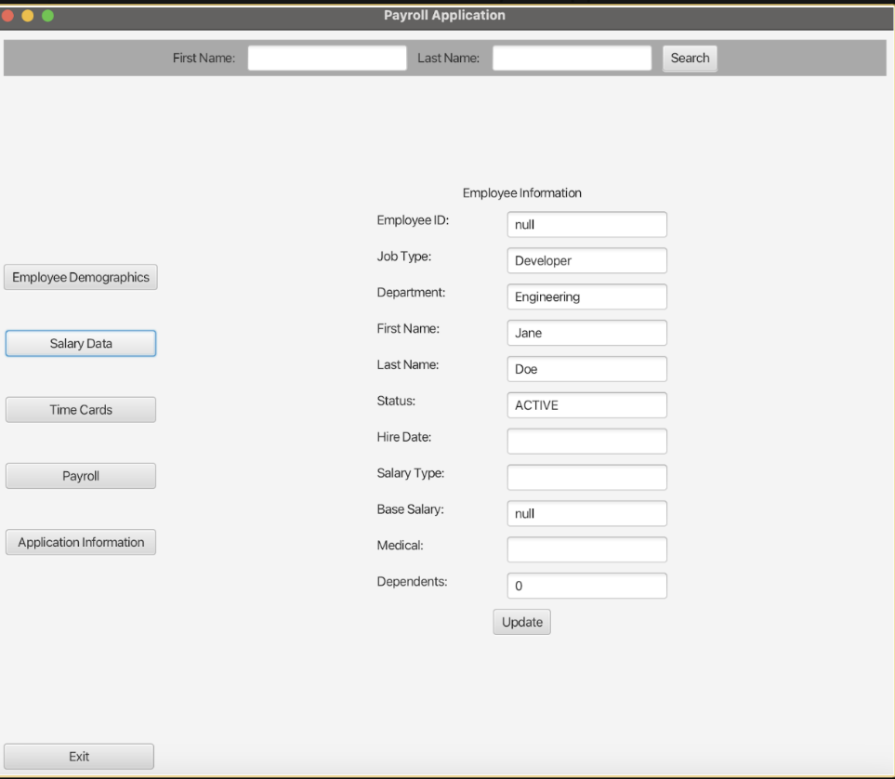

If you are needing to search for a specific name, move your mouse to the top of the screen. Above is two search fields where you can look up an Employee’s first name and last name. Once you type in their full name, click Search.
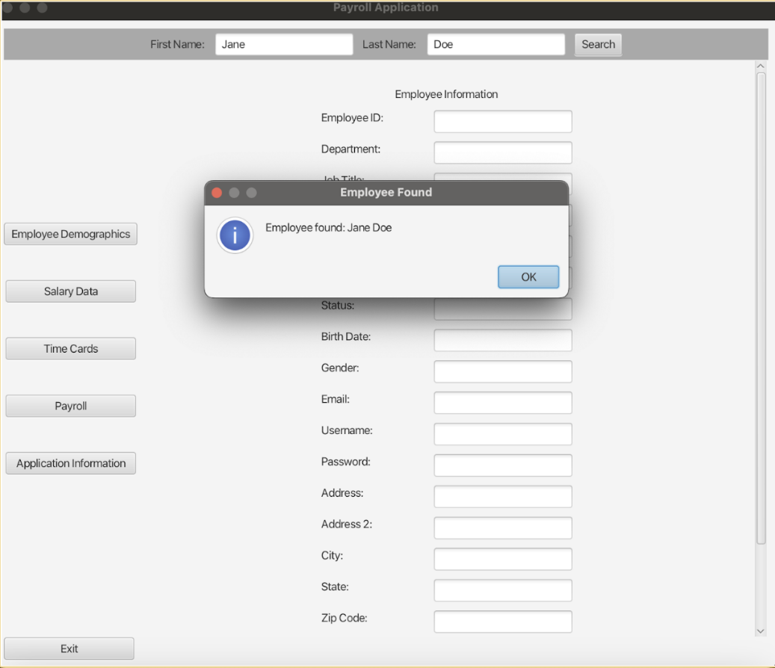

Well done! You have completed the Administrative Demo. Please return to the payroll application. Goodbye.

