Cheatsheet: Cross-Origin Resource Sharing in Siemens' Project UIA

Challenge: SF and AMX in Different Domains. Browser Rejects Cross-Domain AJAX Calls

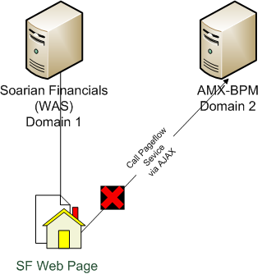

Solution 1: Put Both Sites in Trusted Zone (Internet Explorer Browsers Only)
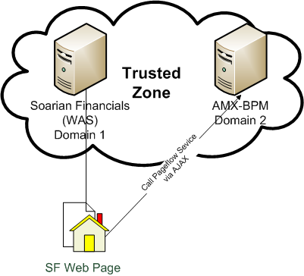

Solution 2: Proxy Puts Both Sites In Same Domain
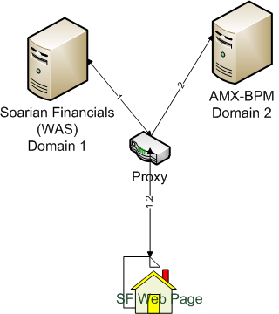
Potentially the solution Siemens will use in PROD.

Solution 3: CORS Filter on AMX Allows Specific Origins

CORS = "Cross Origin Resource Sharing"
(http://en.wikipedia.org/wiki/Cross-origin_resource_sharing)

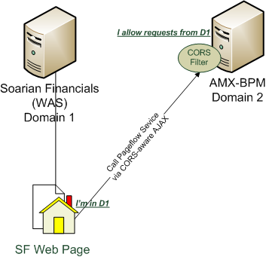

Design of CORS FIlter for AMX
1. Use an open-source CORS servlet filter (org.eclipse.jetty.servlets.CrossOriginFilter). When it is presented with a request, it checks if the Origin header from the request is in its list of allowed origins. If it is, it accepts the request by passing in the response a header called Access-Control-Allow-Origin.

E.g.,
Request has header Origin = SFServerX.
Filter has SFServerX in its allowed origins list, so it sets response header Access-Control-Allow-Origin=SFServerX

2. Put the filter into a composite and deploy the composite to AMX.

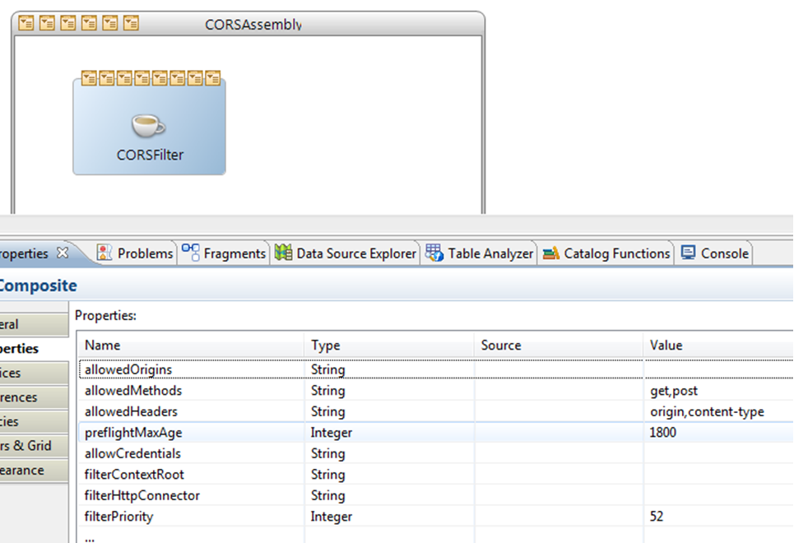

3. Servlet filter is housed in a Java component, but it is not the main implementation class. The main implementation class is called CORSFilter. It has two responsibilities:

- In its init() method, it instantiates the servlet filter, passes it configuration properties (including the allowed origin list), and registers it:
httpInboundResourceAdapter.addServletFilter(corsFilter,
filterHttpConnector, filterContextRoot, filterPriority);

Here, corsFilter is an instance of the servlet filter. The other arguments -- filterHttpConnector, filterContextRoot, and filterPriority are properties discussed in #4 below.

- In its destroy() method, it de-registers the servlet filter.

4. Here's a list of configuration properties used by the servlet filter. They can be set when deploying the composite.

Name | Description | Default
allowedOrigins | Comma-separated list of allowed origins. Empty means all origins allowed. | Empty.
allowedMethods | Comma-separated list of allowed methods. | GET,POST
allowedHeaders | Comma-separated list of allowed headers. | origin,content-type
filterContextRoot | Context roots to which filter applies. Empty means all contexts. | Empty
filterHttpConnector | HTTP Connector resources to which filter applied. Empty means all connectors. | Empty
filterPriority | Priority of filter. Engineering recommends value > 50. | 52

