**AI Project**

# **Introduction:**

Neurons also called a Nerve Cells are the cells responsible for receiving sensory input from the external world and set it as motor commands to our muscle.

Artificial Neurons are atomic computing systems vaguely inspired by biological neurons and are used in artificial intelligence using machine learning. Used mathematics to model real world neuron behavior by taking input, performing weighted sum, using activation function, and producing output.

In Neural networks, an Activation Function of a node is a function that takes the input from the node which is the weighted sum and determines whether the input neuron should be fired or not.

Neural networks, also called Artificial Neural Networks are a circuit of neurons that are built to mimic biological network of neurons in human brain to solve problems using artificial intelligence.

Deep Learning is a sub field of Machine learning in which we make use of neural networks with very deep structures i.e., several hidden layers, to learn from data and make predictions.

TensorFlow is an open-source library used for building and training deep learning neural network models. It was created by google.

# **Problem Definition:**

In this AI practice, will have hands on experience with Tensorflow and use it in Google Colab IDE. Using the MNIST database which contains binary images of handwritten digits.

Create a model using Tensorflow in google colab. The model should correctly (maximum accuracy) make predictions based on data provided in the model.

# **Problem Solution:**

1. Importing libraries- numpy, matplotlib and tensorflow. Doesn’t need to install any of it as they are already installed in google colab.

1. Getting the data using mnist database.

1. Training data set:

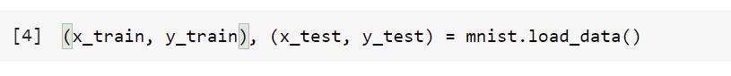

1. Once, the data has been downloaded from the previous code. Plotting the data to have a look at what it contains.

1. The image above contains 28 x 28 pixels. The training data has 60,000 values with the first row of 28 values. Each image has 784 data points.

1. Normalizing the data to remove all the outliers.

1. Creating a model and adding layers:

1. Using the fit function:

1. Evaluating the model:

1. Choosing a number to predict:

# **Conclusion:**

We have successfully created a model in google Colab using tensor flow. As we can see, the model is predicting correctly with the accuracy of 96%. Also, evaluated the model by making a prediction which gives the accurate result.