http://www.schachecke.de/matt2.html

Position 1
Matt in zwei Zügen, Weiß setzt im zweiten Zug matt.
1Q1RKR2/1P2n2P/1r2k2r/4P3/4P3/8/8/8 w - - 0 1
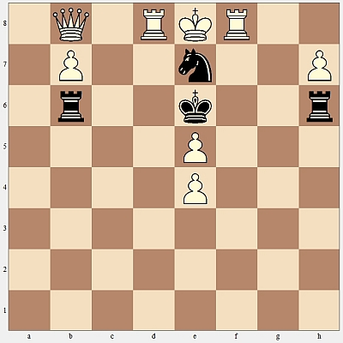
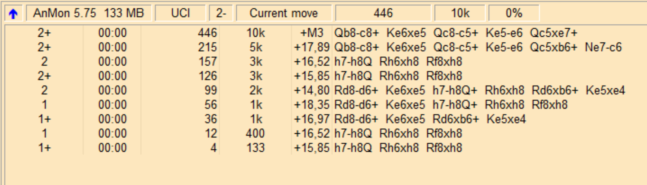
-> position fen 1Q1RKR2/1P2n2P/1r2k2r/4P3/4P3/8/8/8 w - - 0 1
-> go wtime 1800000 btime 1800000 winc 0 binc 0
<- info score cp 1585 lowerbound depth 1 nodes 4 time 0 pv h7h8Q h6h8 f8h8
<- info score cp 1652 depth 1 nodes 12 time 0 pv h7h8Q h6h8 f8h8
<- info score cp 1697 lowerbound depth 1 nodes 36 time 0 pv d8d6 e6e5 d6b6 e5e4
<- info score cp 1835 depth 1 nodes 56 time 0 pv d8d6 e6e5 h7h8Q h6h8 f8h8
<- info score cp 1480 depth 2 nodes 99 time 0 pv d8d6 e6e5 h7h8Q h6h8 d6b6 e5e4
<- info score cp 1585 lowerbound depth 2 nodes 126 time 0 pv h7h8Q h6h8 f8h8
<- info score cp 1652 depth 2 nodes 157 time 0 pv h7h8Q h6h8 f8h8
<- info score cp 1789 lowerbound depth 2 nodes 215 time 0 pv b8c8 e6e5 c8c5 e5e6 c5b6 e7c6
<- info score mate 3 lowerbound depth 2 nodes 446 time 0 pv b8c8 e6e5 c8c5 e5e6 c5e7
<- info cpuload 0
<- bestmove b8c8 ponder e6e5
*1*Found move:Qb8-c8

2QRKR2/7P/1r5r/4k3/4P3/8/8/8 w - - 0 1
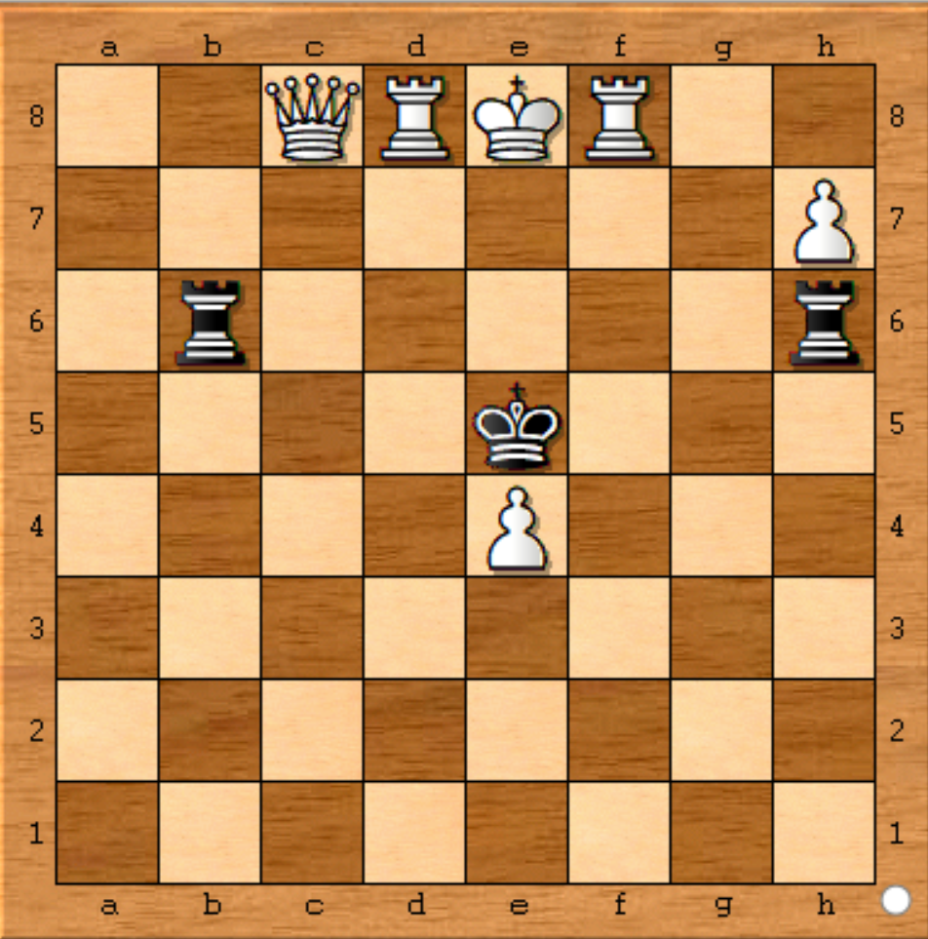
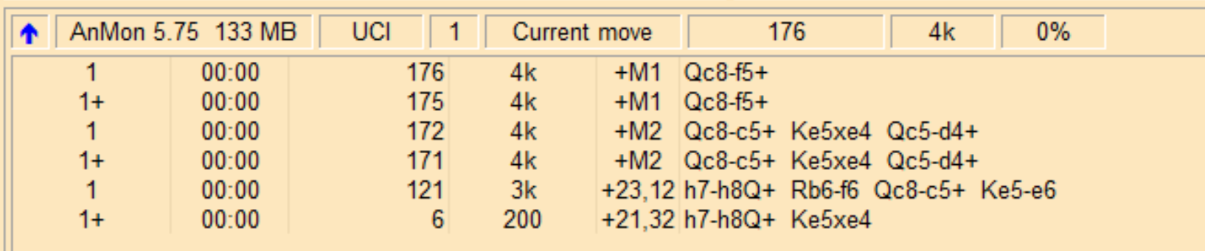
-> position fen 2QRKR2/7P/1r5r/4k3/4P3/8/8/8 w - - 0 1
-> go wtime 1800000 btime 1800000 winc 0 binc 0
<- info score cp 2132 lowerbound depth 1 nodes 6 time 0 pv h7h8Q e5e4
<- info score cp 2312 depth 1 nodes 121 time 0 pv h7h8Q b6f6 c8c5 e5e6
<- info score mate 2 lowerbound depth 1 nodes 171 time 0 pv c8c5 e5e4 c5d4
<- info score mate 2 depth 1 nodes 172 time 0 pv c8c5 e5e4 c5d4
<- info score mate 1 lowerbound depth 1 nodes 175 time 0 pv c8f5
<- info score mate 1 depth 1 nodes 176 time 0 pv c8f5
<- info cpuload 0
<-: bestmove c8f5
*1*Found move:Qc8-f5

