Which collection in C# has fastest “Contains” method?

HashSet

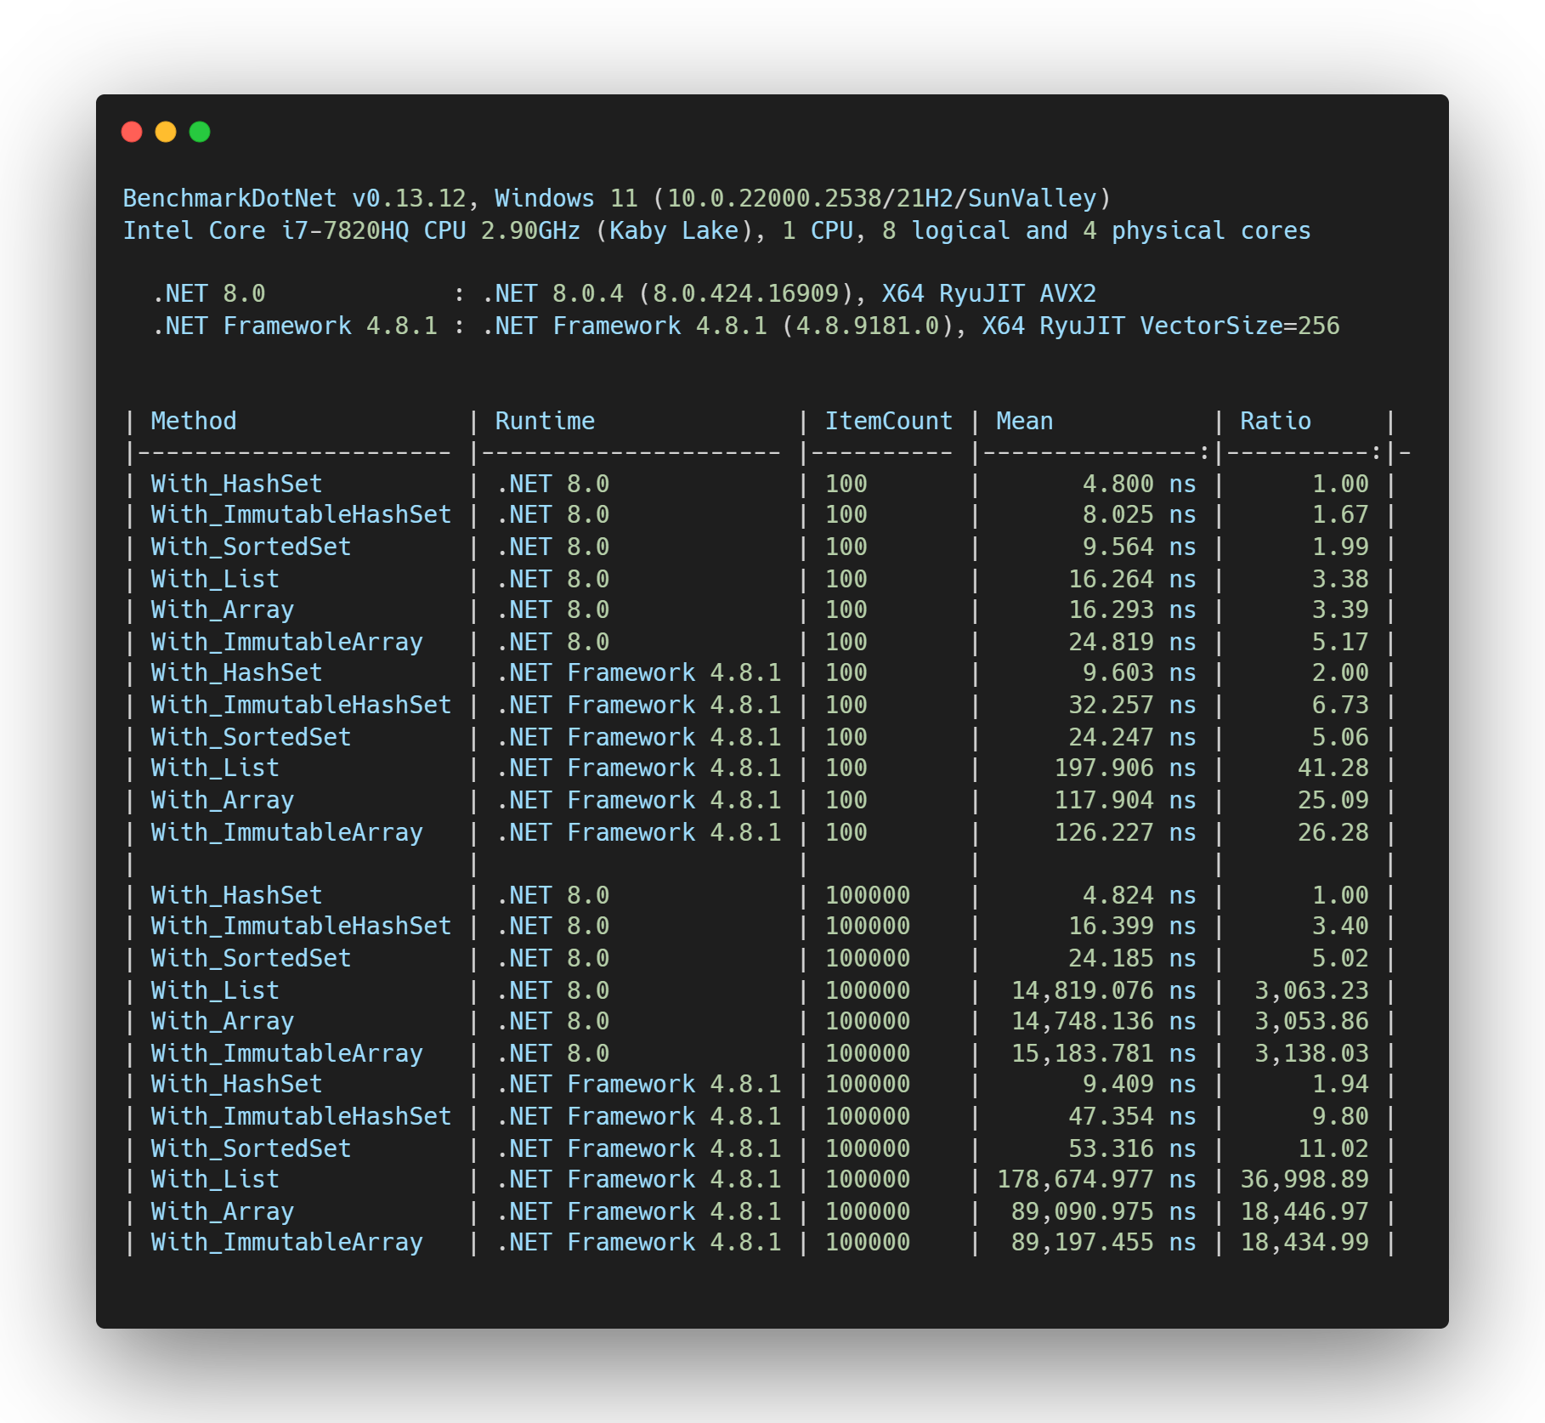

Data is important! An array with “ItemCount” size.

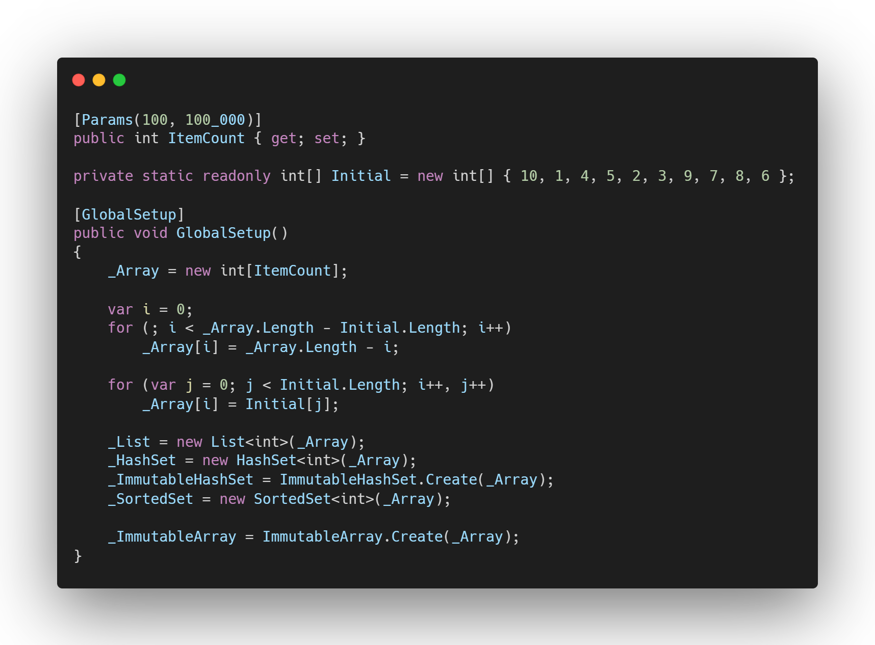Array filled with “data[i] = length-i”, last 10 item isn’t sorted and ended with number 6

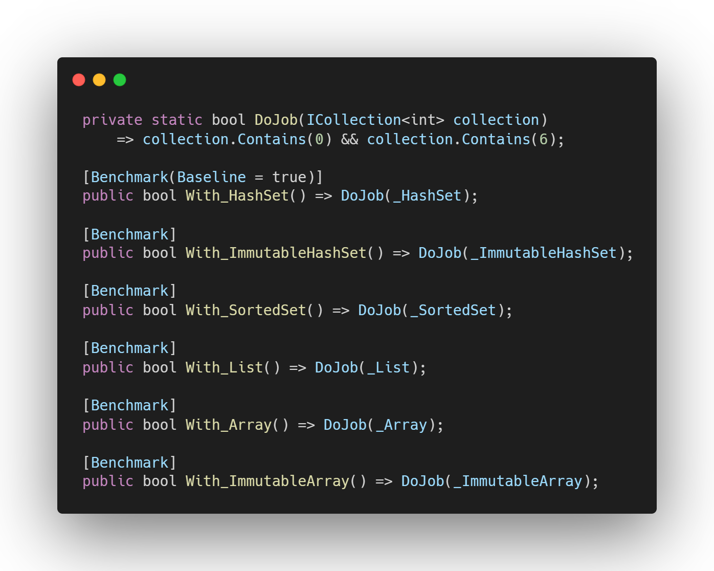We just use Contains method

0 -> not existed 1 -> last item