1.0 Horudhac
Ku soo dhawoow qoraalkaan (documentationkaan), si wacan o faahfaahsan waxa uu kugu sharaxayaa sida aa u isticmaali lahyd systemkaan.
VRLS - waa system loogu talo galay in lagu maamaulo gaadidka nuucyadooda kala duwan, in Wasaarada Gaadiidka ay u isticmaasho diwanglinta iyo losocdoka gaadiidka ay leyhin shacab weynaha somaliyeed.

Awoodaha u leyahy systemkaan:
- Diiwangalinta Maclumaadka Milkilayasha.
- Diwangalinta iyo kala wareejinta Gawaarida.
- Diwaangalinta, Bixnta & Cusboneysinta Rukhsadda wadista Gadidka (liecense).
- Diwangalinta shirkadaha leh baaburta ama so dagsada.
- I.W.M.

Si aad systemka u isticmaasho, waxad u baahanthay marka hore in lagu diwangaliyo oo email iyo furo sireed lagu siiyo, si aad u heshidna waxaad kadalban kartaa Wasarada Gaadiidka.

1.1 Dhowrista Macluumaadka
Systemkaan waxaa horumariyey HSNQ waxana loogu talo galay in loogu adeego bulshada somaliyeed, laguna maamulo macluumaadkooda hoose iyaga iyo gaadiidkoodaba.
Ka digtonow in aad u'isticmasho system-kan si kabaxsan sharciga iyo ujeedada loo sameyay systemkaan, xafid oo ilaali macaluumaadka ku jira sysetm-ka oo ad access-ka uledahay.

1.2 Sidee Systemka Loogalaa (Login)
Si aad si quman ugu gasho syetmka booqo URLka Systemka , kadbina waxa kusoo bixi doona shaashada hoose , kadibna raac talaabooyinkan hoose
- Formka Hoose qeybta sare ee kuqorantahy (email or user name) halkaas waxa galisa accountka lagu sameyay emailkisa

- qeybta hoose ee formka ee ku qorantahay (password) gali furo sireedka lagu sameyay
NB: Haku cel celin hadii uu ku shaqeyn wayo furo sireedka ama emailka midookda si aadan halis ugu galin in accounrka lagaa xiro.

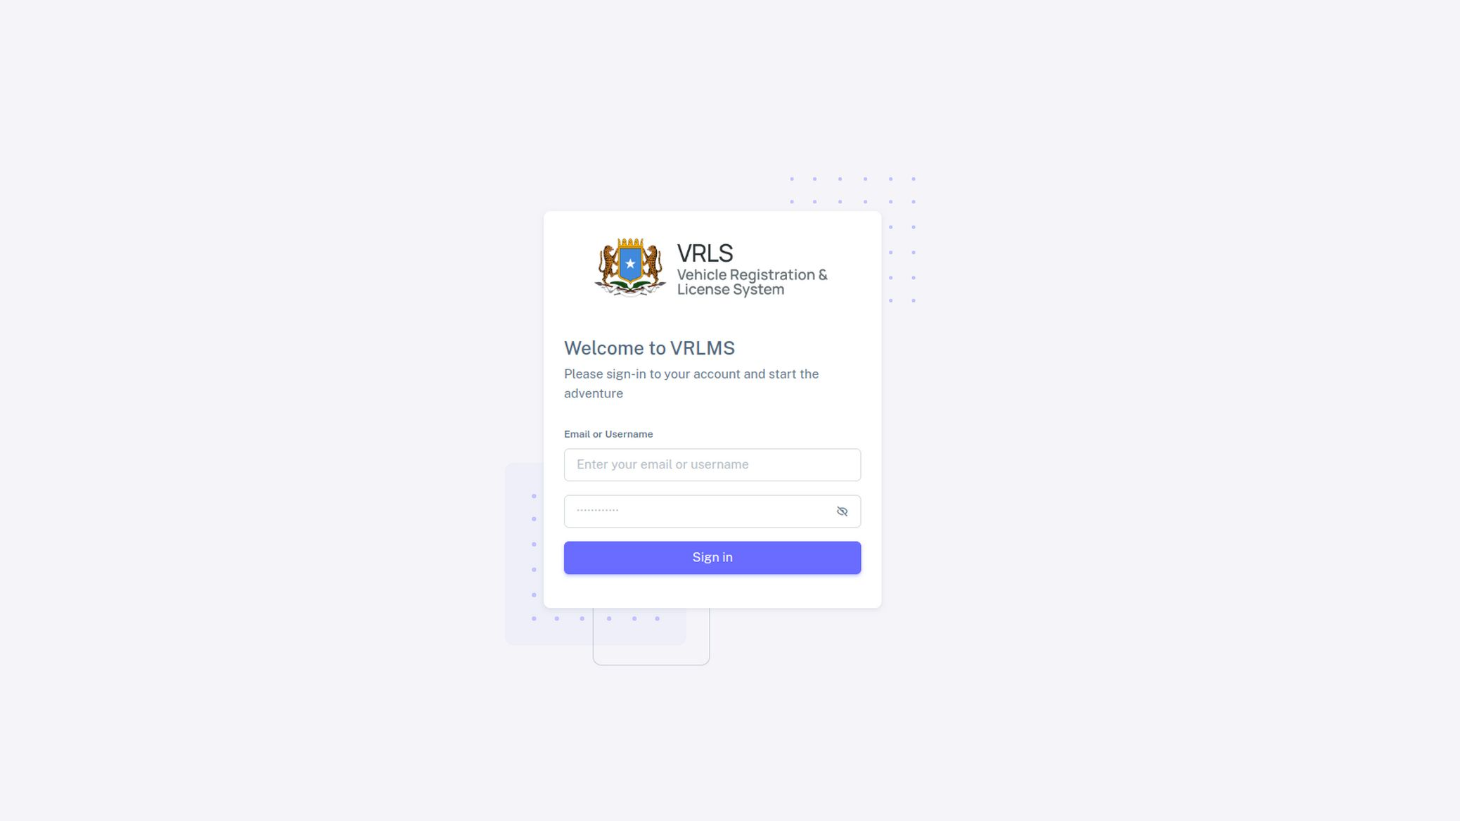

2.0 Dashboard
Hagaag, ugu danbeyn waxa gudaha usoo gasahy systemka adiga oo adan wax caqabad ah kala kulmin irida hore ee systemka laga so galo, waxa kuso baxaya page ama shaashada loyaqano dashboard kaso ku sinaya macluumad kooban o ku saabsan xogta kujirta systemka. Eeg sawirka hoose.
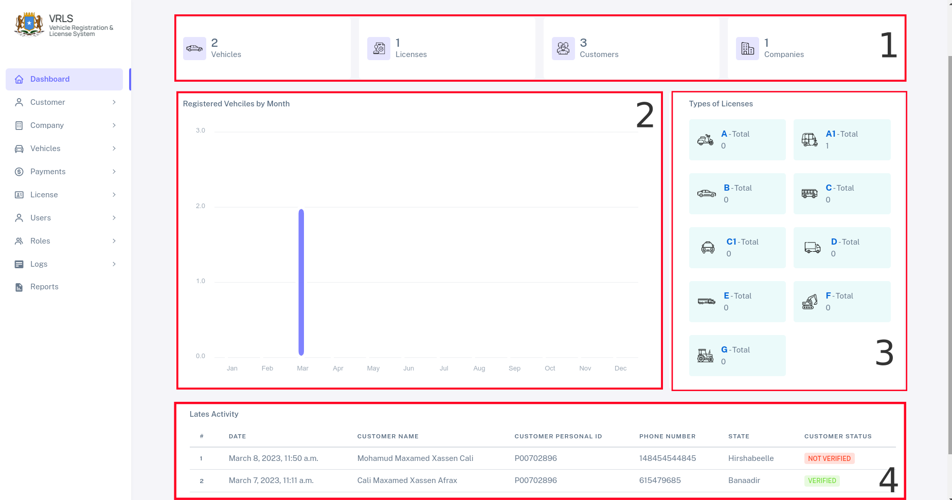
sida kor kaga muqata dashboardka waxa uu ka koobanyhy 4 qeybood oo kala dugan oo mid walba ay shaqo gooni ah qabnyso.
- Qeytba Lambar (1) ku qorantahy oo aan ku calemayay waxay ay soo muujineysaa dhamana inta gaadid ay kujrta systemka, inta macmil, inta license oo labixiyay iyo iyo shirkadood ee diiwaangashan

- Qeybta labaad waxa ay ku muujineysaa gaadidka diawangshan iyo bisha ladiwangaliay oo si shax ahaan ah, si kooban waxa uu soo bandhigyaa inta gaadiid ee diiwangsahan iyo bishii ladiiwangaliyay
- Qeybta seddexaad waxa ay ku tusineysaa liisanda diwangasha iyo nuuc walba oo liisan ah iyo tirada ka diiwaangashan
- Qeybta 4aad waxay ku tusineysaa 5 qofood ee ugu danbesayay ee systemka so gala si kooban.
NB:- Maclumadka halkas kaso baxaya way kala dugaan doonan hadba waxay ku xiranthy heerka / doorka uu yahay userkada

3.0 Customers
(Module) kaan waxa loogu talo galay in lagu maamulo macaamisha dooneysa in gaadid loo diwangaliyo ama in liisan lasiyo, I.W.M, waa halka laga diiwangaliyo laga aqablo, laga xaqiijiyo macaamisha xogtooda,

3.1 Diwangalinta Macmiila (Customer – Registeration)
Tilaabada ugu horeysa ee aad qadeyso si aad macmil u diwangaliso waa inaa tagtaa ama boqataa Customer → Regiser customer eeg sawirka hoose

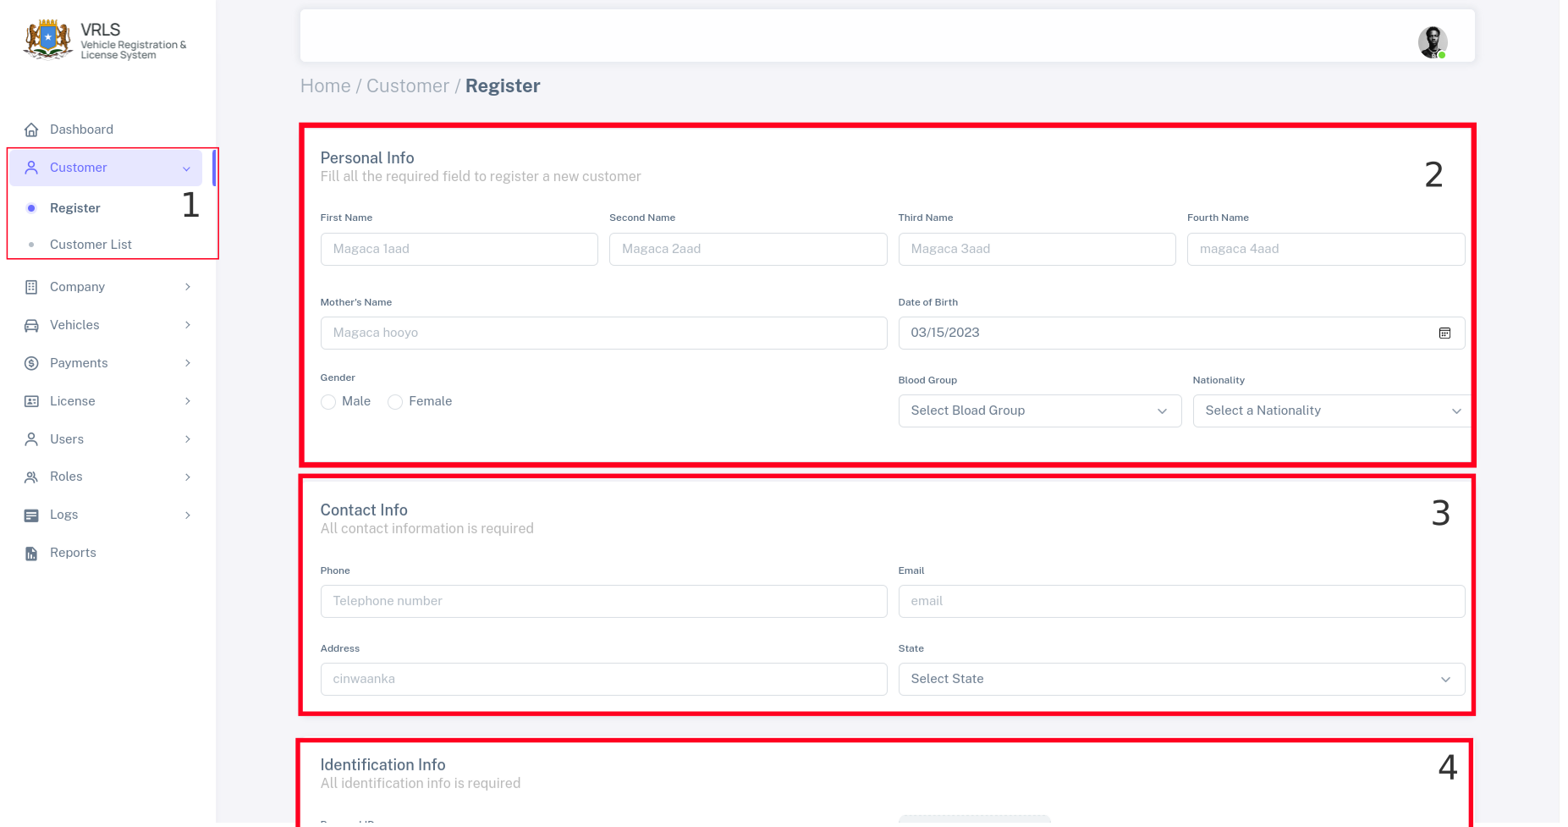
Sida kaaga muqata Sawrika Kore waxa uu ku tusinaya talaabooyinka laqadayo si loo diwangaliyo maclumaadka qof macmiil ah
- Tilaabda Kowaad Imow (Customer → Register Customer ) kadooro kadibna waxa ku sobaxaya foomka laga buuxinayo macmiilka

- waxa buuxisa macluumadka asaasiga ah ee qofka oo kala ah
- Magaca Koowaad ee qofka
- Magaca aabihiisa ama magaca labaad
- Magaca 3xaad ama magaca awoowihiisa
- Magaca 4aad ama magaca awoowgiisa labaad
- Magaca hooyada
- Taariikhda dhalashada
- Laba iyo Dhafig kii uyahay
- Nuuca dhiigiisa
- Iyo Jinsiyada ama dhalshada qofka
Maclumaadka asaasiga ah ee qofka maahna kuwa is bad badla, waa kuwa ugaar ah qofka aad diiwangalineysid
- Marka aad intaas kasoo buuxsio qofka, waxa uso gudubtaa qeybta xiga ee ka hooseysa qeybta aad hada soo buuxisay, qeybtaan waxa qofka ka buuxineysaa macluumadka xariirkisa sida
  - Telephone kiisa Gacanta
  - Emailkisa
  - Cinwaanka ama meesha uu daganyahay
  - iyo Maamul goboleedka uu daganyahy qofka

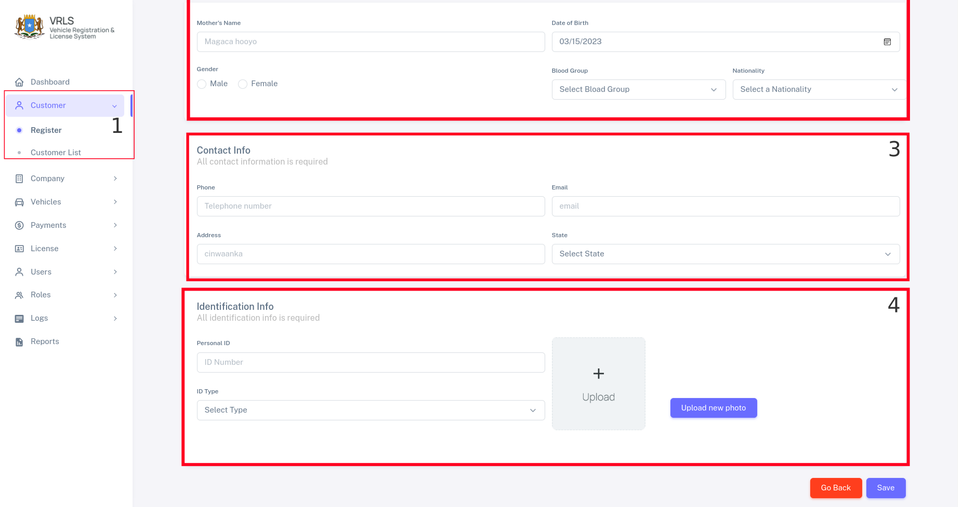
- Qeeybta 4aad ee ugu danbeysa waxa lagu qorya maclumaadka laxariira cadeynta qofka (maclumadka kore aad kaso bixsay document taagreaya), iyo sawrika qofka
  - Formka Persoanl id waxa galineysa, qofka documentga dowladeed ee u wato serial numberkisa
  - kadbna door serial numberka aad so galisay kor document nuce ah ayu koqorna sida passport I.W.M.
- Ugu danbeyn dooro Uppload new photo si aad uso galiso sawrika qofka, ogow swrika qofka waa in uu kujiraa computerkad si aad usoo uppload greyso
NB:- Sawrika aa so doraty wa in uu noqdaa .PNG kaliya hadi kle kama yelayo in aad xareyso sawirka.

ugu danbeyn guji halka ay ku qoranthy (Save) si aad u diiwangaliso Maclumadka kore e aad soo buux buuxisay, xooga yar u dulqaado si loo diiwangaliyo xogta qofka aad soo dirty.
Waxa ku so baxaya qoraal cadeynaya in qofka la diwangaliyay, iyo in aan ladiiwangalin kuu kala shegaya.

3.2 Xaqiijinta Qofka
Marka aad qof soo diiwangaliso waxa qasab ah in qofkaas la xaqiijiyo oo qof maamul ah xaqiijiyo qofka diwangashan in maclumaadkisa saxnyihiin,
NB:- xaqiijinta kaliya waxa sameyn kara qof maamul ah eeg sawirka hoose

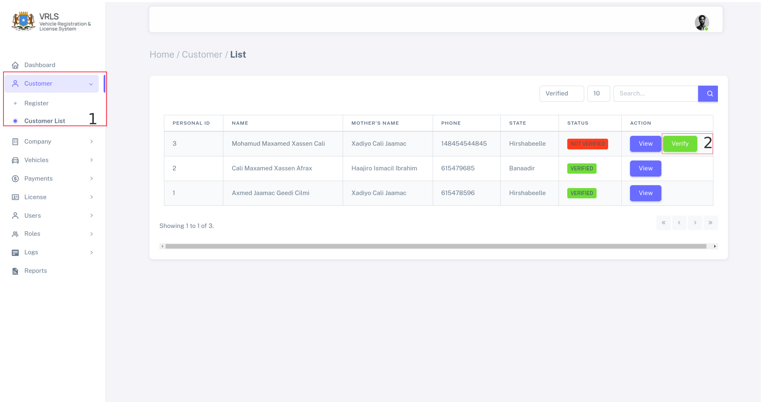
sida ka muuqata sawirka kore, waxa uu ku tusinaya sida loo xagiijiyo qof diiwaangashan , waxa laxaqiijin kara kaliya qof diiwaangashan.
Talaabyooinkaa raac
- Dooro Customer List
- waxa kuu soo baxaya sawirka kore kadibna waxaa doortaaa button cagaaran ee ku qorantahy Verify
- waxa kusoo baxa sawrika hoose buux buuxi maclumadka hoose so uppload garee documentiga cadeynaya qofka sax ahaanshihiisa kadibna verify taabo
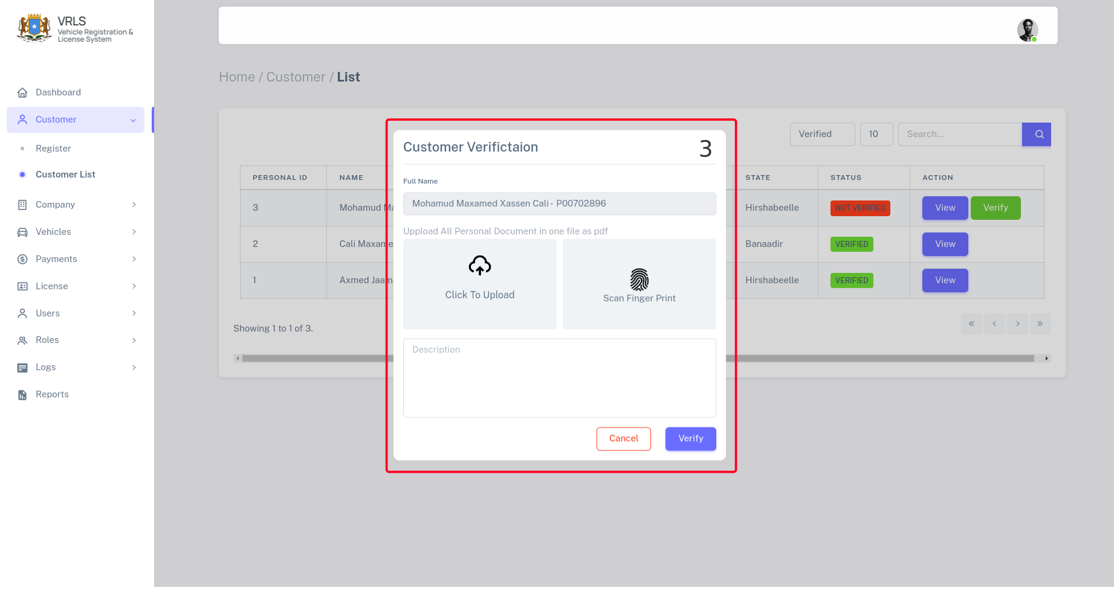
- Marki aad buux buuxiso formkas oo ad taabto verify waxa kuso bixi dona warqad cadeynysa in qofka la aqoonsaday oo la xaqiijiayay

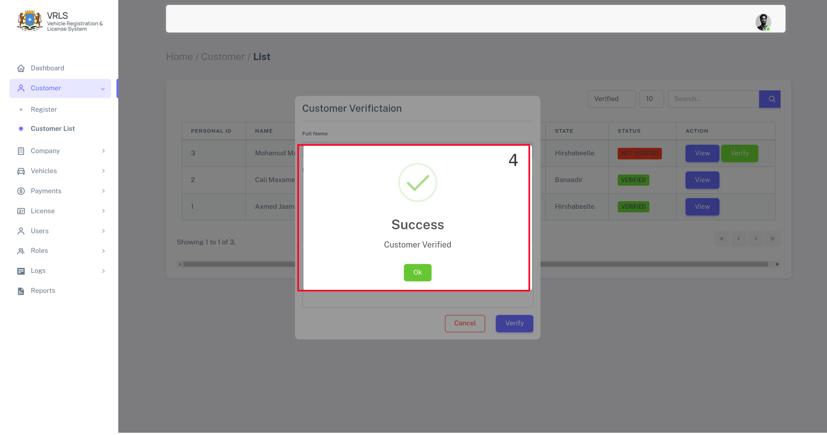
Marki qof la xaqiijiyo kadib ayuu yelan karaa gaari ama licesne I.W.M

3.3 Profile qofka
Profile ka qofka waa goo b laga wada helayo macluumaadka qofka oo dhan laga so bilaabo maalinta uu lagu daray systemka,
si aad u bqooto profile qofka raac taalbooyinaak
- Booqo Customer List → View si aad u hesho maclumaadkisa

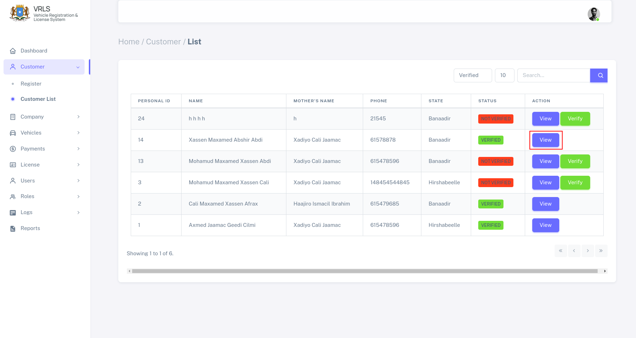
waxaa doorataa View si aad usii aragato macluumaad profilka qofka kadibna waxa kuso baxaya sida tan
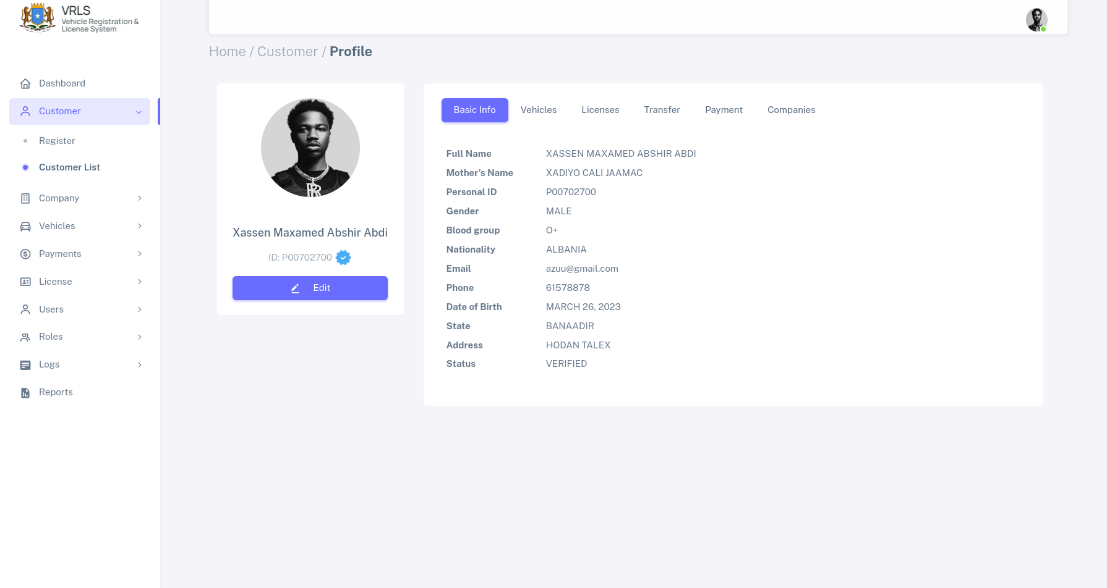
hada waxa kuu soobaxay oo kuu dooran Basic info (maclumadka asaasiga ah ee qofka)
si aad u hesho maclumadka gaadiidka qofkani uu leyahay
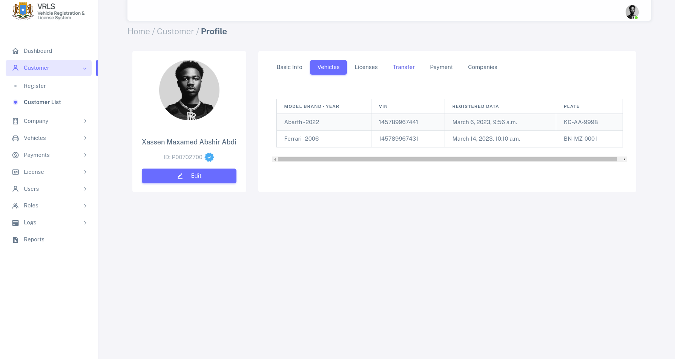
waxa kusoo baxa liiska gaadiidka qofkan oo leyahy oo dhameystiran, licenska qofka u lehay waxa ka dheehan karta boga xiga ee license ku qorantahy
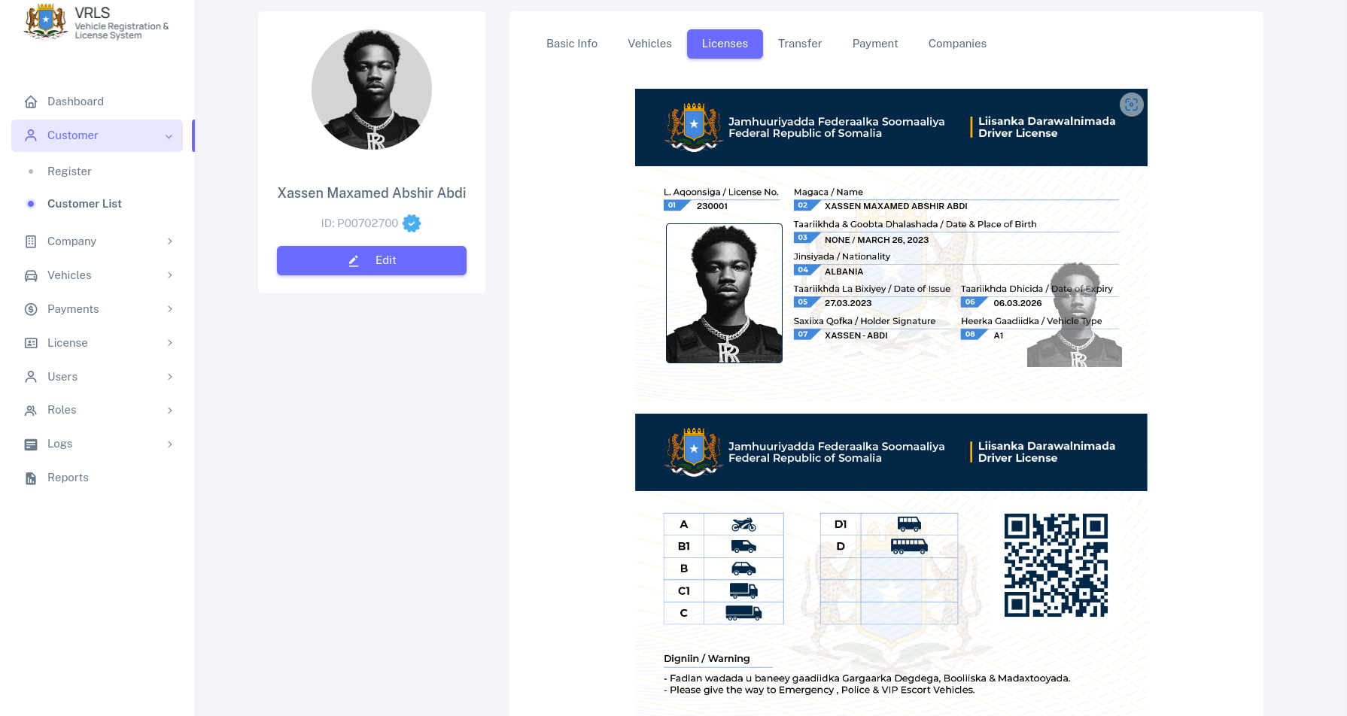
halkaan waxaa ku jira maclumaadka licenka qofka oo au ku dhagnayhy sawrkiisa iyo qrocode xaga danbe kaga yaala oo muujinaya macluumadka qofka,
sidaa kusi wad oo booqo pagegka kala dugan ee qofka leyahy si aad u dhehato macluumaadkiisa

4.0 Shirkadaha (Companies)
Hanaanka diiwaangalinta shirkadaha wxay ka simanyihin hanaanka diiwangalinta macmiilka kaliya waxa kala dugana fieldyada laga kala diiwangalinyo,

4.1 Diiwangalinta Shirkadaha (Company Registration)
Si aad u diinwagaliso shirkad waxay ay lamid tahay sida macmiil loo diiwangaliyo wax farqi weyn o dhaxeya hanaaka diiwangalinta majrio kaliya waxa kala dugan waxa laga diiwangaliyo shirkada iyo macmiilka
si aad u diiwangaliso shirkad raac talaaboyinka so socda
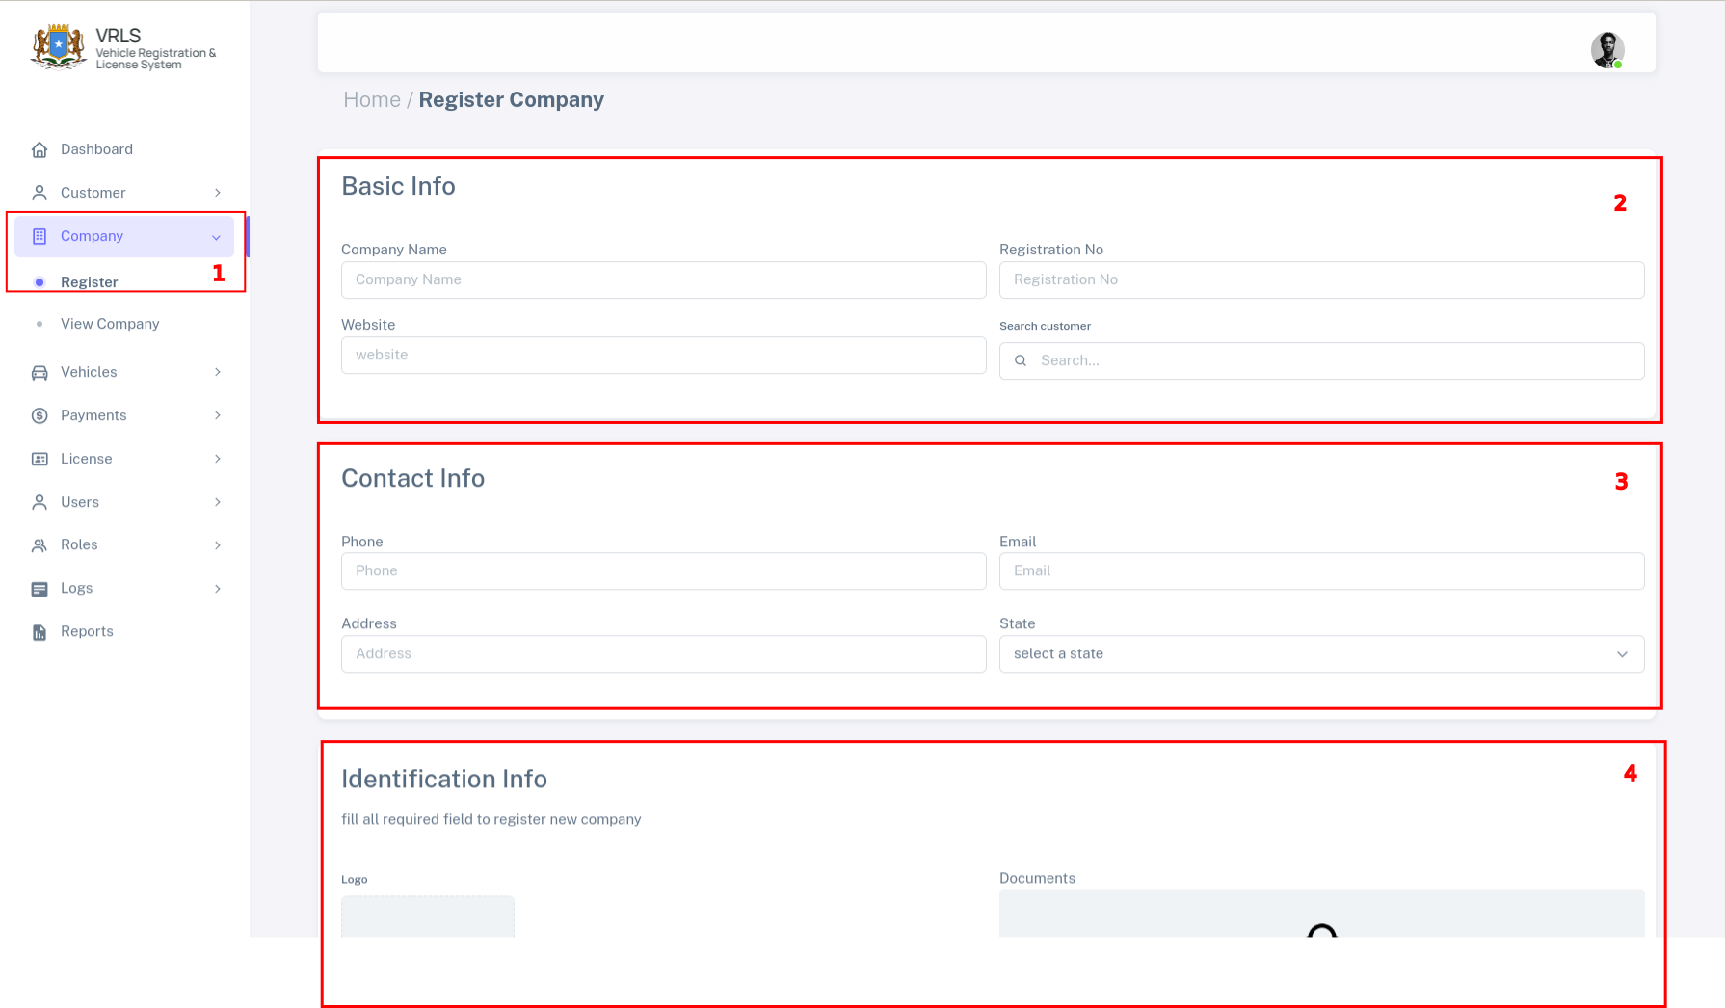
- Dooro Company → Register
- Buux buuxi foomka 3diisa qeyb ee kala dugan
  - Basic Info ah macluumaadka asaasiga ah ee shirkada
  - Contact Info ah macluumaadka xariirka ee shirkada
  - Identification info oo ah macluumaadka laxariira logada shirkada iyo documetyda cadeynaya shirkada
  - ugu danbeyn dooro buttonka save si loo xareyo macluumadka qofka.

4.2 Xayir ama Xayiraada ka qaad shirkada (Block & Unblock)
Si aad u xayirto shirkad (Block) u saarto, waxa raacdaaa tilaabooyinkaan soo socda

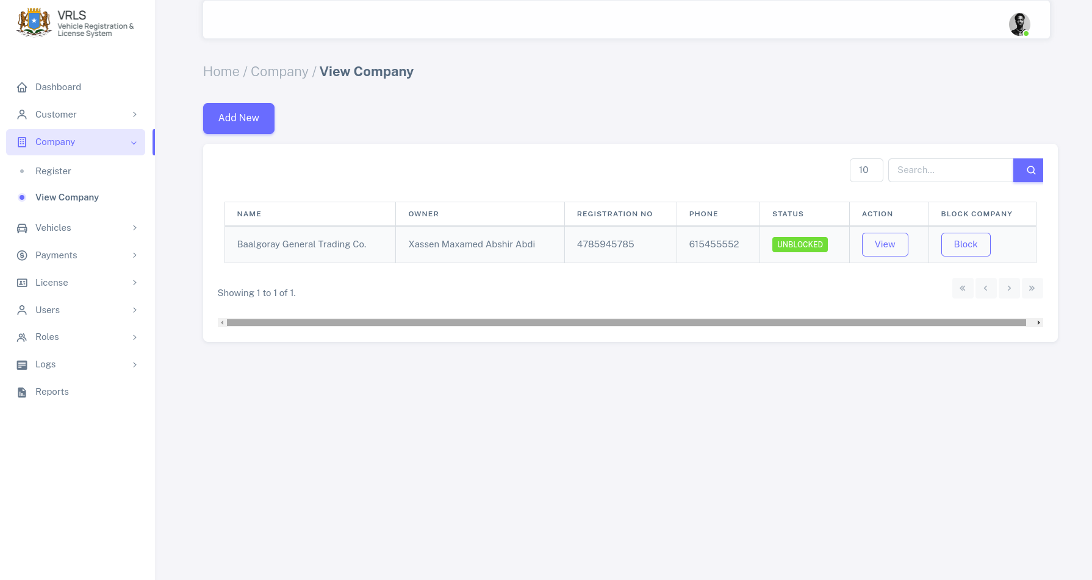
- Dooro Buttonka ay ku qoranthy block kadbna waxa kuso baxaya foomkaan hoose
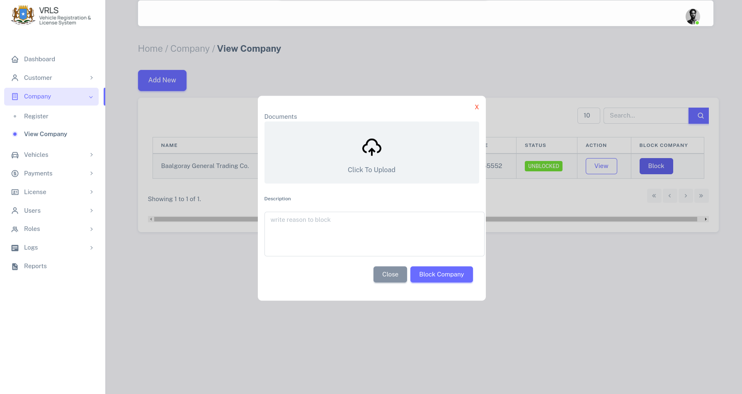

sidaasna aya ku xayirtay oo block ku saartay company
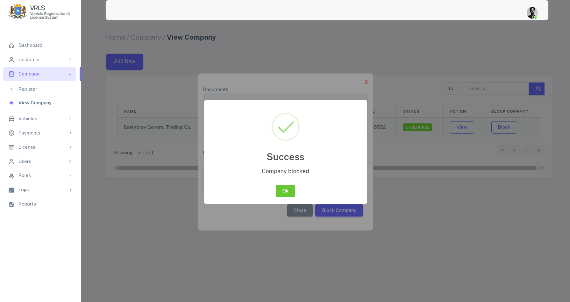
buux buuxi forka soo upload garee documentga lagu xayiray shirkada qor sababta loo xayiraayo shirkada kadbna block dheh.

Si aad xayiraada uga qaado company ama shirkada, waxa ku noqotaa company view kadibna companyga xayiran waxa ku so bix dona buttona y ku qronathy unblock kadibna guji buttonkaas , waxa kuu soo baxaya foromkaan hoose
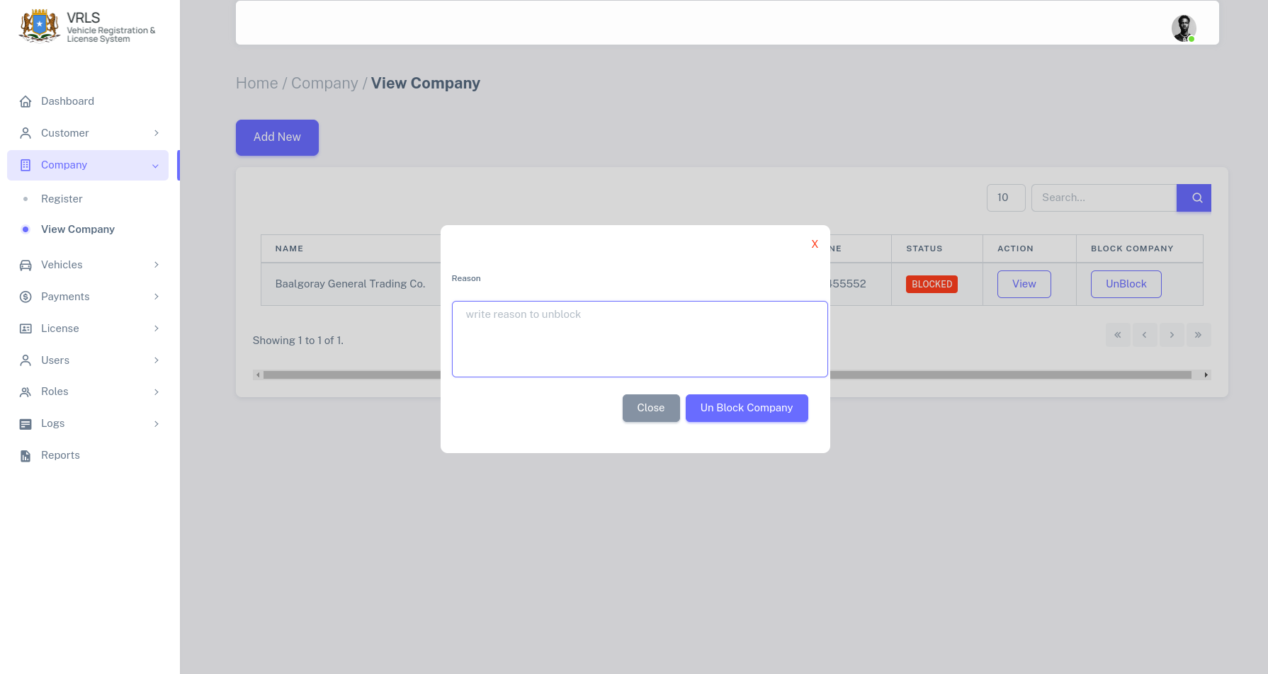
qor sababta xaiyaarada looga qaadayao compnyga kadbna taabo unblock
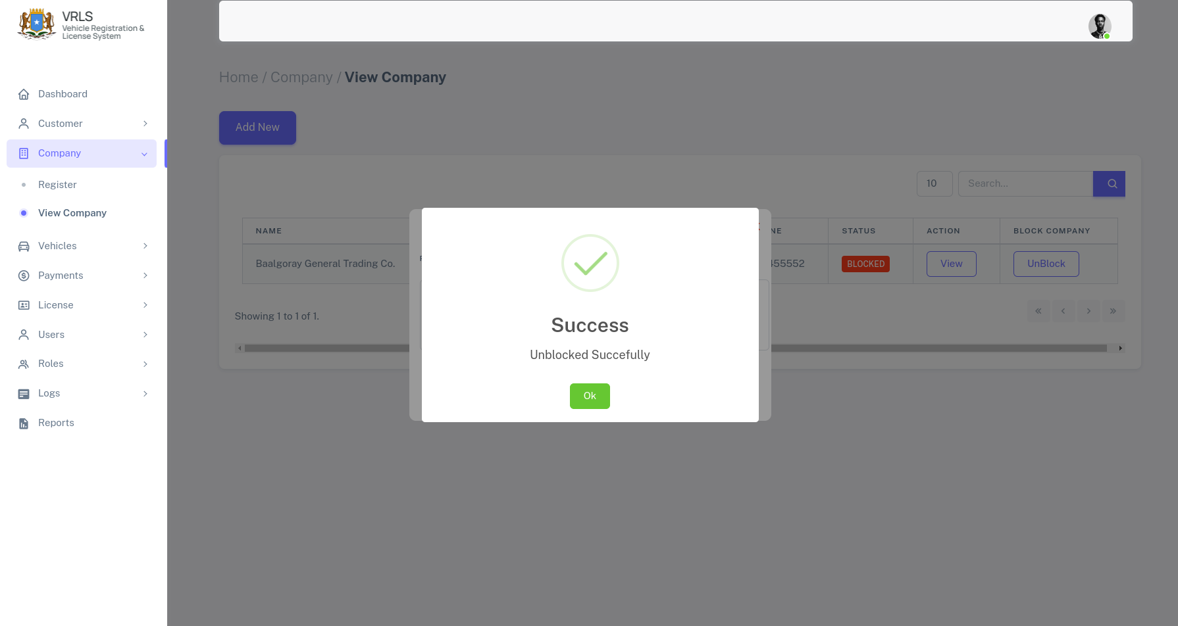
ugu danbeyntii waad ka qaaday xayiraada companyga

4.3 Profile ka Companyga
Profile companyga waxa uu lamid yahy kan customer oo kale si aad ubooqato company profile guji halka ay ku qoranthy view kadbna raac tilmaamahan so socda
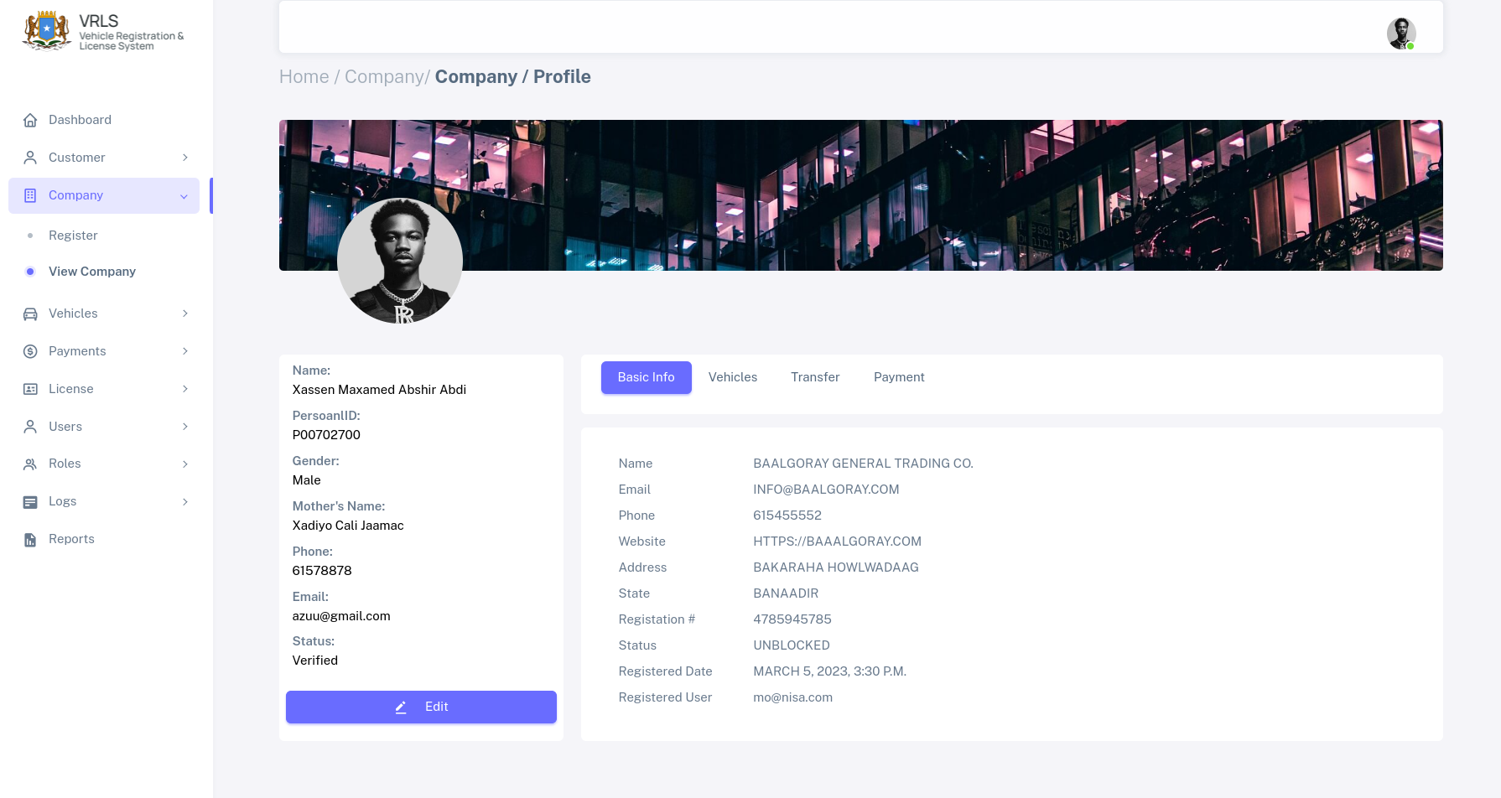
waxa kuu soo baxaysa daaqadan kore dhanka bidixda waxa ku qoran maclumaadka qofka iska leh shirkada, halka dhanka mdigtana uu ku yaalao maclumaadka shirkada asaasiga ah sida magaca shirkada, websitkeda iyo telphonkeeda o kale
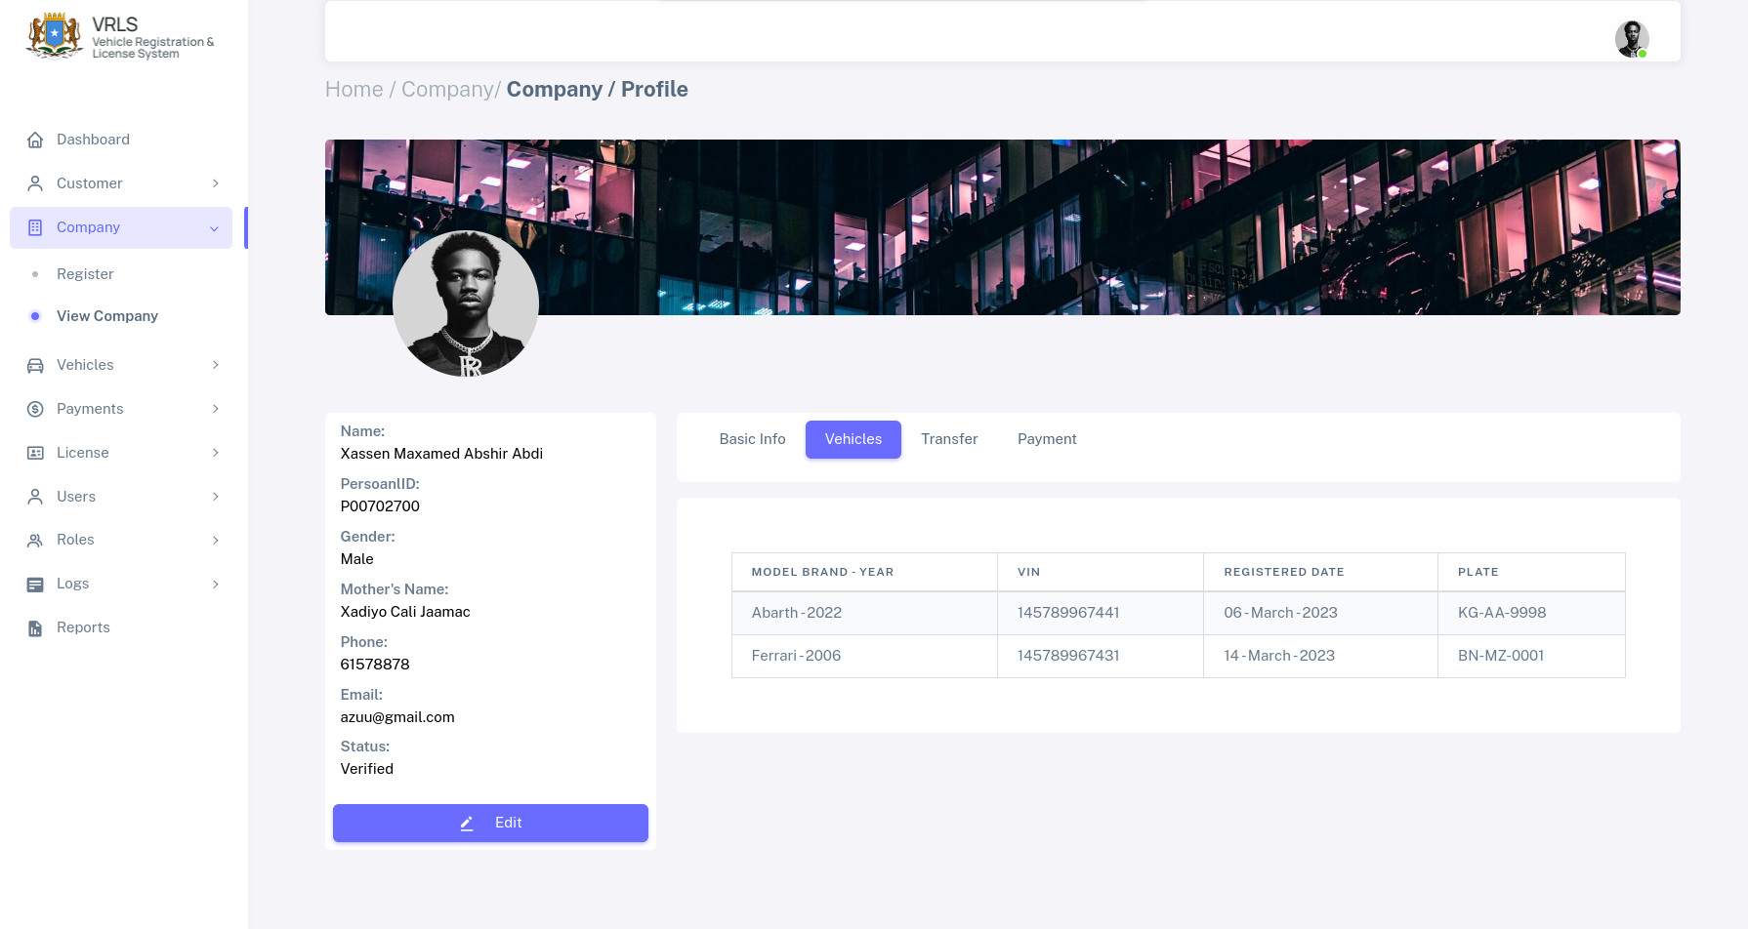
hadii ad ku jiso vehciles waxa kuso baxa companygaan baaburtsa o dhan, booqo tabska kale si aad usi hesho maclumaad dheeri ah

5.0 Gaadiidka (Vehicles)
Qeybtaan waaa qeybta laga maamulo gaadiidka, waxaa ay qabtaa in ay diiwangaliso gaadiidka, in baabur diwangashan loo asteeyo taargo, in la ark karo macluumaadka gaariga , tijaabo laga qaado badqabka gaariga I.W.M

5.1 Diwangalinta Gaadiidka
Si aad gaari u diwangaliso , waxa shardi ah in qofk agaariga loo diwangalinyo u verified ahaado, ama xaqiijisan yahy,
si gaari udiiwaangaliso raac tilmaamaha so socda

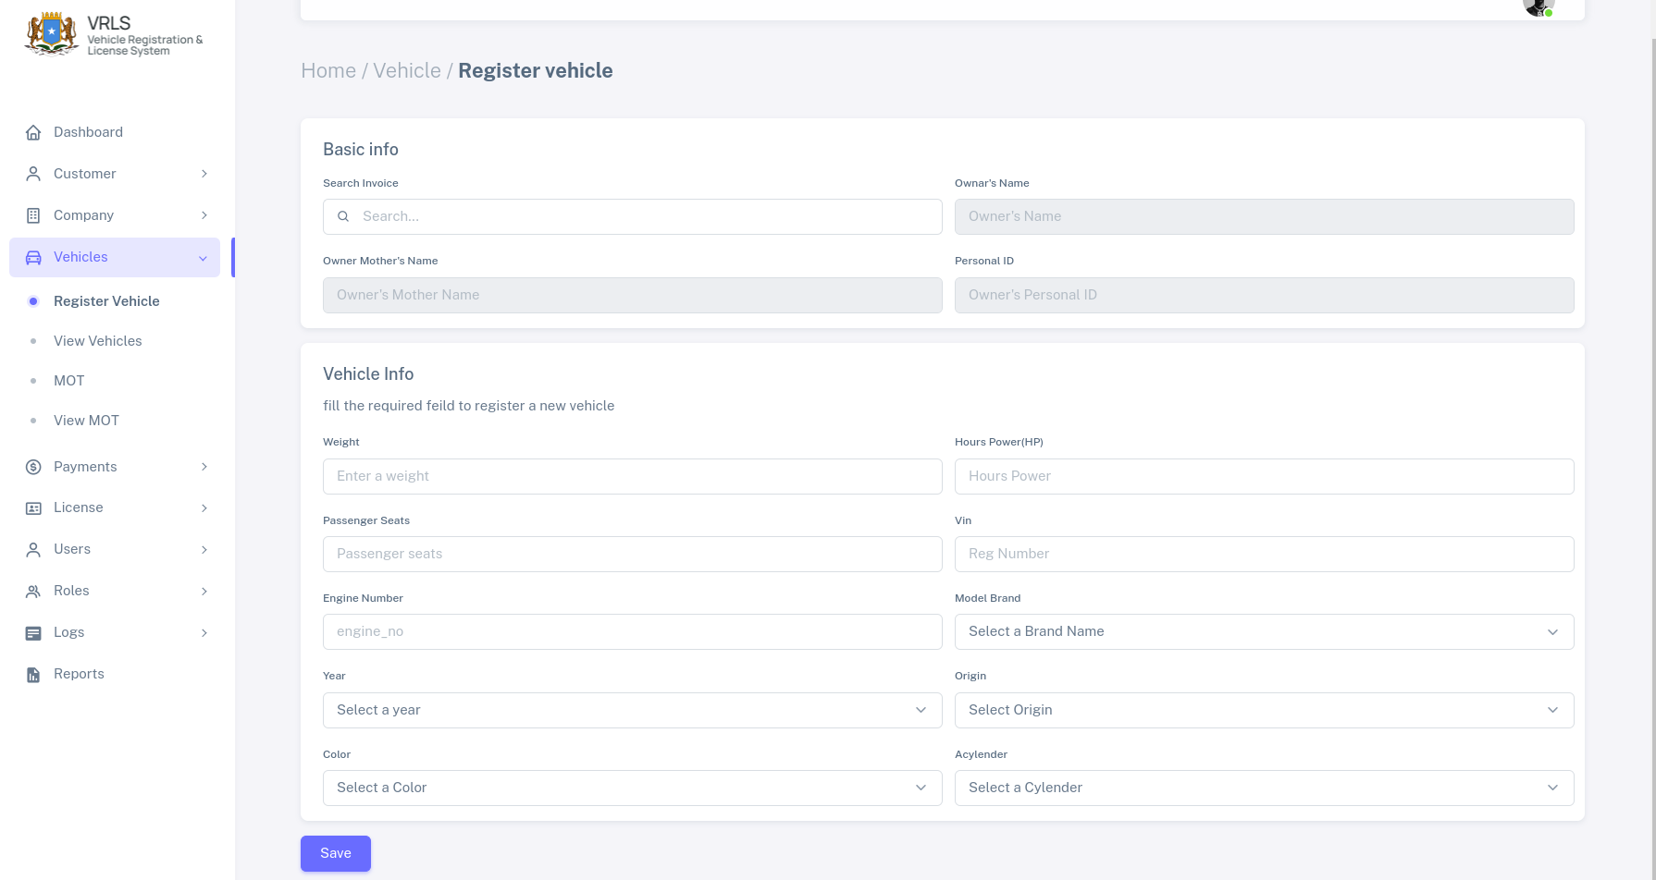
- waxaa booqataa Vehciles → Register Vehcile
- waxaad buux buuxisa basic info ah magaca qofka gaariga iskaleh, si aad uhesho magaca qofka gaariga lo diwangalinyo, waa in uu lacag bixin sameyaa.
- Buux buuxi macluumadka gaariga
- kadibna waxa kujisaa save si loo xareyo maclumaadka gaariga.

5.2 U’asteynta Taargo
Marka aad gaari diwangaliso talaabada xigta waxa weye in aad u diiwangaliso gaariga, taargo si aad taargo ugu asteyso gaari raac talaaboyinkaan

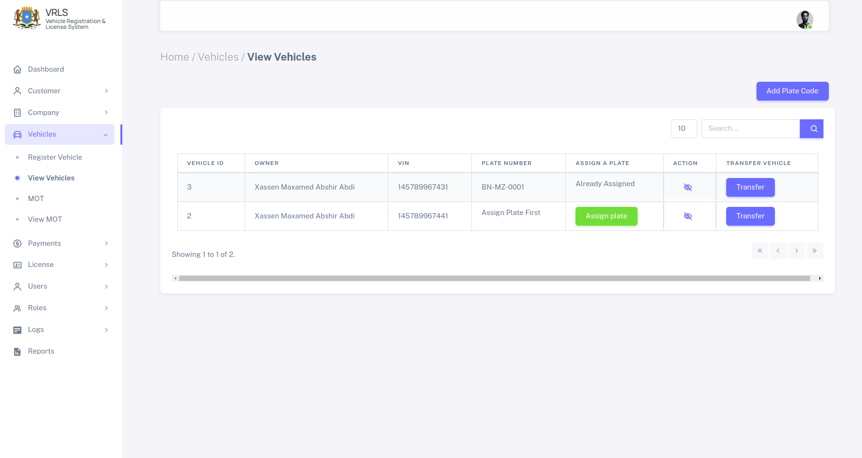
Taabo buttonka cagaaran, oo ay ku qoranthay (Assign Plate) waxa kusoo bixi doona foomka asteynta taargada ee hooose

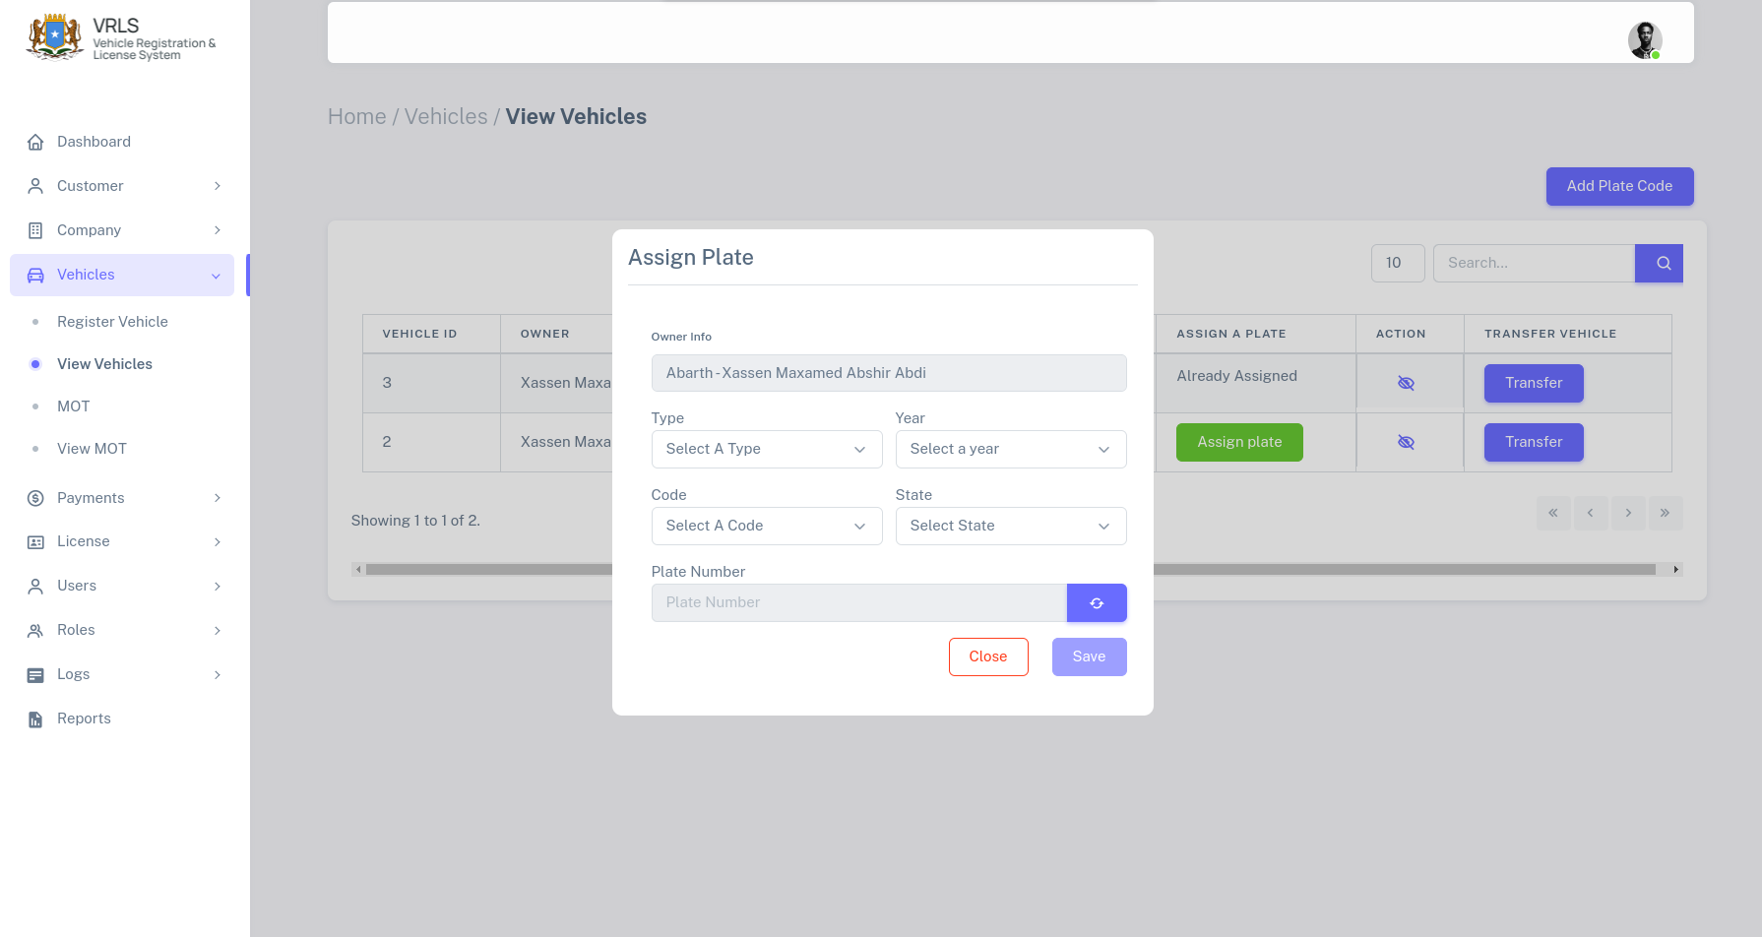
Buux buuxi foomka adigoo kubuuxniyaa kadbna taabo button generate dheh si aad u hesho plate number ku aadan state iyo code aad dooratay, kadbina save dheh si aad u xareyso taargada gaarigaas,

5.3 Profile ka Gaariga
Si aad u hesho macluumaad gaariga oo faahfaahsan waxa taabata buttonka buluuga ah leh iconka eye, waxaa aad arekysaa profilkaan hoose

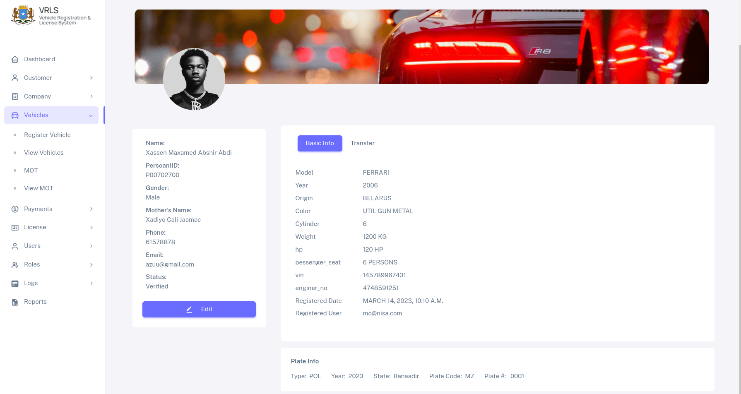
profilka gaariga waxa uu egyahay sidatan, waxa dhanka bidixda yaala profile ka qofka iska leh gaariga wxa dhanka midgta kaso baxaya maclumaadka gaariga halka dhanka hoose, macluumaadka taargada oo faahfaahsan,
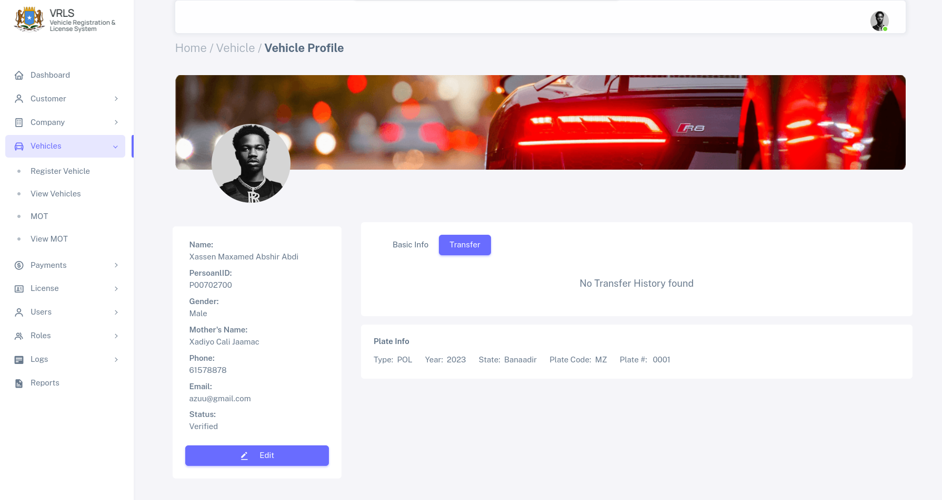
profile ka waxa u kutusinaya transfere, ka baaburka ku dhacay, iyo int mar oo lawarejiaya,

5.4 MOT( Badqabka ) Gaariga
Si loo hubiyo, badqabka waxa laga diiwaangaliyaa imtixaanka badqabka gaariga, si aad diiwangaliso badqabka gaariga, waxa raacda tilmaamahann soo socda,
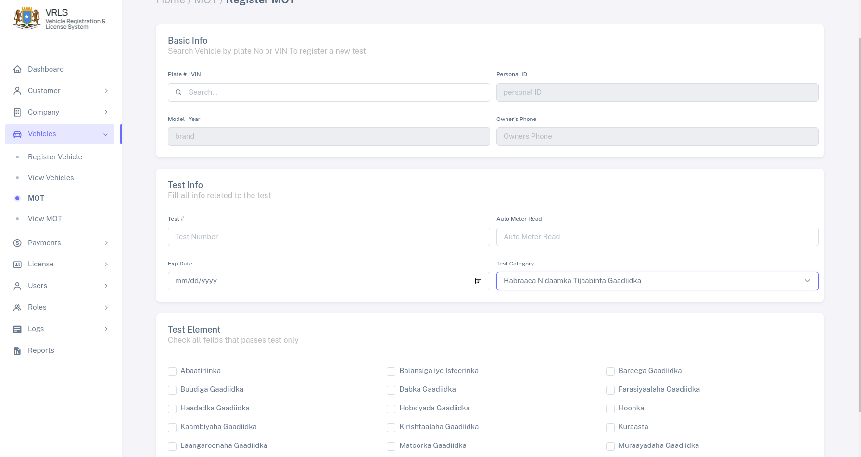
formkaan kore waxaad ka buxineysaa badqabka gaariga adigoo galinaya Baaburka cida iskaleh magaceeda ama chesis numberka (VIN) kadb waxa kuso buxsamaya maclumadkaga gariga o saxn hubi inaad dooraty gaariga ugu saxan ee ad rabto inaa test ga ka qaado
sido kle buuxi buuxi macluumadka testga, dooro testga categorygiisa, check sar kaliya testga uu kubaasay gaariga kuusan ku baasi gaariga faraha ka qaad, oo wax calaamad ah hasaarin

marki gaariga laga qaado test waxad ka dhehan kartaa natiijada testga adigoo tagaya View MOT

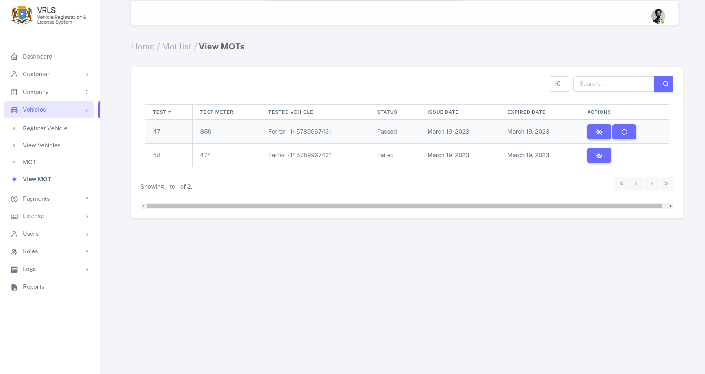
Testga natijadais ayaa halkan kaso baxaysa, waxa ayna ku tusineysaa gaariga baasay, iyo gaariga kan aan ku baasinba, kan baasay waxa uu helaya button looga abuuri karo shahaadada paasida kan aan ku baasin imtixaanawaxa uu helaya kailya meel laga arki karo imtixaankiisa.

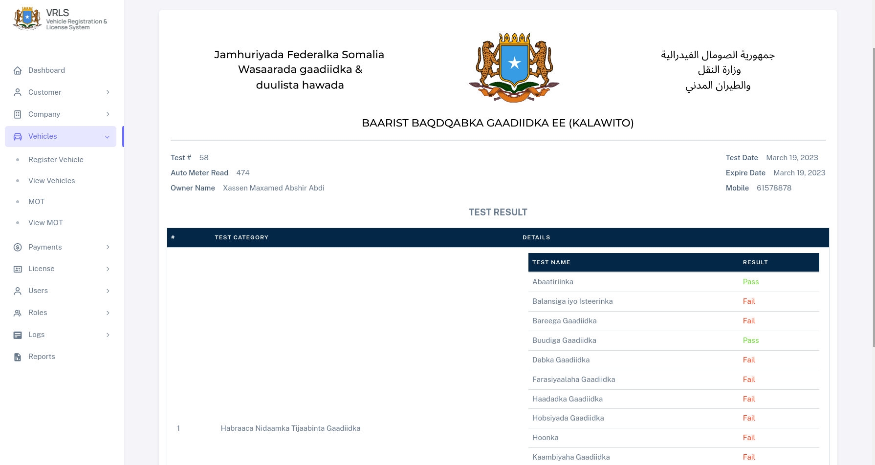
marka aad taabato buttonka isha ku sawiranthay waxa ku so sarayaa macluumaadka imtixaanka oo faah faahsan, wana dabacan kartaa

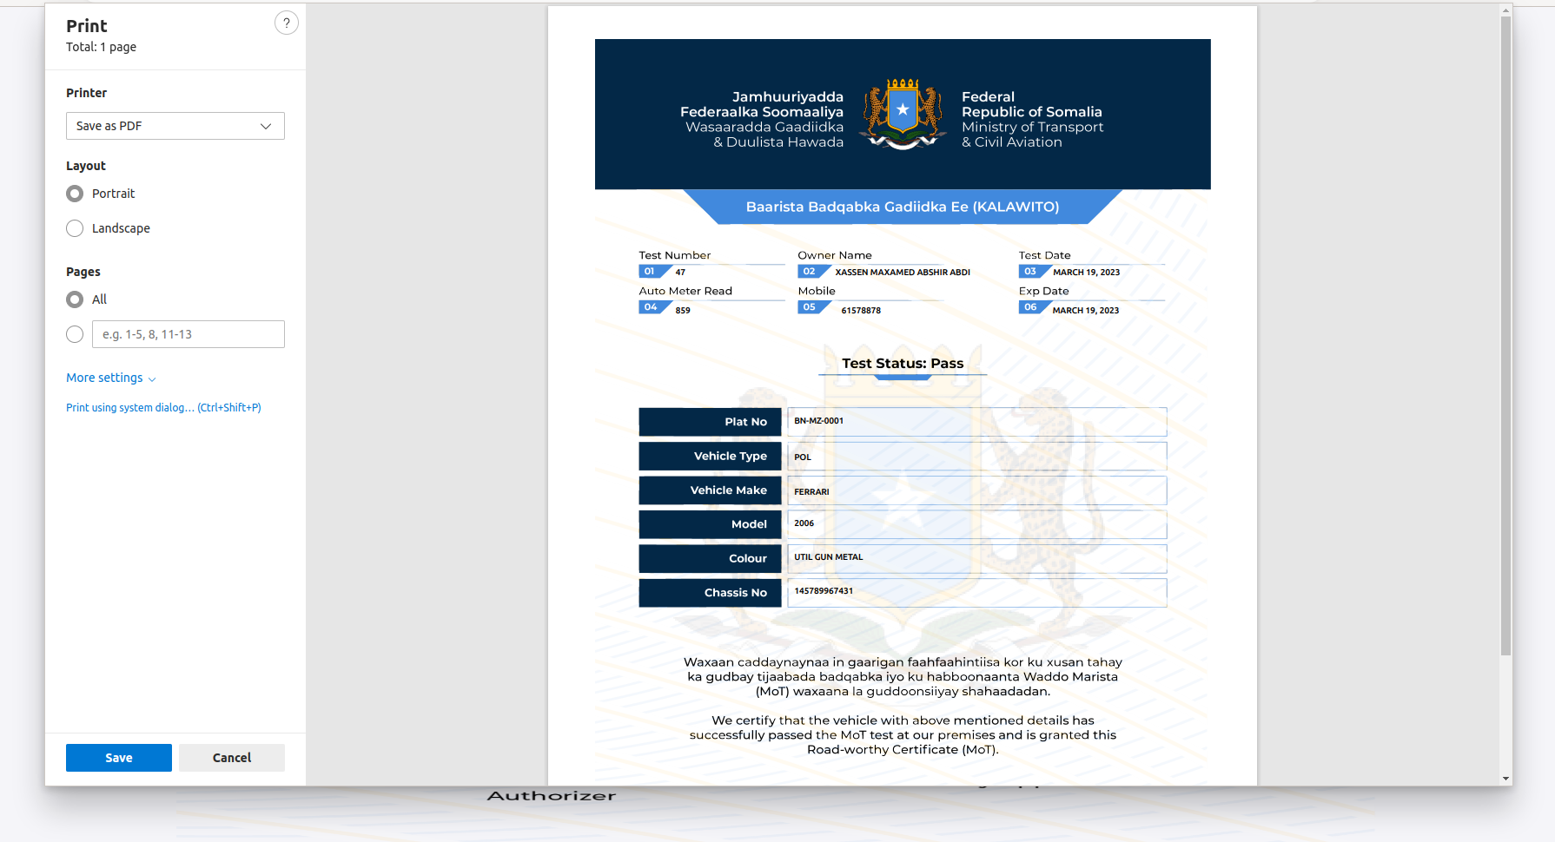
tani waa shahaada uu helayo gaariga marka uu ku baaso imtixaanka badqabka gaariga

6.0 Payments
Halkan waxa ay ku heyneysa lacag qabashada, waxa mesha laga qabto lacagaha ay bixiyaan macaamiisha,
si aad lacag uga qabto qof macmiil ah waxa inaa aburata account ay lacgta qimaheda lagu keydinayo

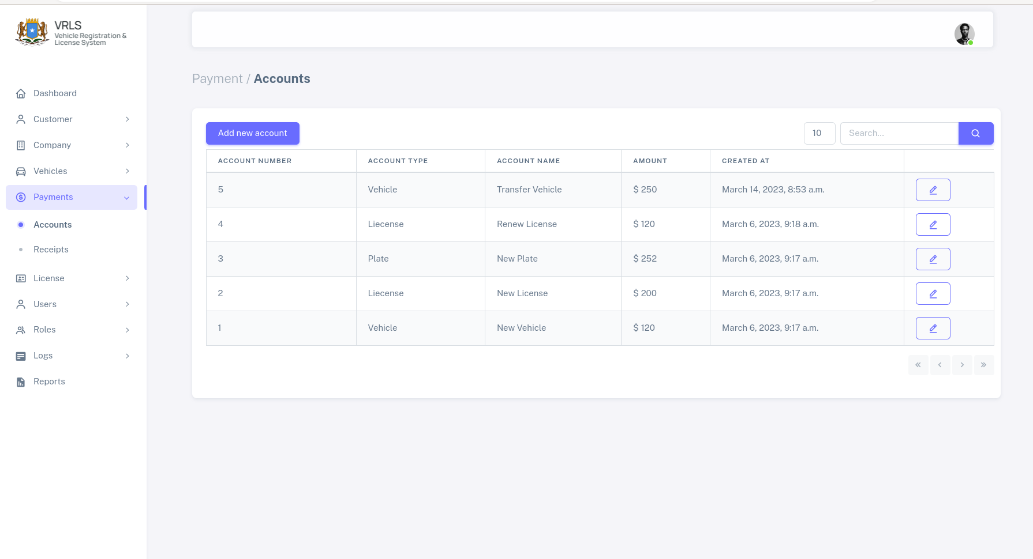
sida ka muuqata sawrika kore accounts wa meel ay kujran lacag cadadeeda ay goanthy, si loga maarm mar walba qof lacag laga qadyo, in dib lo so cel celiyo,
si aad ugu bdarto account cusub wa inaa tabata Add accoun buttonka ay ku qoranthy,
waxa kuso baxa formka hoose

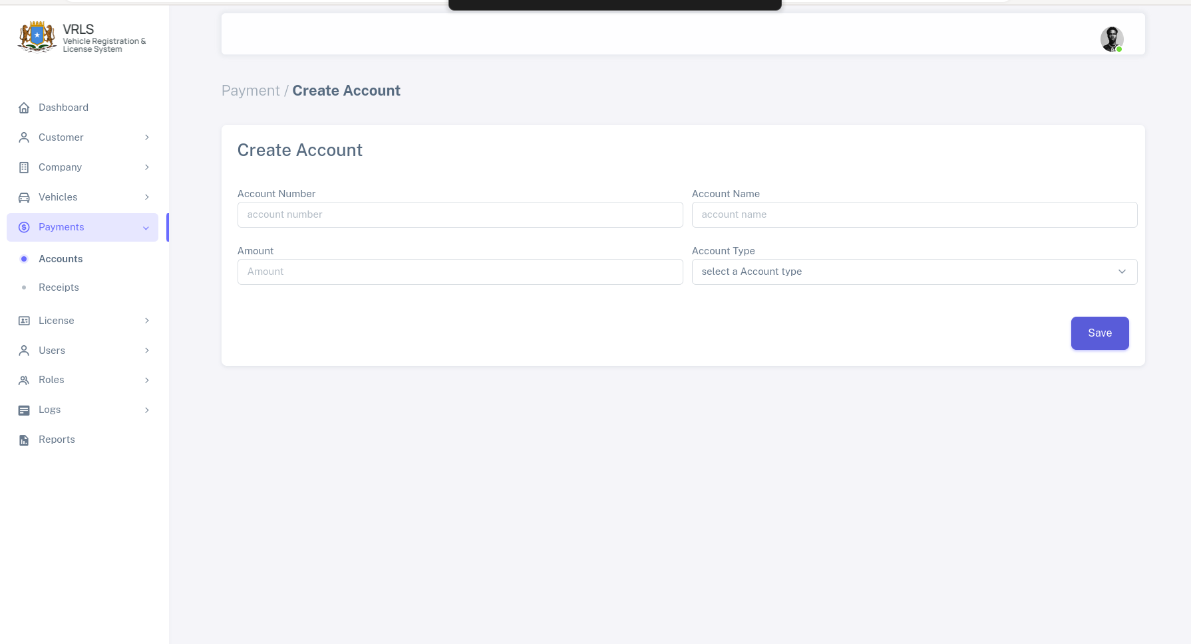
buux buxi formka adigo hubasanaya maclumadka aad galinyso, kadbna save dheh
Hada aya macmil lacag ka qaban kartaa si aad uga qabto tag oo doo recipts dhanka bidix ee sidebarka.
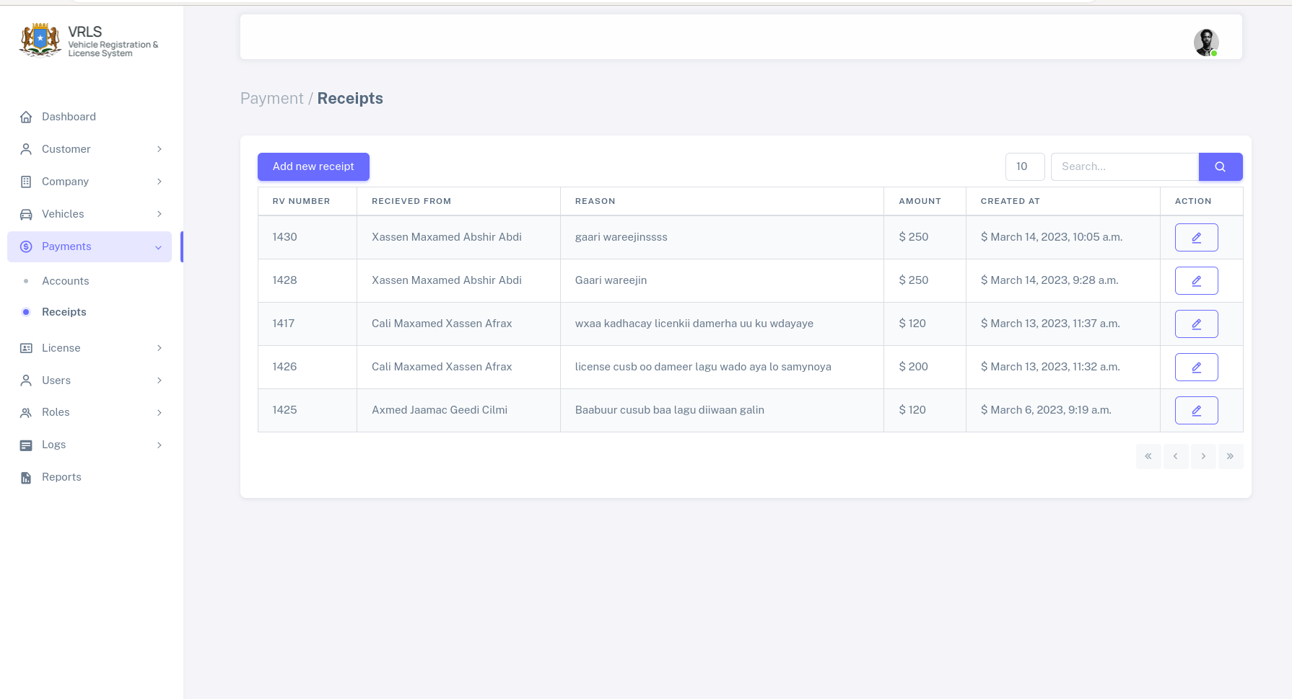
Halkan waxa ka mquuda liiska lacagaha laqabty iyo cida laga qabtay lacagaha, si aad lacag cusub u qabto dusha sare buttonka ay ku qorantahy add new recipt door
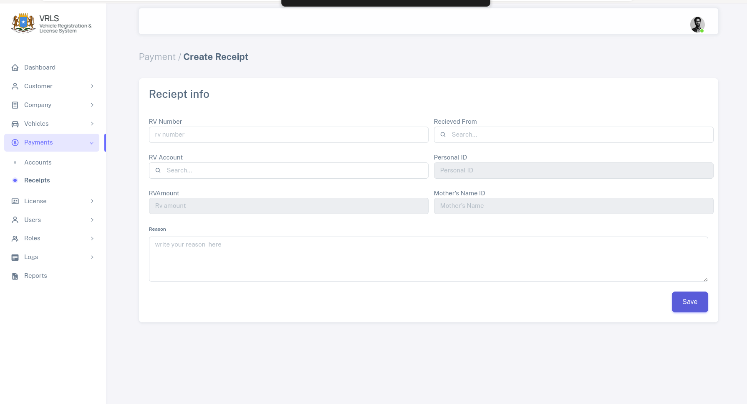
kadbina buux buuxi maclumadka reciptka adiga hubsanaya, si dagan ubuuxi kadibna waxa dhahdaa save, sidaas aya ku qabaty lacag taaso oo katimid macmil
hadaba wa edit grayn kartaa maclumaadka qaarkod, si aad udit grayso kulaabo liiska rescipyda kadbna, taabto button qalinka ku dhax sawrtnayhy kadbna waxa kuso baxaya foomka hoose bad badl wixii ka khaldaamay Ogow maclumadka qaar lama badli karo mar hadi la diiwangaliyo
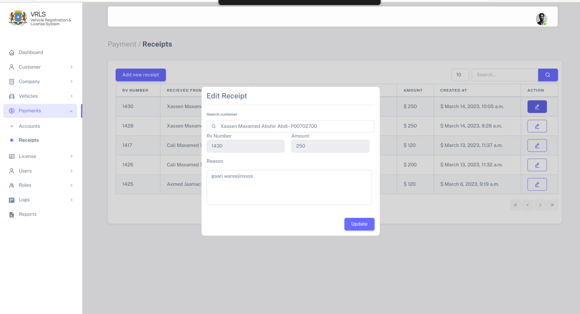
bad badal meelaha an calamada lahyn melaha calaamada leh lama badali karo, gabi ahaanba

7.0 Liisanka (Liecense)
Halkan waxa laga maamulaya licensiga iyo waxa laxariira

7.1 Diwangalinta Liisan Cusub
Si aad u dinwagaliso lisan cusub qofka loo diwangalinyo wa in uu systemka kujraa lana xaqiijayay, lacagbxina sameyaa
Raac talaabooyinkaan
- Booqo License → New License

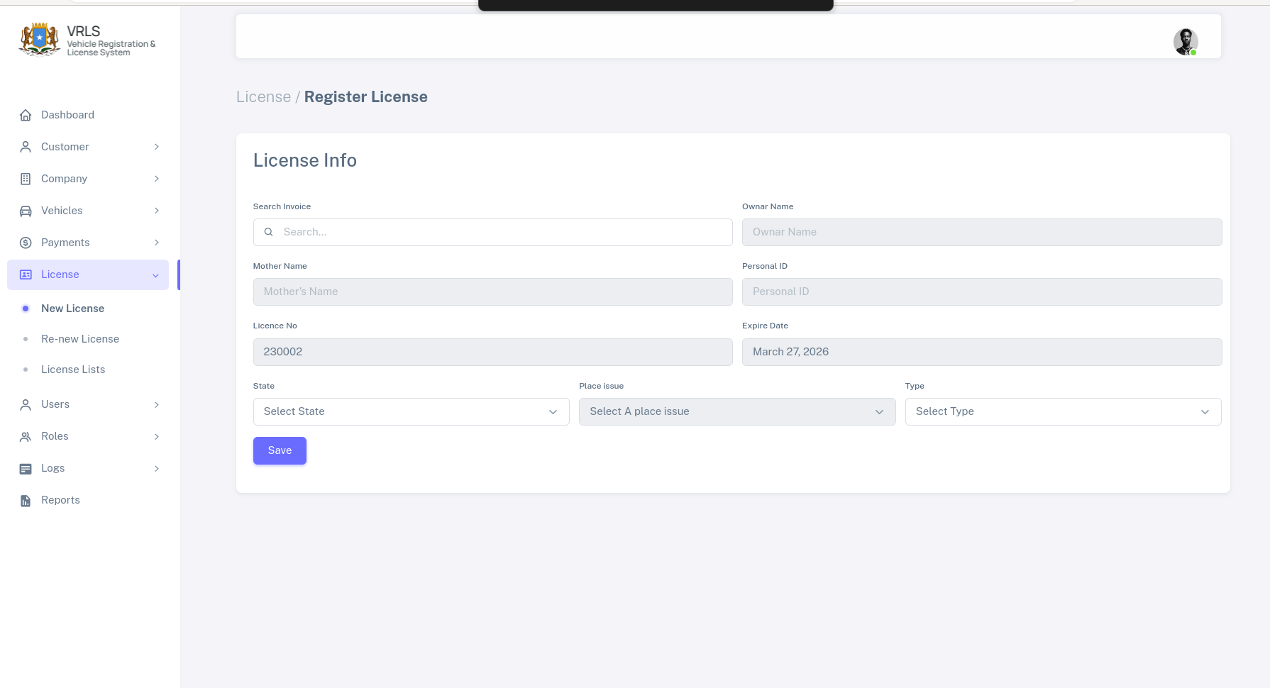
waxa kuu soo bixi doona formkaan oo laga bux buxinyo qofka
- license NO waa automatic
- taarikhda dhicida waa automatic
- taarikhda uso baxay licensga waan auto matic sidoo kale
kadbna save dheh, waxaadna ku guulesaty, inaa aad diwangaliso liisan cusub.

7.2 Cusbooneysinta Liisan Dhacay
Liisanka waxa uu kudhacaya 3 sano mar aya ubaahnthy inaa cusboneysiso hadi kale kuma shaqeynayo, hadaba si loo cusboneysi lisan dhacay
waxaa booqataa License → Renew License

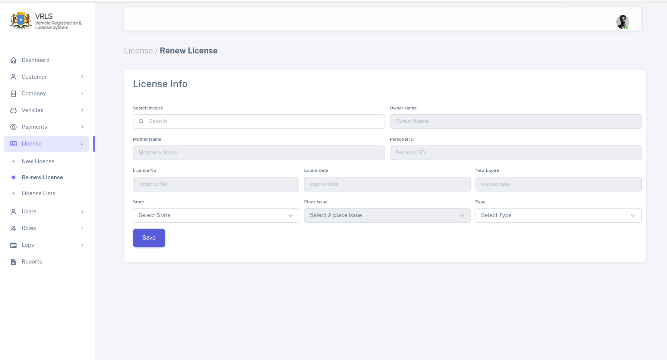
kaliya waxa lacusboneysin karaa liecen dhacay, gali invoice ka lacag baxinta qofka license ka dhacay hadu dhacay waa uu qadan dona hadusna dhicinna wa uu kaa so didi dona xogta si automatic ah ayay isku buuxin dontaa

7.2 Liisk dhamaan lisanada kujira sesytemka
Si aad u aragto dhamaan lisanada kujira systemka, waxa taabanysaa License → License list waxa kusoo bixi doona liskan oo kale

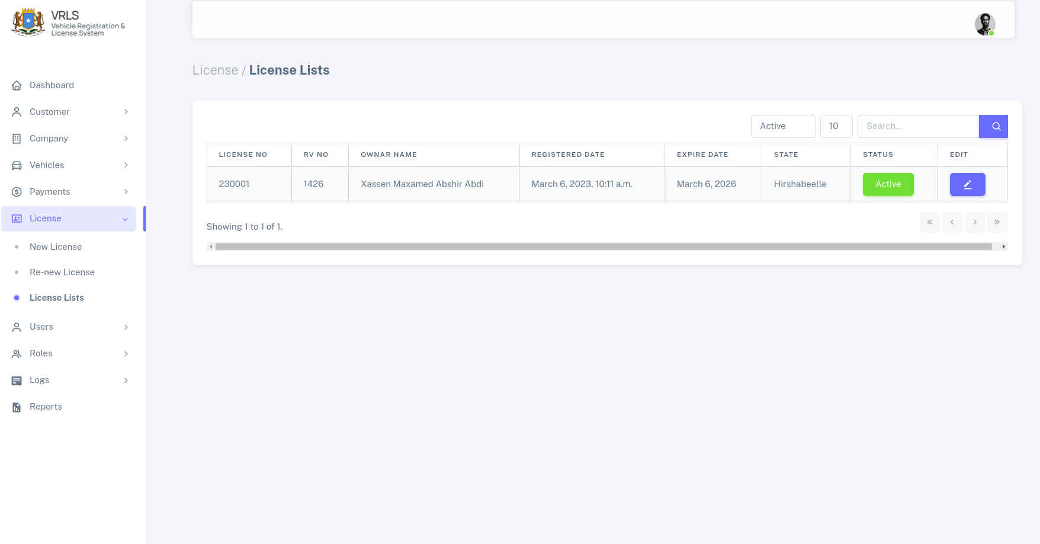
qeybta kore ee liisk waxa ka xulan kartaa lisnada dhacay iyo kuwa aan dhichin iyo wixii lamid ah, waxa kaloo ka radin kartaa, liisanada oo dhan.
Sido kale waxa bad badli karta xaalada lisanka active ayuu u yahy marka hore kadibna waa update gareyn kartaa, waxa kalo edit ku sameyn kartaa, lisanka hadi ay wax ka qaldamaan.

8.0 Users
Halkaan waxa laga maamulaya dhamaan isticmaalayaasha systemka, heer walba oo ay yihiin qeybtaan,

8.1 Abuur User Cusub
si aad u sameyso user cusub, waxa tagtaa users → create users

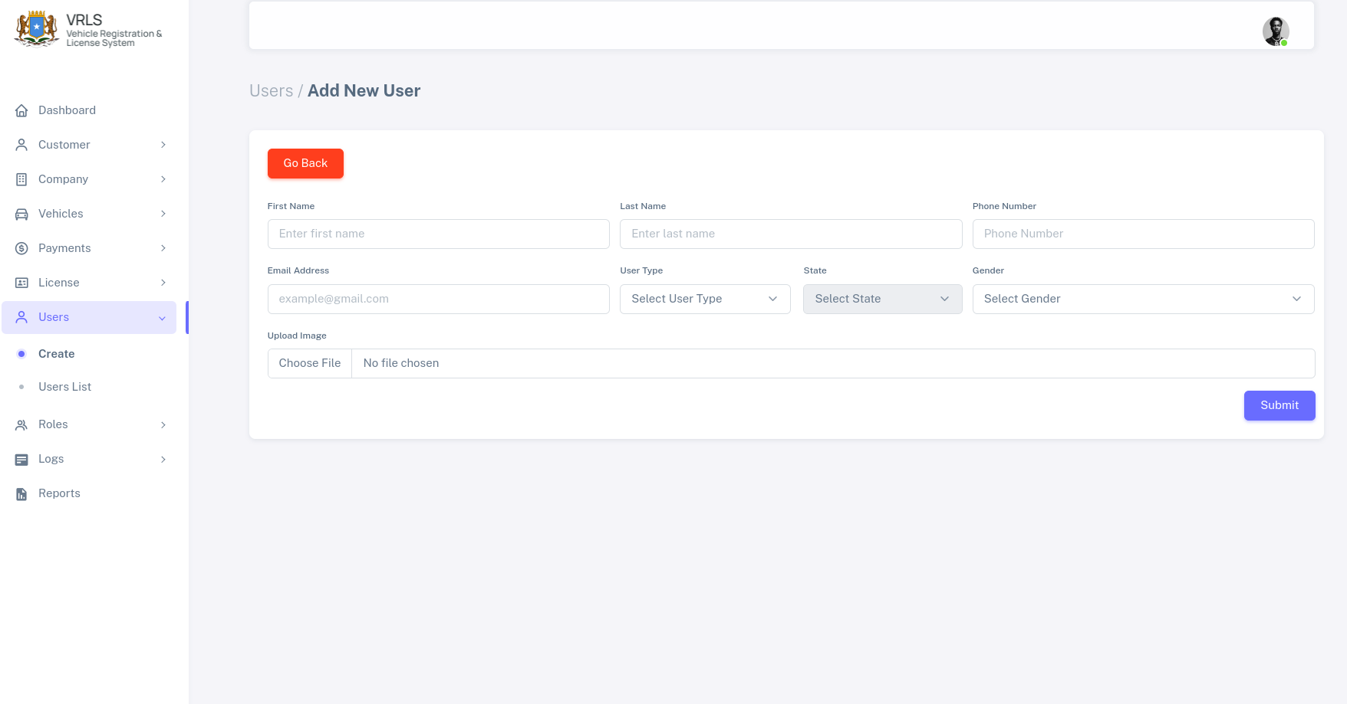
waxa so buuxisaa user macluumaadkisao dhameysiran marka hore user-ka , haduusan super user uusan aheyn waxa uu yahay in active, waxa uu ubaahnaan doona in la active greeyo,

8.2 Active Gree User Cusub
Marka ugu horeysa, waxa u baahanthy in user ka la active greyo, si aad u active greyso waxaa tagtaa Users → User List
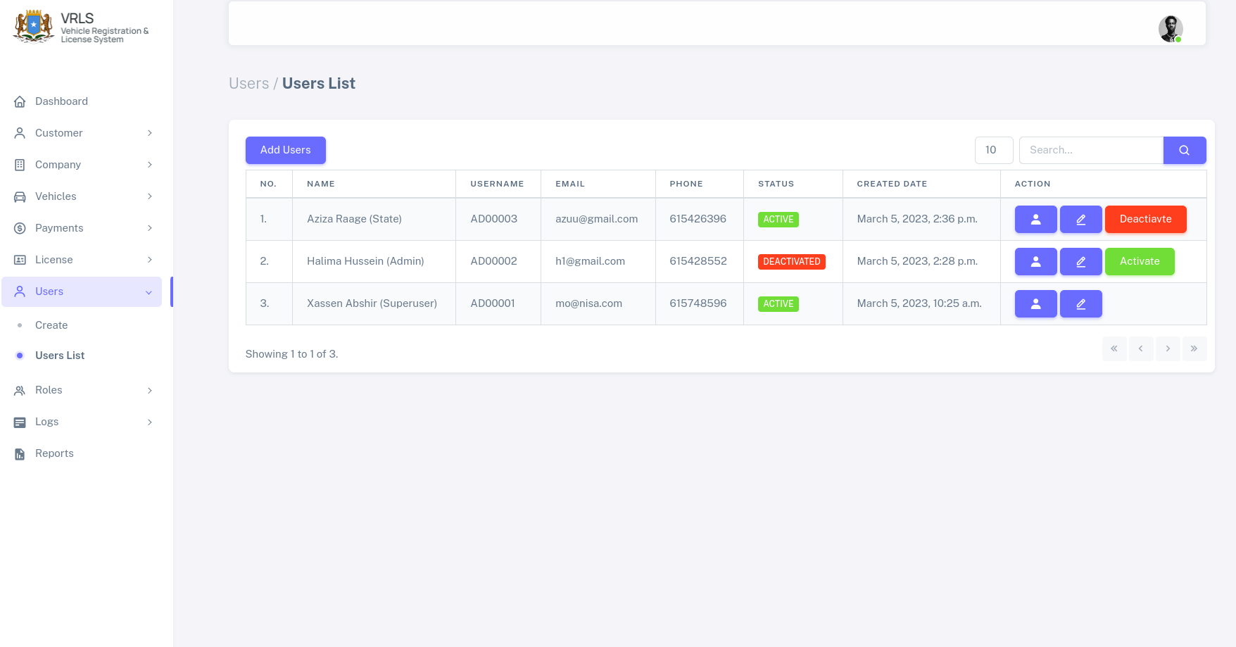
si da ka muuqata shaxda kore, waxa aad u bahntahy in userka active greyso kadibna taabo Activate User si loo active gareyo,
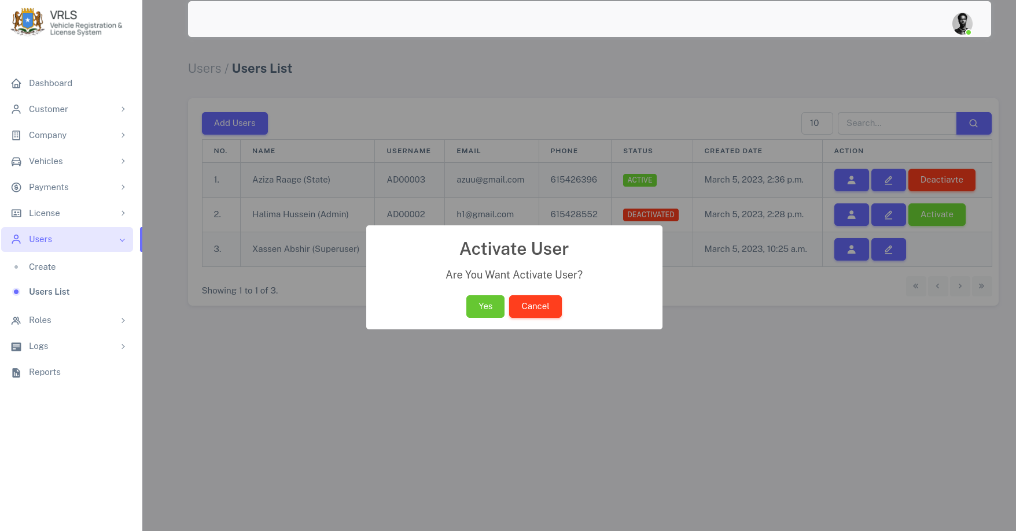
aqbal oo hubi in aad rabtid ina active gareyso, kadbna waa lactivate gereyna userka,

8.3 Wax kabadal Userka (Edit)
Si ad wax uga badasho maclumadka userka edit taabo, kadbna

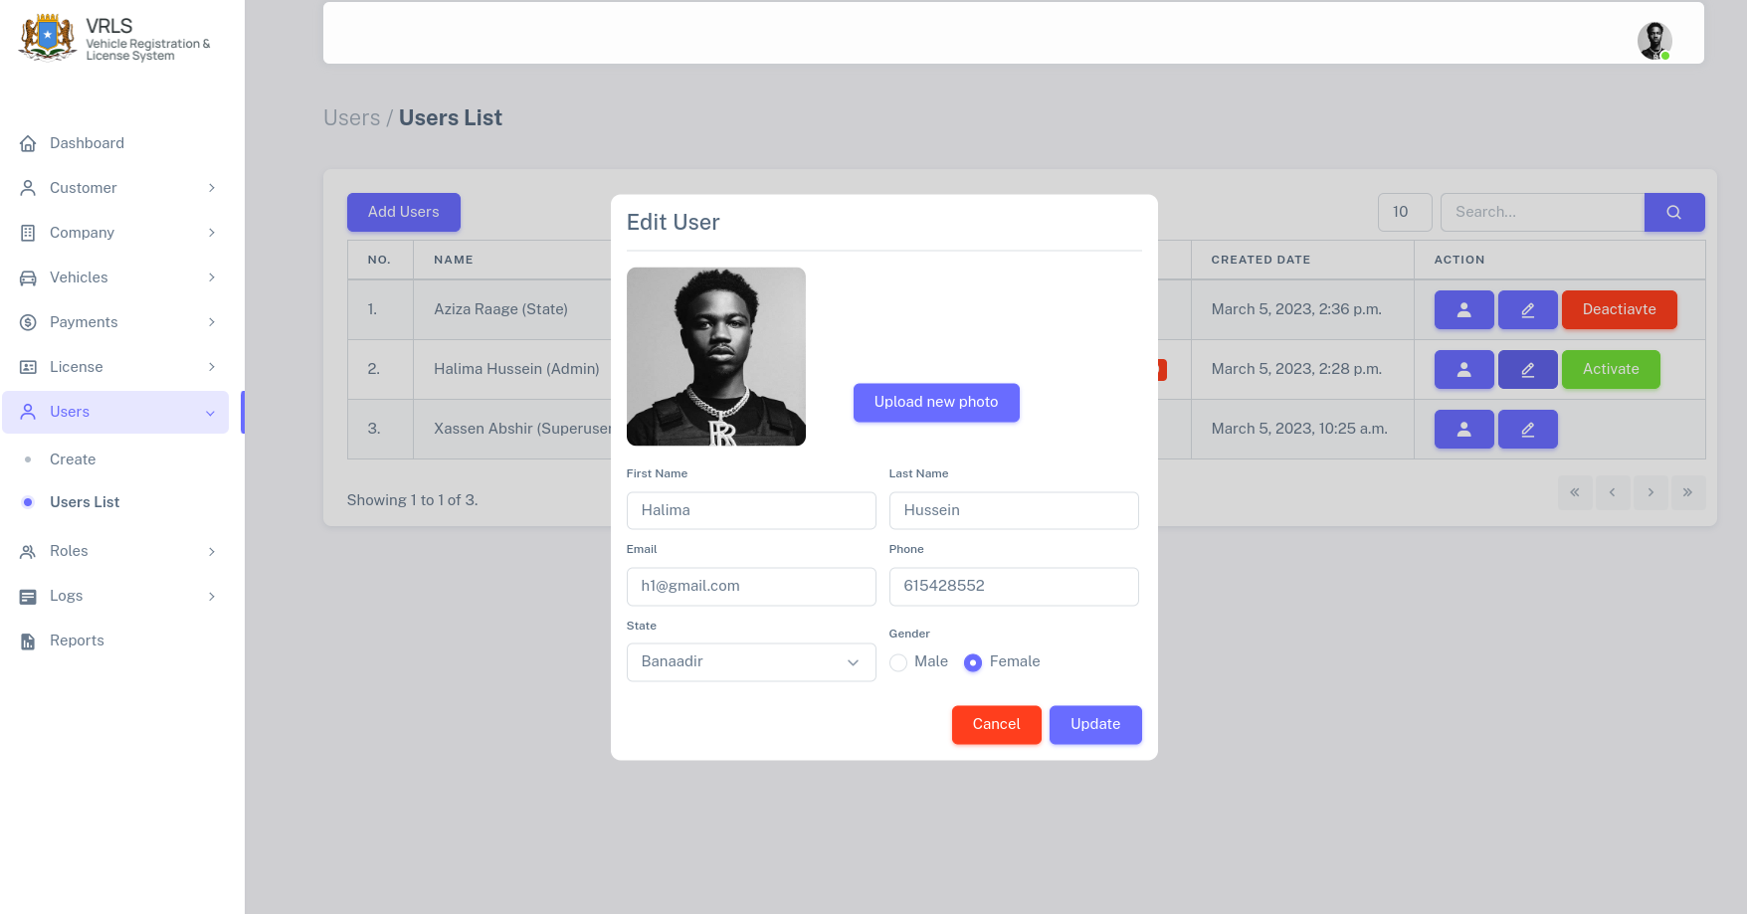
Modelkaan ayaa ksuo baxaya oo ay kujrto mclumadka qofka larabo in wax laga badalo, waxa kabadal kadbna update dheh.

8.4 Profilka Userka
Taabo buttonka profile ka ee kujra shaxda userska, waxa so baxaya, profilka qofka, iyo wax qabdkiisa.

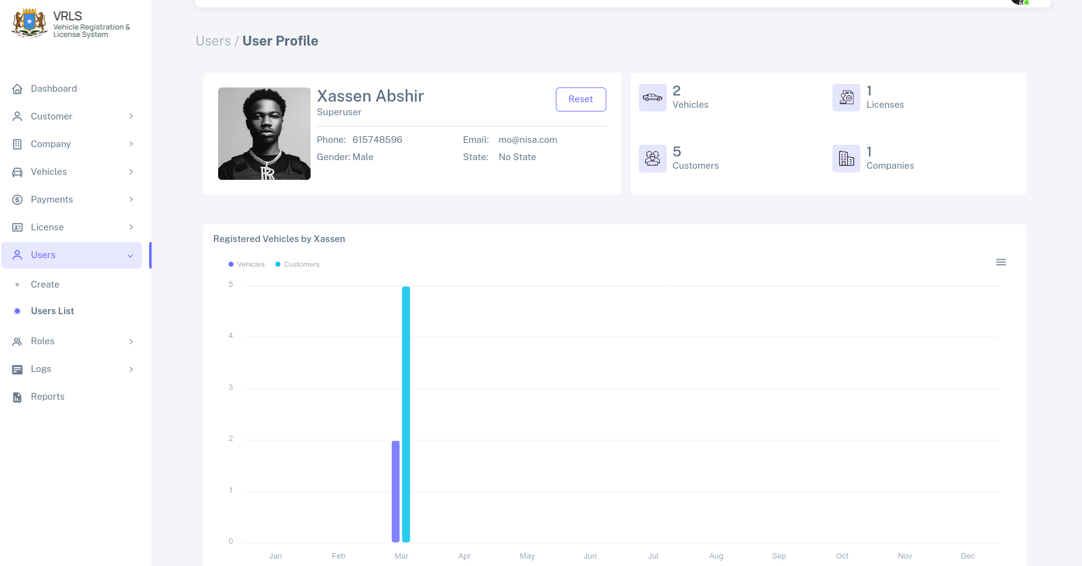

9.0 Roles
Qeybtaan waxa laga maamulaa roleska userks o dhan ,

9.1 Search Role (Raadi Role)
marka aad tagto roles → search role , waxa u ku sinaya rolelka aad radineysid iyo module ka uu ka tirsanyahy,

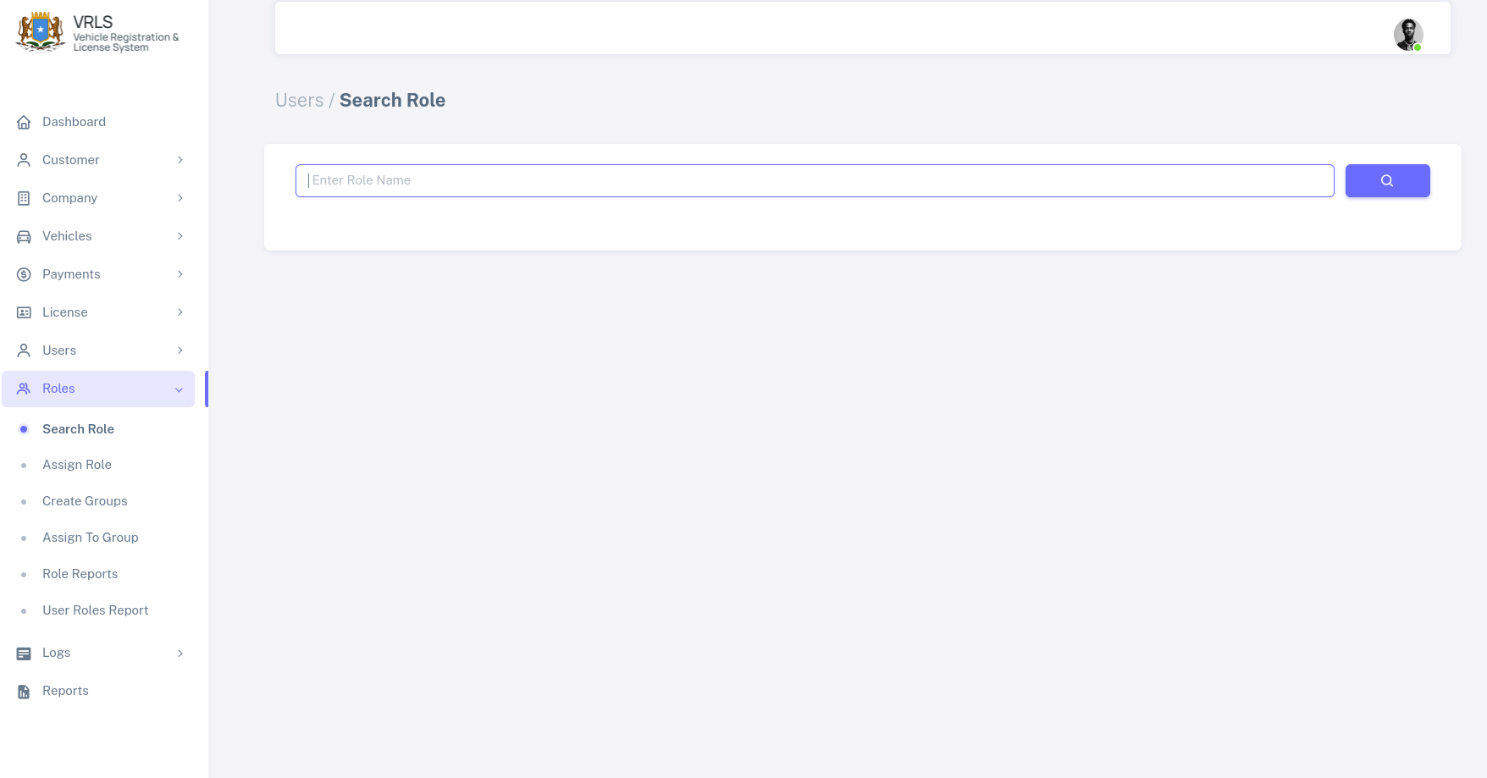
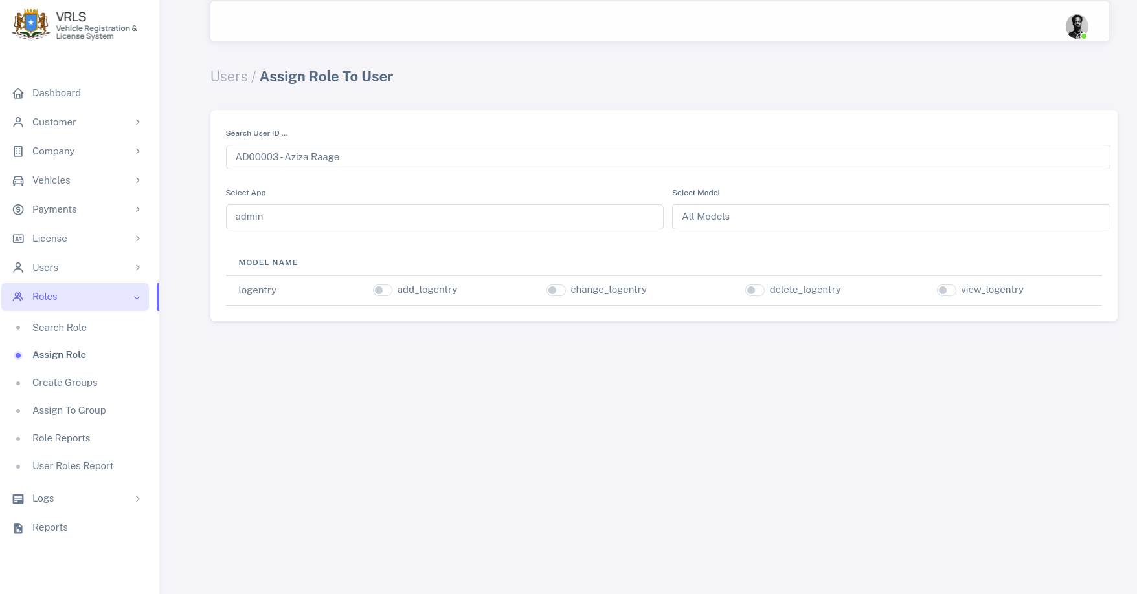

9.2 U’astee Role (Assign Role)
Qyebtan waxa uu shegaya, in aad user gooni ah aad u assign greyn karta role userka kujira,

9.3 Abuur Koox (Create Group)
Taabo buttonka buluuga ah create group , waxa kuso baxaya group pop up oo larabo in aad ku qexdo user magaciisa,
taabo edit roles, si aad ugu darto roles ama role kujira aad uga bixiso.

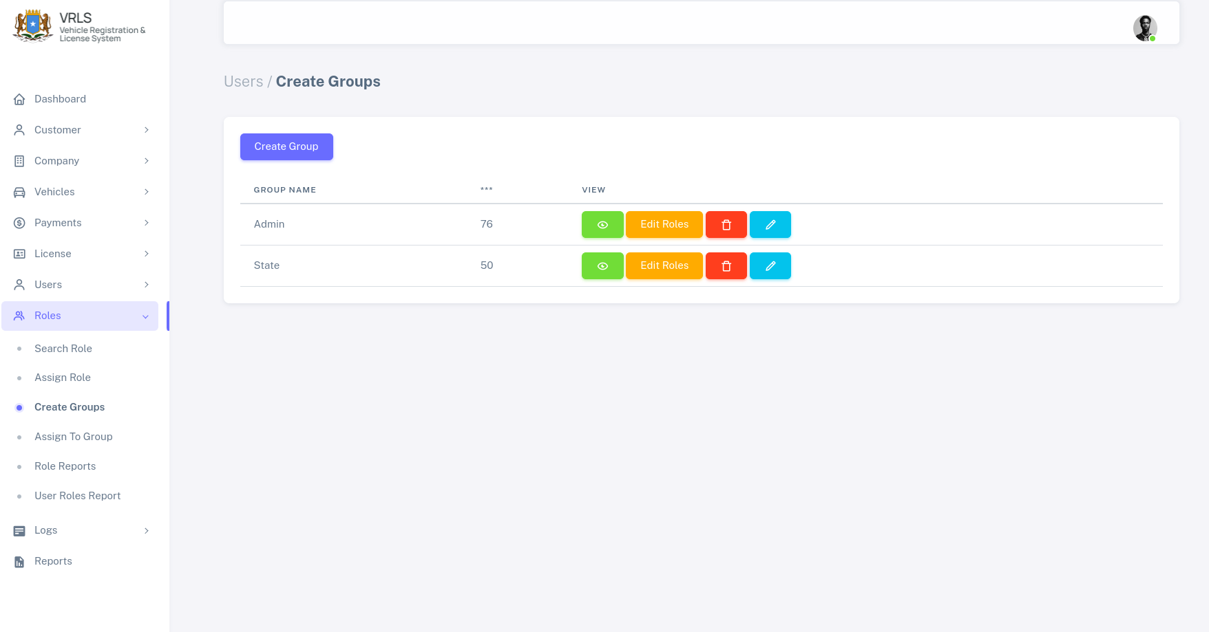

9.4 Assign User To A Group Role
Userka ayaad ku draysa, groupka ad horay uso aburaty, foomka hoose ku qor userka Idgisa, kadbna group ku dar

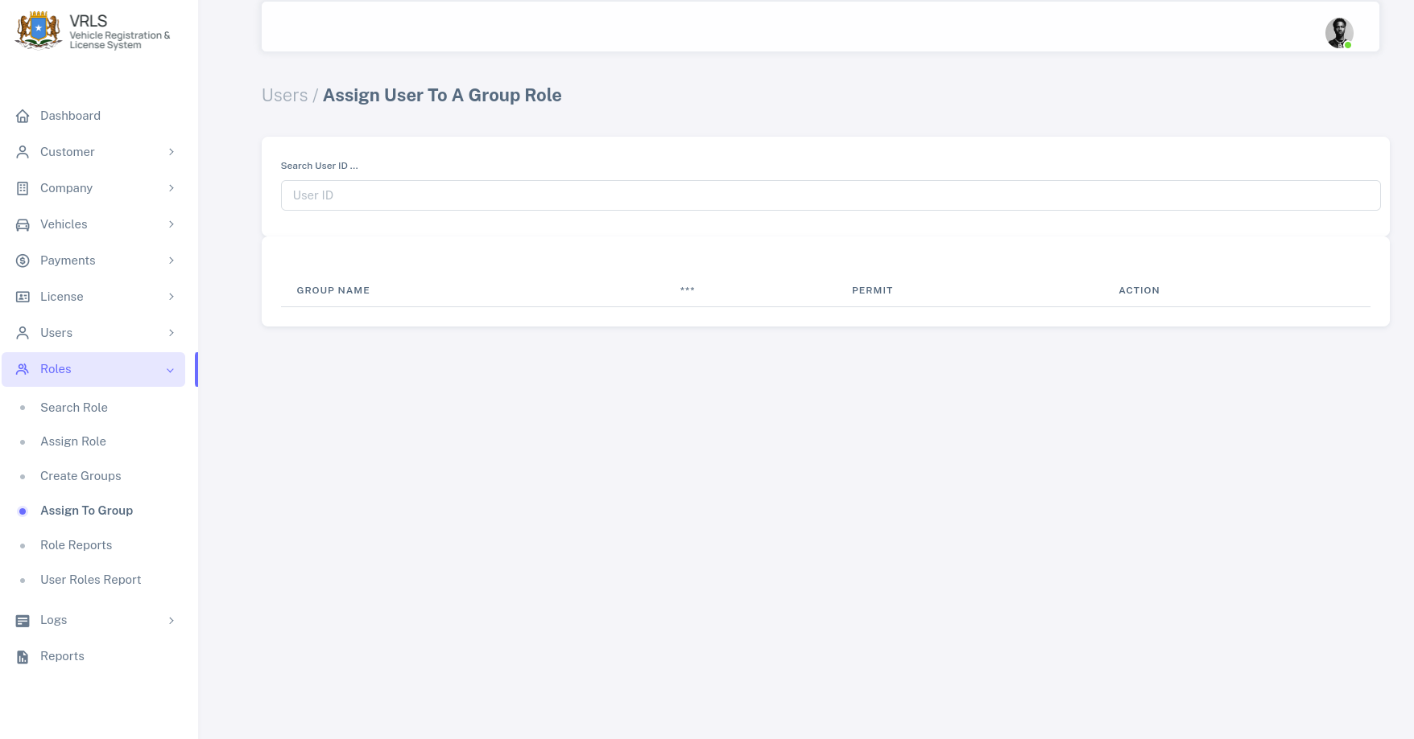

9.5 Roles Report
Waxa u ku sinaya role walba userka hesta, waxa galineysa role ka aad rabto, kadbna waxa ku sinaya maclumad laxariira userska hesta rolekaas.

9.6 User Roles Report

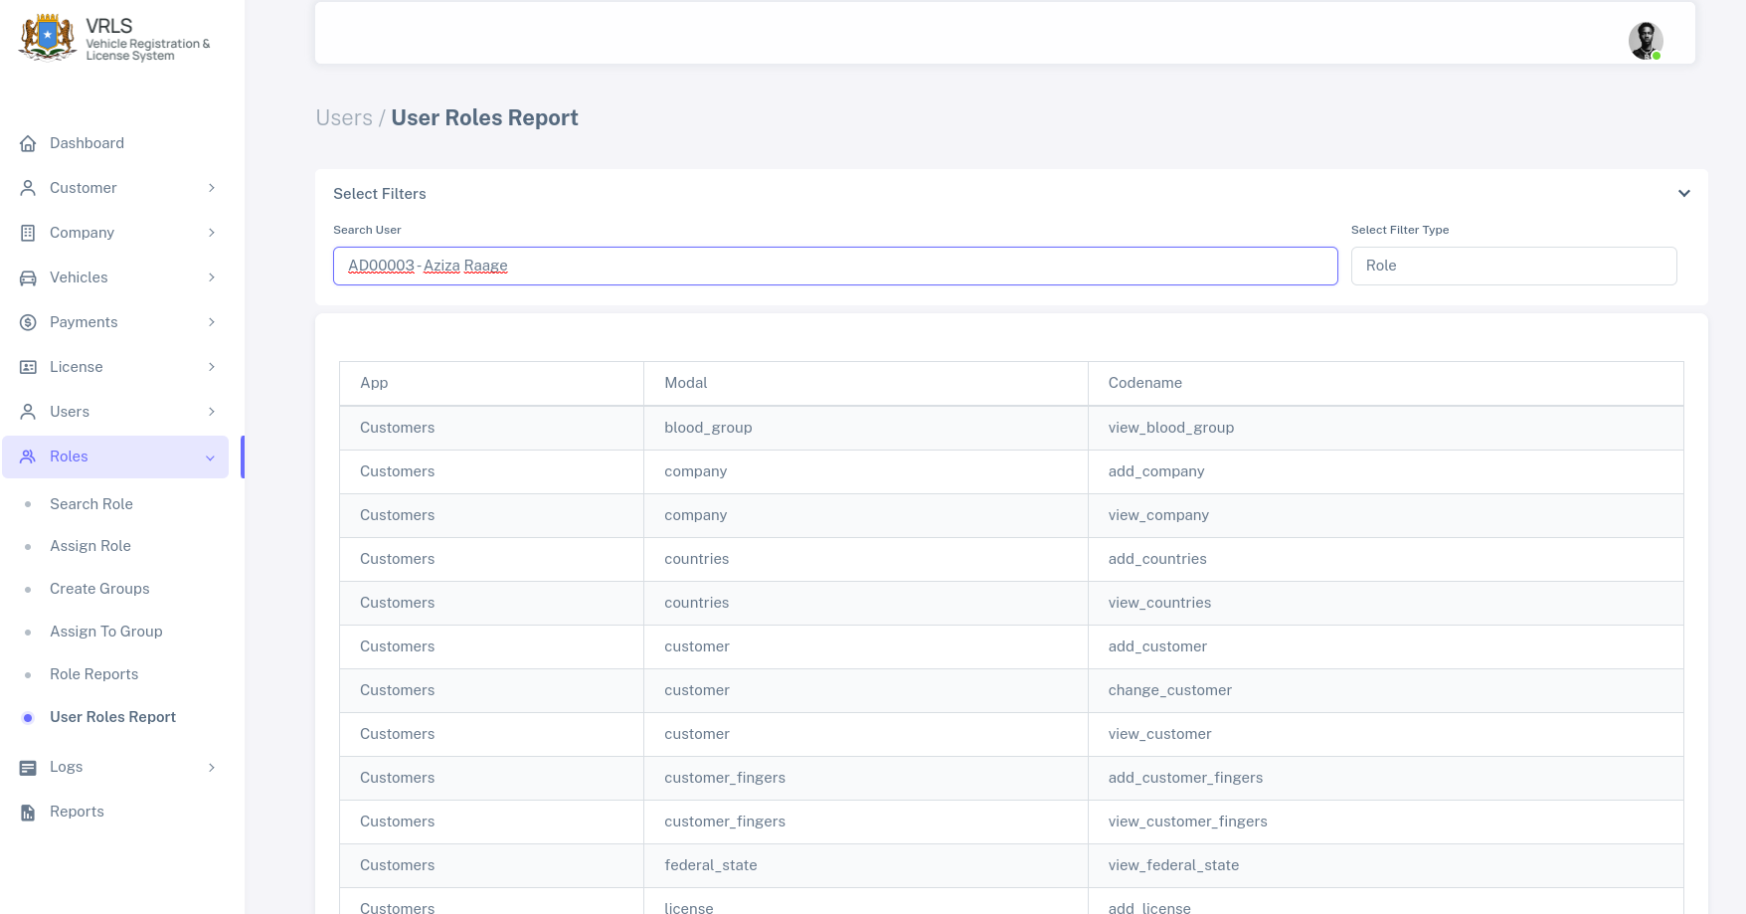
sawirka kore waxa galineysa userka idgisa, kadibna waxaa uu kusinayaa dhamaan roleska uu leyahy userkas.

10.0 Logs
Halkan waxa laga helaya logs dhamaan waxa walba o systemka ka dhacay, waxayna isgu jiraan laba nuuc

10.1 Audit Trials
Waxa u shegyaa, logska dhacay sytemka, userska actionska ay sameyen,
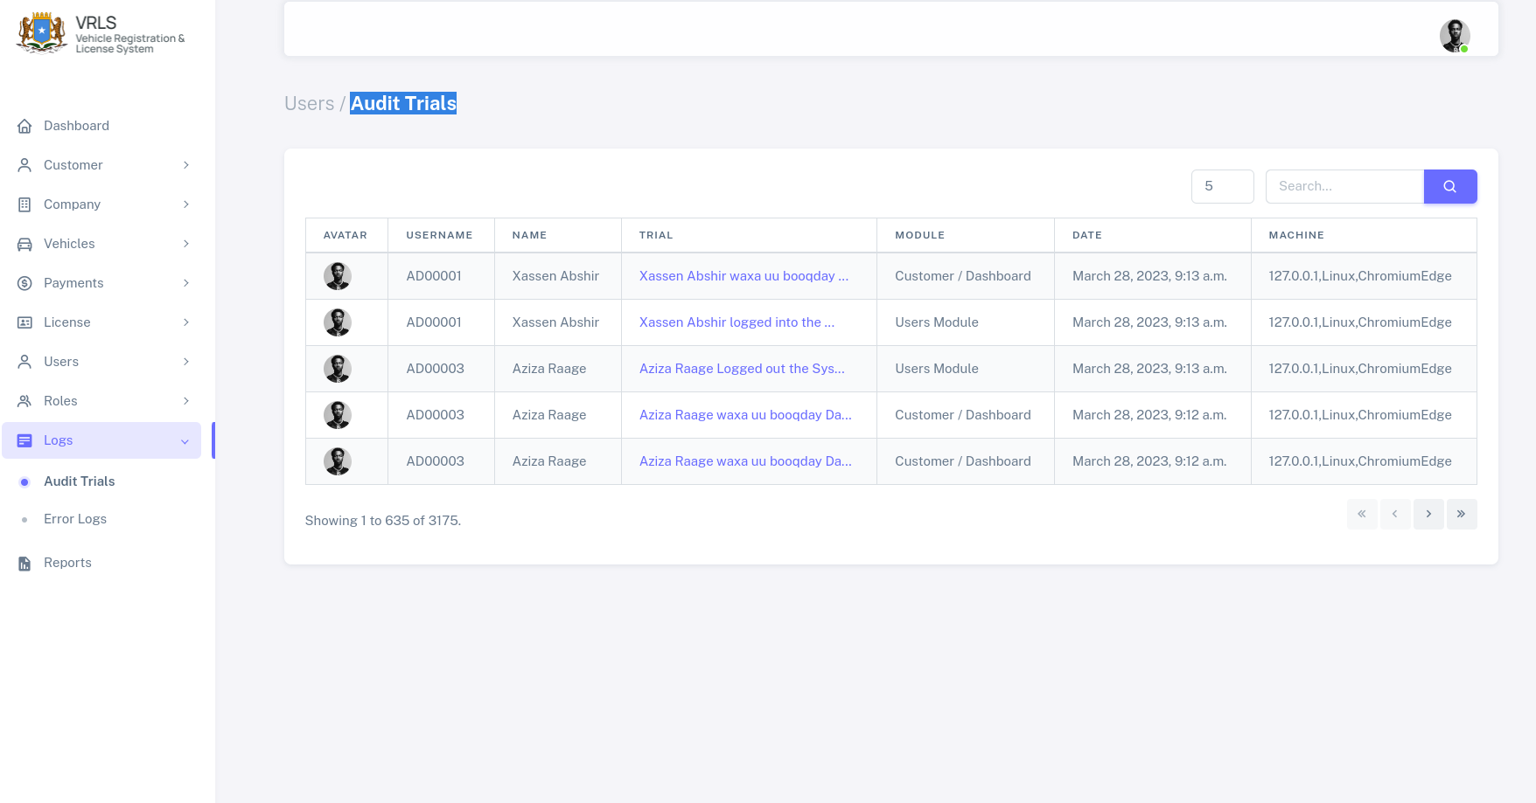

10.2 Error Logs
Waxa u ku shegaya erros ka dhacay systemka, oo dhan iyo meesha ka dhacay,
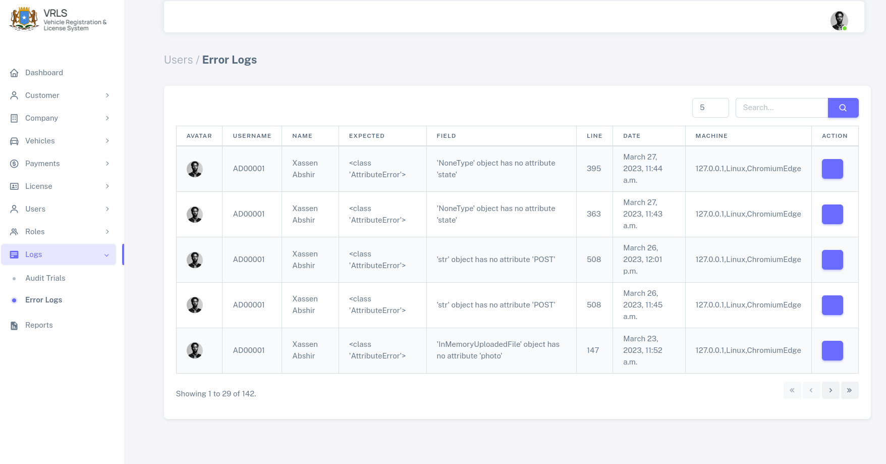

11.0 Reports
Halkan waxa ay ku shegeysa, reports ku saabsan customers, vehicles, iyo companies
mid walba o kamid ah,

11.2 Customer Report
Waxa galineysaa, customer magacisa ama personalID, waxa una ku sinyaa maclumadka qofkaas
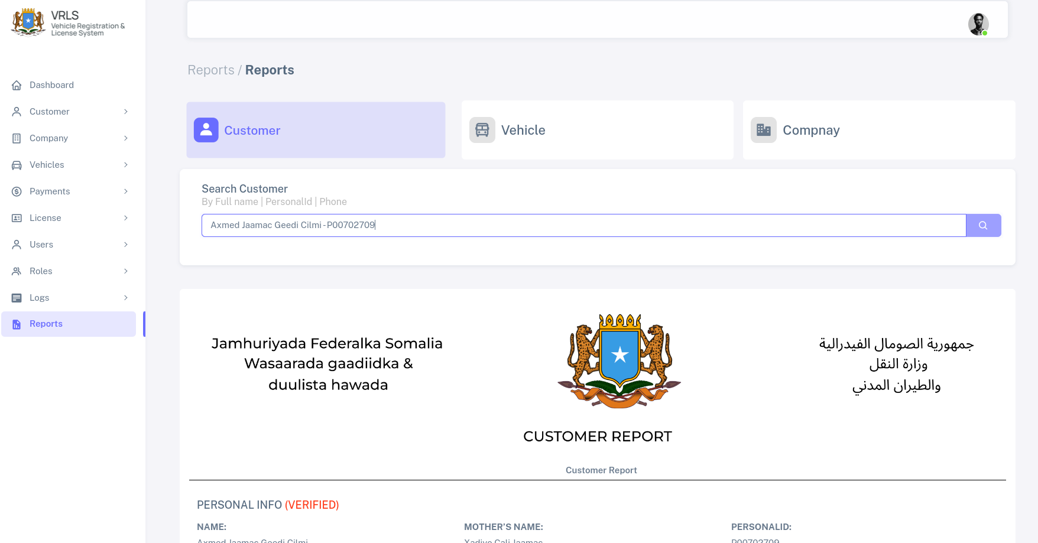

11.3 Vehcile Report
Waxa galineysaa, gaadiidka qofka iskaleh magacisa ama vin numberka , waxa una ku sinyaa maclumadka gaarigaas.
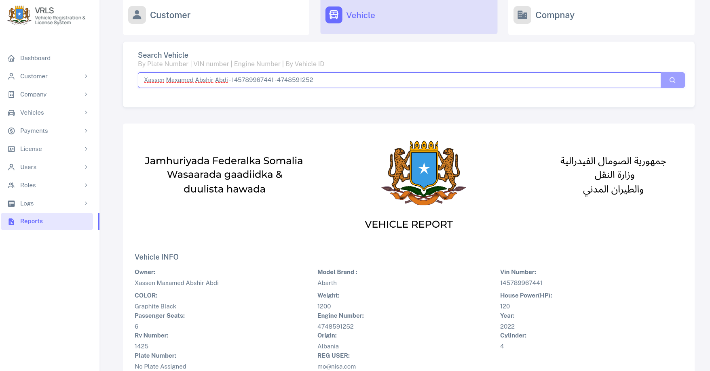

11.2 Comapany Report
Halkan waxa aad galineysa companyga aad raadineyso magacisa ama qofka companyga iska leh magciisa.
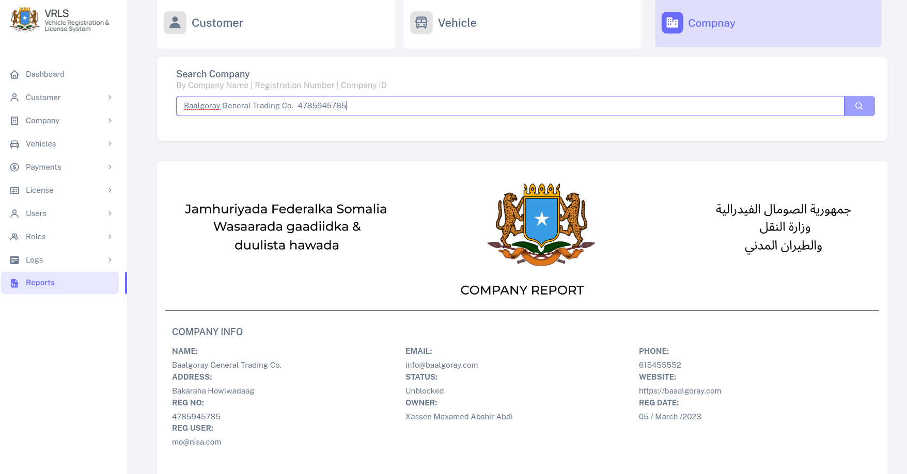
Dhamaad

