PQ 59263/26
To ask the Minister for Justice; Home Affairs and Migration the number of crimes that were recorded where the suspected offenders were on bail in each of the last three years and in 2026 to date, by county and category of offence, in tabular form; and if he will make a statement on the matter.
- Matt Carthy
A summary of ‘on bail’ offending by Garda Region/Division and reported year as follows.
It is important to note that suspected offenders may be responsible for more than one incident.
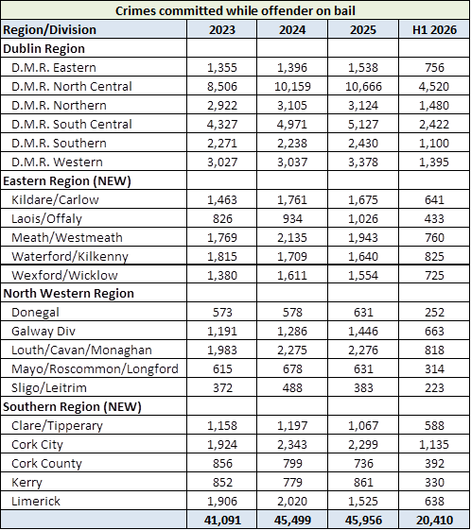

A summary of ‘on bail’ offending by Irish Crime Classification System Crime Group and reported year as follows:
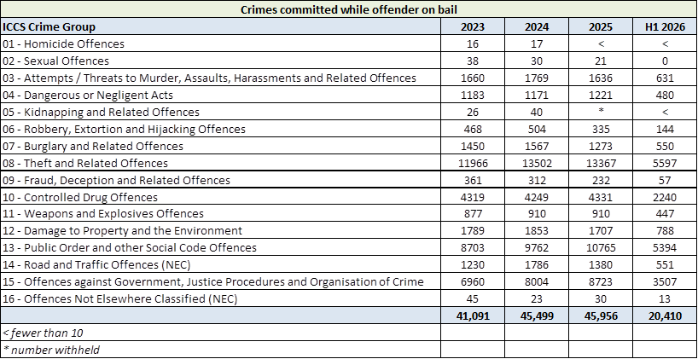
This is operational data taken from PULSE on 24 July 2026 and is liable to change.

