23603-lab-4.R

23603

2023-04-18

buyprice = 5  
aft100 = 3.5  
sellprice = 9  
catfac = 1  
#a  
squared = nfsold^2  
len = length(nfsold)  
  
mean = sum(nfsold)/len  
meansq = sum(squared)/len  
  
k = 1 / ((meansq / mean^2)-1)  
λ = k / mean  
  
hist(nfsold, prob = TRUE, xlab = 'Sales in kg', ylab = 'Density', main = 'Density of Sales', col = '#FF0055')  
curve(dgamma(x, k, λ), add = TRUE, col = '#77A3FF', lwd = 2)

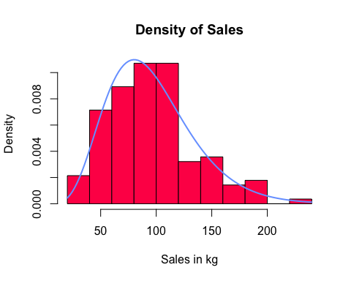

#b  
p = c(1:len) / (len+1)  
q = qgamma(p, k, λ)  
plot(q, sort(nfsold), main="Q-Q plot for real data", xlab="quantiles of fitted model",ylab="ordered sales")  
curve(1*x, add = TRUE, col = 'red', lwd = 2)

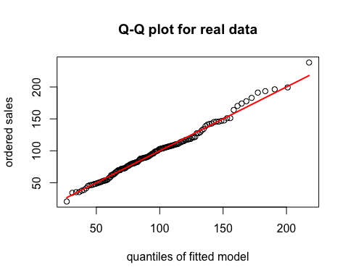

par(mfrow=c(3,2))  
  
plot(q, sort(nfsold), main="Q-Q plot for real data", xlab="quantiles of fitted model",ylab="ordered sales")  
curve(1*x, add = TRUE, col = 'red')  
  
for (i in 1:4)  
{  
 sample = rgamma(len, k, λ)  
 samplesq = sample^2  
 samplemean = mean(sample)  
 samplemsq = mean(samplesq)  
 samplek = 1/ ((samplemsq / samplemean^2)-1)  
 sampleλ = samplek/samplemean  
 q = qgamma(p, samplek, sampleλ)  
 plot(q, sort(sample), main="Q-Q plot for Sampled data", xlab="quantiles of fitted model",ylab="ordered values")  
 curve(1*x, add = TRUE, col = 'red')  
}  
#Based off the histgram, it seems plausible that the sales follow a gamma distribution,   
#As the curve of the pdf has a similar shape to the histogram, with the main difference  
#being a slighlty shifted peak.  
#The QQ plots provide similar results, with slight excursions from the line y=x between  
#The ordered sales and quantiles of the fitted models. When considering the 4 plots based  
#off of sampled values from the gamma distribution being proposed, we see similar qq plots,  
#Suggesting the deviations could be normal sampling error.  
#As such, it is plausible that the fitted model is suitable for Brenda's data  
  
#c  
#i  
cost <- function(n){  
 if (n> 100)  
 {  
 spend = 100*buyprice + (n-100) * aft100  
 } else {  
 spend = n*buyprice  
 }  
 spend  
}  
#ii  
income <- function(n,d) {  
 if (d > n)  
 {  
 gross = n * sellprice  
 } else {  
 gross = d * sellprice + (n-d) * catfac  
 }  
 gross  
}  
#iii  
avg.profit <- function(n,k,lambda, nreps) {  
 kgsold = rgamma(nreps, k, lambda)  
 spend = rep(cost(n), nreps)  
 gross = rep(0, nreps)  
   
 for (i in 1:nreps) {  
 gross[i] = income(n, kgsold[i])  
 }  
   
 net = gross - spend  
 avgprof = mean(net)  
 avgprof  
}  
  
cost(10)

## [1] 50

print(income(10, 8))

## [1] 74

avg.profit(100, k, λ, 100)

## [1] 245.4627

#d  
profsample = rep(0,400)  
  
for (i in 1:400) {  
 profsample[i] = avg.profit(i, k ,λ, 1000)  
}  
  
suspect = which.max(profsample)  
lower = max(0, (suspect - 30))  
upper = min(400, (suspect + 30))  
profsample2 = rep(0,400)  
  
for (i in lower:upper) {  
 profsample2[i] = avg.profit(i, k ,λ, 100000)  
}  
  
bestn = which.max(profsample2)  
sprintf('Brian should buy %i kgs', bestn)

## [1] "Brian should buy 112 kgs"

#e  
#The analysis in part d assumes that Brian and Brenda will sell fish at the same rate and scale.  
#Without knowing how much Brenda sold her fish for, we are unable to say with confidence that   
#Brian's sales will be similar to Brendas. As such, the model we used to predict  
#the amount of fish Brian would sell would be inaccurate, as it was based  
#on the assumption that him and Brenda would have similar sales. Without this assumption,  
#it would not be correct to use Brenda's sales to predict Brians. Therefore, we may have over or  
#underestimated Brian's sales and given an inaaccurate value for how much fish he should buy.  
  
#If the suspicions turned out to be true, it is unlikely that the value we gave   
#optimizes Brian's sale and would need to be adjusted. If Brian sells more or less fish than Brenda,  
#we would need to adjust the parameter's of the gamma distribution in order to better  
#our optimization of profits. If data on Brian's sales are available, we could find new estimates  
#of parameters lambda and k, in order to fit a new model. Otherwise, we would be forced to make  
#adjustments of parameters based on expected changes in sales. For example, higher prices  
#would likely cause fewer sales, and as such, the mean kg sold and the mean of the squared kg sold would  
#decrease. From that, we could adjust our parameters to make a slightly better estimate.   
#This would lead to better analysis on optimization of profit for Brian as negates the impact  
#of the difference in sales between the two and gives a better value for the amount Brian should buy,   
#although the prediction may not be perfect if data is limited.