# 📊 Sales Analytics Dashboard — AdventureWorks

> **End-to-end Power BI sales dashboard** built on the AdventureWorks dataset, covering $16.3M in internet sales across 3 years (2019–2021) — with budget tracking, customer profiling, and product performance analysis.

---

## 📋 Business Context

The sales team needed to move away from static Excel reports toward **interactive visual dashboards** that allow daily monitoring of internet sales performance, customer behavior, and product trends — filterable by any sales rep or manager.

---

## 👥 User Stories

| # | Role | Request | Business Value |
|---|------|---------|----------------|
| 1 | Sales Manager | Dashboard overview of internet sales | Track which customers and products sell best |
| 2 | Sales Representative | Detailed view of internet sales per customer | Follow up high-value customers and identify upsell opportunities |
| 3 | Sales Representative | Detailed view of internet sales per product | Identify best-selling products and optimize stock |
| 4 | Sales Manager | Sales vs Budget dashboard | Monitor sales performance against 2021 budget targets |

---

## 🗂️ Dataset

**Source:** Microsoft AdventureWorks Data Warehouse (DW)

| Table | Description |
|-------|-------------|
| `FactInternetSales` | All internet sales transactions 2019–2021 |
| `DimCustomer` | Customer profiles with city and demographics |
| `DimProduct` | Product catalog with category, sub-category, name |
| `DimDate` | Date dimension for time intelligence |
| `Budget` | Monthly budget targets by product (Excel, 2021) |

**Key numbers:**
- **Total Sales 2020:** $16,351,550
- **Budget 2020:** $15,300,000
- **vs Budget:** +$1,051,550 ↑ (6.9% above target)
- **Top category:** Bikes — $15,359,502 (93.93% of total sales)

---

## 🏗️ Data Model — Star Schema

```
DimDate
│
DimCustomer ── FactInternetSales ── DimProduct
│
Budget (Excel)
```

| Table | Type | Rows |
|-------|------|------|
| `FactInternetSales` | Fact | 60,000+ |
| `DimDate` | Dimension | 1,461 |
| `DimCustomer` | Dimension | 18,484 |
| `DimProduct` | Dimension | 606 |
| `Budget` | Imported from Excel | 18 months |

---

## 📐 Key DAX Measures

```dax
-- Total Sales
Sales = SUM(FactInternetSales[SalesAmount])

-- Total Budget
Budget = SUM(Budget[Budget])

-- Sales vs Budget variance
Sales vs Budget =
[Sales] - [Budget]

-- Sales vs Budget %
Sales vs Budget % =
DIVIDE([Sales] - [Budget], [Budget], 0)

-- Sales by Top 10 Customers (used with RANKX visual filter)
Customer Rank =
RANKX(
ALL(DimCustomer[CustomerName]),
[Sales],
,
DESC,
DENSE
)

-- Sales by Top 10 Products
Product Rank =
RANKX(
ALL(DimProduct[ProductName]),
[Sales],
,
DESC,
DENSE
)
```

---

## 📊 Dashboard Pages

### Page 1 — Sales Overview
High-level summary for the **Sales Manager** — answers user story #1 and #4.

![Sales Overview]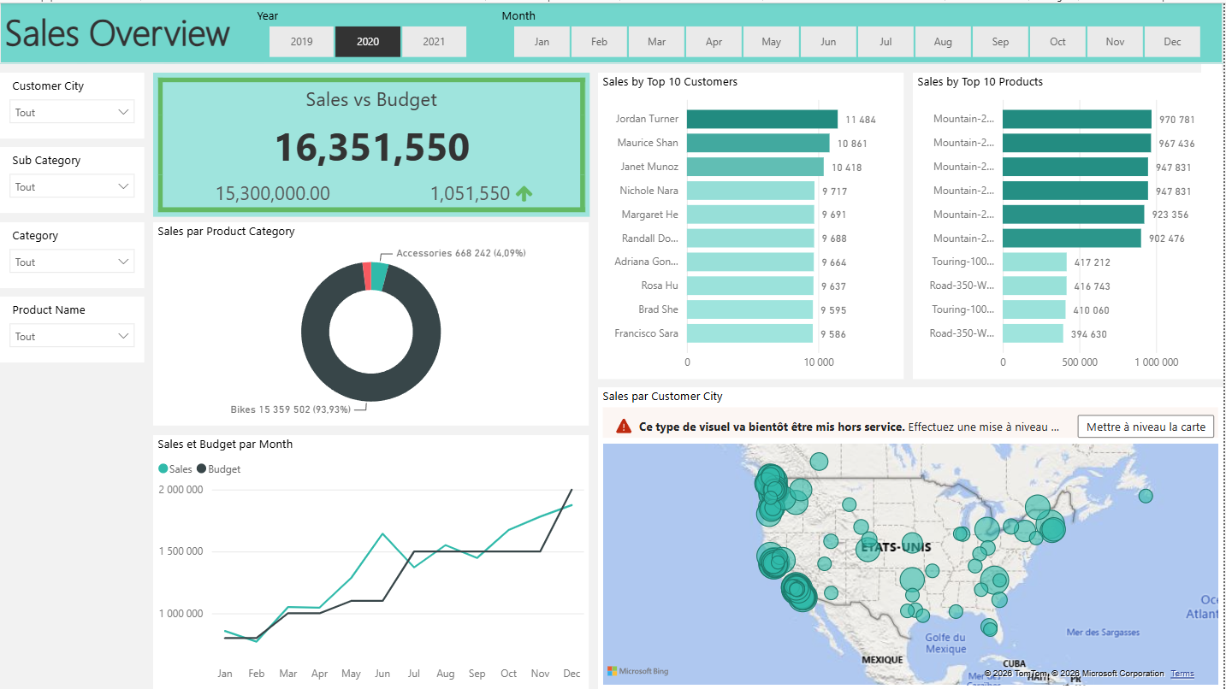

**Visuals:**
- **KPI Card** — Sales vs Budget ($16.3M vs $15.3M → +$1,051,550 ↑)
- **Donut Chart** — Sales by Product Category (Bikes 93.9% / Accessories 4.1%)
- **Line Chart** — Sales and Budget by Month (trend comparison Jan–Dec)
- **Bar Chart** — Top 10 Customers by Sales
- **Bar Chart** — Top 10 Products by Sales
- **Map** — Sales by Customer City (bubble map across the US)

**Slicers:** Year (2019 / 2020 / 2021) · Month · Customer City · Category · Sub Category · Product Name

---

### Page 2 — Customer Details
Deep dive for **Sales Representatives** — answers user story #2.

![Customer Details]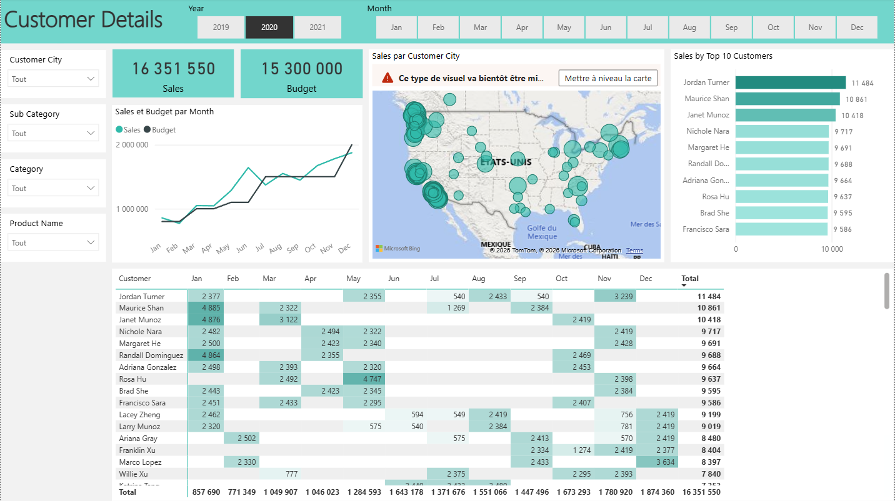

**Visuals:**
- **KPI Cards** — Total Sales · Total Budget
- **Line Chart** — Sales and Budget by Month
- **Map** — Sales by Customer City
- **Bar Chart** — Top 10 Customers by Sales
- **Matrix** — Customer × Month with total (filterable by customer name)

**Key insight:** Jordan Turner leads with $11,484 — Maurice Shan ($10,861) and Janet Munoz ($10,418) follow closely.

---

### Page 3 — Product Details
Deep dive for **Sales Representatives** — answers user story #3.

![Product Details]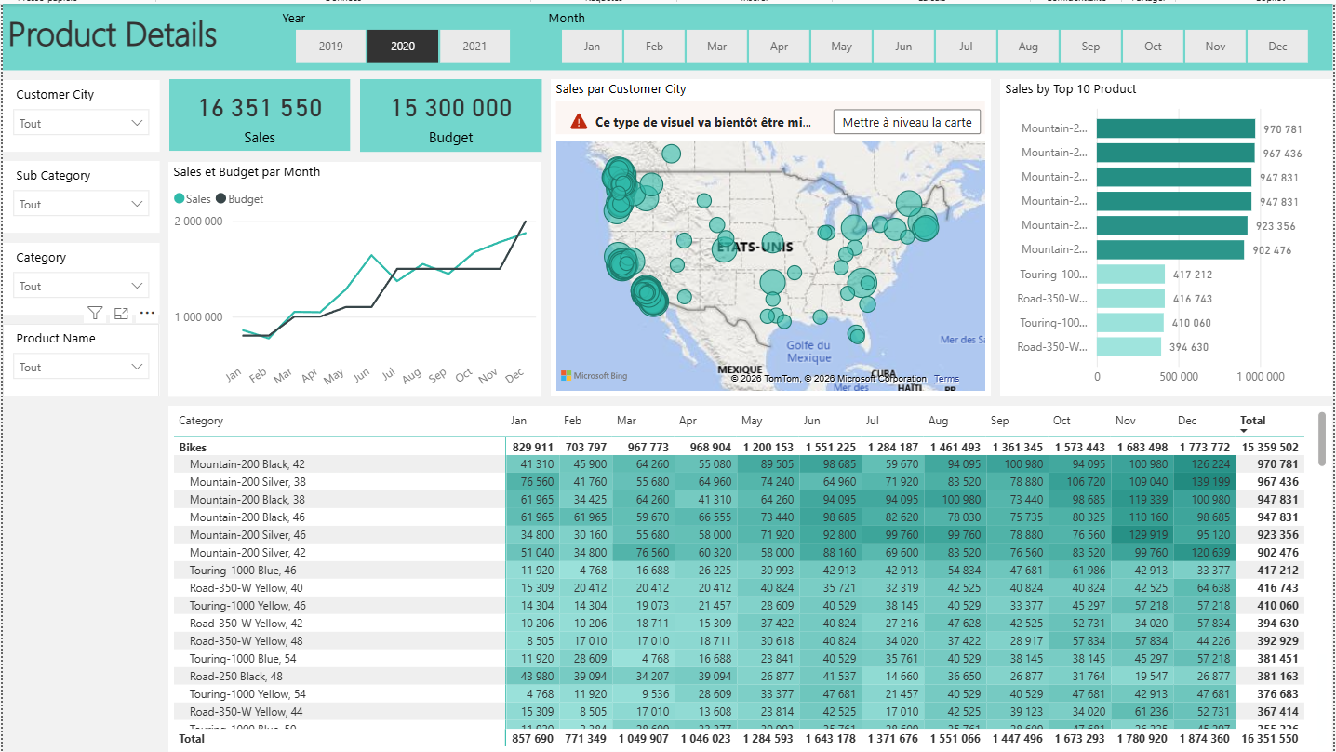

**Visuals:**
- **KPI Cards** — Total Sales · Total Budget
- **Line Chart** — Sales and Budget by Month
- **Map** — Sales by Customer City
- **Bar Chart** — Top 10 Products by Sales
- **Matrix** — Product × Month with category grouping and totals

**Key insight:** Mountain-200 Black 42 leads at $970,781 — the top 6 products are all Mountain-200 variants, accounting for over 35% of total bike revenue.

---

## 💡 Key Business Insights

| # | Insight | Value |
|---|---------|-------|
| 1 | **Sales exceeded budget by $1,051,550** (+6.9%) in 2020 | Target met and surpassed |
| 2 | **Bikes represent 93.93% of total revenue** — Accessories only 4.09% | Heavy product concentration risk |
| 3 | **Top customer Jordan Turner** generated $11,484 — 10x the average | High-value customer to retain |
| 4 | **Sales grew consistently from Jan ($857K) to Dec ($1.87M)** — 118% growth within the year | Strong seasonal uptrend |
| 5 | **Mountain-200 family dominates** with 6 variants in the top 10 products | Star product line |
| 6 | **June and December are peak months** — June: $1.64M, December: $1.87M | Seasonal demand patterns |

---

## 🛠️ Tools Used

| Tool | Purpose |
|------|---------|
| **SQL Server** | Data extraction and transformation from AdventureWorks DW |
| **Power BI Desktop** | Data modeling, DAX measures, visualizations |
| **Power Query (M)** | Data cleaning, joins, type corrections |
| **Excel** | Budget data source (2021 monthly targets) |
| **DAX** | Sales, Budget, Variance, RANKX Top N measures |
| **Bing Maps** | Geographic sales distribution |

---

## 📁 Repository Structure

```
sales-analytics-adventureworks/
│
├── README.md
├── Sales_Report.pbix ← Power BI file
│
├── data/
│ └── AdventureWorks_Budget.xlsx ← Budget data (Excel)
│
├── sql/
│ └── queries.sql ← SQL queries used for data prep
│
└── screenshots/
├── sales_overview.png
├── customer_details.png
└── product_details.png
```

---

## 🚀 How to Use

1. **Download** `Sales_Report.pbix` and open in **Power BI Desktop** (free)
2. If data doesn't load → `Transform Data → Data source settings` → point to your local AdventureWorks DW
3. To get the AdventureWorks dataset: [Microsoft SQL Server Samples](https://github.com/microsoft/sql-server-samples/releases/tag/adventureworks)
4. Use the **Year** and **Month** slicers to filter any page
5. All 3 pages share the same slicers — cross-page filtering is fully enabled

---

## 👤 Author

**Mouhammad Aboubakar**
Data Analyst · Power BI Developer

---

*Built on the AdventureWorks dataset — Microsoft's standard BI sample database used in data analyst interviews worldwide.*

