ASSIGNMENT 7 - AI ERROR DEBUGGING
Name: MOHAMMED ADNAN
Roll No: 2503B05107

Task 1 - Syntax Error Fix
Explanation:
Bug: Missing colon in function definition.
Fix: Added ':' after function header.
Code:
def add(a,b):
return a+b
print(add(10,20))
Output Screenshot:
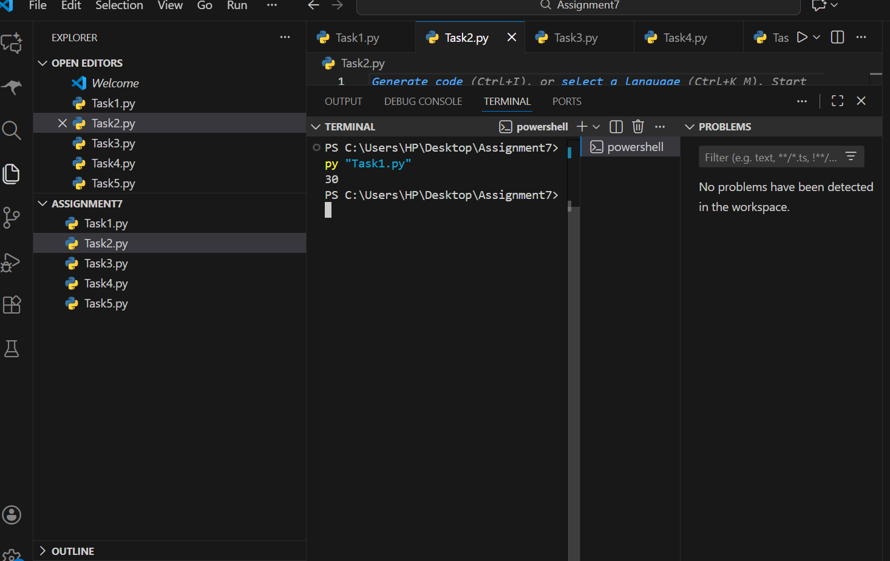
--------------------------------------------------

Task 2 - Infinite Loop Fix
Explanation:
Bug: Loop variable was not incrementing causing infinite loop.
Fix: Added i+=1
Code:
i=1
while i<5:
print(i)
i+=1
Output Screenshot:
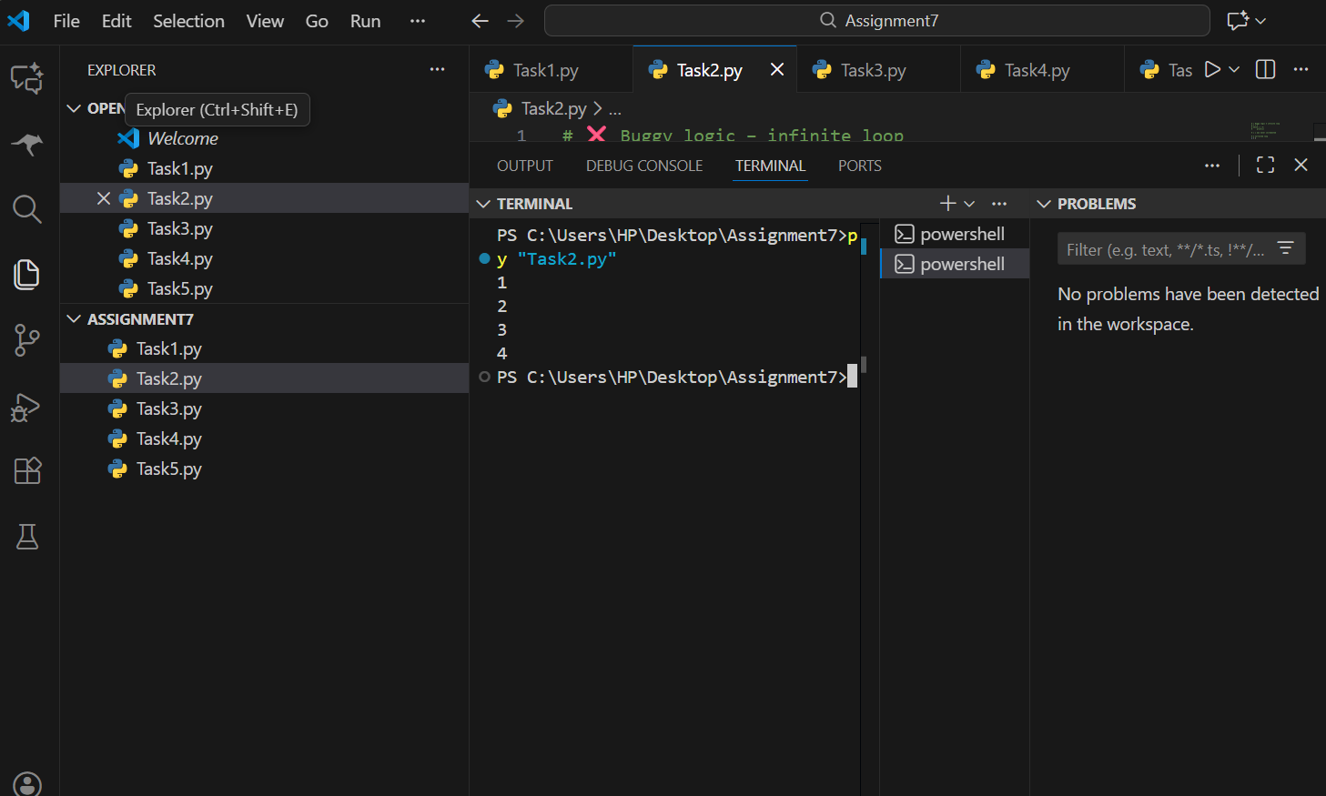
--------------------------------------------------

Task 3 - ZeroDivisionError Fix
Explanation:
Bug: Division by zero causes runtime error.
Fix: Handled with try-except.
Code:
def divide(a,b):
try:
return a/b
except ZeroDivisionError:
return 'Error: Cannot divide by zero!'
print(divide(10,0))
Output Screenshot:
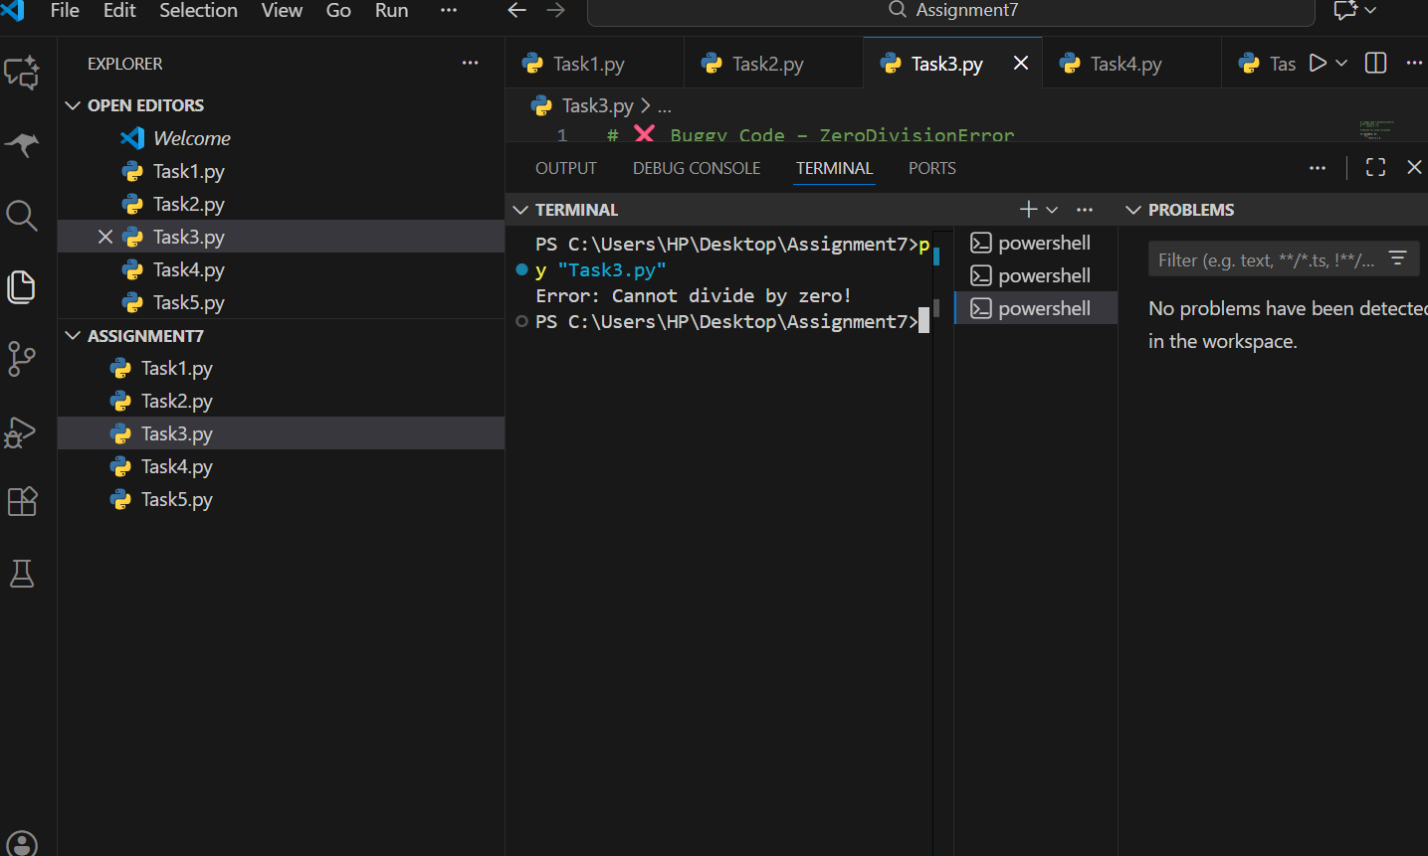
--------------------------------------------------

Task 4 - Missing self parameter
Explanation:
Bug: __init__ had no self, attributes were not assigned.
Fix: Added self and print attributes.
Code:
class Student:
def __init__(self,name,roll):
self.name=name
self.roll=roll
def show(self):
print(self.name,self.roll)
s=Student('Adnan',107)
s.show()
Output Screenshot:
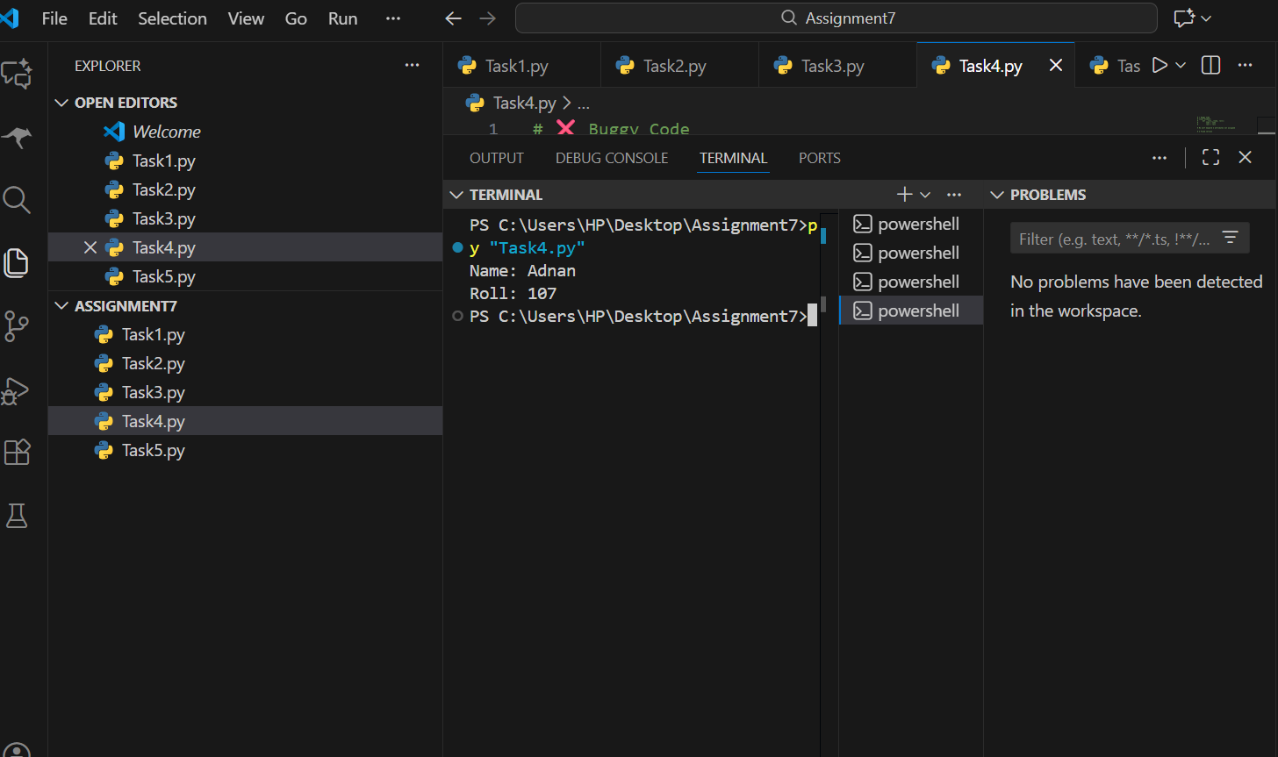
--------------------------------------------------

Task 5 - List Index Error Fix
Explanation:
Bug: Accessing invalid list index.
Fix: Added bounds check.
Code:
nums=[1,2,3]
idx=5
if idx<len(nums): print(nums[idx])
else: print('Index out of range!')
Output Screenshot:



