1. **INTRODUCTION**

# Abstract

This project introduces a seamless shopping experience through a system that allows users to scan items and make payments using QR codes. It integrates real- time billing, mobile-controlled trolleys, and an efficient checkout process through a mobile app. This system aims to reduce time spent in long queues, eliminate the need for physically pushing heavy trolleys, and provide better accessibility for people with physical disabilities. The application includes functionalities for users, admins, and stock managers to enhance the overall management of stock, staff, and user feedback. It consists of Three modules

# ORGANISATION PROFILE

At Ralfiz Technologies, we develop innovative and creative products and services that provide total communication and information solutions. Among a plethora of services, web design, and development, tailor-made applications, ERPs, CRMs, e- commerce solutions, Mobile App Development, managed hosting, and internet portal management are few that we offer.

As a leader in technology exploration, Ralfiz is committed to exporting quality software worldwide. The general purpose of Ralfiz is to develop and promote advanced information technologies for multi-user operation. Ralfiz Technologies business philosophy is to assure the highest quality product, total client satisfaction, timely delivery of solutions, and the best quality/price ratio found in the industry. Our emphasis is on offering a high degree of product user-friendliness through a positive, creative, and focused company staff.

Guide Name: Mr. Jobin Sebastian Designation: Lead Mobile App Developer

Address: Ralfiz Technologies, Level 2, KIMS Avenue, Perinthalmanna

Email: [jobin@ralfiz.com](mailto:jobin@ralfiz.com) Contact No: +919895663498

SYSTEM ANALYSIS

AND SYSTEM STUDY

1. SYSTEM ANALYSIS AND SYSTEM STUDY

# SYSTEM ANALYSIS

System analysis is the process of gathering and interpreting facts, diagnosing problems and using the facts to improve the system. Analysis is a detailed study of various operations performed by a system and their relationship within and outside of the system. This involves gathering information and using structured tools for

analysis. System analysis is the way of studying a system with an eye on solving its problem-using computer. To analyse a system, one has to study the working of the system in detail. The system analyst has to understand the functioning and concept of the system in detail, before designing the appropriate computer-based system that will meet all the requirements of the existing system.

The various techniques used in the study of the present system are:

* + - Observation
    - Interviews
    - Research
    - Discussion

**PRELIMINARY INVESTIGATION**

Preliminary investigation checks whether a system is developed by means of SDLC, a prototyping strategy or structured analysis method or combination of these methods. A project request should be first reviewed. The entire proposal for the required project is submitted to the selection committee for the evaluation to identify how much this project is relevant in today’s internet technology.

**IDENTIFICATION NEEDS**

The identification needs for this project include recognizing key stakeholders such as customers, admins, and stock managers, each requiring specific functionalities. Customers need user-friendly features like QR code scanning, real- time billing, and payment options, along with accessibility tools such as voice guidance and mobile-controlled trolleys. Admins require secure login access to manage accounts, system operations, and analytics, while stock managers need tools for inventory updates and low-stock alerts. The system must also support

IoT-enabled smart trolleys, secure data storage, payment gateways, and multilingual app functionality. Overall, these requirements focus on improving efficiency, accessibility, and inclusivity for all users.

**FACTS FINDING TECHNIQUES**

There are several methods for gathering this sort of information. We can use all of these methods for gathering information from the users of existing systems.

We can introduce several fact-finding techniques.

**RESEARCH**

Another fact-finding technique is to thoroughly research the problem domains. Most problems are not unique. Thorough research has been conducted for the functionalities to be provided by the proposed system through similar websites, journals and reference books. Information from various websites and available documents from the internet are collected for studying the proposed system problems and possible solutions.

**OBSERVATION**

Observation is a fact-finding technique where the system analyst either participates in or watches a person perform activities to learn about the system. This technique is often used when the validity of data collected through other methods is in question or when the complexity of certain aspects of the system prevents a clear explanation by the end users. This is an effective data collection technique for obtaining an understanding of a system.

**QUESTIONNAIRES**

Another fact-finding technique is to conduct surveys through questionnaires. Requirements are collected through questionnaires and modified for the proposed system through valuable suggestions from possible end users such as developers, website handlers etc. These are special documents that allow the analyst to collect the information and opinions from respondents. The document

can be mass-produced and distributed to respondents. This allows analysts to collect facts from a large number of people while maintaining uniform responses.

**INTERVIEWS**

These are fact finding techniques whereby the system analyst collects information from individuals through face-to-face interaction. The personal interview is generally recognized as the most important and most often fact- finding techniques. Interviews are done with developers for finding their requirements needed in the system about their required interfaces and suggestions are used to develop the system interfaces and functionalities and its feasibility is analyzed.

**COST BENEFIT ANALYSIS**

“Cost Benefit Analysis (CBA) estimates and totals up the equivalent money value of the benefits and cost to the community of projects to establish they are worthwhile”.

# SYSTEM STUDY

A detailed study to determine whether, to what extent, and how automatic data processing equipment should be used. We usually include an analysis of the existing system and the design of the new system, including the development of system specifications which provide a basis for the selection equipment.

Preliminary system study is the first stage of the system development life cycle. This is a brief investigation of the system under consideration and gives a clear picture of what actually the physical system is. In practice, the initial system study involves the preparation of a system proposal which lists the Problem Definition, Objectives of the Study, and Terms of reference for Study, Constraints, Expected benefits of the new system etc. in the light of the user requirements. The system proposal is prepared by the System Analyst (who studies the system) and places it before the user management. The management may accept the proposal and the cycle proceeds to the next stage. The management may also reject the proposal or request some modifications in the proposal. In summary, we would say that system study phase passes through the following steps:

* + - Problem identification and project initiation
    - Background analysis
    - Inference or findings

# EXISTING SYSTEM

In traditional shopping systems, customers select items manually, push heavy trolleys around, and then wait in long queues to get their items billed. Payment is typically processed at a centralized billing counter, which creates delays, especially during peak hours. Accessibility issues arise for users with physical disabilities who may find it challenging to navigate stores or push trolleys. The lack of automation in stock management also results in delays in product restocking, which further impacts the overall customer experience.

# PROPOSED SYSTEM

The proposed system introduces a user-friendly mobile application that integrates multiple functionalities, including:

1. **Real-time QR Code Scanning**: Users can scan items as they pick them, generating an instant bill and avoiding the need to wait at the counter.
2. **Mobile-Controlled Trolleys**: Users can connect their mobile devices to smart trolleys, which can be easily controlled, helping people with physical disabilities navigate the store.
3. **Instant Payment**: The application allows users to complete their payments through the app without waiting in queues.
4. **Efficient Stock Management**: Admins can manage products, approve stock requests, and handle staff, while stock managers can monitor stock levels and request replenishment efficiently.
5. **Membership Integration**: Provide loyalty points or discounts through store- specific memberships or credit cards.
6. **Personalized Recommendations**: Suggest items based on the user's purchase history or preferences**.**
7. **Voice Assistance**: For visually impaired users, provide voice guidance for Navigation and item scanning.
8. **Feedback and Rating System**: Users can provide feedback and rate their shopping experience, helping stores improve services and promotions.

The system consists of Three actors: 1.ADMIN

* 1. STOCK MANAGER
  2. USER

## ADMIN

* + - Manage products, staff, and categories.
    - Approve stock requests from the stock manager.
    - View product ratings and feedback.
    - Monitor offers and promotions.
    - Personalized recommendations.
    - Membership Integration

## STOCK MANAGER

* + - Log in to view product quantities.
    - Generate stock purchase requests to the admin.
    - Update product stock levels.

## USER

* + - Register and log in
    - View products, add them to the cart, and generate a bill in real-time.
    - Complete payments through the app
    - Voice Assistance
    - Provide feedback and add ratings to the products· ● View offers and promotions. This system significantly improves the user experience in stores by reducing waiting times, providing easier accessibility, and streamlining stock management processes.

# SYSTEM ENVIRONMENT

Software specification:

Front End : Flutter (Cross Platform Framework Back End : Firebase

IDE : Visual Studio Code/Android Studio Hardware specification (minimal):

Processor : inteli3

Memory : 8GB

Storage : 80GB

Display : Generic PnP Monitor Keyboard : Windows compatible Mouse: Standard Mouse

System design

1. SYSTEM DESIGN
   1. System Design

# SYSTEM ARCHITECHTURE

Design is a multi-step process that focuses on data structure, software architecture, procedural details and interface between the modules. The design process also translates the requirements into the representation of the software that can access for quality before coding begins. Design is the only way that can accurately translate a customer’s requirements into a finished software product.

The most creative and challenging phase of the system development is the system design. It provides the understanding and procedural details necessary for implementing the system recommended in the feasibility study. Design goes through the logical and physical stages of development. System design goes through two phases of development:

* Logical design
* Physical design

## LOGICAL DESIGN

The part of the design process that is independent of any specific hardware or software platform is referred to as logical design. During logical design, all functional features of the system chosen for development in analysis phase are described independently of any computer platform. Logical design concentrates on the business aspects of the system and tends to be oriented to a high level of specificity. During logical design of the proposed system, all the functional features of the system which are identified during the analysis phase is collected and properly specified independent of any hardware and software specifications.

## PHYSICAL DESIGN

During physical design the logical specifications of the system from logical design are transferred into technology specific details from which all programming and system construction can be accomplished.

## INPUT DESIGN

In input design, user originated inputs are converted into computer-based format. In output design, the emphasis is on producing the hard copy of the information requested or displaying the output on the screen in a predefined format. The following features have been incorporated into the input design of the proposed system.

EASY DATA INPUT

Appropriate messages are provided in the message area, which prompts the user entering the right data. Erroneous data inputs are checked at the end of each screen entry.

DATA VALIDATION

The input data is validated to minimize errors in data entry. For certain, data specific codes have been given and validation is done which enables the user to enter the required data or correct them if they entered wrong inputs.

USER FRIENDLINESS

User is never left in a state of confusion as to what is happening, instead appropriate error and acknowledge messages are sent. Flutter alert/Snack bar messages are being used to indicate the error, warning messages.

CONSISTENT FORMAT

A fixed format is adopted for displaying the alert messages. Warning or validation messages errors are shows by snack bars which will automatically disposes after a particular time duration

INTERACTIVE DIALOGUE

The system engages the user in an interactive dialogue. The system is able to extract missing or omitted information from the user by directing the user through appropriate messages, which are displayed.

## OUTPUT DESIGN

Output design generally refers to the results and information generated by the system. For many end users, output is the main reason for developing the system and the basis on which they evaluate the usefulness of application.

The objective of a system finds its shape in terms of the output. The analysis of the objective of a system leads to determination of outputs. Output of a system can take various forms. The most common are reports, screen displays, printed form, graphical drawings etc. The output also varies in terms of their contents, frequency, timing and format. The output from a system is the justification for its existence. If the outputs are inadequate in anyway, the system itself is inadequate. The basic requirement of output is that it should be accurate, timely and appropriate in terms of content, medium and layout for its intended purpose. Hence it is necessary to design output, so that the objective of the system is met in the best possible manner.

When designing output, the system analyst must accomplish things like, to determine what information to be present, to decide whether to display or print the information and select the output medium to distribute the output to intended recipients.

External outputs are those, whose destination will be outside the organization and which requires special attention as the project image of the organization. Internal output is those whose destination within the organization. It is to be carefully designed, as they are the user’s main interface with the system. Interactive outputs are those which the user uses to communicate directly with the computer.

## DATA FLOW DIAGRAM

The database may be defined as an organized collection of related information. The organized information serves as a base from which further recognizing can be retrieved desired information or processing the data. The most important aspect of building an application system is the design of tables.

The data flow diagram is used for classifying system requirements to major transformation that will become programs in system design. This is starting point of the design phase that functionally decomposes the required specifications down to the lower level of details. It consists of a series of bubbles joined together by lines.

* Bubbles: Represent the data transformations.
* Lines: Represents the logic flow of data.

Data can trigger events and can be processed to useful information. System analysis recognizes the central goal of data in organizations. This data flow analysis tells a great deal about organization objectives are accomplished.

Data flow analysis is studying the use of data in each activity. It documents this finding in DFD’s. Dataflow analysis give the activities of a system from the viewpoint of data where it originates show they are used or hanged or where they go, including the stops along the way from their destination. The components of data flow strategy span both requirements determination and system’s design. The first part is called data flow analysis. As the name suggests, we didn’t use the dataflow analysis tools exclusively for the analysis stage but also in the designing phase with documentation.

## CONSTRUCTING A DFD

* Several rules of thumb are used in drawing DFDs:
* Process should be named and numbered for easy reference.
* The direction of flow is from source to destination, although they may flow back to a source. One way to indicate this is to draw a long flow line back to the source. An alternative way is to repeat the source symbol as a destination.
* When a process is exploded into lower-level details, they are numbered.

## PROCESS

Process shows work of the system. Each process has one or more data inputs and produce one or more data outputs. Processes are represented by circles in DFDs.

## DATA STORES

Data stores are the repositories of data. Process can enter data into store or retrieve the data from data store. Data stores are represented by parallel lines which may be depicted horizontally or vertically.

## DATA FLOWS

The arrows represent data flow. A data flow is data in motion. Data flow represents an input of data to a process or the output of the data from a process.

## EXTERNAL ENTITIES

External entities are outside the system but they either supply input to the system or use other system outputs. They are entities on which the designer has control. External entities that supply data into the system are sometimes called source. External entities that use the system are called sinks, represented by rectangles.

## Data Flow Diagram Symbols

|  |  |  |  |  |
| --- | --- | --- | --- | --- |
| **Symbol** | | | **Name** | **Function** |
|  | | | Process | Performs some transformation of input data to yield output data. |
|  | | | Data Flow | Used to connect processes to each other, to sources or Sinks, the arrow head indicates direction of  data flow. |
|  | | | Source or sink (External Entity) | A source of system inputs or sinks of system outputs. |
|  | |  |
|  | | |
|  | |  | Data Store (Internal Storage) | A repository of data. |
|  |  |
|  | |

**DATA FLOW DIAGRAMS**

**LEVEL 0**



**LEVEL 1**

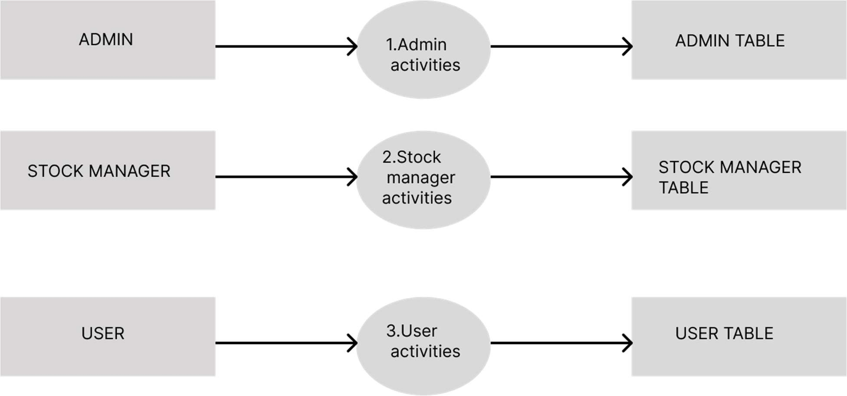

**LEVEL 2**

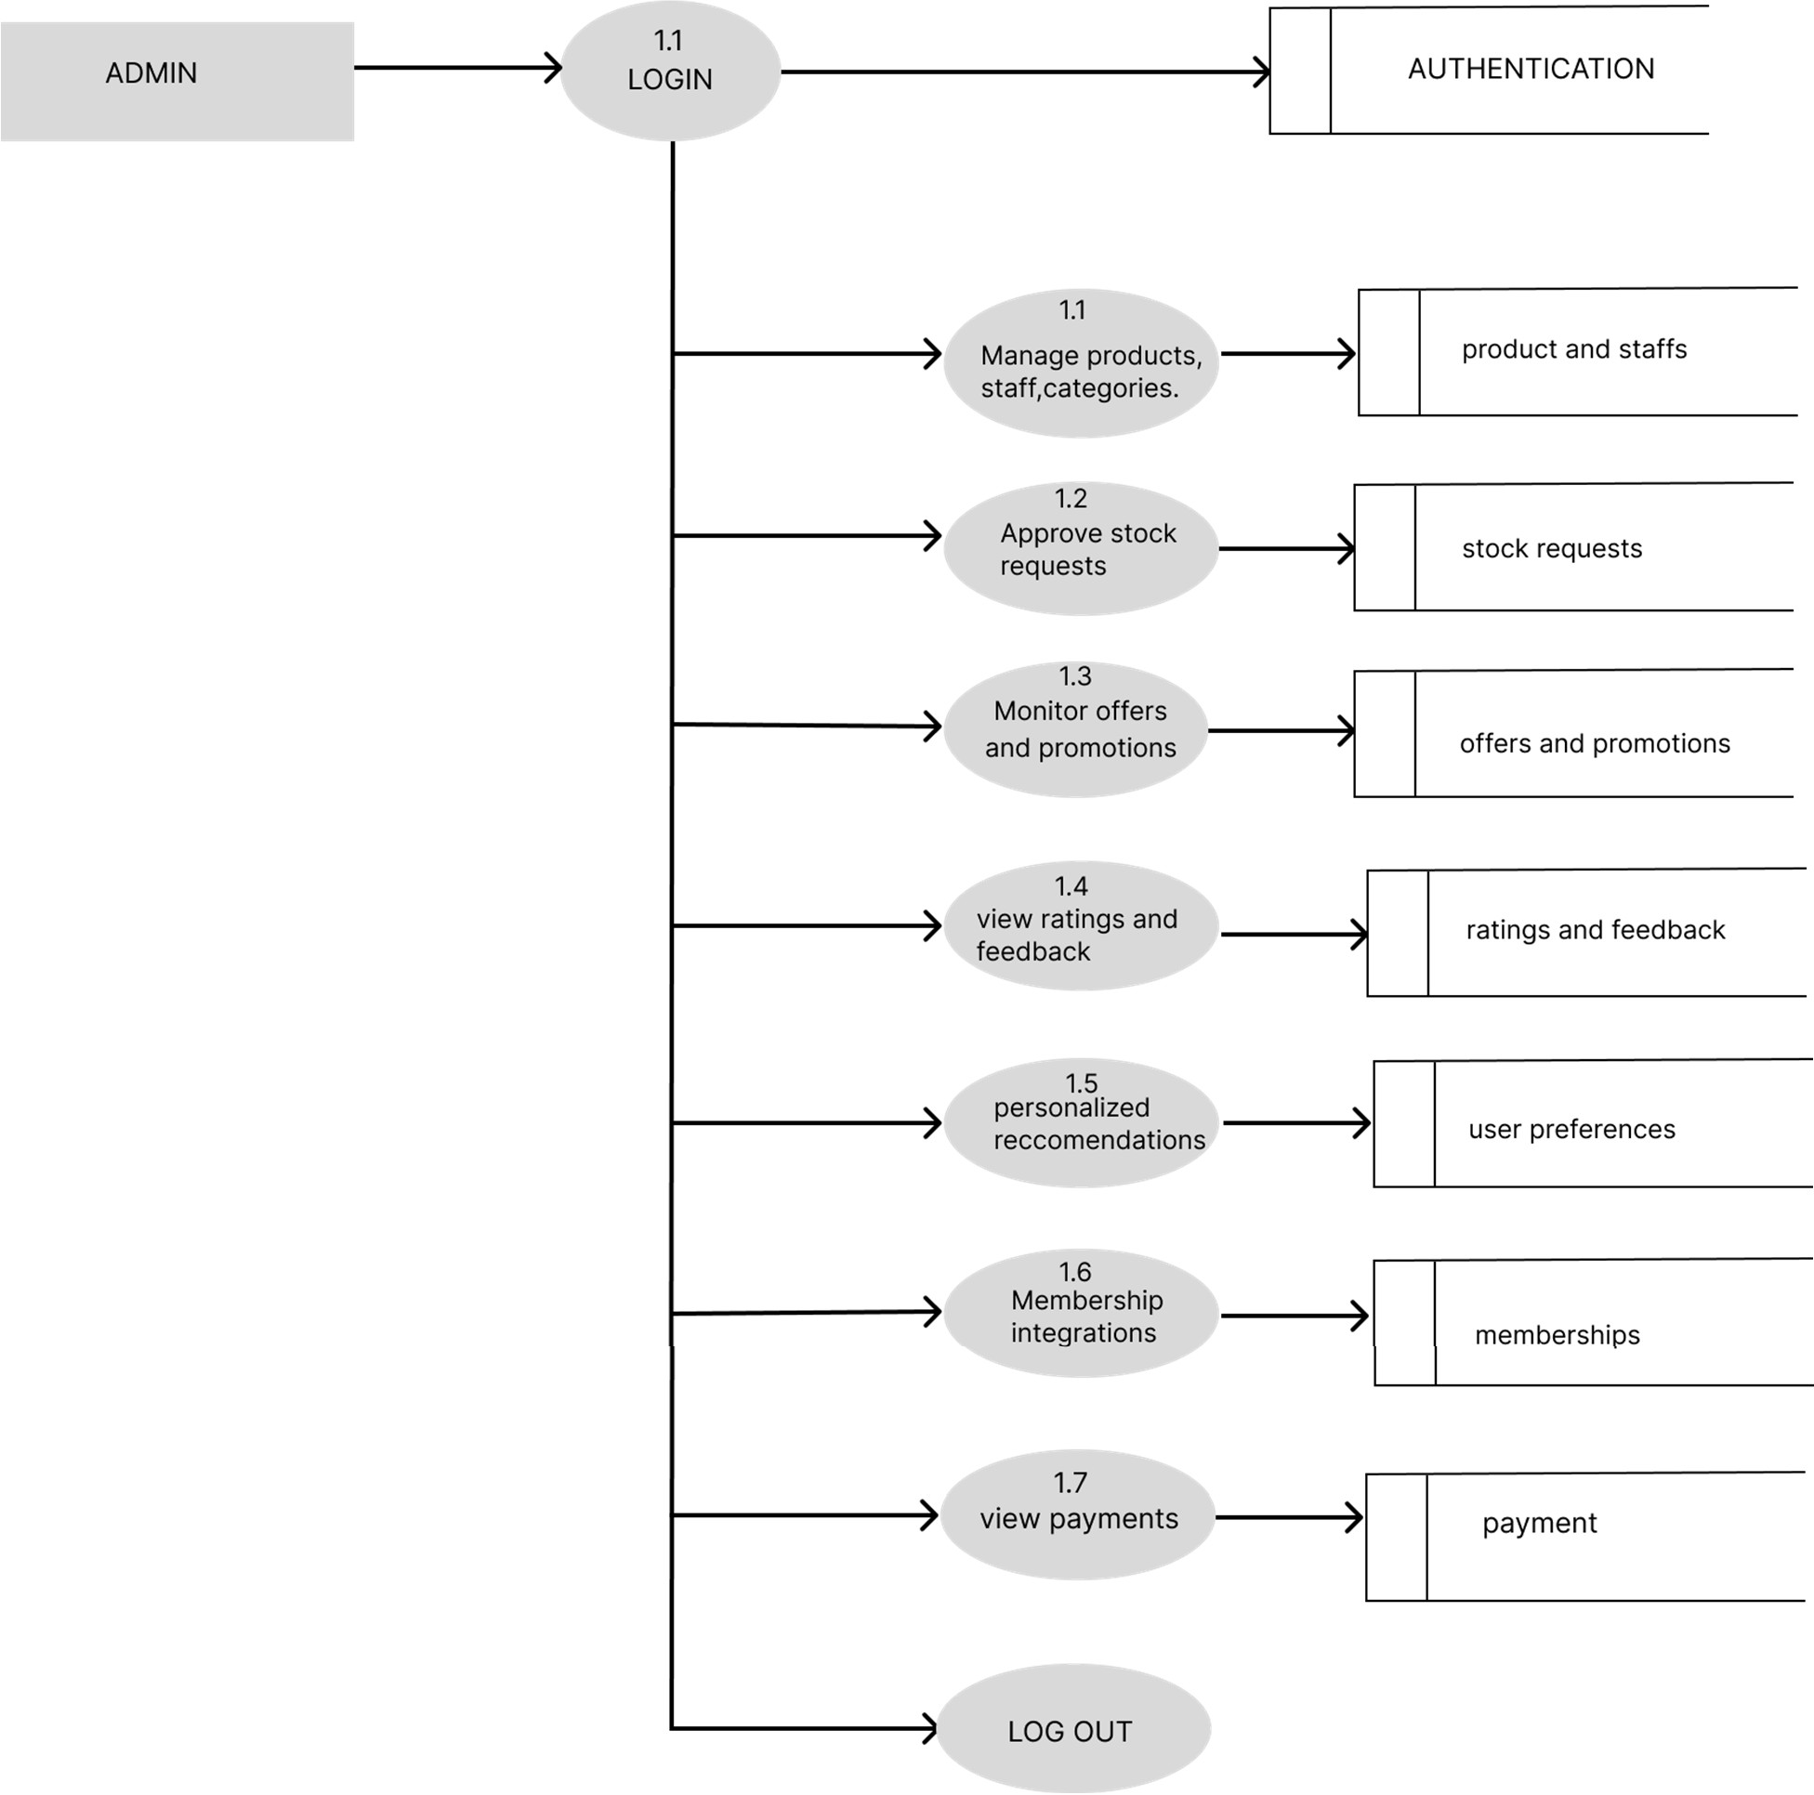

**LEVEL 3**



