**DFD FOR CORPORATE EMAIL BREACH CHECKER**

**Submitted by :Shakir Jamal EP**

**Submitted to :Anitha(miss)**

**MODULES**

* 1-USER MANAGEMENT
* Manages user accounts, authentication, and profiles. User registration with corporate email.
* Edit profile details (name, email, notifications). Dashboard to view breach history and security tips.
* upload bulk emails lsit for checking breches .
* 2-EMAIL BREACH CHECKING
* Scans emails for security breaches in real-time.
* Enter and validate corporate email.
* Scan email against breach databases (XposedOrNot, BreachDirectory).
* Show detailed breach reports (source, severity, exposed data).
* Bulk scanning – upload multiple emails via CSV.
* 3-REPORTS & DOWNLOADS
* Generates reports for users and admins.
* Auto-generate reports (daily, weekly, monthly).
* View breach insights with charts and severity indicators.
* Download reports as PDF, CSV, or DOCX. Email reports directly to users and admins.
* 4-EDUCATIONAL RESOURCES
* Provides cyber security tips and news.
* Daily updates on security breaches and cyber threats. Best practices for passwords, Single email
* checking fpr breached or nor , and File transfer tips.
* Links to trusted security tools (VPNs, password managers).
* 5-ADMIN MANAGEMENT
* Gives admin control over users, breaches, and reports. Secure admin login with 2FA.
* View and manage user accounts and breach data.
* Generate breach analytics and reports.
* User’s messages

**Data Flow Diagram Symbols**

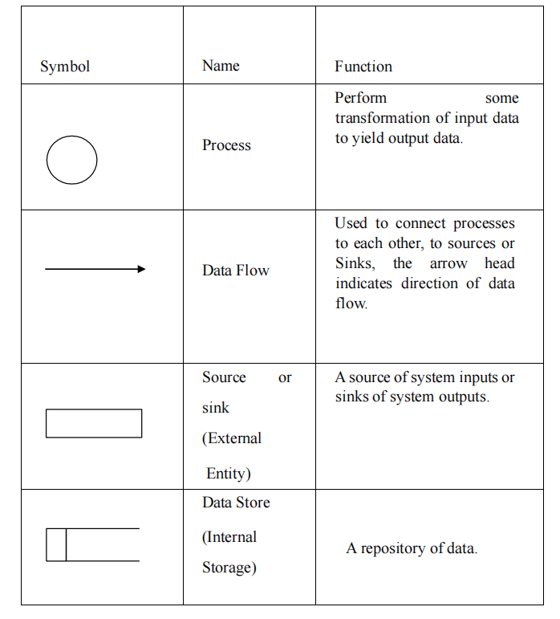

**LEVEL 0:**

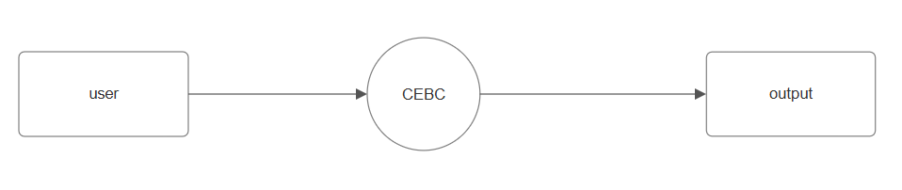

**LEVEL 1:**

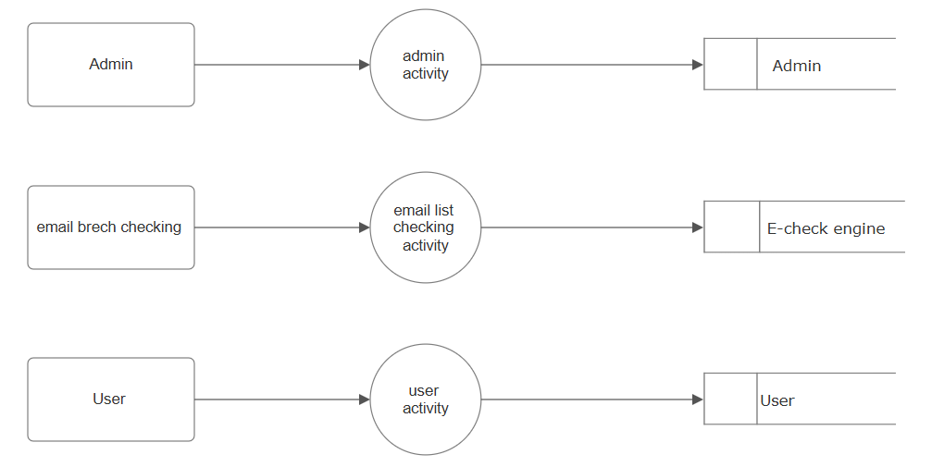

**LEVEL 2:**

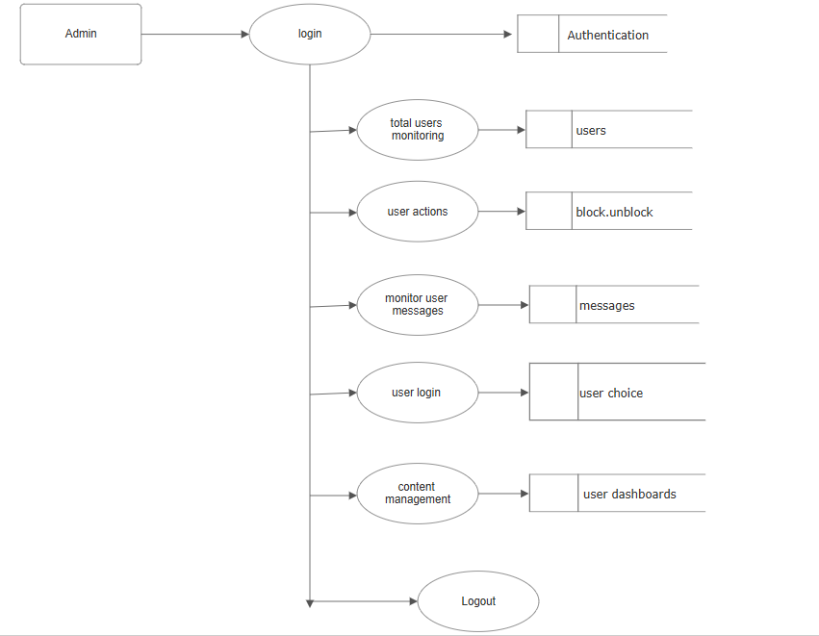

**LEVEL 3:**

