CONTENTS
1 | Abstract
2 | Introduction
3 | System Analysis
3.1 | Existing System
3.2 | Proposed System
3.3 | Feasibility Study
3.3.1 | Technical Feasibility
3.3.2 | Operational Feasibility
3.3.3 | Economic Feasibility
4 | System Requirements
4.1 | Software Requirements
4.2 | Hardware Requirements
4.3 | Programming Languages & Tools
5 | System Design
5.1 | Modules
5.2 | Use Case Diagram
5.3 | Data Flow Diagram
5.4 | System Architecture
6 | Source Code
7 | System Testing
7.1 | Unit Testing
7.2 | Integration Testing
8 | System Implementation
9 | System Maintenance
10 | Conclusion
11 | Future Enhancements
12 | Bibliography / References

1. ABSTRACT

The rapid advancement of digital healthcare systems has created a need for secure, efficient, and intelligent medical record management solutions. This project presents an AI-Enabled Blockchain-Based Healthcare Record Management System (Simulated) designed to ensure secure data access, role-based control, and intelligent medical insights.
The system supports three primary roles: Admin, Doctor, and Patient, each with distinct responsibilities and permissions. Patients can securely store and manage their medical records, grant or deny access to doctors, and track all access activities through audit logs. Doctors can request access to patient records, upload medical reports, and utilize AI-powered analysis for better understanding of medical data. Admins oversee user management and authorization processes, ensuring system integrity.
A key feature of this system is the integration of Artificial Intelligence using the Gemini API, which enables automated analysis and summarization of medical records. This enhances decision-making and improves healthcare efficiency.
The system simulates blockchain concepts such as decentralized identity, access control, and audit trails using in-memory data structures. Although it does not implement real blockchain or persistent storage, it successfully demonstrates the architectural design and workflow of a blockchain-based healthcare system.
Overall, this project provides a modern, scalable, and intelligent approach to healthcare data management, making it suitable for academic demonstration and future real-world expansion.
2. INTRODUCTION

Healthcare data management is one of the most critical aspects of modern digital systems. Traditional healthcare systems rely on centralized databases, which often lead to issues such as data breaches, unauthorized access, lack of transparency, and inefficient data sharing between patients and doctors.
With the emergence of blockchain technology and artificial intelligence, it is now possible to design more secure, transparent, and intelligent healthcare systems. Blockchain provides decentralized data management, while AI enhances data analysis and decision-making.
This project introduces an AI-Enabled Blockchain-Based Healthcare Record Management System (Simulated) that aims to improve security, accessibility, and efficiency in handling medical records. The system uses a role-based architecture consisting of Admin, Doctor, and Patient.
Patients have full control over their medical data and can grant or revoke access to doctors. Doctors can request access and analyze patient records using AI tools. Admins manage user authorization and system monitoring.
Although the system does not implement a real blockchain, it simulates key blockchain features such as decentralized identity, access control, and audit logging using structured frontend logic and service layers.
Additionally, the integration of AI enables automated interpretation of medical records, reducing manual effort and improving healthcare insights.
This project demonstrates how modern technologies can be combined to create a secure and intelligent healthcare ecosystem suitable for future enhancements and real-world applications.

3. SYSTEM ANALYSIS

System Analysis is the process of understanding the existing system, identifying its limitations, and designing an improved system to overcome those issues. It plays a crucial role in ensuring that the proposed system is efficient, secure, and meets user requirements.
In this project, the system analysis focuses on comparing traditional healthcare record systems with the proposed AI-enabled blockchain-based solution.

3.1 EXISTING SYSTEM
The existing healthcare record management systems are mostly centralized and rely on manual or semi-digital processes. These systems are widely used in hospitals and clinics but suffer from several limitations.
Features of Existing System
- Centralized data storage
- Manual record handling in some cases
- Limited data sharing between doctors and patients
- Basic authentication mechanisms
- Lack of transparency in access control
- No AI-based medical analysis
Limitations of Existing System
- Data Security Issues
Centralized databases are vulnerable to hacking and unauthorized access.
- Lack of Patient Control
Patients do not have full control over their medical records.
- No Transparency
There is no proper tracking of who accessed the data.
- Inefficient Data Sharing
Sharing records between hospitals and doctors is slow and complex.
- Manual Errors
High chances of human errors in record management.
- No Intelligent Insights
No AI integration for analyzing medical records.

3.2 PROPSED SYSTEM

Key Features of Proposed System

- Role-Based Access Control

- Admin, Doctor, and Patient roles
- Each role has specific permissions
- Secure access management

- AI Integration (Gemini API)

- Automated summaries
- Intelligent insights

- Wallet-Based Identity (Simulated)

- Unique user identity
- Session-based authentication
- Blockchain-like identity concept

- Audit Logging System

- Tracks all activities
- Maintains transparency
- Helps in monitoring access history

- Emergency Access Mechanism

- Temporary access during emergencies
- Controlled and time-limited

- Access Control Management

- Patients grant/revoke access
- Doctors request permissions
- Secure sharing mechanism

- Medical Record Management

- Upload and view records
- Structured data storage
- Easy retrieval

Advantages of Proposed System
- Enhanced data security using blockchain-inspired mechanisms
- Complete patient control over medical records
- Transparent audit logs for tracking system activities
- AI-assisted analysis for improved healthcare insights
- Faster and more efficient data sharing
- Scalable and modular system architecture
- Improved reliability and reduced manual errors

3.3 FEASIBILITY STUDY

A feasibility study is conducted to determine whether the proposed system is practical, achievable, and beneficial. It helps in evaluating the system from different perspectives before implementation. In this project, the feasibility study is divided into three main categories: technical feasibility, operational feasibility, and economic feasibility.

3.3.1 Technical Feasibility

Technical feasibility focuses on whether the required technology, tools, and resources are available to develop and run the system effectively.
The proposed AI-Enabled Blockchain-Based Healthcare Record Management System is technically feasible because it is developed using modern web technologies such as React, TypeScript, and Vite, which are widely used and well-supported. The system follows a modular architecture, making it easier to develop, maintain, and scale.
The integration of Artificial Intelligence through the Gemini API further enhances the system by enabling automated analysis of medical records. The application runs on standard computers and does not require high-end hardware or complex infrastructure.
However, the system currently simulates blockchain functionality using in-memory data structures and does not implement a real blockchain or backend database. Despite this limitation, the system successfully demonstrates the architecture and working principles, making it suitable for academic purposes.

3.3.2 Operational Feasibility

Operational feasibility evaluates how well the system will function in a real-world environment and whether users can easily interact with it.
The proposed system is highly user-friendly and designed with clear role-based dashboards for Admin, Doctor, and Patient. Each user has access only to the features relevant to their role, which improves usability and security. The workflows such as registration, record management, access requests, and approvals are simple and easy to understand.
The system also includes features like audit logs, emergency access, and simulated security mechanisms, which enhance usability and provide better control over medical data. Users do not require advanced technical knowledge to operate the system, making it practical for demonstration and learning purposes. Additionally, features like audit logs, access control, and emergency access mechanisms enhance usability and ensure that users can efficiently manage healthcare data. The system does not require advanced technical knowledge, making it suitable for a wide range of users.

3.3.3 Economic Feasibility

Economic feasibility determines whether the system is cost-effective and financially viable.
The proposed system is economically feasible because it uses open-source technologies and modern development tools that are freely available. There is no need for expensive hardware or infrastructure, as the system runs entirely on the client side.
The cost of development and maintenance is minimal, and AI API usage can be managed based on requirements. Since the system is designed for academic demonstration, it does not require investment in servers, databases, or blockchain networks.
Overall, the system provides a cost-effective solution while demonstrating advanced concepts like blockchain simulation and AI integration. The proposed AI-Enabled Blockchain-Based Healthcare Record Management System is economically feasible as it utilizes modern, open-source technologies, which significantly reduce development costs. The system is designed to operate efficiently without requiring expensive infrastructure or high-end hardware.
The integration of advanced features such as AI-based medical analysis adds value to the system while maintaining cost efficiency. The overall design ensures that the system remains affordable, scalable, and suitable for future enhancements.

4. SYSTEM REQUIREMENTS

System requirements specify the essential software, hardware, and technologies needed for the successful development and operation of the system. These requirements ensure that the system performs efficiently, remains reliable, and supports all intended functionalities.
The proposed system is designed using modern web technologies, making it lightweight, scalable, and easy to deploy. It does not require complex infrastructure and can run on standard computing devices. The system also supports AI-based features, which require internet connectivity for API communication.
The requirements are divided into three main categories: software requirements, hardware requirements, and programming technologies.

4.1 SOFTWARE REQUIREMENTS

Sl.No | Software Component | Description
1 | Operating System | Windows 10 or above
2 | Frontend Technology | React.js with TypeScript
3 | Styling Framework | CSS / Tailwind CSS
4 | Scripting Language | JavaScript
5 | Development Tool | Visual Studio Code
6 | Build Tool | Vite
7 | Web Browser | Google Chrome / Microsoft Edge
8 | API Integration | Gemini AI API
9 | Version Control (Optional) | Git
4.2 HARDWARE REQUIREMENTS

Sl.No | Hardware Component | Description
1 | Processor | Intel Core i3 or above
2 | RAM | Minimum 4 GB
3 | Hard Disk | Minimum 500 GB
4 | System Type | 64-bit computer
5 | Input Devices | Keyboard and Mouse
6 | Internet Connection | Required for API usage

4.3 Programming Languages

This section explains the various programming languages, frameworks, and tools used in the development of the system. Each technology plays a specific role in building a complete and efficient application.

HTML (HyperText Markup Language)
HTML is the fundamental building block of the web application. It is used to create the structure and layout of all pages. It defines elements such as headings, forms, buttons, input fields, tables, and navigation components.
In this project, HTML is used to design:
- Login and registration pages
- Dashboard layouts
- Medical record forms
- Data display sections
It ensures proper organization of content and serves as the backbone of the user interface.

CSS / Tailwind CSS
CSS is used to style and design the application. It controls colors, fonts, spacing, alignment, and layout. Tailwind CSS is a utility-first framework that allows faster UI development with predefined classes.
In this project, CSS/Tailwind is used for:
- Responsive design (mobile & desktop)
- Dashboard styling
- Button and form design
- Layout consistency
- Smooth transitions and animations
It improves the visual appearance and user experience of the system.

JavaScript

JavaScript is used to add interactivity and dynamic behavior to the system. It allows the application to respond to user actions without reloading the page.
In this project, JavaScript is used for:
- Handling user input and form validation
- Managing dynamic data updates
- Implementing access control logic
- Processing record operations
- Handling events and user interactions
It makes the system interactive and responsive.

TypeScript
TypeScript is an advanced version of JavaScript that adds type safety and improves code quality. It helps developers detect errors early and write more structured code.
In this project, TypeScript is used for:
Defining data models (users, records, access logs)
Ensuring type safety
Improving maintainability
Reducing runtime errors
It enhances reliability and scalability of the application.

React.js

React.js is a popular frontend library used to build user interfaces using reusable components. It allows efficient rendering and improves application performance.
In this project, React is used for:
Creating modular UI components
Managing application state
Building dashboards for different roles
Rendering dynamic data efficiently
It helps in organizing the application into smaller, manageable parts.

API integration
The Gemini API is used to integrate AI capabilities into the system. It allows the application to analyze and interpret medical data.
In this project, it is used for:
- Generating medical summaries
- Providing AI-based insights
- Enhancing decision-making
This feature adds intelligence and modern capability to the system.

In this project, different technologies are used to develop a complete and efficient system. HTML is used to create the structure of the web pages, while CSS is used to design and improve the appearance of the application. JavaScript adds interactivity and dynamic behavior to the system.
TypeScript improves code quality by providing type safety and better structure. React.js is used to build a responsive and component-based user interface. Vite helps in faster development and efficient build processing.
The integration of the Gemini API adds intelligent features such as medical data analysis and improves the overall functionality of the system.
Together, these technologies work effectively to create a modern, scalable, and user-friendly healthcare management system.
5. SYSTEM DESIGN

System Design is the process of defining the structure, components, modules, and architecture of the proposed system. It acts as a blueprint that explains how the system will function and how different parts of the system interact with each other.
The main goal of system design is to convert system requirements into a structured solution that ensures efficiency, security, and scalability. In this project, the system is designed using a modular approach, which improves maintainability and flexibility.
The system follows a layered architecture consisting of the frontend interface, application logic, and data handling components. Each part of the system is responsible for specific tasks and works together to provide a complete solution.
5.1 MODULES
The system is divided into several modules based on functionality. Each module performs a specific task and contributes to the overall system operation.

1. Authentication Module
This module handles user registration and login.
Functions:
- User registration
- Login using wallet-based identity
- Role assignment (Admin, Doctor, Patient)
- Session handling

2. Admin Module
This module is responsible for managing the entire system.
Functions:
View all registered users
- Approve or reject doctors
- Manage user authorization
- Monitor system activities

3. Doctor Module
This module allows doctors to interact with patient data.
Functions:
- Register as doctor
- Provide professional details
- Wait for admin approval
- Search patients
- Request access to records
- View granted records
- Upload medical records

4. Patient Module
This module gives patients full control over their medical data.
Functions:
- Register as patient
- Upload medical records
- View records
- Grant or deny access to doctors
- View audit logs
- Manage access permissions
- Enable emergency access

5. Medical Record Module
This module manages all healthcare data.
Functions:
- Store medical records
- Retrieve records
- Organize patient data
- Maintain structured record format

6. Access Control Module
This module ensures secure data sharing.
Functions:
- Handle access requests
- Grant or deny permissions
- Manage access list
- Enforce role-based restrictions

7. AI Integration Module
This module adds intelligent features to the system.
Functions:
- Analyze medical data
- Generate summaries
- Provide insights
- Assist doctors in decision making

8. Audit Log Module
This module maintains system transparency.
Functions:
- Record user activities
- Track data access
- Maintain history of actions
- Provide logs for monitoring
5.2 USE CASE DIAGRAMS
A Use Case Diagram is a type of Unified Modeling Language (UML) diagram used to represent the interaction between users and a system. It provides a simple and clear way to describe the functional requirements of a system by showing what actions users can perform.In a use case diagram, the users are known as actors. Actors can be individuals or external systems that interact with the application. The actions performed by these actors are called use cases.The diagram mainly consists of actors, use cases, and the relationships between them. Actors are usually represented by stick figures, while use cases are shown as ovals. Lines are used to connect actors with the use cases they interact with.The main purpose of a use case diagram is to provide a high-level view of the system’s functionality. It helps in understanding how the system works from the user’s perspective without going into technical details.

Actors:
- Admin
- Doctor
- Patient

Patient Use Cases:

- Register / Login
- Upload medical records
- View records
- Grant access
- Deny access
- View audit logs

Doctor Use Cases:

- Register as doctor
- Provide details
- Request access
- View patient records
- Upload reports
- Use AI analysis

Admin Use Cases:
- Manage users
- Approve doctors
- Monitor system
- Control access
USE CASE DIAGRAM :

ADMIN:
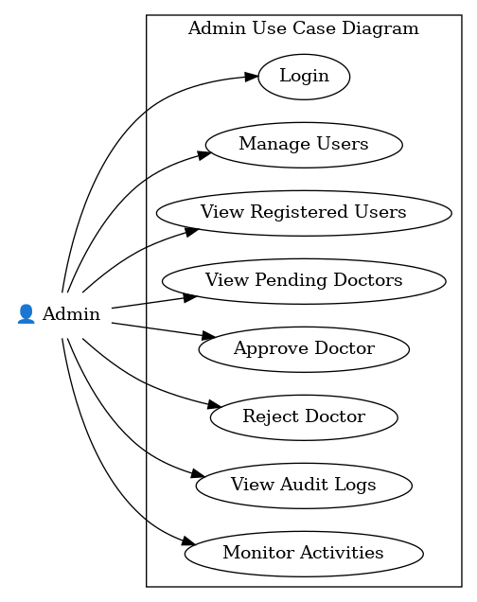
PATIENT:
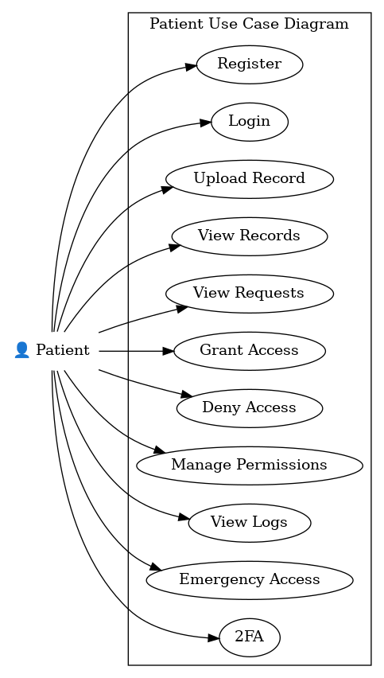
DOCTOR:
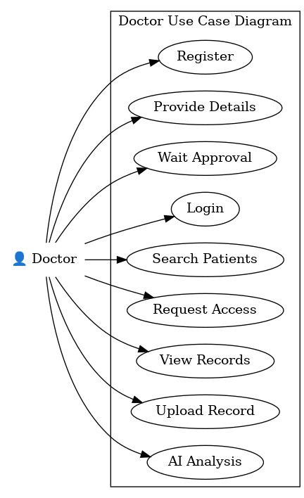
5.3 DATA FLOW DIAGRAM
A Data Flow Diagram (DFD) is a graphical representation that shows how data moves through a system. It explains how data is input, processed, stored, and output within the system. The main purpose of a DFD is to provide a clear understanding of how information flows between different components of the system. A Data Flow Diagram focuses on the logical flow of data rather than the technical details of implementation. It helps in analyzing the system and identifying how data is handled at each stage.
Main Components of a Data Flow Diagram
A DFD consists of four main components:

External Entity :

Rectangle
External entities are the users or outside systems that interact with the system. They provide input data and receive output from the system.

Process :

Circle or Bubble

A process represents an activity or function that transforms input data into output data. It performs operations such as calculations, validations, or data processing.

Data Store :

One end opened rectangle

A data store represents a place where data is stored. It can be a database, file, or any storage system where information is kept for future use.

Data Flow :

Arrow

Data flow represents the movement of data between entities, processes, and data stores. It is usually shown using arrows.
Levels of Data Flow Diagram
DFDs are divided into different levels to represent the system in a more detailed manner.

Level 0 (Context Diagram)

The Level 0 DFD, also known as the Context Diagram, represents the entire system as a single process. It shows how external entities interact with the system.
In this level:
The whole system is shown as one process
External entities interact with the system
Basic input and output data flows are represented
This level provides a high-level overview of the system.

Level 1 Data Flow Diagram
The Level 1 DFD breaks down the main system into smaller processes. It shows the major functions of the system and how data flows between them.
In this level:
The system is divided into main processes
Data stores are introduced
Data flow between processes is shown clearly
This level gives a more detailed understanding of system functionality.

Level 2 Data Flow Diagram
The Level 2 DFD provides a detailed breakdown of the processes defined in Level 1. It explains how each process works step by step.
In this level:
Individual processes are further divided
Detailed data flow is shown
Internal operations of the system are explained
This level helps in understanding the working of each function in detail.

Rules of Data Flow Diagram (DFD):
- Every process must have at least one input and one output
A process cannot exist without receiving data and producing output.
- Data should not flow directly between external entities
All data must pass through a process; external entities cannot exchange data directly.
- Data store must be connected through a process
Data cannot move directly between a data store and an external entity without a process.
- Data flow should be clearly labeled
Every data flow arrow must have a meaningful name to show what data is being transferred.
- Processes should be numbered and clearly named
Each process must have a unique number and a descriptive name to indicate its function.

Level 0 Data Flow Diagram
The Level 0 Data Flow Diagram, also known as the context diagram, represents the entire system as a single process and shows the interaction between the system and external entities. It gives a general overview of how data enters and leaves the system.
In this project, the main external entities are Admin, Doctor, and Patient. These entities interact with the Healthcare Record Management System to perform different operations.
Admin manages user approvals, doctor authorization, and monitors system activities.
Doctor registers in the system, requests access to patient records, uploads medical records, uses chatbot assistance, and performs medical report analysis.
Patient registers in the system, uploads medical records, grants or denies doctor access requests, uses chatbot assistance, and views analysis reports.
The system processes these requests and returns the required information, approval status, medical records, access responses, chatbot replies, and analysis results.
MEDICHAIN SECURE
AI SERVICES
ADMIN
PATIENT
DOCTOR
Level 1 DFD – Patient

The Level 1 DFD for the Patient module shows the main functions performed by patients in the system. Patients can register, upload medical records, manage doctor access requests, analyze medical reports, and use chatbot assistance.
The main functions performed by the patient are:

- Patient Registration – submits patient details for account creation.

- Upload Medical Records – stores personal medical reports and related documents.

- View Access Requests – checks requests sent by doctors.

- Grant or Deny Access – manages doctor permissions to view records.

- Medical Report Analysis – analyzes uploaded medical reports and views the generated results.

- Chatbot Assistance – interacts with the chatbot for quick support and guidance.

- View Audit Logs – checks record access history and user activities.

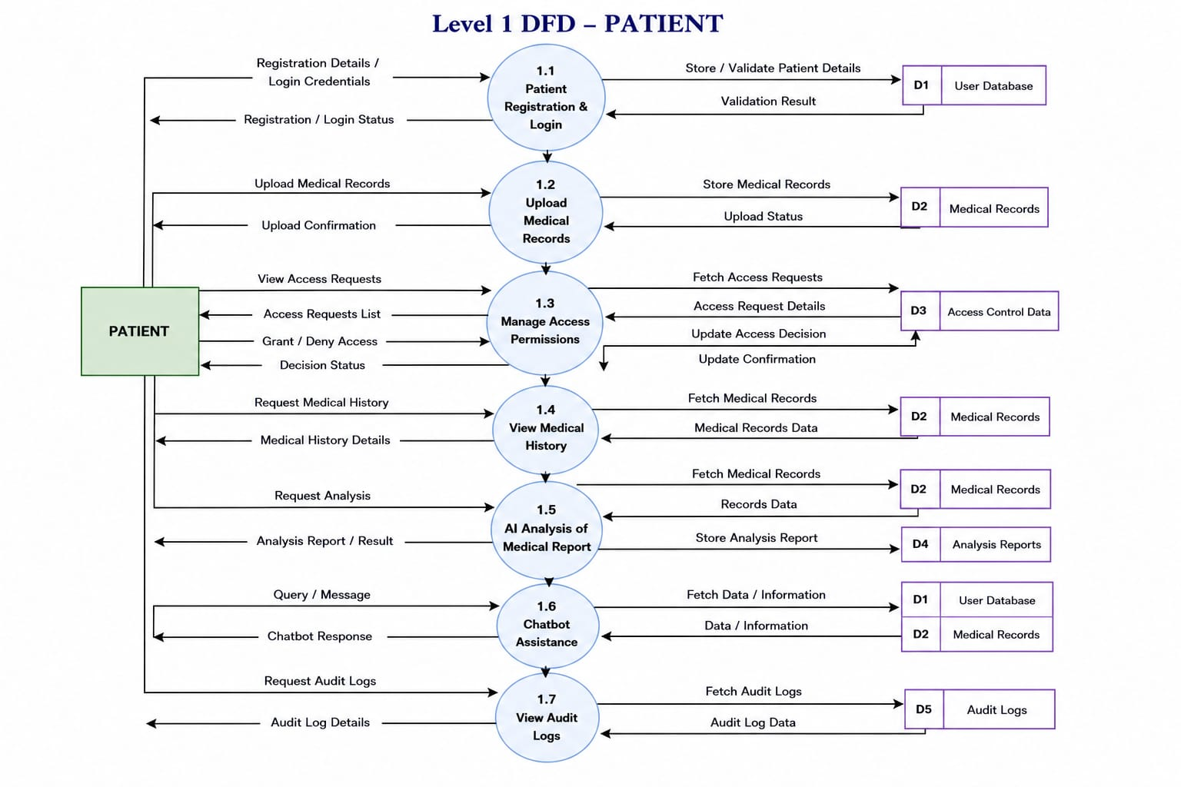
Level 1 DFD – Doctor

The Level 1 DFD for the Doctor module shows the main functions performed by doctors in the system. Doctors can register, search patient records, request access, upload medical records, use chatbot assistance, and perform medical report analysis.
The main functions performed by the doctor are:

- Doctor Registration – submits doctor details such as specialization, license number, and experience.

- Search Patient – searches patient information and available records.

- Request Access – sends requests to patients for permission to view records.

- View / Upload Medical Records – allows viewing authorized records and uploading new records.

- Medical Report Analysis – analyzes patient medical reports and views the generated results.

- Chatbot Assistance – interacts with the chatbot for quick help and guidance.

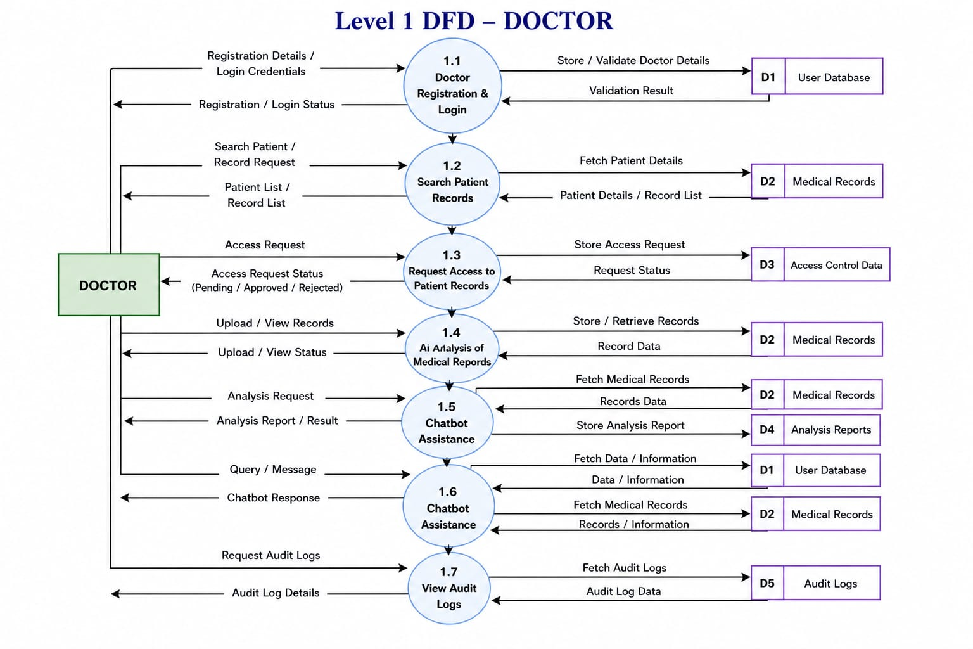

Level 1 DFD – Admin

The Level 1 DFD for the Admin module shows the functions performed by the administrator in the system. The admin is responsible for managing users, verifying doctor registrations, approving or rejecting requests, and monitoring system activities.
The main functions performed by the admin are:

- View Registered Users – displays the list of registered users in the system.

- View Pending Doctor Requests – shows doctors waiting for approval.

- Approve or Reject Doctors – verifies doctor details and updates approval status.

- Manage Authorization – controls user access permissions.

- View Audit Logs – monitors user activities and system operations.
- 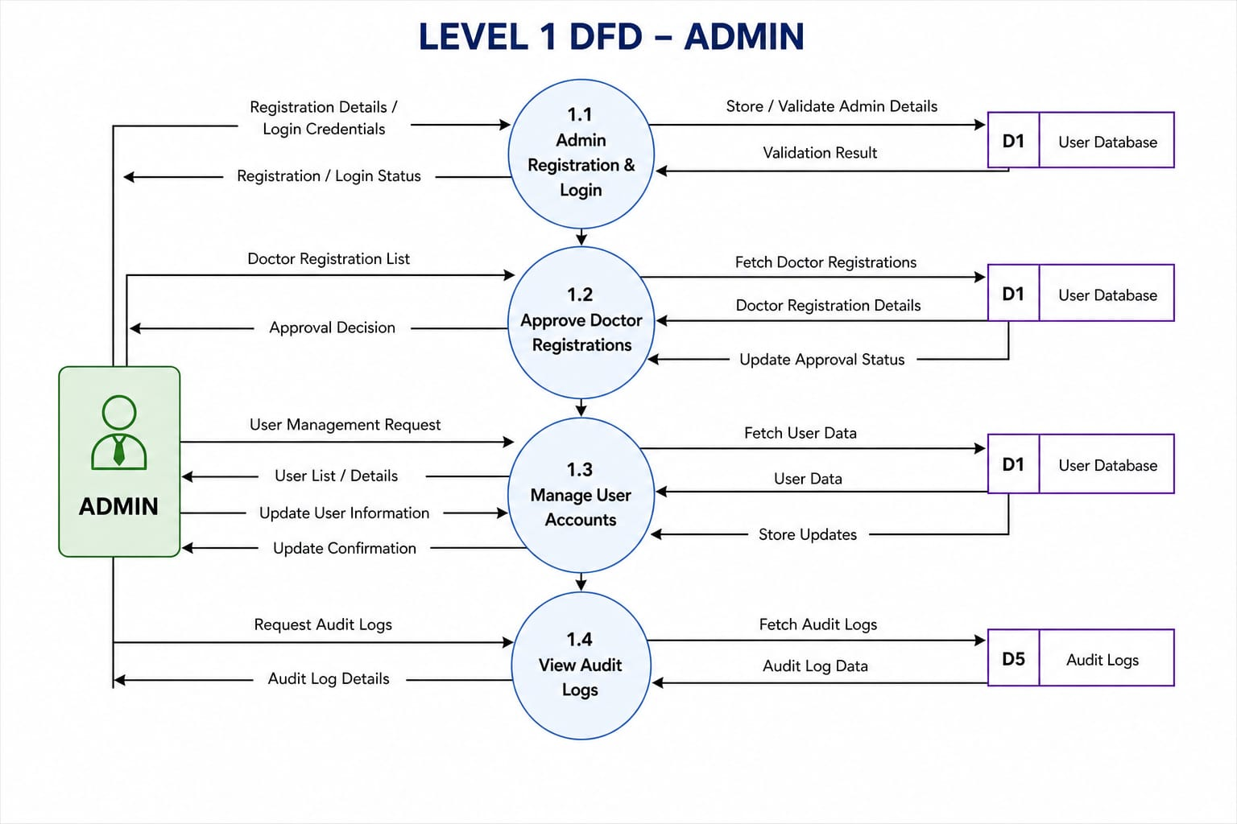
5.4 SYSTEM ARCHITECTURE

System Architecture refers to the overall structure of the system and defines how different components are organized and interact with each other. It acts as a blueprint that shows how data flows within the system and how different modules work together.The AI-Enabled Healthcare Record Management System follows a layered architecture combined with a modular design. This helps in improving performance, scalability, and maintainability of the system.

1. Presentation Layer (Frontend Layer)
The Presentation Layer is the user interface of the system where users interact with the application. It is developed using React.js with TypeScript and styled using CSS/Tailwind.This layer provides different dashboards for Admin, Doctor, and Patient based on their roles.
Functions:
- Displays login and registration pages
- Provides role-based dashboards (Admin, Doctor, Patient)
- Allows users to upload and view medical records
- Shows access requests and audit logs
- Displays AI analysis results

2. Application Layer (Logic Layer)
This layer handles the core functionality and processing of the system.
It connects the frontend with data handling components.
The Application Layer handles the core logic and processing of the system.
It acts bridge between the frontend interface and data handling components

Functions:
- Processes user requests
- Manages role-based access control
- Handles medical record operations
- Controls access permissions
- Maintains audit logs
- Integrates AI through geminiService.ts

3. Data Layer
The Data Layer is responsible for storing, managing, and retrieving all the data used in the system. It ensures that information is organized properly and can be accessed whenever required by the application.In this system, the data layer maintains all important details such as user information, medical records, access permissions, and activity logs. The data is structured in an organized format, which helps in efficient data handling and quick retrieval.
Functions:
- Stores user details and roles
- Stores medical records of patients
- Maintains access control information
- Records audit logs and system activities
- Retrieves data when requested by the application

The system architecture provides a well-structured and organized framework for the application. The layered and modular design ensures efficient communication between components and supports secure and intelligent healthcare data management.

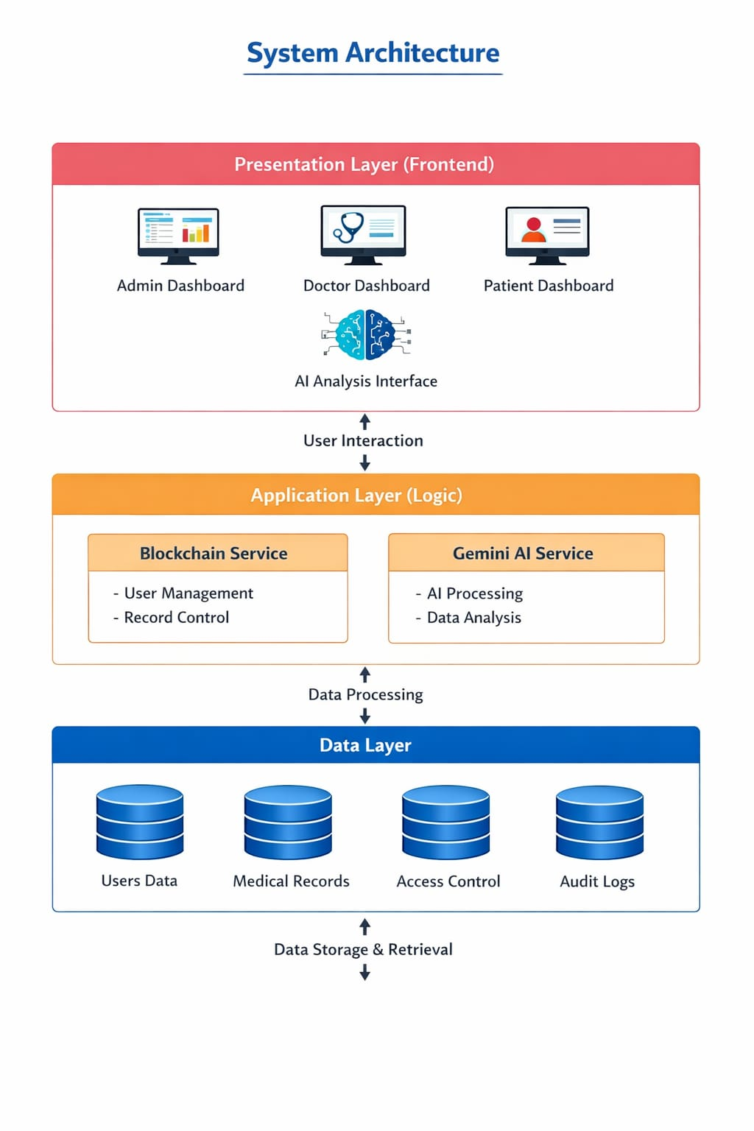
6. SYSTEM TESTING

System Testing is a comprehensive testing process conducted to verify the complete and integrated functionality of the system. The main purpose of system testing is to ensure that the entire application works correctly as a whole and meets all specified requirements. In this stage, the fully integrated system is tested to confirm that all modules function properly together. The focus is on verifying the behavior of the entire system, including the user interface, functionality, performance, and reliability. System testing helps in identifying issues that may arise when different components interact with each other. It ensures that the system performs correctly under various conditions and that all features operate according to the design specifications.
Objectives of System Testing
- To verify that all system functionalities work correctly
- To identify and fix errors or bugs
- To ensure proper integration between different modules
- To validate system performance and reliability
- To ensure that the system meets user requirements

Unit Testing
Unit testing is a testing method in which individual components or modules of the system are tested separately. The purpose of unit testing is to verify that each part of the application works correctly on its own before integrating it with other modules.In this system, each functional module such as user registration, login, record upload, access control, and AI analysis was tested independently. This helps to identify errors at an early stage and ensures that each unit performs its intended task correctly.
Objectives of Unit Testing
- To verify the correctness of individual modules
- To detect errors at an early stage
- To ensure each function works independently
- To reduce bugs in later stages of development
- Examples of Unit Testing in the System
- Testing the user registration functionality
- Testing login and authentication
- Testing upload and retrieval of medical records
- Testing access request and approval functions
- Testing AI analysis module individually

Advantages of Unit Testing
- Makes debugging easier
- Improves code reliability
- Reduces future development effort
- Ensures high code quality

Integration Testing
Integration testing is performed after unit testing to verify that different modules work correctly together. It focuses on testing the interaction and data flow between modules to ensure that they function as a complete system.In this project, integration testing ensures that user roles, access control, record management, and AI analysis work together smoothly without conflicts or errors.
Objectives of Integration Testing
- To verify interaction between modules
- To detect interface-related issues
- To ensure smooth data flow between components
- To confirm overall system functionality
Examples of Integration Testing in the System
- Interaction between patient and doctor modules
- Verification of access control between users
- Data exchange between frontend and application logic
- Integration between medical record module and AI module
Advantages of Integration Testing
- Ensures combined functionality of modules
- Detects communication errors between components
- Improves system reliability
- Confirms smooth workflow across the system

Unit Testing
Unit tests focus on verifying the smallest testable parts of the application, like individual functions or methods in isolation.

Test Case ID | Module / Component | Test Scenario | Expected Result | Actual Result | Status
UT-01 | Input Field | Enter valid input | Input accepted successfully | Works correctly | Pass
UT-02 | Input Field | Enter empty input | Validation error displayed | Error shown | Pass
UT-03 | Button Component | Click submit button | Action is triggered | Works correctly | Pass
UT-04 | Form Validation | Enter invalid characters | Error message displayed | Error shown | Pass
UT-05 | API Service Function | Send request to API | Correct response returned | Response received | Pass
UT-06 | Data Rendering | Receive data from API | Data displayed correctly | Works properly | Pass
UT-07 | Error Handling | Force API failure | Error message displayed | Error shown | Pass
UT-08 | State Update | Update state in component | UI updates correctly | Works correctly | Pass

Integration Testing
Integration tests verify that different modules or services work together as expected

Test Case ID | Integrated Modules | Test Scenario | Expected Result | Actual Result | Status
IT-01 | UI + API | Submit data and receive response | Response shown in UI | Works correctly | Pass
IT-02 | UI + Validation | Submit empty form | Error message shown | Error displayed | Pass
IT-03 | Navigation + UI | Click navigation link | Correct page opens | Navigation successful | Pass
IT-04 | UI + State Management | Change input value | UI updates properly | Works correctly | Pass
IT-05 | API + Error Handling | Simulate API failure | Error message displayed | Error shown | Pass
IT-06 | Form + Validation + API | Enter valid data and submit | Data processed correctly | Works properly | Pass
IT-07 | UI + Data Rendering | Receive list data from API | List displayed correctly | Works correctly | Pass
IT-08 | Session / Workflow | Perform full user workflow | System functions smoothly | No errors found | Pass

7. SYSTEM IMPLEMENTATION

Implementation is the phase where the system design is converted into a working application. It involves coding the system, integrating different modules, configuring the environment, testing functionalities, and ensuring that the users are able to use the system effectively. The success of the system largely depends on proper implementation.During this phase, all planned functionalities are developed and combined into a fully functional system. The implementation process also includes user training, system setup, and preparation for real-world usage.
Requirement Gathering
Requirement gathering is the first and most important stage of system implementation. In this phase, all necessary information about the system is collected and analyzed. This includes identifying user needs, system goals, and functional expectations.
During this phase, both functional and non-functional requirements were identified. Functional requirements define what the system should do, while non-functional requirements define how the system should perform.
- Key Activities in Requirement Gathering
- Understanding user needs and expectations
- Identifying different user roles and responsibilities
- Defining system functionalities and features
- Identifying data management and storage requirements
- Understanding security and access control requirements
- Planning AI-based functionalities
- Identifying performance and usability requirements
System Design
System design is the process of defining the structure, components, modules, interfaces, and data flow of the system. This phase acts as a blueprint for the development phase.
During system design, the overall architecture of the system was defined. The system was divided into different modules to ensure proper organization and easy development.
Key Activities in System Design
Designing the system architecture
Dividing the system into modules
Defining relationships between modules
Designing user interfaces
Defining data structures and data flow
Planning access control and security
Designing interaction with AI services
.Development
The development phase involves the actual coding and implementation of the system based on the design. In this phase, all modules are developed and integrated to form a complete application.The system was developed using modern web technologies and a modular approach. Each module was implemented separately and then combined to form the complete system.
Key Activities in Development
- Developing user interface components
- Implementing user authentication and role management
- Developing admin, doctor, and patient modules
- Implementing access control mechanisms
- Managing medical records
- Integrating AI-based functionality
- Ensuring smooth interaction between modules
System Integration
System integration is the process of combining all individually developed modules into a single complete system. After each module is developed and tested separately, they are integrated to ensure that they work together smoothly.
In this phase, the interaction between different modules is tested to ensure proper communication and data flow. The integration ensures that the system behaves as expected when all components are connected.
Key Activities in System Integration
Integrating the user authentication module with the role-based dashboards
Connecting the admin, doctor, and patient modules
Linking the access control system with the record management module
Integrating AI-based analysis with the medical record module
Ensuring smooth data flow between frontend and application logic
Testing
Testing is an important part of implementation. It ensures that the system works correctly and meets the required standards. Various types of testing were performed to identify and fix errors.
Types of Testing Performed
- Unit testing to test individual modules
- Integration testing to test interaction between modules
- System testing to test overall functionality
- User acceptance testing to ensure user satisfaction
.
Deployment
Deployment is the process of making the system available for use. After successful development and testing, the system was deployed in a working environment.
Key Activities in Deployment
- Setting up the execution environment
- Running the application in a browser
- Ensuring system accessibility
- Providing basic user training
Training
Training is an important part of system implementation to ensure that users can operate the system effectively. Even though the system is designed to be user-friendly, proper training helps users understand the features and use the system efficiently.Training was provided to different users based on their roles. Users were introduced to the system interface and guided on how to perform tasks such as login, uploading medical records, managing access permissions, and using AI-based analysis features.
Key Training Activities:
- Introduction to system features and workflow
- Role-based training for Admin, Doctor, and Patient
- Demonstration of system functions
- Guidance on access control and data management
Monitoring
Monitoring is the continuous process of observing system performance and user activities to ensure smooth operation. It helps in identifying errors, security issues, and performance problems.Monitoring activities include tracking user activities, verifying access control operations, and checking system performance. Audit logs are used to monitor system usage and maintain transparency.
Monitoring Activities:
- Monitoring user actions and system behavior
- Checking access requests and permissions
- Tracking system performance
- Identifying issues and improving efficiency

Support Evaluation
Support evaluation focuses on providing assistance to users and resolving issues encountered during system usage. It ensures user satisfaction and system reliability.User feedback is collected and analyzed to identify problems and areas for improvement. Support activities help maintain system stability and improve user experience.
Support Activities:
- Providing help and guidance to users
- Resolving user issues
- Collecting feedback for improvements
- Ensuring smooth system operation
Maintenance and Update Evaluation
Maintenance ensures that the system continues to function properly after deployment. It includes fixing errors, improving system performance, and adapting the system to new requirements.
Maintenance Activities:
- Correcting system errors and bugs
- Improving system performance
- Enhancing security features
- Updating system components
Update Evaluation:
- Adding new features based on user feedback
- Improving user interface and usability
- Enhancing AI functionality
- Ensuring compatibility with new technologies

8. SYSTEM MAINTENANCE

System maintenance is an important phase of the system life cycle that begins after the system has been deployed. The main objective of maintenance is to ensure that the system continues to operate efficiently, reliably, and securely over time. It involves correcting errors, improving performance, updating features, and adapting the system to new requirements or technological changes.System maintenance ensures that the system remains useful and effective throughout its life cycle. Regular monitoring and updates help prevent system failures, improve user satisfaction, and ensure smooth functioning of all system modules.
Need for System Maintenance
- System maintenance is necessary for several reasons:
- To correct errors or bugs identified after deployment
- To improve system performance and reliability
- To enhance security and protect data
- To add new features or improve existing ones
- To adapt the system to changing user needs and technologies

Types of System Maintenance
Corrective Maintenance
Corrective maintenance refers to identifying and fixing errors or problems in the system after it has been implemented. These problems may include coding errors, logic errors, performance issues, or unexpected system behavior.Corrective maintenance is essential to ensure that the system works as intended and does not cause errors during use. It is usually performed when users report problems or when system testing reveals issues.
Examples of Corrective Maintenance:
- Fixing bugs in the application code
- Correcting errors in data processing
- Resolving login or authentication problems
- Fixing broken links or system crashes
Adaptive Maintenance
Adaptive maintenance involves making changes to the system to adapt it to new environments or technologies. This type of maintenance is required when external conditions change, such as hardware upgrades, new operating systems, or updated software platforms.Adaptive maintenance ensures that the system continues to function correctly even when the surrounding environment changes.

Examples of Adaptive Maintenance:
- Updating the system to work with new web browsers or devices
- Modifying the system for compatibility with updated software tools
- Updating the system to support new technologies or standards
Perfective Maintenance
Perfective maintenance focuses on improving the system’s performance, functionality and user experience. This includes adding new features, enhancing existing features, and improving system efficiency based on user feedback.The goal of perfective maintenance is to make the system more useful and efficient over time.
Examples of Perfective Maintenance:
- Improving the user interface design
- Enhancing system performance and response time
- Adding new features based on user needs
- Optimizing system workflows
Preventive Maintenance
Preventive maintenance involves taking proactive steps to prevent potential problems before they occur. This type of maintenance helps reduce the risk of system failures and ensures long-term system stability.Preventive maintenance improves the reliability and performance of the system by identifying and resolving potential issues early.
Examples of Preventive Maintenance:
- Regular system monitoring and updates
- Improving security measures
- Optimizing code and performance
9. FUTURE ENHANCEMENTS

Future enhancements refer to the improvements and additional features that can be implemented in the system after its initial development. These enhancements are intended to improve the system’s performance, security, usability, and overall functionality. As technology continues to evolve, upgrading the system becomes necessary to meet new user expectations and industry standards.The purpose of future enhancements is to make the system more efficient, reliable, and user-friendly. By adding new features and improving existing functionalities, the system can provide better services to users and adapt to changing requirements. Future enhancements also help the system remain competitive, scalable, and capable of handling larger amounts of data and more complex operations.Continuous improvement through future enhancements ensures that the system remains relevant and effective in real-world applications, providing better performance and an improved user experience over time.

Smart Notifications
Smart notifications can be introduced to improve user awareness and system interaction. Instead of users manually checking for updates, the system can automatically notify users about important activities.
Possible notification types include:
- New access requests from doctors
- Approval or rejection notifications
- Appointment reminders
- Alerts for abnormal health readings
- System updates and warnings
Smart notifications can be delivered through in-app alerts, SMS, or email, improving real-time communication and decision-making.

Biometric Authentication
To improve system security, biometric authentication can be implemented. This includes authentication methods such as fingerprint scanning, facial recognition, or iris scanning.
Benefits of biometric authentication:
- Stronger user verification
- Reduced risk of unauthorized access
- Faster and more convenient login
- Enhanced data security
This feature can replace or complement traditional password-based login.

Personalized Health Insights
Artificial Intelligence can be used to analyze user medical history and health patterns. Based on this analysis, the system can provide personalized health insights and recommendations.
Examples include:
- Personalized diet and nutrition suggestions
- Health risk predictions
- Exercise and lifestyle recommendations
- Early warnings based on medical patterns
This helps users take preventive actions and supports better healthcare decisions.

Health Monitoring Integration
The system can be integrated with wearable devices and health sensors to collect real-time health data automatically.
- Possible integrations include:
- Heart rate monitoring
- Blood pressure tracking
- Sleep pattern analysis
Step count and physical activity tracking
This data can be used by doctors to monitor patient health continuously and provide timely medical advice.

Improved Data Security
Data security can be enhanced using advanced security techniques to protect sensitive medical information.
Security improvements include:
- Data encryption for stored and transmitted data
- Multi-factor authentication
- Secure communication protocols
- Protection against unauthorized access
- These measures help protect user privacy and maintain data integrity.

Advanced Analytics and Reporting
Advanced analytics can be added to provide deeper insights into healthcare data. This helps doctors, patients, and administrators make informed decisions.
Features may include:
- Visual dashboards and graphs
- Trend analysis of medical data
- Health progress reports
- Statistical analysis for better decision-making
- This helps identify health trends and supports better treatment planning.

Cloud Integration
Cloud integration allows the system to store and manage data on cloud platforms instead of local storage.
Benefits of cloud integration:
- Scalable data storage
- Remote access from anywhere
- Improved system reliability
- Automatic backups and disaster recovery
- Cloud support makes the system more flexible and reliable.

10. CONCLUSION

The project was successfully designed and implemented to develop an efficient healthcare record management system that supports secure handling of medical information and effective interaction among different users. The system was developed with clearly defined roles for administrators, doctors, and patients, allowing each user to perform specific functions according to their responsibilities. This role-based approach helps in maintaining organized system operation and controlled access to information.
The system provides a structured method for managing healthcare records. Patients can upload and manage their medical records, doctors can request access and review authorized records, and administrators can manage user approvals and monitor overall system activities. This organized workflow improves the management of healthcare information and reduces the complexity of handling records manually.
One of the major strengths of the project is the integration of intelligent features such as AI-based medical report analysis and chatbot assistance. The AI analysis feature helps users better understand medical records by generating simplified analysis reports, while the chatbot provides quick assistance and improves user interaction with the system. These features enhance the overall functionality of the application and make it more user-friendly.
The project also includes important management features such as access permission control, audit logging, and monitoring of user activities. These functions improve transparency, accountability, and proper handling of sensitive information. Throughout the development process, all major stages including requirement gathering, system design, development, integration, testing, implementation, maintenance planning, and future enhancement analysis were completed in a systematic manner.
In conclusion, the project successfully achieved its objectives by developing a useful and well-structured healthcare management application. It demonstrates how modern web technologies and intelligent features can be combined to improve healthcare data management. The project also provides a strong foundation for future improvements and can be enhanced further to support more advanced healthcare services and wider practical applications.

11. APPENDIX

Screen shots:
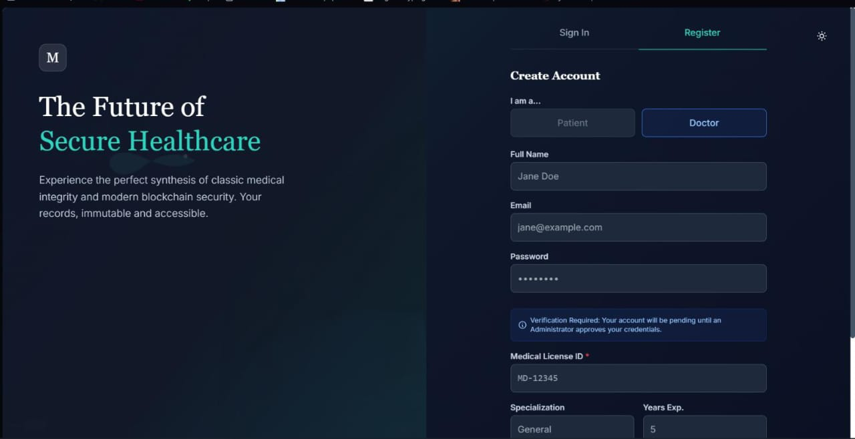

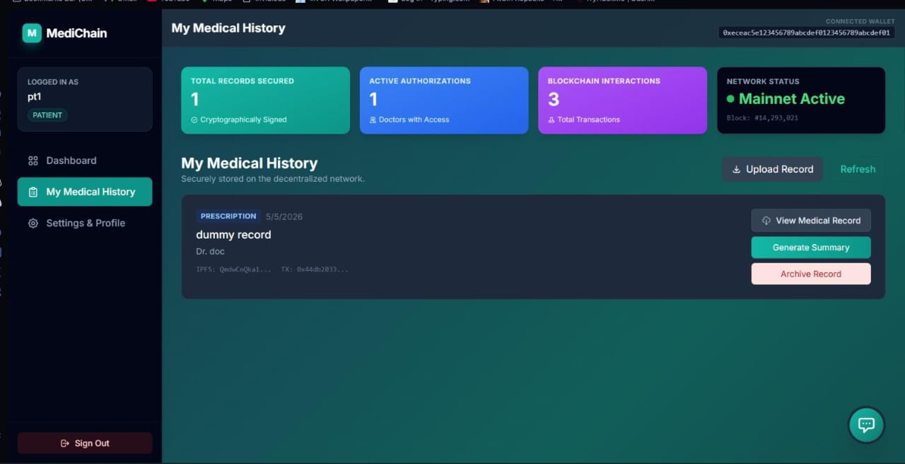
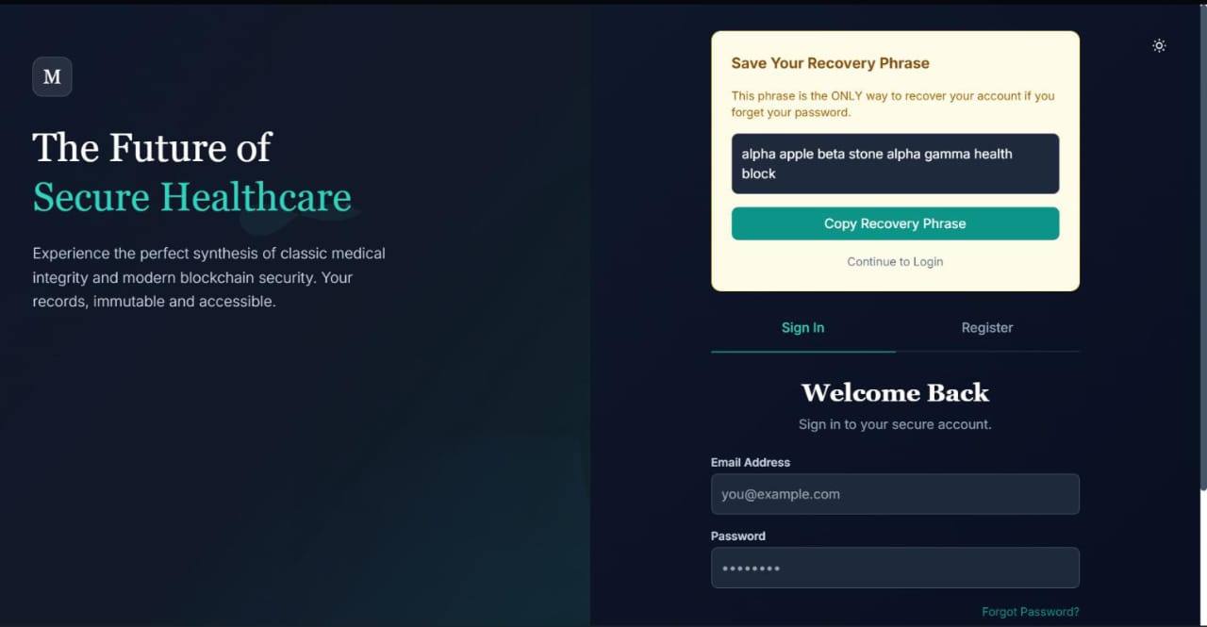
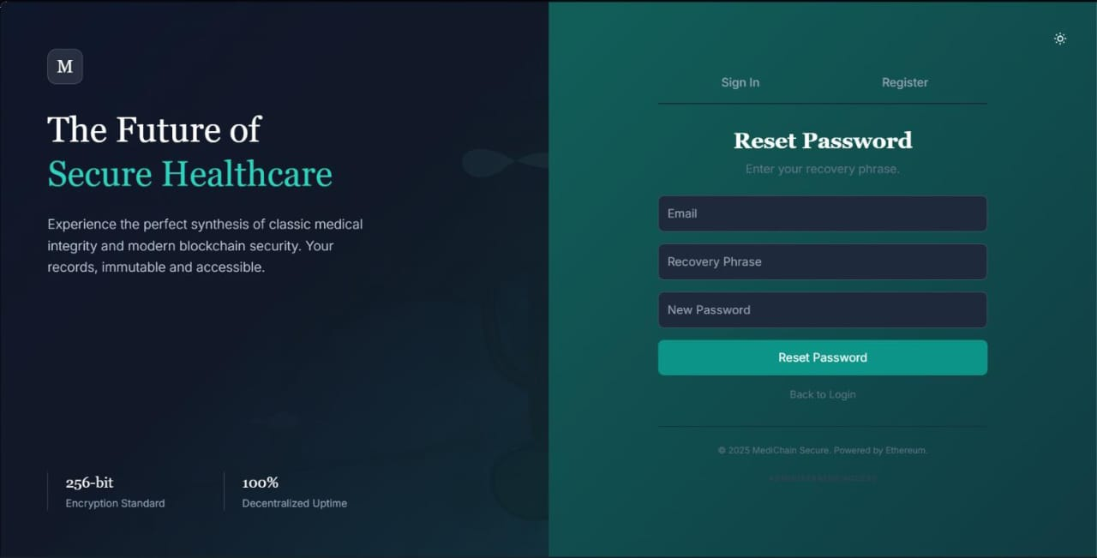

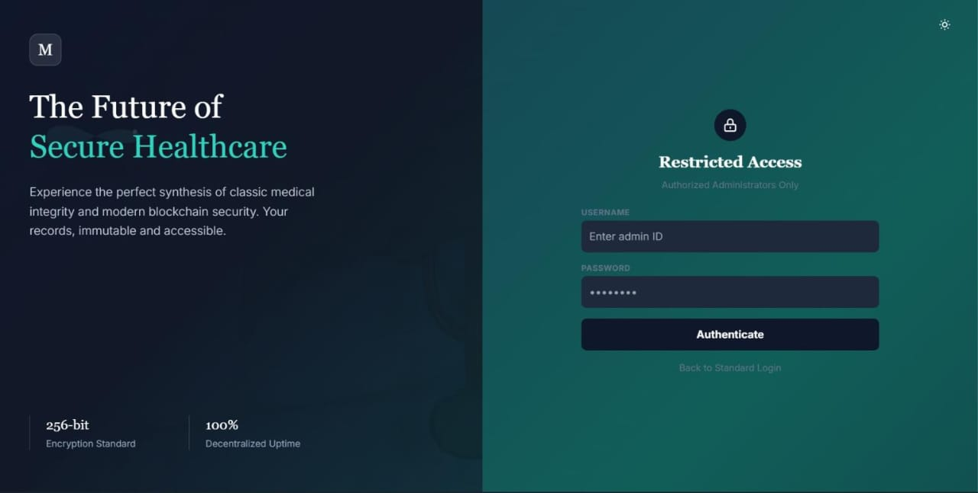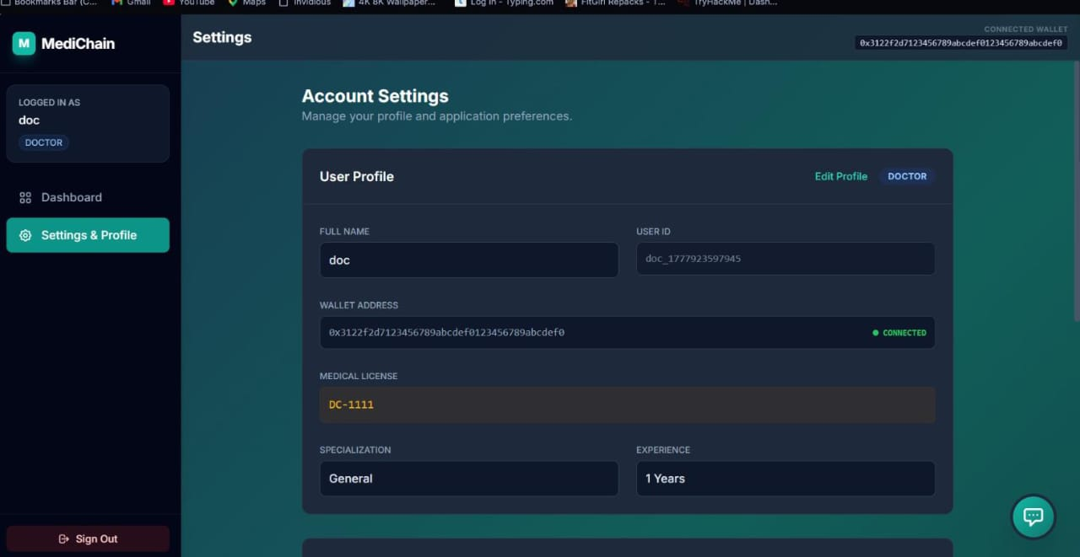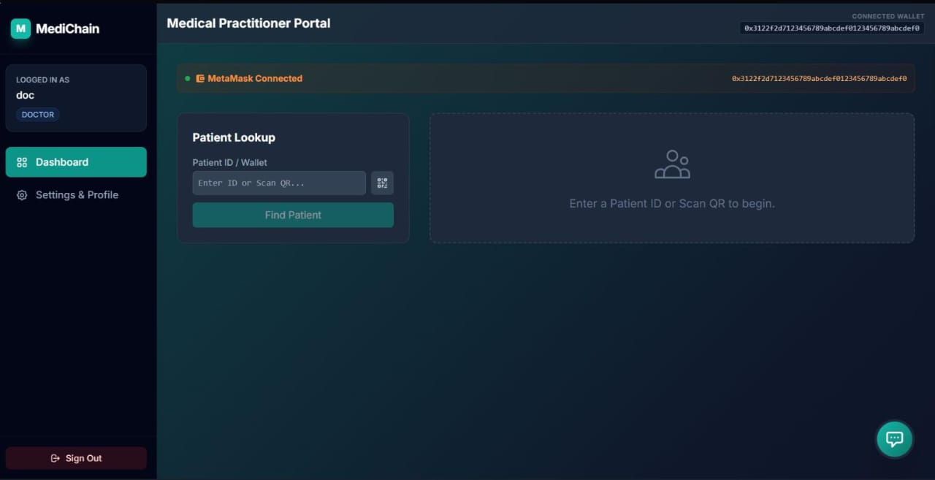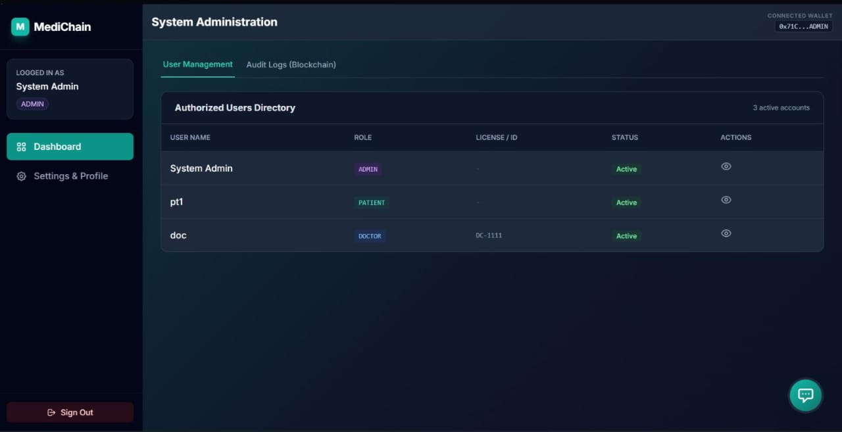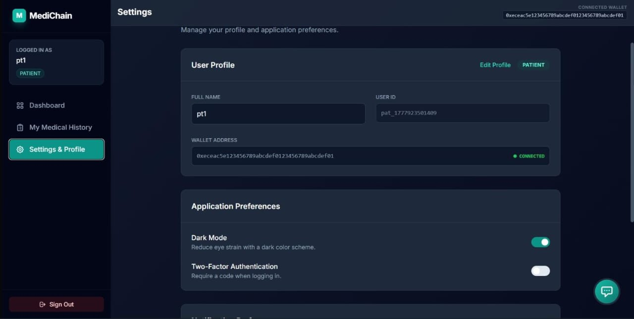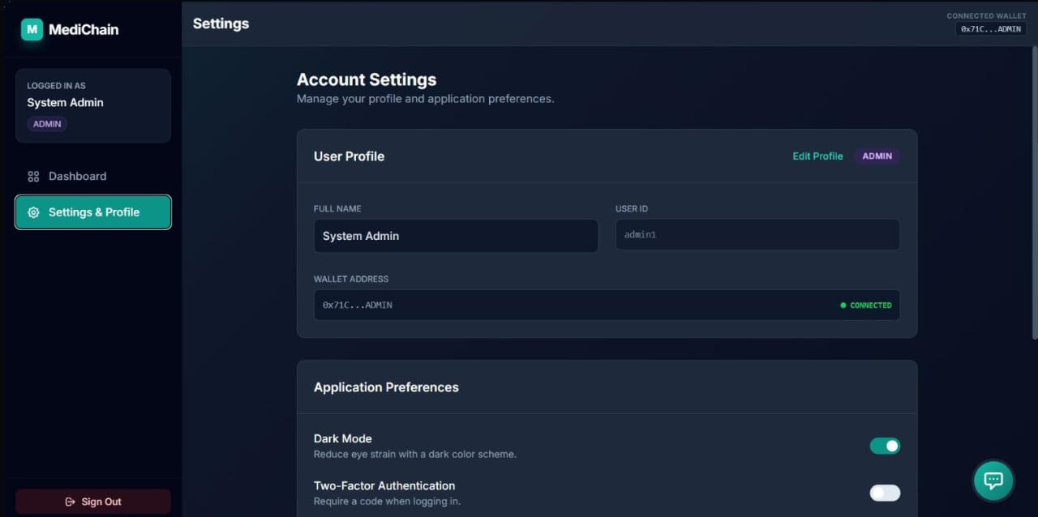

12. BIBLIOGRAPHY

- React Official Documentation.
- TypeScript Official Documentation.
- Vite Official Documentation.
- Google Gemini API Documentation.
- Visual Studio Code Official Documentation.
- Software Engineering, Pearson Education.
- System Analysis and Design, Galgotia Publications.
- Online tutorials, technical articles, and project development
references used during implementation.

