AranMed — User and Verification Guide
PACS · Electronic Health Record · Inter-hospital exchange · Radiology AI
Generated: 2026-10-05
commit bec8240

Contents
1. About this guide
2. Test summary
3. Installation and configuration
4. Signing in, roles and accounts
5. Reporting workspace
6. The EHR section
7. The unified patient chart
8. Between hospitals: shared records and transfers
9. EMS inbound
10. PACS: archive, viewer and reporting
11. PACS: devices and protocols
12. Interoperability standards
13. Education, models, settings and appearance
14. Protocol support
15. Other automated tests

1. About this guide
Every screenshot in this guide was taken automatically from a running network of two hospitals with synthetic patients, and every test table is filled from the latest test reports (docs/test-results). Each section shows its screens and the tests that prove it works. Regenerate with: npm run test:e2e, the screenshot runs, pytest with --junitxml, then node scripts/docs/build_docx.js.

2. Test summary
Run | Passed | Failed | Skipped | Time
Full suite (SQLite): unit, functional, MedRAG | 350 | 0 | 8 | 3.1 min
Backend suite on PostgreSQL | 258 | 0 | 8 | 4.0 min
Mixed network: one hospital on SQLite, one on PostgreSQL | 10 | 0 | 0 | 1.0 min
Browser end-to-end (Playwright, two live hospitals) (skipped: screenshot runs, executed separately per language) | 23 | 0 | 13 | 36.0 s

3. Installation and configuration
Requirements: Python 3.11+, Node 18+, optionally PostgreSQL 14+ (SQLite by default). Copy .env.example to .env; every host, port, AE title, facility identity and secret is configured there.
Set the hospital identity before connecting to others: FACILITY_OID (globally unique), FACILITY_NAME, PUBLIC_BASE_URL, PACS_AE_TITLE and PHI_ENCRYPTION_KEYS. Register DICOM devices under PACS → DICOM Nodes and peer hospitals under Interoperability (shared secrets live in environment variables, never in the database).
cp .env.example .env
python -m venv .venv && . .venv/bin/activate && pip install -r requirements-dev.txt
PYTHONPATH=backend uvicorn app:app --host 0.0.0.0 --port 8010 --app-dir backend
cd frontend && npm install && npm run build && BACKEND_URL=http://127.0.0.1:8010 npm start
docker compose up -d --build
Running the tests: pytest (SQLite); with DATABASE_URL against PostgreSQL; the mixed network with HOSPITAL_PG_DSN_BASE and HOSPITAL_PG_OIDS; browser tests: npx playwright test in frontend.

4. Signing in, roles and accounts
Pick the role that fits your work; each role gets its own workspace. Visitors can register themselves only for the roles in SELF_REGISTER_ROLES (default student). Doctors, radiologists, residents and administrators are created by an administrator under Settings → Users; every refused sign-up is audited.
Sign-in is protected by a lockout after repeated failures, optional TOTP multi-factor authentication, and session management.

Screens
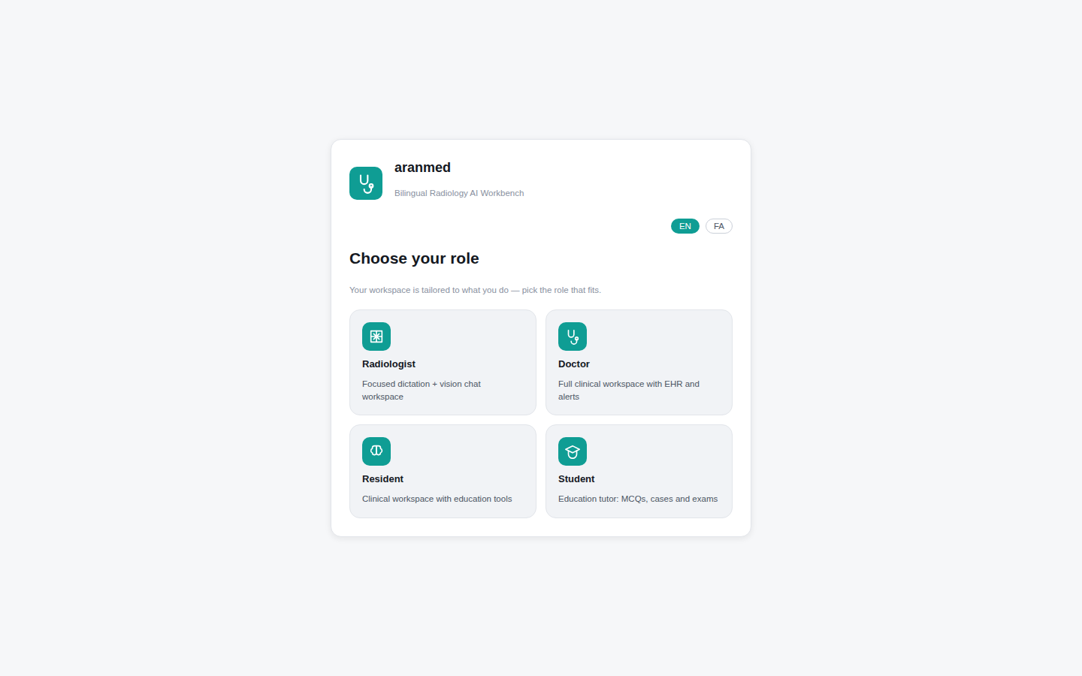
Figure 1: Role picker
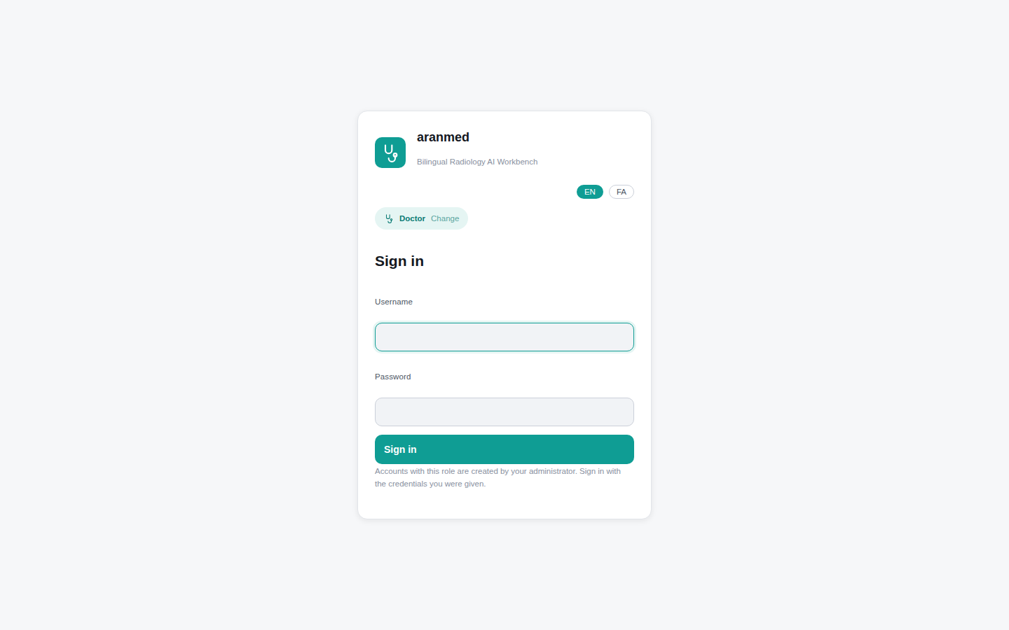
Figure 2: Sign-in; clinical accounts come from the administrator
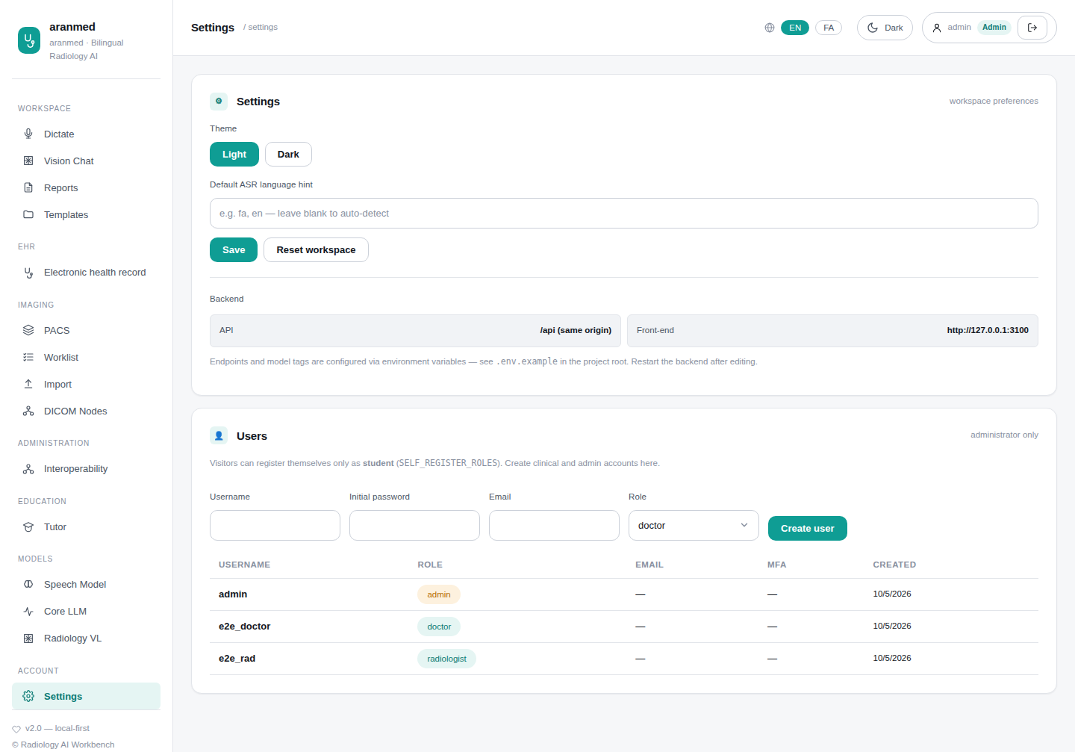
Figure 3: Settings → Users (administrator)

Tests
What it verifies | Test | Result
Self-registration creates a student account; sign-in returns a working session | test_auth_db_api.py  test_register_and_login | ✔ SQLite: passed · 0.24 s  ✔ PostgreSQL: passed · 0.38 s
Anonymous sign-up as admin/doctor/radiologist/resident is refused (403) and audited | test_auth_db_api.py  test_self_register_cannot_claim_privileged_roles | ✔ SQLite: passed · 0.11 s  ✔ PostgreSQL: passed · 0.33 s
Only an administrator creates clinical and admin accounts; user list is admin-only | test_auth_db_api.py  test_admin_creates_privileged_accounts | ✔ SQLite: passed · 0.26 s  ✔ PostgreSQL: passed · 0.53 s
SELF_REGISTER_ROLES controls who may sign up; empty disables sign-up | test_auth_db_api.py  test_self_register_roles_configurable | ✔ SQLite: passed · 0.09 s  ✔ PostgreSQL: passed · 0.21 s
Wrong password is rejected | test_auth_db_api.py  test_login_rejects_bad_password | ✔ SQLite: passed · 0.13 s  ✔ PostgreSQL: passed · 0.27 s
Password policy enforced at registration | test_auth_db_api.py  test_short_password_rejected | ✔ SQLite: passed · 0.02 s  ✔ PostgreSQL: passed · 0.22 s
Protected endpoints require a session | test_auth_db_api.py  test_protected_endpoint_without_token | ✔ SQLite: passed · 0.03 s  ✔ PostgreSQL: passed · 0.22 s
Browser: sign-in through the role picker opens the doctor's workspace | pacs.spec.js  UI sign-in lands a doctor in the app with Imaging in the nav | ✔ Playwright: passed · 2.39 s

5. Reporting workspace
Dictation (Persian, English or both) is transcribed and drafted into a structured report in the institutional template; mismatches between what was dictated and the chosen template are flagged, and critical findings raise alerts. Vision chat answers knowledge questions and describes images. Saved reports and the 56 institutional templates are a click away.

Screens
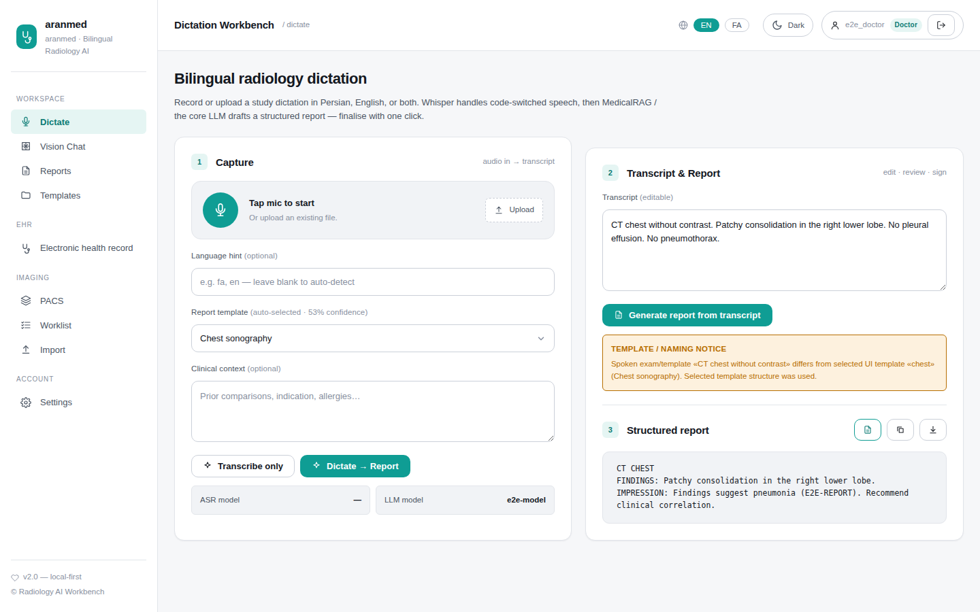
Figure 4: Dictation workbench with a structured report
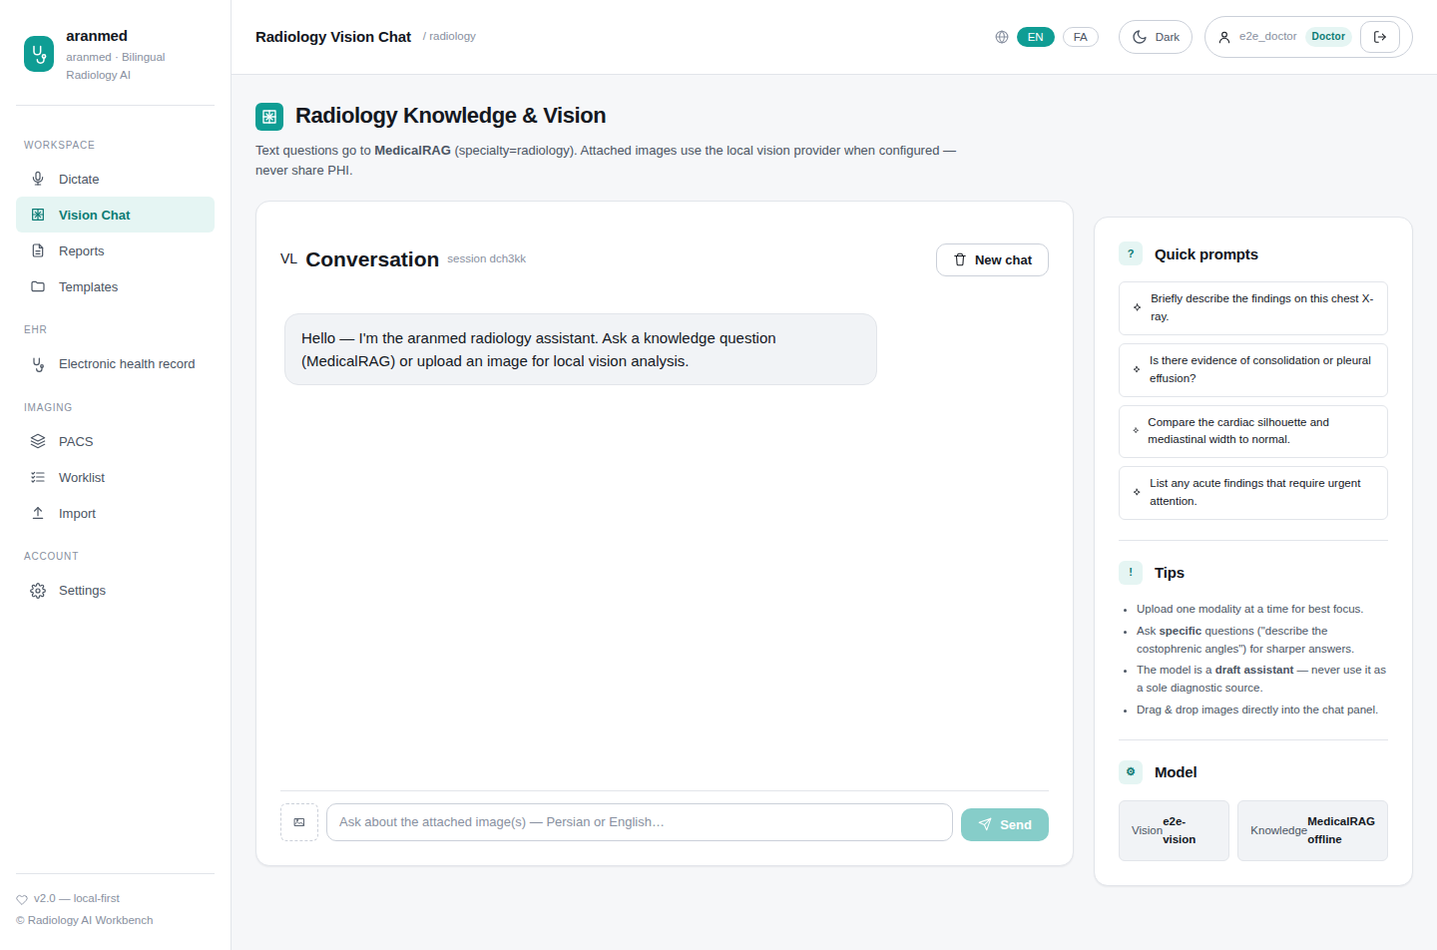
Figure 5: Radiology vision chat
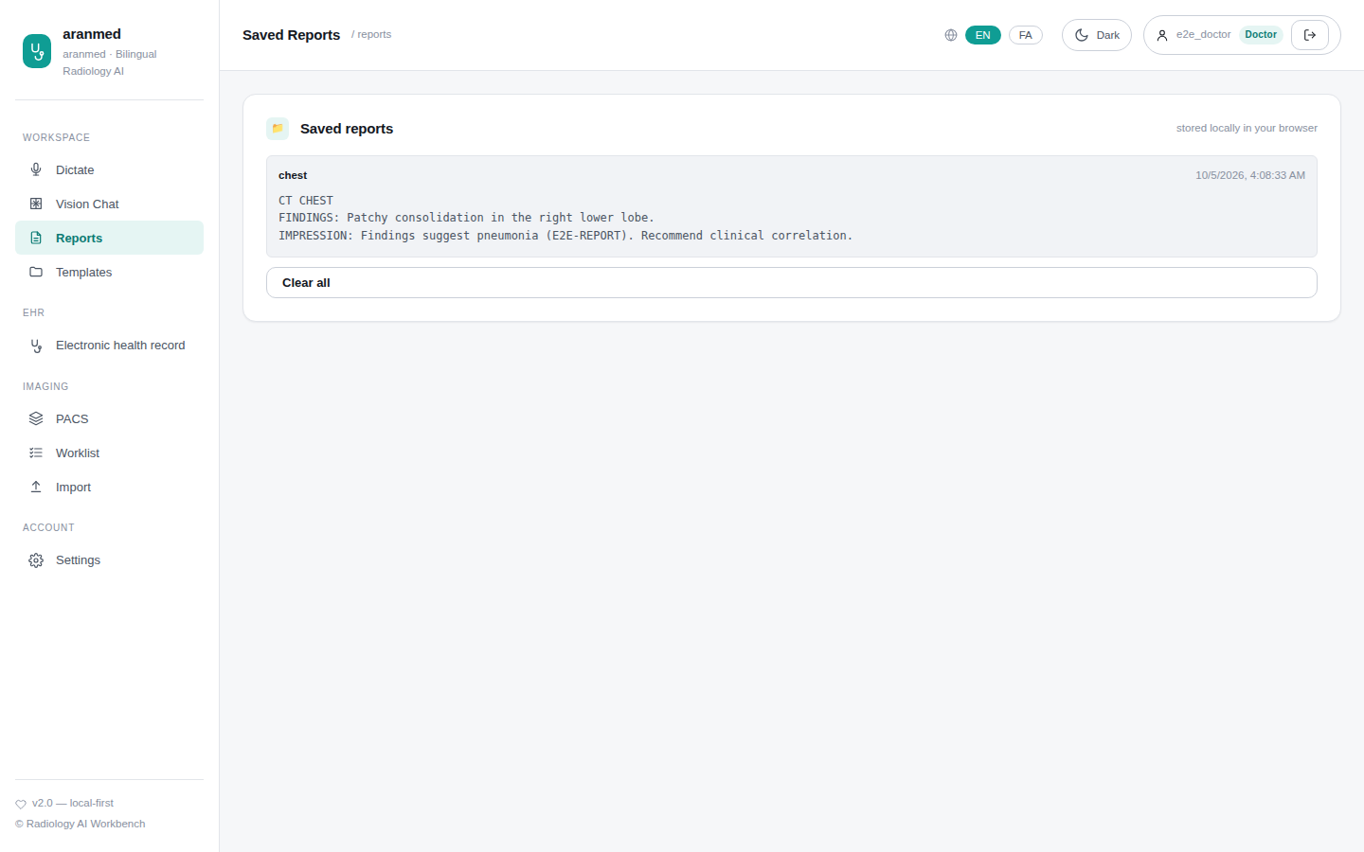
Figure 6: Saved reports
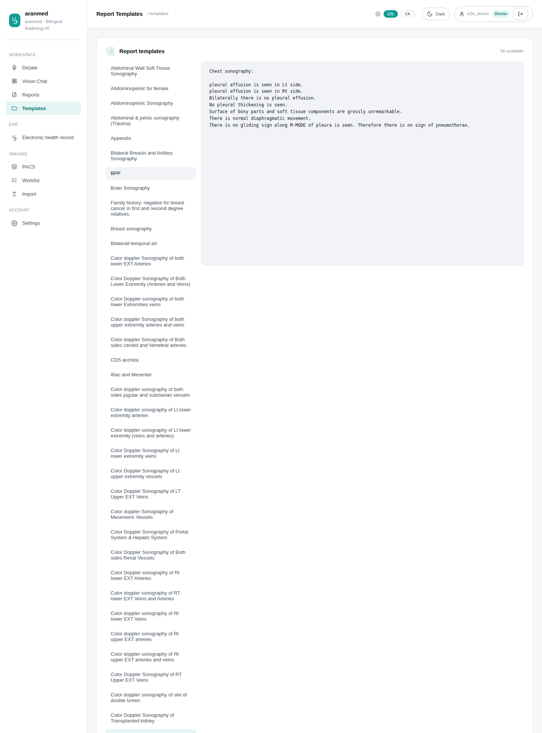
Figure 7: Report templates

Tests
What it verifies | Test | Result
Health endpoint reports all services | test_api.py  test_health | ✔ SQLite: passed · 0.33 s  ✔ PostgreSQL: passed · 1.57 s
Model registry is served to the UI | test_api.py  test_models | ✔ SQLite: passed · 0.25 s  ✔ PostgreSQL: passed · 0.65 s
Speech is transcribed | test_api.py  test_transcribe_endpoint | ✔ SQLite: passed · 0.60 s  ✔ PostgreSQL: passed · 0.42 s
Dictation produces transcript and structured report | test_api.py  test_dictate_endpoint | ✔ SQLite: passed · 0.32 s  ✔ PostgreSQL: passed · 0.65 s
Transcript becomes a structured report in the template | test_api.py  test_report_endpoint | ✔ SQLite: passed · 0.30 s  ✔ PostgreSQL: passed · 0.43 s
Institutional templates are listed | test_api.py  test_templates | ✔ SQLite: passed · 0.27 s  ✔ PostgreSQL: passed · 0.43 s
Vision chat answers with audio and image attachments | test_api.py  test_chat_endpoint_with_audio_and_image | ✔ SQLite: passed · 0.32 s  ✔ PostgreSQL: passed · 0.38 s
Chat sessions can be reset | test_api.py  test_chat_session_reset | ✔ SQLite: passed · 0.30 s  ✔ PostgreSQL: passed · 0.39 s
Critical finding (tension pneumothorax) raises an alert | test_clinical_safety.py  test_triage_critical_tension_ptx | ✔ SQLite: passed · 0.03 s  ✔ PostgreSQL: passed · 0.16 s
No false alarm for non-critical reports | test_clinical_safety.py  test_triage_non_critical_no_false_alarm | ✔ SQLite: passed · 0.02 s  ✔ PostgreSQL: passed · 0.19 s
Spoken exam vs selected template mismatch is flagged | test_clinical_safety.py  test_template_mismatch_spoken_vs_selected | ✔ SQLite: passed · 0.05 s  ✔ PostgreSQL: passed · 0.21 s
Institutional naming rules applied | test_clinical_safety.py  test_naming_rule_forbidden_neck_ct | ✔ SQLite: passed · 0.04 s  ✔ PostgreSQL: passed · 0.21 s
Report API returns critical alerts and template notice | test_clinical_safety.py  test_api_report_critical_and_mismatch | ✔ SQLite: passed · 0.10 s  ✔ PostgreSQL: passed · 0.22 s
Report API without alerts for normal reports | test_clinical_safety.py  test_api_report_non_critical | ✔ SQLite: passed · 0.09 s  ✔ PostgreSQL: passed · 0.22 s
Report payload enriched with safety findings | test_clinical_safety.py  test_enrich_report_payload_critical_and_mismatch | ✔ SQLite: passed · 0.03 s  ✔ PostgreSQL: passed · 0.16 s
Agent transcribes then structures the report | test_agent.py  test_agent_calls_transcribe_then_structure | ✔ SQLite: passed · 0.09 s  ✔ PostgreSQL: passed · 0.29 s
Agent uses the vision model for images | test_agent.py  test_agent_calls_vision | ✔ SQLite: passed · 0.04 s  ✔ PostgreSQL: passed · 0.21 s
Agent remembers the session | test_agent.py  test_agent_session_memory_persists | ✔ SQLite: passed · 0.03 s  ✔ PostgreSQL: passed · 0.18 s
Report tool uses the current dictation | test_tools.py  test_structure_report_uses_state | ✔ SQLite: passed · 0.09 s  ✔ PostgreSQL: passed · 0.22 s
Template tool lists templates | test_tools.py  test_list_templates | ✔ SQLite: passed · 0.02 s  ✔ PostgreSQL: passed · 0.17 s

6. The EHR section
Everything about a patient lives in one place: the EHR entry in the sidebar opens the EHR section, with a tab for each area: Patients (search across this hospital and the network, register), Transfers, EMS inbound, Medication alerts and Text intake (free text turned into a structured record). The chart opens inside the same section. Tabs follow the user's role, and old links redirect here.

Screens
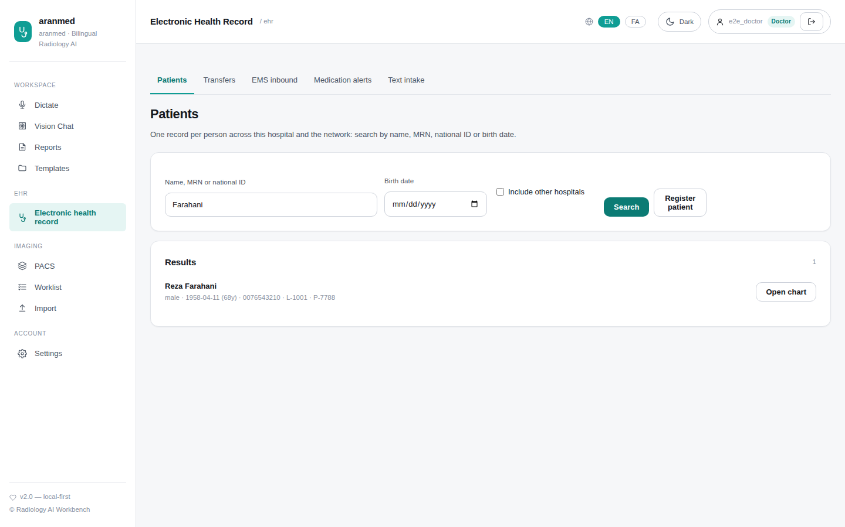
Figure 8: EHR → Patients
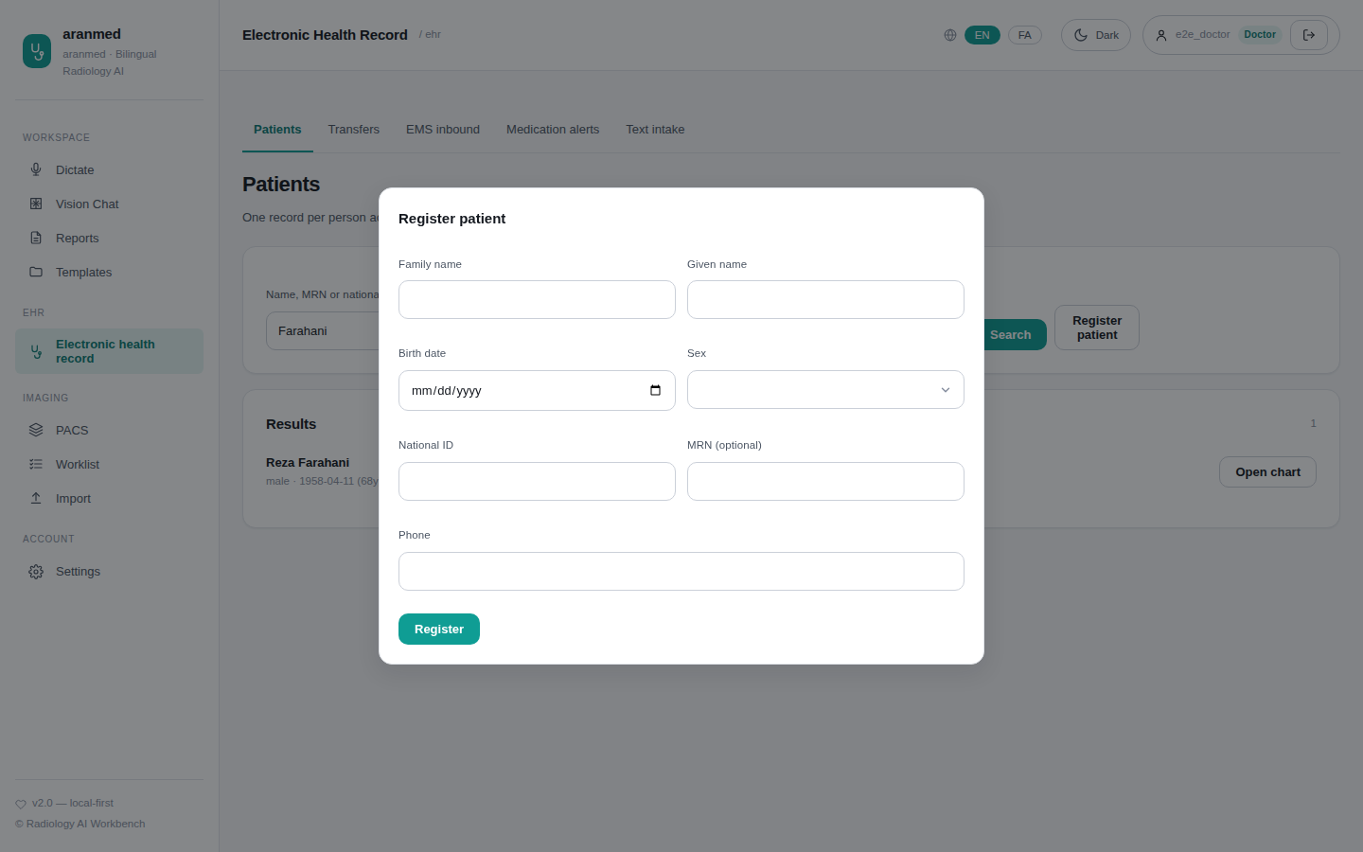
Figure 9: Register a patient
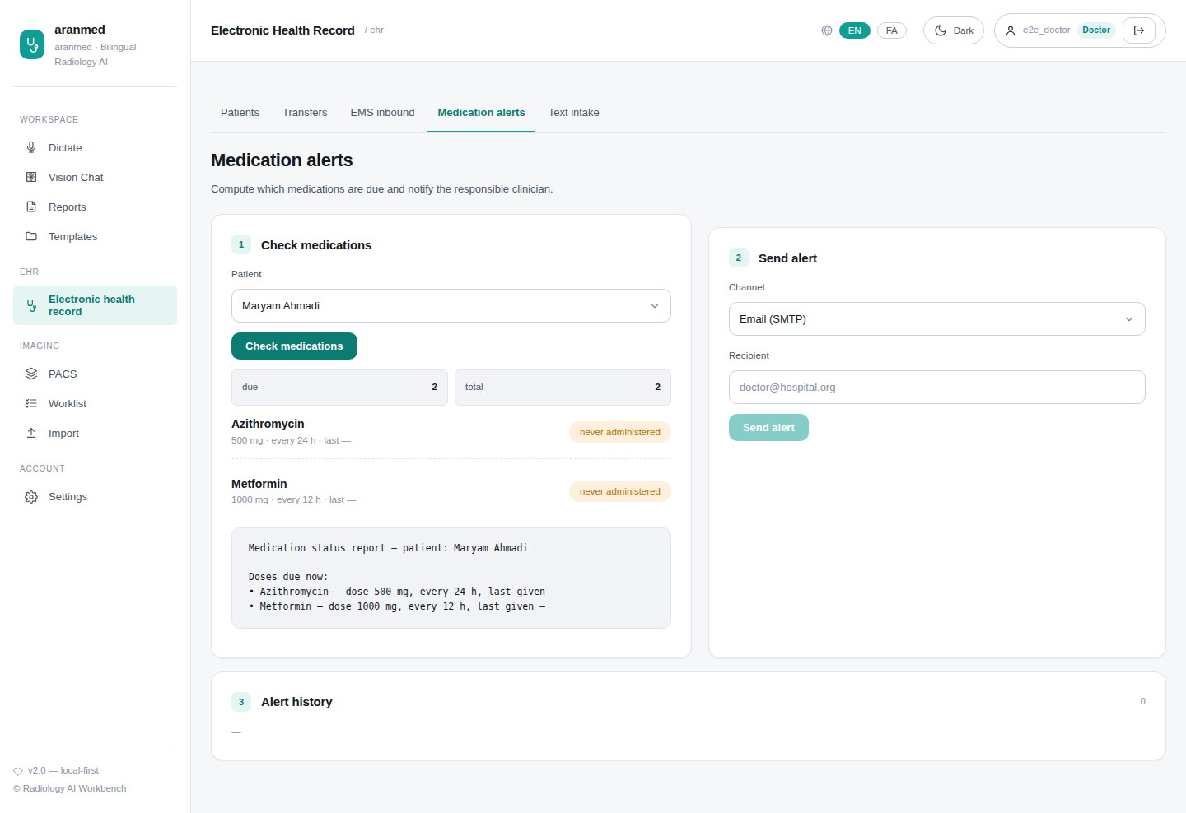
Figure 10: EHR → Medication alerts
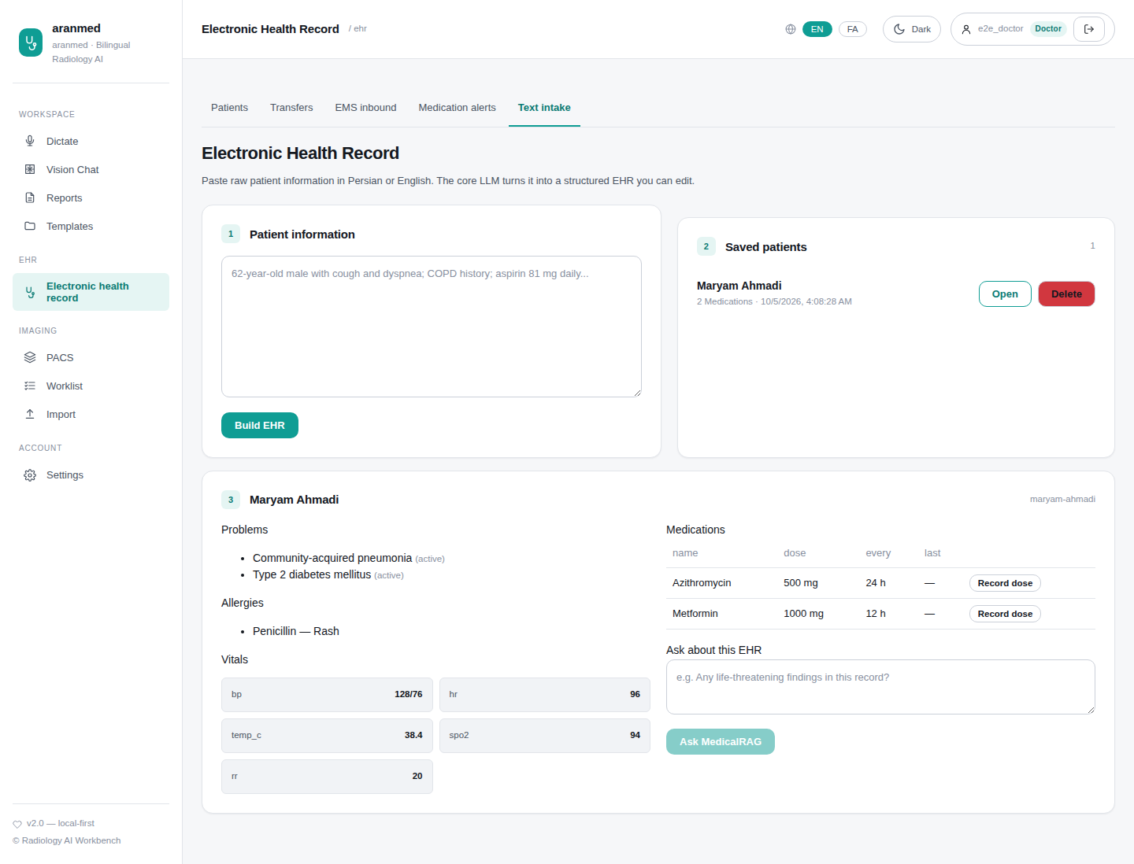
Figure 11: EHR → Text intake

Tests
What it verifies | Test | Result
Browser: one EHR entry opens every patient screen as a tab | ehr_hub.spec.js  one EHR entry in the sidebar opens the hub; each tab shows its screen | ✔ Playwright: passed · 1.54 s
Browser: old bookmarks redirect into the EHR section | ehr_hub.spec.js  old patient URLs redirect into the EHR section | ✔ Playwright: passed · 0.78 s
Browser: tabs follow the user's role | ehr_hub.spec.js  tabs follow the role: a radiologist sees patients and transfers only | ✔ Playwright: passed · 0.40 s
Browser: Persian EHR section is right-to-left and translated | ehr_hub.spec.js  Persian: EHR hub is right-to-left with translated title and tabs | ✔ Playwright: passed · 0.49 s
Browser: register a new patient | clinical.spec.js  register a new patient | ✔ Playwright: passed · 0.60 s
Free-text intake builds, lists, opens and deletes a record | test_auth_db_api.py  test_ehr_build_get_list_delete | ✔ SQLite: passed · 0.20 s  ✔ PostgreSQL: passed · 0.56 s
Invalid model output is rejected, never stored | test_auth_db_api.py  test_ehr_build_rejects_garbage_llm_output | ✔ SQLite: passed · 0.15 s  ✔ PostgreSQL: passed · 0.29 s
Intake records are private to their author | test_auth_db_api.py  test_ehr_scoped_per_user | ✔ SQLite: passed · 0.31 s  ✔ PostgreSQL: passed · 0.82 s
Medication alerts computed and sent | test_auth_db_api.py  test_alerts_check_and_send_dry_run | ✔ SQLite: passed · 0.20 s  ✔ PostgreSQL: passed · 0.58 s
Recording a dose resets its due state | test_auth_db_api.py  test_record_dose_resets_due_state | ✔ SQLite: passed · 0.27 s  ✔ PostgreSQL: passed · 0.75 s
Agent and API share one patient store | test_fabric_ehr_unification.py  test_agent_tool_and_rest_path_share_one_store | ✔ SQLite: passed · 0.11 s  ✔ PostgreSQL: passed · 0.32 s
Free-text intake flows into the relational chart and the MPI | test_ehr_clinical.py  test_legacy_ehr_record_flows_into_relational_chart | ✔ SQLite: passed · 0.56 s  ✔ PostgreSQL: passed · 1.45 s

7. The unified patient chart
The chart shows one person across this hospital and the network: summary, encounters, results with trends, medications with dose history, documents (encrypted at rest), imaging, orders, a timeline and consent. Ticking “Records from other hospitals” fetches the patient's records live from peer hospitals; every item carries a source badge. Restricted records require a stated reason and time-limited emergency access.

Screens
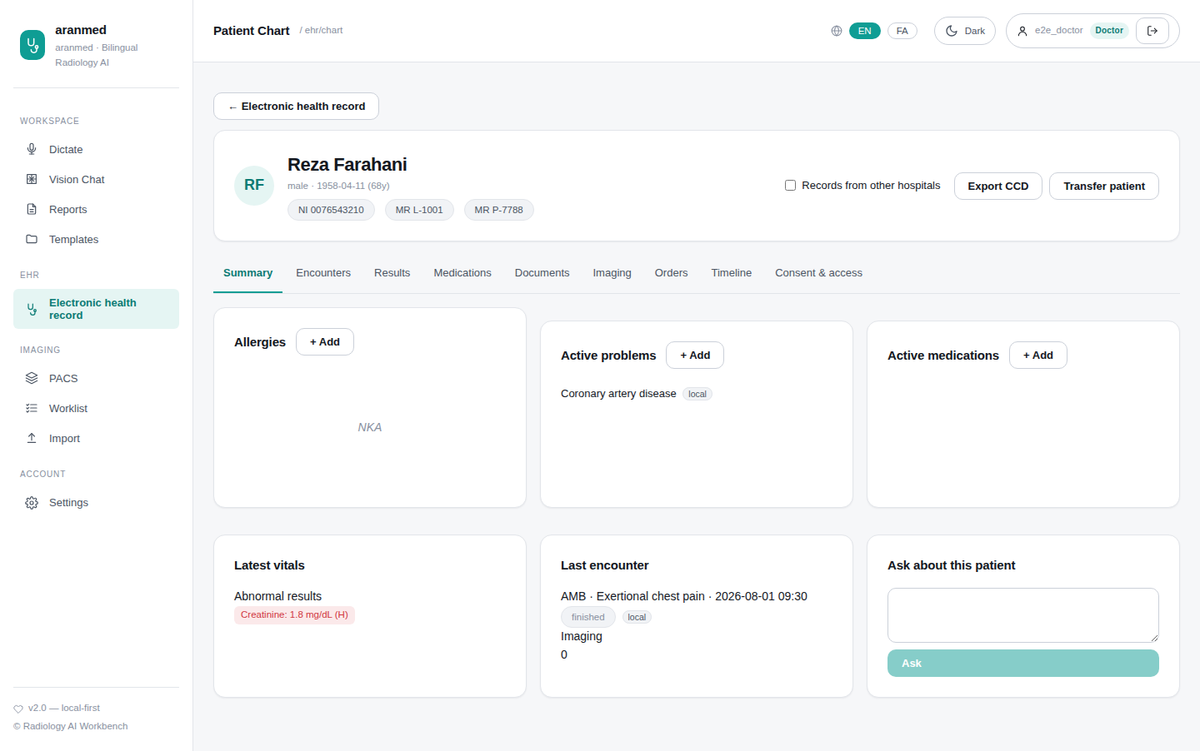
Figure 12: Chart summary
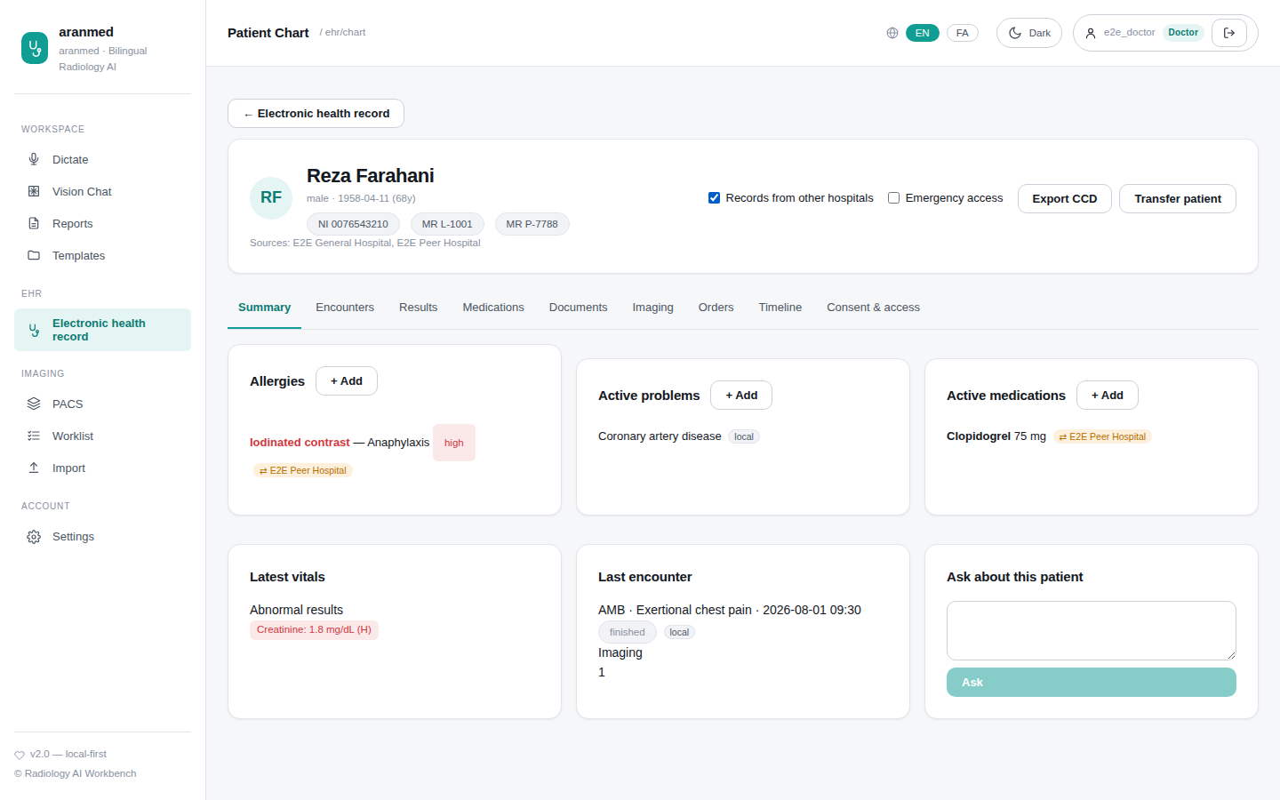
Figure 13: With another hospital's records (orange source badges)
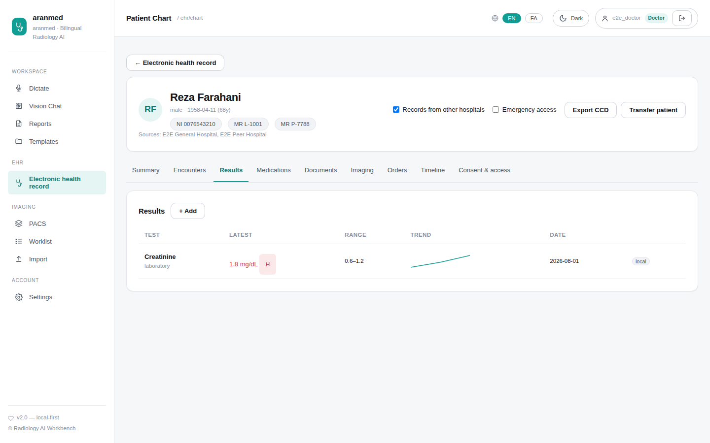
Figure 14: Results with trend
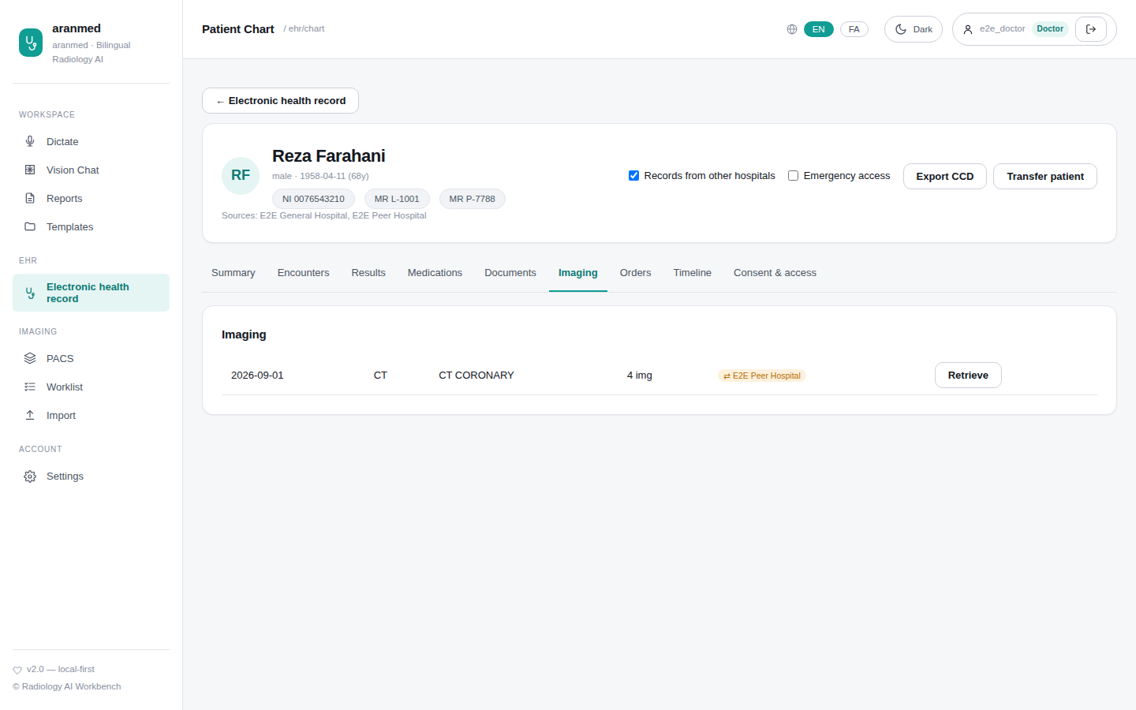
Figure 15: Imaging, including another hospital's
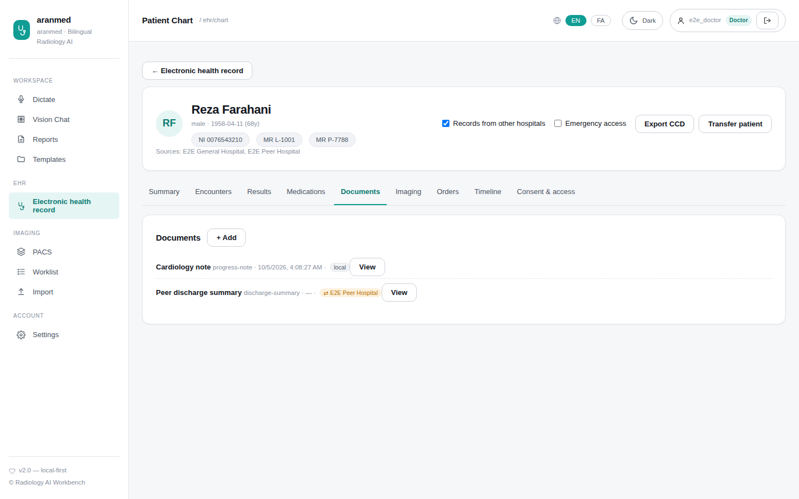
Figure 16: Documents
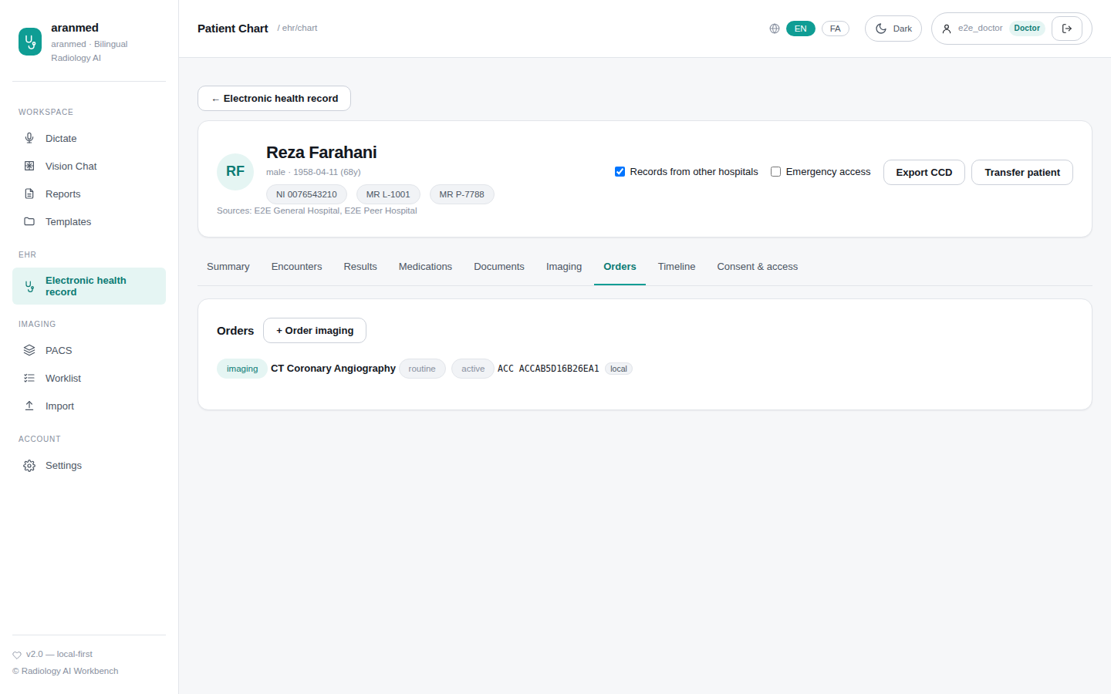
Figure 17: Orders
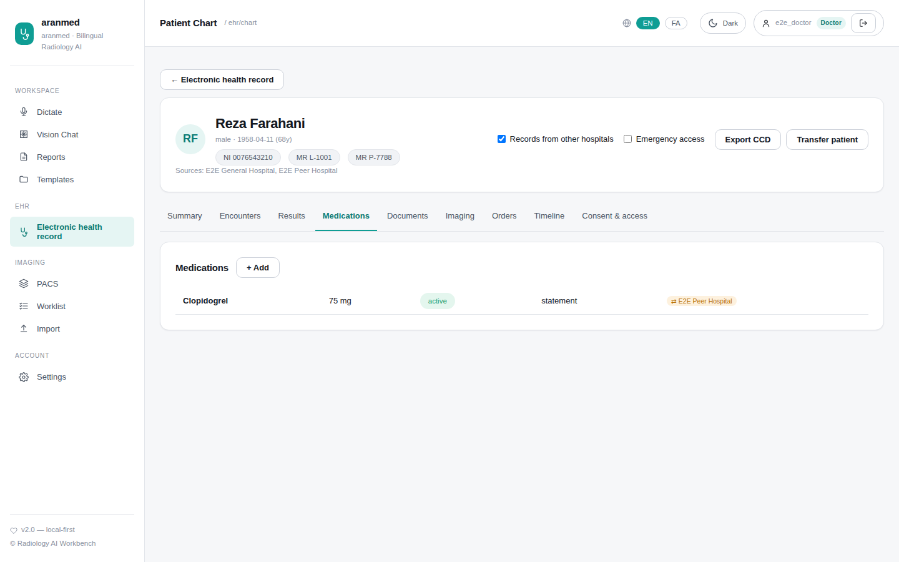
Figure 18: Medications
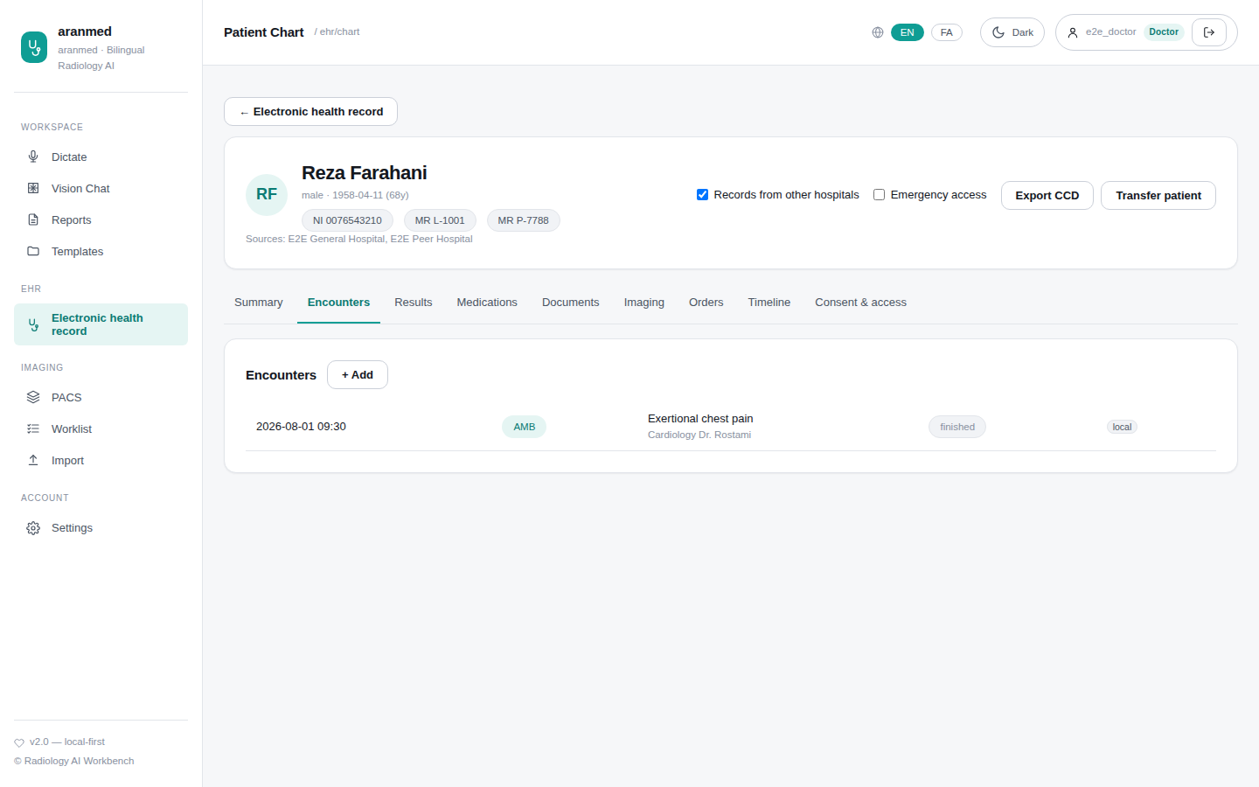
Figure 19: Encounters
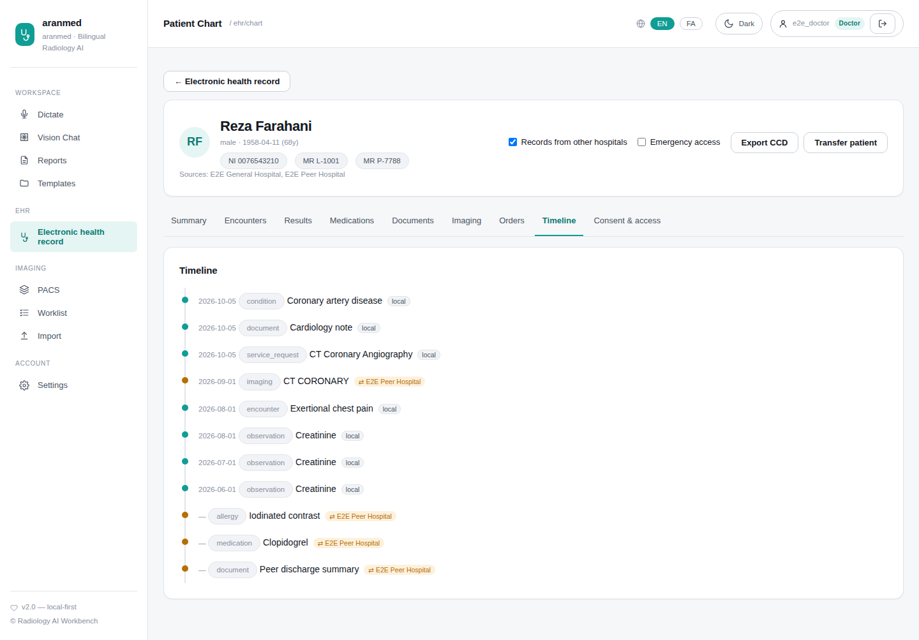
Figure 20: Timeline
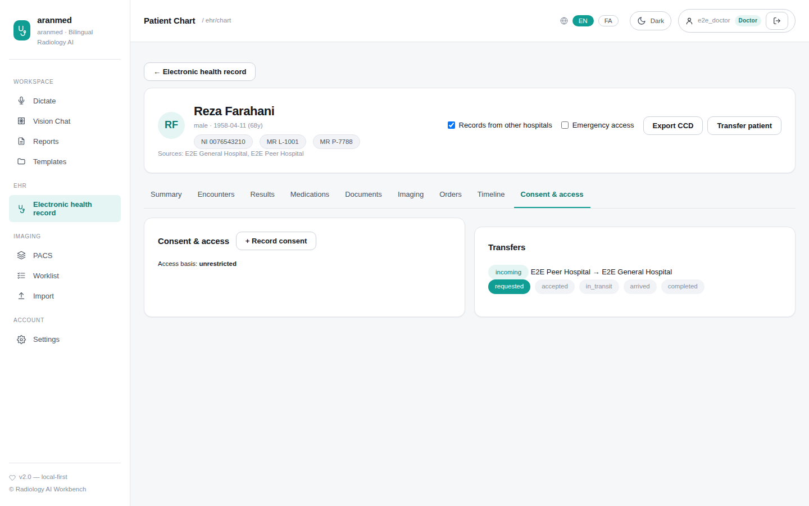
Figure 21: Consent & access
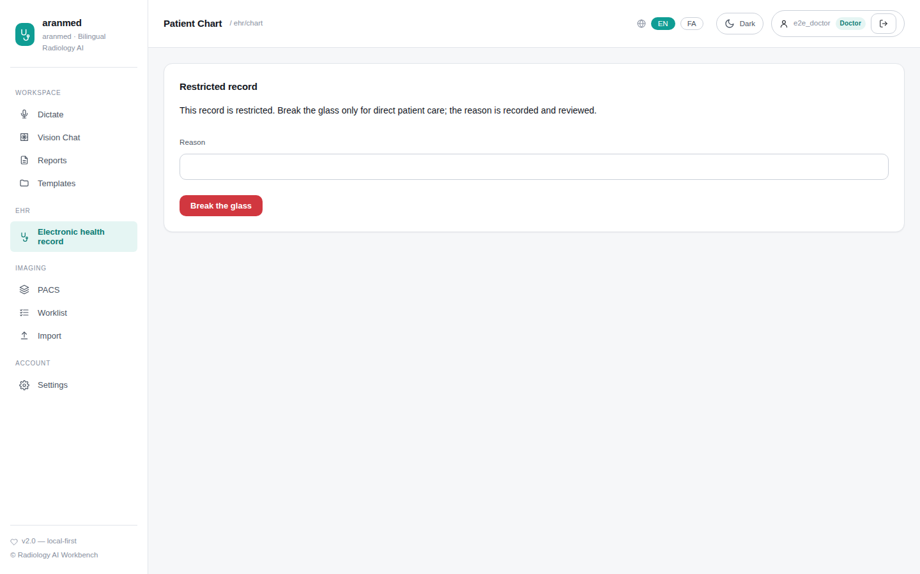
Figure 22: Restricted record (break the glass)

Tests
What it verifies | Test | Result
Chart lifecycle: all record types, versions, orders → worklist → report | test_ehr_clinical.py  test_chart_lifecycle_with_imaging_orders_and_reports | ✔ SQLite: passed · 0.64 s  ✔ PostgreSQL: passed · 1.64 s
Restricted record needs a reason and time-limited emergency access | test_ehr_clinical.py  test_restricted_record_needs_break_glass | ✔ SQLite: passed · 0.46 s  ✔ PostgreSQL: passed · 0.95 s
Patient merge keeps encrypted documents readable | test_ehr_clinical.py  test_merge_keeps_encrypted_documents_readable | ✔ SQLite: passed · 0.40 s  ✔ PostgreSQL: passed · 0.75 s
Ask about this patient uses the whole chart | test_ehr_clinical.py  test_chart_ask_uses_agent_with_chart_context | ✔ SQLite: passed · 0.35 s  ✔ PostgreSQL: passed · 0.68 s
Agent answers from the chart and the EMS board | test_clinical_agent.py  test_agent_answers_from_chart_and_ems_board | ✔ SQLite: passed · 0.49 s  ✔ PostgreSQL: passed · 1.02 s
Agent tools obey permissions and restricted records | test_clinical_agent.py  test_clinical_tools_respect_permissions_and_restrictions | ✔ SQLite: passed · 0.68 s  ✔ PostgreSQL: passed · 1.21 s
Browser: find a patient and open the chart | clinical.spec.js  find a patient and open the unified chart | ✔ Playwright: passed · 0.76 s
Browser: results trend, documents, add data, CCD export | clinical.spec.js  results trend, documents, adding data and CCD export | ✔ Playwright: passed · 1.00 s
Browser: imaging order from the chart reaches the worklist | clinical.spec.js  imaging order from the chart lands on the worklist | ✔ Playwright: passed · 0.76 s
Browser: restricted record requires break-the-glass | clinical.spec.js  restricted record requires break-the-glass | ✔ Playwright: passed · 0.62 s
Browser: Persian chart is right-to-left | clinical.spec.js  Persian chart renders RTL | ✔ Playwright: passed · 0.49 s

8. Between hospitals: shared records and transfers
Every AranMed hospital runs the same database schema and exchanges data over FHIR R4, DICOMweb/DICOM and HL7 v2, signed with short-lived peer tokens. A visiting patient's records and images at another hospital are seen live with their source. A transfer sends the whole record — every type and field, including medication dose, route, frequency, interval and the dose-change history — plus the images byte-for-byte; the receiving hospital keeps the original author of each record, and re-sending never duplicates. Patient consent governs both records and images; emergency access is audited at both hospitals.
These guarantees are proven by four real hospital processes talking to each other, on SQLite, on Postgres and on a mixed network (one hospital on each).

Screens
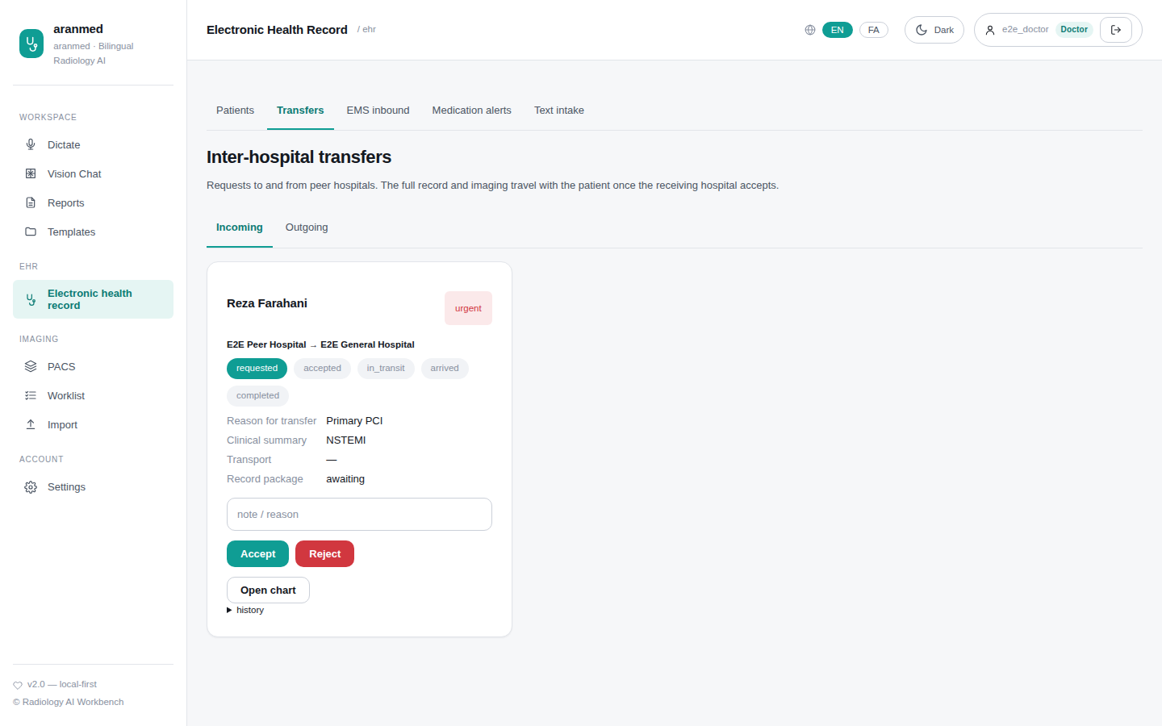
Figure 23: EHR → Transfers: incoming transfer

Tests
What it verifies | Test | Result
Full record to a new hospital: every type and field incl. dose & dose history; encounter links; decrypted documents; byte-identical images; author kept; timeline | test_interhospital_records.py  test_full_record_transfer_to_new_hospital | ✔ SQLite: passed · 14.4 s  ✔ PostgreSQL: passed · 14.4 s  ✔ Mixed: passed · 16.8 s
Known patient merges onto their record; re-sending adds nothing; failed transactions never delete existing rows | test_interhospital_records.py  test_existing_patient_merges_and_resend_is_idempotent | ✔ SQLite: passed · 3.28 s  ✔ PostgreSQL: passed · 3.42 s  ✔ Mixed: passed · 4.66 s
Reject, cancel, offline receiver, retry after 5xx, imaging-only failure, invalid steps | test_interhospital_records.py  test_transfer_failure_paths | ✔ SQLite: passed · 9.04 s  ✔ PostgreSQL: passed · 9.12 s  ✔ Mixed: passed · 10.3 s
A → B → C chain keeps each hospital's authorship and the dose history | test_interhospital_records.py  test_chain_a_to_b_to_c_keeps_authorship | ✔ SQLite: passed · 2.89 s  ✔ PostgreSQL: passed · 2.90 s  ✔ Mixed: passed · 4.14 s
Visiting patient: live view of every type, document content on demand, timeline and images; no duplicates after transfer | test_interhospital_records.py  test_visiting_patient_sees_every_type_live_then_no_duplicates_after_transfer | ✔ SQLite: passed · 3.25 s  ✔ PostgreSQL: passed · 3.63 s  ✔ Mixed: passed · 3.68 s
Consent covers record and images: wildcard refusal, opt-in, ETREAT audited at both ends | test_interhospital_records.py  test_consent_governs_record_and_images_across_hospitals | ✔ SQLite: passed · 3.94 s  ✔ PostgreSQL: passed · 3.88 s  ✔ Mixed: passed · 4.71 s
MPI merge after a transfer moves the record and images | test_interhospital_records.py  test_mpi_merge_after_transfer_moves_record_and_images | ✔ SQLite: passed · 0.80 s  ✔ PostgreSQL: passed · 0.84 s  ✔ Mixed: passed · 1.31 s
Agent reads remote records and requests a transfer | test_interhospital_records.py  test_agent_tools_read_and_act_across_hospitals | ✔ SQLite: passed · 2.18 s  ✔ PostgreSQL: passed · 3.46 s  ✔ Mixed: passed · 3.14 s
Patient journey: EMS, live records from another hospital, consent, transfer end to end | test_interhospital.py  test_patient_journey_across_hospitals | ✔ SQLite: passed · 8.03 s  ✔ PostgreSQL: passed · 7.88 s  ✔ Mixed: passed · 13.2 s
Peer connection test: reachable, compatible schema, token accepted | test_interhospital.py  test_peer_test_endpoint_reports_compatibility | ✔ SQLite: passed · 0.91 s  ✔ PostgreSQL: passed · 1.22 s  ✔ Mixed: passed · 1.04 s
Every resource type survives FHIR exchange field-for-field (12 cases) | test_fhir_map_roundtrip.py  test_row_fhir_row_is_lossless | ✔ SQLite: passed 12/12 · 0.35 s  ✔ PostgreSQL: passed 12/12 · 2.50 s
Dose travels structured, with its history; older peers still understood | test_fhir_map_roundtrip.py  test_medication_dose_history_and_legacy_peer_text | ✔ SQLite: passed · 0.02 s  ✔ PostgreSQL: passed · 0.20 s
Patient demographics round-trip completely | test_fhir_map_roundtrip.py  test_patient_round_trip_keeps_aliases_language_deceased | ✔ SQLite: passed · 0.04 s  ✔ PostgreSQL: passed · 0.15 s
Everything emitted is valid FHIR R4B | test_fhir_map_roundtrip.py  test_every_emitted_resource_is_valid_fhir_r4b | ✔ SQLite: passed · 0.53 s  ✔ PostgreSQL: passed · 0.79 s
Browser: other hospital's records shown with source; images retrieved on demand | clinical.spec.js  records from the peer hospital appear with their source; imaging is retrieved on demand | ✔ Playwright: passed · 2.27 s
Browser: accept an incoming transfer through completion | clinical.spec.js  incoming transfer: accept, package arrives, arrive and complete | ✔ Playwright: passed · 11.7 s

9. EMS inbound
Ambulances post NEMSIS v3.5 or FHIR pre-arrival reports. Each creates the patient identity, an emergency encounter, vitals, treatments, the ePCR document, a board card with abnormal vitals flagged and a MIST handover, and alerts to the emergency department.

Screens
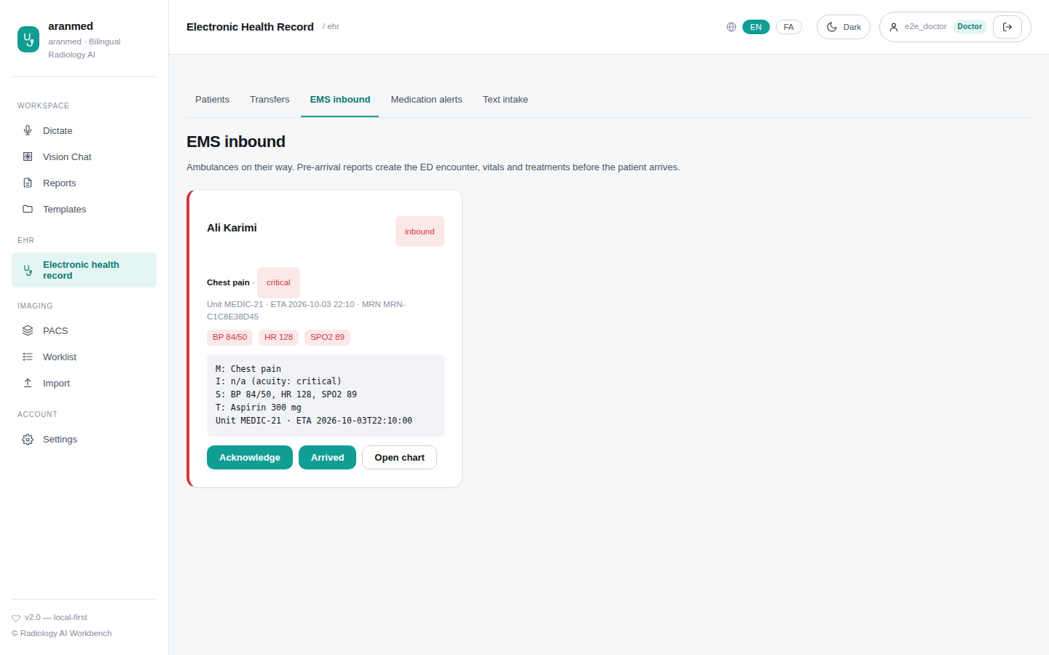
Figure 24: EHR → EMS inbound

Tests
What it verifies | Test | Result
NEMSIS report builds identity, encounter, vitals, board card and handover | test_cda_ems.py  test_ems_prearrival_board_and_handover | ✔ SQLite: passed · 0.66 s  ✔ PostgreSQL: passed · 1.93 s
EMS agency authenticates with a signed token | test_cda_ems.py  test_ems_agency_with_peer_token | ✔ SQLite: passed · 0.36 s  ✔ PostgreSQL: passed · 0.73 s
Browser: inbound critical patient through handover | clinical.spec.js  EMS board: inbound critical patient through handover | ✔ Playwright: passed · 0.78 s

10. PACS: archive, viewer and reporting
The imaging archive searches this hospital or the whole network. The viewer (Cornerstone3D) offers window/level presets, pan, zoom, cine, layouts and measurements in true modality units (HU for CT). The AI assistant drafts a structured read; the radiologist edits and signs it, and the final report reaches the EHR.

Screens
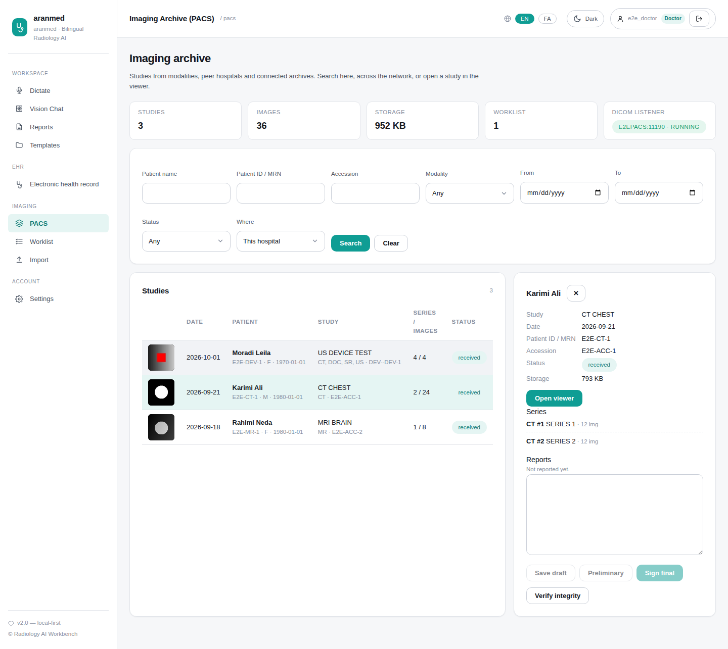
Figure 25: Imaging archive
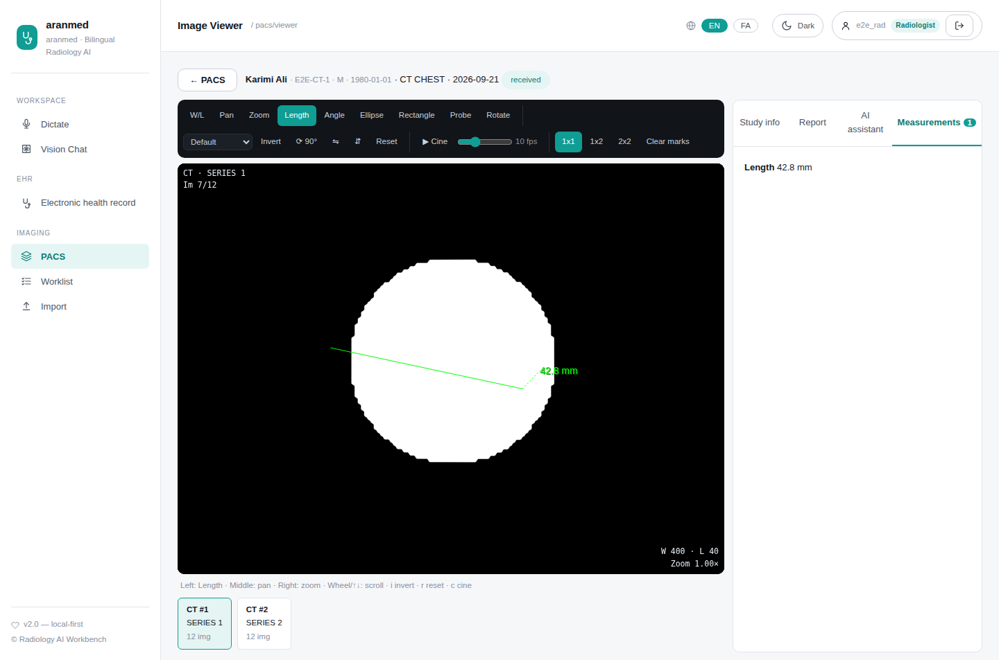
Figure 26: Viewer with a measurement
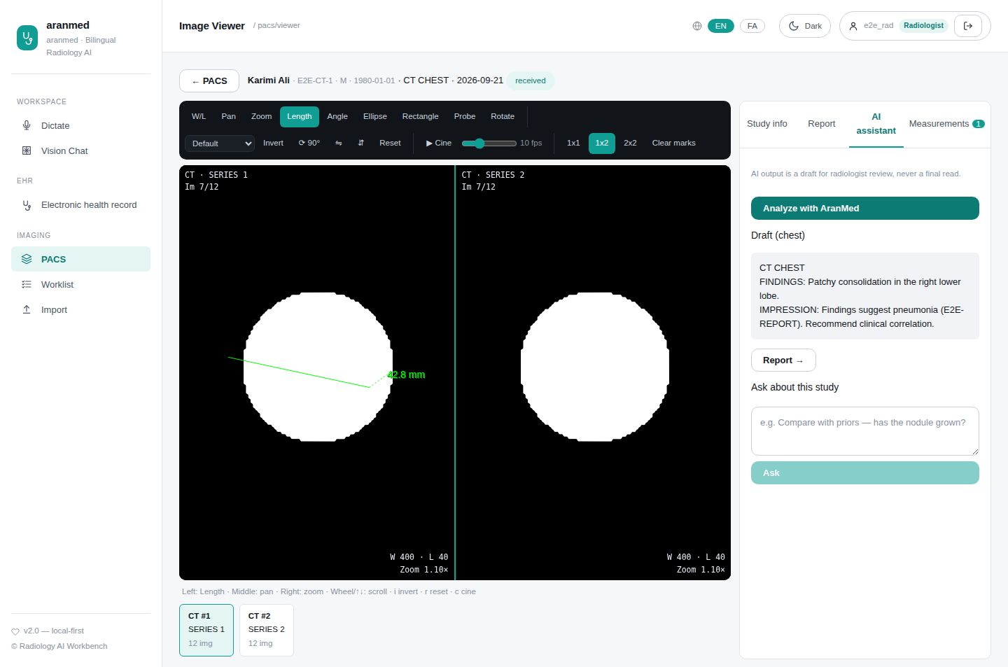
Figure 27: AI draft read
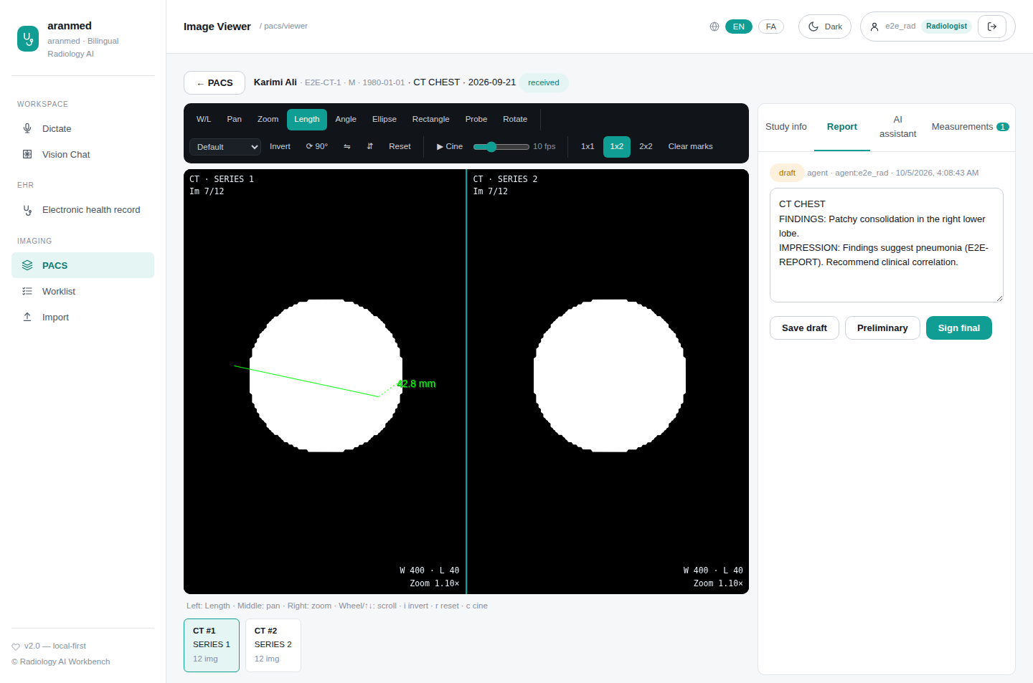
Figure 28: Report sign-off
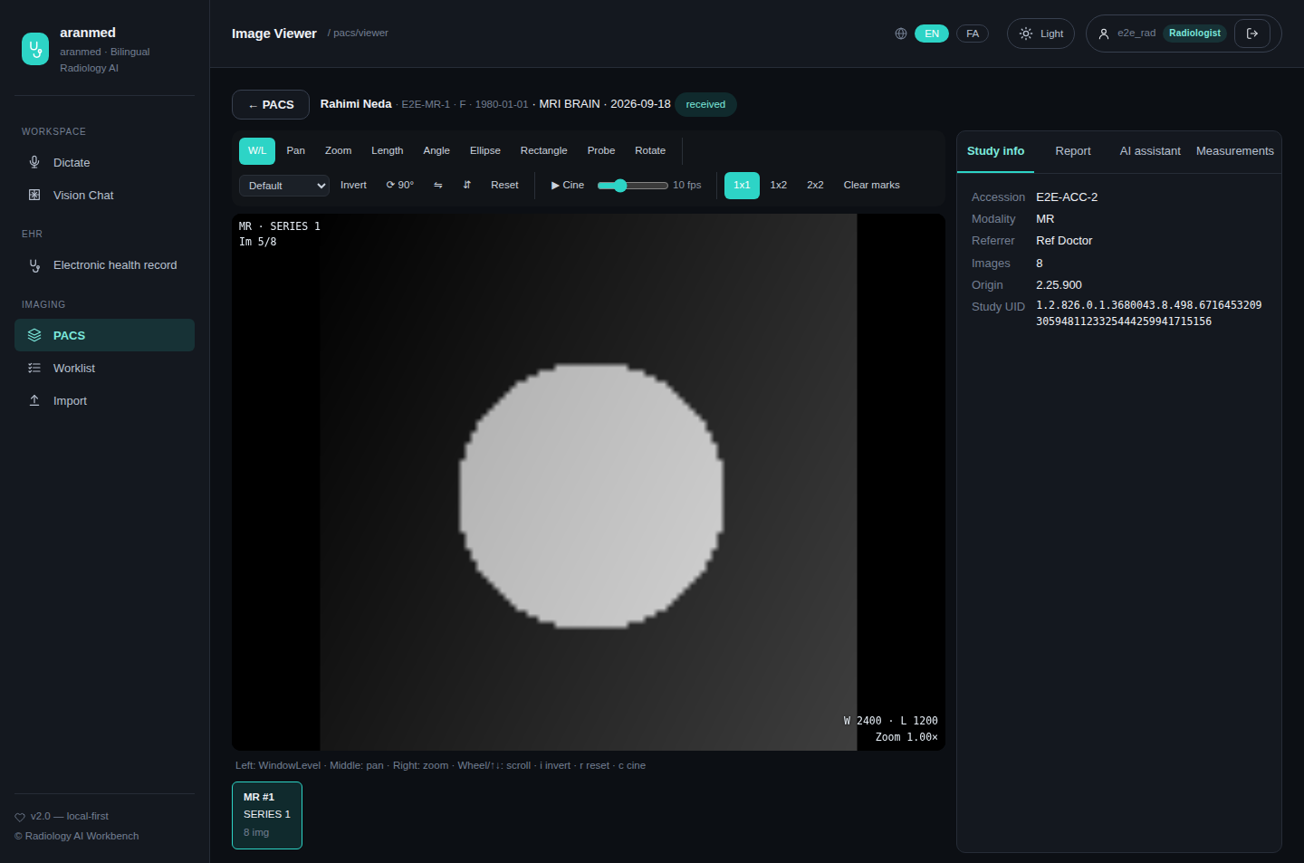
Figure 29: Viewer in dark theme

Tests
What it verifies | Test | Result
STOW, QIDO, WADO metadata/frames/rendered as the viewer uses them | test_pacs_dicomweb_api.py  test_stow_qido_wado_viewer_path | ✔ SQLite: passed · 0.49 s  ✔ PostgreSQL: passed · 1.09 s
Upload, browse, report sign-off, worklist | test_pacs_dicomweb_api.py  test_pacs_api_upload_browse_report_worklist | ✔ SQLite: passed · 0.46 s  ✔ PostgreSQL: passed · 1.15 s
Node administration and validation | test_pacs_dicomweb_api.py  test_node_admin_and_validation | ✔ SQLite: passed · 0.42 s  ✔ PostgreSQL: passed · 0.76 s
AI draft read then sign-off | test_pacs_agent.py  test_analyze_endpoint_and_report_signoff | ✔ SQLite: passed · 0.50 s  ✔ PostgreSQL: passed · 0.81 s
Agent finds and reads a study | test_pacs_agent.py  test_agent_finds_and_reads_study_via_ask | ✔ SQLite: passed · 0.63 s  ✔ PostgreSQL: passed · 0.97 s
Agent compares priors and reads the worklist | test_pacs_agent.py  test_priors_and_worklist_tools | ✔ SQLite: passed · 0.40 s  ✔ PostgreSQL: passed · 0.66 s
Imaging tools enforce permissions | test_pacs_agent.py  test_agent_tools_enforce_auth_and_rbac | ✔ SQLite: passed · 0.42 s  ✔ PostgreSQL: passed · 0.64 s
Browser: study browser, filters, details panel | pacs.spec.js  study browser: stats, filters, details panel | ✔ Playwright: passed · 0.92 s
Browser: viewer shows real pixels; window/level, scroll, measure | pacs.spec.js  viewer renders real pixels; W/L presets, scrolling and measurements work | ✔ Playwright: passed · 1.91 s
Browser: AI draft then radiologist sign-off | pacs.spec.js  AI draft read then radiologist sign-off from the viewer | ✔ Playwright: passed · 1.63 s
Browser: import a DICOM file and open it | pacs.spec.js  import a DICOM file and open it | ✔ Playwright: passed · 1.53 s
Browser: Persian imaging screens are right-to-left | pacs.spec.js  Persian UI switches to RTL with translated imaging nav | ✔ Playwright: passed · 0.58 s

11. PACS: devices and protocols
The PACS accepts every storage SOP class and transfer syntax over DICOM (C-STORE) and DICOMweb (STOW), and shows what real devices send: JPEG baseline/extended/lossless, JPEG-LS, JPEG 2000 and RLE, colour (RGB, YBR, palette), multi-frame and Enhanced objects, 1-bit segmentations and 32-bit dose grids. Structured reports, PDFs and video are listed under the study. Workstations that cannot take a compressed syntax receive a transcoded copy with the same identity. Modality worklist, MPPS, storage commitment, TLS/mTLS, Persian names and legacy character sets, and patient consent over DICOM are all supported.
The table below is produced from the test run: one row per device family and transfer syntax, each sent over DICOM and checked pixel-for-pixel.

Screens
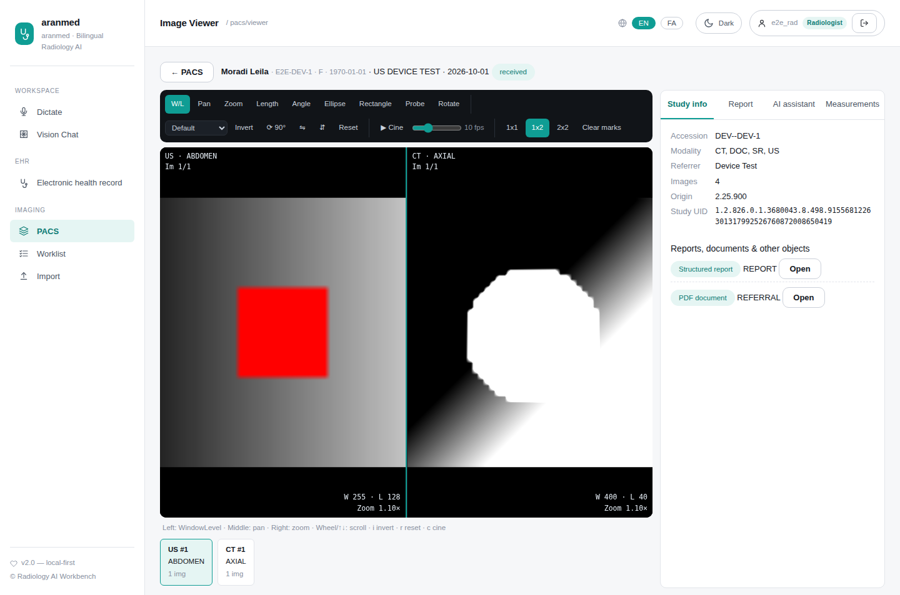
Figure 30: Compressed colour ultrasound beside a JPEG Lossless CT; SR and PDF listed as objects
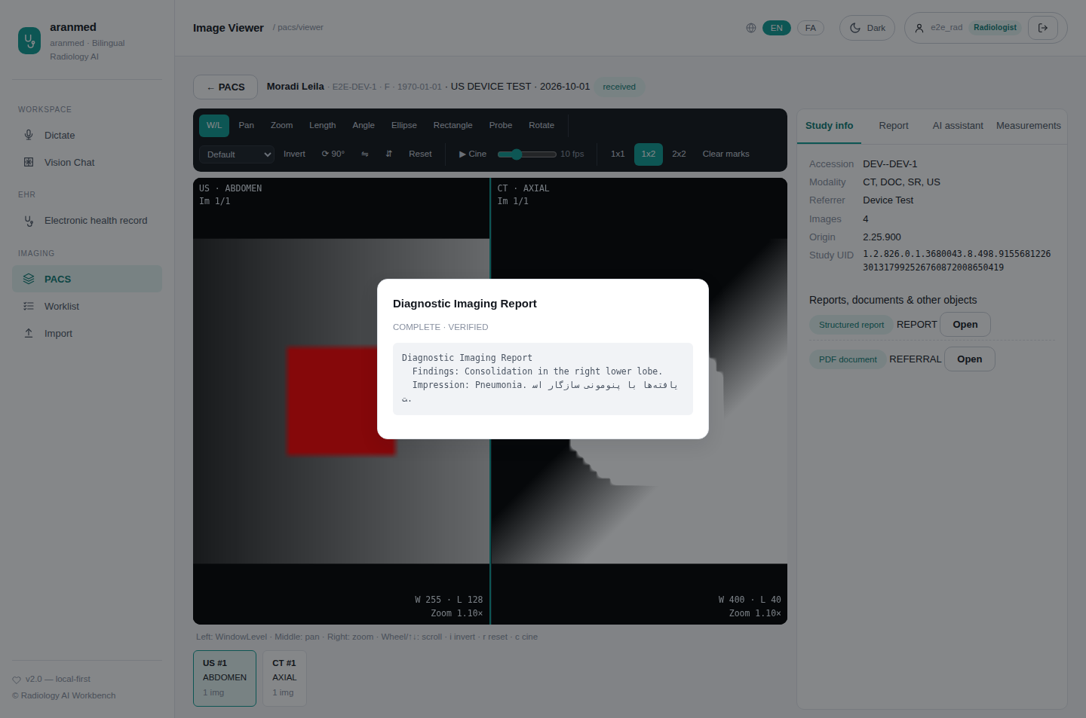
Figure 31: Structured report shown as text
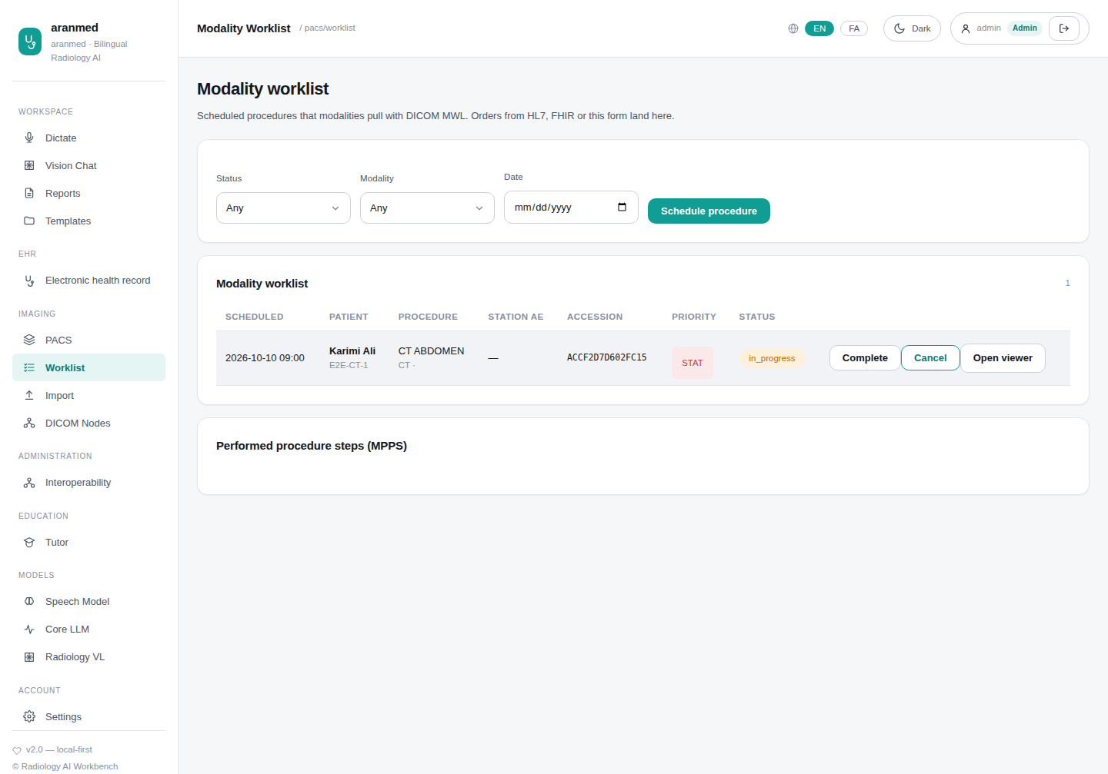
Figure 32: Modality worklist with MPPS
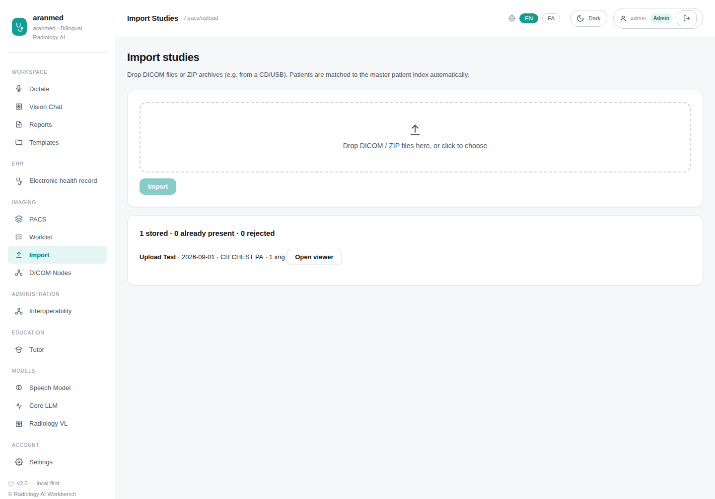
Figure 33: Import from CD/USB or files
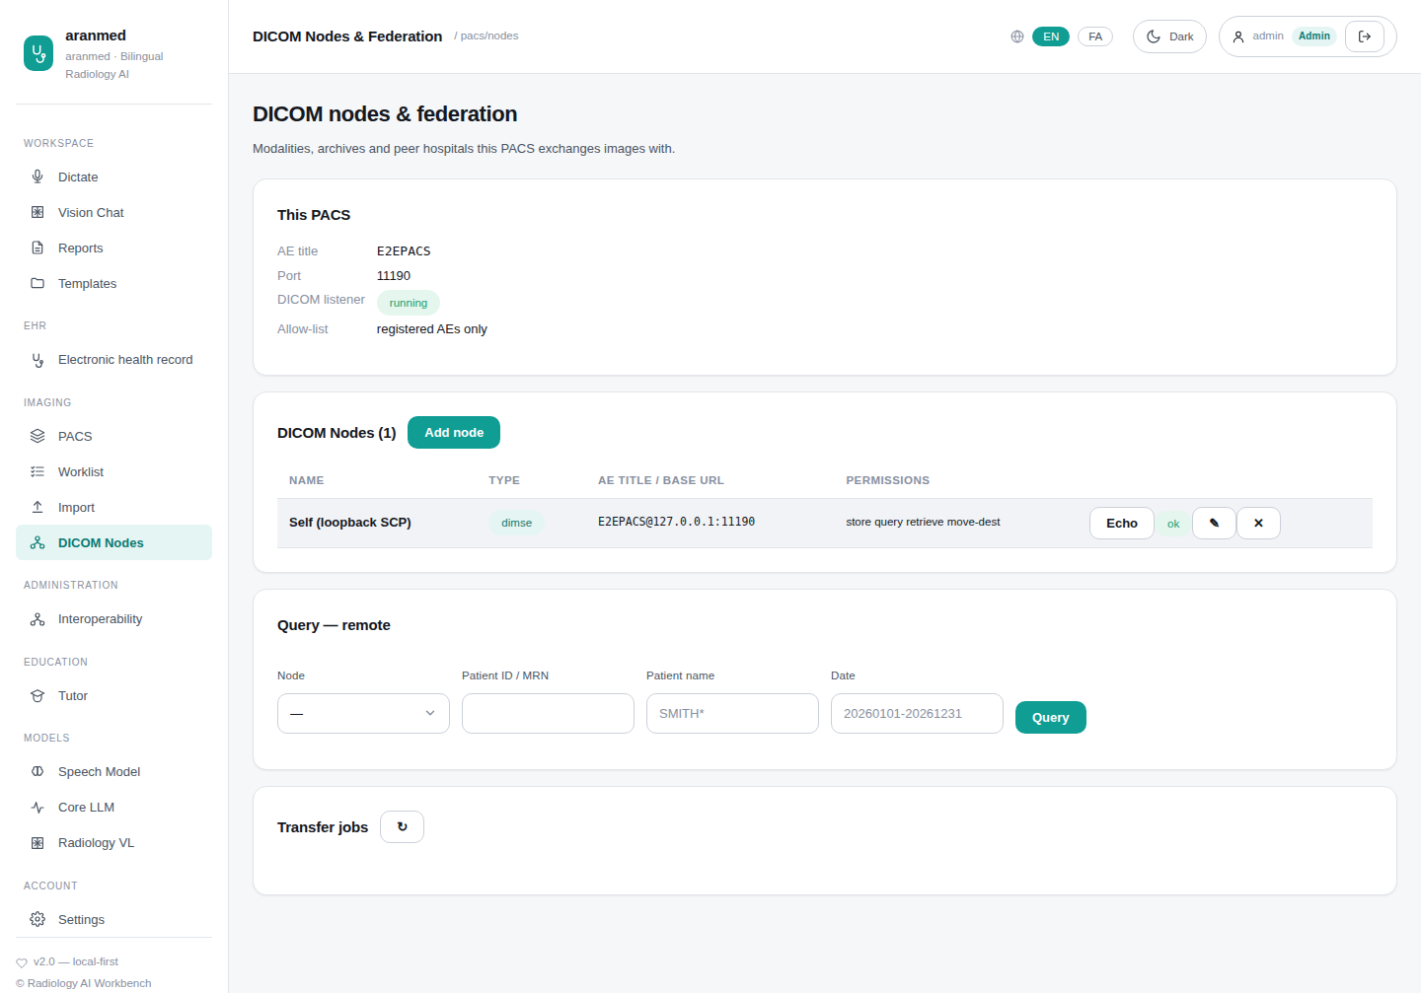
Figure 34: DICOM nodes with live C-ECHO

Tests
What it verifies | Test | Result
Real-world files from scanners and toolkits: every codec decodes and displays (22 cases) | test_pacs_devices.py  test_real_world_image_files | ✔ SQLite: passed 22/22 · 20.7 s  ✔ PostgreSQL: passed 22/22 · 24.4 s
Corrupt streams are archived and refused clearly, never crash (2 cases) | test_pacs_devices.py  test_real_world_corrupt_streams_fail_cleanly | ✔ SQLite: passed 2/2 · 1.88 s  ✔ PostgreSQL: passed 2/2 · 2.14 s
SR, RT Plan/Struct and ECG are stored and served (4 cases) | test_pacs_devices.py  test_real_world_non_image_files | ✔ SQLite: passed 4/4 · 3.65 s  ✔ PostgreSQL: passed 4/4 · 4.30 s
Each device family in each syntax it uses: pixel-exact (lossless), colour checked, native transcoding (54 cases) | test_pacs_devices.py  test_device_in_transfer_syntax | ✔ SQLite: passed 54/54 · 50.3 s  ✔ PostgreSQL: passed 54/54 · 1.0 min
Persian names: search folds Persian/Arabic letters; C-FIND in UTF-8 | test_pacs_devices.py  test_name_search_handles_persian_letters | ✔ SQLite: passed · 1.02 s  ✔ PostgreSQL: passed · 1.42 s
Legacy devices without character set (cp1256) and Arabic charset indexed correctly | test_pacs_devices.py  test_untagged_legacy_charset_and_arabic_sample_are_indexed | ✔ SQLite: passed · 0.97 s  ✔ PostgreSQL: passed · 1.36 s
SR as text, PDF document, video stream, vendor-private class | test_pacs_devices.py  test_sr_pdf_video_and_private_objects | ✔ SQLite: passed · 1.85 s  ✔ PostgreSQL: passed · 2.29 s
C-MOVE/C-GET transcode for workstations without compression; same SOP UID | test_pacs_devices.py  test_move_and_get_transcode_for_receivers_without_compression | ✔ SQLite: passed · 2.61 s  ✔ PostgreSQL: passed · 3.20 s
Sending splits associations and transcodes as needed | test_pacs_devices.py  test_scu_store_splits_associations_and_transcodes | ✔ SQLite: passed · 1.40 s  ✔ PostgreSQL: passed · 1.77 s
Orders from HL7/FHIR are found by modality date queries | test_pacs_devices.py  test_worklist_from_orders_is_found_by_dicom_date_queries | ✔ SQLite: passed · 1.62 s  ✔ PostgreSQL: passed · 2.00 s
MPPS duplicate and discontinued handled per standard | test_pacs_devices.py  test_mpps_duplicate_and_discontinued | ✔ SQLite: passed · 0.90 s  ✔ PostgreSQL: passed · 1.26 s
DICOM TLS and mutual TLS, incoming and outgoing | test_pacs_devices.py  test_dimse_tls_and_mutual_tls_on_scp_and_scu | ✔ SQLite: passed · 1.94 s  ✔ PostgreSQL: passed · 2.72 s
Called AE title, unknown AE and association limit enforced | test_pacs_devices.py  test_association_limits_and_called_ae | ✔ SQLite: passed · 1.45 s  ✔ PostgreSQL: passed · 1.78 s
Bulk data, WADO-URI, CD/USB media with DICOMDIR, zip-bomb cap | test_pacs_devices.py  test_bulk_wado_uri_and_media_import | ✔ SQLite: passed · 1.04 s  ✔ PostgreSQL: passed · 1.33 s
Another hospital's PACS sees only consented patients over DICOM | test_pacs_devices.py  test_other_hospitals_pacs_sees_only_consented_patients_over_dimse | ✔ SQLite: passed · 1.41 s  ✔ PostgreSQL: passed · 1.81 s
C-STORE, C-FIND (all levels), C-MOVE byte-identical, C-GET | test_pacs_dimse.py  test_store_query_retrieve_full_cycle | ✔ SQLite: passed · 3.04 s  ✔ PostgreSQL: passed · 3.56 s
C-ECHO and the AE allow-list | test_pacs_dimse.py  test_echo_and_association_allowlist | ✔ SQLite: passed · 0.71 s  ✔ PostgreSQL: passed · 0.95 s
Per-node store/query/retrieve permissions | test_pacs_dimse.py  test_per_node_permissions | ✔ SQLite: passed · 0.63 s  ✔ PostgreSQL: passed · 0.86 s
Worklist (MWL) and procedure steps (MPPS) | test_pacs_dimse.py  test_scheduled_workflow_mwl_mpps | ✔ SQLite: passed · 1.06 s  ✔ PostgreSQL: passed · 1.19 s
Storage commitment report | test_pacs_dimse.py  test_storage_commitment_report | ✔ SQLite: passed · 1.31 s  ✔ PostgreSQL: passed · 1.52 s
Outgoing DICOM operations | test_pacs_dimse.py  test_scu_module_against_scp | ✔ SQLite: passed · 0.90 s  ✔ PostgreSQL: passed · 1.15 s
Search and retrieve between hospitals over DICOMweb | test_pacs_federation.py  test_federated_search_and_wado_retrieve_between_hospitals | ✔ SQLite: passed · 4.44 s  ✔ PostgreSQL: passed · 5.12 s
Query and move between hospitals over DIMSE | test_pacs_federation.py  test_dimse_query_and_move_between_hospitals | ✔ SQLite: passed · 1.08 s  ✔ PostgreSQL: passed · 1.54 s
Push to a peer; a wrong secret is refused | test_pacs_federation.py  test_push_study_to_peer_and_bad_secret | ✔ SQLite: passed · 0.72 s  ✔ PostgreSQL: passed · 1.00 s
Orthanc adapter round trip | test_pacs_federation.py  test_orthanc_adapter_roundtrip | ✔ SQLite: passed · 2.27 s  ✔ PostgreSQL: passed · 3.14 s
Browser: worklist and scheduling | pacs.spec.js  worklist: seeded STAT order and scheduling a new one | ✔ Playwright: passed · 0.81 s
Browser: DICOM nodes with live echo; admin only | pacs.spec.js  admin: DICOM nodes with a live C-ECHO; doctors cannot see the page | ✔ Playwright: passed · 1.57 s
Browser: compressed colour ultrasound, JPEG Lossless CT, SR and PDF | pacs.spec.js  devices as they send it: compressed colour US, JPEG Lossless CT, SR and PDF | ✔ Playwright: passed · 1.38 s

Device × transfer syntax results
Combinations: 54 · Passed: 54 · Failed: 0
Device | Explicit LE | Implicit LE | Big Endian | Deflate | RLE | JPEG Baseline | JPEG Lossless | JPEG-LS | JPEG 2000
CT | ✔ | ✔ | ✔ | ✔ | ✔ |  | ✔ | ✔ | ✔
MR | ✔ | ✔ | ✔ |  | ✔ |  | ✔ | ✔ | ✔
DX (digital X-ray) | ✔ |  |  |  | ✔ |  | ✔ | ✔ | ✔
MG (mammography) | ✔ |  |  |  |  |  | ✔ | ✔ | ✔
PT (PET) | ✔ | ✔ |  |  | ✔ |  |  |  | ✔
NM (palette colour) | ✔ |  |  |  | ✔ |  |  | ✔
US (colour) | ✔ |  |  |  | ✔ | ✔ |  | ✔ | ✔
US cine (multi-frame) | ✔ |  |  |  | ✔ | ✔
XA (angiography, multi-frame) | ✔ |  |  |  | ✔ | ✔ |  | ✔
Enhanced MR (functional groups) | ✔ |  |  |  | ✔ |  |  |  | ✔
Secondary capture RGB | ✔ |  | ✔ |  | ✔ | ✔
SEG (1-bit segmentation) | ✔ | ✔
RT Dose (32-bit) | ✔ |  | ✔

Real-world files
Test file | Description | Result
693_J2KI.dcm | JPEG 2000 irreversible | ✔ decoded and displayed
CT_small.dcm | CT, Explicit VR LE, signed 16-bit | ✔ decoded and displayed
JPEG2000.dcm | JPEG 2000 (lossy) | ✔ decoded and displayed
JPEGLSNearLossless_16.dcm | JPEG-LS near-lossless 16-bit | ✔ decoded and displayed
JPGExtended.dcm | JPEG Extended 12-bit (Process 2/4) | ✔ decoded and displayed
MR_small_RLE.dcm | RLE Lossless 16-bit | ✔ decoded and displayed
MR_small_bigendian.dcm | MR, Explicit VR Big Endian | ✔ decoded and displayed
MR_small_implicit.dcm | MR, Implicit VR LE | ✔ decoded and displayed
MR_small_jp2klossless.dcm | JPEG 2000 Lossless | ✔ decoded and displayed
MR_small_jpeg_ls_lossless.dcm | JPEG-LS Lossless | ✔ decoded and displayed
SC_rgb_jls_lossy_sample.dcm | JPEG-LS near-lossless RGB | ✔ decoded and displayed
SC_rgb_jpeg_dcmtk.dcm | JPEG Baseline YBR_FULL_422 (DCMTK) | ✔ decoded and displayed
SC_rgb_jpeg_gdcm.dcm | JPEG Lossless SV1 RGB (GDCM) | ✔ decoded and displayed
SC_rgb_rle_32bit_2frame.dcm | RLE 32-bit RGB, 2 frames | ✔ decoded and displayed
SC_ybr_full_422_uncompressed.dcm | uncompressed YBR_FULL_422 | ✔ decoded and displayed
examples_jpeg2k.dcm | JPEG 2000 RGB | ✔ decoded and displayed
examples_palette.dcm | PALETTE COLOR | ✔ decoded and displayed
examples_ybr_color.dcm | YBR_FULL colour, multi-frame | ✔ decoded and displayed
image_dfl.dcm | Deflated Explicit VR LE | ✔ decoded and displayed
liver_1frame.dcm | Enhanced multi-frame (functional groups) | ✔ decoded and displayed
rtdose.dcm | RT Dose, 32-bit multi-frame with grid scaling | ✔ decoded and displayed
rtdose_rle.dcm | RT Dose, RLE 32-bit | ✔ decoded and displayed
JPEG-lossy.dcm | JPEG Extended with invalid SOS parameters (NEMA WG04 NM1_JPLY) | ✔ archived; refused cleanly (406)
JPEG2000-embedded-sequence-delimiter.dcm | JPEG 2000 with a sequence delimiter inside the codestream | ✔ archived; refused cleanly (406)
rtplan.dcm | RT Plan | ✔ stored and served
rtstruct.dcm | RT Structure Set | ✔ stored and served
test-SR.dcm | Structured Report | ✔ stored and served
waveform_ecg.dcm | 12-lead ECG waveform | ✔ stored and served

12. Interoperability standards
FHIR R4 server (read, search, history, transactions, $everything, $summary, $match/PDQm, PIXm, MHD), HL7 v2 over MLLP (ADT, orders, results, documents, immunizations, PDQ/PIX), C-CDA R2.1 import/export, NEMSIS for EMS and the Master Patient Index. The Interoperability page (administrators) tests peer connections, sends HL7 messages, imports CCDs, reviews possible duplicate patients and shows the message log.

Screens
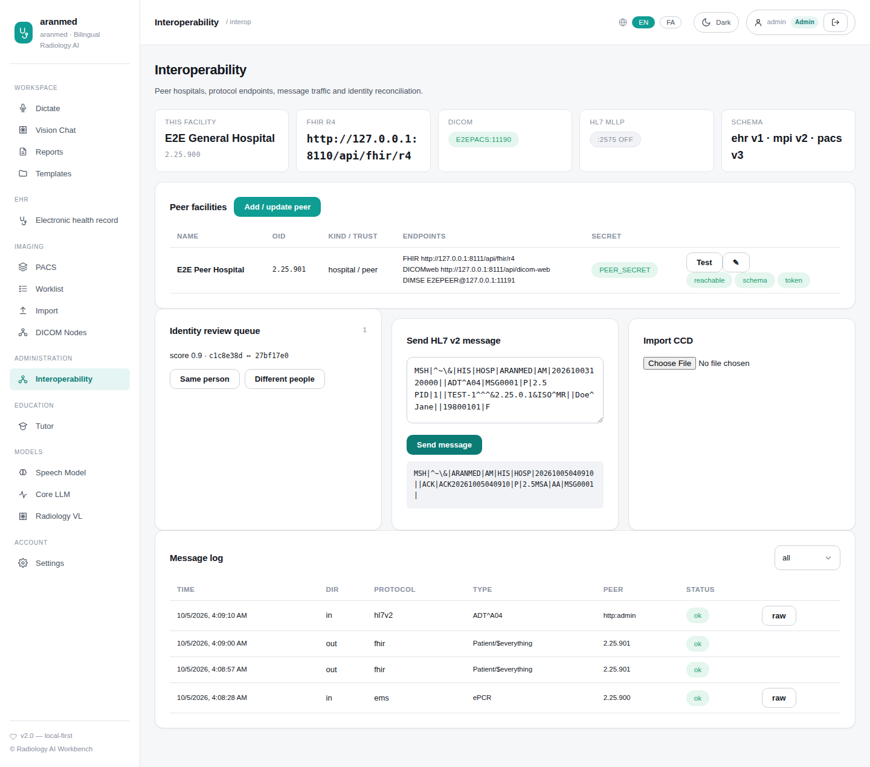
Figure 35: Interoperability administration

Tests
What it verifies | Test | Result
FHIR R4: CRUD, search, history, transactions, $everything, $match, PIXm, MHD | test_fhir_server.py  test_fhir_server_end_to_end | ✔ SQLite: passed · 1.62 s  ✔ PostgreSQL: passed · 3.29 s
HL7 v2 over MLLP: ADT, orders, results, documents, PDQ/PIX | test_hl7_mllp.py  test_adt_orders_results_documents_queries | ✔ SQLite: passed · 0.48 s  ✔ PostgreSQL: passed · 1.18 s
Many HL7 messages on one connection | test_hl7_mllp.py  test_mllp_multiple_messages_one_connection | ✔ SQLite: passed · 0.10 s  ✔ PostgreSQL: passed · 0.28 s
C-CDA export and import | test_cda_ems.py  test_ccd_export_and_import | ✔ SQLite: passed · 1.05 s  ✔ PostgreSQL: passed · 1.93 s
Master Patient Index: match, link, review | test_mpi_facilities.py  test_mpi_identity_lifecycle | ✔ SQLite: passed · 0.48 s  ✔ PostgreSQL: passed · 0.87 s
Patient merge updates every database | test_mpi_facilities.py  test_mpi_merge_runs_hooks_and_is_idempotent | ✔ SQLite: passed · 0.35 s  ✔ PostgreSQL: passed · 0.62 s
Demographics encrypted at rest | test_mpi_facilities.py  test_mpi_demographics_encrypted_at_rest | ✔ SQLite: passed · 0.32 s  ✔ PostgreSQL: passed · 0.53 s
Facility registry administration | test_mpi_facilities.py  test_facility_registry_admin_flow | ✔ SQLite: passed · 0.34 s  ✔ PostgreSQL: passed · 0.64 s
Capabilities report identity and schema versions | test_mpi_facilities.py  test_capabilities_reports_identity_and_schema | ✔ SQLite: passed · 0.09 s  ✔ PostgreSQL: passed · 0.27 s
Browser: peer test, HL7 message, message log | clinical.spec.js  interop admin: peer test, HL7 message, message log | ✔ Playwright: passed · 1.07 s

13. Education, models, settings and appearance
The education tutor generates questions, cases, mock exams and explanations. Model consoles show which model serves each role, from the model registry. Settings hold theme and language; administrators manage users. The whole interface works in English and Persian (right-to-left) and in light or dark theme.

Screens
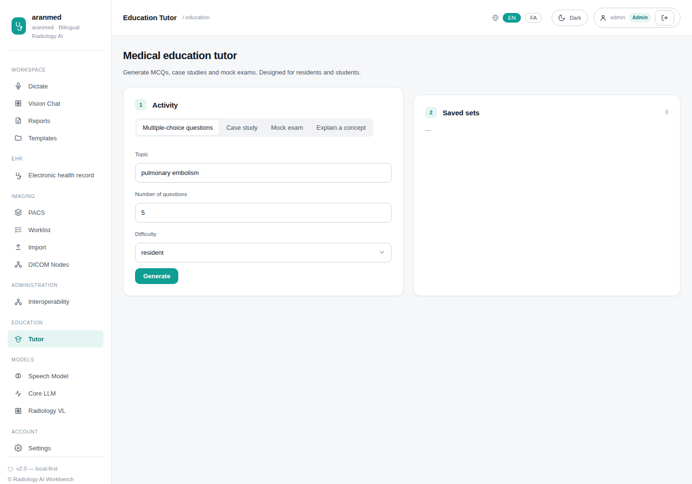
Figure 36: Education tutor
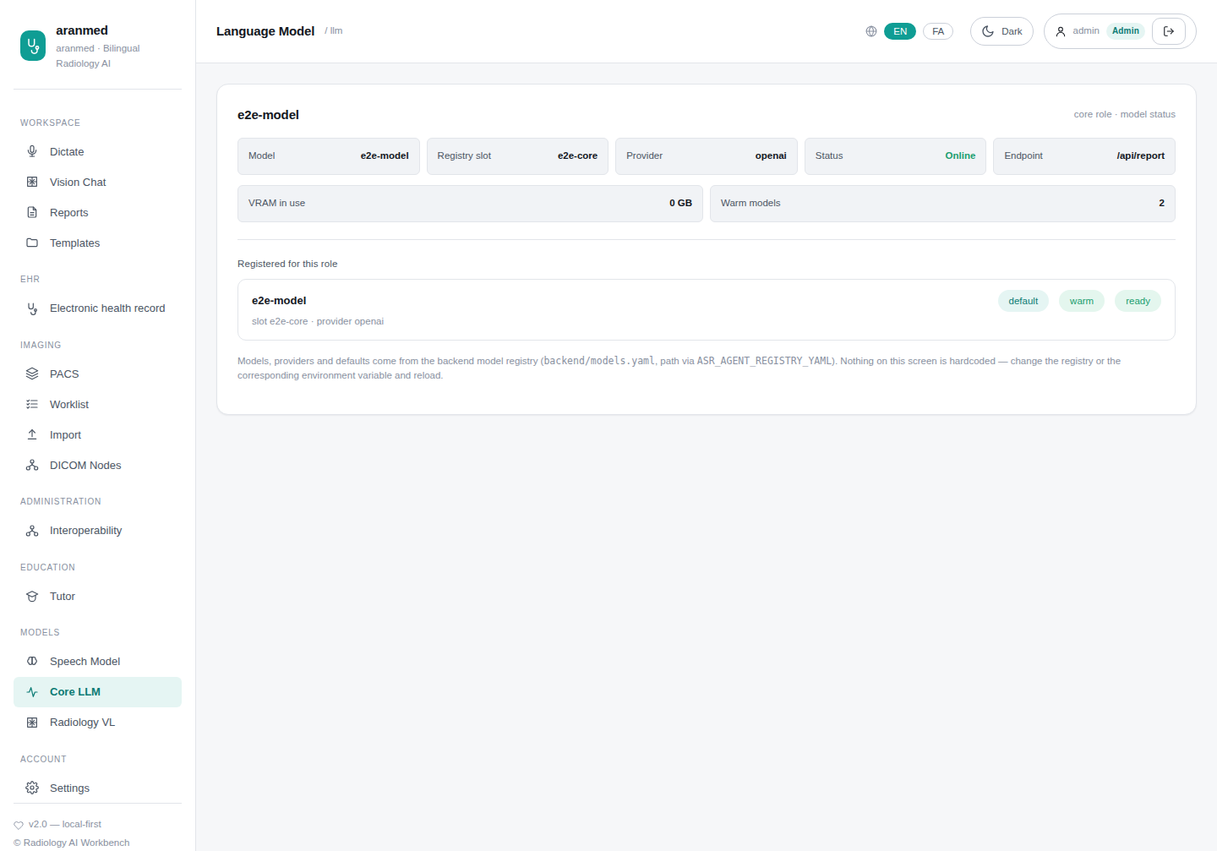
Figure 37: Language model console
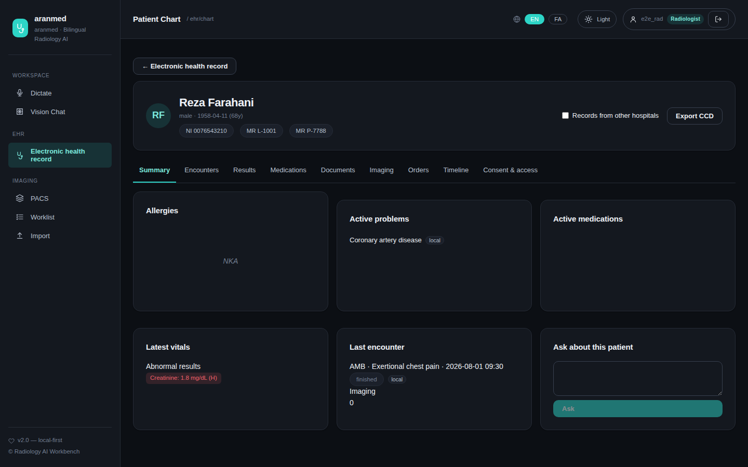
Figure 38: Chart in dark theme

Tests
What it verifies | Test | Result
Tutor generates and saves questions | test_auth_db_api.py  test_education_mcq_creates_quiz | ✔ SQLite: passed · 0.19 s  ✔ PostgreSQL: passed · 0.38 s
Tutor explains a concept | test_auth_db_api.py  test_education_explain | ✔ SQLite: passed · 0.19 s  ✔ PostgreSQL: passed · 0.32 s
Model registry lists providers | test_registry.py  test_registry_lists_providers | ✔ SQLite: passed · 0.03 s  ✔ PostgreSQL: passed · 0.18 s
Models load on demand | test_registry.py  test_registry_get_text_loads_lazily | ✔ SQLite: passed · 0.02 s  ✔ PostgreSQL: passed · 0.18 s
Memory budget respected | test_registry.py  test_registry_lru_evicts_when_over_budget | ✔ SQLite: passed · 0.03 s  ✔ PostgreSQL: passed · 0.17 s

14. Protocol support
Standard | Scope
DICOM DIMSE | C-ECHO, C-STORE (all storage classes, all transfer syntaxes, private classes), C-FIND/C-MOVE/C-GET (Patient & Study Root), MWL, MPPS, Storage Commitment, TLS/mTLS, transcoding
DICOMweb | QIDO-RS, WADO-RS (metadata, frames incl. transcoding, rendered, thumbnail, bulk), STOW-RS, WADO-URI, SR/PDF/video endpoints
Transfer syntaxes | Implicit/Explicit LE, Big Endian, Deflate, RLE, JPEG baseline/extended/lossless, JPEG-LS, JPEG 2000, MPEG-2/H.264/HEVC video
HL7 v2 (MLLP) | ADT A01–A40, ORM/OMI/OMG, ORU, MDM, VXU, QBP Q22/Q23 (PDQ/PIX), ACK
FHIR R4 | CRUD, search, history, transaction/batch, $everything, $summary, $match (PDQm), $ihe-pix (PIXm), MHD; 16 resource types; validated against R4B
C-CDA R2.1 | CCD export and import
NEMSIS v3.5 | EMS pre-arrival reports (XML, JSON) and FHIR EMS bundles
IHE | PDQ/PDQm, PIX/PIXm, MHD, XCPD/XCA-style federation, PDI media (DICOMDIR)

15. Other automated tests
The remaining suites cover speech recognition configuration, the agent, MedRAG retrieval and the clinical rule engine. Tests marked live need real model servers and are skipped in this environment.
Test file | Tests | Passed | Failed | Skipped
medrag/test_artifact_pilot_eval.py | 7 | 7 | 0 | 0
medrag/test_colbert_selfrag.py | 6 | 6 | 0 | 0
medrag/test_documents.py | 3 | 3 | 0 | 0
medrag/test_embed_resume.py | 1 | 1 | 0 | 0
medrag/test_index_integrity.py | 7 | 7 | 0 | 0
medrag/test_ingest.py | 3 | 3 | 0 | 0
medrag/test_ingest_integration.py | 1 | 1 | 0 | 0
medrag/test_knowledge_artifacts.py | 20 | 20 | 0 | 0
medrag/test_knowledge_mvp.py | 9 | 9 | 0 | 0
medrag/test_layout.py | 4 | 4 | 0 | 0
medrag/test_llm_client.py | 7 | 7 | 0 | 0
medrag/test_multimodal.py | 2 | 2 | 0 | 0
medrag/test_pdf_io.py | 2 | 2 | 0 | 0
medrag/test_rag_advanced.py | 10 | 10 | 0 | 0
medrag/test_rules_engine.py | 8 | 8 | 0 | 0
medrag/test_system_smoke.py | 2 | 2 | 0 | 0
test_agent.py | 2 | 2 | 0 | 0
test_code_switching.py | 10 | 10 | 0 | 0
test_code_switching_integration.py | 1 | 1 | 0 | 0
test_fabric_ehr_unification.py | 2 | 2 | 0 | 0
test_live.py | 4 | 0 | 0 | 4
test_providers.py | 4 | 4 | 0 | 0
test_real_pipeline.py | 4 | 0 | 0 | 4
test_rules_engine.py | 44 | 44 | 0 | 0
test_tools.py | 4 | 4 | 0 | 0

