Agile Development & Devops Lab
Muhammed Imaan
23MIS0681
_____________________________________________________

Case Study 1: New Project Version Control Setup Scenario:
You are assigned to develop a Library Management System. Before coding, your team decides to enable version control.
Tasks:
- Create a project folder and open it in VS Code
- Initialize a Git repository
- Create a Python file and track it using Git
- Commit the initial version

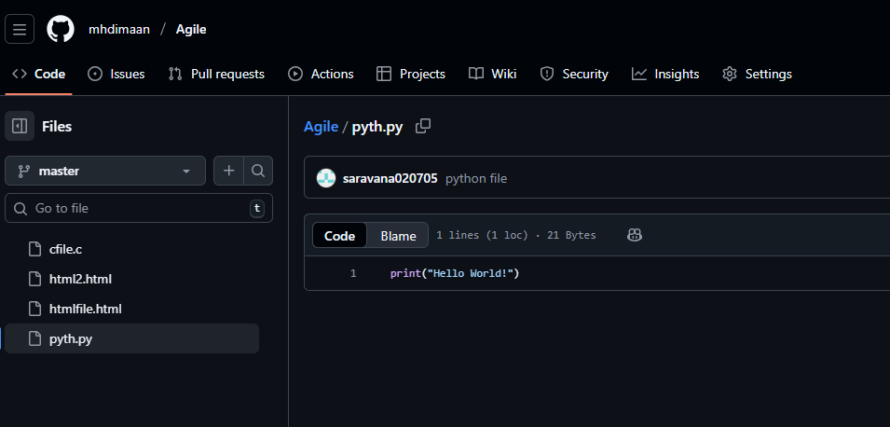

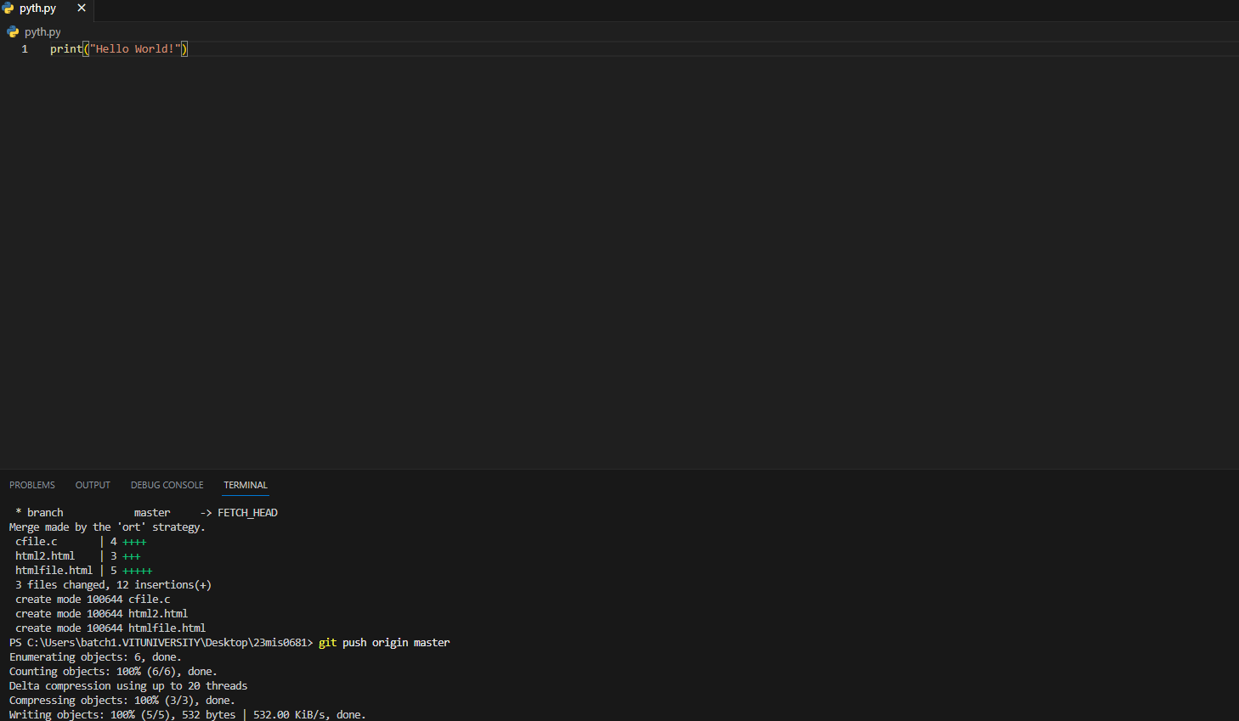
Code:
- git init
- git add .
- git add pyth.py
- git commit -m "python file"
- git remote add origin https://github.com/mhdimaan/Agile.git
- git push origin master

Case Study 2: Tracking Daily Code Changes Scenario:
You are working on a Student Registration Module. You make small updates daily and need to record them.
Tasks:
- Modify an existing file
- Check file differences
- Stage and commit changes
- View commit history

Updated File:
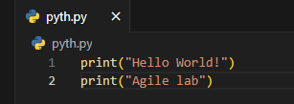

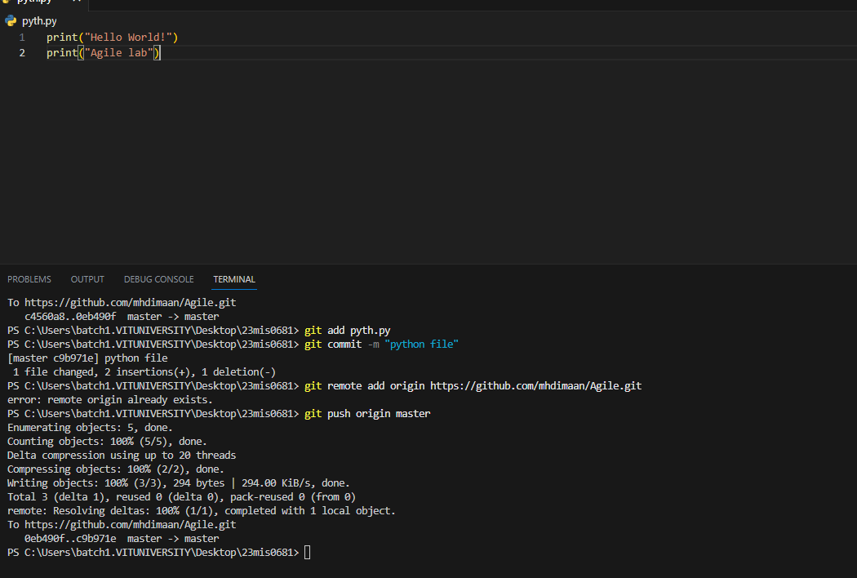
Commit History:
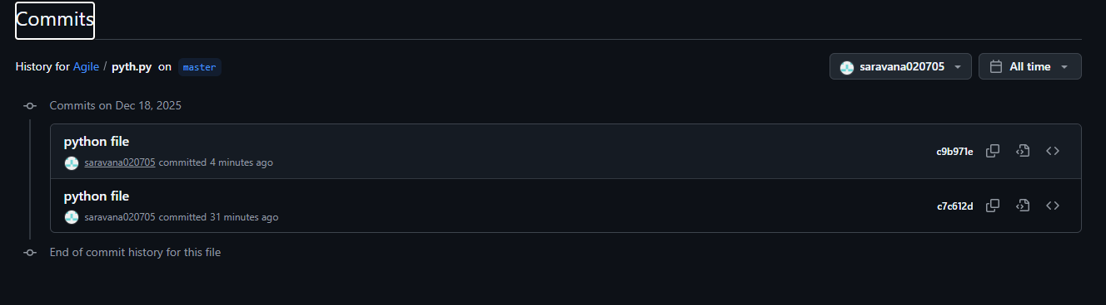

Case Study 3: Feature Development Using Branches Scenario
A new Login feature must be developed without disturbing main code.
Tasks:
- Create a new branch
- Add login-related code
- Commit changes
- Switch between branches

1. New Branch
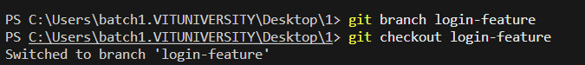

2. Login Related code

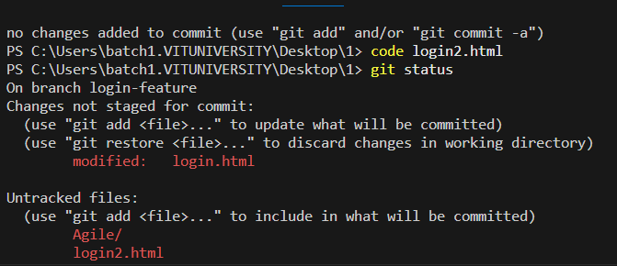

3. Commit Changes
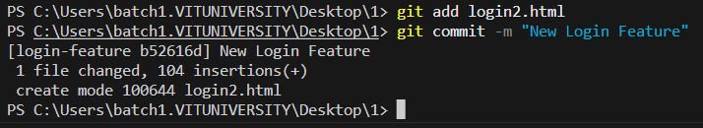

4. Switch between branches
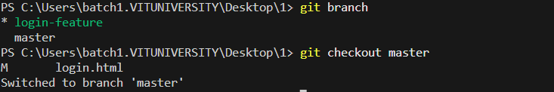
Case Study 4: Merging Feature into Main Code Scenario:
The login feature is tested and approved.
Tasks:
- Switch to main branch
- Merge feature branch
- Verify merged content

1. Switch to main branch
2. Merge feature branch
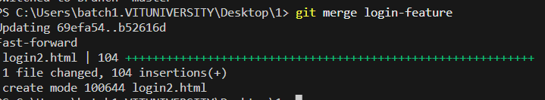
3. Verify merge branch
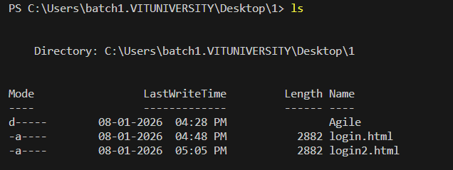

Case Study 5: Working with Remote Repository Scenario
The project must be shared using GitHub.
Tasks:
- Create remote repository
- Add remote origin
- Push code to GitHub

1. Create remote repository
2. Add remote origin
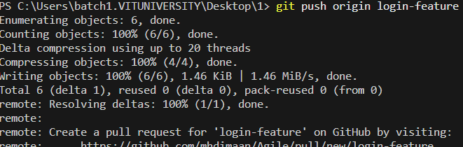
3. Push code to Github

