OS: Bridge bw computer h/w and user.

Linux: in simple terms linux is free and open source OS.

In 2nd module installation and setup, chose virtual box or cloud or the convenience

Here am going with rhel in cloud

**Module 3- Access and file s/m**

Linux kernal not a OS it is a small s/w within linux os that takes commands from user and pass them to s/m hardware and peripherals.

File s/m- it a s/m used by an os to manage files. How data saved or retrieved.

Eg: ext3, ext4, xfs, NTFS ….

/boot – contains files that used by boot loader

/root – root home directory

/dev – s/m devices (disk, keyboard…)

/etc – confgrtn files

/bin – user cmnds

/sbin – system commands

/opt – optional or 3rd party applctn

/proc – running process

/lib – c program library

/tmp – temporary files

/home – user home directory

/var – log files

/run – system runs

/mnt – mount external filesystem

/media – cdrom mounts

File or directory properties.

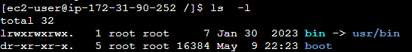

First column indicates type and permission 1- indicates the no of hard links associated

Next 2 are owners and groups of file or directory then size and modified date of them

**Types of files**

* - regular files

d – directory

l – link

c – special/device file

s – socket

p – Named pipe

b – blocked device

what is root – 3 types root user root / first directory and home directory of root

passwd – to change the password of user

* absolute path - start with / form root

cd /var/log/samba

* relative path – does not start with /

cd /var cd log cd samba

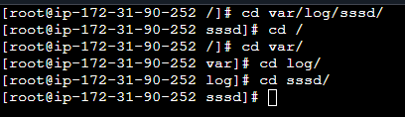

**Creating files and directories**

touch , cp , mkdir , editors like vi, nano etc…

to copy directories

cp -R <source> <destination>

-R recursively represents the entire things in directory.

**Finding files and directories:**

Find – this commands helps to find the files by different properties.



Locate: command works in same way

Eg : locate <filename> but the db should be updated each time “updatedb”. Means each time when we are creating new files the local db should be updated otherwise it cannot be located.

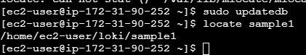

**Wildcards:**

*represent zero or more chanrecters

? – represent single character

[] – represents range of charecters

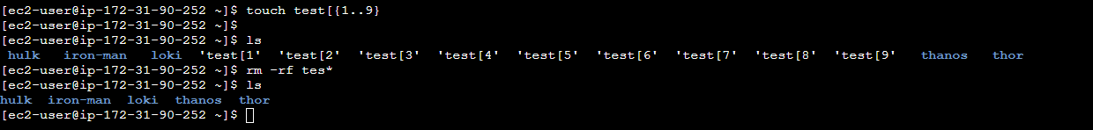



**Soft and Hard links**

Inode: pointer or number of a file in hard disk

Soft : link will be removed if file removed or renamed

Hard : deleting or renaming will not affect

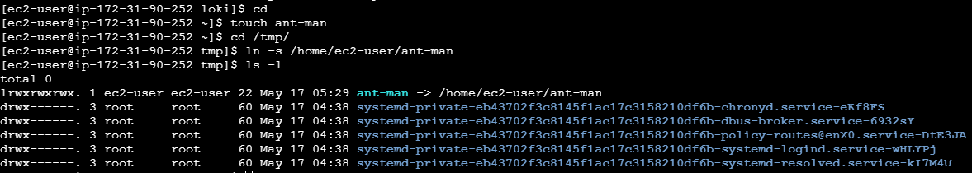

Whatever change I did in my home folder to that file will reflect in temp folder file as well.

Inode numbers will be different.same for hard link

Hard link will remain even if we delete the source files.

**Module 4 – Linux fundamentals.**

File permission

Change owner and group:

Chown- ownership change

Chgrp – group ownership change

-R option will change all the ownership within that folder.

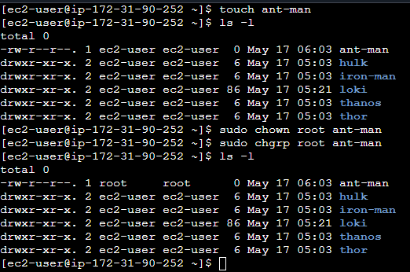

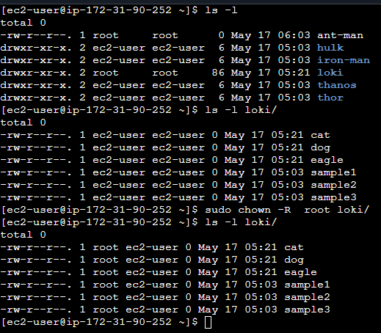

ACL:

Top level access permission, in scenario like a user want access to files or specific file without be part of group it can be grant through the acls

Setfacl is the command

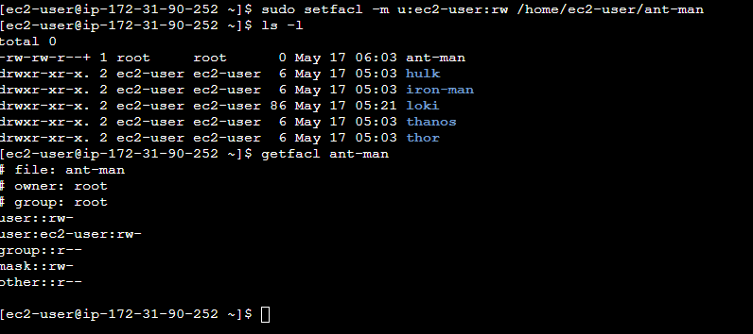

Helping command:

Man, whatis

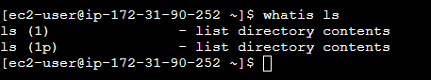

I/p and o/p redirect

Stdin – 0

Stdout – 1

Stderr- 2

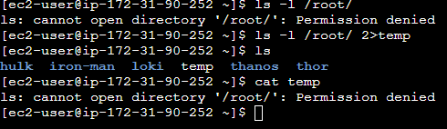

Tee – do 2 task write and print the content.

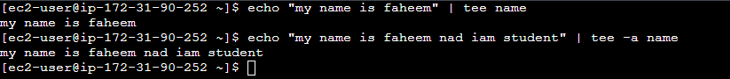

-a is to append the content

Filters and text processing:

Cut : command to cut as per the columns(position, delimeter etc..)

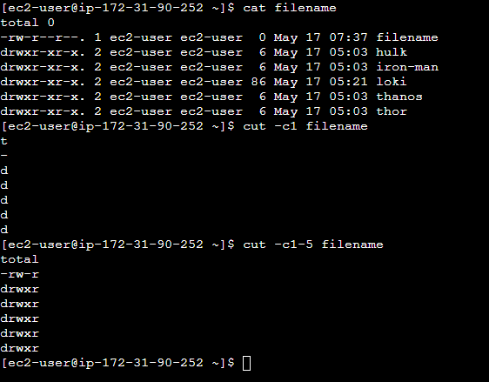

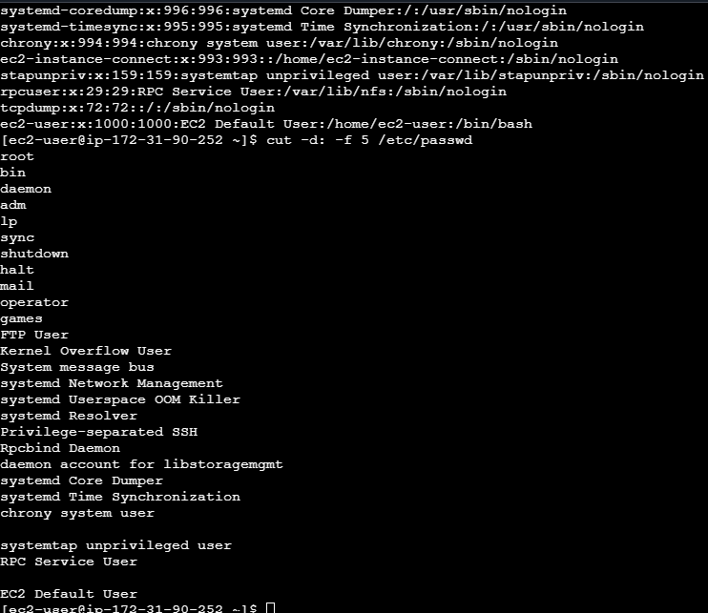

Awk: extracts fields form files

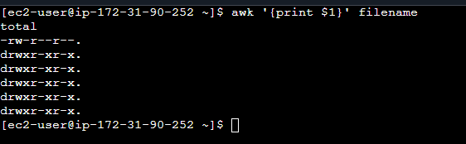

With awk we can do search as well also we can do the same function of cut as well. Also to replace the words.

Grep/egrep: searching

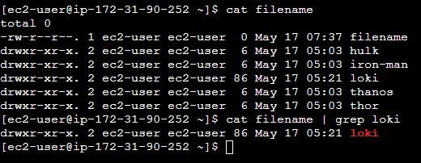

Egrep is for multiple words

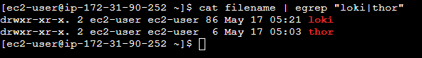

Sort : sort in alphabetical order

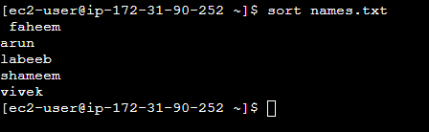

Uniq: remove duplicating data

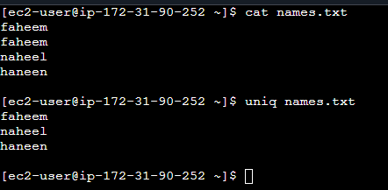

Wc- word count

Comparing the files:

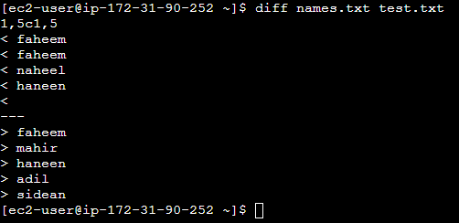

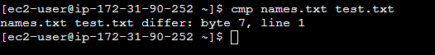

Compressing:

Tar: zipping the files

Gzip: compress the files means reduce the size

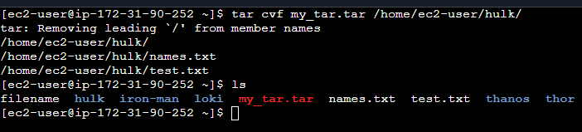

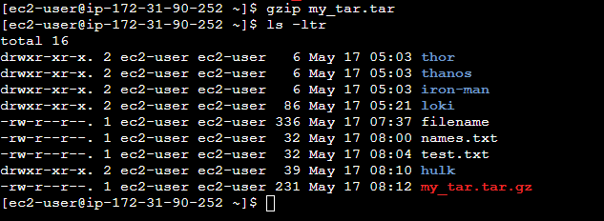

We can gzip any file other that tar too

Truncate: to shrink or extend of file size

Combine and split file:

Cat file1 file2 file3 > file4

Split -l 300 file.txt childfile.txt

Multiple commands:

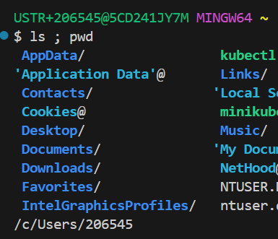

**Module 5- system administration**

Sed: it uses to replaces test inside a file

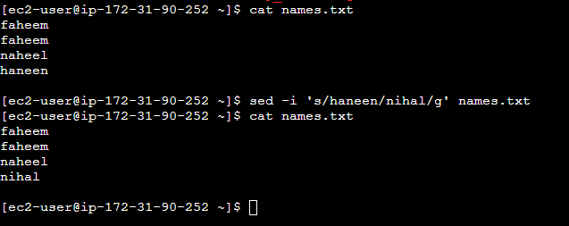

-i option is to affect the change in files with out I it wont reflect.

User management:

Useradd and adduser are same but in adduser by default a home directory is created.

Usermod : command to add user in group

Usermod -aG <group> <user>

Monitoring user:

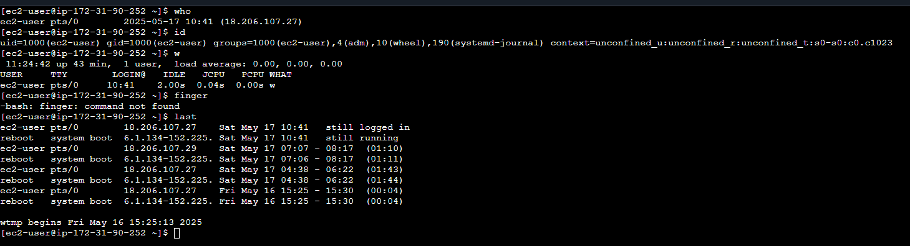

Talking to user:

Suppose we want to announce something to user that are logged into server we can achieve through the wall, write rtc.. commands

Linux account authentication:

Local account : normal user created by useradd command

Domain/directory account: if we have multiple users to manage there will be a directory server which deal with users. In case of windows it is active directory

LDAP is a protocol to authenticate against a directory

IDM – active directory in linux.

s/m utility commands:

date,cal, uptime, hostname, uname …

process: application or service that running in linux. A process is generated when an application running

daemon- process in background

job – scheduler

systemctl: start/stop your application. Enable means when system reboot it automatically start up

ps: list all running programs

top: real time view of running system

-u flag in both represent the processes by specific user

Kill: terminate the process

Signals are short message send to processes

Crontab : schedule task

By running crontab -e it redirect ti vi and we can schedule the task

***** echo “my first entry” > filename

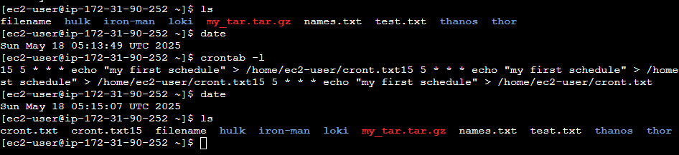

At : same purpose but it can be scheduled at once

Process management:

Background and foreground processes  
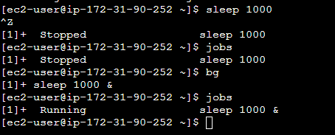



s/m monitoring:

df : disk related information

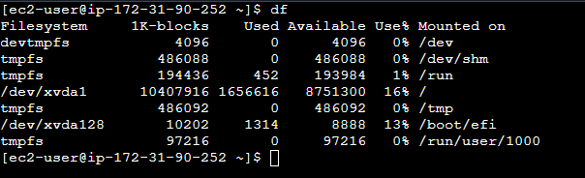

Dmesage: system related warning

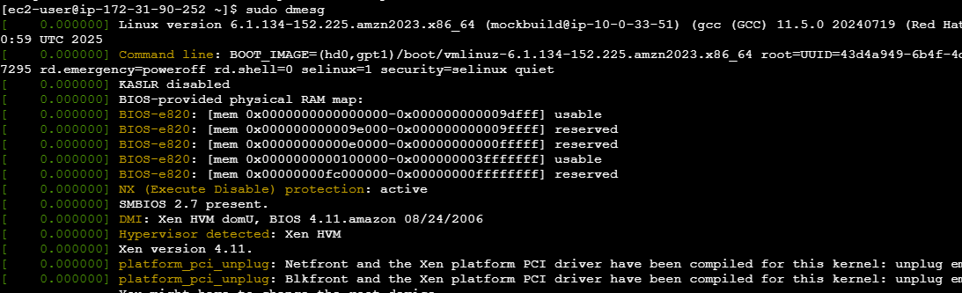

Iostat: i/p o/p stats

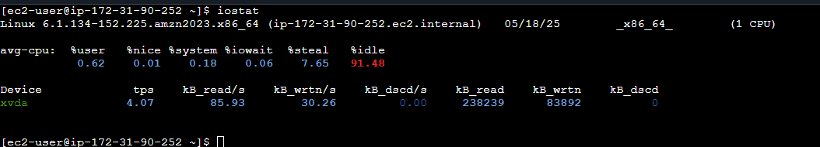

Netstat  
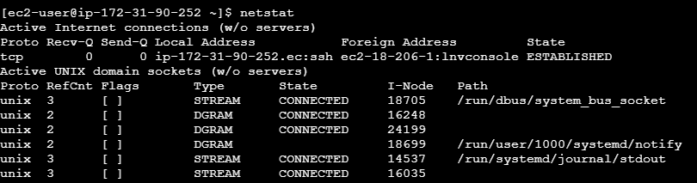

Free, proc/cpu_info, proc/mem_info etcc are there

s/m maintenance: to reboot s/m and shutdown etc..

eg: shutdown, reboot, init, halt etc…

hostnamectl : to change the hostname

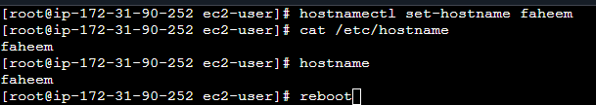

After rebooting it will reflect in prompt

Uname : it will provide the OS info

Dmidecode is command which gives more details on OS

To find arch of system :



Script commands used to record our activity in a file

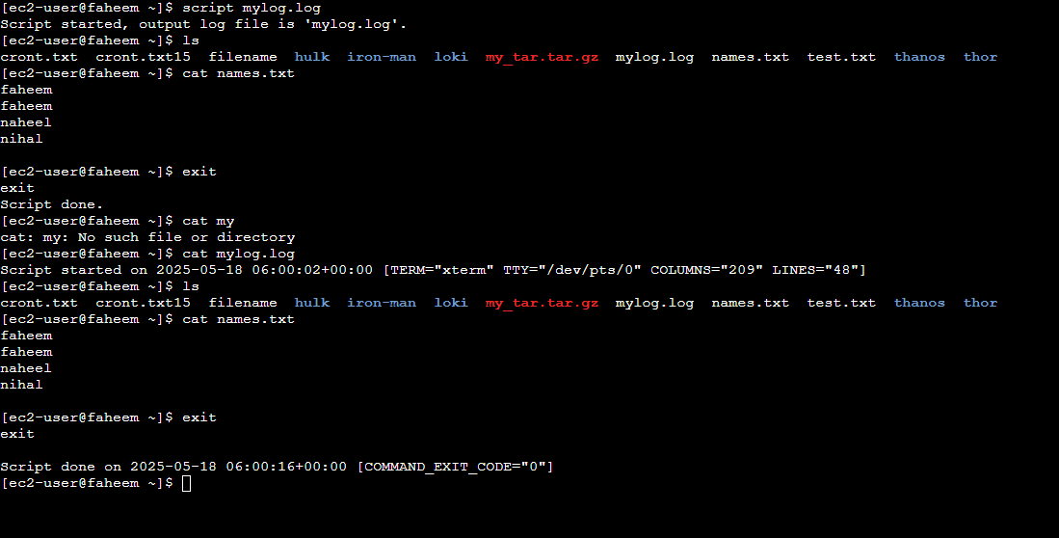

Env variables : set of defined rules and values to build an environment

Export TEST=1 is cmnd to set variable

.basrc file to set env permanently and /etc/profile or /etc/bashrc to set globally

Screen command help to play with window screen( multiple, divide etc..)

Module 6 – scripting – will cover in different course

**Module 7 – Networking**

User making request is client and the providing one is server.

Interface configuration files

/etc/nsswitch.conf

/etc/hosts

/etc/resolv.conf

/etc/sysconfig/ etc…

Lo: it is a special interface that our computer uses to communicate with itself.

Nic information can be get from ethtool <interface name>

We can achieve nic bonding ( binding multiple ports) for high availability and redundancy.

Network utilities provide a UI feature by running command to add modify interface and other n/w related changes

Wget : is to download any app of files

Curl : can be use to download and get content

FTP: protocol used to transfer a file from serverA to serverB

2 servers needed to setup this as client and server

* install ftp in server

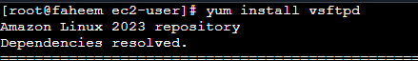

* get into conf file and do some changes

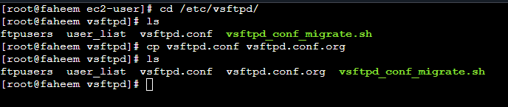

* updated config file with some changes

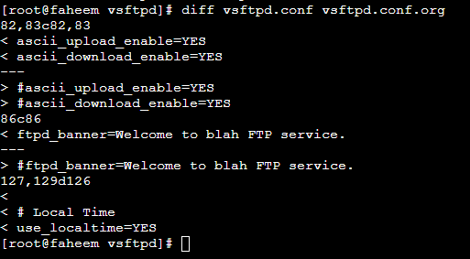

* start the service with systemctl do same for firewalld usually we add rule to allow that port, but since we are doing testing working like this.
* In 2nd server install ftp ( client package which is ftp)

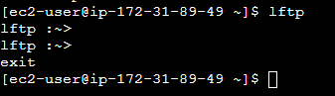

* Create a file
* Switch into server with ip



* Transfer the file  
  

SCP:

Similar to ftp with security and authentication.



User, ip and location are to server details where file copying.

Rsync: same to transfer files between machines

If we transfer a file with 2 mb size for first time it will transfer and if we updated that file and shared again it wont transfer completely, extra contents are transferred

It is powerful that ftp and scp, mainly large files are transferred

System patch and update:

Apt-get update or upgrade : this will help to update minor version 9.0 to 9.1 for major we cant do with dnf or yum like 8 to 9

Update preserve update and preserve old files by upgrade it update by removing all old versions

DNS:

PTR record: ip to hostname

A record: hostname to ip

CNAME record : hostname to hostname

* Install dns package



* Configure the dns
* Create 2 files in named folder

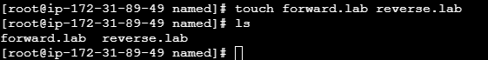

In these files we will update client entry, actually we will setup client in different machine. But here used the same.

Name server details that we setup above are marked in client machine etc/resolv.conf

These are the process to setup a dns server

Nslooup : to find the ip details and vice versa. While we ran this command the first details are our dns server details.

NTP : used to synchronize time in servers. Chronyd is the latest protocol for ntp

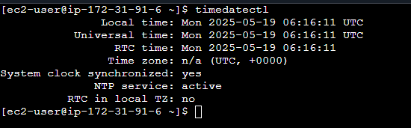

Apache -HTTPD

To serve webpage

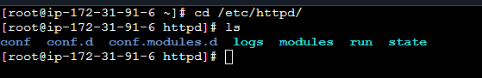

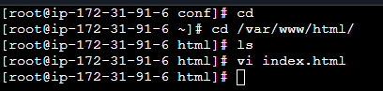

To access use the ip of server make sure firewall is configured or disabled

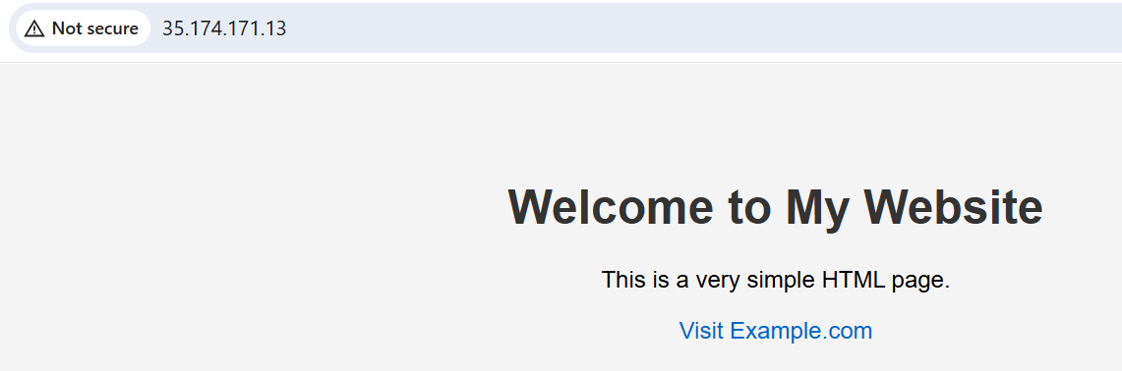

Nginx: powerful high performance web server

Reverse proxy : middle man b/w user and web server like a receptionist.

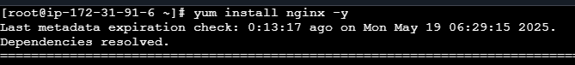

Start nginx and disable firewalld

Here nginx running on 80 and not starting because the previous httpd occupied in that same port   
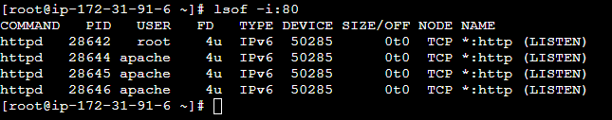

Configure nginx and create index file

Then check with ip the content are able to access

Reverse proxy :

We have a machine with previous setup, now we have another machine that accept all traffic from fist machine. So the first machine acts as a middle man.

Do all setup in 2nd machine as well. Then edit the conf of 1st machine.

Now when we hit ip of 1st machine it provide content saved in 2nd machine.



Nagios: it is for monitoring



Traceroute : to identify the traffic flow

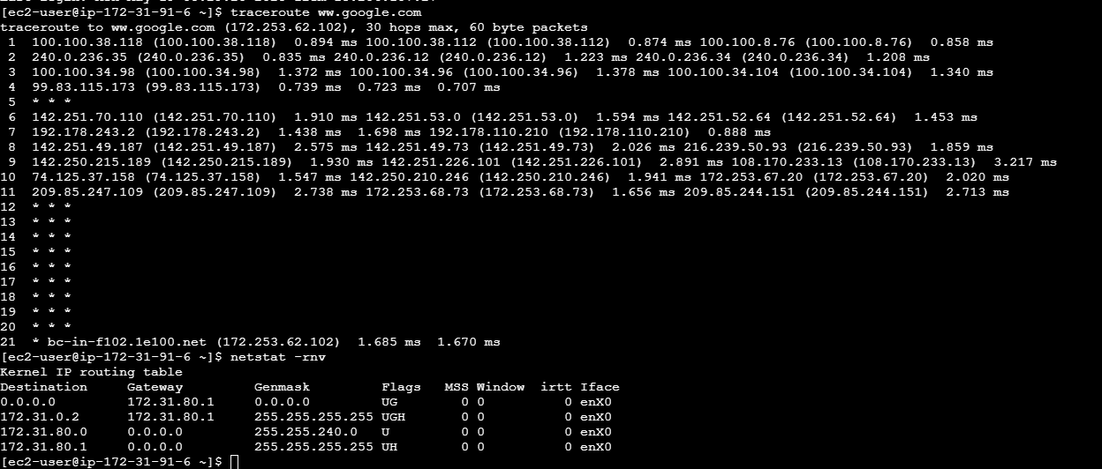

Firewall:

Rules defined on who can enter or leave the system

2 types s/w and h/w. we are discussing of s/w at OS

Iptables and firewalld are 2 services

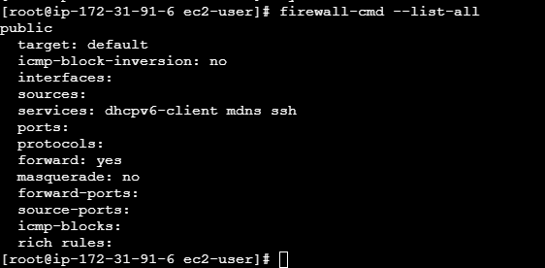

To add a service here httpd

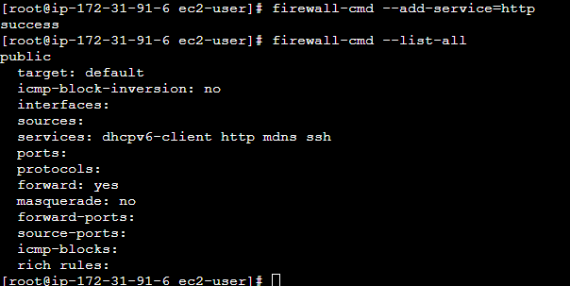

To add a 3rd party service which does not have a predefined port or setting

Go to specific path, these folder has many example xml files we should replicate the same according to our services and rules

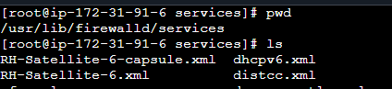

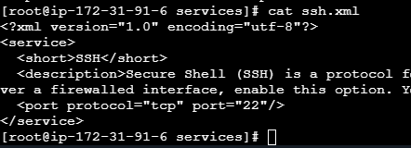

Then add service like above

To add port

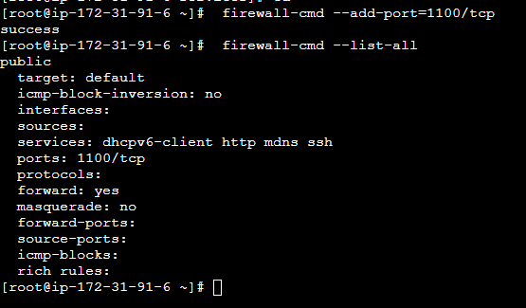

Reject ip coming to server

--add-rich-rule…

Outgoing : there is a command

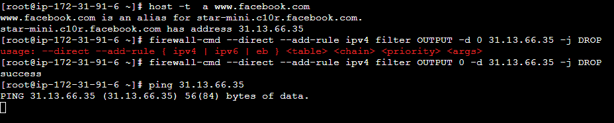

Run container:

Podman is an alternative to docker

**Module 8 – Disk management**

Local storage : HDD, SDD, RAM…

DAS- direct attached storage. Cd drive USB…

Storage area network- storage attached through fibre cable

Network attached storage- storage attached over network

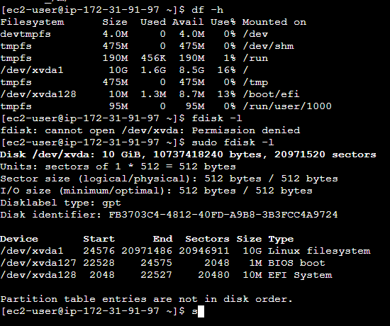

Add disk and partition.

In aws created a volume and attached to instance with a device name.

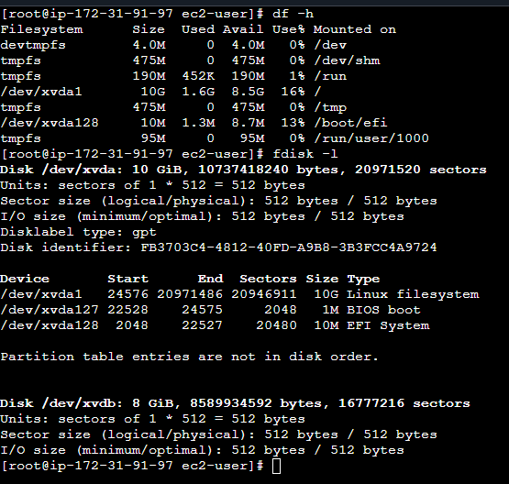

To add partition

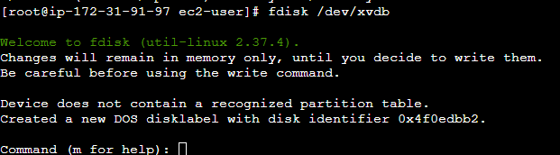

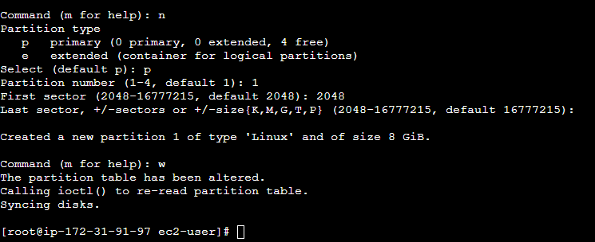

Volume is created now to assign it to filesystem to use.

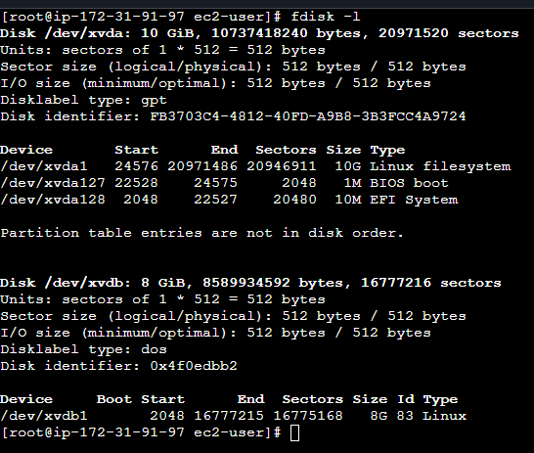

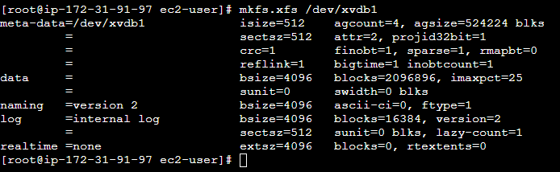

Next is to mount it into a location.

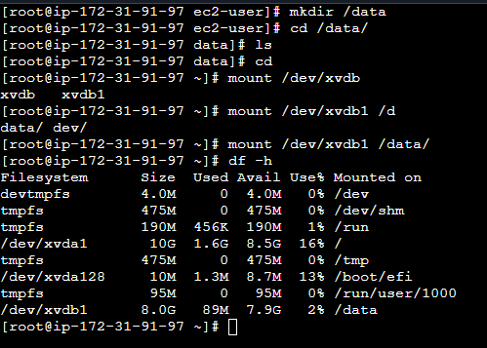

To make it permeant means be there even after reboot we should add entry to /etc/fstab

LVM

Instead of partition multiple disk alone group them to a volume group and partitioning from that volume group.-

* Create 2 volumes and attached to instance

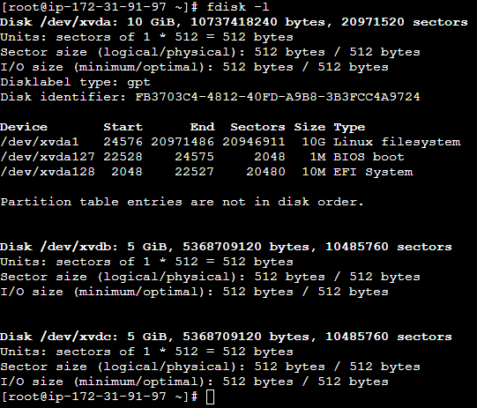

* Create partitioning like we did above, then physical volume creation from it after that volume group from that and then logical volumes and attaching to filesystem.

Swap : virtual memory in linux. If we have full of physical memory

NFS : sharing files or directory with other sytems.

1. Server configuration install packages and start

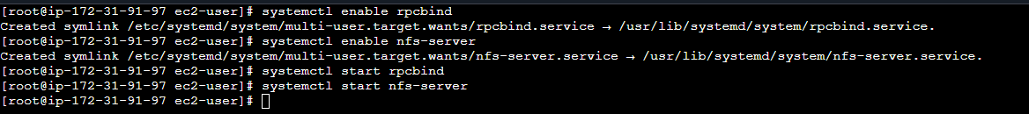

Directory created and gave enough permission

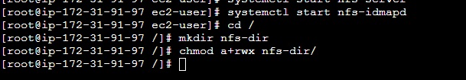

Modify the files configuration /etc/exports



Now export the filesystem



Setup a client server and install packages.disable firewall

Then showmount -e <ip of server> shows the folder in sync

The create a folder and mount filesystem into that.

Samba: share filesystem between different OS unlike NFS

Mysql and mariadb:

Install and enable service

Secure the db by setting password

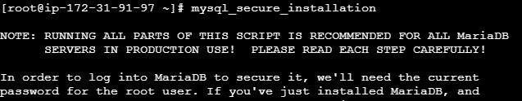

Create db and user

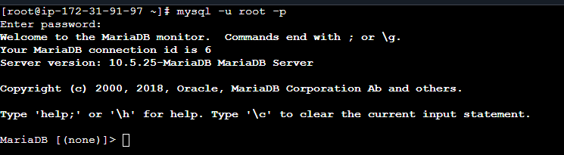

Next steps are in doc

