AWS EC2 - Docker, Jenkins, Apache, Nginx & Tomcat Installation

Launch an EC2 Instance (Amazon Linux 2)
- Step 1: Sign in to the AWS Management Console.
- Step 2: Launch an EC2 instance using Amazon Linux 2.
- Step 3: Configure inbound rules for ports 22, 80, 81, 82 and 8080.
- Step 4: Connect to the instance using EC2 Instance Connect or SSH.

Install Docker
- Step 1: Update packages.
- Step 2: Install Docker using yum.
- Step 3: Start and enable Docker.
- Step 4: Verify Docker is running.
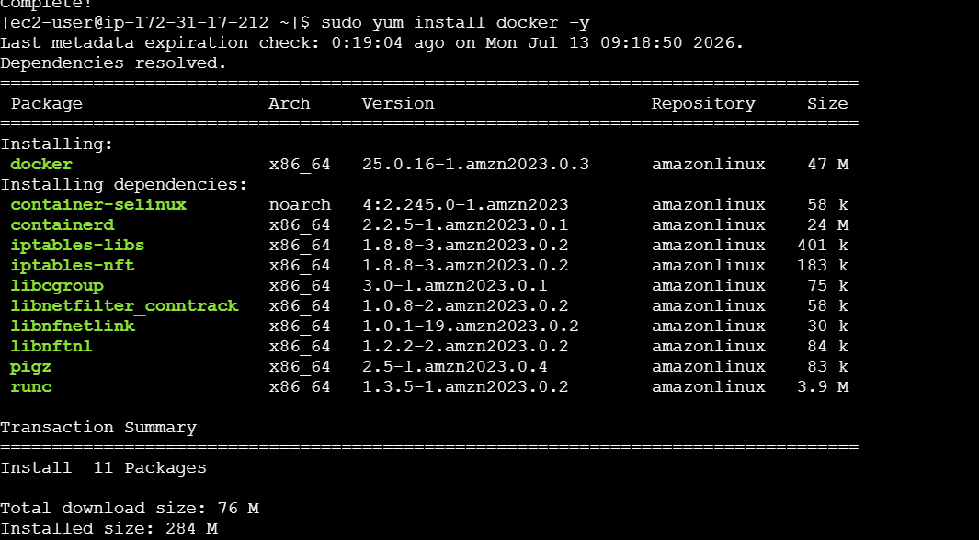
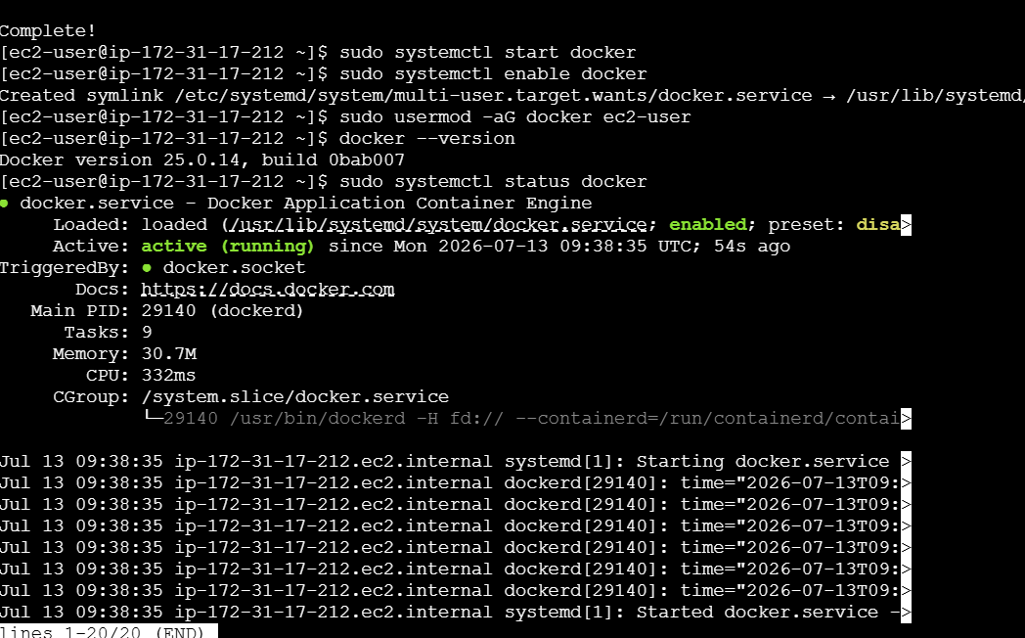

Install Jenkins
- Step 1: Install Java 17.
- Step 2: Configure the Jenkins repository.
- Step 3: Install and start Jenkins.
- Step 4: Open port 8080 and unlock Jenkins using the initial password.
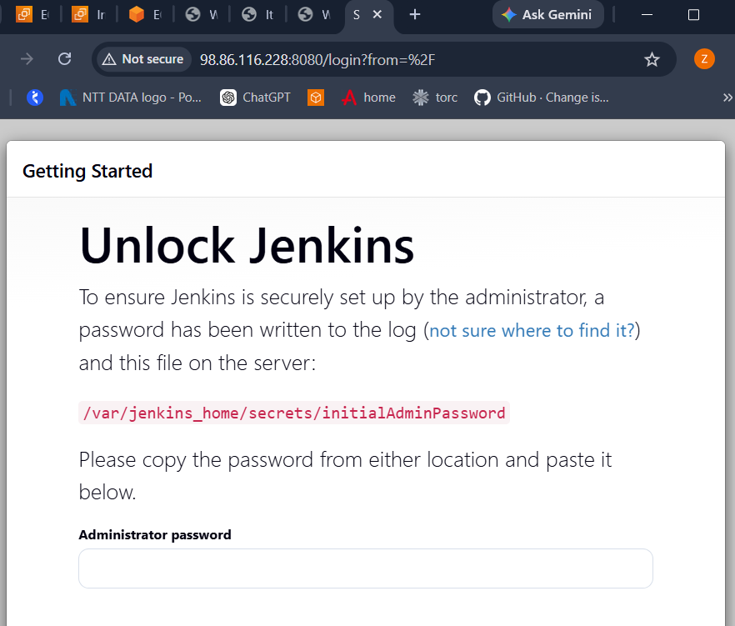

Install Apache HTTP Server
- Step 1: Install httpd.
- Step 2: Start and enable the service.
- Step 3: Verify the service status.
- Step 4: Open Apache in the browser.
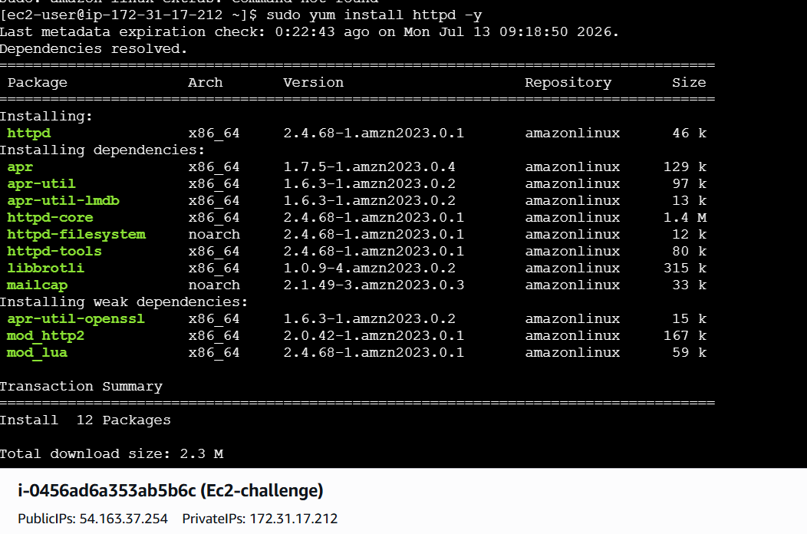
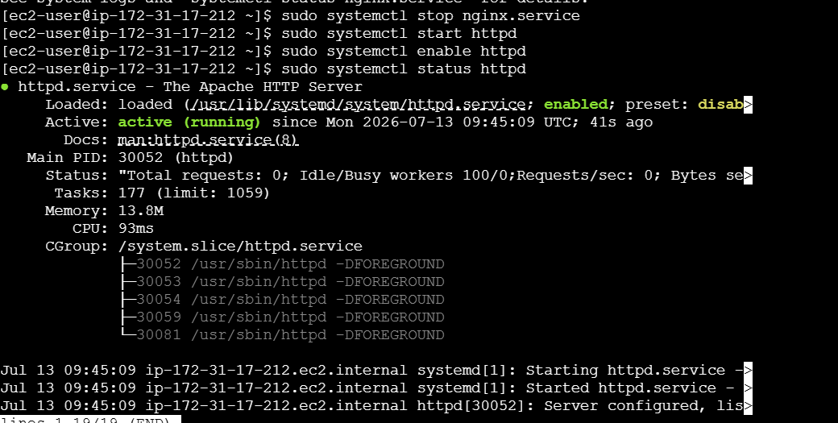
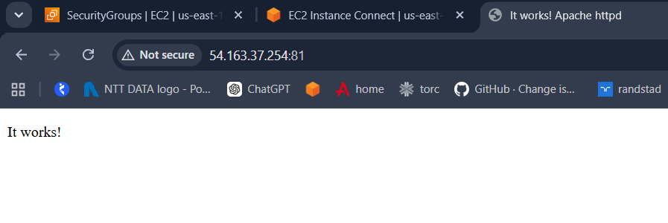
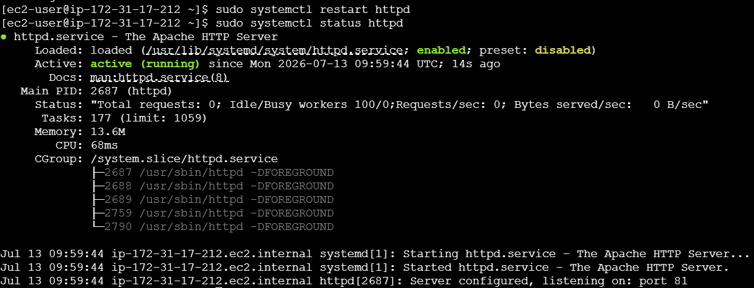

Install Nginx
- Step 1: Install Nginx.
- Step 2: Start and enable Nginx.
- Step 3: Verify the service.
- Step 4: Customize the default page.
- Step 5: Access Nginx in a browser.
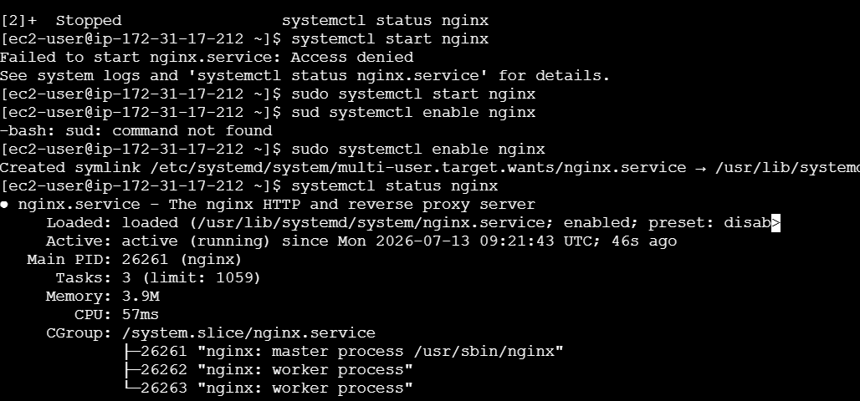
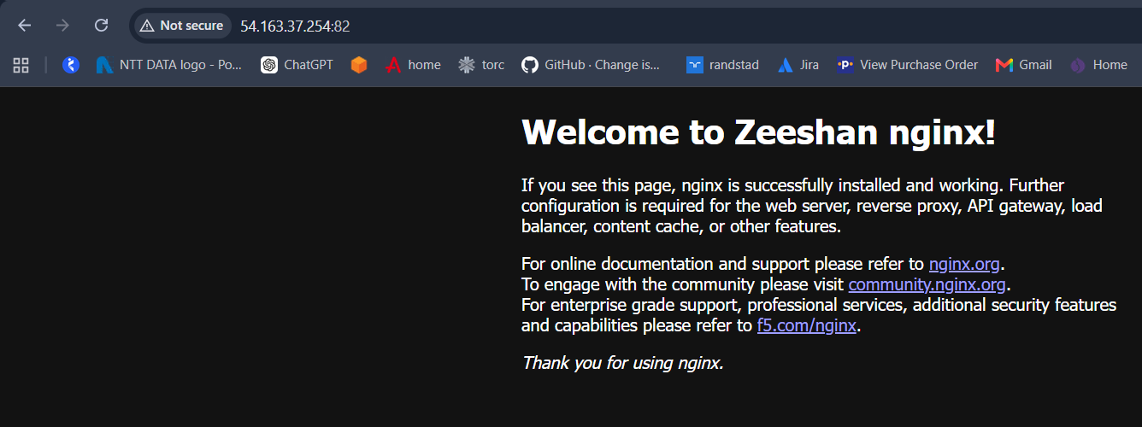
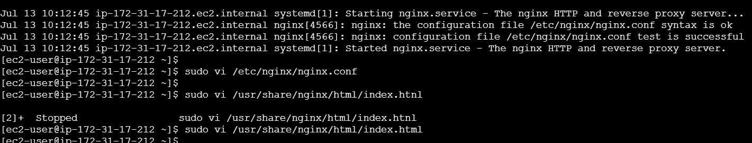

Install Apache Tomcat
- Step 1: Install Java.
- Step 2: Install and configure Tomcat.
- Step 3: Start Tomcat.
- Step 4: Verify Tomcat on port 8080.
