Bash Scripting Assignment - Task Completion Evidence
This document contains execution evidence for the completed Bash scripting tasks on an AWS EC2 Linux instance.

Task 1: Check if a directory is available or not
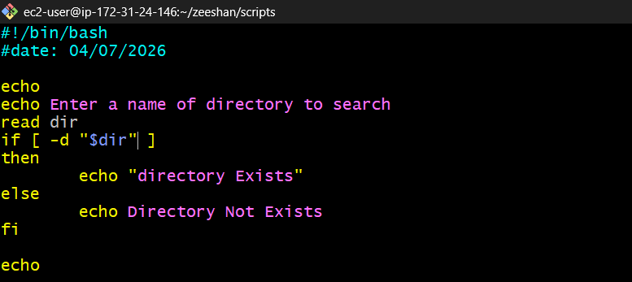

Task 2: Create multiple files
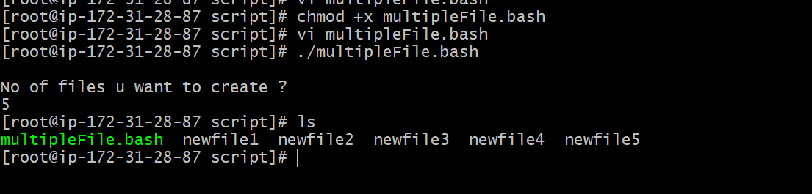

Task 3: Take a backup of a directory
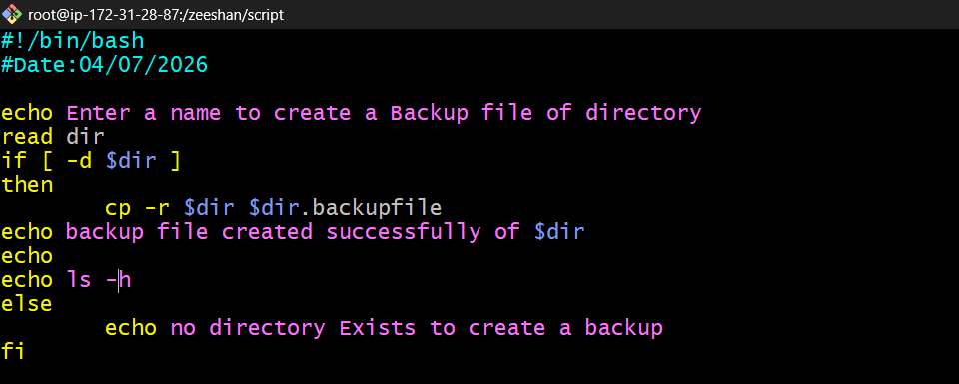
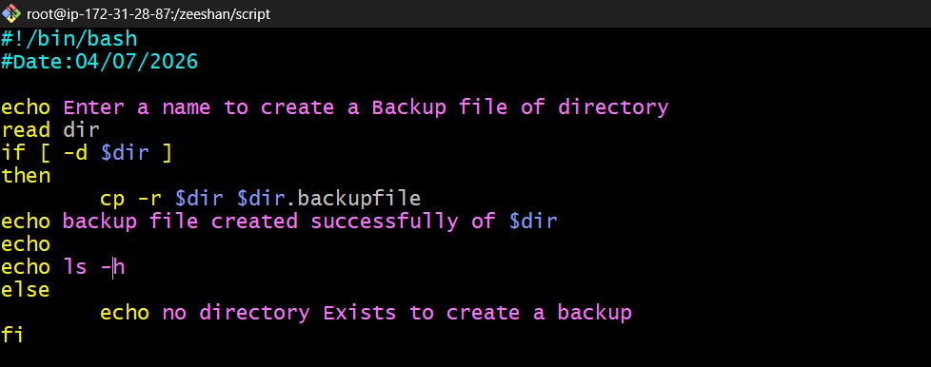

Task 4: Install Nginx on an EC2 server
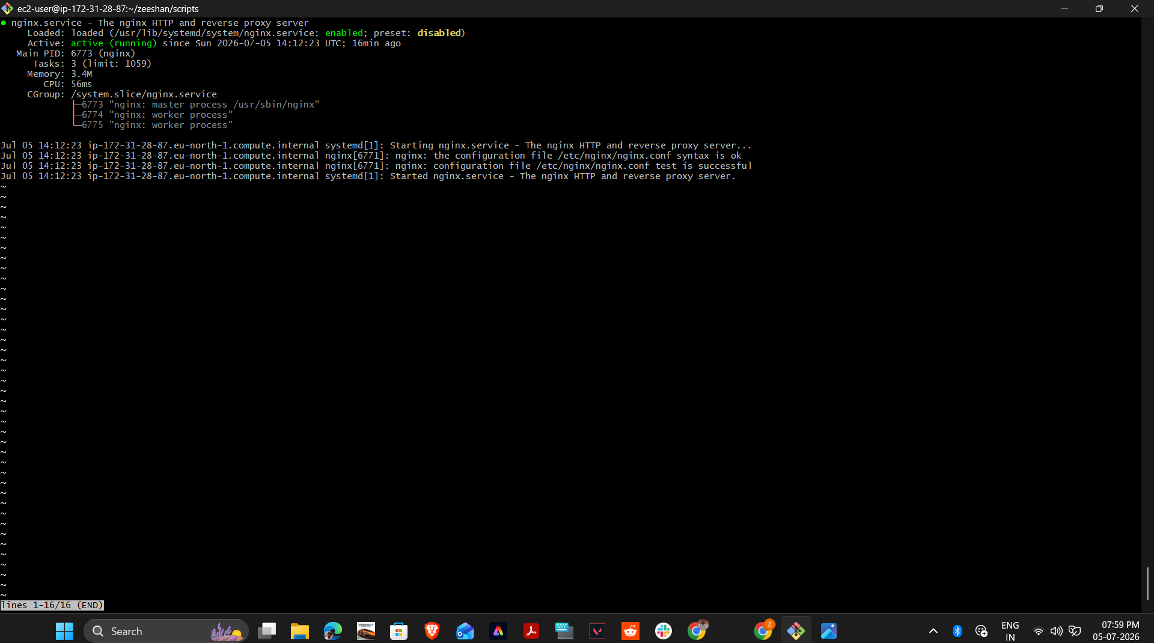

Task 5: Install Apache Tomcat on an EC2 server
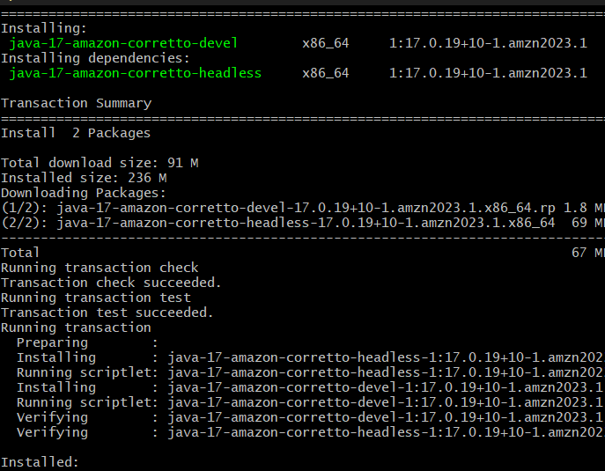

Task 6: Check if the Nginx service is running; if not, start the service
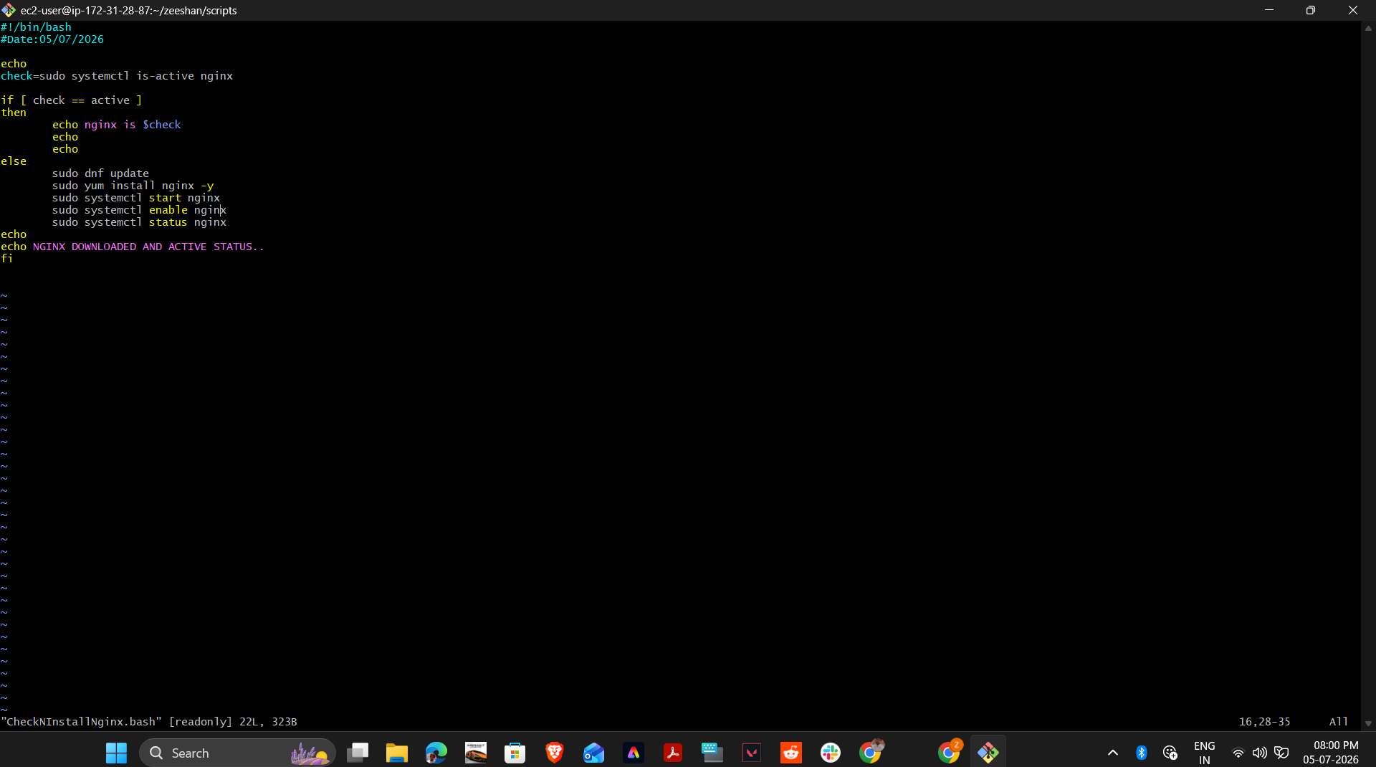
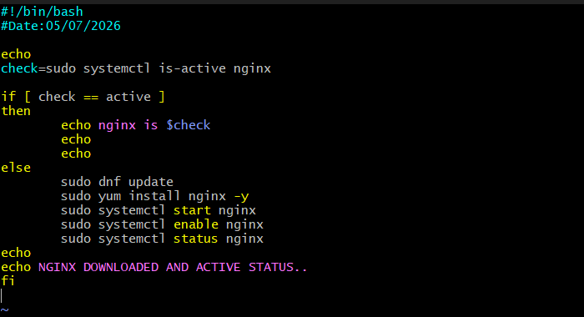
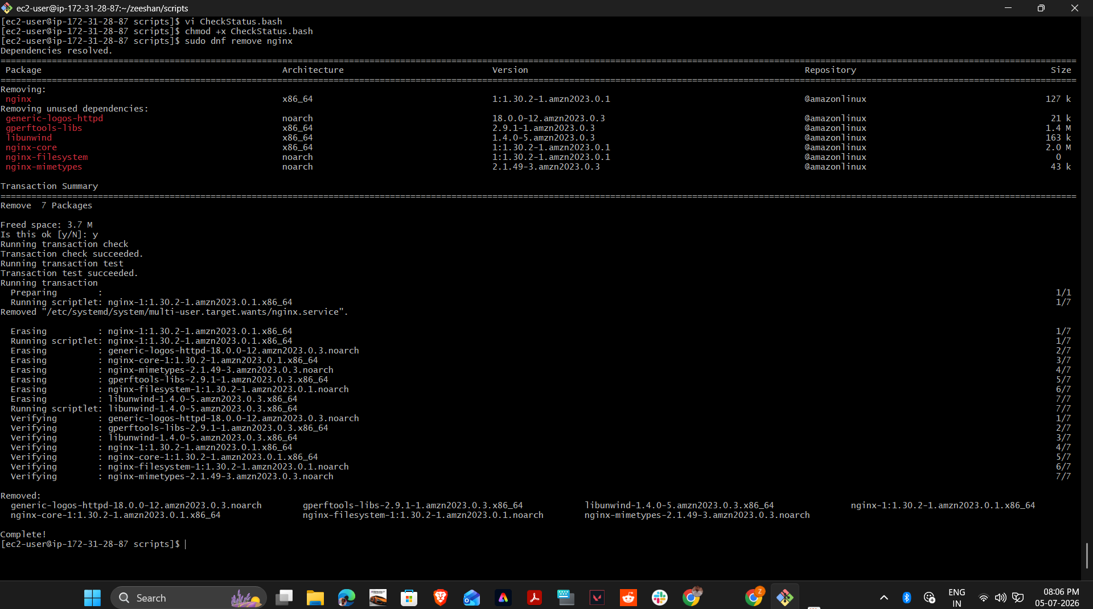
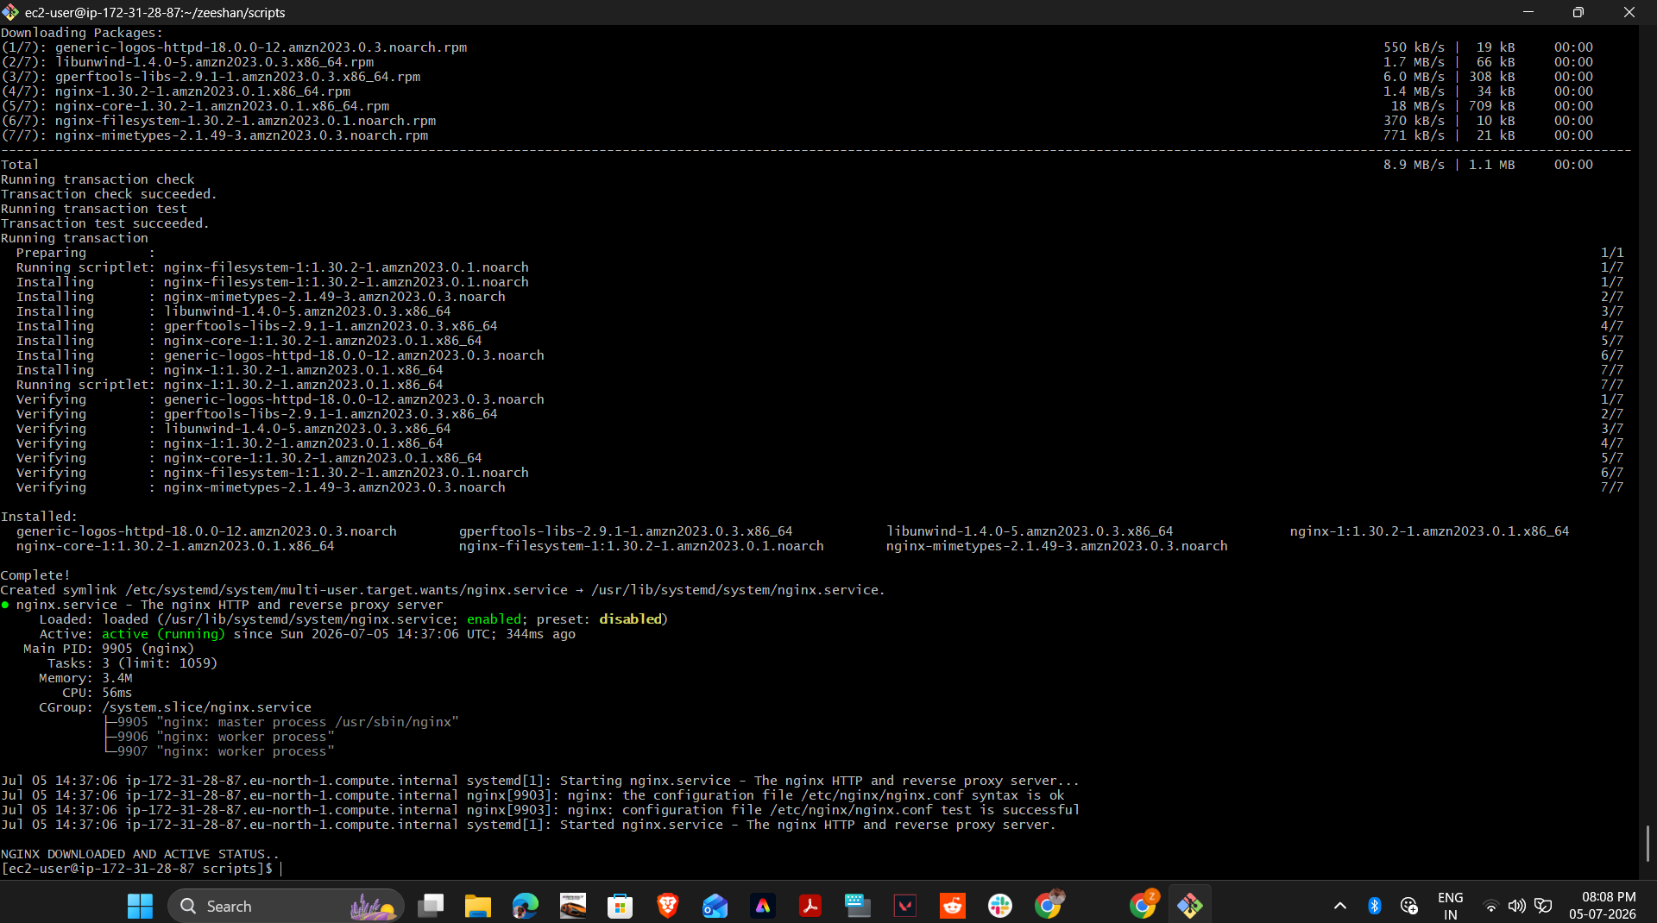
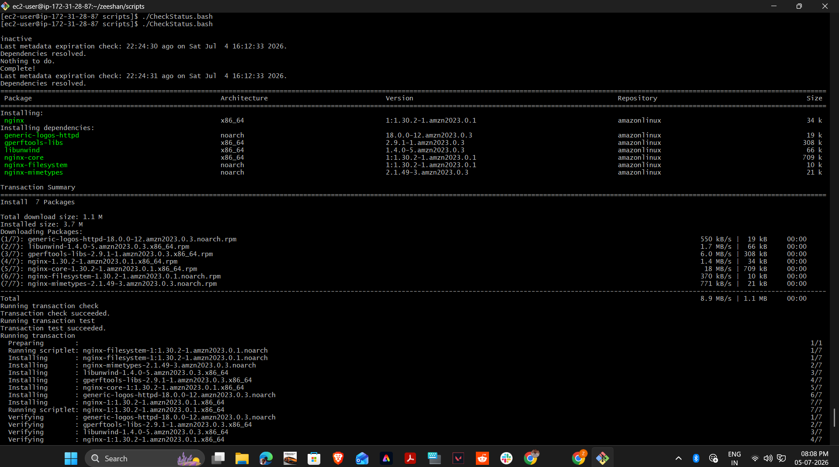
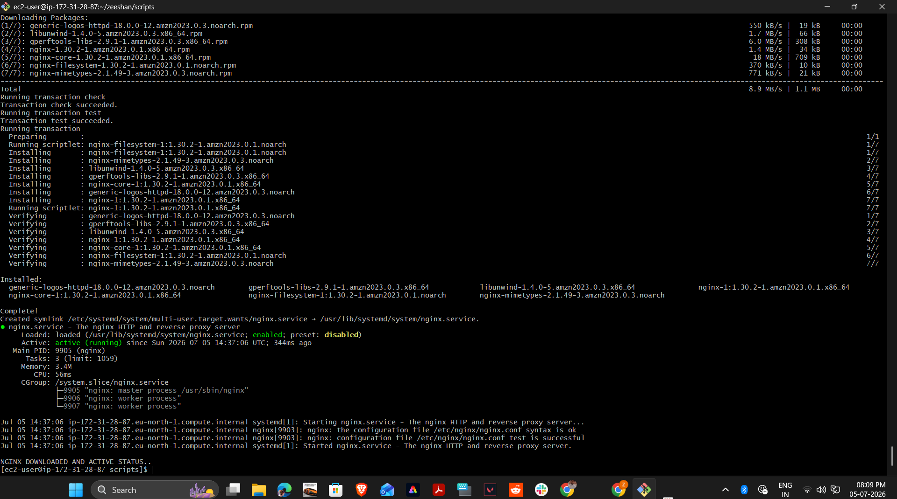


Task 7: Calculator script
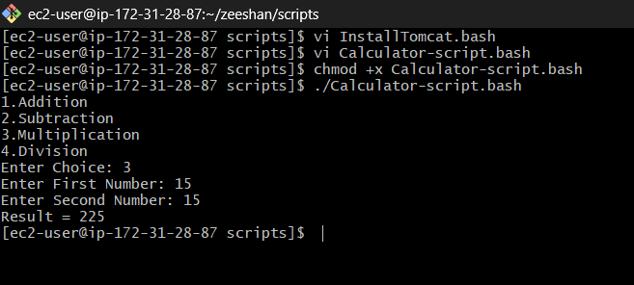
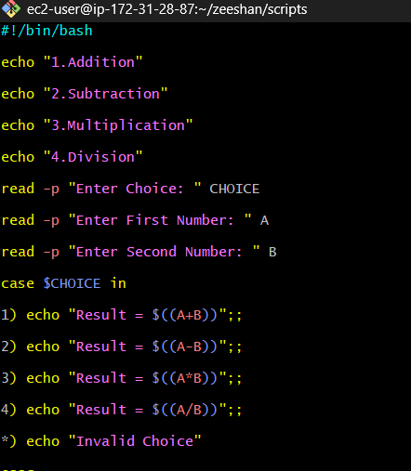

Task 8: Check if a directory exists; if not, create it
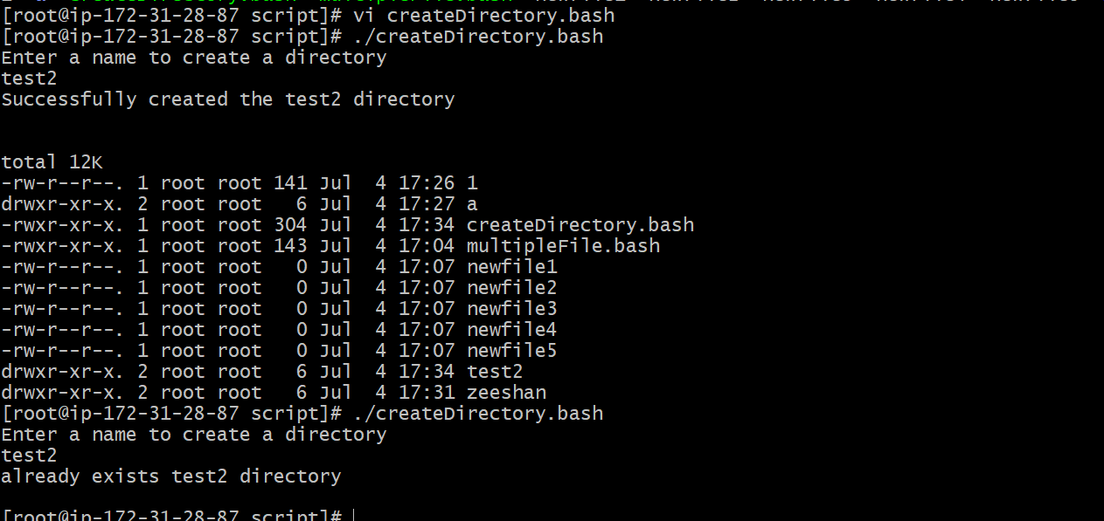
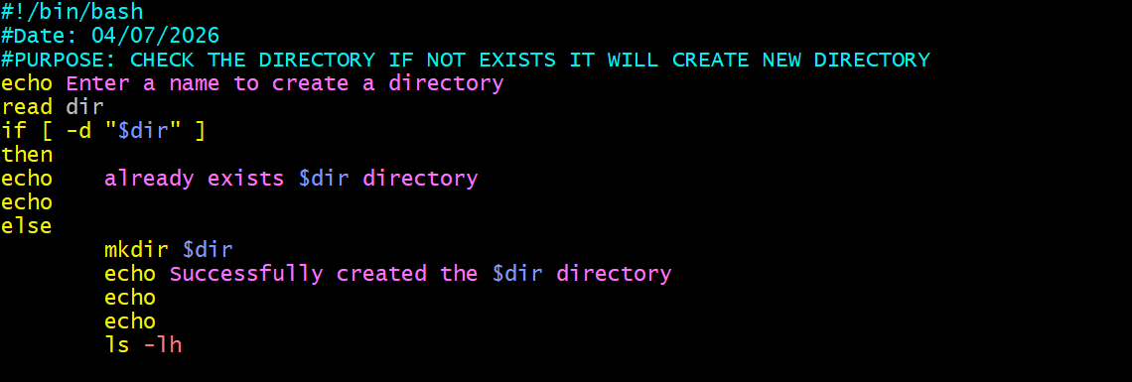

Task 9: Delete the last 3 lines of a file
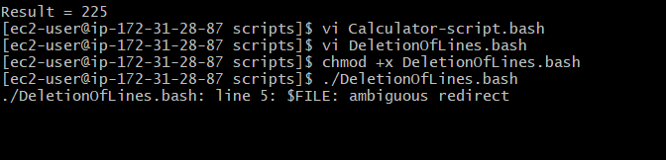

Task 9: Delete the Last 3 Lines of a File (Additional Evidence)
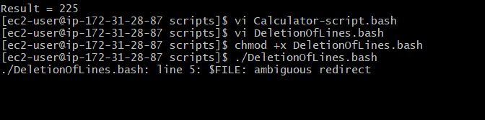

Task 10: CPU Monitoring Script (>80%)
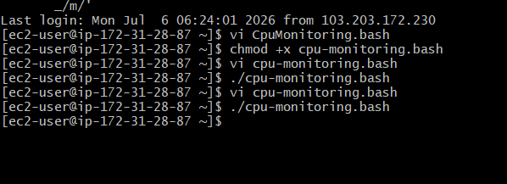
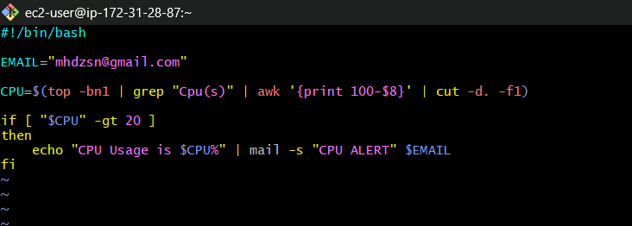

Task 11: Disk Monitoring Script (>80%)
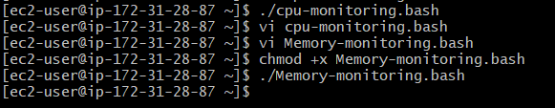
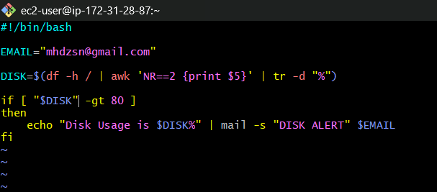

Task 12: Memory Monitoring Script (>80%)
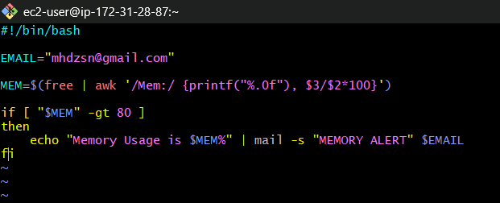
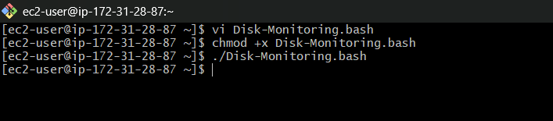

Exercise: Crontab Entries
Commands Executed
Command | Purpose
sudo systemctl status crond | Checks whether the cron daemon is running.
crontab -e | Opens the user's crontab for editing.
crontab crontab.sh | Installs cron jobs from crontab.sh.
crontab -l | Displays all installed cron jobs.

Crontab Entries
Requirement | Cron Expression
April 5th Midnight | 0 0 5 4 *
5th of January, June, November if Thursday | 0 0 5 1,6,11 4
At 05 and 27 minutes of 9,10,11 hours every day | 5,27 9-11 * * *
9:34 AM on 15th August | 34 9 15 8 *
Every Midnight | 0 0 * * *
Every Saturday at 11:59 PM | 59 23 * * 6
After Every Reboot | @reboot

Execution Evidence
