Bash Scripting Task Completion Report
Date: 03/07/2026
Objective: Execute Bash scripting tasks and document the execution steps with evidence.

Task 1: IF / IF ELSE
Steps:
1. Create/Edit the bash script.
2. Provide execute permission using chmod +x.
3. Execute using ./scriptname.bash.
4. Verify the expected output.
Result: Executed voter eligibility script and verified conditional execution.

Task 2: CASE
Steps:
1. Create/Edit the bash script.
2. Provide execute permission using chmod +x.
3. Execute using ./scriptname.bash.
4. Verify the expected output.
Result: Executed menu-driven case statement for date, ls, who, uptime.

Task 3: Backup State
Steps:
1. Create/Edit the bash script.
2. Provide execute permission using chmod +x.
3. Execute using ./scriptname.bash.
4. Verify the expected output.
Result: Verified backup decision using current weekday.

Task 4: IF THEN
Steps:
1. Create/Edit the bash script.
2. Provide execute permission using chmod +x.
3. Execute using ./scriptname.bash.
4. Verify the expected output.
Result: Validated numeric comparison using if-then.

Task 5: File Check
Steps:
1. Create/Edit the bash script.
2. Provide execute permission using chmod +x.
3. Execute using ./scriptname.bash.
4. Verify the expected output.
Result: Verified file existence using -e condition.

Task 6: Variable Test
Steps:
1. Create/Edit the bash script.
2. Provide execute permission using chmod +x.
3. Execute using ./scriptname.bash.
4. Verify the expected output.
Result: Validated variable-based condition.

Task 7: User Interaction
Steps:
1. Create/Edit the bash script.
2. Provide execute permission using chmod +x.
3. Execute using ./scriptname.bash.
4. Verify the expected output.
Result: Collected user input and displayed conditional output.

Task 8: DO WHILE / WHILE
Steps:
1. Create/Edit the bash script.
2. Provide execute permission using chmod +x.
3. Execute using ./scriptname.bash.
4. Verify the expected output.
Result: Executed loop printing messages repeatedly.

Execution Evidence
Evidence 1
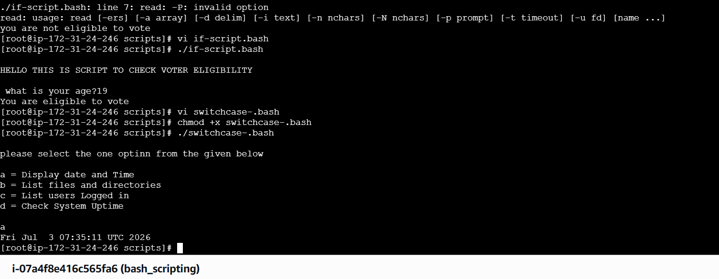
Evidence 2
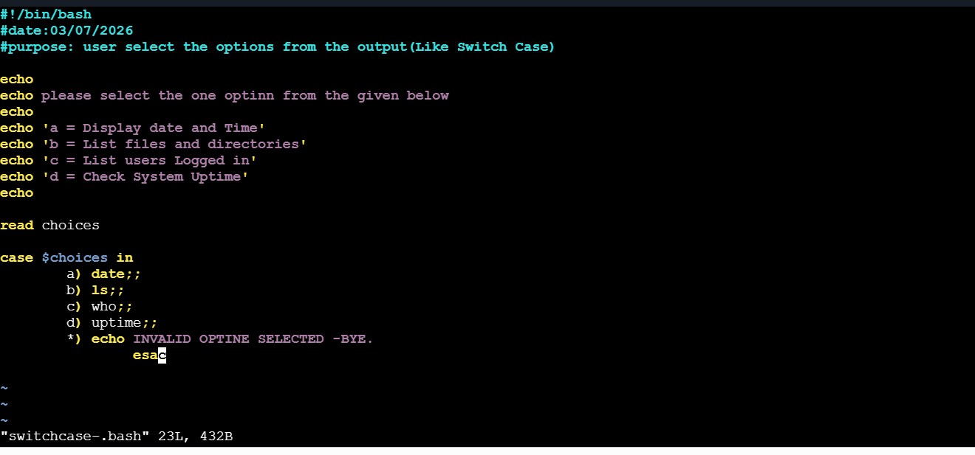
Evidence 3
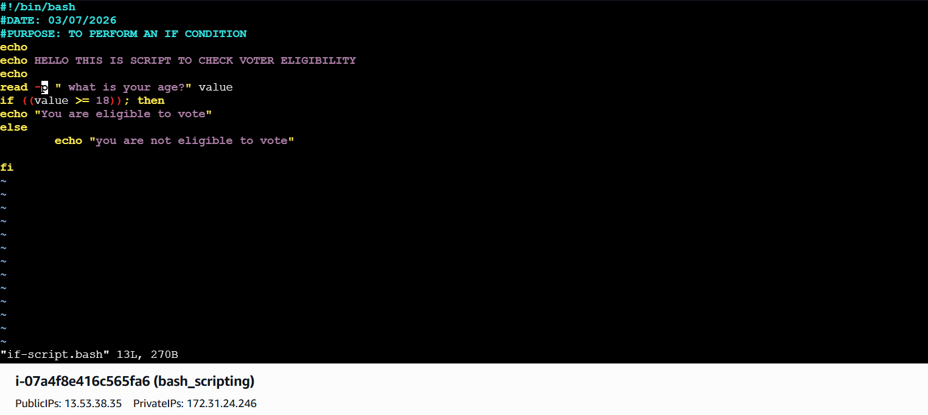
Evidence 4
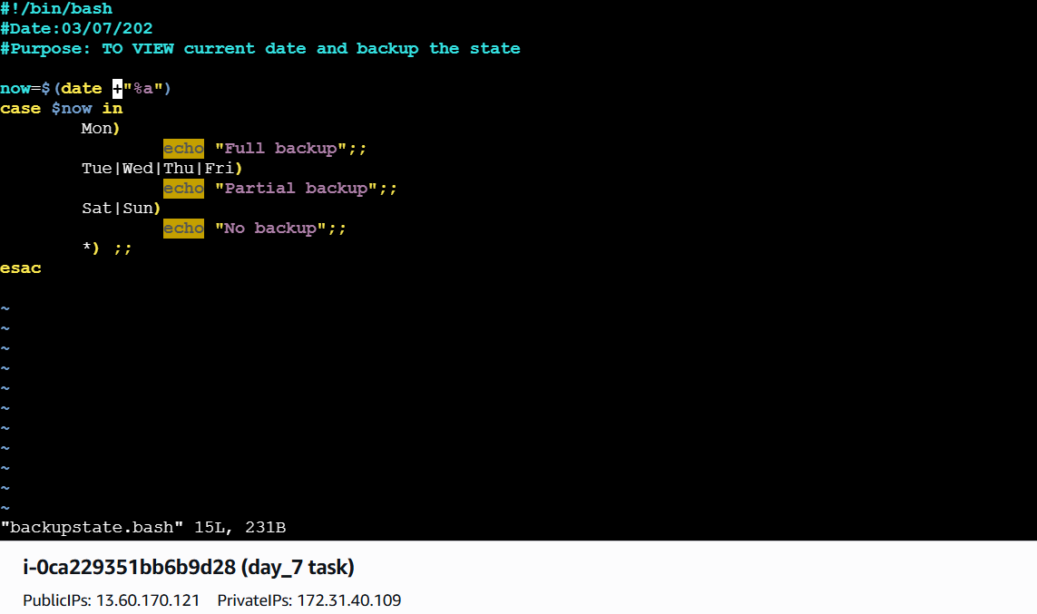
Evidence 5
Evidence 6
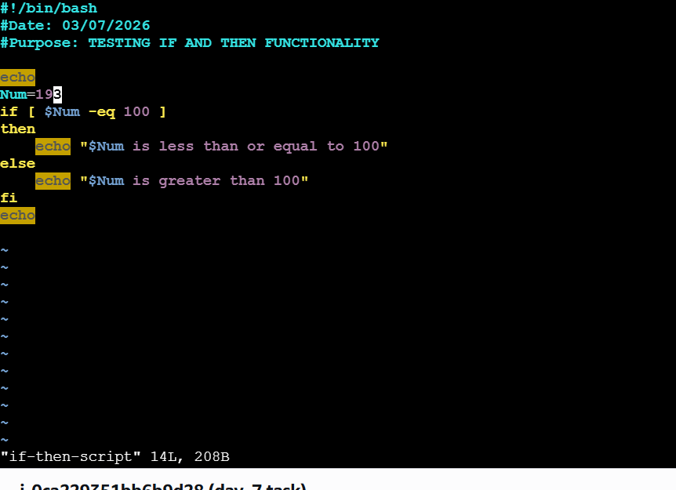
Evidence 7
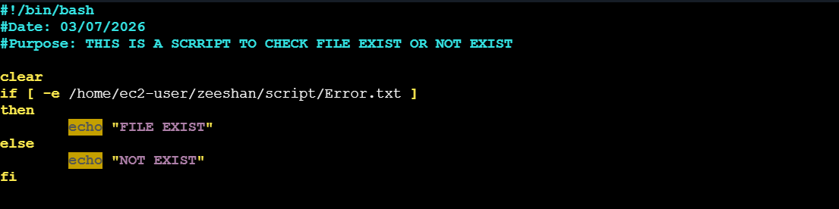
Evidence 8
Evidence 9
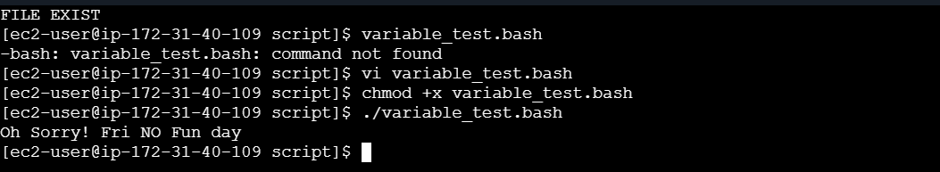
Evidence 10
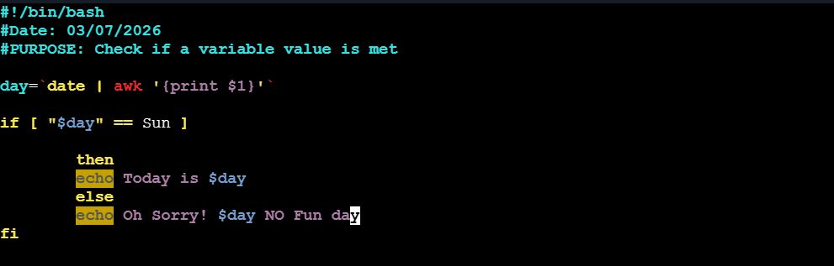
Evidence 11
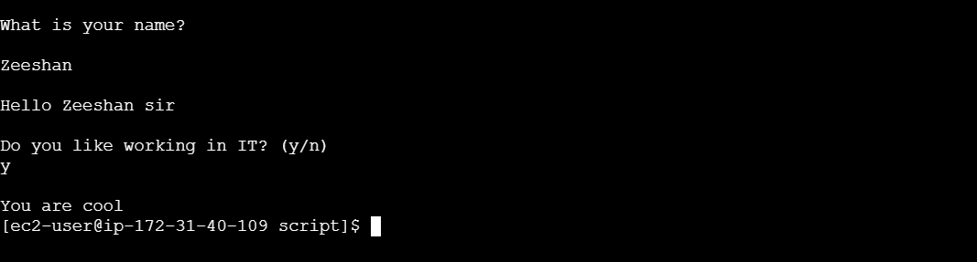
Evidence 12
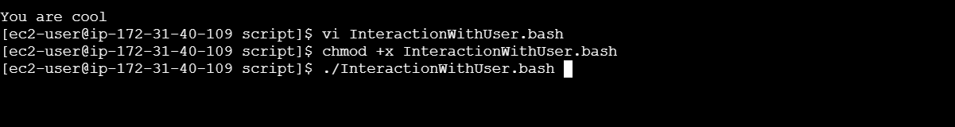
Evidence 13
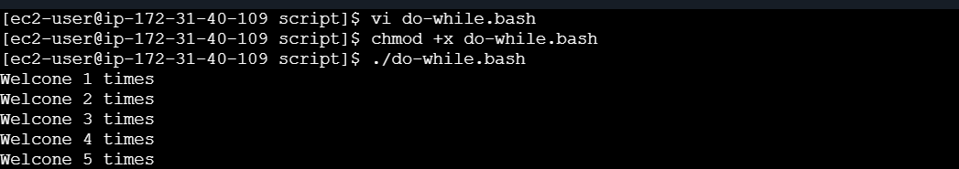
Evidence 14
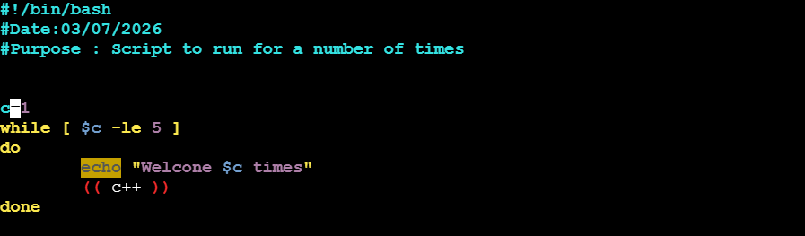
Evidence 15
Evidence 16
