AWS VPC Project Documentation

Create VPC with 2 Public and 2 Private Subnets
- Step 1: Create a VPC.
- Step 2: Create two public and two private subnets.
- Step 3: Assign CIDR blocks.
- Step 4: Verify subnet creation.
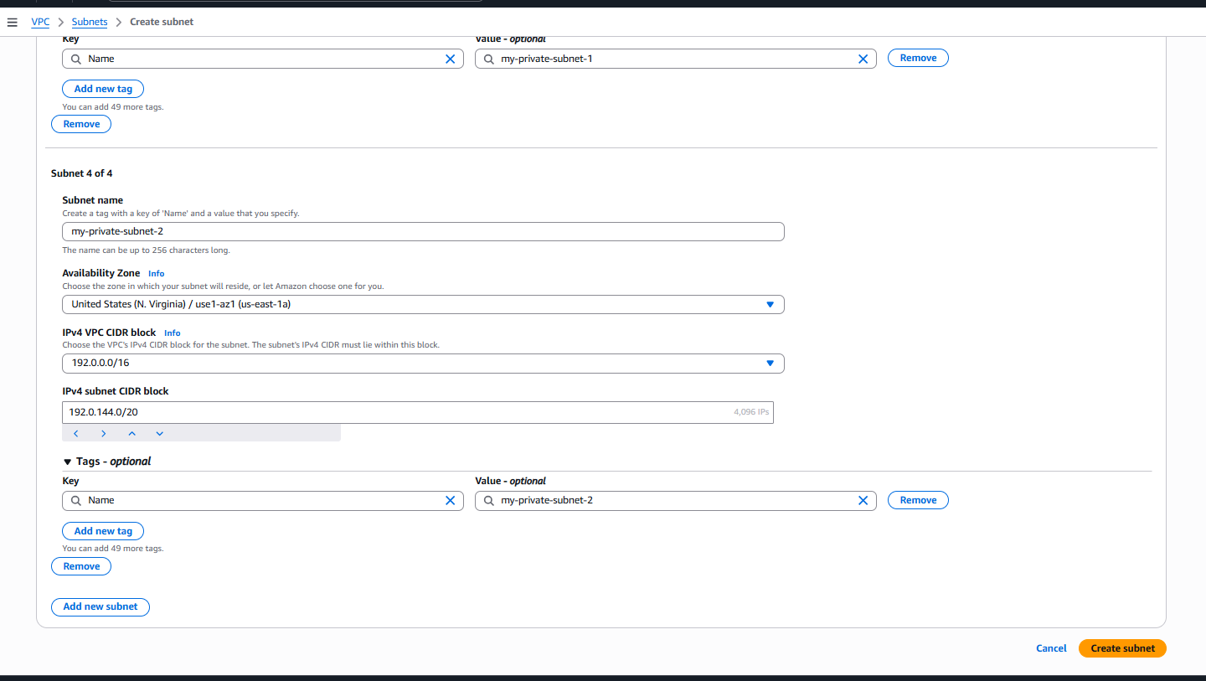
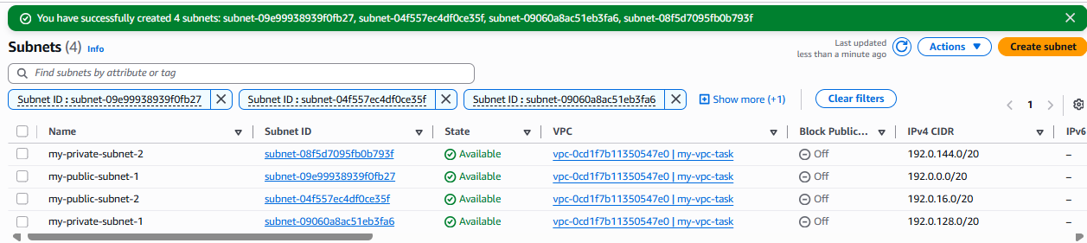

Enable DNS Hostnames
- Step 1: Open VPC settings.
- Step 2: Enable DNS Resolution.
- Step 3: Enable DNS Hostnames.
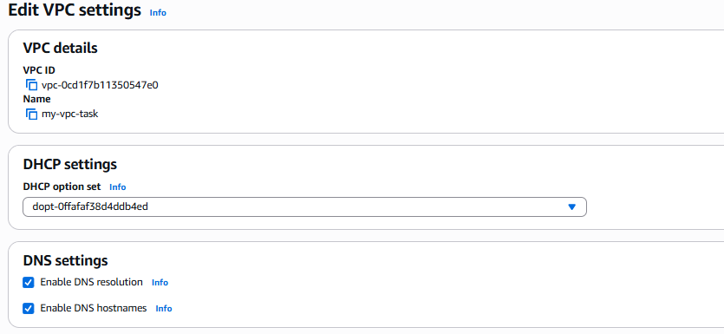

Enable Auto Assign Public IP
- Step 1: Select public subnets.
- Step 2: Edit subnet settings.
- Step 3: Enable Auto-assign Public IP.
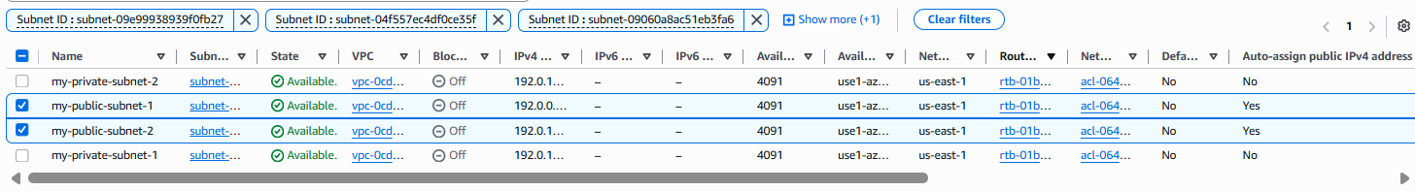

Associate Route Tables
- Step 1: Associate private subnets with the private route table.
- Step 2: Associate public subnets with the public route table.
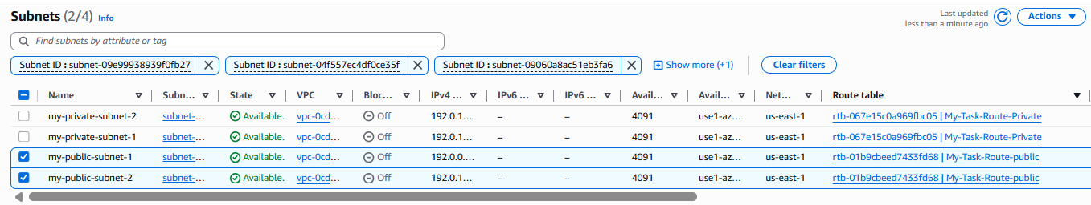
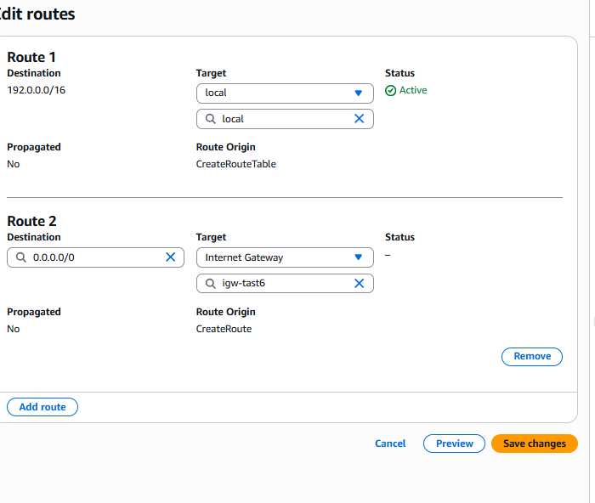

Internet Gateway and Public Route
- Step 1: Attach an Internet Gateway.
- Step 2: Add 0.0.0.0/0 route.
- Step 3: Verify routing.
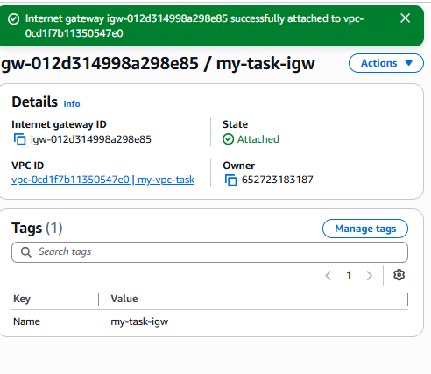
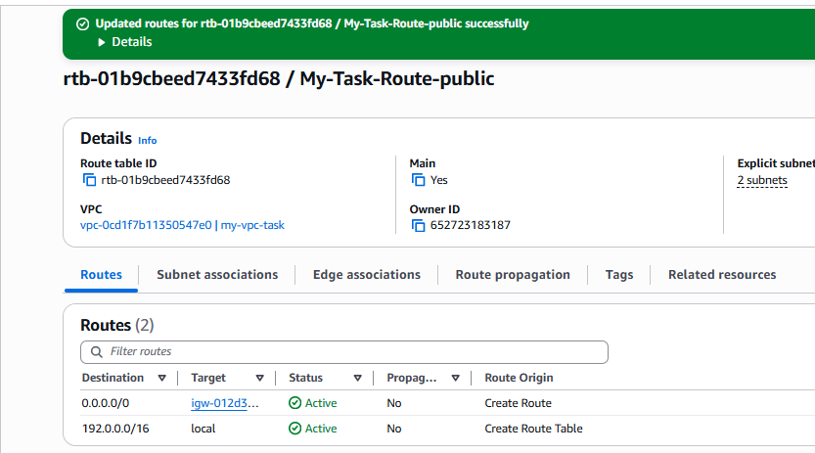
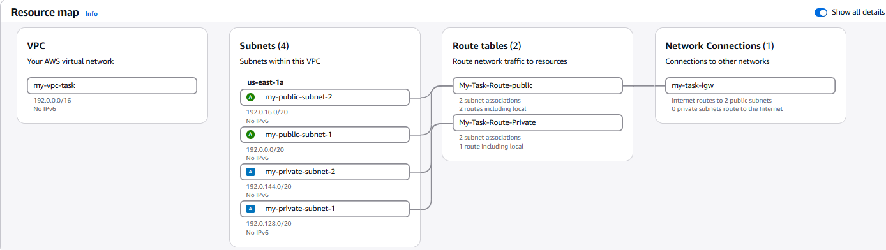

Launch Public EC2 and Install PHP
- Step 1: Launch EC2 in the public subnet.
- Step 2: Install Apache and PHP.
- Step 3: Verify PHP page.
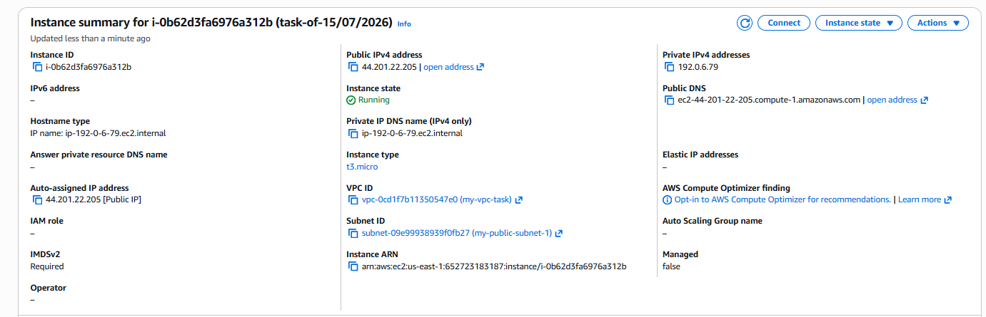
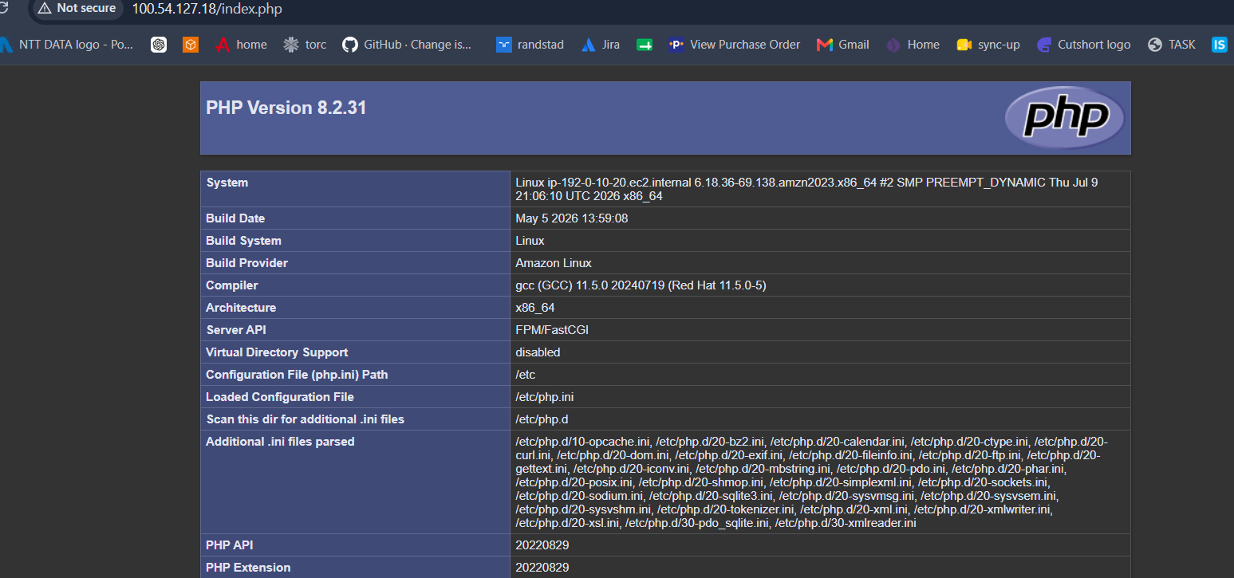
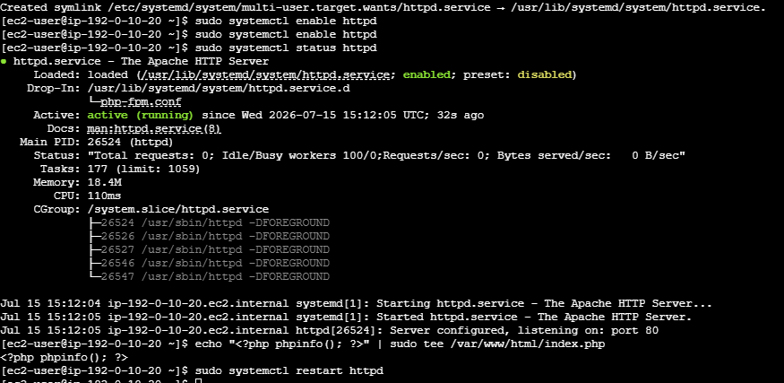

Configure NAT Gateway
- Step 1: Create a NAT Gateway.
- Step 2: Associate an Elastic IP.
- Step 3: Update the private route table.
- Step 4: Verify internet from the private EC2.
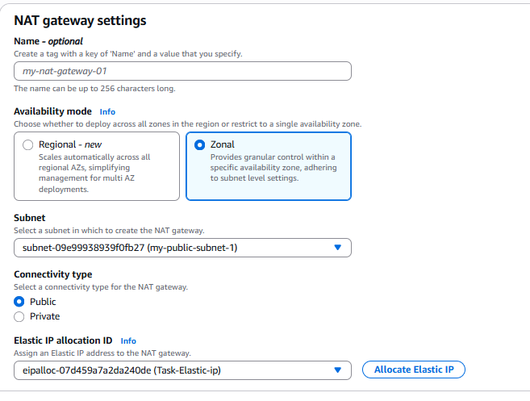
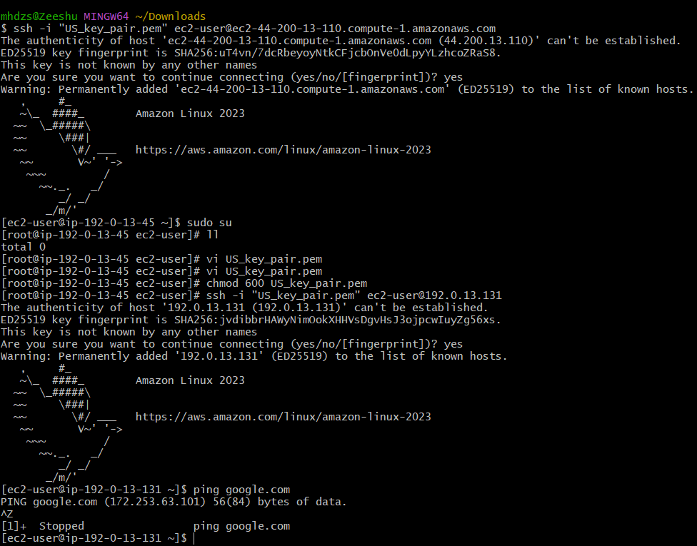

Install Apache Tomcat
- Step 1: Install Java.
- Step 2: Configure Tomcat.
- Step 3: Deploy a sample application.
- Step 4: Verify Tomcat.
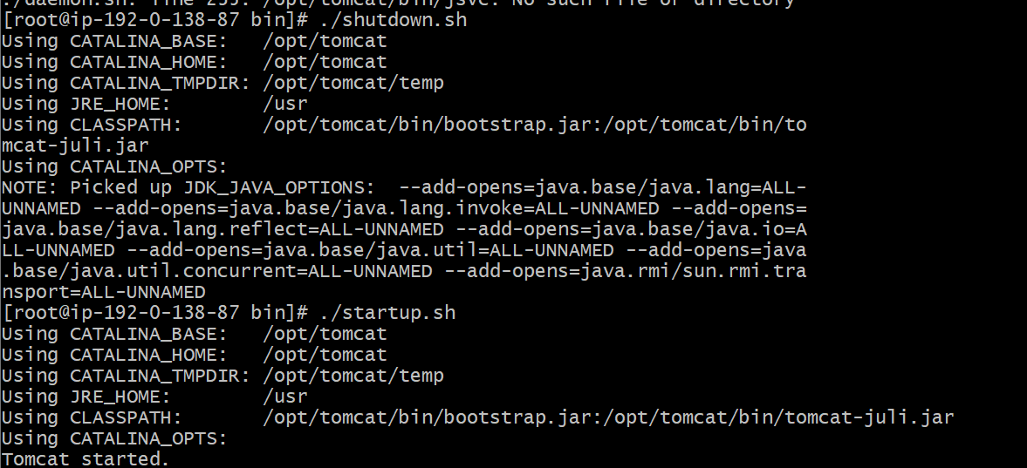
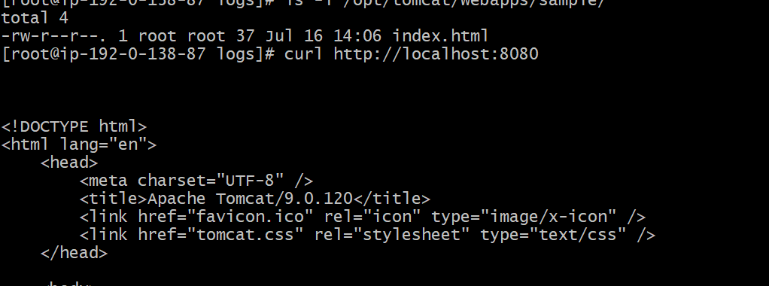
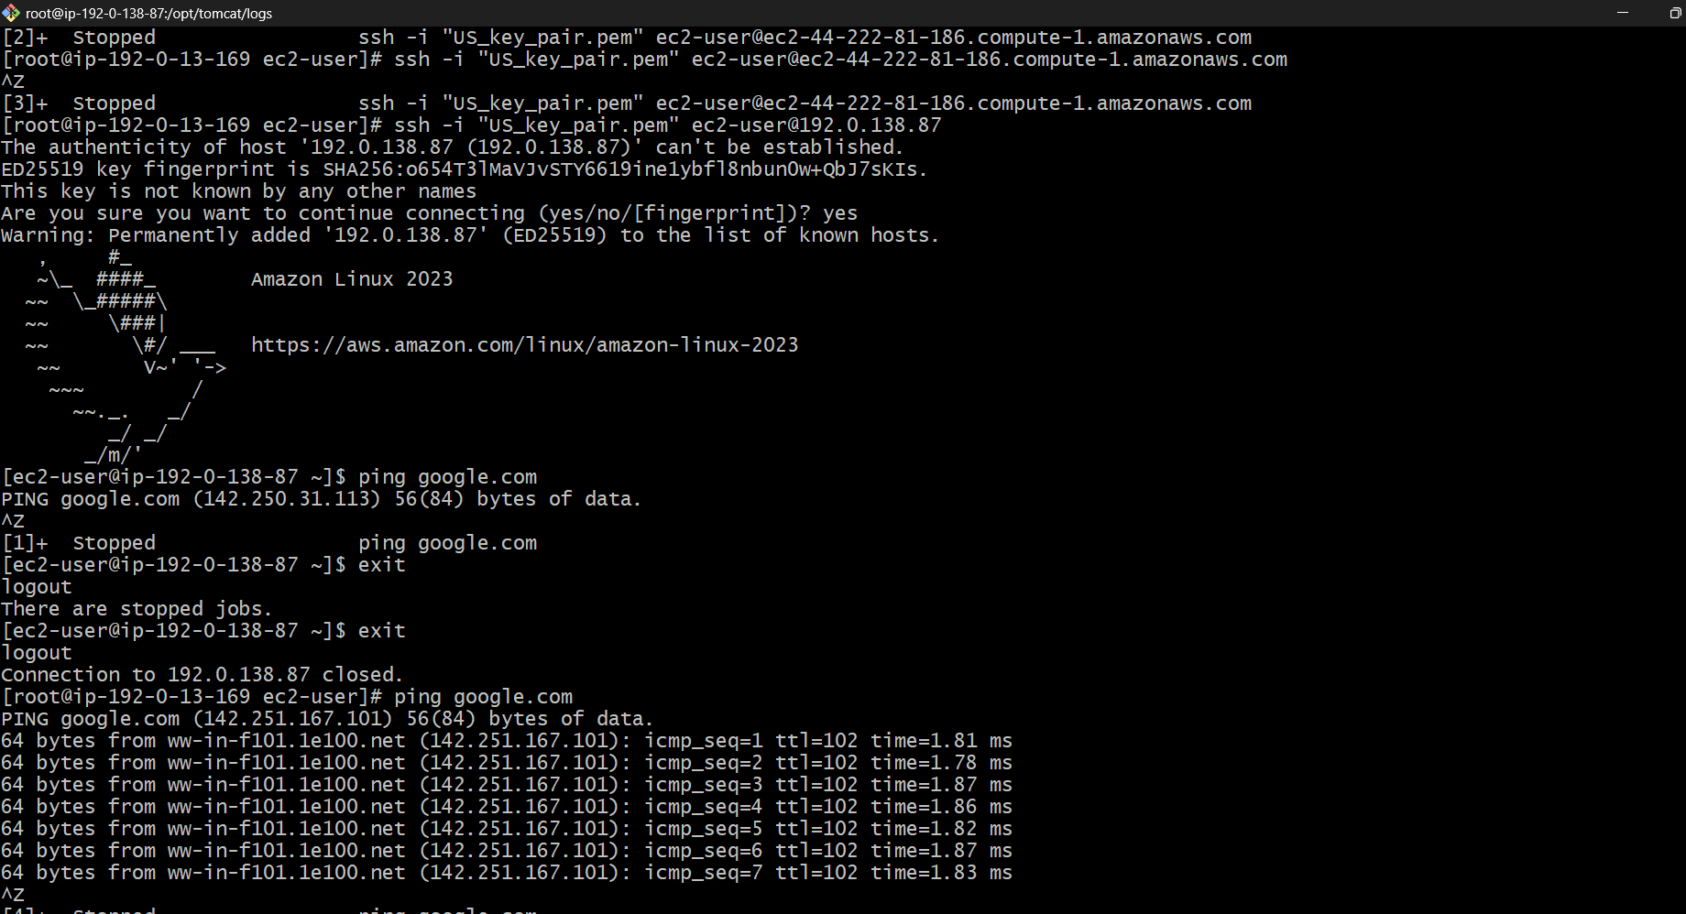

Configure VPC Flow Logs
- Step 1: Create VPC Flow Logs.
- Step 2: Store logs in S3.
- Step 3: Store logs in CloudWatch.
- Step 4: Verify logs.
