AWS EC2

Outcome
Successfully completed all EC2 administration tasks.

Objective
Demonstrate EC2 provisioning, user data, Windows, snapshots, SSH, Spot, termination protection and AWS CLI.

Prerequisites
AWS Account, IAM User, Key Pair, Security Group, Internet Access, AWS CLI.

Architecture Overview
Amazon Linux 2, Ubuntu and Windows Server instances were used to deploy Apache, Nginx and Tomcat.

Amazon Linux 2 + Apache
- Step 1: Launch the required EC2 instance.
- Step 2: Perform the required configuration.
- Step 3: Verify the successful execution.
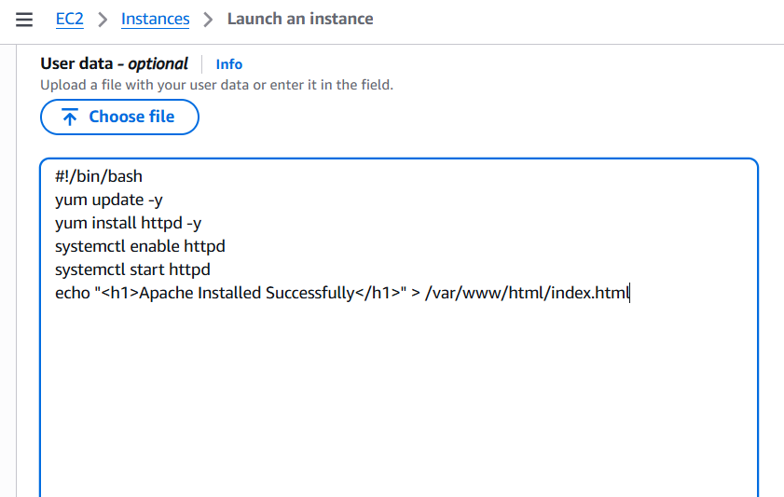
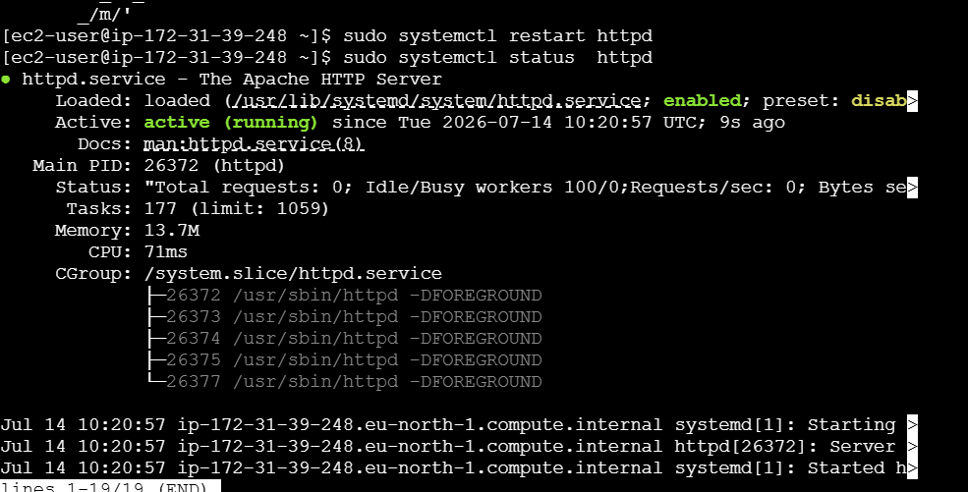
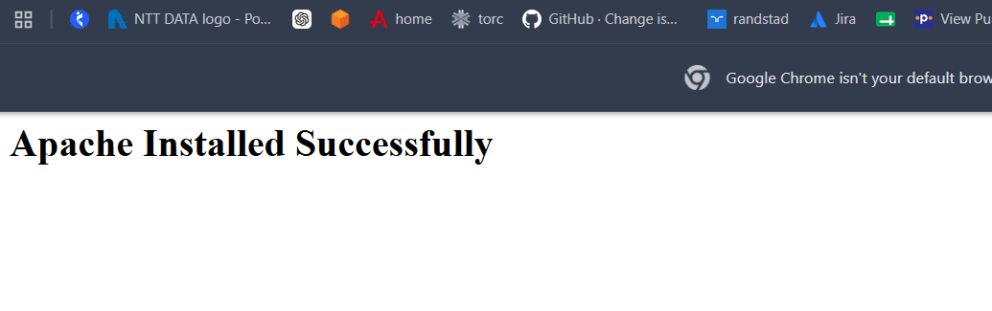

Ubuntu + Nginx
- Step 1: Launch the required EC2 instance.
- Step 2: Perform the required configuration.
- Step 3: Verify the successful execution.
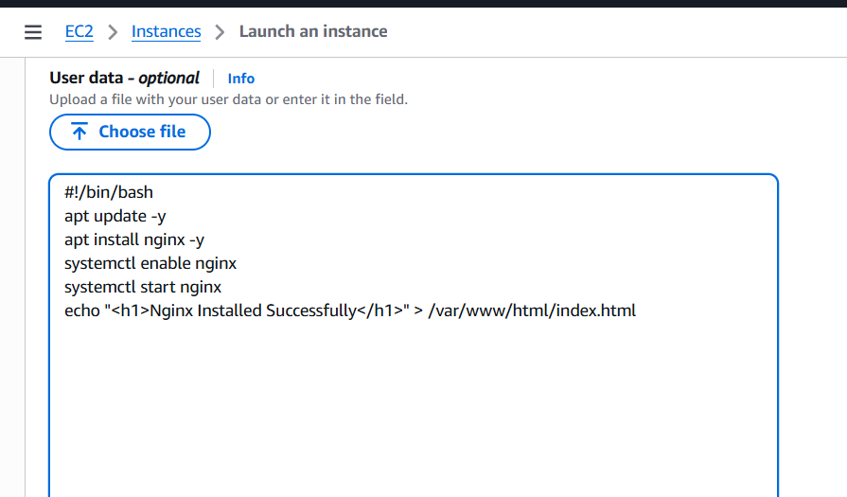
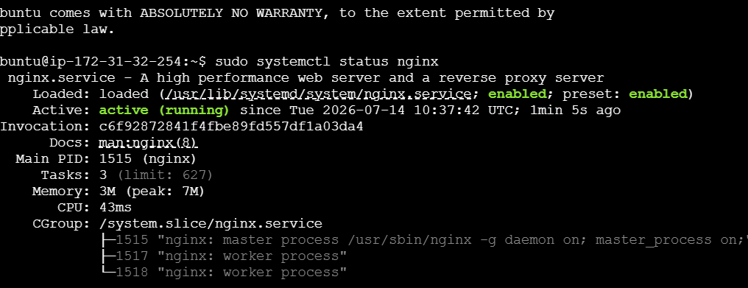
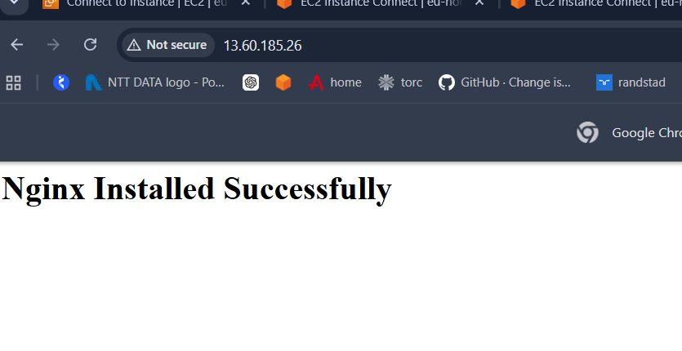

Windows + Tomcat
- Step 1: Launch the required EC2 instance.
- Step 2: Perform the required configuration.
- Step 3: Verify the successful execution.
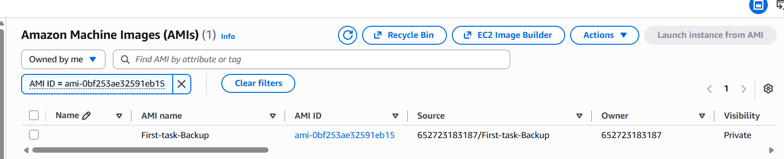
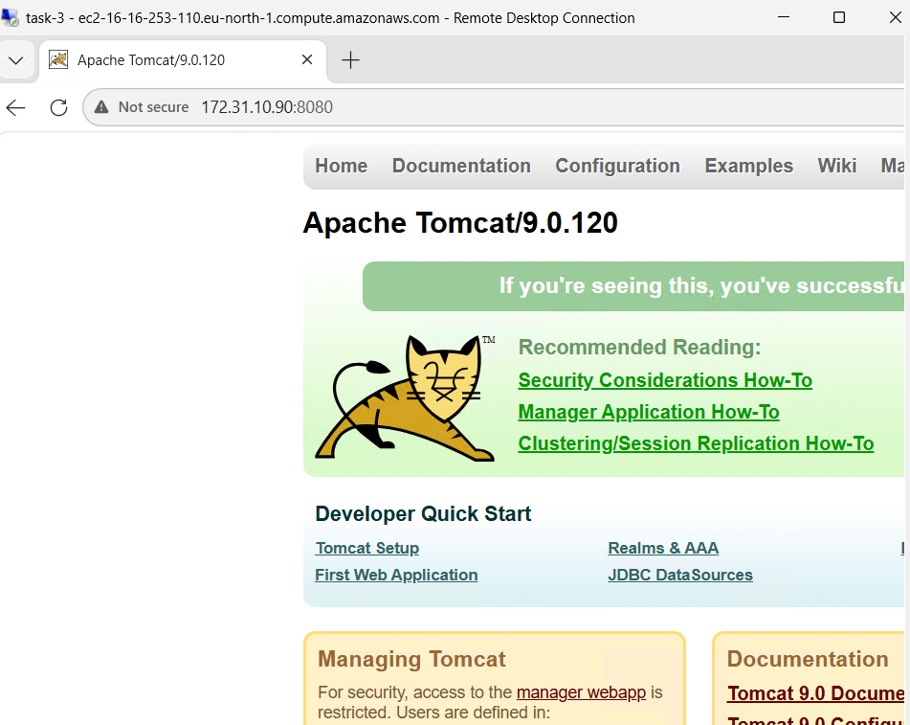

Snapshot
- Step 1: Launch the required EC2 instance.
- Step 2: Perform the required configuration.
- Step 3: Verify the successful execution.
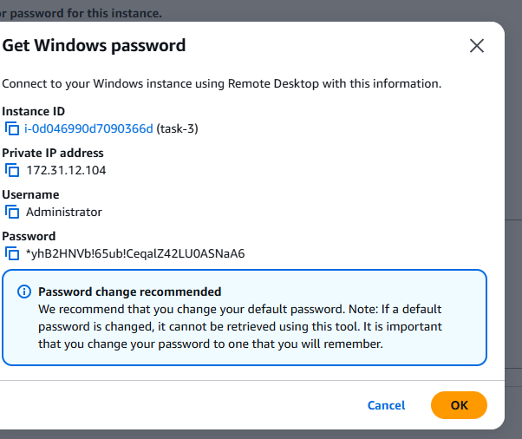

Passwordless Authentication
- Step 1: Launch the required EC2 instance.
- Step 2: Perform the required configuration.
- Step 3: Verify the successful execution.
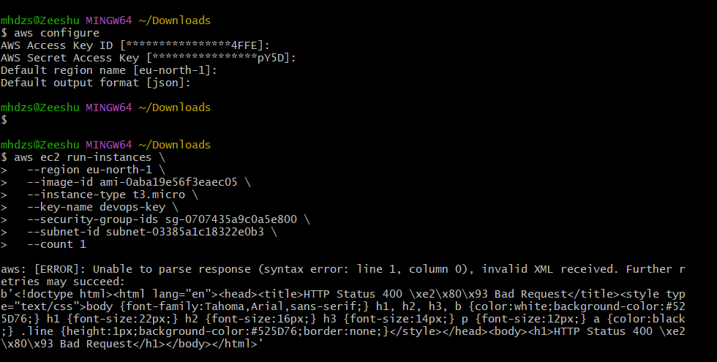

Spot Instance
- Step 1: Launch the required EC2 instance.
- Step 2: Perform the required configuration.
- Step 3: Verify the successful execution.

Termination Protection
- Step 1: Launch the required EC2 instance.
- Step 2: Perform the required configuration.
- Step 3: Verify the successful execution.
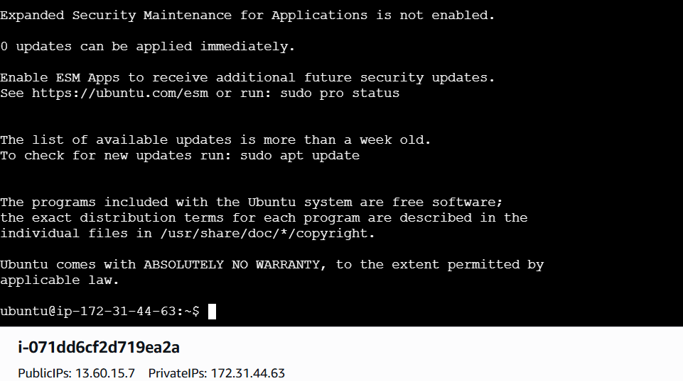

AWS CLI Launch
- Step 1: Launch the required EC2 instance.
- Step 2: Perform the required configuration.
- Step 3: Verify the successful execution.
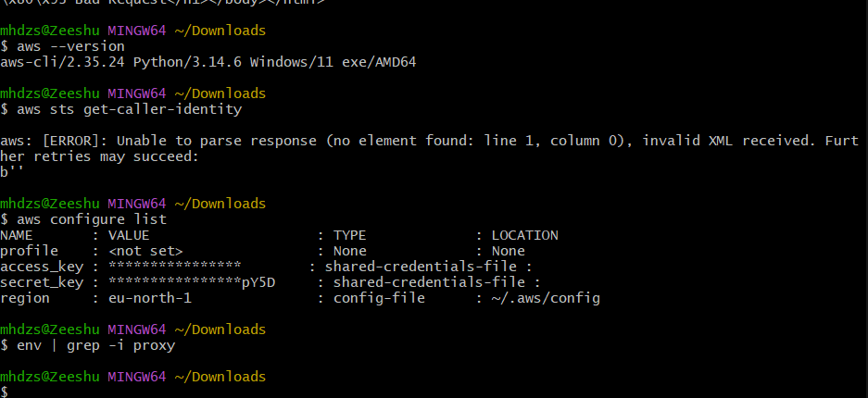
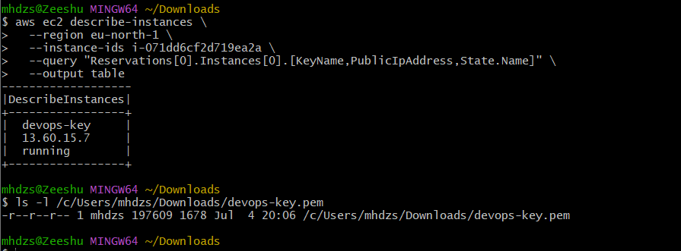
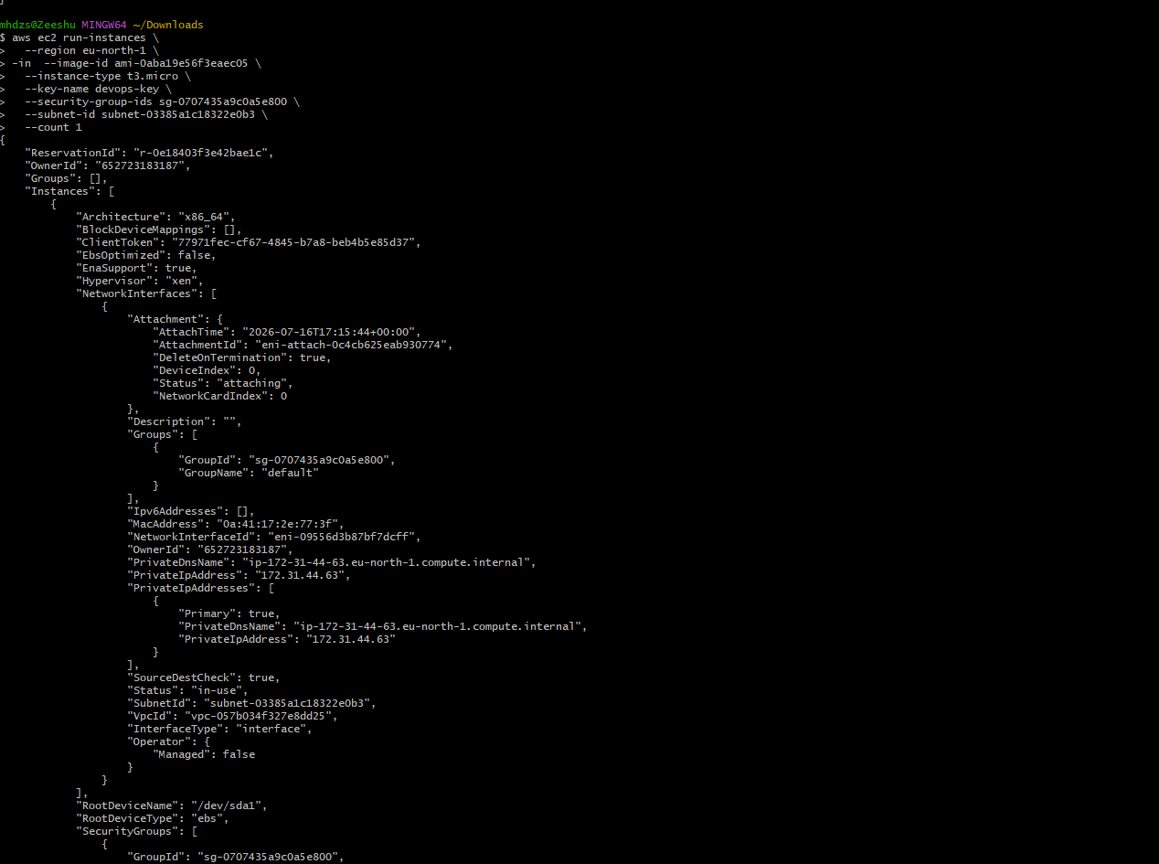

Verification
All tasks were verified using browser output, terminal status, and AWS console.

Conclusion
The EC2 administration tasks were completed successfully.

