AWS Transit Gateway and VPC Endpoints - Multi VPC Architecture

Purpose
Design and implement a scalable AWS network architecture using Transit Gateway and VPC Endpoints to provide secure communication among multiple VPCs and private access to AWS services.

Scenario
A large organization migrated multiple department VPCs (Admin, HR, Sales and Account) to AWS. AWS Transit Gateway was deployed as the central hub for VPC connectivity, while a VPC Endpoint was configured for secure access to AWS services without traversing the public internet.

1. Create Multiple VPCs and Subnets
- Create separate VPCs for Admin, HR, Sales and Account.
- Create public and private subnets in each VPC.
- Verify all VPCs and subnets are available.
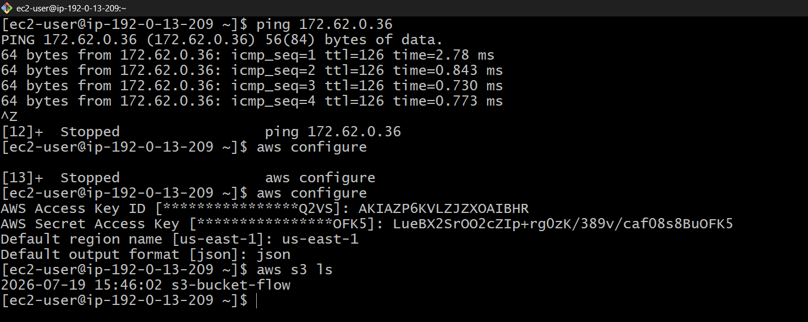
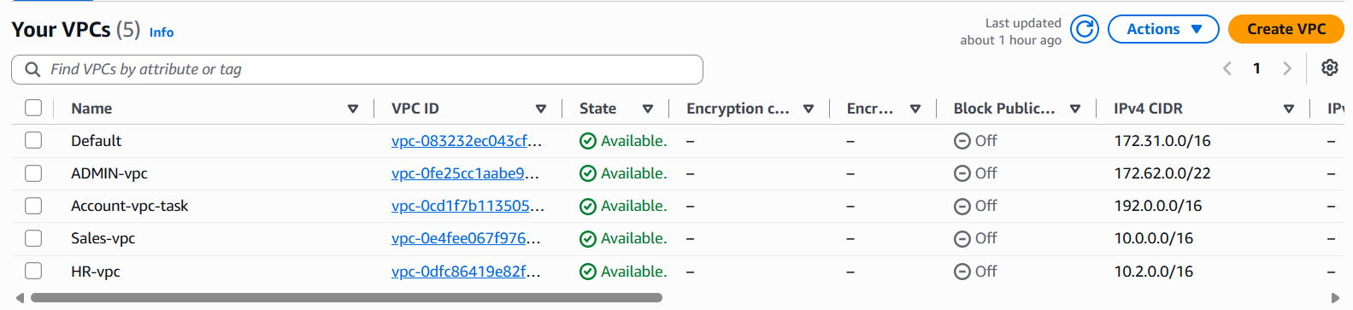
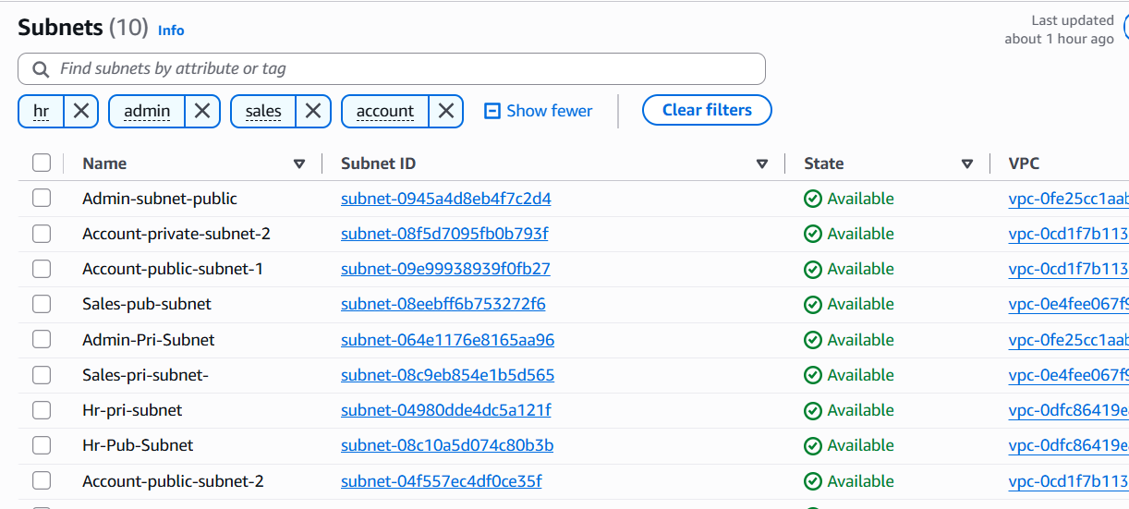

2. Configure Internet Gateways and Route Tables
- Attach Internet Gateways to required VPCs.
- Create and associate route tables with subnets.
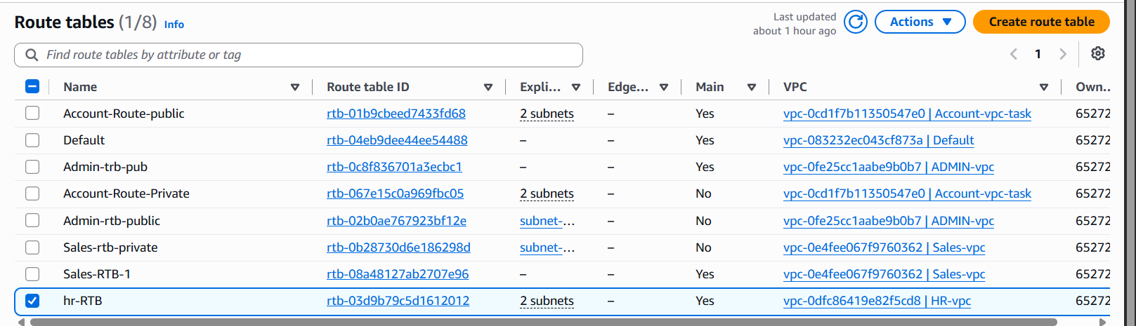
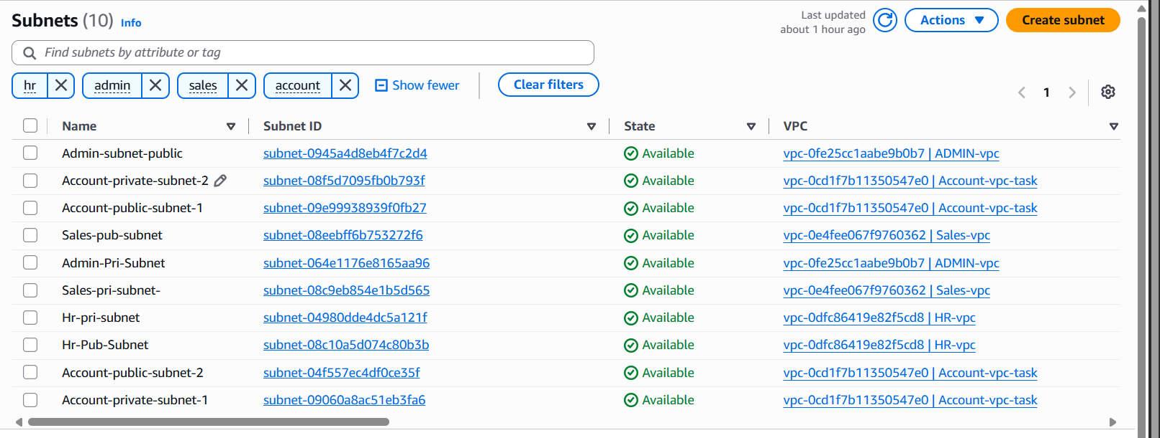

3. Create AWS Transit Gateway
- Create a Transit Gateway.
- Verify the Transit Gateway status.
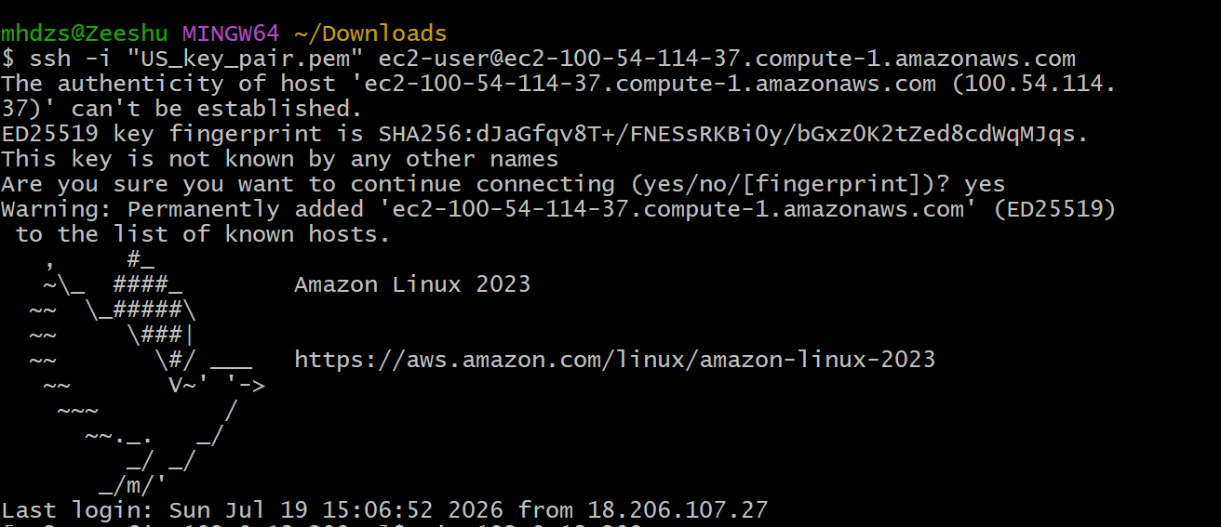

4. Attach VPCs to Transit Gateway
- Create Transit Gateway attachments for Admin, HR, Sales and Account VPCs.
- Verify attachment status.
- Configure Transit Gateway Route Table.
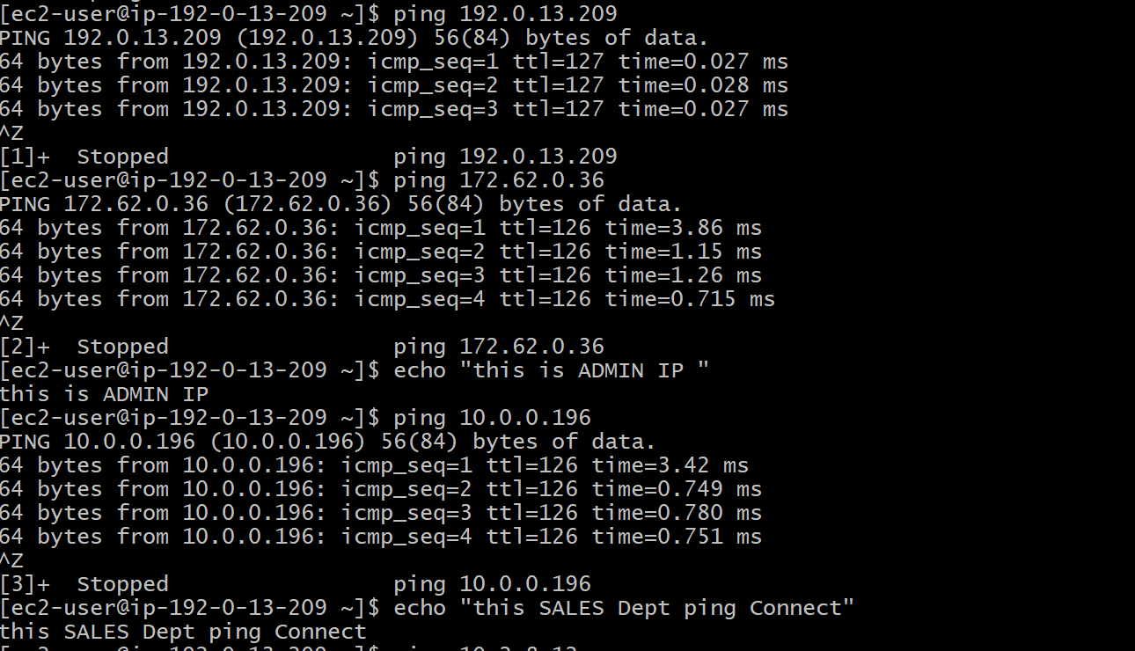
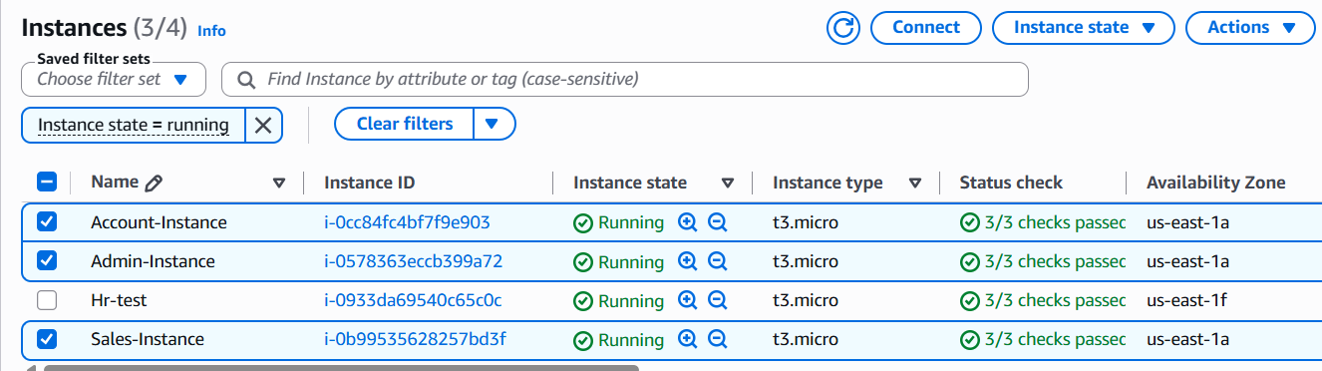

5. Configure VPC Endpoint
- Create a Gateway Endpoint for Amazon S3.
- Associate the endpoint with the required route table.
- Verify endpoint availability.
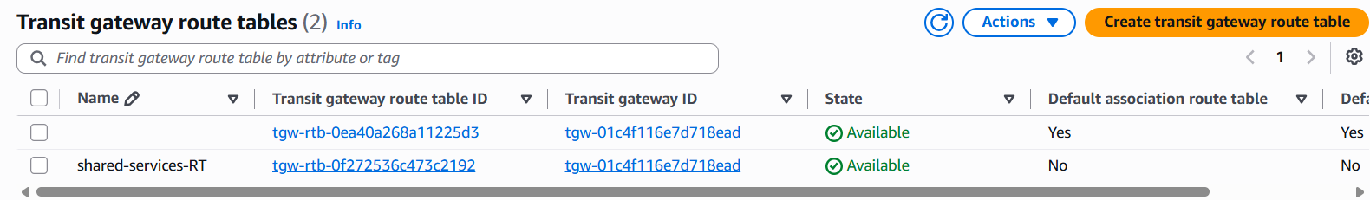

6. Validate Connectivity
- Launch EC2 instances in different VPCs.
- Verify connectivity through Transit Gateway using ping.
- Validate S3 access through the VPC Endpoint using AWS CLI.
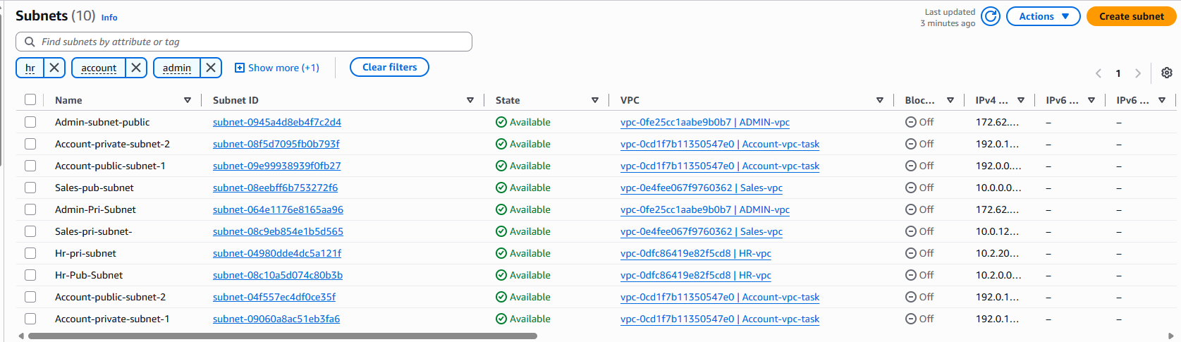
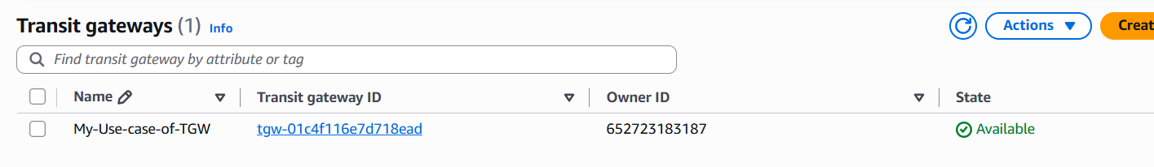
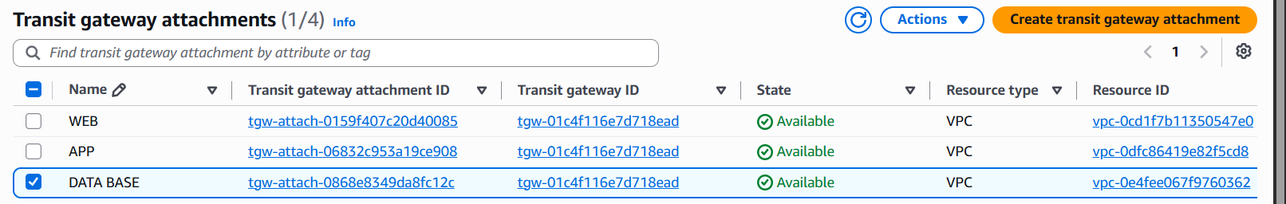
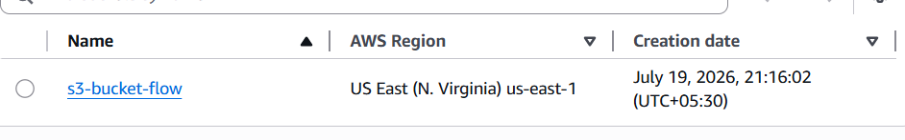

Outcome
Successfully implemented a scalable hub-and-spoke network using AWS Transit Gateway, connected multiple department VPCs, configured an Amazon S3 VPC Endpoint for private service access, and verified end-to-end connectivity between VPCs and AWS services.

Conclusion
The implemented architecture simplifies VPC connectivity, reduces routing complexity, improves scalability, and enhances security by enabling private access to AWS services without using Internet Gateways or NAT Gateways.

