Task 1 Install Git
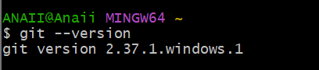
Task 2 Create GitHub Repository
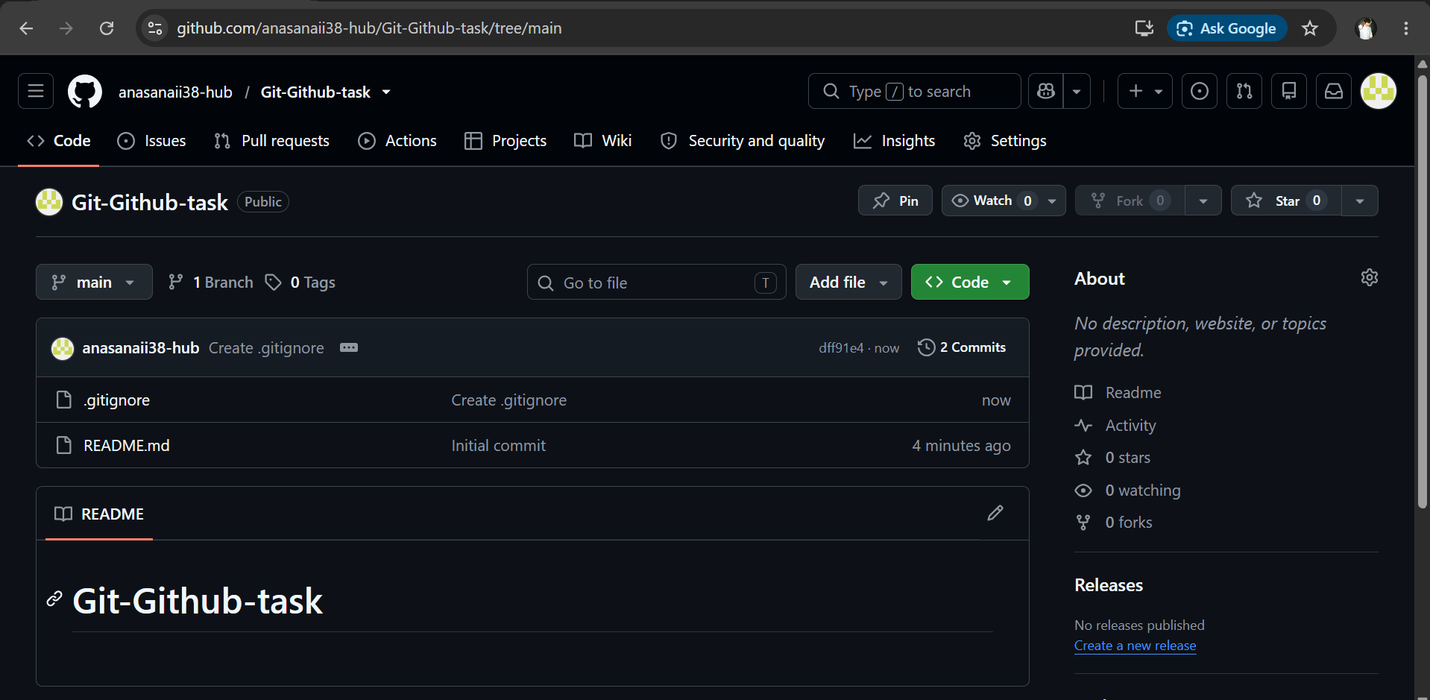
Task 3 Clone Repository
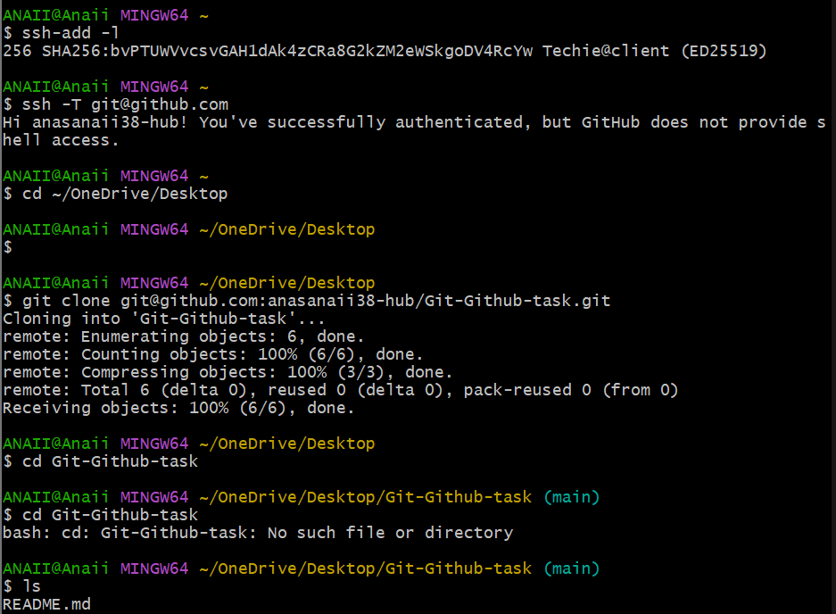
Task 4: Create Two Files
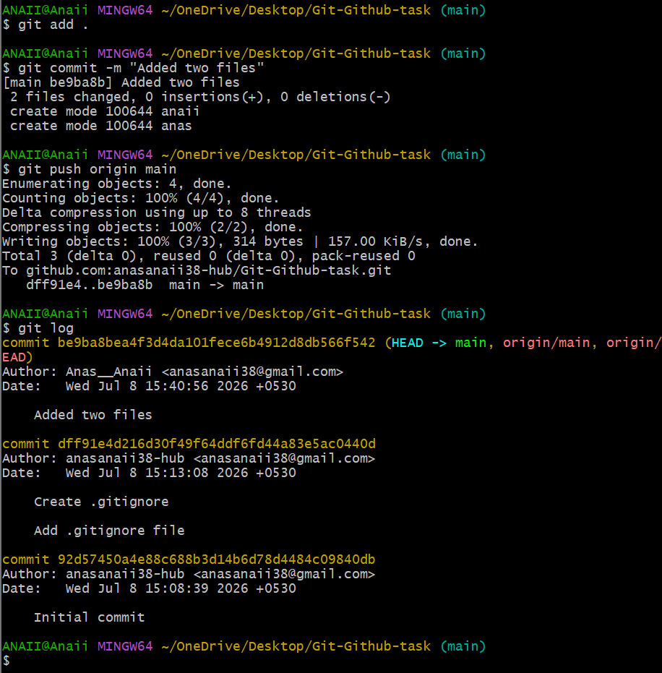
Task 6: Create Local Branch
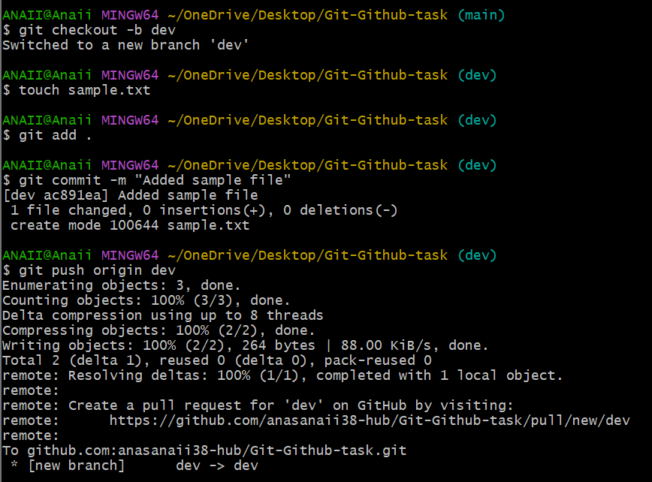
Task 7: Create Branch in GitHub
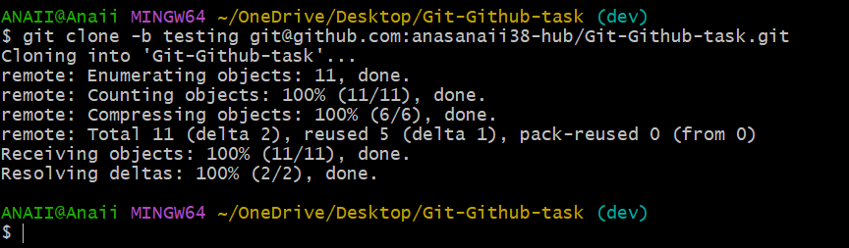
Task 8: Merge Branch with Main Locally

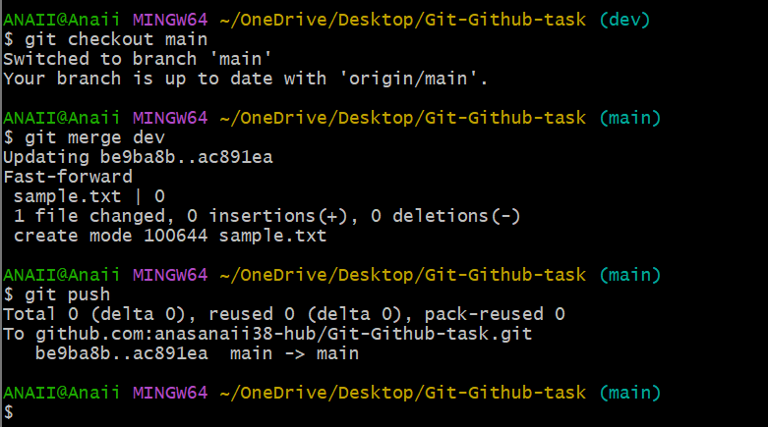
Task 9: Merge Branch via Pull Request
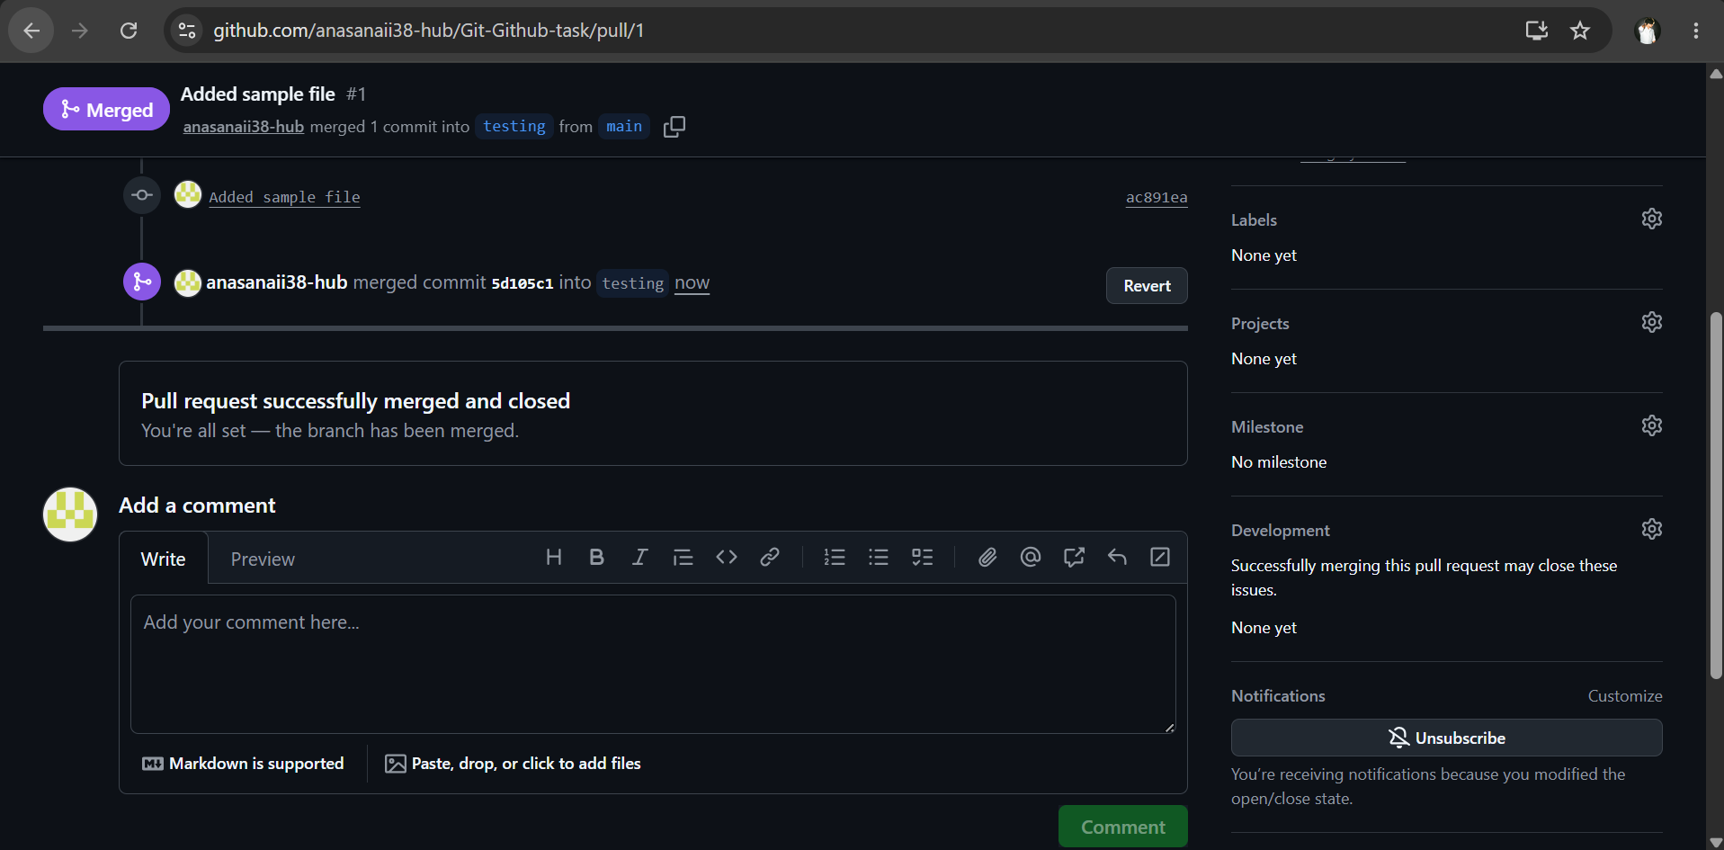
Task 10: Push File to Branch
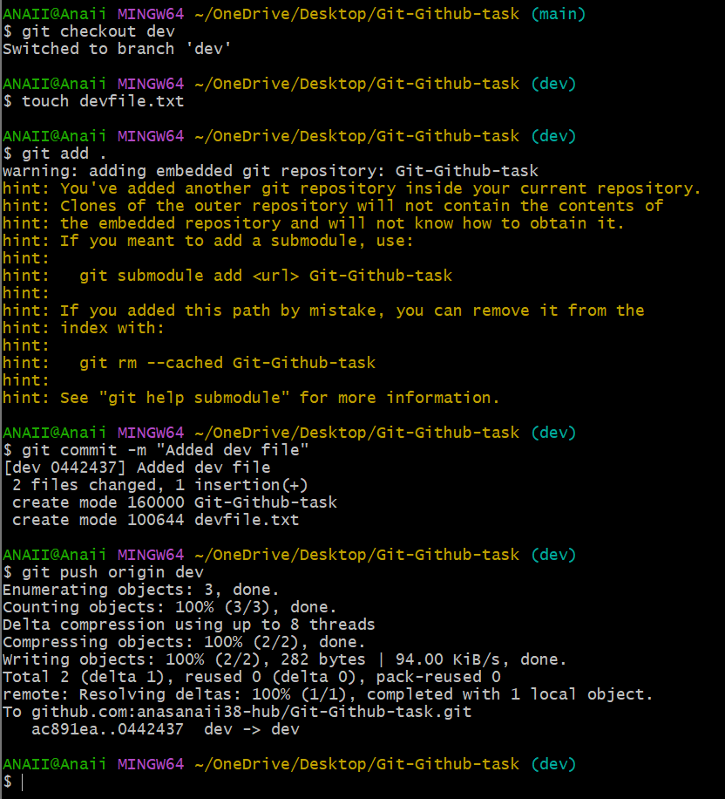
Task 11: Clone Only One Branch
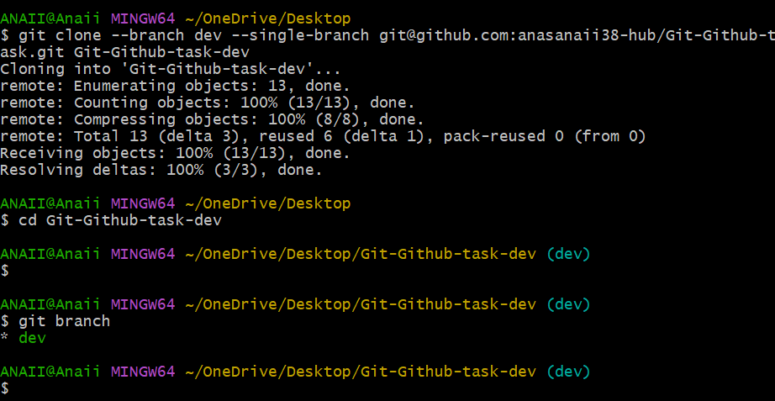
Task 12: Ignore Password File
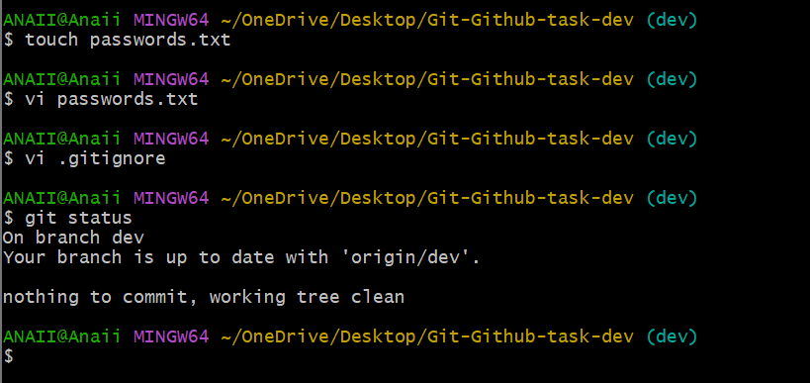
Task 13: Reset Last Commit
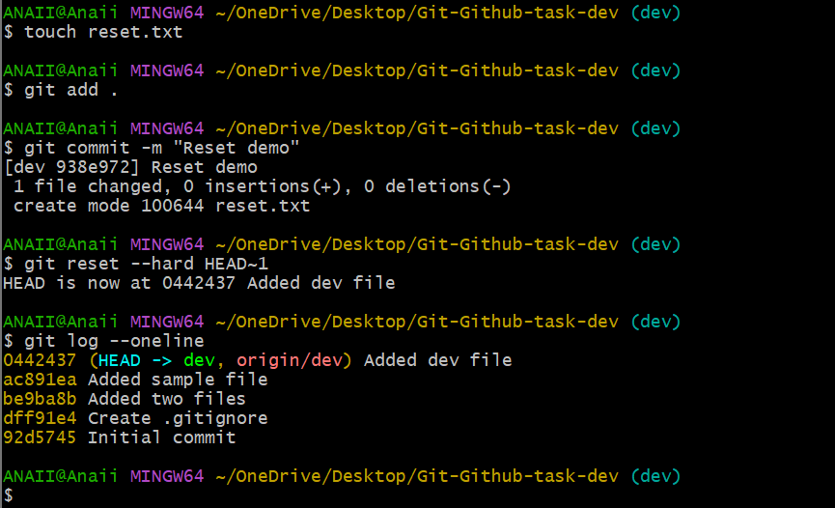
Task 14: Revert Commit
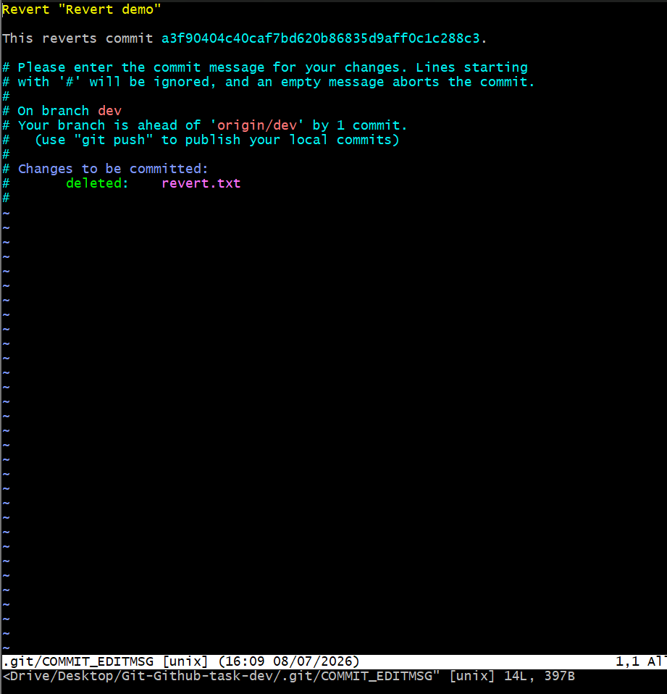
Task 15: Git Stash
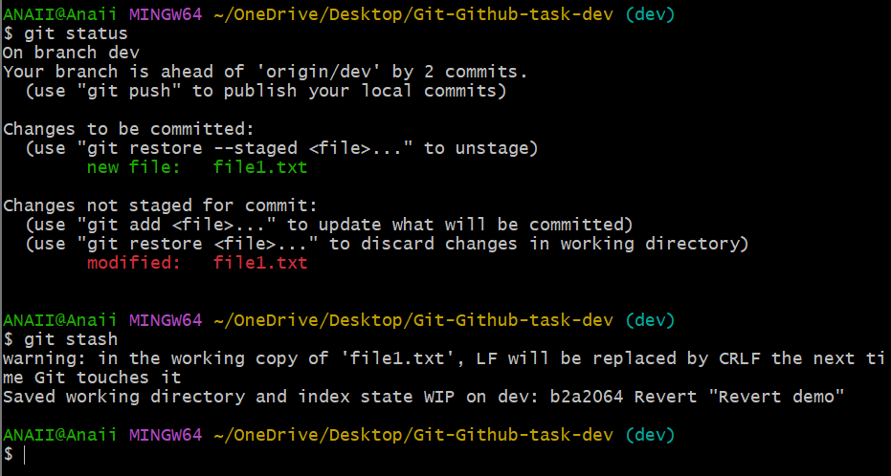
Task 16: Restore Stash
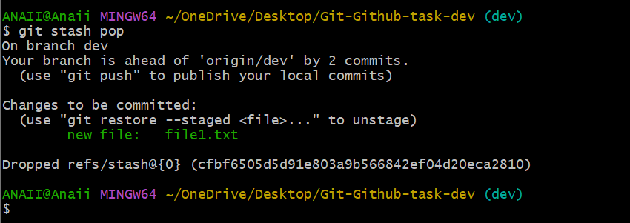
Task 17: SSH Key
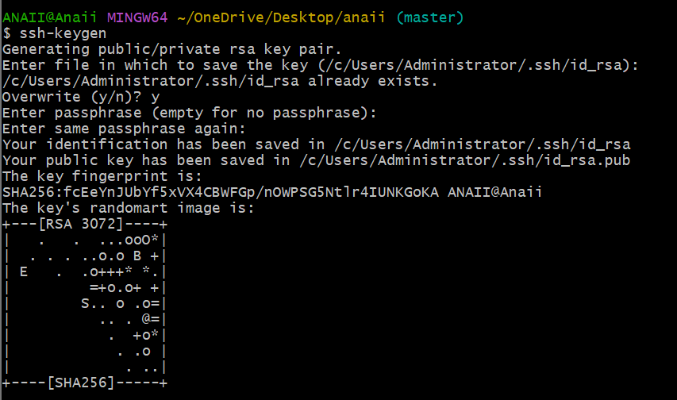
Task 18: Configure Webhook
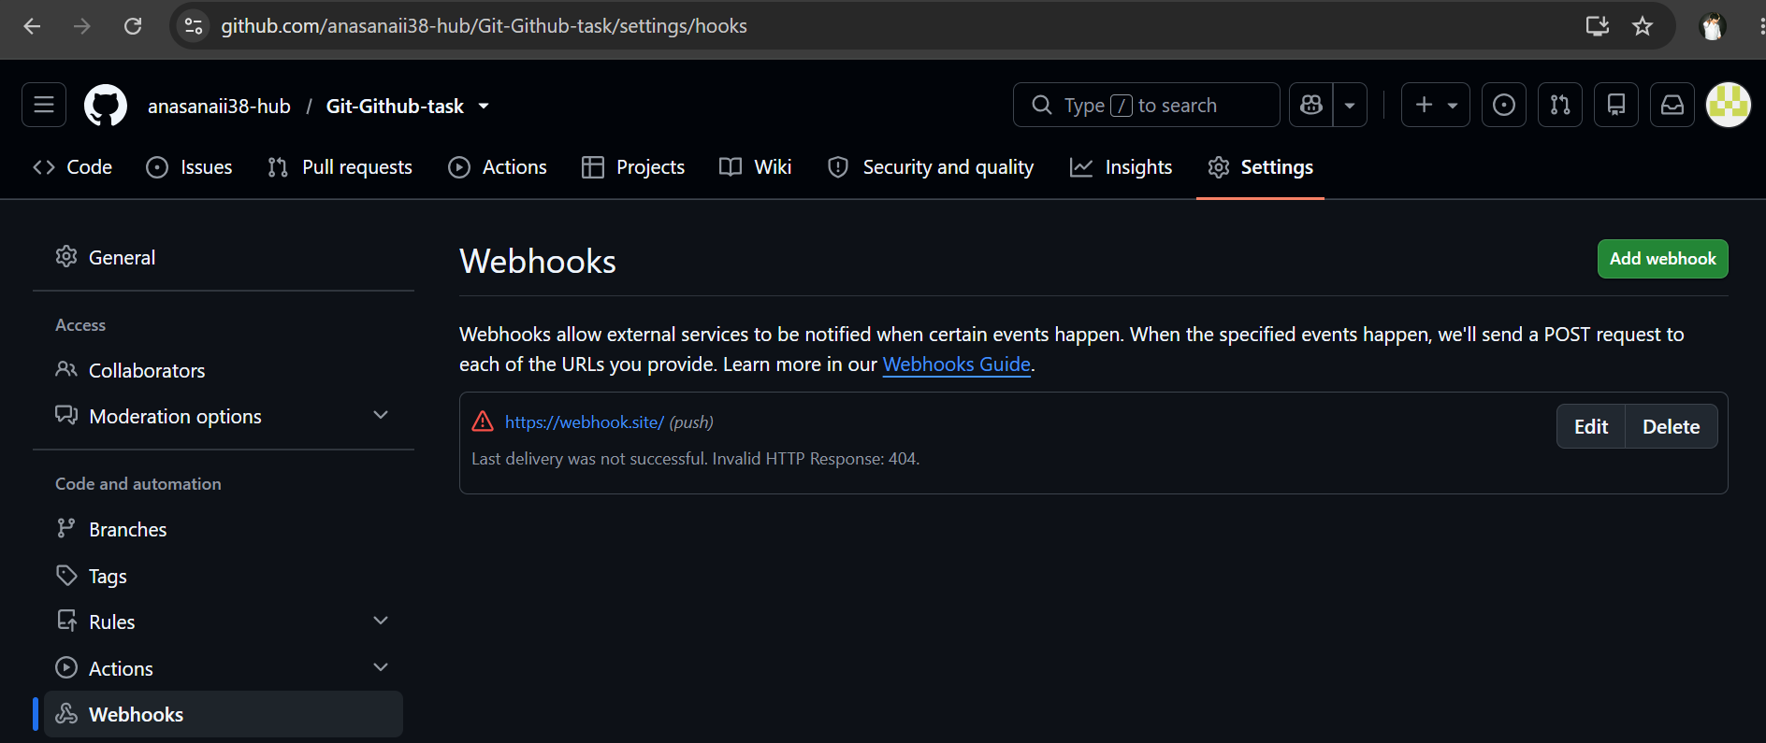
Task 19: Basic Understanding of .git
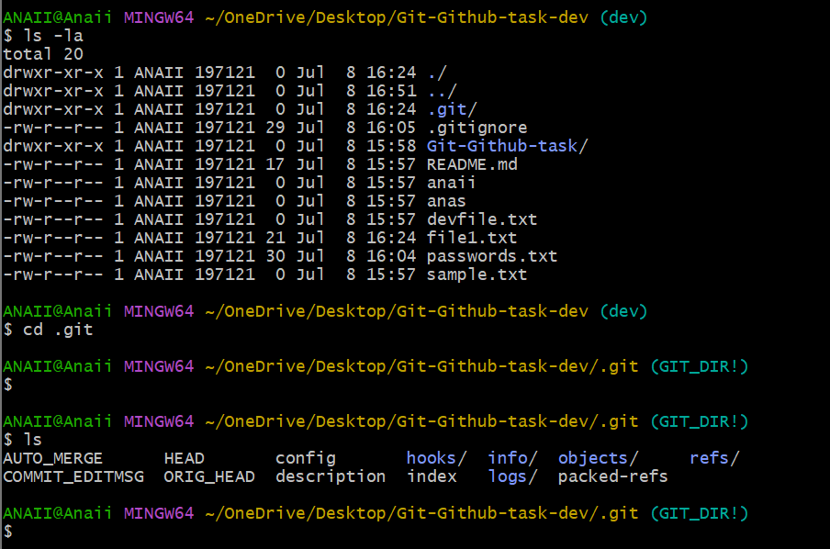
Task 20: Git Logs
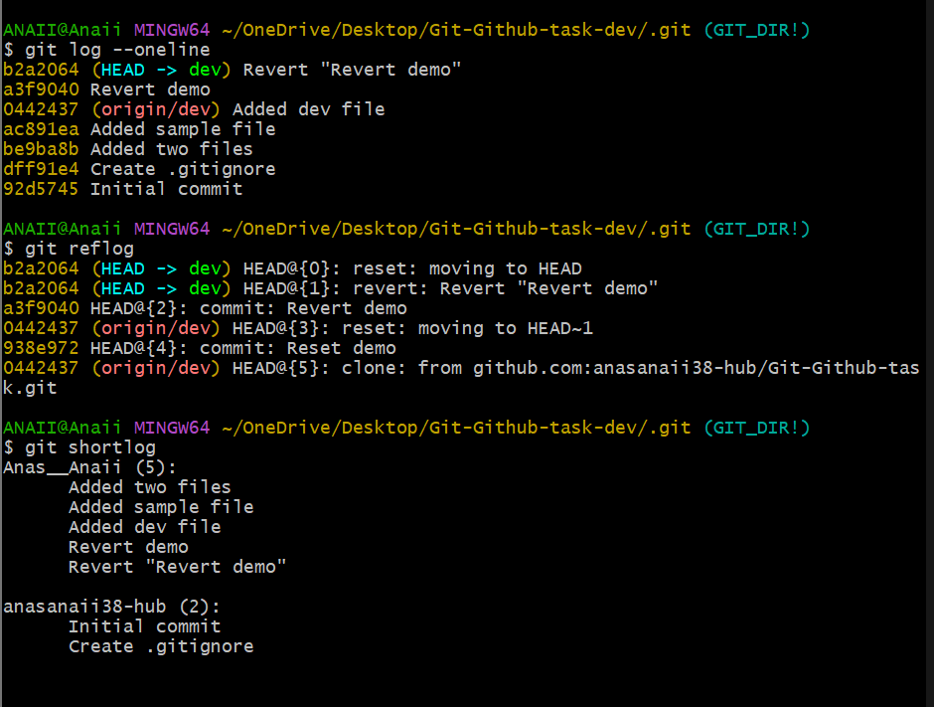
Task 21: Rename Commit Message
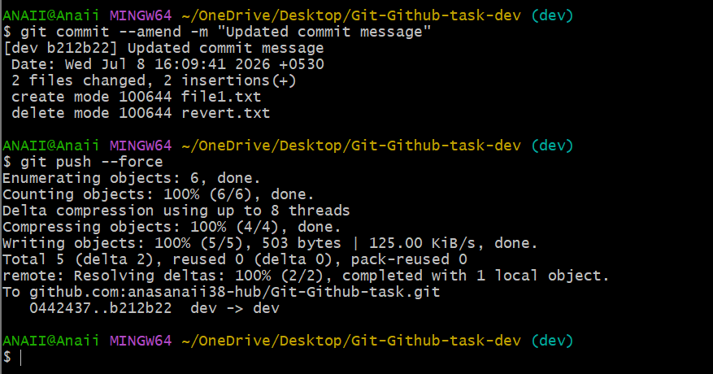

Task 22: Squash Multiple Commits
