Git Challenges Documentation

Resolve Merge Conflicts
Objective: Demonstrate resolve merge conflicts.
- Step 1: Create two branches and modify the same line in a file.
- Step 2: Merge the branches to intentionally create a conflict.
- Step 3: Edit the file to resolve conflict markers.
- Step 4: Stage, commit, and push the resolved changes.
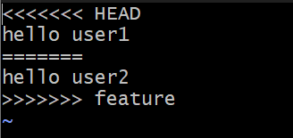
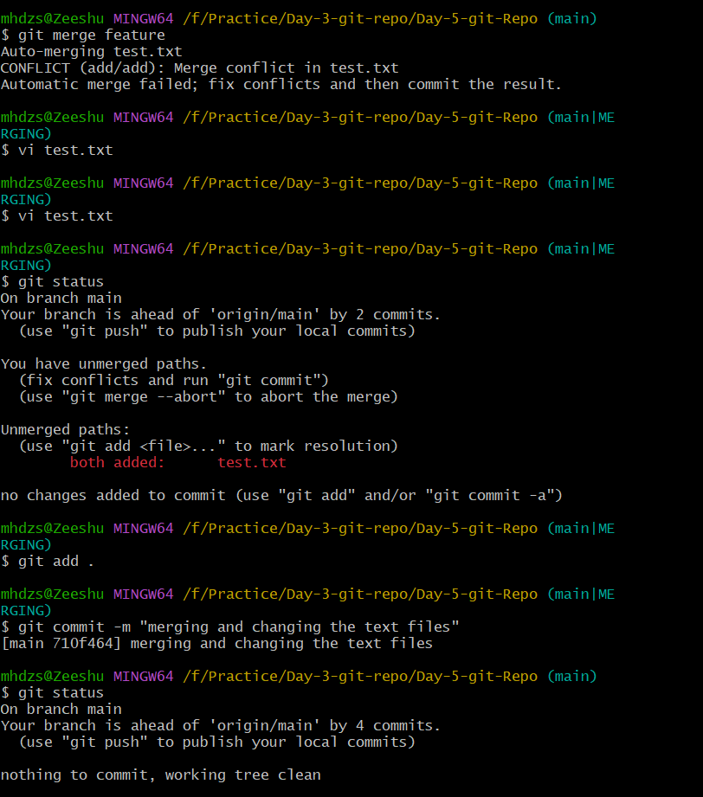
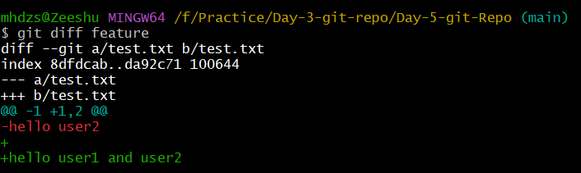

Recover Deleted Branch
Objective: Demonstrate recover deleted branch.
- Step 1: Delete the local branch.
- Step 2: Use git reflog to find the commit.
- Step 3: Create the branch again using the commit hash.
- Step 4: Verify the branch is restored.
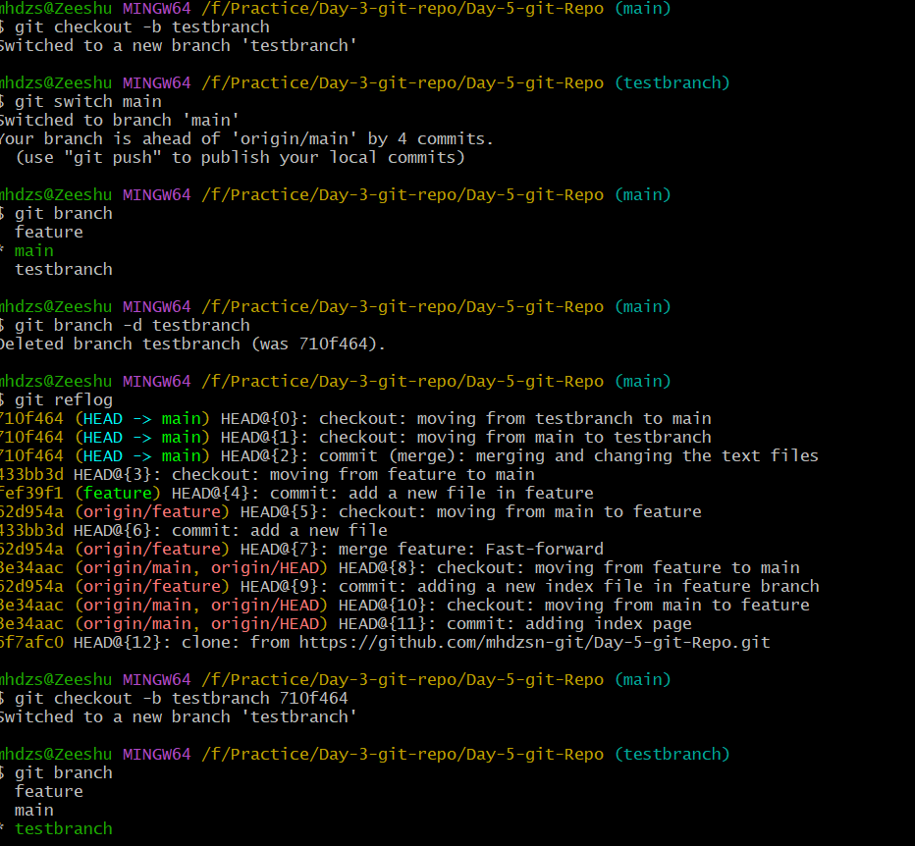

Undo Wrong Push
Objective: Demonstrate undo wrong push.
- Step 1: Create and push a commit.
- Step 2: Run git revert on the pushed commit.
- Step 3: Push the revert commit to preserve history.
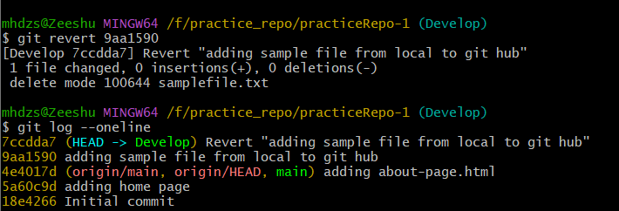

Amend a Commit
Objective: Demonstrate amend a commit.
- Step 1: Create a commit.
- Step 2: Add the missing file.
- Step 3: Run git commit --amend --no-edit to include it.
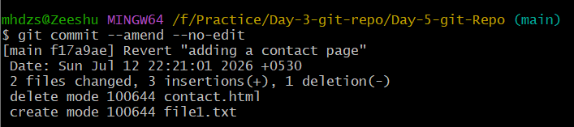

Cherry-pick a Commit
Objective: Demonstrate cherry-pick a commit.
- Step 1: Create a commit in one branch.
- Step 2: Switch to the target branch.
- Step 3: Run git cherry-pick <commit-id>.
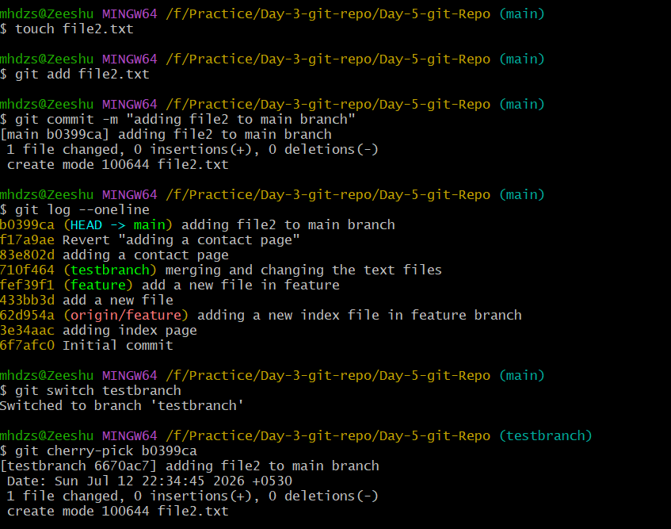

Interactive Rebase
Objective: Demonstrate interactive rebase.
- Step 1: Create multiple commits.
- Step 2: Run git rebase -i HEAD~2.
- Step 3: Squash commits into one.
- Step 4: Force-push with --force-with-lease if already pushed.
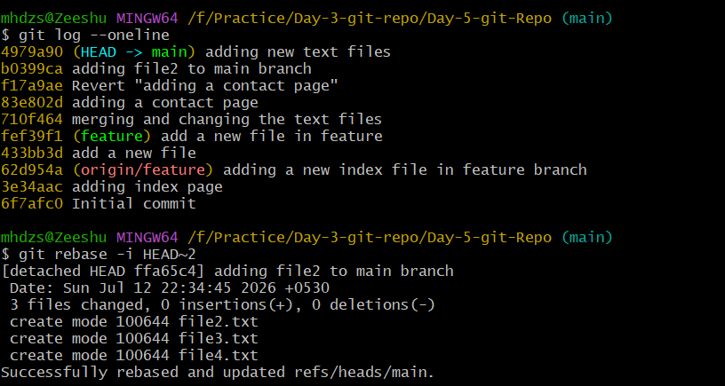
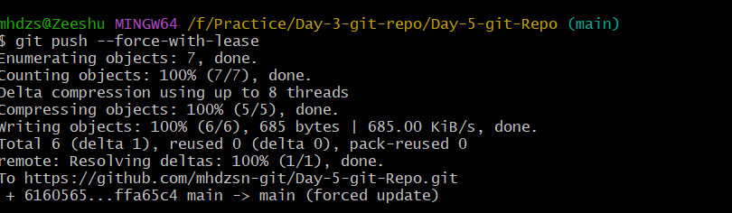

Tagging & Release
Objective: Demonstrate tagging & release.
- Step 1: Create tag v1.0.0.
- Step 2: Push the tag.
- Step 3: Delete the local tag.
- Step 4: Restore it from the remote.
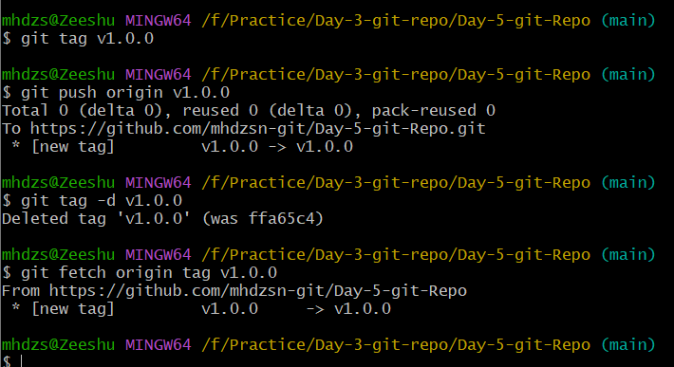

Clone with Sparse Checkout
Objective: Demonstrate clone with sparse checkout.
- Step 1: Clone using sparse checkout.
- Step 2: Enable sparse checkout for the required directory.
- Step 3: Verify only the selected content is available.
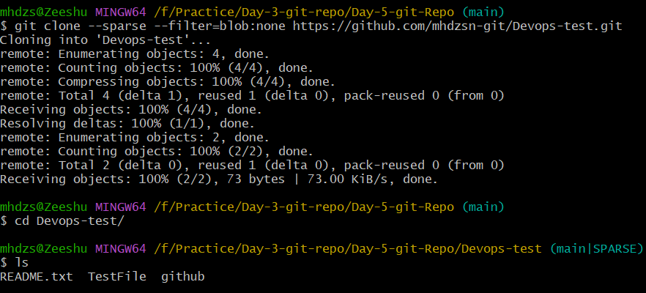
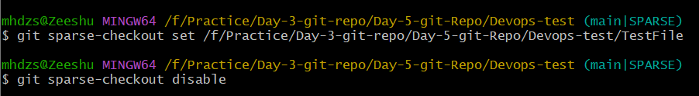

Reset vs Revert Challenge
Objective: Demonstrate reset vs revert challenge.
- Step 1: Create commits.
- Step 2: Use git reset --hard to discard local history.
- Step 3: Use git revert to create a reverse commit without rewriting history.

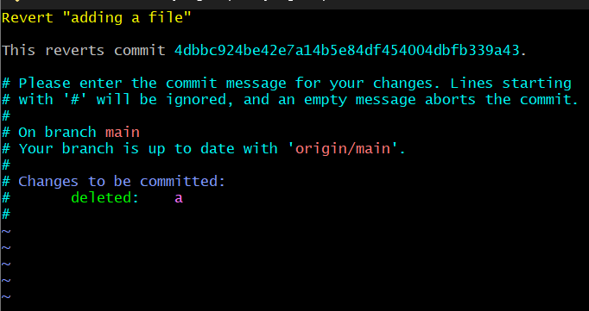

Detached HEAD Challenge
Objective: Demonstrate detached head challenge.
- Step 1: Checkout a specific commit.
- Step 2: Git enters detached HEAD state.
- Step 3: Create a new branch from that commit.

Git Hooks Challenge
Objective: Demonstrate git hooks challenge.
- Step 1: Create a pre-commit or commit-msg hook.
- Step 2: Validate the commit message format (e.g., JIRA-123).
- Step 3: Reject commits that do not match the required format.

Squash Merge vs Rebase Merge
Objective: Demonstrate squash merge vs rebase merge.
- Step 1: Demonstrate squash merge and compare it with interactive rebase.
- Step 2: Verify commit history differences using git log.

Fork & Pull Request Workflow
Objective: Demonstrate fork & pull request workflow.
- Step 1: Fork the repository.
- Step 2: Clone the fork.
- Step 3: Create a feature branch and commit changes.
- Step 4: Push the branch and open a Pull Request to the original repository.

Recover Lost Commit
Objective: Demonstrate recover lost commit.
- Step 1: Create a commit.
- Step 2: Run git reset --hard.
- Step 3: Use git reflog to find the lost commit.
- Step 4: Recover it using git checkout or git reset.


