Git & GitHub Assignment Documentation

Task 1: Create GitHub Account
Outcome
Create GitHub Account completed successfully.
Objective
To perform and validate the create github account process.
Prerequisites
• Git installed
• GitHub account
• Git Bash/Terminal access
Step-by-Step Implementation
Perform the steps required for Create GitHub Account as shown below.
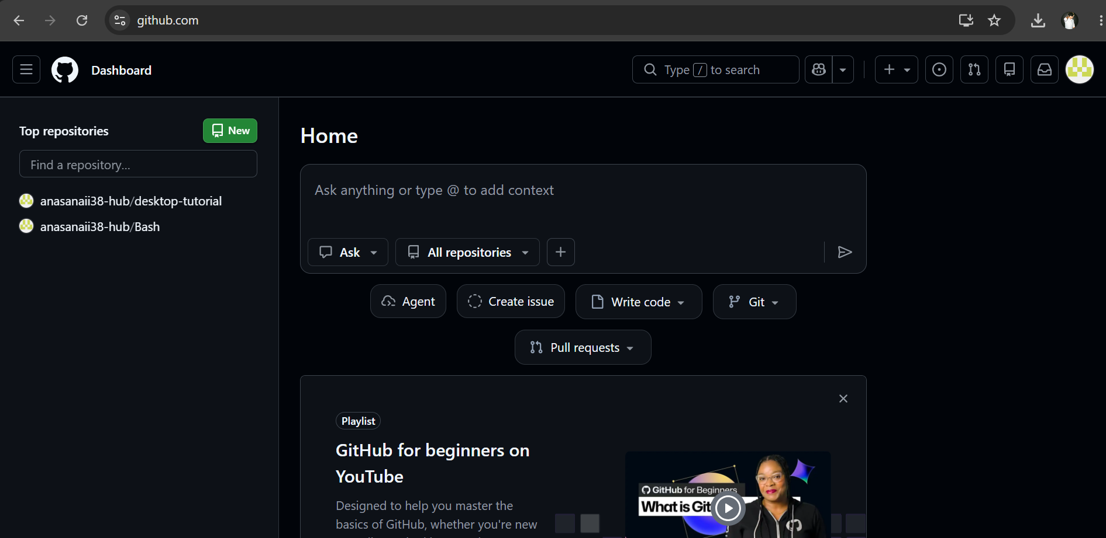
Screenshot Evidence (Mandatory)
Validation Steps
Verify the task completed successfully.
Explanation
This task demonstrates create github account as part of a standard Git workflow.
Real-Time Use Case
Used by development teams to manage source code and collaborate using GitHub.
Common Errors and Troubleshooting
Check command syntax, authentication, repository URL, and network connectivity.

Task 2: Set up GitHub MFA
Outcome
Set up GitHub MFA completed successfully.
Objective
To perform and validate the set up github mfa process.
Prerequisites
• Git installed
• GitHub account
• Git Bash/Terminal access
Step-by-Step Implementation
Perform the steps required for Set up GitHub MFA as shown below.
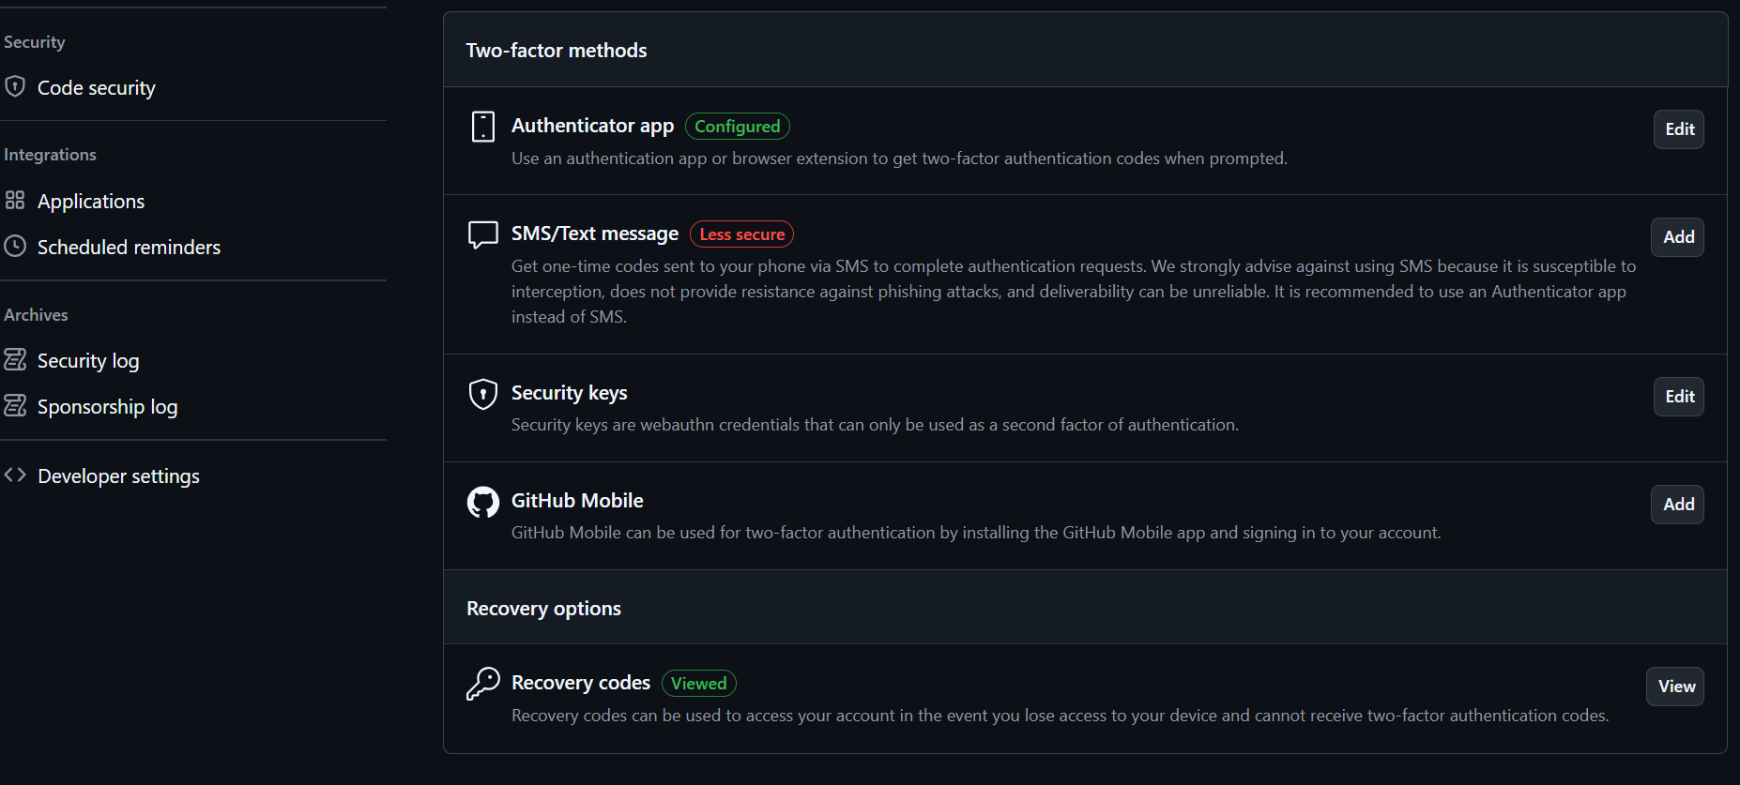
Screenshot Evidence (Mandatory)
Validation Steps
Verify the task completed successfully.
Explanation
This task demonstrates set up github mfa as part of a standard Git workflow.
Real-Time Use Case
Used by development teams to manage source code and collaborate using GitHub.
Common Errors and Troubleshooting
Check command syntax, authentication, repository URL, and network connectivity.

Task 3: Install Git
Outcome
Install Git completed successfully.
Objective
To perform and validate the install git process.
Prerequisites
• Git installed
• GitHub account
• Git Bash/Terminal access
Step-by-Step Implementation
Perform the steps required for Install Git as shown below.
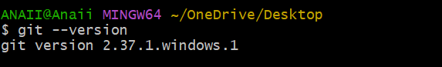
Screenshot Evidence (Mandatory)
Validation Steps
Verify the task completed successfully.
Explanation
This task demonstrates install git as part of a standard Git workflow.
Real-Time Use Case
Used by development teams to manage source code and collaborate using GitHub.
Common Errors and Troubleshooting
Check command syntax, authentication, repository URL, and network connectivity.

Task 4: Initialize Git Repository
Outcome
Initialize Git Repository completed successfully.
Objective
To perform and validate the initialize git repository process.
Prerequisites
• Git installed
• GitHub account
• Git Bash/Terminal access
Step-by-Step Implementation
Perform the steps required for Initialize Git Repository as shown below.
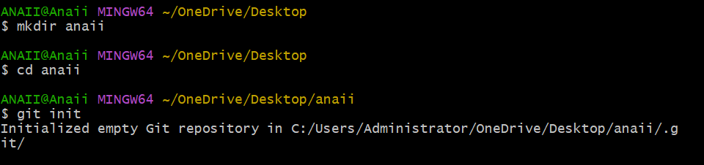
Screenshot Evidence (Mandatory)
Validation Steps
Verify the task completed successfully.
Explanation
This task demonstrates initialize git repository as part of a standard Git workflow.
Real-Time Use Case
Used by development teams to manage source code and collaborate using GitHub.
Common Errors and Troubleshooting
Check command syntax, authentication, repository URL, and network connectivity.

Task 5: Check Repository Status
Outcome
Check Repository Status completed successfully.
Objective
To perform and validate the check repository status process.
Prerequisites
• Git installed
• GitHub account
• Git Bash/Terminal access
Step-by-Step Implementation
Perform the steps required for Check Repository Status as shown below.
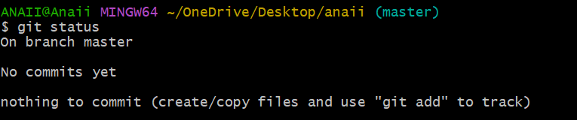
Screenshot Evidence (Mandatory)
Validation Steps
Verify the task completed successfully.
Explanation
This task demonstrates check repository status as part of a standard Git workflow.
Real-Time Use Case
Used by development teams to manage source code and collaborate using GitHub.
Common Errors and Troubleshooting
Check command syntax, authentication, repository URL, and network connectivity.

Task 6: Configure Git Username & Email
Outcome
Configure Git Username & Email completed successfully.
Objective
To perform and validate the configure git username & email process.
Prerequisites
• Git installed
• GitHub account
• Git Bash/Terminal access
Step-by-Step Implementation
Perform the steps required for Configure Git Username & Email as shown below.
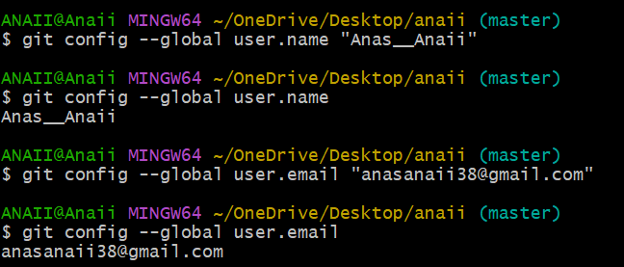
Screenshot Evidence (Mandatory)
Validation Steps
Verify the task completed successfully.
Explanation
This task demonstrates configure git username & email as part of a standard Git workflow.
Real-Time Use Case
Used by development teams to manage source code and collaborate using GitHub.
Common Errors and Troubleshooting
Check command syntax, authentication, repository URL, and network connectivity.

Task 7: Create Files
Outcome
Create Files completed successfully.
Objective
To perform and validate the create files process.
Prerequisites
• Git installed
• GitHub account
• Git Bash/Terminal access
Step-by-Step Implementation
Perform the steps required for Create Files as shown below.
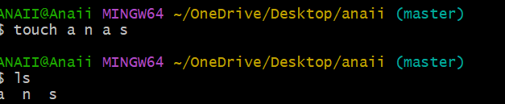
Screenshot Evidence (Mandatory)
Validation Steps
Verify the task completed successfully.
Explanation
This task demonstrates create files as part of a standard Git workflow.
Real-Time Use Case
Used by development teams to manage source code and collaborate using GitHub.
Common Errors and Troubleshooting
Check command syntax, authentication, repository URL, and network connectivity.

Task 8: Add Files to Staging Area
Outcome
Add Files to Staging Area completed successfully.
Objective
To perform and validate the add files to staging area process.
Prerequisites
• Git installed
• GitHub account
• Git Bash/Terminal access
Step-by-Step Implementation
Perform the steps required for Add Files to Staging Area as shown below.
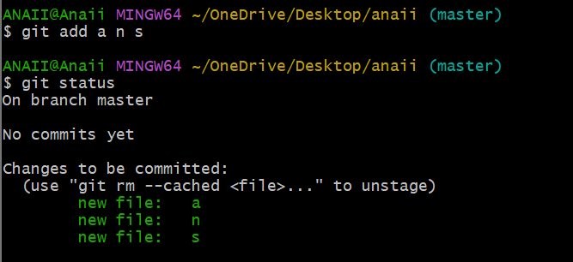
Screenshot Evidence (Mandatory)
Validation Steps
Verify the task completed successfully.
Explanation
This task demonstrates add files to staging area as part of a standard Git workflow.
Real-Time Use Case
Used by development teams to manage source code and collaborate using GitHub.
Common Errors and Troubleshooting
Check command syntax, authentication, repository URL, and network connectivity.

Task 9: Commit Files
Outcome
Commit Files completed successfully.
Objective
To perform and validate the commit files process.
Prerequisites
• Git installed
• GitHub account
• Git Bash/Terminal access
Step-by-Step Implementation
Perform the steps required for Commit Files as shown below.
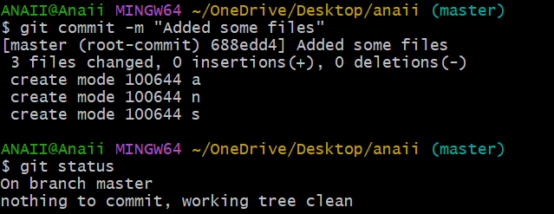
Screenshot Evidence (Mandatory)
Validation Steps
Verify the task completed successfully.
Explanation
This task demonstrates commit files as part of a standard Git workflow.
Real-Time Use Case
Used by development teams to manage source code and collaborate using GitHub.
Common Errors and Troubleshooting
Check command syntax, authentication, repository URL, and network connectivity.

Task 10: Generate SSH Key
Outcome
Generate SSH Key completed successfully.
Objective
To perform and validate the generate ssh key process.
Prerequisites
• Git installed
• GitHub account
• Git Bash/Terminal access
Step-by-Step Implementation
Perform the steps required for Generate SSH Key as shown below.
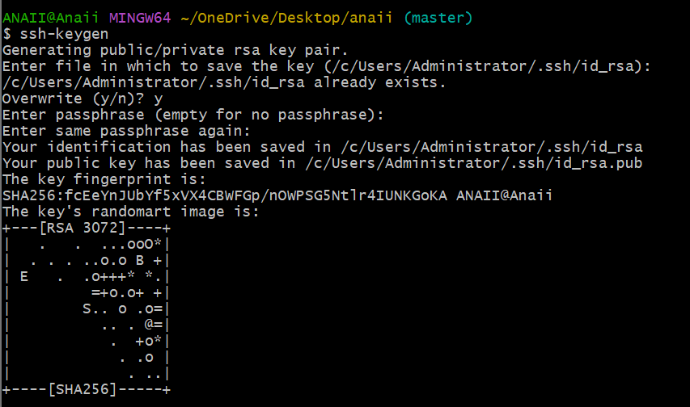
Screenshot Evidence (Mandatory)
Validation Steps
Verify the task completed successfully.
Explanation
This task demonstrates generate ssh key as part of a standard Git workflow.
Real-Time Use Case
Used by development teams to manage source code and collaborate using GitHub.
Common Errors and Troubleshooting
Check command syntax, authentication, repository URL, and network connectivity.

Task 11: Create GitHub Repository
Outcome
Create GitHub Repository completed successfully.
Objective
To perform and validate the create github repository process.
Prerequisites
• Git installed
• GitHub account
• Git Bash/Terminal access
Step-by-Step Implementation
Perform the steps required for Create GitHub Repository as shown below.
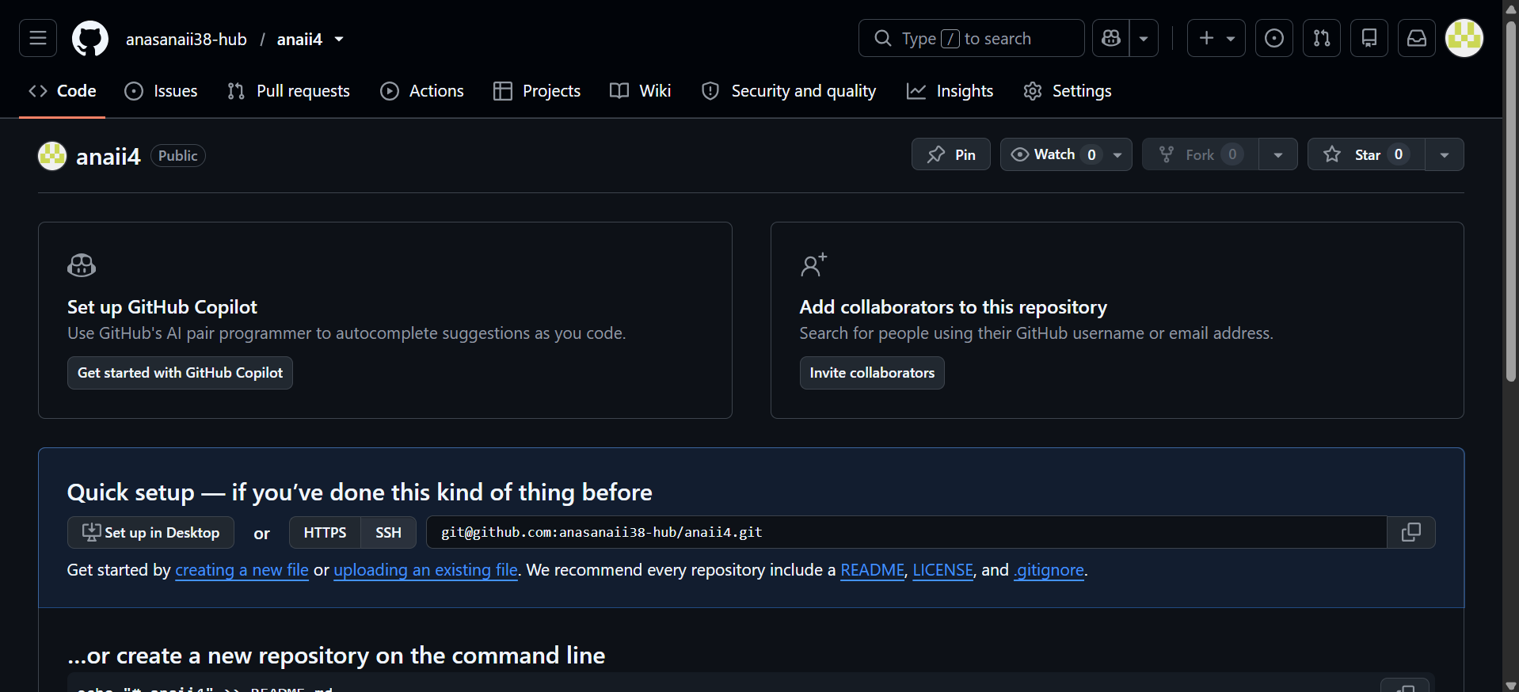
Screenshot Evidence (Mandatory)
Validation Steps
Verify the task completed successfully.
Explanation
This task demonstrates create github repository as part of a standard Git workflow.
Real-Time Use Case
Used by development teams to manage source code and collaborate using GitHub.
Common Errors and Troubleshooting
Check command syntax, authentication, repository URL, and network connectivity.

Task 12: Connect Local Repository to GitHub
Outcome
Connect Local Repository to GitHub completed successfully.
Objective
To perform and validate the connect local repository to github process.
Prerequisites
• Git installed
• GitHub account
• Git Bash/Terminal access
Step-by-Step Implementation
Perform the steps required for Connect Local Repository to GitHub as shown below.
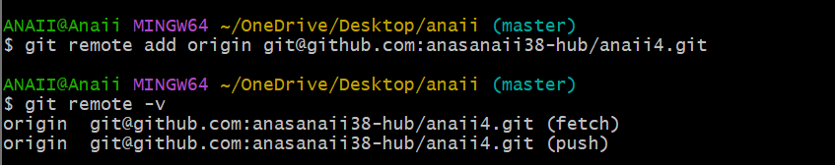
Screenshot Evidence (Mandatory)
Validation Steps
Verify the task completed successfully.
Explanation
This task demonstrates connect local repository to github as part of a standard Git workflow.
Real-Time Use Case
Used by development teams to manage source code and collaborate using GitHub.
Common Errors and Troubleshooting
Check command syntax, authentication, repository URL, and network connectivity.

Task 13: Push Files to GitHub
Outcome
Push Files to GitHub completed successfully.
Objective
To perform and validate the push files to github process.
Prerequisites
• Git installed
• GitHub account
• Git Bash/Terminal access
Step-by-Step Implementation
Perform the steps required for Push Files to GitHub as shown below.
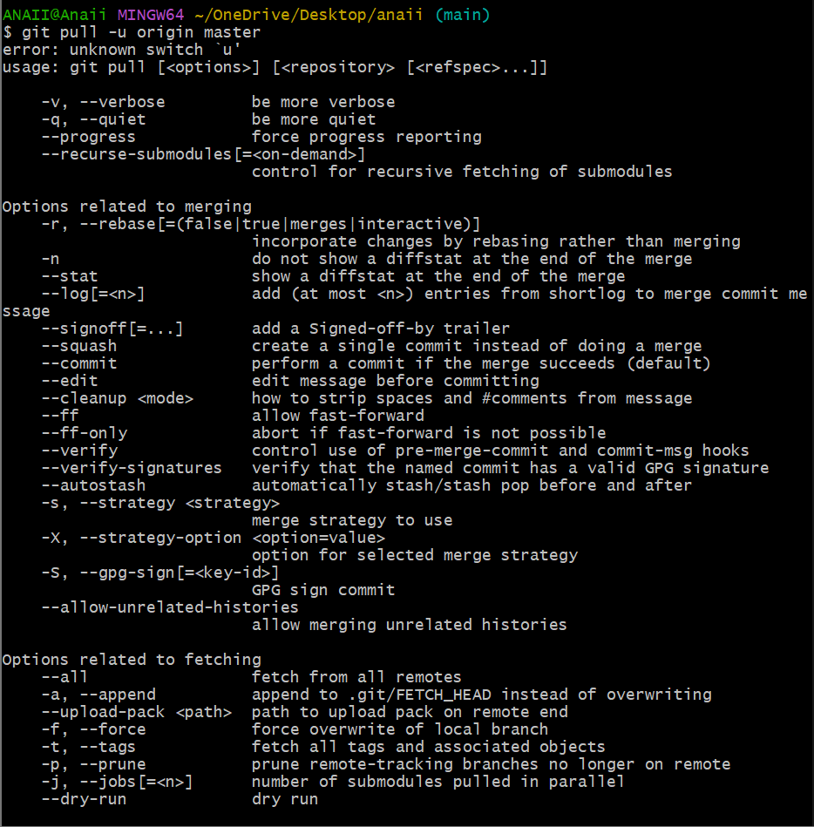
Screenshot Evidence (Mandatory)
Validation Steps
Verify the task completed successfully.
Explanation
This task demonstrates push files to github as part of a standard Git workflow.
Real-Time Use Case
Used by development teams to manage source code and collaborate using GitHub.
Common Errors and Troubleshooting
Check command syntax, authentication, repository URL, and network connectivity.

Task 14: Verify Repository
Outcome
Verify Repository completed successfully.
Objective
To perform and validate the verify repository process.
Prerequisites
• Git installed
• GitHub account
• Git Bash/Terminal access
Step-by-Step Implementation
Perform the steps required for Verify Repository as shown below.
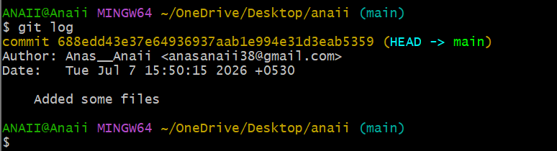
Screenshot Evidence (Mandatory)
Validation Steps
Verify the task completed successfully.
Explanation
This task demonstrates verify repository as part of a standard Git workflow.
Real-Time Use Case
Used by development teams to manage source code and collaborate using GitHub.
Common Errors and Troubleshooting
Check command syntax, authentication, repository URL, and network connectivity.

