Git & GitHub Assignment Documentation

Task 1: Install Git

Outcome
Git was installed successfully on the local machine.

Objective
To enable version control using Git.

Prerequisites
• Windows system
• Internet connection
• Git installer

Step-by-Step Implementation
Execute the required Git/GitHub commands as per the assignment.

Screenshot Evidence
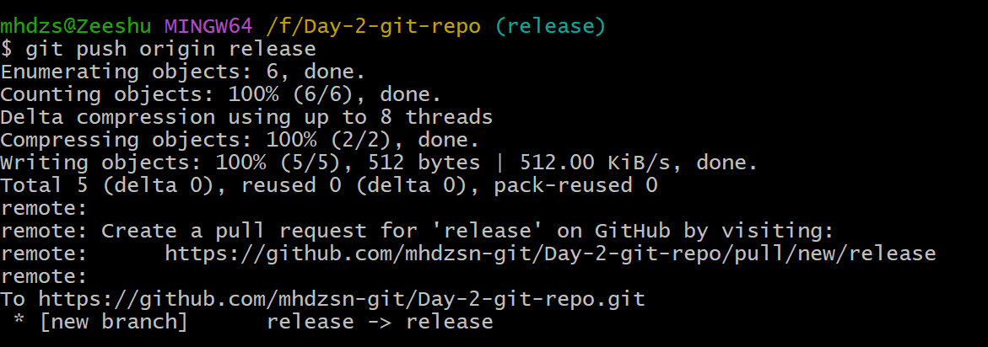

Validation Steps
Verify the expected output was achieved.

Explanation
This task demonstrates the corresponding Git/GitHub concept and workflow.

Real-Time Use Case
Used in collaborative software development and version control.

Common Errors and Troubleshooting
Error | Cause | Resolution
Command failed | Incorrect configuration | Verify commands and repository state

Task 2: Create GitHub Repository

Outcome
Repository with README.md and .gitignore created.

Objective
To host source code remotely.

Prerequisites
• GitHub account

Step-by-Step Implementation
Execute the required Git/GitHub commands as per the assignment.

Screenshot Evidence
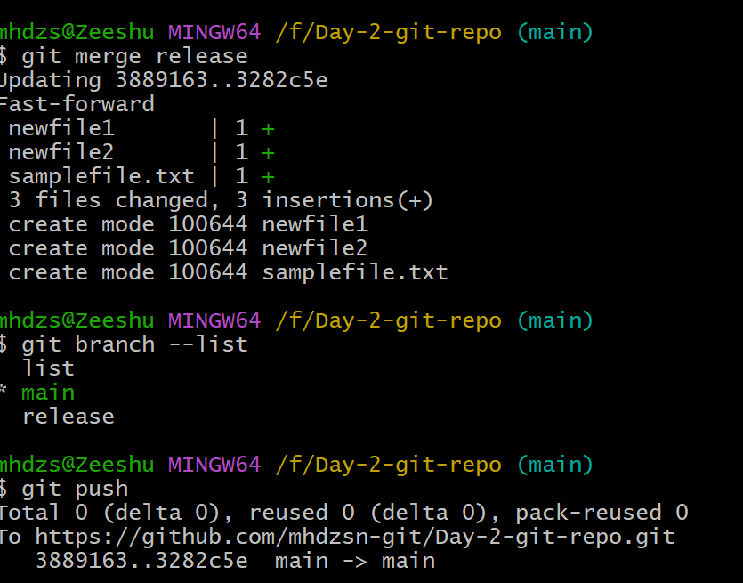

Validation Steps
Verify the expected output was achieved.

Explanation
This task demonstrates the corresponding Git/GitHub concept and workflow.

Real-Time Use Case
Used in collaborative software development and version control.

Common Errors and Troubleshooting
Error | Cause | Resolution
Command failed | Incorrect configuration | Verify commands and repository state

Task 3: Clone Repository

Outcome
Repository cloned locally.

Objective
To work on repository locally.

Prerequisites
• Git installed

Step-by-Step Implementation
Execute the required Git/GitHub commands as per the assignment.

Screenshot Evidence
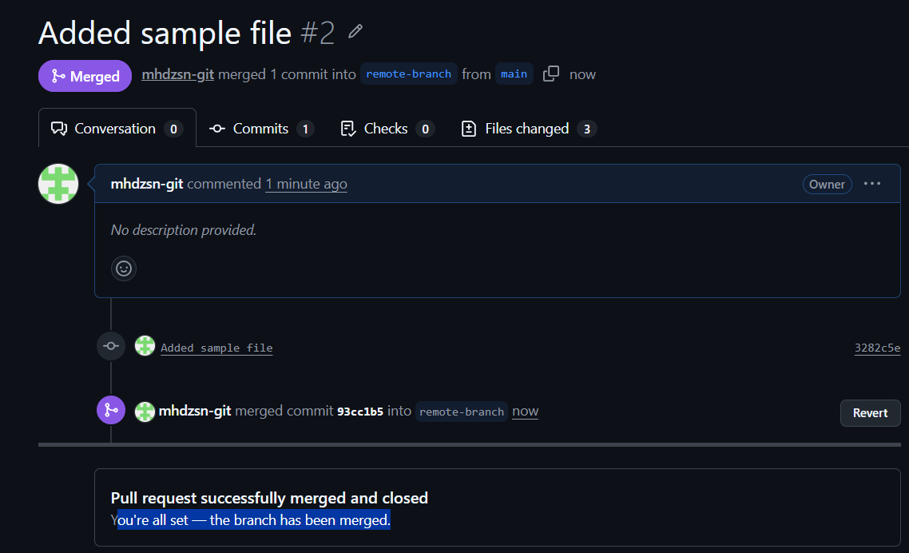

Validation Steps
Verify the expected output was achieved.

Explanation
This task demonstrates the corresponding Git/GitHub concept and workflow.

Real-Time Use Case
Used in collaborative software development and version control.

Common Errors and Troubleshooting
Error | Cause | Resolution
Command failed | Incorrect configuration | Verify commands and repository state

Task 4: Create, Commit and Push Files

Outcome
Two files committed and pushed.

Objective
To track and synchronize changes.

Prerequisites
• Local repository

Step-by-Step Implementation
Execute the required Git/GitHub commands as per the assignment.

Screenshot Evidence
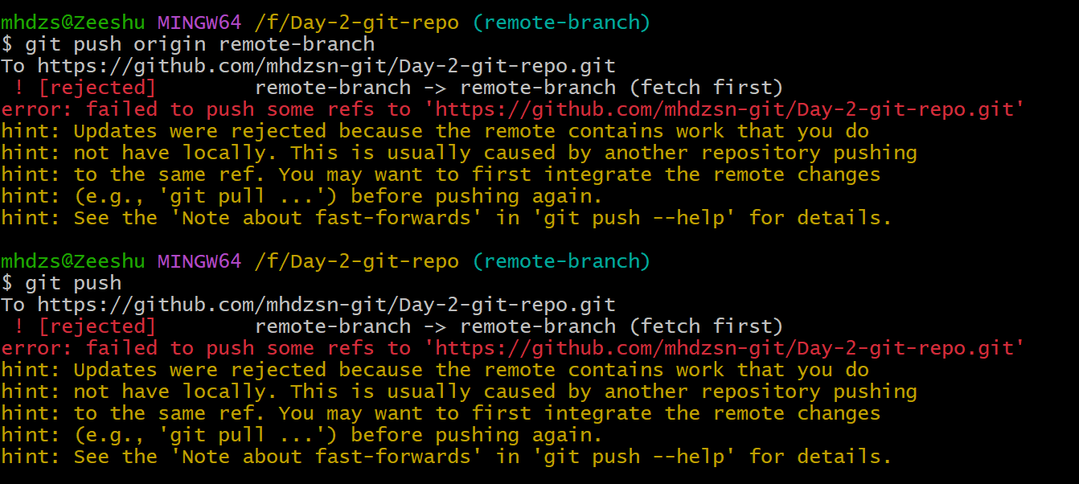

Validation Steps
Verify the expected output was achieved.

Explanation
This task demonstrates the corresponding Git/GitHub concept and workflow.

Real-Time Use Case
Used in collaborative software development and version control.

Common Errors and Troubleshooting
Error | Cause | Resolution
Command failed | Incorrect configuration | Verify commands and repository state

Task 5: Create Local Branch and Push

Outcome
Branch created and pushed.

Objective
To isolate feature development.

Prerequisites
• Existing repository

Step-by-Step Implementation
Execute the required Git/GitHub commands as per the assignment.

Screenshot Evidence
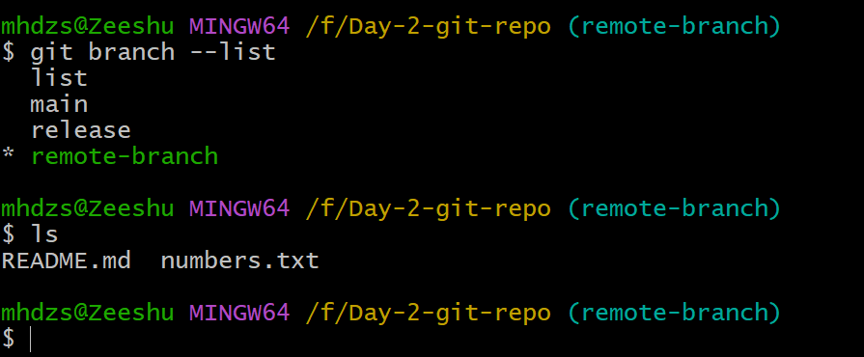

Validation Steps
Verify the expected output was achieved.

Explanation
This task demonstrates the corresponding Git/GitHub concept and workflow.

Real-Time Use Case
Used in collaborative software development and version control.

Common Errors and Troubleshooting
Error | Cause | Resolution
Command failed | Incorrect configuration | Verify commands and repository state

Task 6: Create GitHub Branch and Clone

Outcome
Remote branch cloned.

Objective
To work on a specific remote branch.

Prerequisites
• GitHub repository

Step-by-Step Implementation
Execute the required Git/GitHub commands as per the assignment.

Screenshot Evidence
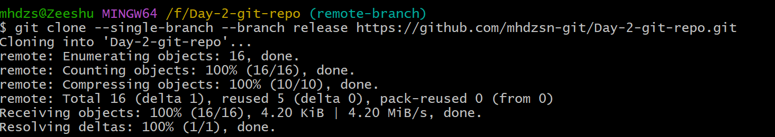

Validation Steps
Verify the expected output was achieved.

Explanation
This task demonstrates the corresponding Git/GitHub concept and workflow.

Real-Time Use Case
Used in collaborative software development and version control.

Common Errors and Troubleshooting
Error | Cause | Resolution
Command failed | Incorrect configuration | Verify commands and repository state

Task 7: Merge Branch Locally

Outcome
Branch merged into main.

Objective
To integrate changes.

Prerequisites
• Local branches

Step-by-Step Implementation
Execute the required Git/GitHub commands as per the assignment.

Screenshot Evidence
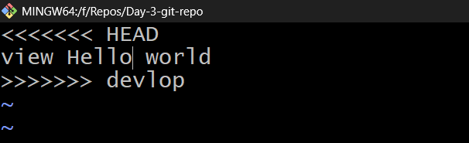

Validation Steps
Verify the expected output was achieved.

Explanation
This task demonstrates the corresponding Git/GitHub concept and workflow.

Real-Time Use Case
Used in collaborative software development and version control.

Common Errors and Troubleshooting
Error | Cause | Resolution
Command failed | Incorrect configuration | Verify commands and repository state

Task 8: Merge using Pull Request

Outcome
Pull request merged.

Objective
To integrate code through review.

Prerequisites
• GitHub access

Step-by-Step Implementation
Execute the required Git/GitHub commands as per the assignment.

Screenshot Evidence
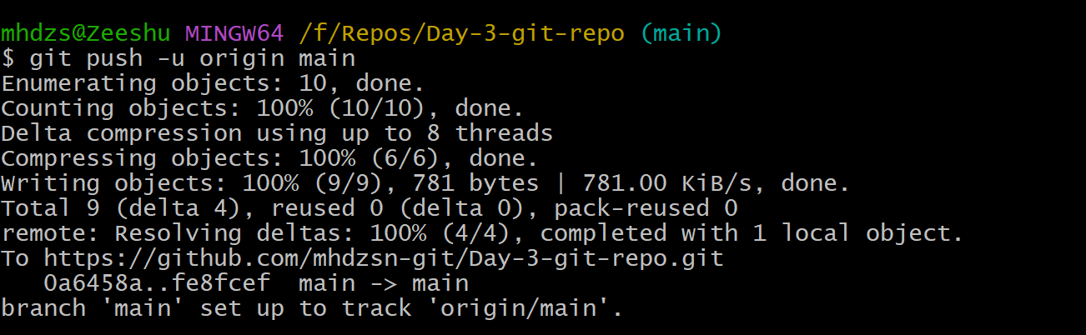

Validation Steps
Verify the expected output was achieved.

Explanation
This task demonstrates the corresponding Git/GitHub concept and workflow.

Real-Time Use Case
Used in collaborative software development and version control.

Common Errors and Troubleshooting
Error | Cause | Resolution
Command failed | Incorrect configuration | Verify commands and repository state

Task 9: Push File to Remote Branch

Outcome
File pushed to GitHub branch.

Objective
To synchronize branch changes.

Prerequisites
• Remote branch

Step-by-Step Implementation
Execute the required Git/GitHub commands as per the assignment.

Screenshot Evidence
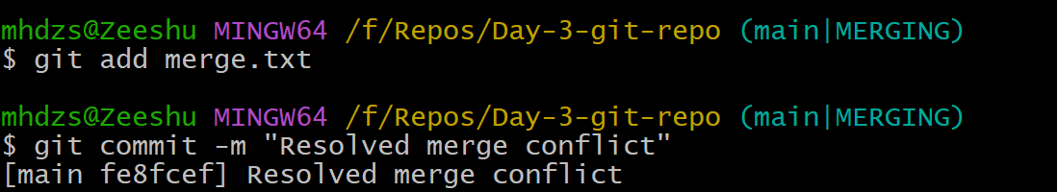

Validation Steps
Verify the expected output was achieved.

Explanation
This task demonstrates the corresponding Git/GitHub concept and workflow.

Real-Time Use Case
Used in collaborative software development and version control.

Common Errors and Troubleshooting
Error | Cause | Resolution
Command failed | Incorrect configuration | Verify commands and repository state

Task 10: Clone Single Branch

Outcome
Single branch cloned.

Objective
To reduce unnecessary history.

Prerequisites
• Branch exists

Step-by-Step Implementation
Execute the required Git/GitHub commands as per the assignment.

Screenshot Evidence
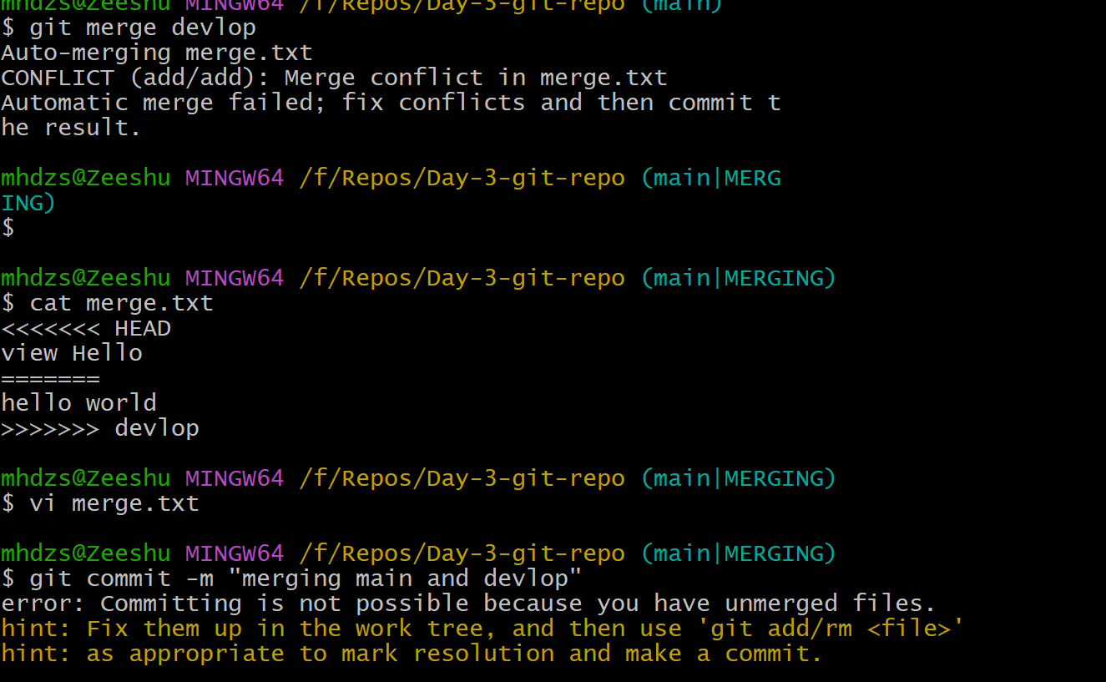

Validation Steps
Verify the expected output was achieved.

Explanation
This task demonstrates the corresponding Git/GitHub concept and workflow.

Real-Time Use Case
Used in collaborative software development and version control.

Common Errors and Troubleshooting
Error | Cause | Resolution
Command failed | Incorrect configuration | Verify commands and repository state

Task 11: Ignore Password File

Outcome
.gitignore configured.

Objective
To avoid committing sensitive files.

Prerequisites
• .gitignore

Step-by-Step Implementation
Execute the required Git/GitHub commands as per the assignment.

Screenshot Evidence
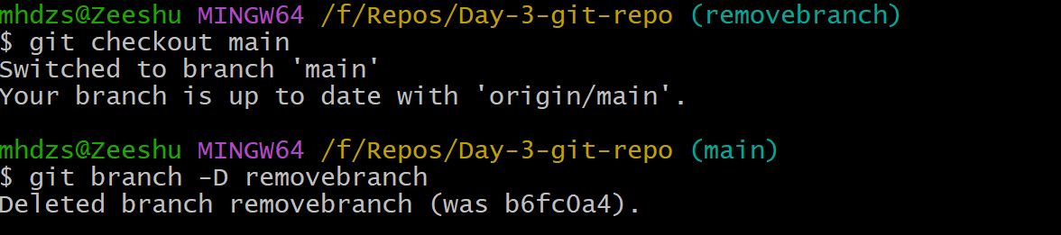

Validation Steps
Verify the expected output was achieved.

Explanation
This task demonstrates the corresponding Git/GitHub concept and workflow.

Real-Time Use Case
Used in collaborative software development and version control.

Common Errors and Troubleshooting
Error | Cause | Resolution
Command failed | Incorrect configuration | Verify commands and repository state

Task 12: Reset Commit

Outcome
Commit removed using reset.

Objective
To undo unwanted commit.

Prerequisites
• Git history

Step-by-Step Implementation
Execute the required Git/GitHub commands as per the assignment.

Screenshot Evidence
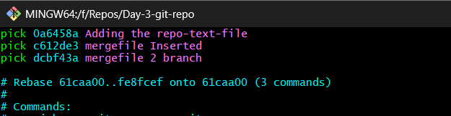

Validation Steps
Verify the expected output was achieved.

Explanation
This task demonstrates the corresponding Git/GitHub concept and workflow.

Real-Time Use Case
Used in collaborative software development and version control.

Common Errors and Troubleshooting
Error | Cause | Resolution
Command failed | Incorrect configuration | Verify commands and repository state

Task 13: Revert Commit

Outcome
Older version restored.

Objective
To safely undo history.

Prerequisites
• Existing commit

Step-by-Step Implementation
Execute the required Git/GitHub commands as per the assignment.

Screenshot Evidence
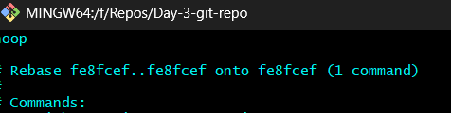

Validation Steps
Verify the expected output was achieved.

Explanation
This task demonstrates the corresponding Git/GitHub concept and workflow.

Real-Time Use Case
Used in collaborative software development and version control.

Common Errors and Troubleshooting
Error | Cause | Resolution
Command failed | Incorrect configuration | Verify commands and repository state

Task 14: Git Stash

Outcome
Changes stashed/restored.

Objective
To switch work without committing.

Prerequisites
• Modified files

Step-by-Step Implementation
Execute the required Git/GitHub commands as per the assignment.

Screenshot Evidence
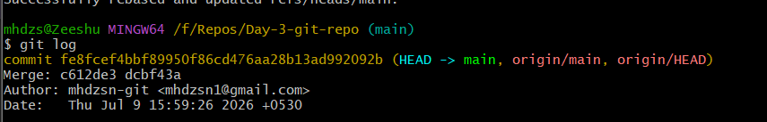

Validation Steps
Verify the expected output was achieved.

Explanation
This task demonstrates the corresponding Git/GitHub concept and workflow.

Real-Time Use Case
Used in collaborative software development and version control.

Common Errors and Troubleshooting
Error | Cause | Resolution
Command failed | Incorrect configuration | Verify commands and repository state

Task 15: SSH Key

Outcome
SSH key configured.

Objective
Passwordless GitHub authentication.

Prerequisites
• GitHub account

Step-by-Step Implementation
Execute the required Git/GitHub commands as per the assignment.

Screenshot Evidence
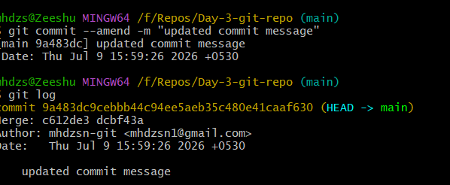

Validation Steps
Verify the expected output was achieved.

Explanation
This task demonstrates the corresponding Git/GitHub concept and workflow.

Real-Time Use Case
Used in collaborative software development and version control.

Common Errors and Troubleshooting
Error | Cause | Resolution
Command failed | Incorrect configuration | Verify commands and repository state

Task 16: Configure Webhooks

Outcome
Webhook configured.

Objective
Automate repository events.

Prerequisites
• GitHub repository

Step-by-Step Implementation
Execute the required Git/GitHub commands as per the assignment.

Screenshot Evidence
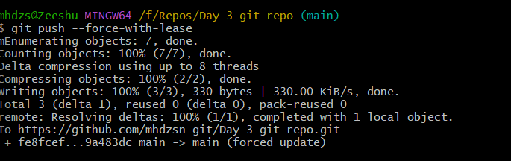

Validation Steps
Verify the expected output was achieved.

Explanation
This task demonstrates the corresponding Git/GitHub concept and workflow.

Real-Time Use Case
Used in collaborative software development and version control.

Common Errors and Troubleshooting
Error | Cause | Resolution
Command failed | Incorrect configuration | Verify commands and repository state

Task 17: Understand .git

Outcome
Viewed .git contents.

Objective
Understand Git metadata.

Prerequisites
• Local repository

Step-by-Step Implementation
Execute the required Git/GitHub commands as per the assignment.

Screenshot Evidence
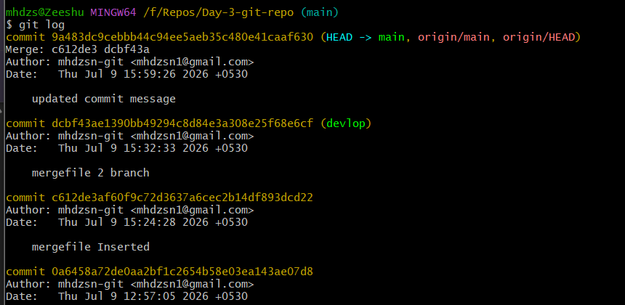

Validation Steps
Verify the expected output was achieved.

Explanation
This task demonstrates the corresponding Git/GitHub concept and workflow.

Real-Time Use Case
Used in collaborative software development and version control.

Common Errors and Troubleshooting
Error | Cause | Resolution
Command failed | Incorrect configuration | Verify commands and repository state

Task 18: View Logs

Outcome
Git logs displayed.

Objective
Review commit history.

Prerequisites
• Repository

Step-by-Step Implementation
Execute the required Git/GitHub commands as per the assignment.

Screenshot Evidence
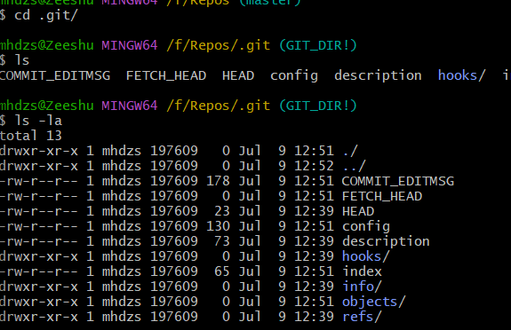

Validation Steps
Verify the expected output was achieved.

Explanation
This task demonstrates the corresponding Git/GitHub concept and workflow.

Real-Time Use Case
Used in collaborative software development and version control.

Common Errors and Troubleshooting
Error | Cause | Resolution
Command failed | Incorrect configuration | Verify commands and repository state

Task 19: Rename Commit

Outcome
Commit amended.

Objective
Correct commit message.

Prerequisites
• Existing commit

Step-by-Step Implementation
Execute the required Git/GitHub commands as per the assignment.

Screenshot Evidence
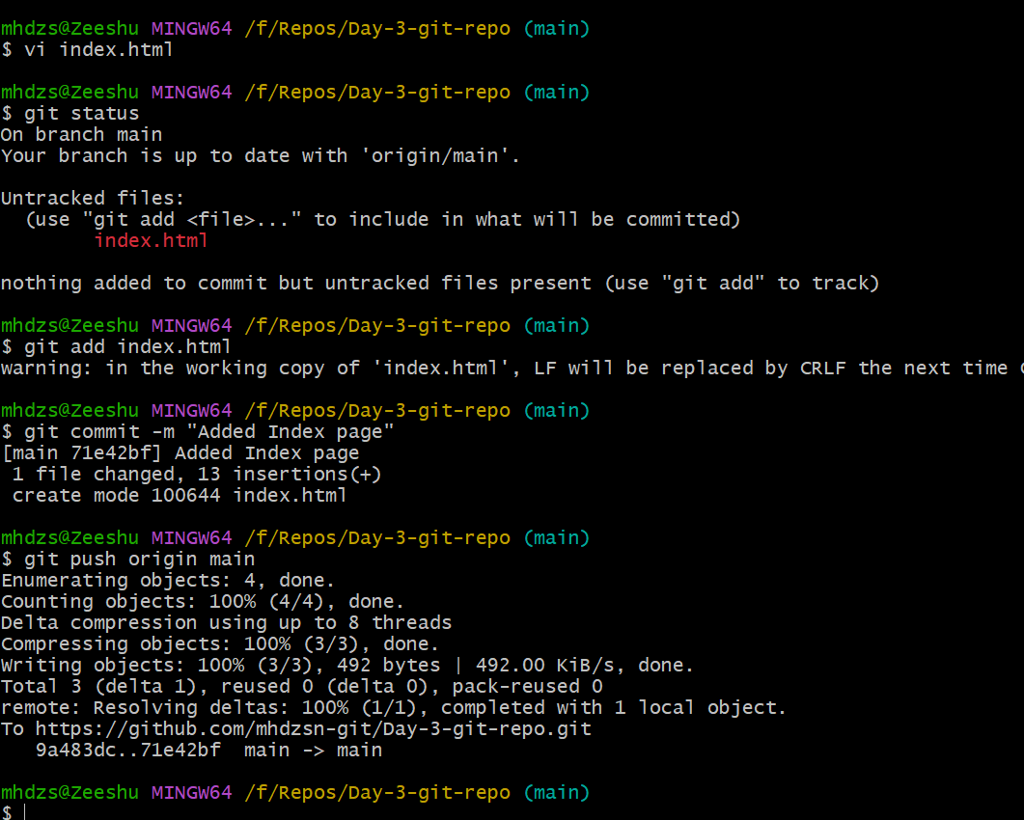

Validation Steps
Verify the expected output was achieved.

Explanation
This task demonstrates the corresponding Git/GitHub concept and workflow.

Real-Time Use Case
Used in collaborative software development and version control.

Common Errors and Troubleshooting
Error | Cause | Resolution
Command failed | Incorrect configuration | Verify commands and repository state

Task 20: Squash Multiple Commits

Outcome
Commits squashed.

Objective
Keep clean history.

Prerequisites
• Multiple commits

Step-by-Step Implementation
Execute the required Git/GitHub commands as per the assignment.

Screenshot Evidence
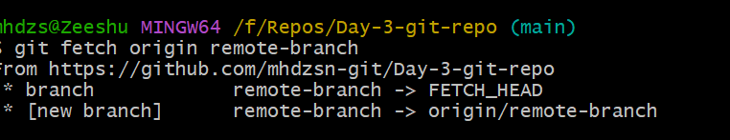

Validation Steps
Verify the expected output was achieved.

Explanation
This task demonstrates the corresponding Git/GitHub concept and workflow.

Real-Time Use Case
Used in collaborative software development and version control.

Common Errors and Troubleshooting
Error | Cause | Resolution
Command failed | Incorrect configuration | Verify commands and repository state

