Git & GitHub Task Completion Evidence
Evidence screenshots for Git & GitHub practical assignment.

GitHub Dashboard
Created a account and login to github and Enable the MFA
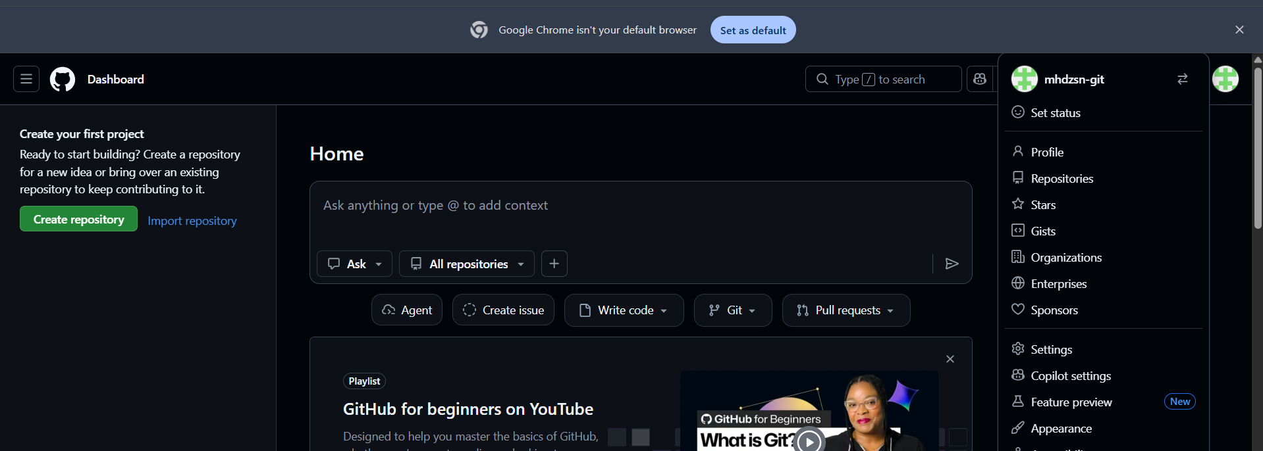

GitHub MFA Enabled
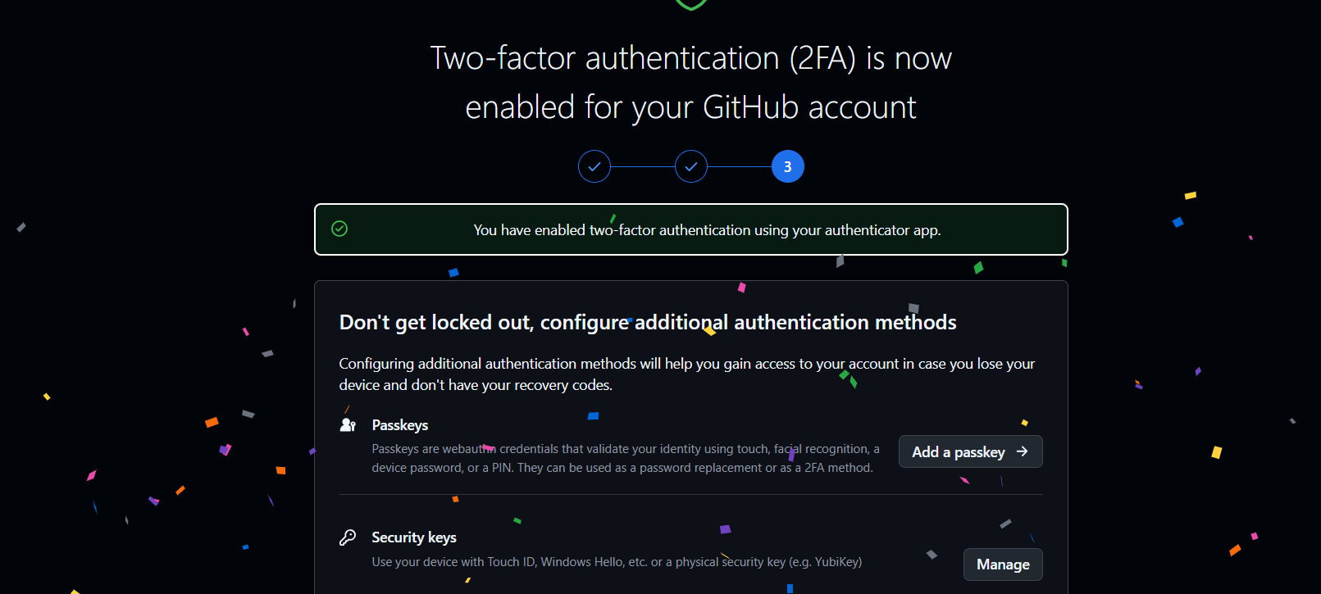

Push to GitHub
Git push -u origin main for push the main branch
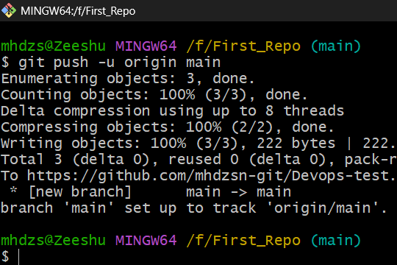

Push Result
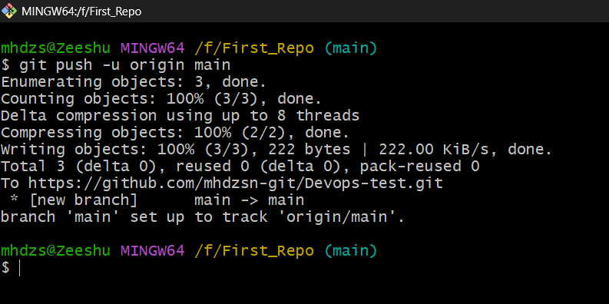

Create Repository Folder
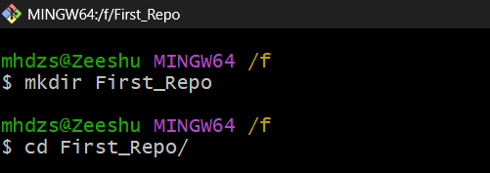

Create Files and Initialize Git
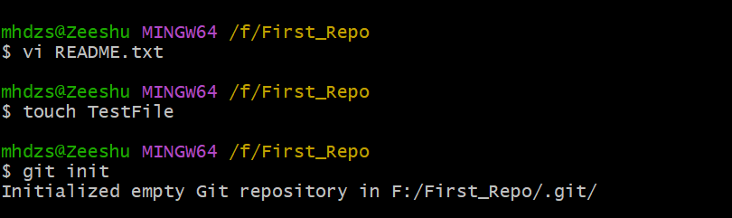

Git Status
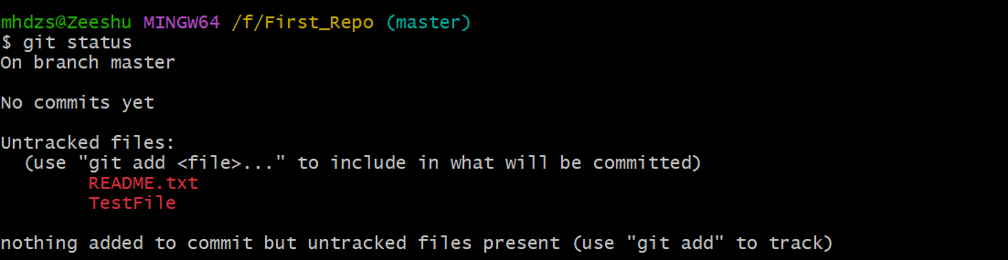

Git Add
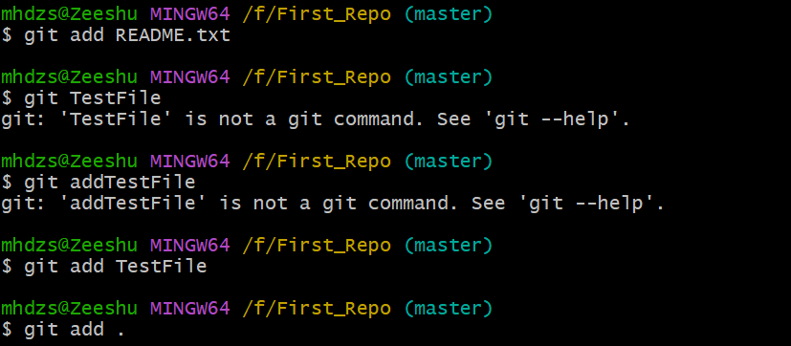

Git Status After Add
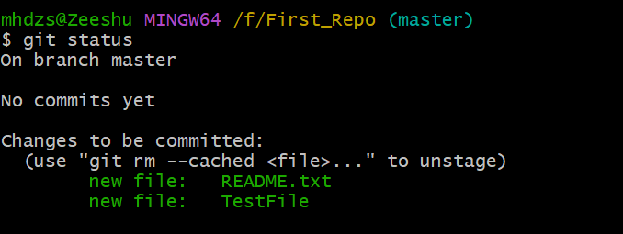

Configure Git
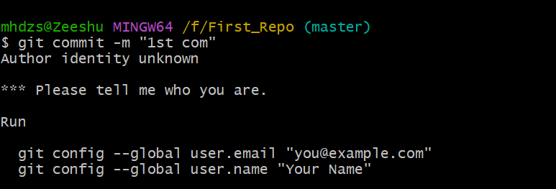

Branch Operations
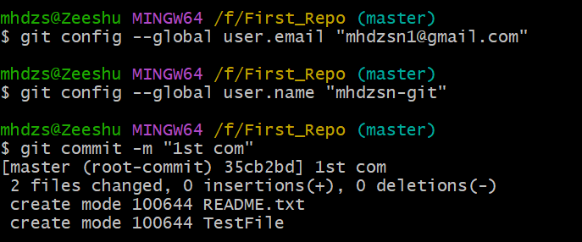

Remote Add
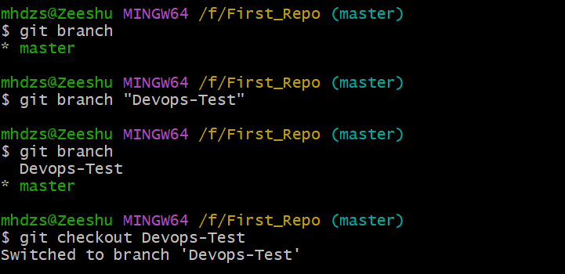

Remote Verify
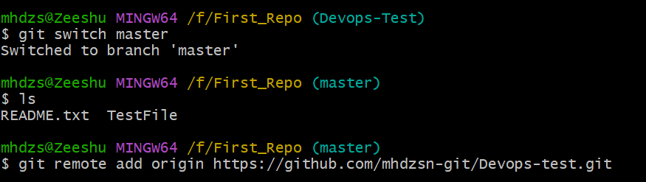

Push Main
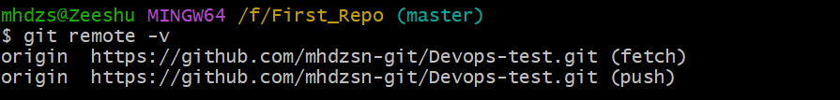

Clone Repository
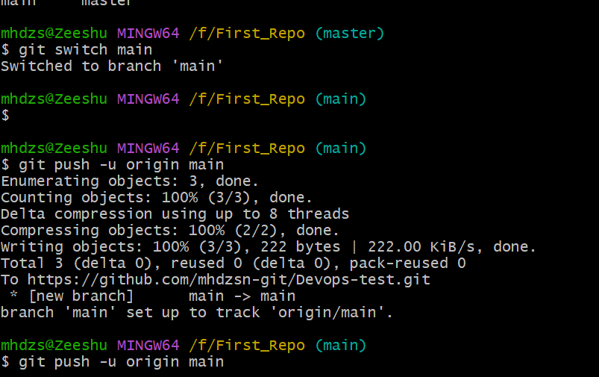

Git Log
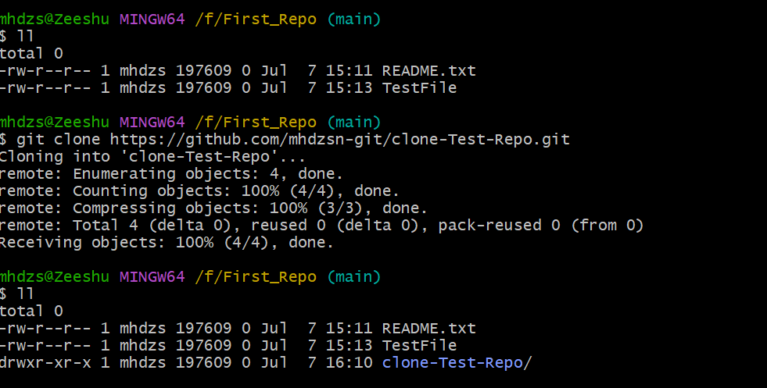

Git Pull
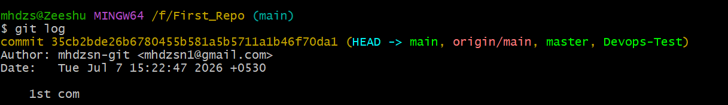

Final Evidence
