AWS IAM Project Report

Purpose
Implement AWS IAM administration tasks including IAM users, groups, policies, roles, scripting and cross-account S3 access.

Task 1 – Create IAM user and assign EC2 & S3 Full Access
- Open IAM > Users.
- Create a new IAM user.
- Attach AmazonEC2FullAccess and AmazonS3FullAccess.
- Review and create.
- Verify user.
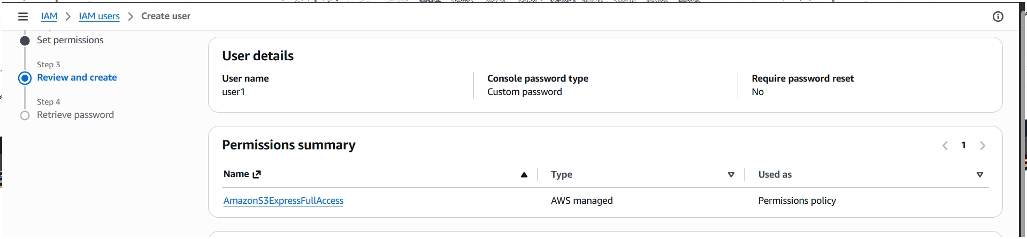
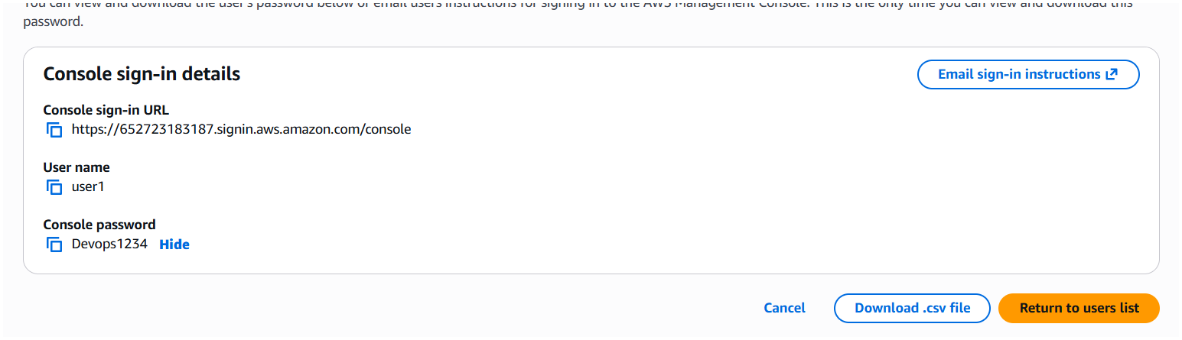

Task 2 – Create IAM group with EC2 Read access
- Create IAM group.
- Attach AmazonEC2ReadOnlyAccess.
- Verify group.
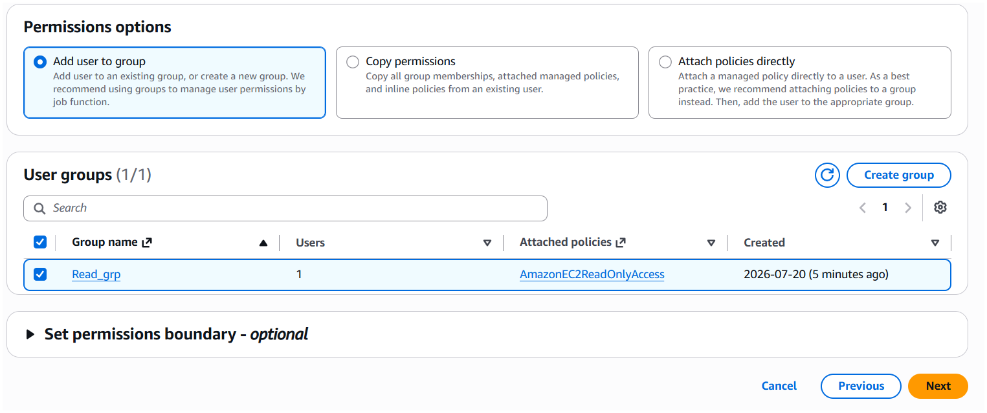
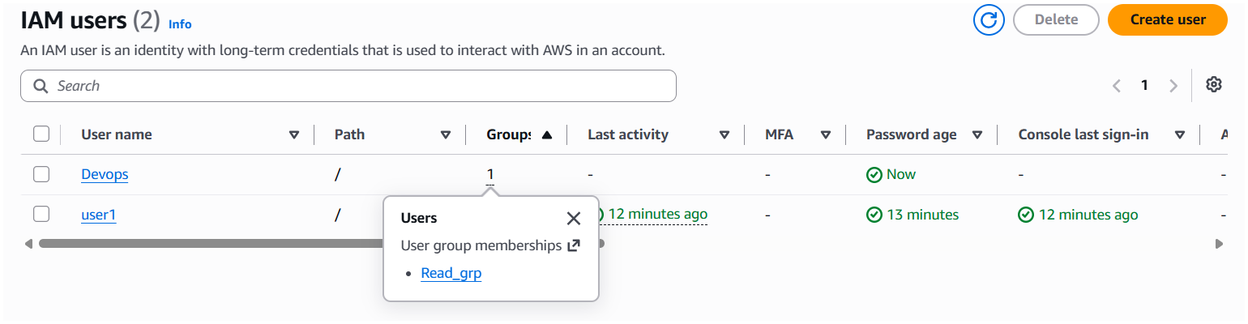

Task 3 – Create Devops user and add to group
- Create Devops user.
- Select existing Read_grp.
- Create user.
- Verify membership.
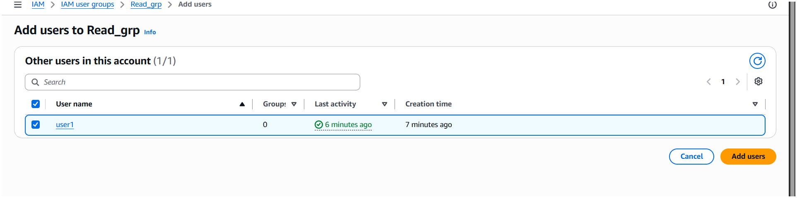
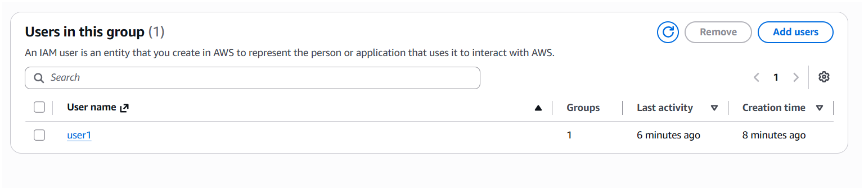
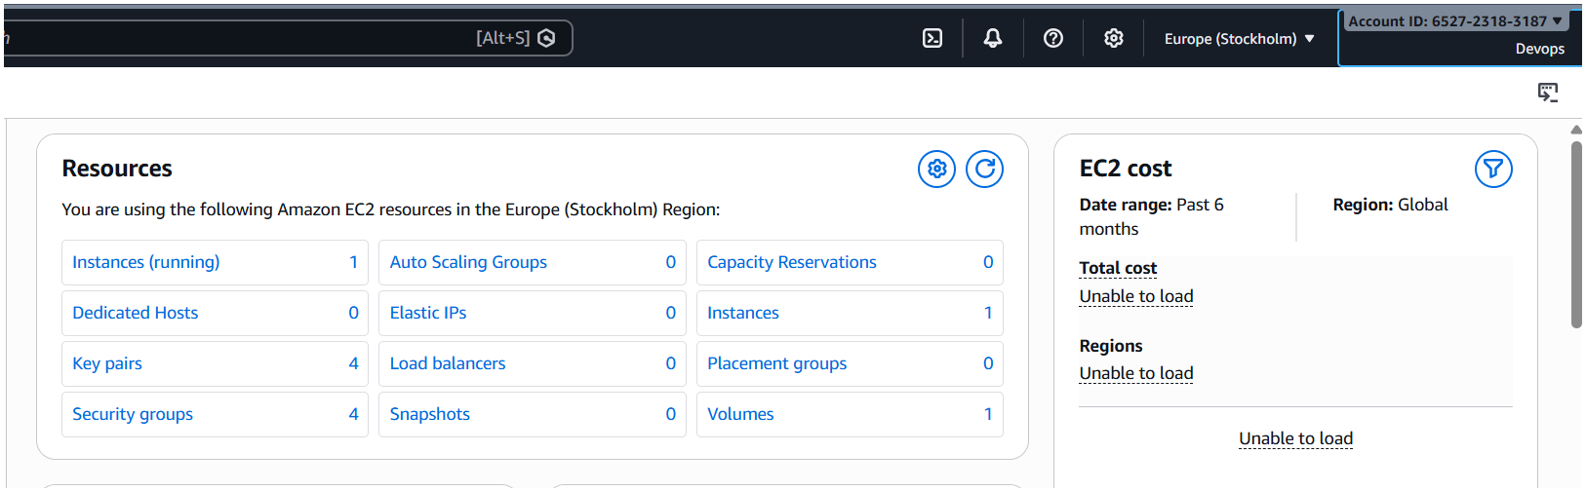

Task 4 – Bash script for IAM user with VPC Full Access
- Create bash script.
- Run AWS CLI commands.
- Attach AmazonVPCFullAccess.
- Verify output.
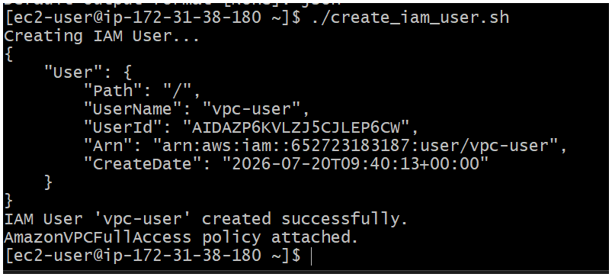
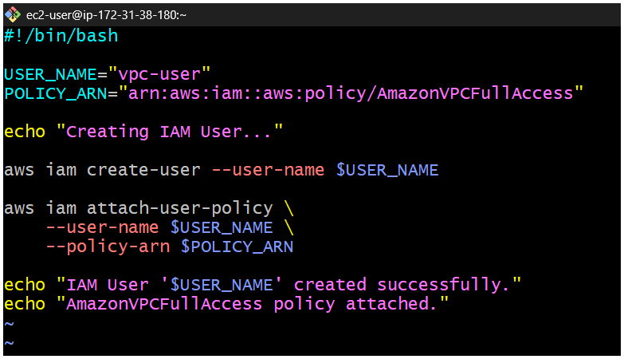
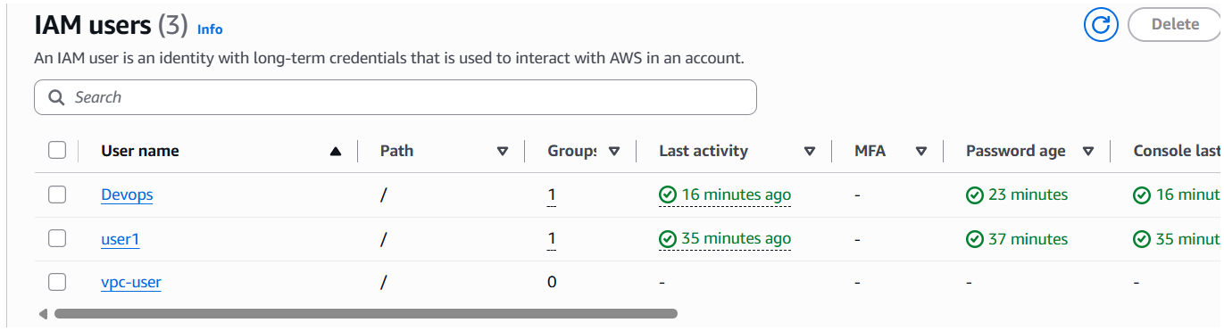

Task 5 – Restrict EC2 to specific region
- Create custom policy.
- Use RequestedRegion condition.
- Save policy.
- Verify creation.
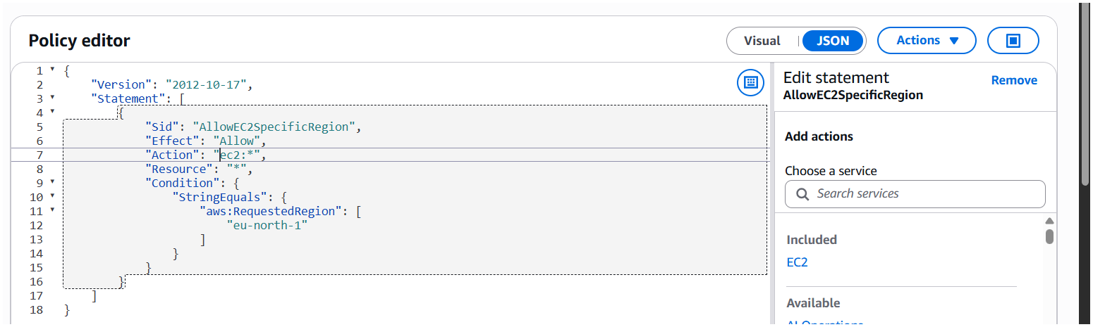
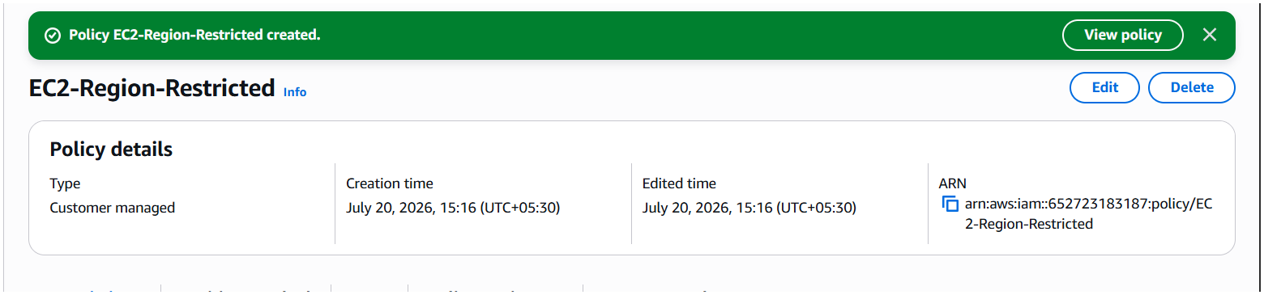

Task 6 – Cross-account S3 access
- Create bucket.
- Configure policy.
- Create role and trust.
- Test access.
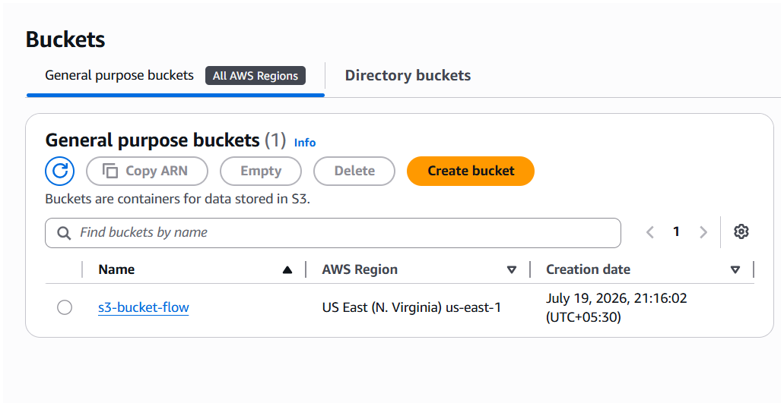
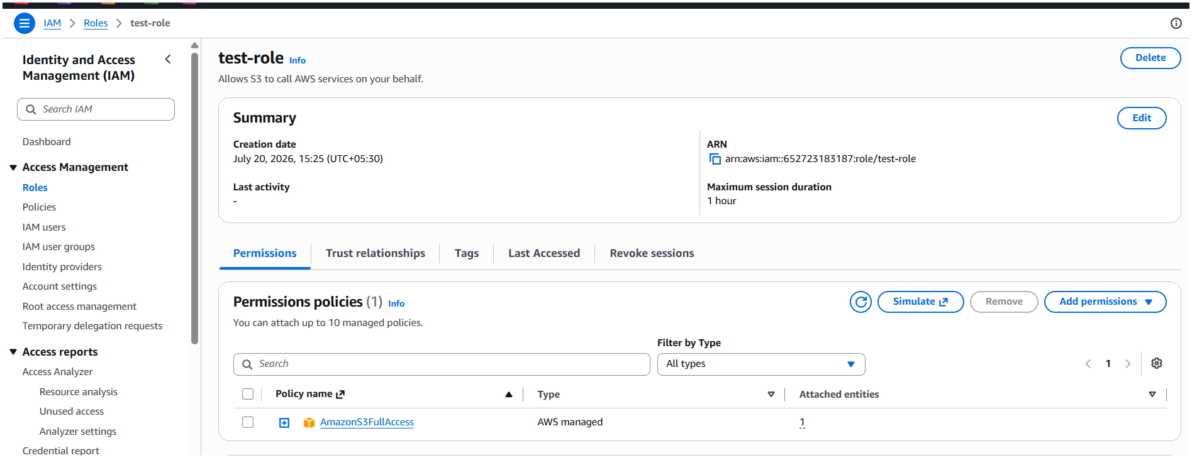
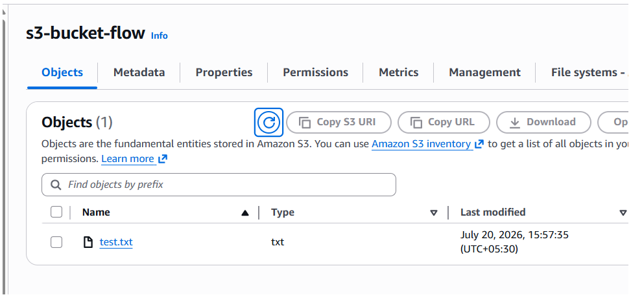
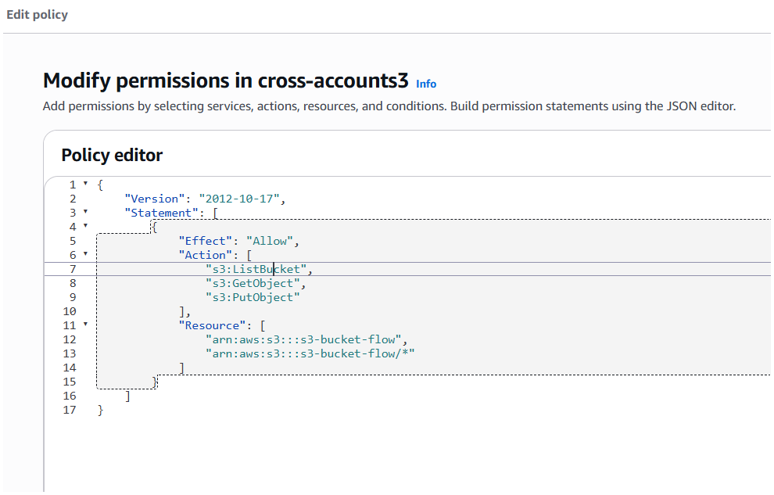
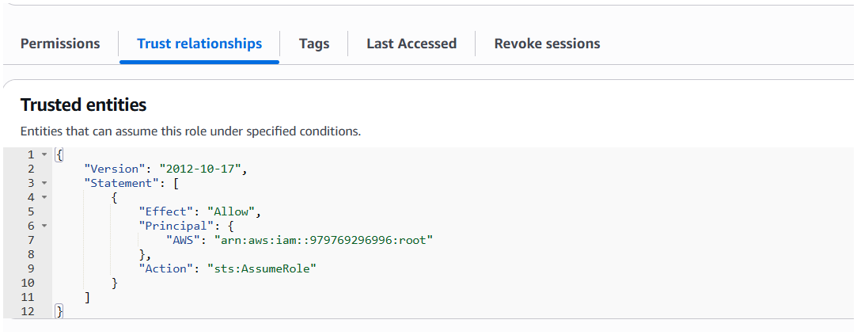

Conclusion
All IAM tasks were completed and verified successfully.

