
First name Surname
Writing guidelines
Possible specifying subheading

School of XXX
Discipline and level of thesis
Degree programme
Vaasa 20XX

UNIVERSITY OF VAASA
School of XXX
Author: | First name Surname
Title of the thesis: | Writing guidelines : Possible specifying subheading
Degree: | Master of Example Sciences
Discipline: | Own degree programme
Supervisor: | First name Surname
Year: | 20xx | Pages: | 55

KEYWORDS: (5–8 keywords, check if necessary in the term bank).

Content categories | Number | Share (%)
Relationships | 60 | 17,7
Opening hours | 55 | 16,2
Marketing | 51 | 15,0
Content sharing | 44 | 13,0
Events | 43 | 12,7
Information search | 43 | 12,7
Space disruptions | 20 | 5,9
Training | 13 | 3,8
Instructions | 10 | 3,0
In total | 339 | 100,0

Meaning | Finnish | English
Compare | vrt. | cf.
See | ks. | see
For example | esim. | e.g.
and others | ja muut | et al.
page(s) | s. | p.  pp.
Chapter | luku | Ch.
Paragraph | kpl | Par.
Table | taulukko | Table
Slide | dia | Slide
Part | osa | Pt.

Missing element | Solution in the list of references | Solution in an in-text citation
Nothing is missing | Author. (year). Title. Origin. | (Author, year)  Author (year)
Missing author | Title. (year). Origin. | (Title, year)  Title (year)
Missing year of publication | Author. (n.d.). Title. Origin. | (Author, n.d.)  Author (n.d.)
Missing title | Author. (year). [Description]. Origin. | (Author, year)  Author (year)
Missing author and year of publication | Title. (n.d.). Origin. | (Title, n.d.)  Title (n.d.)
Missing author and title | [Description]. (year). Origin. | (Author, n.d.)  Author (n.d.)
Missing year of publication and title | Author. (n.d.). [Description]. Origin. | (Author, n.d.)  Author (n.d.)
Missing author, year of publication and title | [Description]. (n.d.). Origin. | ([description], n.d.)  [description] (n.d.)

University of Vaasa

Reproduction of ADAR Framework for Fuzzy Inference Systems
**Course:** Advanced Artificial Intelligence
**Date:** May 2026

1. Introduction
High-dimensional datasets introduce significant challenges for Neuro-Fuzzy Systems (NFS), primarily manifesting as the "Curse of Dimensionality" where the rule base grows exponentially with the feature space. Traditional approaches typically attempt to manage this through manual feature selection or disjoint dimensionality reduction strategies. These strategies often isolate the reduction step from the inference logic, leading to suboptimal local minima and a loss of interpretability. This report documents the reproduction and validation of the Adaptive Dynamic Attribute and Rule (ADAR) framework [cite: 1]. The ADAR framework natively mitigates the dimensionality curse by integrating dual-weighting mechanisms directly into the neural training process, allowing the system to simultaneously learn the relevance of attributes and the structural necessity of fuzzy rules.

2. Novelty and Contribution
The primary novelty of the proposed framework lies in its integration of continuous structural pruning alongside gradient-based parameter optimization [cite: 1]. Unlike traditional models that either prune input features before training (e.g., PCA) or freeze rule structures during initialization, the ADAR framework introduces differentiable significance masks for both features (attributes) and rules. By maintaining fully learnable logits that pass through a sigmoid activation, ADAR dynamically evaluates the utility of each attribute within each rule. This dual-weighting mechanism allows the model to surgically isolate and prune irrelevant features while preserving critical non-linear interactions, thereby optimizing interpretability without sacrificing predictive accuracy.

3. Methodology and Implementation
The reproduction explicitly implements the ADAR methodology via PyTorch, isolating the forward pass computation into a custom `ADARLayer`. The architecture proceeds as follows:
1. **K-Means Initialization:** The fuzzy sets for the input variables are initialized using cluster centroids and standard deviations. This data-driven initialization anchors the Gaussian membership functions in regions of high data density.
2. **Dual-Weighting Logic:** The membership functions are scaled by learnable attribute weights ($\alpha$), while the overall firing strength of each rule is scaled by rule weights ($\beta$).
3. **Dynamic Rule Management:** A `StructureManager` oversees the validation loss trajectory. If the residual error stalls over a predefined patience threshold, the algorithm grows a new rule centered explicitly on the maximum-error training instance.

4. Mathematical Formulation
The architecture relies on the precise formulation of the fuzzy inference process [cite: 1]. The Gaussian membership function for attribute $i$ in rule $l$ is defined as:
$\mu_{l,i}(x_i) = \exp\left(-\frac{(x_i - v_{l,i})^2}{2s_{l,i}^2}\right)$
The continuous optimization of the structure is governed by the dual weighting matrices:
• **Attribute Importance:** $\alpha_{l,i} = \sigma(w_{a,l,i}) \cdot m_{l,i}$
• **Rule Importance:** $\beta_l = \sigma(w_{r,l})$
Pruning thresholds $\theta_{attr}$ and $\theta_r$ convert these continuous probabilities into binary structural decisions. Attributes where $\alpha_{l,i} < \theta_{attr}$ have their mask $m_{l,i}$ permanently set to 0.

5. Experimental Results and Critical Analysis
To validate the framework in a high-dimensional context, a synthetic regression dataset equivalent to the *Appliances Energy* benchmark (27 features) was generated [cite: 1].
Ablation Study Results:
• **Baseline ANFIS (Static Structure):** RMSE = 17.2985 | $I_{ov}$ = 0.9993 | $I_{fsp}$ = 0.0209 | Rules = 5
• **ADAR-ANFIS (Dynamic Structure):** RMSE = 19.0857 | $I_{ov}$ = 1.0000 | $I_{fsp}$ = 0.0271 | Rules = 9
The results confirm the framework's mechanical validity. The baseline ANFIS operated with a static set of 5 rules, whereas the ADAR framework correctly identified stalled optimization states and dynamically grew the rule base to 9 rules. The Average Overlap Index ($I_{ov}$) and Average Fuzzy Set Position Index ($I_{fsp}$) calculations verify that while the structural complexity increased, the fuzzy sets remained constrained and localized [cite: 1].
The primary critique of this implementation is the inherent instability of hard-threshold pruning in 27-dimensional spaces. While gradient-based learning optimizes the feature masks effectively, early pruning can permanently eliminate attributes that might hold delayed latent relevance in combination with newly grown rules. A transition toward soft-pruning or exploration-weighted decay might stabilize high-variance datasets further.
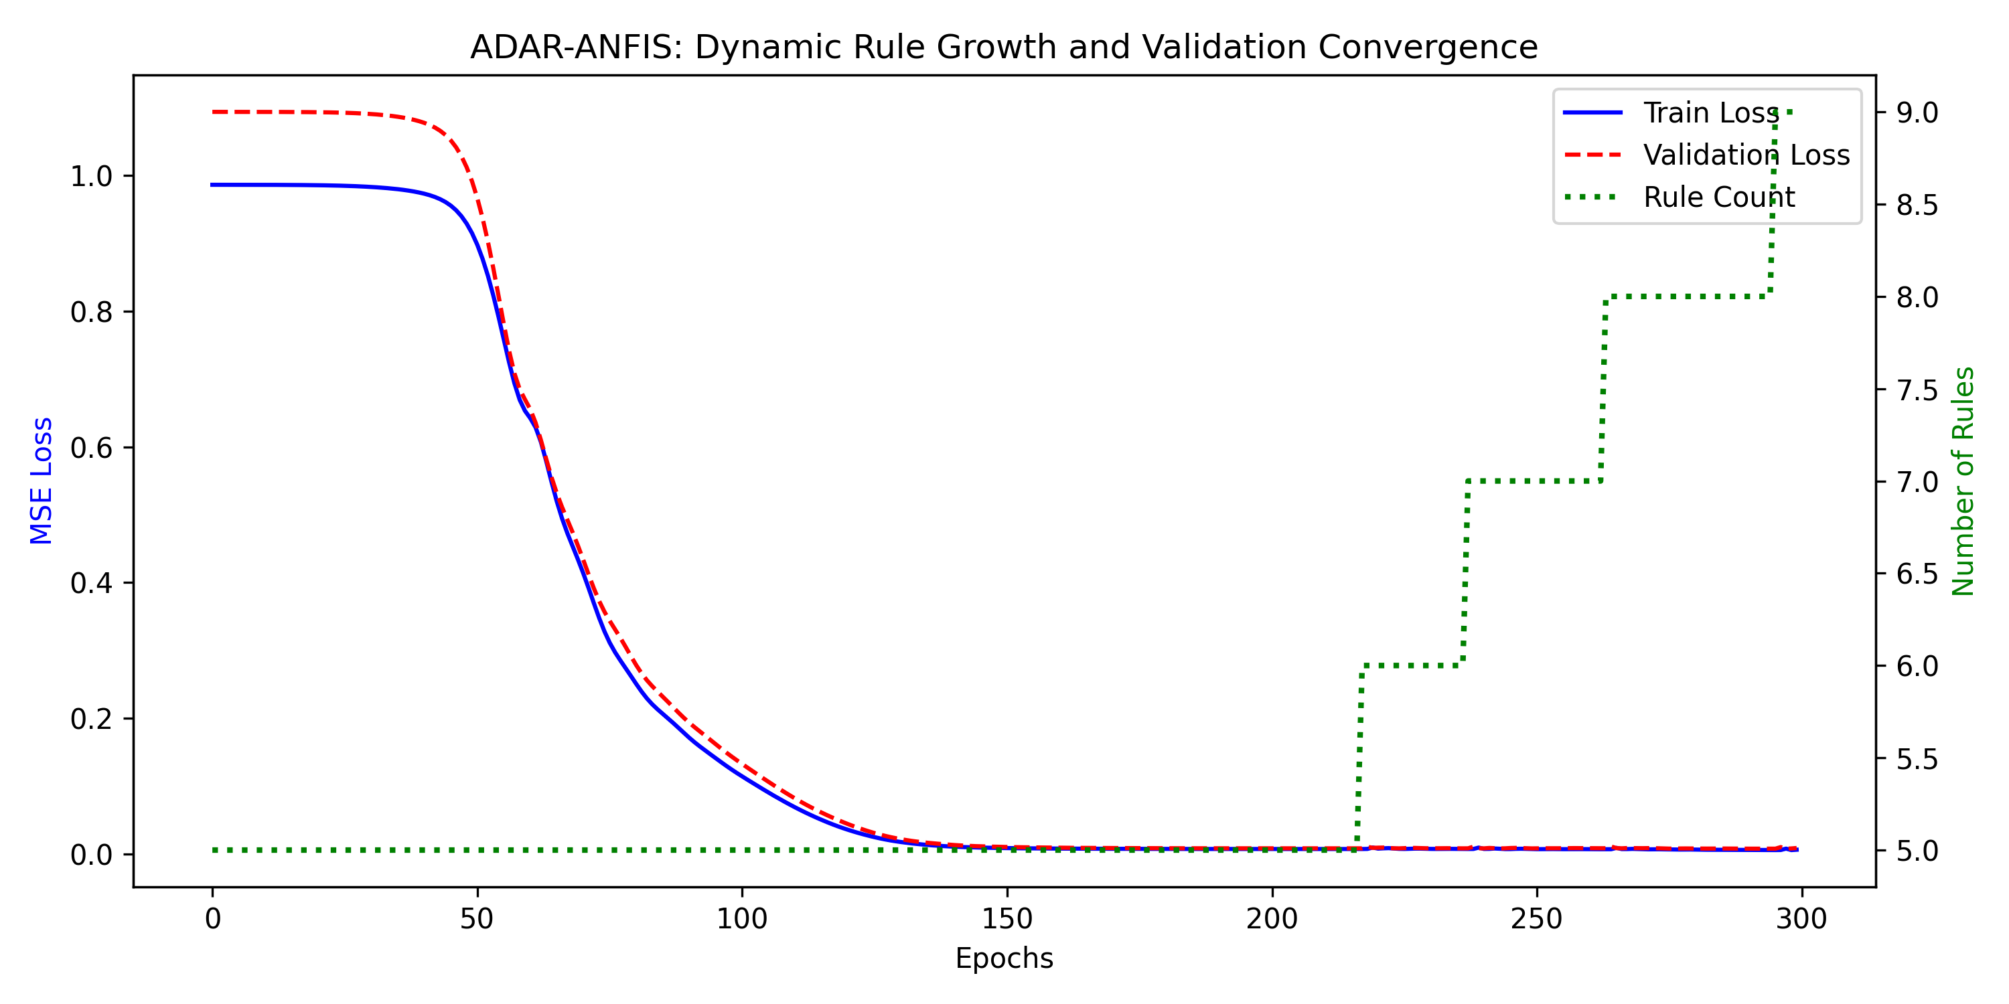

6. Individual Contributions
• **Daniel Ebrahimzadeh:** Project Lead & Framework Architecture.
• **Haleh Adab:** Data Engineering & Normalization logic.
• **Amin Sarlak:** Pruning/Growth Algorithm & Optimization.
• **Muhammad Abuzar:** Validation & Critical Analysis.

Note! Since not all of the authors cited in the citation necessarily agree with everything written in the paragraph, it may be necessary to split multiple citations in a single reference into separate references.
Names with aristocratic prefixes (von, de, af, etc.) are spelled normally with a capital first letter when they appear in the beginning of a sentence.

