S&P 500 Momentum &
Performance Analytics
Version 1.0 Research Report
Point-in-time S&P 500 membership, canonical and sector-relative momentum,
issuer attention, and intraday liquidity-sweep testing | 2021-2025
Miguel Hechavarria
September 2026
Research report - not investment advice

Executive Summary
What the completed Version 1.0 research program found

This project tests four momentum-related research branches on a point-in-time S&P 500 universe using independently audited data, preregistered confirmatory rules, and a reporting architecture that keeps frozen inference separate from visualization. The objective was to test defined hypotheses and preserve the result even when the evidence was negative.
8  Frozen primary tests | 0  Supported | 7  Not supported | 1  Contradicted
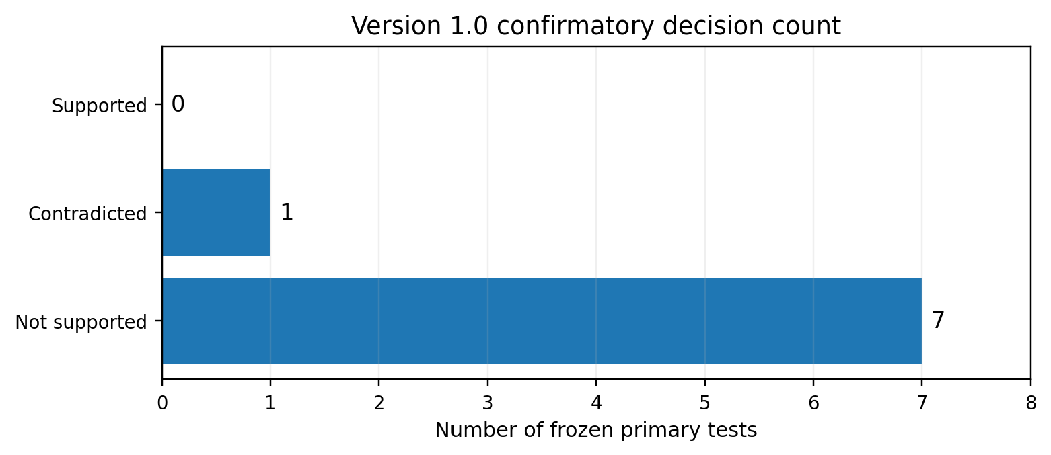
Figure 1. Final Version 1.0 confirmatory decision count.
Overall conclusion
The completed research program did not establish confirmatory support for canonical momentum, sector-relative momentum, or issuer-attention effects under the tested specifications. H4A was statistically contradicted: the mean signed post-sweep return moved in the opposite direction from the preregistered rejection hypothesis.
Component | Primary question | Decision
H1 | Canonical 12-1 momentum across point-in-time S&P 500 constituents | NOT SUPPORTED
H2 | Sector-relative 12-1 momentum within point-in-time GICS sectors | NOT SUPPORTED
H3A | Issuer attention -> next-month sector-relative return | NOT SUPPORTED
H3B | Issuer attention -> next-month Winner entry | NOT SUPPORTED
H3C | Attention incremental effect for current Winners | NOT SUPPORTED
H4A | Liquidity-sweep / same-bar rejection -> 30-minute reversal | CONTRADICTED

1. Research Design and Analytical Architecture
A reproducible, point-in-time, outcome-controlled workflow

1.1 Core design principles
- Point-in-time index membership: historical portfolios use the securities that were actually in the S&P 500 at each ranking date rather than retroactively applying the current constituent list.
- Permanent security identity: ticker changes are separated from issuer/security identity so return and membership continuity are preserved.
- Feature support is not membership: validated pre-membership prices may support trailing momentum calculations without granting earlier index eligibility.
- Forward returns are joined only after signals, ranks, and portfolio assignments are fixed.
- Preregistration and outcome firewalls are used for later hypotheses so model rules and source construction cannot be tuned after seeing confirmatory outcomes.
- Power BI presents and explores validated results but does not recalculate official p-values or hypothesis decisions.

1.2 System architecture
Layer | Responsibility
Sources | State Street / S&P Global / SEC / Yahoo / Tiingo / Investing.com / FRED / GDELT / Alpaca SIP
Python | Acquisition, deterministic identity resolution, source validation, independent audits, preregistration tooling, confirmatory inference where required
Azure SQL | Normalized core data, point-in-time analytics, rankings, forward returns, research warehouse, reporting semantic layer
Power BI | Interactive presentation, descriptive filtering, research communication

1.3 Version 1.0 study windows
60  H1/H2 ranking months | 59  Completed forward months | 58  H3 predictor months | 164  H4 eligible events
H1 and H2 rank monthly from January 2021 through December 2025. December 2025 remains a valid ranking month but its January 2026 one-month outcome is outside the frozen project scope. H3 predicts one month ahead from an attention interval ending in November 2025 and excludes June 2025 under the frozen GDELT source-coverage rule. H4 uses the 2021-2025 SPY intraday sample after its independent SIP coverage and event-construction gates.
Project source: docs/project_log.md, Sections 2.9-3.44, 3.62-3.75, and SQL/Power BI closeout sections.

2. Data, Point-in-Time Controls, and Quality Gates
Why the project emphasizes reproducibility before inference

2.1 Membership and historical market data
The current constituent anchor was built from State Street SPY holdings and reconciled backward with documented S&P 500 membership actions. The resulting security-level history preserves additions, deletions, ticker changes, spin-offs, acquisitions, and other cases that make a simple current-constituent backtest unreliable.
503 securities  Current anchor | 593  Historical identities | 596 / 596  Price requests passed | 783,086  Standardized observations

2.2 Price and tradability controls
- Yahoo Finance served as the primary daily-price route, with Tiingo and one validated archived Investing.com source used where historical coverage required fallback resolution.
- Independent security inception and termination references prevent the audit from demanding prices before a security existed or after independent public trading ended.
- Raw provider files remain immutable. Verified exceptions are applied only in the analysis-ready representation.
- The final analysis-ready price audit passed all 596 requests with zero unexplained missing sessions, duplicate dates, OHLC integrity failures, or adjusted-close nulls.

2.3 Corrected momentum feature scope
Critical methodological correction
An early SQL feature layer used membership-clipped month-end data for both ranking eligibility and trailing price support. That design omitted valid pre-membership lookback prices. The project corrected the feature-support boundary, independently audited it, and superseded the earlier 47-month result before final interpretation.
The corrected architecture uses 2020-2025 historical prices for trailing feature support while keeping 2021-2025 point-in-time membership as the ranking eligibility rule. The corrected canonical signal population contains 30,121 momentum assignments across 60 ranking months, with 59 completed one-month performance months.
Project source: docs/project_log.md, Sections 3.9-3.24 and 3.43-3.44.

3. H1 - Canonical 12-1 Momentum
Monthly equal-weight momentum deciles on the point-in-time S&P 500

3.1 Hypothesis and implementation
H1 tests whether the canonical 12-1 momentum signal produces reliable cross-sectional return ordering and whether the highest-momentum decile outperforms both the lowest-momentum decile and SPY. The signal is adjusted-close return from month -12 to month -1, intentionally skipping the ranking month.
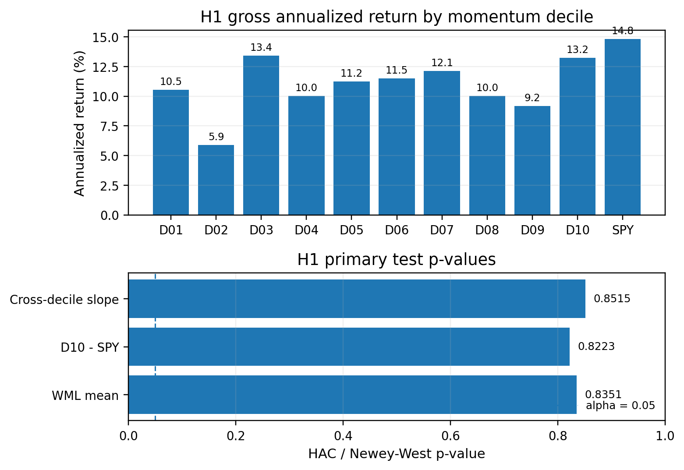
Figure 2. H1 annualized returns and primary HAC / Newey-West p-values. All Holm-adjusted primary p-values were 1.0000.
D10 earned approximately 13.23% annualized versus 10.54% for D01, while SPY earned approximately 14.83%. D03, at 13.40%, slightly exceeded D10; adjacent annualized decile returns increased in only 5 of 9 transitions.
84.21%  D10 cumulative | 63.67%  D01 cumulative | -1.63%  WML cumulative | 97.40%  SPY cumulative
H1 decision - NOT SUPPORTED
Mean WML return was not statistically different from zero (HAC p = 0.8351), D10 excess return versus SPY was not significant (HAC p = 0.8223), and the cross-decile slope was not significant (HAC p = 0.8515). The corrected sample therefore does not establish a reliable canonical momentum premium.

4. H2 - Sector-Relative Momentum
Testing momentum after neutralizing broad sector composition

4.1 Point-in-time sector design
H2 re-ranks securities within their point-in-time GICS sector, assigns deterministic within-sector quintiles, and combines all 11 sector Winner and Loser sleeves with equal sector weights. The design asks whether momentum remains after removing the possibility that one or two large sectors dominate the market-wide signal.
59  Completed W-L months | +0.186%  Mean monthly W-L | +2.24%  Annualized arithmetic mean | 0.6043  HAC(3) p-value
Metric | Result
Annualized volatility | 11.399%
Maximum drawdown | -13.234%
Winner annualized return | 12.575%
Loser annualized return | 9.482%
W-L Sharpe ratio | 0.196
SPY annualized return | 14.834%
Base-case 10 bps + 100 bps borrow net W-L | -0.049% annualized
Largest additive sector contribution | 50.719%
The aggregate point estimate was positive, and all 11 leave-one-sector-out estimates remained positive. However, the preregistered primary HAC test was not significant, no individual sector survived Holm adjustment, the base-case implementation result was slightly negative, and the frozen cross-sector concentration threshold was narrowly failed.
H2 decision - NOT SUPPORTED
A positive estimate is not enough under the preregistered rule. The primary two-sided HAC(3) p-value of 0.6043 did not satisfy the alpha = 0.05 threshold, so H2 remains not supported.
Project source: docs/project_log.md, Sections 3.45-3.46.

5. H3 - Issuer Attention and Momentum Outcomes
Outcome-blind construction of a point-in-time news-attention predictor

5.1 Attention source and predictor
H3 uses direct GDELT Global Knowledge Graph archives to construct a historical issuer-news attention measure. Company-name identity was resolved through a conservative point-in-time alias process using SEC and project identity evidence. Attention was aggregated to issuer-day, deduplicated to issuer-month, transformed with log1p scaling, standardized within month across eligible issuers, and only then mapped back to security rows.
June 2025 was excluded before outcome access because GDELT primary source coverage fell to approximately 43.3%, below the frozen 90% month-eligibility threshold. No missing attention was imputed for primary inference.
29,287  Frozen predictor rows | 58  Eligible predictor months | 583  Issuer clusters | 807  H3B Winner-entry events
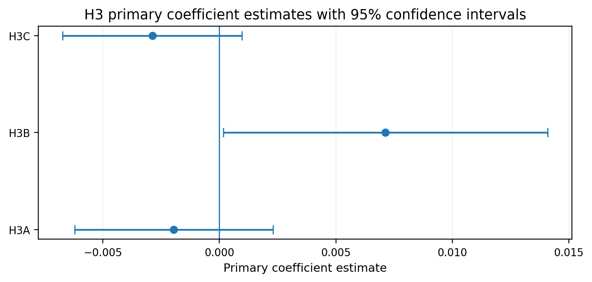
Figure 3. H3 primary coefficients with two-way clustered 95% confidence intervals.
Component | Estimate | Raw p | Holm p | Decision
H3A | -0.001959 | 0.3607 | 0.3607 | NOT SUPPORTED
H3B | +0.007130 | 0.0449 | 0.1346 | NOT SUPPORTED
H3C | -0.002878 | 0.1405 | 0.2809 | NOT SUPPORTED
Why H3B is not a positive finding
H3B is the only component with the preregistered positive sign and an unadjusted p-value below 0.05. But the hypothesis family was frozen in advance and required Holm adjustment across H3A, H3B, and H3C. The adjusted H3B p-value is 0.1346, so the result is a nominal signal, not confirmatory support.

6. H4 - Intraday Liquidity Sweeps
A preregistered SPY five-minute support/resistance reversal test

6.1 Location first, trigger second, outcome last
H4 moves from monthly cross-sectional momentum to SPY intraday market structure. The location engine uses only previous-day, previous-week, and previous-month highs/lows known before the session. Levels become ATR-normalized zones, overlapping same-direction zones are merged, and only the first contact with each zone can produce a primary event.
The primary trigger is a same-bar liquidity sweep and rejection: price must exceed the reference level by at least 0.02 x prior-day ATR(14) and close back through the level on the same five-minute bar. The primary outcome is the signed 30-minute forward return, where positive values always represent movement in the preregistered rejection direction.
164  Eligible events | 156  Session clusters | -0.061314%  Mean signed 30m | CONTRADICTED  Decision
Primary H4A statistic | Result
Mean signed 30-minute return | -0.000613142249862
Economic effect | -0.061314 percentage points
Session-clustered SE | 0.000288872659684
95% confidence interval | [-0.00118378, -0.00004251]
Two-sided p-value | 0.0354
Inference | Session-cluster robust, alpha = 0.05
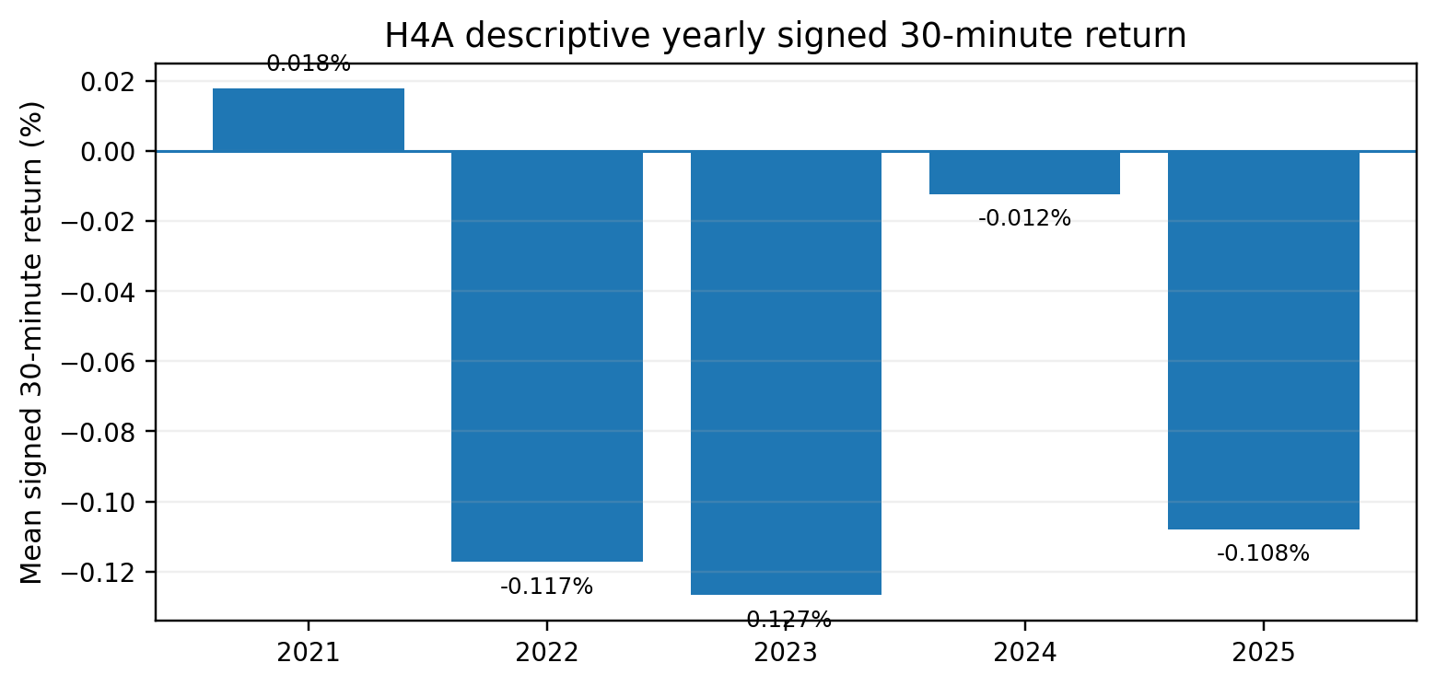
Figure 4. Descriptive H4A yearly mean signed 30-minute returns. Four of five years were negative.
H4A decision - CONTRADICTED
The primary signed return was significantly negative, opposite the preregistered reversal direction. The first-contact sweep/rejection formulation is therefore contradicted; a continuation interpretation would require a new hypothesis.

7. Integrated Interpretation
What the combined H1-H4 evidence says - and what it does not say

7.1 Across hypotheses
The four research branches progressively changed the proposed mechanism rather than repeatedly tuning one failed specification. H1 tested market-wide cross-sectional momentum. H2 asked whether sector composition explained the effect. H3 introduced an external issuer-attention variable under an outcome firewall. H4 moved to a separate intraday price-location mechanism. None of these branches was altered after its confirmatory result to manufacture support.
Branch | Economic pattern | Confirmatory interpretation
H1 | D10 > D01 economically, but SPY > D10; WML compounded slightly negative | No reliable canonical momentum premium
H2 | Positive sector-neutral W-L point estimate | Statistically weak and not cost/concentration robust
H3 | H3B nominal positive raw p < 0.05 | Did not survive the frozen Holm family
H4 | Negative signed post-sweep return | Statistically opposite to the preregistered reversal direction

7.2 Interpretation boundary
Not supported is not the same as impossible
The results do not prove that momentum, attention, or liquidity-sweep effects can never exist. They show that the specific definitions, data windows, eligibility rules, and inferential procedures frozen for Version 1.0 did not establish the proposed effects reliably.
This distinction is particularly important for H1-H3. Failing to reject a null does not demonstrate that the true effect is exactly zero. At the same time, the project should not dismiss the negative evidence as merely a power problem: several point estimates were small, non-monotonic, or opposite the expected sign. H4 is stronger directionally because the significant primary estimate is negative under a convention where positive values represent the predicted rejection direction.

7.3 Why the negative result is useful
- It shows how survivorship-bias controls and pre-membership lookback support can materially change an apparent momentum result.
- It demonstrates that multiple-testing adjustment can change the interpretation of an otherwise nominally significant result.
- It preserves contradicted evidence rather than relabeling it after the fact.
- It produces a reusable SQL/Python/Power BI research architecture for future, separately preregistered Version 2 work.

8. Limitations, Reproducibility, and Reporting
Version 1.0 scope and the audit trail behind the results

8.1 Principal limitations
- The primary ranking and outcome period is 2021-2025; longer historical windows may produce different estimates.
- H1/H2 transaction and borrow costs are sensitivity scenarios rather than reconstructed historical execution records.
- FRED DGS1MO is used as a constant-maturity yield proxy, not as the realized return from purchasing a specific Treasury bill.
- CAPM is a one-factor market control and does not exhaust alternative factor explanations.
- H3 depends on GDELT source availability and conservative point-in-time issuer aliases; June 2025 is excluded from primary attention eligibility.
- H4 applies only to the explicitly coded support/resistance, same-bar sweep/rejection definition and the 30-minute primary horizon.
- H4 is a gross price-return signal test and does not authorize a deployable trading-strategy claim.

8.2 Reproducibility assets
Artifact | Purpose
docs/project_log.md | Chronological technical audit trail and methodological decisions
README.md | Publication-facing project overview
sql/schema + sql/analytics | Database and research-layer migrations
src/ingestion + src/analysis | Acquisition, transformation, audits, and confirmatory execution
reports/data_quality | Independent integrity-audit outputs
reports/confirmatory | Frozen confirmatory result artifacts
docs/power_bi_dax_measures.md | Permanent report-layer DAX and presentation fields
dashboards/sp500_momentum_analysis_report.pbix | Canonical interactive Power BI report

8.3 Reporting boundary
The Power BI report contains an Executive Research Summary, H1-H4 pages, and an Interpretation & Research Limits page. Descriptive visuals may respond to a synchronized Year slicer, but frozen inferential cards and official decisions do not. This preserves the distinction between interactive exploration and the full-sample preregistered research decision.
Project source: docs/project_log.md, Sections 3.76-3.83 and the final Power BI documentation.

9. Conclusion and Version 1.0 Closeout
The project is complete as a research program; future work should be separately versioned

Version 1.0 of S&P 500 Momentum & Performance Analytics is scientifically complete. The final research program contains eight frozen primary tests: zero supported, seven not supported, and one contradicted. The results do not validate the tested momentum and attention hypotheses, and the intraday H4A reversal formulation is statistically contradicted.
The central contribution of the project is therefore not a claimed trading edge. It is a reproducible empirical framework that combines point-in-time index membership, audited market-data exceptions, deterministic identity controls, SQL analytical layers, independent Python quality gates, preregistration, outcome firewalls, multiplicity control, and an interactive reporting layer that does not redefine inference.
Version 1.0 closeout
Future historical extensions, factor models, post-2025 updates, continuation interpretations of H4 events, or any new H5 hypothesis should begin as Version 2 research. They should not be used to rewrite the completed Version 1.0 decisions.

Project data and evidence sources
- State Street SPDR S&P 500 ETF Trust holdings - current constituent anchor.
- S&P Dow Jones Indices / S&P Global - historical membership actions and GICS effective-date evidence.
- SEC filings and issuer identity data - historical sector-state and point-in-time company-name evidence.
- Yahoo Finance - primary historical daily price route; Tiingo and archived Investing.com data used for validated fallback cases.
- FRED DGS1MO - ex-ante one-month Treasury constant-maturity yield proxy.
- GDELT Global Knowledge Graph - historical issuer news-attention source.
- Alpaca SIP - consolidated SPY one-minute intraday source used in H4.

Primary internal references
- docs/project_log.md - complete chronological technical record.
- docs/analytical_methodology.md - price, return, and momentum conventions.
- docs/h2_sector_relative_momentum_preregistration.md - H2 frozen design.
- docs/h3_statistical_preregistration_v2.md - H3 frozen design.
- data/reference/h4/h4_primary_liquidity_sweep_inference_v1.json - H4 frozen primary inference specification.
- docs/power_bi_semantic_model.md and docs/power_bi_dax_measures.md - reporting contract and presentation logic.
Project source: This report summarizes the validated Version 1.0 project record and does not replace the underlying audit artifacts.

