WeatherTop 2.0

ICT Skills 1 Assignment Briefing

*Version 1*

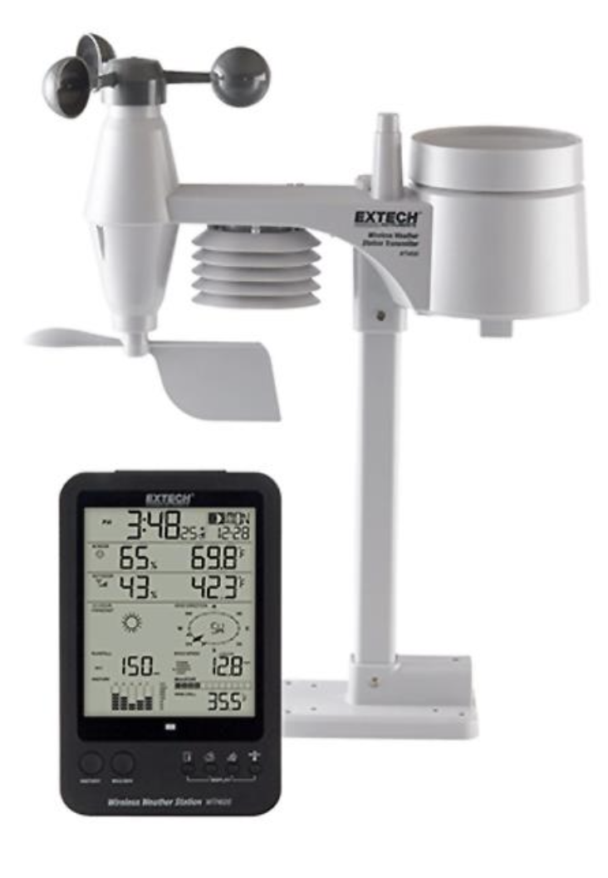

WeatherTop Inc. have requested a revised version of the WeatherTop application – called WeatherTop 2. This is to be reimplementation of the original (WeatherTop 1) specification implemented as a Glitch/Node application.

As well as the features as specified in the WeatherTop 1 specification, they are looking for 3 new features to be prototyped:

* *Auto Generate Reading*: When a reading is being submitted, an ‘Auto’ button will populate a reading from the OpenWeatherMap Service (<https://openweathermap.org>). This service can generate a reading from any given lat/lng value.
* *Graph of Trends:* A simple line chart of temperature, wind and pressure trends.
* *Map of Stations*: A Map with markers indicating the location of the Stations

These features, or a subset thereof, are to be part of a new ‘Release 4’ version.

## Project Deliverables

The payment schedule has been revised, with Starter & Baseline merged + a new Release 4 added which includes a prototype of the new features.

|  |  |  |
| --- | --- | --- |
| Version | Package Label | Payment |
| 1 | **Baseline** | 0%-20% |
| 2 | **Release 1** | 20%-45% |
| 3 | **Release 2** | 45%-60% |
| 4 | **Release 3** | 60%-70% |
| 5 | **Release 4** | 70%-100% |

We will accept the most complete version only, as one of the following:

1. A glitch project link
2. A zipped archive of all code for the version (named version-codename.zip)
3. A GitHub repository

We have a preference for (3), but are happy to accept (1) or (2)

## Grading Rubric

|  | Reading | Station | Member | Features | Code |
| --- | --- | --- | --- | --- | --- |
| Baseline | Code Temp Wind Speed  Pressure | Station Name  Latest weather, Temp C, F, Wind Bft, pressure | None | Load and display stations + their readings from JSON file display latest weather for station | Zipped archive + Readme |
| Release 1 | + Wind Direction | + Wind Chill, Wind Compass | None | Dashboard shows station list + button to open station view. Include forms to add new Station + new reading | + Glitch Project |
| Release 2 |  | +Lat, Lng  Max/Min (Temp, Wind, Pressure) | First Name, Last Name, Email, Password  + Stations | Members can signup/log in. Members may create any number of weather stations. Members + sample stations + readings loaded from JSON | + Github repo |
| Release 3 | + Time/Date | Temp, Wind Pressure Trends | User can edit their personal details. | Member dashboard list summary lists latest conditions for all stations.  (alphabetically). Members can delete reports or stations | + Github repo with history |
| Release 4 | Auto Read from OpenWeatherMap API | Station Map View |  | Simple Graph of Trends | + Github repo tags |

## Auto Generate Reading

OpenWeatherMap is a service that provides a public API for accessing global weather data:

## <https://openweathermap.org/>

Developers can register for an account to get an API Key, and then use this key to request weather data. The API includes a feature to get the current weather data from a specific lat/lng.

The Auto Generate button ignores the values in the form and creates acquires a new reading from the OpenWeatherMap API.

We recommend accessing the API using the Axios component:

* <https://axios-http.com/>

## Graph of Trends

Display trends visually as a simple line chart:

The above shows temperature only. WeatherTop are interested in variations on the above – including ability to show temperature, wind and pressure trends.

We recommend using the Frappe Chart component:

* <https://frappe.io/charts>

## Maps

On the Dashboard, display a map showing the locations of each station:

We recommend using the Leaflet mapping component:

* <https://leafletjs.com/>