Supplementary Material

Aquaculture is subject to more regulations than any other food sector in the United States

Margaret Hegwood^{1,2*}, Halley E. Froehlich^{3,4,5}, Michael Clark^{6,7,8,9}, Matthew G. Burgess¹⁰⁺, & Peter Newton¹⁺

- Data compilation and preparation.
To quantify the number of regulations for different U.S. food industries, we used the most recent complete version of RegData (Version 4.1) from the George Mason University Mercatus Center QuantGov project (QuantGov, 2024). RegData is “both a methodology and a database that quantifies regulations by industry, by regulatory agency, and over time” (McLaughlin & Sherouse, 2019). The methodology of RegData uses machine learning to quantify the number, restrictiveness, and relevance of regulations found in U.S. Code of Federal Regulations (CFR) for each U.S. food industry using the North American Industry Classification System.

In alignment with RegData, we used industry codes and descriptions of food industries from the North American Industry Classification System (NAICS) (U.S. Census Bureau, 2024a). Food industries produce food for human consumption. We chose the term ‘food industry’ rather than ‘agriculture industries’ because agriculture does not explicitly include aquaculture or other forms of food production (e.g., commercial fishing, hunting). NAICS codes use a classification system that places six-digit industry codes into a hierarchical structure that decreases in specificity as code lengths decrease from more (e.g., six) to fewer (e.g., two) digits. For the purposes of this study, we used data from RegData corresponding to the six-digit NAICS because they are the most specific industry codes and correspond directly with existing U.S. industries. First, we selected all of the industries in Agriculture, Forestry, Fishing and Hunting sector (NAICS code 11). Within this sector, there are 64 six-digit U.S. industries. We filtered these 64 U.S. industries down to 44 food production industries (see Supplementary Dataset 1), removing 20 U.S. industries not related to food production including the subsectors Forestry and Logging (NAICS code 113) and Support Activities for Agriculture and Forestry (NAICS code 115) as well as some more specific industries including Nursery and Floriculture Production (NAICS code 11142), fodder production (e.g. hay), fiber production (e.g. cotton), and non-food animal production (e.g., fur production). We note that Version 4.1 of RegData uses NAICS codes from 2007, some of which may be outdated compared to the most recent 2022 version of NAICS codes. However, according to crosswalk files comparing 2007 to 2012 and 2017 NAICS codes (U.S. Census Bureau, 2024b). NAICS codes for the Agriculture, Forestry, Fishing and Hunting sector (NAICS code 11) have not changed between 2007 and 2022.

We categorized the remaining 44 U.S. food industries into five food sectors based on primary production system: Aquaculture, Crop Farming, Terrestrial Animal Farming, Hunting and Trapping, and Fishing (see Supplementary Dataset 1). In this study, a “food sector” is made up of food industries that produce and/or acquire food for human consumption. For this reason, we include Hunting and Trapping even though only a small fraction of food consumed in the U.S. is from hunting. Fishing includes commercial fishing. Our definition of food sector does not include non-food producing industries (e.g., fiber) nor downstream industries, such as food processing, retailing, or marketing. We note that this definition differs slightly from the term ‘sector’ used by the NAICS code system, which uses sector to define its 2-digit NAICS codes.

- Calculating direct regulations.
"Direct regulations” refers to the number of regulations explicitly for a given industry (Al-Ubaydli & Mclaughlin, 2017). Direct regulations include those from all CFR titles and federal agencies relevant to a given industry, including those that apply to all industries (e.g., business, safety regulations). Consistent with previous publications using RegData (e.g., Chambers, Collins and Krause, 2019; Staples et al., 2021, 2022; Staples, Chambers and Malone, 2022), we counted the number of direct regulations from the entire CFR using RegData’s most recent restrictions metric (Restrictions 2.0), which is the sum of all instances of restrictive words in a given regulatory document. Restrictive terms include the words “may not”, “shall”, “required”, “must”, and “prohibited”. We determined the numbers of regulations for each industry by using RegData’s industry relevance score, which is equivalent to the probability that a given regulatory document applies to a particular industry using NAICS codes. RegData determines the relevance of each regulatory document (i.e., section) within the CFR using natural language processing (see Al-Ubaydli and Mclaughlin, 2017 and QuantGov, 2024) for more information on this methodology). We combined these industry relevance scores with the number of restrictions in each document to calculate the expected number of regulations for all 44 food industries according to Al-Ubaydli and Mclaughlin (2017) from 1970 to 2020 as follows:

$r_{yi}= \sum_{p=1}^{n}{a_{pyi}R_{py}}$ (1)

Where $r_{yi}$is equivalent to the total number of direct regulations in year, $y$, for industry, $i$; $a_{pyi}$ is equivalent to the probability that document part, $p$, of the CFR in year, $y$, is relevant to industry, $i$; $R_{py}$ is the number of restrictions in document part, $p$, of the CFR in year, $y$.

One concern with this approach for calculating direct regulations is that there could be very low-probability documents (i.e., low $a_{pyi}$) that contain a disproportionately high number of regulations (i.e., high $R_{py}$). If this were the case, our estimate for direct regulations could be biased upwards. Additionally, if this trend were true for some industries and not others then our main finding that some industries are regulated more than others may be less robust. To address this issue, we conducted a sensitivity analysis where we compared the results from our estimated value approach (see Equation 1) where regulations from all documents were considered regardless of $a_{pyi}$ with scenarios where we used a range of cutoff values (e.g., 0.1, 0.5) for $a_{pyi}$ (Al-Ubaydli & Mclaughlin, 2017). Results from this analysis (see Supplementary Dataset 1 and Extended Data Fig. 1) show that changing the cutoff value for $a_{pyi}$ does not substantially alter our findings beyond lowering the overall number of regulations for each industry, which is expected as the cutoff value for $a_{pyi}$ increases. The majority (>66%) of regulations for aquaculture come from high probability ($a_{pyi}$ >0.9) documents and aquaculture is subject to the most regulations on average as compared to other industries regardless of the cutoff value (Extended Data Fig. 1). We also found that the other trends observed in our main results, such as crop farming facing more regulations than terrestrial animal farming and fishing remained consistent (Extended Data Fig. 1).

- Calculating indirect regulations
“Indirect regulations” are those that apply to input industries (Chambers et al., 2019). For example, the regulation of soybeans may indirectly affect dairy farming because soybeans are a main feed source for dairy cows. Similarly, other food industries are subject to the regulations of their primary inputs, such as hay for animal farming, construction materials for barns, and other resources necessary for food production. We considered indirect regulations in our supplementary analyses because they may add burden to input industries and increase the aggregate regulatory burden of producing a product. However, regulations of input industries do not directly burden producers in the main industry of interest. For example, beef producers do not need to separately ensure that their corn feeds are compliant with corn regulations, since their corn suppliers already do that.

One way to calculate indirect regulations for a given industry is to use a weighted approach (Chambers et al., 2019). With this method, indirect regulations are equal to the sum of the regulations from input industries weighted by their relative contributions to a given industry of interest. Chambers, Collins, & Krause (Chambers et al., 2019), as well as several other studies using RegData (Al-Ubaydli & Mclaughlin, 2017; Malone & Chambers, 2017; McLaughlin & Sherouse, 2019), considered indirect regulations using this method; they used data from the Bureau of Economic Analysis (BEA) Input-Output (I-O) tables, which provide information on the value of domestic inputs by commodity directly required by an industry to produce one dollar of output (Bureau of Economic Analysis & BEA, 2024) to calculate weights. We used a similar approach (Extended Data Fig. 2A) although with slightly different weights (Staples et al., 2021; Staples, Chambers, & Malone, 2022; Staples, Chambers, Melstrom, et al., 2022) due to data complexities related to mapping BEA industry codes onto NAICS codes (see Supplementary Dataset 1 and Supplementary Software 1 for this calculation). To determine which industries contribute economic value (in the form of commodity inputs) to other industries, we used the BEA’s I-O use tables (Bureau of Economic Analysis & BEA, 2024), which document the use (in millions USD) of commodities by industry. We then divided the individual value of a single input commodity by the sum of all input commodity values to calculate its relative contribution (i.e., weight) for a single industry. We multiplied these weights by the number of regulations for the upstream industry and summed the results across all upstream industries to calculate indirect regulations. Using this approach, we found similar results to other previous studies that used a weighted approach (Staples et al., 2021; Staples, Chambers, Melstrom, et al., 2022), which found that total regulations (indirect plus direct) for aquaculture were nearly 80,000 in 2019.

Another way to conceptualize indirect regulations is to use an additive approach (Extended Data Fig. 2B). Rather than using I-O tables to weight indirect regulations from input industries, we used the I-O tables to create a binary indicator that specifies whether or not one industry contributes to another. That is, we applied a weight of one to all regulations no matter how marginal their contribution to a given industry. We think this approach is more representative of the true regulatory count of upstream regulations than the weighted approach because regulations for a given input industry do not necessarily scale with their relative input volume or value. For example, if soybean farming contributes 5% of the commodity value to dairy farming, the regulations impacting soybean farming for dairy are unlikely to be equivalent to 5% of overall soybean farming regulations. More likely, all of the regulations for soybean farming apply to the soy inputs for dairy farming. Using this approach, the total number of regulations (i.e., indirect plus direct) dramatically increases due to the large number of industries that contribute to one another. When considering indirect and direct regulations, aquaculture was subject to more regulations than all other sectors on average, but some industries – especially those that have a large number of inputs, such as dairy farming – had the highest number of regulations. However, we note that these regulations are predominantly burdening the input industries. Regardless of method (weighted versus additive), we found (see Supplementary Dataset 1) that the aquaculture sector remained the most regulated on average, although dairy farming and sugarcane farming were the most regulated individual industries when using the additive approach.

To map BEA data onto RegData, we used the NAICS to BEA code crosswalk files that map BEA industry codes onto NAICS codes (see Supplementary Dataset 1). For this process, it is important to note two key aspects of the industry code data. First, BEA industry codes do not map perfectly onto to NAICS codes. Most often, one BEA code is captured by multiple NAICS codes (e.g., BEA industry code 1111A0 stands for Oilseed farming, which includes NAICS codes 111110 and 111120). In these cases, we assumed that the values from the BEA data for our indirect regulation calculation were split equally across their corresponding NAICS codes. In some cases, predominantly with government BEA codes, there are no corresponding NAICS codes. As a result, we exclude any regulations related to these industries from our analysis. However, government self-regulation is minimal and in many cases, the contribution of government to industry GDP is not quantified, so we anticipate very little contribution of these industries to our overall regulation counts (Staples, Chambers, Melstrom, et al., 2022). Second, Version 4.1 of RegData uses NAICS codes from 2007 which may be outdated compared to the most recent 2017 NAICS codes used by the BEA. To adjust for this, we converted all BEA codes to their 2007 version for our primary analysis of indirect regulations (see Extended Data Fig. 2). While we anticipate that the binary contribution of one industry to another is unlikely to change from year to year, the exact value of that contribution (e.g., input value) could likely change. Thus, our results from the weighted approach to calculating indirect regulations may be sensitive to annual changes.

- Comparing regulations and environmental impacts
We compared the global median environmental impacts (GHG emissions (kg CO₂e), land use (m²), and freshwater withdrawals (L) per kg of product to the number of regulations for a given industry using life-cycle assessment data from two global meta-analyses (Gephart et al., 2021; Poore & Nemecek, 2018). We note that the United States may have lower emissions per unit product compared to other countries (Halpern et al., 2022). Thus, findings may overestimate the environmental impacts of food products in the United States. However, reliable country-level meta-analyses of the environmental impacts of U.S. products from all food industries are not readily available. Further, while existing analyses suggest that U.S. food production may have lower environmental impacts per kg product than other countries, the disparity in emissions between food groups (e.g., crops vs livestock) still persists (Halpern et al., 2022).

We compared industry regulations versus the three environmental impacts (emissions, land use, freshwater use) per kg for food production (Fig. 4, Supplementary Fig. 3). We also included comparisons to three additional impacts (acidification emissions, eutrophication emissions, and scarcity-weighted water use) in Figure S3, but not in the main text because this data is not included in Gephart et al (2021). To combine the regulation and environmental impact data, we assigned the food products from Gephart et al (2021) and Poore & Nemecek (2018) (Gephart et al., 2021; Poore & Nemecek, 2018) to U.S. industry NAICS codes (U.S. Census Bureau, 2024a) (see Supplementary Dataset 1). In most cases, a single industry code was responsible for one product. For example, maize is produced via Corn (maize) Farming (NAICS code 111150). However, in some cases multiple industries may be responsible for regulating a single product. For example, Poore & Nemecek (Poore & Nemecek, 2018) aggregates the emissions for citrus fruits—which could be regulated as Orange Groves (NAICS code 111310) or Citrus (except Orange) Groves (NAICS code 111320). In these cases, we averaged the number of regulations for a product across all applicable industries. Multiple different food products may also be regulated by the same industry. For example, herring (Clupea sp.) and cod (Gadus sp.) fishing are both regulated by Finfish Fishing (NAICS code 114111). Some foods, including palm oil, cacao, and coffee are not produced in the United States and have no NAICS code; they are thus excluded from our analysis. We do include minimally processed foods in our analysis (e.g., cheese, milk) because a majority of their emissions come from production rather than downstream processing. We include several comparisons of regulations versus emissions intensity: total direct regulations, direct environmental regulations, and both methods of indirect regulations calculations, all of which can be found in Supplementary Dataset 1.

One limitation of our data is that environmental data from Gephart et al (2021) included cradle-to-gate impacts, whereas our data on impacts from Poore and Nemecek (2018) included environmental impacts from the entire supply chain. This slightly biases the environmental impact estimates from Poore and Nemecek (2018) upwards when compared to direct regulations, which only include those from the production industry. We justify this comparison because a majority of food’s environmental impacts come from the production (i.e., farming) stage of a product’s lifecycle (Halpern et al., 2022; Poore & Nemecek, 2018). For livestock, ~10% of environmental impacts are downstream (e.g., processing, transport, distribution, retail) compared to 39% for crops (Poore and Nemecek, 2018). Thus, we would expect that removing downstream impacts would further exacerbate the differences between high- and low-impact foods when comparing environmental impacts and direct regulations. To demonstrate this, we included an additional sensitivity analysis (see Extended Data Fig. 4) comparing only Poore and Nemecek (2018) production GHG emissions data to direct regulations. We were unable to disaggregate data for other environmental impacts due to a lack of data, but it is reasonable to assume that for most foods water and land use are also dominated by production itself rather than downstream processing. Nevertheless, we note that the data from Poore and Nemecek (2018) and Gephart et al (2021) may not be directly comparable due to these boundary differences.

- Determining sensitivity of regulation number to species-related production differences.
NAICS industries are categorized using a “production-oriented concept, meaning that it groups establishments into industries according to similarity in the processes used to produce goods or services.” (U.S. Census Bureau, 2024b). Some critiques of this categorization system include that the NAICS industry codes may not capture species-related differences in regulation. For example, different types of finfish (e.g., salmon vs trout) may be regulated differently due to their different production systems. If true, our results for the number of direct regulations for aquaculture industries may be overestimated for some species, by counting regulations that only apply to other species. To test for sensitivity to species differences, we estimated an edge case scenario where the number of regulations by farmed aquaculture species is directly correlated with the cost of regulation for that species. To calculate this, we combined our data on regulatory counts for each six-digit NAICS code aquaculture industry (Finfish Farming, Shellfish Farming, and Other Aquaculture) with data from Engle et al (2025) on the costs of U.S. aquaculture regulation. Engle et al report seven major finfish species farmed in the U.S.: Catfish, Salmonids, Baitfish/ sportfish, Ornamentals, Tilapia, Hybrid striped bass, and Redfish as well as two major categories of shellfish: pacific coast and Atlantic coast shellfish. We used the fraction of regulatory costs for each species to generate weights and then multiplied the number of direct regulations in the year 2020 by this weight to obtain species-specific aquaculture regulations (see Supplementary Dataset 1).

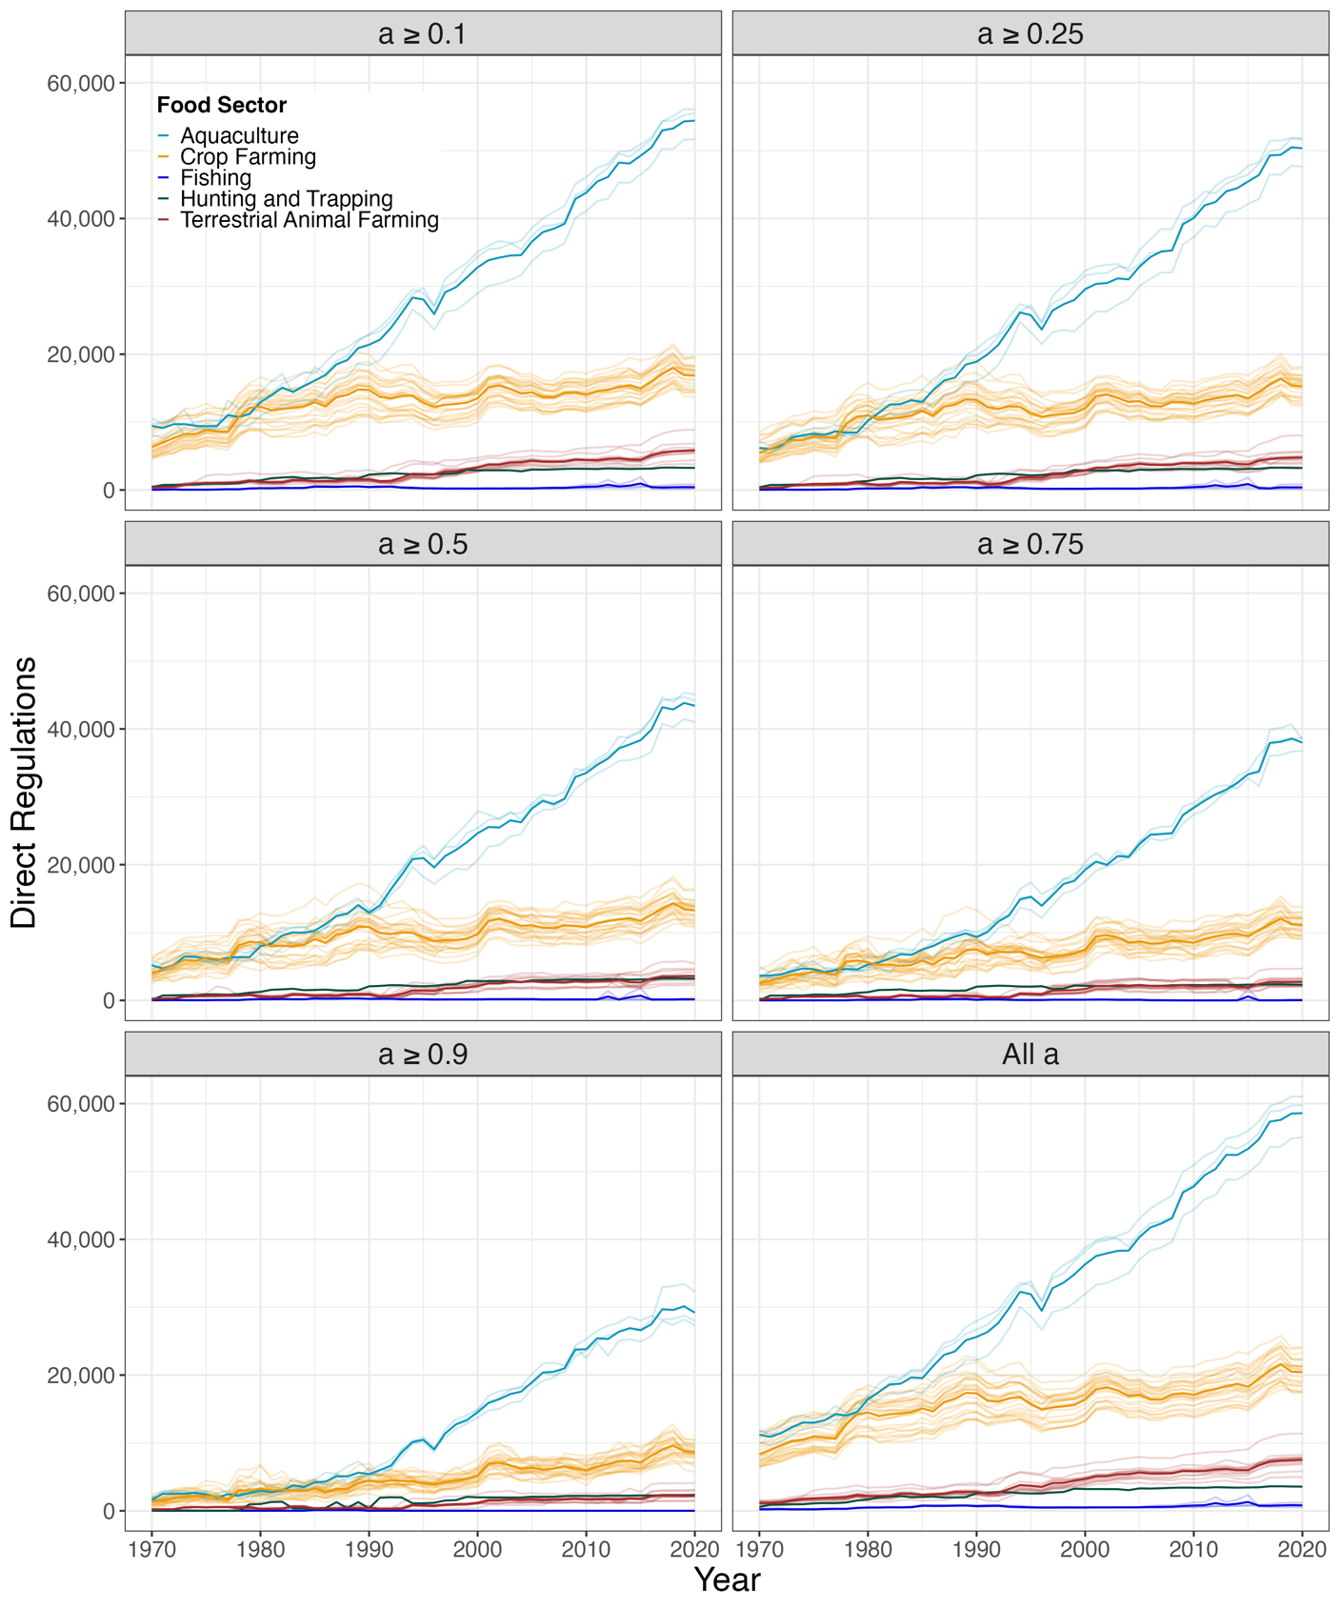
Supplementary Figures
Supplementary Fig. 1: Direct regulations with different $a_{pyi}$ value cutoffs. Here, we replicate the results from Fig. 1 of our main text using different $a_{pyi}$ values. The title of each figure represents the cutoff. For example, a ≥ 0.25 means that regulations from all documents with a probability greater than or equal to 0.25 were summed to calculate the direct regulations for each six-digit NAICS food industry. As the cutoff increases towards 1 (i.e., 100% probability) we observed an overall decrease in regulations for each industry, but consistent trends across industries.
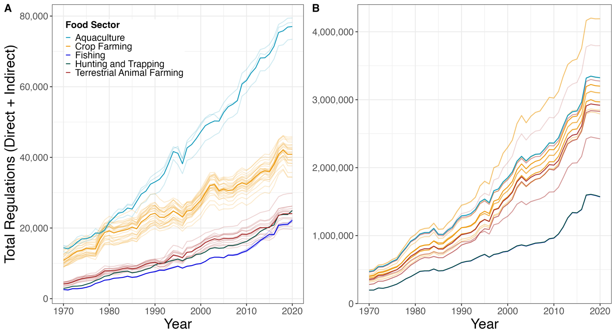
Supplementary Fig. 2: Total regulations over time, including direct and indirect regulations. (A) Represents the multiplicative approach, where indirect regulations are weighted based on their fractional contribution to gross domestic product (GDP). (B) Represents the additive approach where regulations from every input industry are added together. Note that with this approach Hunting and Trapping and Fishing have a very similar number of total regulations, which result in near overlapping lines.

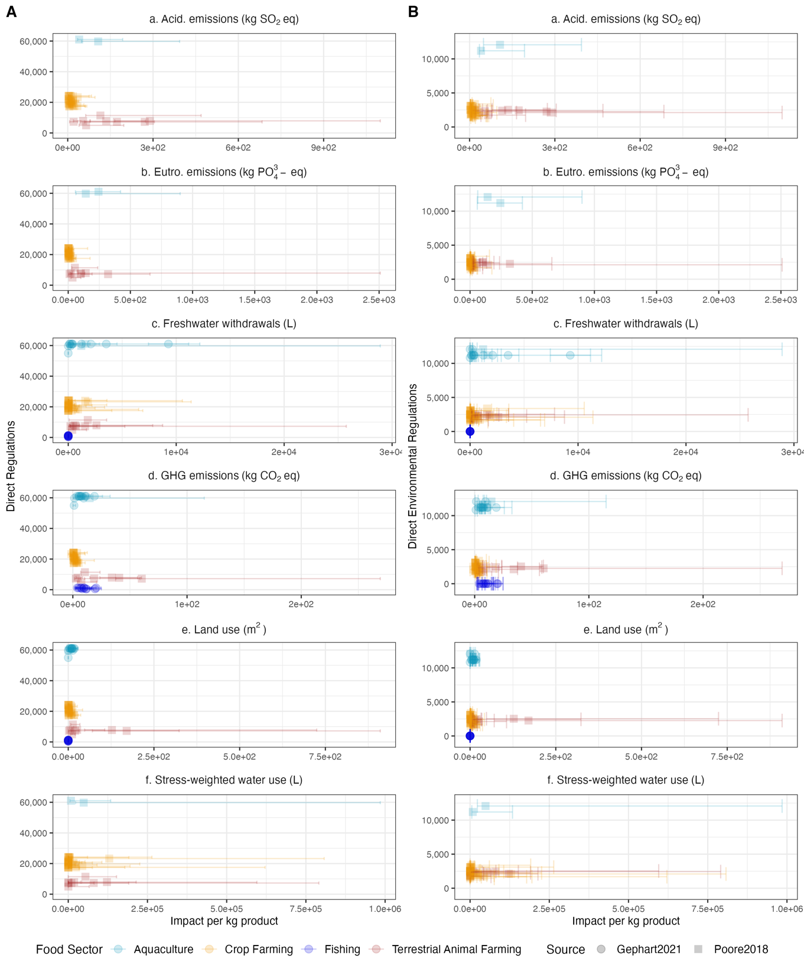
Supplementary Figure 3: Regulations versus environmental impacts. (Aa-f) Direct regulations for year 2020 versus environmental impacts per kg of product for six different environmental impacts: acidifying (acid.) emissions (kg SO₂ eq), eutrophying (eutro.) emissions (kg PO₄³⁻ eq), freshwater withdrawals (L), greenhouse gas (GHG) emissions (kg CO₂ eq), land use (m²), and stress-weighted water use (L). (Ba-f) The same as (Aa-f) except compared to direct environmental regulations for the year 2020 (that is, all regulations from Title 40 of the Code of Federal Regulations). Colors represent food sector. Low and high bars represent the 5 and 95 percentile respectively for the environmental impacts of different food products. Different shapes represent different meta-analysis sources for environmental data.
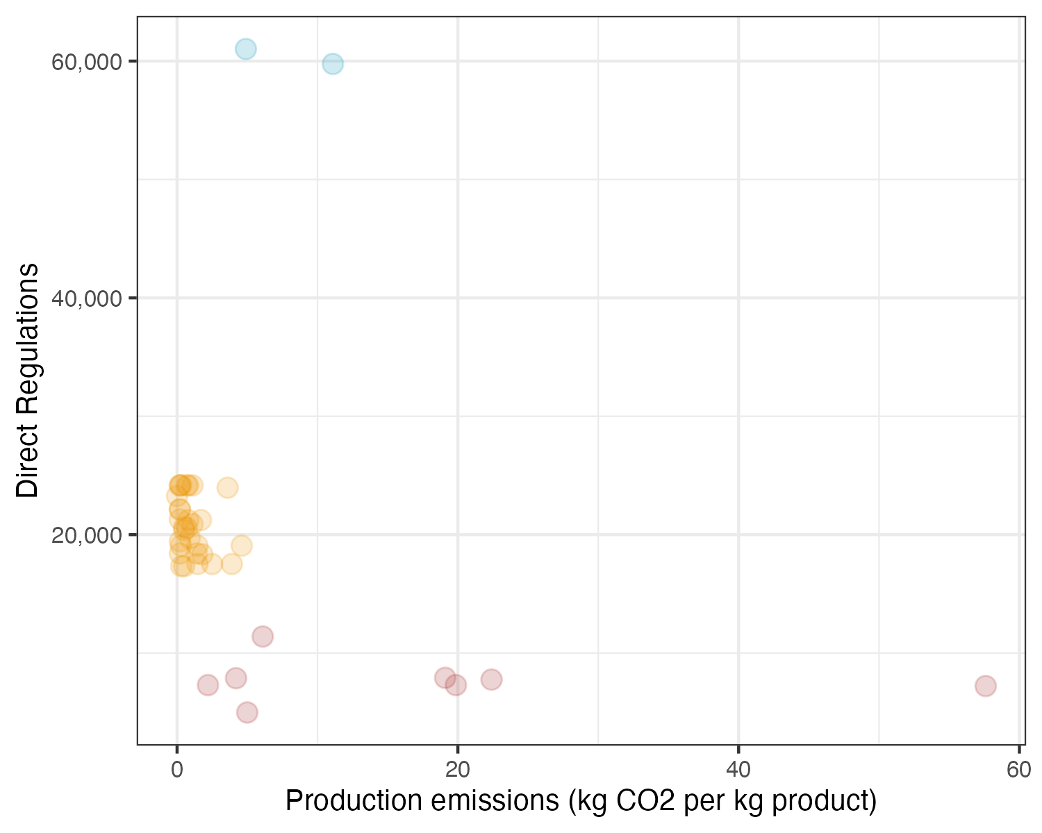
Supplementary Figure 4: Direction regulations versus production emissions. Data on greenhouse gas emissions from Poore and Nemecek (2018) only versus direct regulations.

References
Al-Ubaydli, O., & Mclaughlin, P. A. (2017). RegData: A numerical database on industry-specific regulations for all United States industries and federal regulations, 1997-2012. https://doi.org/10.1111/rego.12107
Bureau of Economic Analysis, & BEA. (2024). Direct Requirements/After Redefinitions/Producer Value. Retrieved from https://apps.bea.gov/industry/xls/io-annual/CxI_DR_2017_DOM_DET.xlsx
Chambers, D., Collins, C. A., & Krause, A. (2019). How do federal regulations affect consumer prices? An analysis of the regressive effects of regulation. Public Choice, 180(1–2), 57–90. https://doi.org/10.1007/S11127-017-0479-Z/TABLES/9
Gephart, J. A., Henriksson, P. J. G., Parker, R. W. R., Shepon, A., Gorospe, K. D., Bergman, K., … Troell, M. (2021). Environmental performance of blue foods. Nature, 597(7876), 360–365. https://doi.org/10.1038/s41586-021-03889-2
Halpern, B. S., Frazier, M., Verstaen, J., Rayner, P.-E., Clawson, G., Blanchard, J. L., … Williams, D. R. (2022). The environmental footprint of global food production. Nature Sustainability, 5(12), 1027–1039. https://doi.org/10.1038/s41893-022-00965-x
Malone, T., & Chambers, D. (2017). Quantifying Federal Regulatory Burdens in the Beer Value Chain. https://doi.org/10.1002/agr.21507
McLaughlin, P. A., & Sherouse, O. (2019). RegData 2.2: a panel dataset on US federal regulations. Public Choice, 180(1–2), 43–55. https://doi.org/10.1007/S11127-018-0600-Y/TABLES/3
Poore, J., & Nemecek, T. (2018). Reducing food’s environmental impacts through producers and consumers. Science, 360(6392), 987–992. https://doi.org/10.1126/science.aaq0216
QuantGov. (2024). QuanGov.
Staples, A. J., Abaidoo, E., Jescovitch, L. N., Chambers, D., Melstrom, R. T., & Malone, T. (2021). Regulatory Landscape of the U.S. Aquaculture Supply Chain, 36(4), 1–9. https://doi.org/10.2307/27187712
Staples, A. J., Chambers, D., & Malone, T. (2022). How many regulations does it take to get a beer? The geography of beer regulations. Regulation and Governance, 16(4), 1197–1210. https://doi.org/10.1111/REGO.12403
Staples, A. J., Chambers, D., Melstrom, R. T., & Malone, T. (2022). Regulatory Restrictions Across U.S. Protein Supply Chains. Journal of Agricultural and Applied Economics, 54(1), 1–27. https://doi.org/10.1017/AAE.2021.28
U.S. Census Bureau. (2024a). Economic Census: NAICS Codes & Understanding Industry Classification Systems. Retrieved from https://www.census.gov/programs-surveys/economic-census/year/2022/guidance/understanding-naics.html
U.S. Census Bureau. (2024b). Introduction to NAICS.

