Design and Steady-State Performance Analysis of a Capillary-Driven Heat Pipe for Electronic Chip Cooling
Marie-Batisse Heite & Asal Ghorbani
MCENG 258 - Project 1
February 23, 2026

Table of Contents
1. Introduction 2
2. Steady-State Operating Conditions for Water (Task 1(b)) 2
3. Effective Thermal Conductivity of the Heat Pipe (Task (1c)) 4
4. Applications of the Code for Analysis Purposes (Task 2) 5
5. Determination of Optimal (UA)e​ and εc​ Through Error Minimization (Task 3) 9
6. Methanol as the Working Fluid (Task 4) 12
References 20
Appendices 21
Appendix A - Task 1 21
Appendix B - Task 2 29
Appendix C - Task 3 51
Appendix D. Task 4 64

Introduction
This project investigates the steady-state operation and performance of a capillary-driven heat pipe designed for cooling a computer processor chip housed within an electronic cabinet. As described in the project brief, the objective is to transport heat generated inside the cabinet to the external environment using a passive two-phase heat exchanger. The heat pipe accomplishes this by evaporating liquid at the heated evaporator section, transporting vapor through a central core, condensing the vapor at a cooler condenser section, and returning the liquid to the evaporator through a porous wick structure driven solely by capillary forces.
Unlike conventional solid conduction, heat pipes utilize phase change to transfer large amounts of heat with minimal temperature difference between the evaporator and condenser. The operation is governed by thermodynamic equilibrium at the vapor–liquid interfaces, vapor flow pressure drops, Darcy flow through the wick, and capillary pressure generated by interface curvature within the porous structure. In this study, a one-dimensional steady-state model is implemented to determine the operating temperatures, pressures, mass flow rate, and chip temperature for specified geometric parameters, wick properties, and condenser cooling conditions. The model incorporates saturation property correlations, vapor friction losses, liquid flow resistance in the wick, and capillary pressure constraints to identify the operating point and assess performance limits.
This analysis provides insight into the coupled thermodynamic and fluid dynamic mechanisms that enable passive heat transport and establishes the effective thermal conductivity and heat transport capacity of the designed heat pipe system.

Steady-State Operating Conditions for Water (Task 1(b))

A steady-state solution was obtained for the heat pipe operating with water as the working fluid under the specified geometric parameters, wick characteristics, evaporator conductance, and condenser cooling conditions. The governing relations include vapor momentum balance, Darcy flow in the wick, capillary pressure equilibrium at the evaporator interface, and heat transfer constraints at the evaporator and condenser (Appendix A1). The numerical implementation used to obtain the solution is provided in Appendix A2.
For a chip heat dissipation rate of 250 W, the computed operating conditions are summarized below (Table 1).

Table 1 | Summary of key operating and design parameters of the heat pipe under steady-state conditions
Quantity | Value
Heat transfer rate, 𝑞̇ | 250 W
Chip temperature, $T_{chip}$ | 324.35 K (51.20 °C)
Evaporator vapor temperature, $T_{1}$ | 301.20 K
Condenser vapor temperature, $T_{2}$ | 300.96 K
Vapor mass flow rate, $ṁ$ | $1.03 × {10}^{-4} kg/s$
Effective interface radius, $r_{e}$ | $9.30 × {10}^{-5} m$
Minimum allowable radius, $r_{e, min}$ | $6.40 × {10}^{-5} m$

The vapor temperature difference between evaporator and condenser is

$ΔT_{v}=T_{1}-T_{2} = 0.24 K$

This small temperature difference reflects the high effective thermal conductance associated with phase-change heat transport.
2.1 State Point Conditions
The thermodynamic state points are defined as:
1 — evaporator vapor
2 — condenser vapor
3 — condenser liquid
4 — evaporator liquid
The computed steady-state pressures and temperatures are given in Table 2.
Table 2 | State points of the heat pipe cycle showing the steady-state thermodynamic conditions at four characteristic locations. States 1 and 4 correspond to the evaporator section, while states 2 and 3 represent the condenser section.
State | Temperature (K) | Pressure (Pa)
1 | 301.20 | 3811.74
2 | 300.96 | 3761.85
3 | 300.96 | 3761.85
4 | 301.20 | 2272.33
As required by interfacial equilibrium at the condenser,
$P_{2} = P_{3}$
The vapor pressure drop is
$ΔP_{v}={P_{1}-P_{2}=49.89 Pa,}_{}$
and the liquid pressure drop in the wick is
$ΔP_{l}=P_{3}-P_{4}=1489.51 Pa.$
The capillary pressure generated at the evaporator interface is
$P_{1}-P_{4}=1539.4 Pa,$
which satisfies the steady-state capillary balance condition
$\frac{2σ}{r_{e}}=ΔP_{v}+ΔP_{l} .$

Effective Thermal Conductivity of the Heat Pipe (Task (1c))

The effective thermal conductivity of the heat pipe between states 1 (evaporator vapor) and 2 (condenser vapor) was evaluated using an equivalent one-dimensional conduction formulation. Although heat transfer in the device occurs primarily through phase change and vapor transport, an effective conductivity may be defined by equating the heat pipe performance to Fourier conduction across the same length and cross-sectional area.
The effective conductivity is defined as
$k_{eff}=\frac{q̇ L_{eff}}{A_{v} (T_{1}-T_{2})} ,$
where
𝑞̇ is the heat transfer rate,
$L_{eff}$ is the effective heat pipe length,
$A_{v}$ is the vapor core cross-sectional area, and
$T_{1}-T_{2}$ is the vapor temperature difference between evaporator and condenser.
Using the computed steady-state values:
$k_{eff}= 4.3 ×{10}^{6} W/m⋅K$
For reference, the thermal conductivity of copper at room temperature is approximately
$k_{Cu} ≈401 W/m⋅K$ at 300 K [1]
The ratio of heat pipe effective conductivity to copper conductivity is therefore
$\frac{k_{eff}}{k_{Cu}}=\frac{4.3×{10}^{6}}{401}≈1.1×{10}^{4}$ .
Thus, the heat pipe exhibits an effective thermal conductivity roughly four orders of magnitude greater than that of solid copper.
The extremely high effective thermal conductivity of the heat pipe arises from latent heat transport rather than molecular conduction. Because large amounts of energy are transferred through phase change with only a very small temperature difference (0.24 K), the equivalent conductive behavior appears extraordinarily high. This result is consistent with the fundamental principle that heat pipes behave as nearly isothermal heat transport devices, with effective conductivities commonly in the range of ${10}^{4}-{10}^{6}$ W/m·K depending on operating conditions and geometry [2].
The computed value confirms that, under the specified operating conditions, the heat pipe functions as a highly efficient thermal transport structure relative to conventional solid conductors.

Applications of the Code for Analysis Purposes (Task 2)

Various heat rejection rates were simulated to determine the chip temperature $T_{chip}$ in degrees Celsius and the effective evaporator interface $r_{e}$ in µm. The results are detailed in Table 3 below. The relation between $T_{chip}$ and the chip heat transfer rate as well as the relation between $r_{e}$ and the chip heat transfer rate can be seen in Figure 1 below.

Table 3 | Task 2(a) Results - $q_{dot}$, $T_{chip}$, and $r_{e}$ Values.
Chip Heat Transfer  Rates, $q_{dot}$ (W) | Chip Temperature, $T_{chip}$ ($C)$ | Effective Evaporator  Interface, $r_{e}$ (µm)
50 | 22.620 | 373.839
100 | 29.810 | 196.062
150 | 36.961 | 137.732
200 | 44.088 | 109.346
250 | 51.202 | 92.972
300 | 58.309 | 82.575

The chip temperature increases with the rise in $q_{dot}$, however $r_{e}$ decreases with the rise in $q_{dot}$. It makes sense for the temperature of the chip to increase with the rate of heat transfer, since the driving force of heat transfer is the difference between the hot and cold temperatures in the heat pipe. The reason for the decrease of $r_{e}$ with an increasing rate of heat transfer is that as $q_{dot}$ increases, the $r_{e}$ decreases so that the wick can provide enough capillary pressure to pump the liquid in the system and maintain consistent flow in the heat pipe.
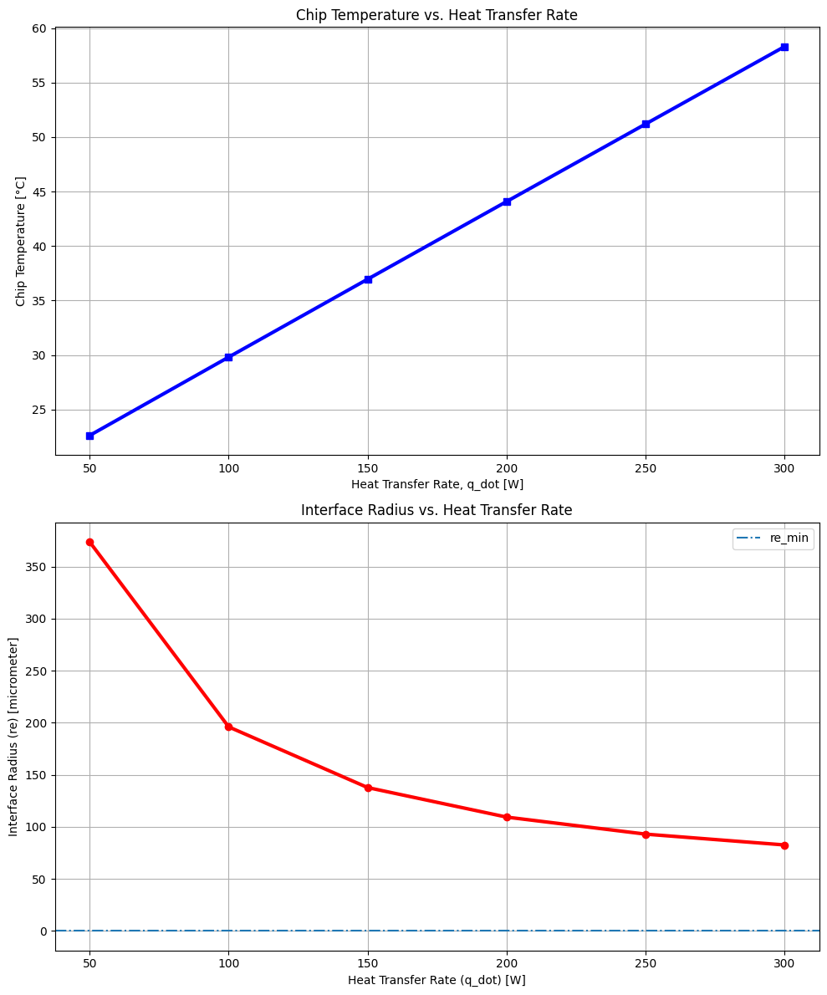
Figure 1 | Plot of $T_{chip}$ versus the $q_{dot}$ as well as $r_{e}$ versus $q_{dot}$.

It would be beneficial to understand the limitation and the best possible performance capability of the system. Therefore, as requested in Task 2(b), we determine the largest heat transfer, $q_{dot}$ that the pipe can carry with water as the working fluid. The largest $q_{dot}$ value possible is dictated by the minimum pore radius ($r_{p,min})$ and similarly as a result by the minimum $r_{e}$ value, denoted as $r_{e,min}$. Because as we saw earlier, as $q_{dot}$ increases, the $r_{e}$ decreases so that the wick can provide enough capillary pressure to pump/create suction for the liquid to maintain consistent flow in the heat pipe and overcome the increased pressure loss due to friction at these higher $q_{dot}$ values. There is a limit to the curvature that can be achieved for the liquid entering the wick and it cannot enter the wick anymore if it reaches the physical size of the pores on the wick. This is the capillary limit and it is reached when the required pressure difference to move the working fluid exceeds the maximum pressure that can be generated by the wick. So, when the meniscus is not capable of curving into a smaller size than the pore it is entering, the system fails to generate enough pressure to combat the increased pressure drop and run the system effectively. Refer to the equation below to see the relation between the difference in pressure required to run the system and $r_{e}$.
$\frac{2σ}{r_{e}}=ΔP_{capillary}=ΔP_{v}+ΔP_{l}$
So, the max heat transfer rate is $q_{dot, max}$ = 472.58 W and was found when $r_{e}$ corresponds to:
$\frac{2σ}{r_{e}}$= $ΔP_{v}+ΔP_{l}$
At this point, we used Python to sweep through a wide range of $q_{dot}$ values and find the one that corresponds to $r_{e}$ - $r_{e,min}$= 0 . That one is $q_{dot, max}$.
Additionally, the cooling capabilities of the system can deteriorate due to fatigue or operational degradation with time. Therein, per Task 2(c), an analysis was carried out to determine the effects of a 30% decreased water flow rate compared to the initial condenser coolant flow rate conditions at:
$q_{dot}$= 300W.

Table 4 below, reports the predicted operating pressure and temperature conditions at points 1 and 2. As well as the chip temperature before and after the coolant flow reduction occurs. We can see that the reduction in coolant flow rate results in every temperature and pressure increasing as expected. This flow rate directly affects the $T_{2}$ equation and value. Then $T_{1 }$, $P_{2}$, $P_{1}$ , and $T_{chip}$can be calculated based on $T_{2}$ given the equations provided in the assignment brief document. To illustrate further, based on the equation below for $T_{2}$, with the decrease in condenser flow rate, $T_{2}$ must increase. Due to directly proportional relations of $T_{2}$ with $T_{1 }$, $P_{2}$, $P_{1}$ , and $T_{chip}$, they also increase.

$T_{2}=\frac{T_{f, cond in }+ q_{dot}}{m_{dot}c_{p,f}ε_{c}}$

Table 4 | $T_{1}$ , $T_{2 }$, $P_{1}$, $P_{2}$ , and $T_{chip}$ Sensitivity to Condenser Coolant Flow Rate.
Chip Heat Transfer  Rates, $q_{dot}$ (W) | 300
Flow Rate of Condenser Coolant (kg/s) | Before  0.0080 | After  (0.7)(0.0080) = 0.0056
$T_{1}$ (°$C)$ | 30.531 | 36.841
$T_{2}$ (°$C)$ | 30.302 | 36.710
$P_{1}$ (Pa) | 4395.960 | 6256.865
$P_{2}$ (Pa) | 4343.163 | 6218.227
$T_{chip}$ (°$C)$ | 58.309 | 64.619

Please note that the calculations and code used to find the values and results reported in this section (Section 4) are accessible in Appendix B for reference.

Determination of Optimal (UA)e​ and εc​ Through Error Minimization (Task 3)
A key objective of this study is to determine the evaporator conductance (UA)e​ and condenser heat exchanger effectiveness εc​ that best reproduce the thermal behavior of the investigated heat pipe under a specific operating condition. Although the governing heat transfer and fluid flow relations are known, the effective values of (UA)e​and εc​ are not directly measurable and depend on internal transport processes within the evaporator, condenser, and wick structure. These parameters must therefore be estimated by comparing model predictions to experimentally measured chip temperatures (Appendix C1).
To perform this estimation, a single experimental operating point was selected (Row 2 of the dataset, Appendix C1), corresponding to a coolant inlet temperature Tf,cond,in=8.0 °C, applied heat load 𝑞̇ = 200 W, and measured chip temperature Tchip,data=32.4 °C. A parametric sweep was then carried out over 36 physically realistic parameter combinations, covering evaporator conductance values (UA)e = 6–17 W/K and condenser effectiveness values εc = 0.25–0.94. For each parameter combination, the thermodynamic model was executed for this operating condition, and the absolute temperature difference between the measured and predicted chip temperatures was computed (Python code see Appendix C2).
Table 5 | Absolute temperature difference ∣ΔT∣=∣Tchip,data−Tchip,pred∣ for the selected operating condition (Tf,cond,in​=8.0°C, 𝑞̇ ​=200 W, Tchip,data=32.4°C) as a function of evaporator conductance (UA)e​ and condenser effectiveness εc​.
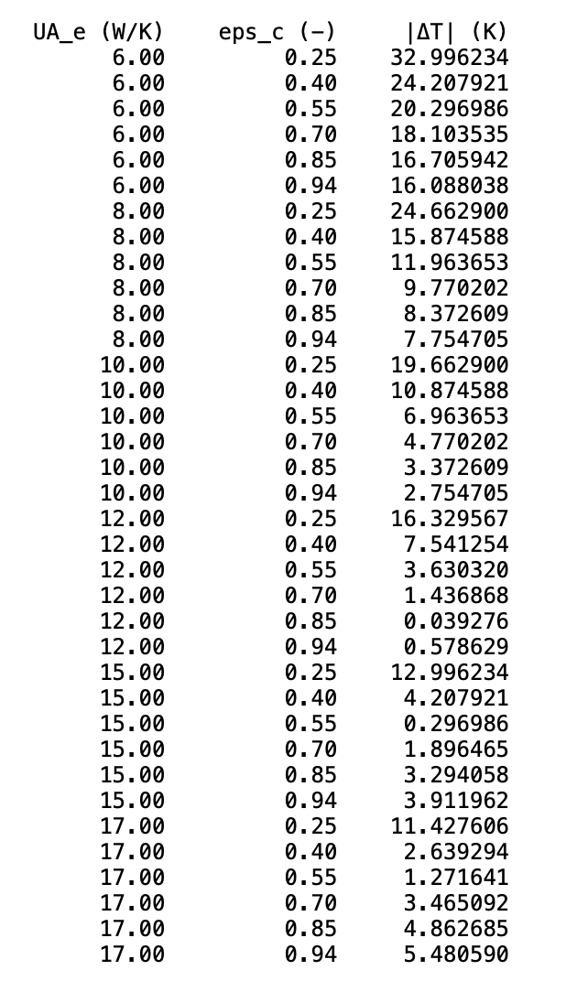
The results reveal a strong dependence of the prediction error on both the evaporator conductance (UA)e​ and the condenser effectiveness εc​. For low evaporator conductance values (6–8 W/K), the model significantly overpredicts chip temperature, leading to large errors exceeding 20 K in several cases. Increasing (UA)e​ consistently reduces the temperature discrepancy, indicating that insufficient evaporator conductance artificially increases the predicted temperature rise across the evaporator interface.
A similarly pronounced trend is observed with respect to condenser effectiveness. At low εc​ values (e.g., 0.25–0.40), the condenser is modeled as less efficient at removing heat, which results in higher predicted vapor temperatures and consequently higher chip temperatures. This leads to large absolute temperature deviations. As εc​ increases, the condenser more effectively transfers heat to the coolant, lowering the predicted vapor and chip temperatures and thereby reducing the error. However, beyond an intermediate range of effectiveness, further increases in εc​ do not always continue to reduce the deviation, suggesting an interaction between evaporator conductance and condenser performance in determining the overall thermal response.
A minimum in the absolute error is observed at (UA)e=12 W/K and εc​=0.85, where ∣ΔT∣=0.039 K (Table 3). This represents nearly perfect agreement between model and experiment for this operating condition. Another low error is obtained at (UA)e=15 W/K and εc​=0.55, where ∣ΔT∣=0.297 K. These results indicate a compensatory interaction: increasing (UA)e can offset lower εc while maintaining accurate chip temperature predictions.
To complement the tabulated results, the 36 computed error values were additionally visualized in a two-dimensional contour plot (Figure 2) (Appendix C2). It is important to note that this plot does not represent a continuous optimization or an interpolated parameter space; rather, it is a graphical representation of the same 36 discrete (UA)e and εc combinations listed in Table 5. Each point in the contour map therefore corresponds directly to one evaluated parameter pair from the parametric sweep.

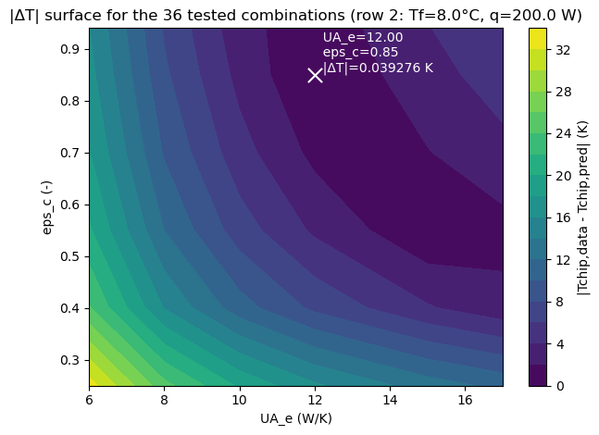
Figure 2 | Contour surface of the absolute temperature difference ∣ΔT∣=∣Tchip,data−Tchip,pred∣ as a function of evaporator conductance (UA)e and condenser effectiveness εc​ for the selected operating condition (Tf,cond,in​=8.0°C, 𝑞̇ ​=200 W and Tchip,data=32.4°C). The white cross-marker indicates the parameter combination yielding the minimum temperature deviation within the investigated range.

To evaluate predictive robustness beyond the calibration point, the optimized parameters (UA)e=12 W/K and εc=0.85 were applied to five randomly selected operating conditions from the experimental dataset (Appendix C1). For each case, the model was executed without further adjustment and the absolute deviation ∣ΔT∣=∣Tchip,data−Tchip,pred∣ was calculated (Table 6). The resulting errors (0.09–1.04 K) remain small, indicating that the calibrated parameters provide a consistent and physically sound representation of the heat pipe behavior across varying loads and inlet temperatures.

Table 6 | Predictions computed using calibrated parameters (UA)e​=12 W/K and εc=0.85.
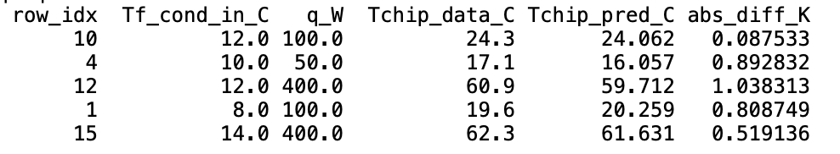
Following the discrete evaluation of the 36 predefined parameter combinations, a continuous grid-based optimization was performed to determine the minimum of the absolute temperature deviation with higher resolution. The error function |ΔT| = |Tchip,data − Tchip,pred| was evaluated over the full physically admissible parameter ranges UAe ∈ [5.7, 17.7] W/K and εc ∈ [0.20, 0.95].
First, a coarse grid consisting of 81 × 81 uniformly spaced values (6,561 combinations) was constructed across these ranges to locate the approximate position of the global minimum (Figure 3A). Subsequently, a refined local grid (201 × 201 points; 40,401 combinations) was generated within a reduced neighborhood of ±1.0 W/K in UAe and ±0.10 in εc around the coarse minimum (Figure 3B). This two-stage grid search enabled a high-resolution evaluation of the error landscape while maintaining numerical robustness (Appendix C2).
The refined search yielded an optimal parameter pair of approximately UAe ≈ 12.62 W/K and εc ≈ 0.759, with a minimum absolute temperature deviation on the order of 10⁻⁴ K, indicating near-perfect agreement between model prediction and experimental measurement for the selected operating condition.
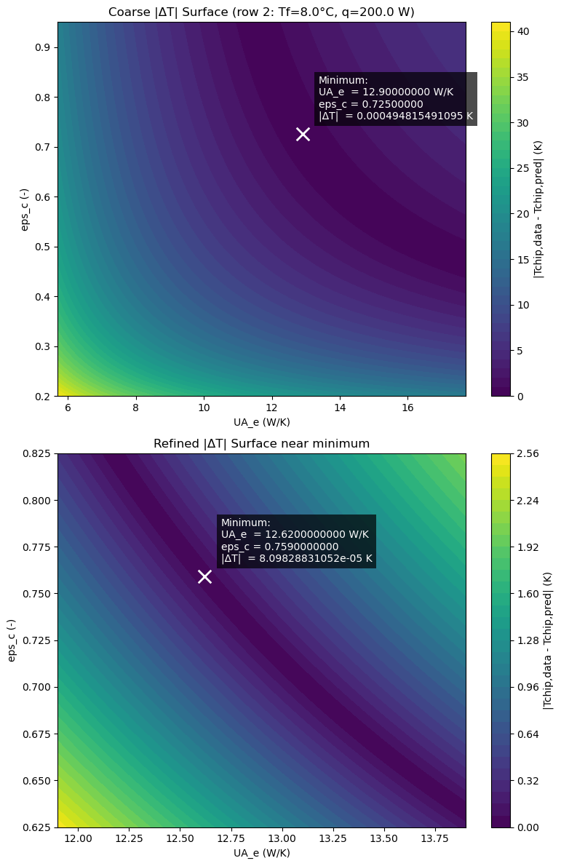Figure 3 | Contour surfaces of the absolute temperature difference |ΔT| = |T_chip,data − T_chip,pred| as a function of evaporator conductance (UA)_e and condenser effectiveness ε_c for the selected operating condition (Tf,cond,in = 8.0 °C, q̇ = 200 W, Tchip,data = 32.4 °C). A) Coarse grid search over the full parameter domain (UA)e = 5.7–17.7 W/K and εc = 0.20–0.95 using an 81 × 81 grid (6,561 combinations). The white cross-marker indicates the minimum identified from the coarse search. B) Refined grid search in the vicinity of the coarse minimum using a 201 × 201 grid (40,401 combinations) within ±1.0 W/K in (UA)e and ±0.10 in εc. The white cross-marker indicates the refined minimum parameter combination.

Methanol as the Working Fluid (Task 4)
There is a proposal to use methanol as the working fluid instead of water. The reason is twofold, methanol does not freeze at temperatures above -97.6 C, and it has a favourable merit number in the temperatures corresponding to the application of interest. In this section, we will discuss the performance of this proposal. Merit number $N_{l}$, ranks heat pipes and it is as follows:
$N_{l}=\frac{ρ_{l}σλ}{μ_{l}}$
$ρ_{l}$ is the liquid density. $σ$ is the surface tension. $λ$ is the latent heat. $μ_{l }$is the liquid viscosity. Figure 4 below displays a comparison of the merit numbers of the most commonly used fluids. Please refer to Appendix D for relevant reference charts, calculations, and the code used to obtain the values and results reported in Section 6.
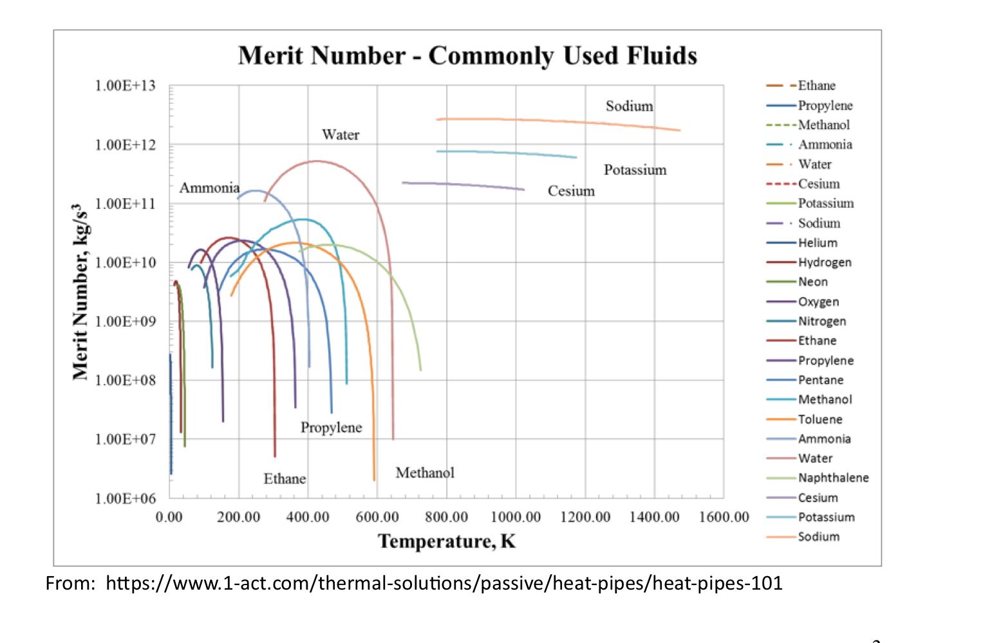
Figure 4 | Merit Number - Commonly Used Fluids Comparison
So, we proceed with the modeling of a heat pipe with the same design parameters as Task 1 but with a methanol working fluid. Task 4(a) is carried out by modifying the code. The following parameter values are the code output when methanol is the working fluid and the rate of heat transfer is 80 W. Resutls are seen in Table 7 below.

Table 7 | Methanol Working Fluid Resulting System Parameters (Task 4(a)).
Quantity | Value
Heat transfer rate, 𝑞̇ | 80 W
Chip temperature, $T_{chip}$ | 334.920 K (61.770 °C)
Evaporator vapor temperature, $T_{1}$ | 327.513 K
Condenser vapor temperature, $T_{2}$ | 292.487 K
Vapor mass flow rate, $ṁ$ | 6.854 $× {10}^{-5} kg/s$
Effective interface radius, $r_{e}$ | $7.631× {10}^{-5} m$
Minimum allowable radius, $r_{e, min}$ | $4.569× {10}^{-5} m$

Next, per Task 4(b), we determined that this heat pipe cannot reach a stable operating point at $q_{dot}$= 80W using methanol as the working fluid. Other heat transfer rate values were tried until the stable steady state capillary condition was satisfied.
As a reminder, the thermodynamic state points are defined as:
1 — evaporator vapor
2 — condenser vapor
3 — condenser liquid
4 — evaporator liquid
The computed steady-state pressures and temperatures are given below in Table 8.
Table 8 | State Point Conditions of System (Methanol Working Fluid at 80 W).
State | Temperature (K) | Pressure (Pa)
1 | 327.513 | 15526.80
2 | 292.487 | 15522.18
3 | 292.487 | 15522.18
4 | 327.513 | 14928.05
As required by interfacial equilibrium at the condenser,
$P_{2} = P_{3}$
The vapor pressure drop is
$ΔP_{v}={P_{1}-P_{2}= 4.620 Pa,}_{}$
and the liquid pressure drop in the wick is
$ΔP_{l}=P_{3}-P_{4}=594.132 Pa.$
The capillary pressure generated at the evaporator interface is
$P_{1}-P_{4}=598.746 Pa,$
To satisfy the steady-state capillary balance condition, we must have:
$P_{1}-P_{4}=\frac{2σ}{r_{e}}=ΔP_{v}+ΔP_{l}$
($ΔP_{v}+Δ{P_{l})}_{}$- ($P_{1}-P_{4}$) = 0
which at 80 W, will yield the following:
($ΔP_{v}+Δ{P_{l})}_{}$- ($P_{1}-P_{4}$) = 0.0059
Notice that this value is not zero. Therefore, we cannot satisfy the steady-state capillary balance condition at 80 W. As directed in the assignment brief, we tried heat transfer rate values between 80 and 30 W (See Appendix D). It was found that the stable condition of steady-state capillary balance can be achieved at 68 W of heat transfer rate with methanol as the working fluid. Since the value of the following equation becomes significantly close to zero at this heat transfer rate value and can be approximated as zero:
($ΔP_{v}+Δ{P_{l})}_{}$- ($P_{1}-P_{4}$) = 9.0000000000e-05 = 0
The parameters at this heat transfer rate value can be seen in Table 9 below.
Table 9 | Methanol Working Fluid Resulting System Parameters (Task 4(a)).
Quantity | Value
Heat transfer rate, 𝑞̇ | 68 W
Chip temperature, $T_{chip}$ | 333.253 K (60.103 °C)
Evaporator vapor temperature, $T_{1}$ | 326.956 K
Condenser vapor temperature, $T_{2}$ | 291.889 K
Vapor mass flow rate, $ṁ$ | 5.823 $× {10}^{-5} kg/s$
Effective interface radius, $r_{e}$ | $8.930× {10}^{-5} m$
Minimum allowable radius, $r_{e, min}$ | $4.569× {10}^{-5} m$
The computed steady-state pressures and temperatures are given below in Table 10.
Table 10 | State Point Conditions of System (Methanol Working Fluid at 68 W).
State | Temperature (K) | Pressure (Pa)
1 | 326.957 | 15107.90
2 | 291.889 | 15103.87
3 | 291.889 | 15103.87
4 | 326.957 | 14595.09

We can see the impact of using methanol on the heat transfer rate $q_{dot}$ compared to water as the working fluid, with methanol we can achieve a stable system at 68 W but 80 W is too high to achieve stability. However, with water the system achieved stability at 250 W of heat transfer rate. This reduced heat transfer rate capability of the methanol system is due to lower Merit number of methanol compared to water by about 2 orders of magnitude around the 300-400 K temperature range (see Figure 4). So, the proposal to use methanol as the working fluid instead of water in this case, does not improve the performance of the system.
Water has a higher density and surface tension than methanol and has a higher latent heat than methanol. Referencing the equation of the Merit number in the beginning of Section 6, we see that the exceeding value of these properties compared to methanol results in water having a higher Merit number than methanol overall and in the temperature range that this heat pipe design operates.
Next, per Task 4(c), we determined the chip temperature and the effective evaporator interface for various heat rejection rates $q_{dot}$ (Table 11 below). The relation between $T_{chip}$ and the chip heat transfer rate as well as the relation between $r_{e}$ and the chip heat transfer rate can be seen in Figure 5 below.
Table 11 |${ q}_{dot}$, $T_{chip}$, and $r_{e}$ Values (Task 4(c)).
Chip Heat Transfer  Rates, $q_{dot}$ (W) | Chip Temperature, $T_{chip}$ (°$C)$ | Effective Evaporator  Interface, $r_{e}$ (µm) | System Stability
20 | 53.429 | 297.609 | Stable
30 | 54.820 | 199.213 | Stable
50 | 57.601 | 120.525 | Stable
60 | 58.991 | 100.866 | Stable

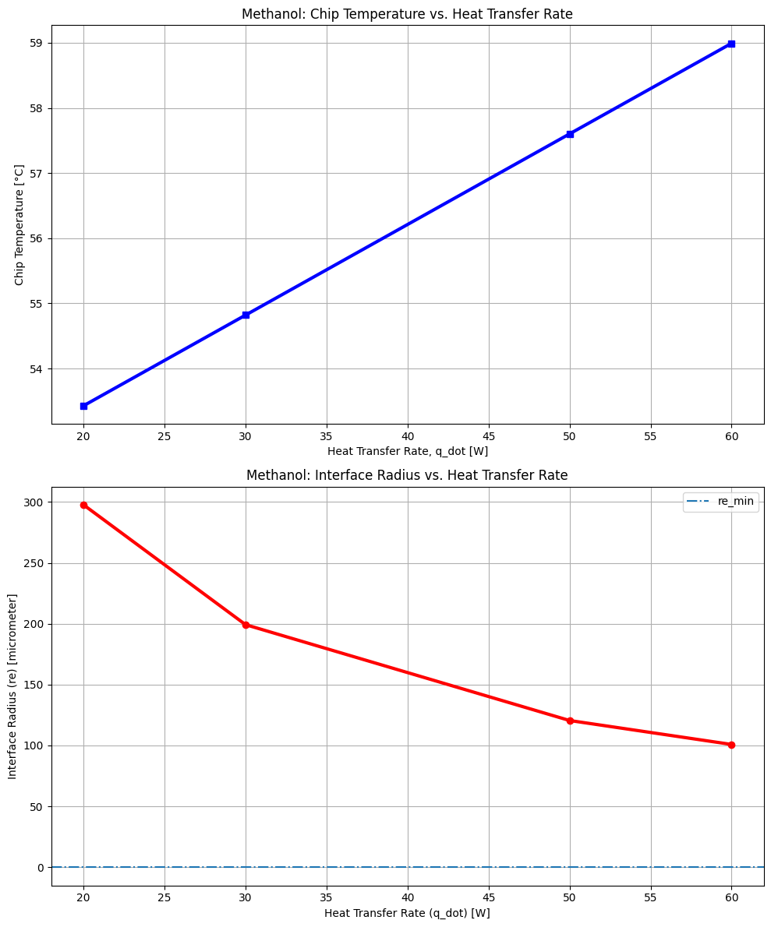
Figure 5 | Plot of $T_{chip}$ versus the $q_{dot}$ as well as $r_{e}$ versus $q_{dot}$
Similar to Task 2, we see the chip temperature increasing with the increase in heat transfer rate and the interface radius ($r_{e}$) decreasing with the increase in heat transfer rate. The same reasoning applies here. Note for these values the system was determined stable. To check if the system was stable, we considered the capillary limit as was explained in Task 1 and 2, as long as we are in compliance with the critical difference in pressure needed to operate the heat pipe the system can operate stably. See Appendix D for the code.
Lastly, an analysis routine was done to test whether the minimum pore radius and permeability of the wick can achieve a 30% increase in the heat transfer rate per Task 4(d). Table 12 below, displays the results of the analysis on this modified design. Keeping in mind that a properly functional design must have $r_{e}$> $r_{e, min}$.
Table 12 | Task 4(d) Results - $r_{p, min}$, $κ$, $q_{dot}$, $r_{e, min}$, $r_{e}$ Values.
$q_{dot}$ (W) | $r_{p, min}$(m) | $κ$($m^{2}$) | $r_{e, min}$ (µm) | $r_{e}$ (m) | Status
78.0 | 2.00E-10 | 4.80E-05 | 4.90E-05 | 5.2e-05 | Stable
78.0 | 2.00E-10 | 4.00E-05 | 4.10E-05 | 5.2e-05 | Stable
78.0 | 2.00E-10 | 3.80E-05 | 3.90E-05 | 5.2e-05 | Stable
78.0 | 2.00E-10 | 3.00E-05 | 3.00E-05 | 5.2e-05 | Stable
78.0 | 4.00E-10 | 4.80E-05 | 4.90E-05 | 1.0e-04 | Stable
78.0 | 4.00E-10 | 4.00E-05 | 4.10E-05 | 1.0e-04 | Stable
78.0 | 4.00E-10 | 3.80E-05 | 3.90E-05 | 1.0e-04 | Stable
78.0 | 4.00E-10 | 3.00E-05 | 3.00E-05 | 1.0e-04 | Stable
78.0 | 8.00E-10 | 4.80E-05 | 4.90E-05 | 2.1e-04 | Stable
78.0 | 8.00E-10 | 4.00E-05 | 4.10E-05 | 2.1e-04 | Stable
78.0 | 8.00E-10 | 3.80E-05 | 3.90E-05 | 2.1e-04 | Stable
78.0 | 8.00E-10 | 3.00E-05 | 3.0E-05 | 2.1e-04 | Stable
78.0 | 1.00E-09 | 4.80E-05 | 4.9E-05 | 2.60E-04 | Stable
78.0 | 1.00E-09 | 4.00E-05 | 4.1E-05 | 2.60E-04 | Stable
78.0 | 1.00E-09 | 3.80E-05 | 3.9E-05 | 2.60E-04 | Stable
78.0 | 1.00E-09 | 3.00E-05 | 3.0E-05 | 2.60E-04 | Stable

In a heat pipe, when we increase the permeability $κ$, we decrease the liquid pressure drop since it influences the frictional effect equation provided in the assignment brief. Reducing the pore radius $r_{p, min}$, increases the capillary pumping or suction capability offered by the wick in this heat pipe system. So, by increasing the pumping or suction of the working fluid, we can increase the heat transfer rate. That can be achieved by reducing $r_{p, min}$ or by increasing $κ$ to make the structure more porous and enable for more fluid suction. The values in the table above where${ q}_{dot}=78 W$ correspond to a 30% increase in $q_{dot}$ from an initial 60 W baseline while the system remains stable. Theoretically, the best possible values are the max kappa in the table and the min pore radius in the table since all of the different combinations yielded stable results. So, we pick the highlighted row: $κ$= 1.00E-09 $m^{2}$ and $r_{p, min}$= 3.0e-5 m that have stably achieved 78W.

Table of Contributions

Task Number or Description | Person Responsible
Task 1 | Marie-Batisse Heite
Task 2 | Asal Ghorbani
Task 3 | Marie-Batisse Heite
Task 4 | Asal Ghorbani
Report Writing | Both Marie-Batisse and Asal for their respective sections and appendices.

References

[1] Incropera, F. P., DeWitt, D. P., Bergman, T. L., & Lavine, A. S. (2011). Fundamentals of heat and mass transfer (7th ed.). Wiley.
[2] Li, X., Xiong, H., Chen, C., Xin, G., Li, J., & Chen, Y. (2026). Experimental study on thermal performance of ultra-thin flat heat pipe with double condensation sections for server memory modules. International Journal of Thermal Sciences, 220(Part A), 110278. https://doi.org/10.1016/j.ijthermalsci.2025.110278
[3] Methanol - thermophysical properties, https://www.engineeringtoolbox.com/methanol-methyl-alcohol-properties-CH3OH-d_2031.html (accessed Feb. 23, 2026).

Appendices

Appendix A - Task 1

Appendix A1 - Governing Equations and Numerical Solution Procedure

- The condenser vapor temperature $T_{2}$ was determined from the condenser heat exchanger relation

𝑞̇ = $ṁ{ c}_{p,c} ε_{c}(T_{2}-T_{c,in})$.

- The corresponding condenser pressure was obtained from the saturation relation

$P_{2}=P_{sat}(T_{2}) = exp(C_{0}+\frac{C_{1}}{T})$.

- Saturated thermophysical properties at $P_{2}$ were evaluated using curve fits to tabulated data.
- The vapor mass flow rate was computed from the latent heat relation

$ṁ$ = $\frac{q̇}{h_{lv}}$

- Vapour pressure drop between states 1 and 2 was calculated using a 1-D momentum balance in the core.
- The evaporator vapor pressure was computed as

$P_{1}=P_{2}+ΔP_{v}$

- Liquid pressure drop in the wick between states 3 and 4 was evaluated using Darcy’s law.
- The evaporator interface radius $r_{c}$ was obtained from the capillary balance condition

$\frac{2σ}{r_{c}}=(P_{1}-P_{2})+ (P_{3}-P_{4})$. (and $P_{2}$ = $P_{3})$

- The evaporator temperature $T_{1}$ was determined from the curved-interface equilibrium relation linking $P_{1}, T_{1},$ and $r_{c}.$
- The chip temperature was then computed from the evaporator conductance relation

𝑞̇ = $(UA)_{e}(T_{chip}-T_{1})$.

Appendix A2 - Python Implementation

import math
import numpy as np

# ============================================================
# (i) Heat pipe design + evaporator structure parameters
# ============================================================
Dp = 0.015 # m
Levap = 0.025 # m
Ladiab = 0.30 # m
Lcond = 0.025 # m

Leff = Ladiab + 0.5 * Levap + 0.5 * Lcond # m

tw = 0.0025 # m (wick thickness; multiple layers - mesh)
UA_e = 10.8 # W/K evaporator conductance

Aw = (math.pi / 4.0) * (Dp**2 - (Dp - 2.0 * tw)**2) # wick cross-sectional area, m^2
Dv = Dp - 2.0 * tw # vapor core diameter, m
Av = (math.pi / 4.0) * (Dv**2) # vapor core area, m^2

rp_min = 0.000063 # m minimum pore radius
kappa = 1.94e-10 # m^2 permeability
theta_deg = 10.0 # degrees
theta_rad = math.radians(theta_deg)
re_min = rp_min / math.cos(theta_rad) # m

# ============================================================
# (ii) Condenser design + operating parameters
# ============================================================
Tf_cond_in = 15.5 + 273.0 # K
q_dot = 250.0 # W
m_dot_c = 0.0080 # kg/s
eps_c = 0.6 # condenser heat exchanger effectiveness
cp_f = 4180.0 # J/(kg*K)

# ============================================================
# (iii) Determine T2, then compute P2 = Psat(T2)
# ============================================================
T2 = Tf_cond_in + q_dot / (m_dot_c * cp_f * eps_c) # K

# Given correlation: Psat(T) = exp(C0 + C1/T)
C0 = 25.73
C1 = -5266.0
P2 = math.exp(C0 + C1 / T2) # units per correlation (treat as Pa in this assignment context)

# ============================================================
# (iv) Lagrange interpolation in pressure-space using anchors
# Anchors are Psat at 15/30/45/60 C (given) and saturated
# properties at those temperatures (from your table page).
# ============================================================

#for water, set ideal gas constant R and critical temp to
R = 461.5 #J/kgK
Tc = 647.3 #K

# Psat anchor points (Pa) at 15, 30, 45, 60 °C (given by prof)
PA = 1.71e3
PB = 4.25e3
PC = 9.59e3
PD = 19.95e3

# ---- Saturated properties at 15/30/45/60 °C from the table ----
# Densities (kg/m^3): computed as 1/(vapor specific volume) from table
# Liquid density from table
rhol15, rhol30, rhol45, rhol60 = 999.1, 995.6, 990.2, 983.2

# Vapor specific volumes from table (m^3/kg): 77.875, 32.878, 15.252, 7.6672
# Vapor densities = 1/v (kg/m^3)
rhov15 = 1.0 / 77.875
rhov30 = 1.0 / 32.878
rhov45 = 1.0 / 15.252
rhov60 = 1.0 / 7.6672

# Viscosities from table are in μPa·s -> convert to Pa·s (multiply by 1e-6)
mul15, mul30, mul45, mul60 = 1137.6e-6, 797.4e-6, 596.1e-6, 466.4e-6
muv15, muv30, muv45, muv60 = 9.59e-6, 10.01e-6, 10.46e-6, 10.93e-6

# Surface tension from table is in mN/m -> convert to N/m (divide by 1000)
sig15, sig30, sig45, sig60 = 73.49e-3, 71.19e-3, 68.78e-3, 66.24e-3

# Latent heat h_lv = h_g - h_f using table enthalpies (kJ/kg) -> convert to J/kg
# 15C: hf=62.98, hg=2528.33
# 30C: hf=125.73, hg=2555.55
# 45C: hf=188.43, hg=2582.43
# 60C: hf=251.18, hg=2608.83
hlv15 = (2528.33 - 62.98) * 1e3
hlv30 = (2555.55 - 125.73) * 1e3
hlv45 = (2582.43 - 188.43) * 1e3
hlv60 = (2608.83 - 251.18) * 1e3

# ---- Lagrange weights (exactly as professor wrote) ----
WA = (P2 - PB) * (P2 - PC) * (P2 - PD) / ((PA - PB) * (PA - PC) * (PA - PD))
WB = (P2 - PA) * (P2 - PC) * (P2 - PD) / ((PB - PA) * (PB - PC) * (PB - PD))
WC = (P2 - PA) * (P2 - PB) * (P2 - PD) / ((PC - PA) * (PC - PB) * (PC - PD))
WD = (P2 - PA) * (P2 - PB) * (P2 - PC) / ((PD - PA) * (PD - PB) * (PD - PC))

# ---- Interpolated saturated properties at P2 ----
rhov = WA * rhov15 + WB * rhov30 + WC * rhov45 + WD * rhov60
rhol = WA * rhol15 + WB * rhol30 + WC * rhol45 + WD * rhol60
muv = WA * muv15 + WB * muv30 + WC * muv45 + WD * muv60
mul = WA * mul15 + WB * mul30 + WC * mul45 + WD * mul60
sig = WA * sig15 + WB * sig30 + WC * sig45 + WD * sig60
hlv = WA * hlv15 + WB * hlv30 + WC * hlv45 + WD * hlv60

# ============================================================
# Print results
# ============================================================
print("=== (i) Geometry / Wick ===")
print(f"Leff = {Leff:.6f} m")
print(f"Aw = {Aw:.8e} m^2")
print(f"Dv = {Dv:.6f} m")
print(f"Av = {Av:.8e} m^2")
print(f"re_min = {re_min:.8e} m")

print("\n=== (iii) Condenser end state ===")
print(f"T2 = {T2:.6f} K")
print(f"P2 = {P2:.6e} (per Psat correlation)")

print("\n=== (iv) Lagrange weights ===")
print(f"WA, WB, WC, WD = {WA:.6g}, {WB:.6g}, {WC:.6g}, {WD:.6g}")
print(f"Sum weights = {(WA+WB+WC+WD):.6g}")

print("\n=== (iv) Saturated properties at P2 (interpolated) ===")
print(f"rhov = {rhov:.6g} kg/m^3")
print(f"rhol = {rhol:.6g} kg/m^3")
print(f"muv = {muv:.6g} Pa·s")
print(f"mul = {mul:.6g} Pa·s")
print(f"sig = {sig:.6g} N/m")
print(f"hlv = {hlv:.6g} J/kg")

# ============================================================
# (v) Vapor-flow pressure drop and P1
# ============================================================

# --- sanity checks (avoid silent crashes / nonsense) ---
if hlv <= 0:
raise ValueError(f"hlv must be > 0 (J/kg). Got {hlv}.")
if rhov <= 0:
raise ValueError(f"rhov must be > 0 (kg/m^3). Got {rhov}.")
if Av <= 0 or Dv <= 0:
raise ValueError(f"Av and Dv must be > 0. Got Av={Av}, Dv={Dv}.")
if muv <= 0:
raise ValueError(f"muv must be > 0 (Pa·s). Got {muv}.")
if Leff <= 0:
raise ValueError(f"Leff must be > 0 (m). Got {Leff}.")

# Mass flow rate of vapor (kg/s)
m_dot_v = q_dot / hlv

# Vapor average velocity (m/s)
Vv = m_dot_v / (rhov * Av)

# Vapor Reynolds number (-)
Re_v = (rhov * Vv * Dv) / muv

# Fanning friction factor (laminar) (-)
fv = 16.0 / Re_v

# Vapor pressure rise from condenser end (P2) to evaporator end (P1) due to flow (Pa)
deltaP_v = 4.0 * fv * (Leff / Dv) * (rhov * Vv**2 / 2.0)

# Pressure at evaporator end (Pa)
P1 = P2 + deltaP_v

print("\n=== (v) Vapor flow / pressure drop ===")
print(f"m_dot_v = {m_dot_v:.6g} kg/s")
print(f"Vv = {Vv:.6g} m/s")
print(f"Re_v = {Re_v:.6g} (-)")
print(f"f_v = {fv:.6g} (-)")
print(f"deltaP_v = {deltaP_v:.6g} Pa")
print(f"P1 = {P1:.6g} Pa")

# ============================================================
# (vi) Liquid flow pressure drop in porous wick (Darcy) and
# pressure difference across curved interface in evaporator
# ============================================================

# --- sanity checks ---
if mul <= 0:
raise ValueError(f"mul must be > 0 (Pa·s). Got {mul}.")
if kappa <= 0:
raise ValueError(f"kappa must be > 0 (m^2). Got {kappa}.")
if rhol <= 0:
raise ValueError(f"rhol must be > 0 (kg/m^3). Got {rhol}.")
if Aw <= 0:
raise ValueError(f"Aw must be > 0 (m^2). Got {Aw}.")
if m_dot_v <= 0:
raise ValueError(f"m_dot_v must be > 0 (kg/s). Got {m_dot_v}.")
if Leff <= 0:
raise ValueError(f"Leff must be > 0 (m). Got {Leff}.")

# Liquid flow pressure drop through wick (Pa)
# (m_dot is the same mass flow rate circulating: m_dot_v = q_dot/hlv)
deltaP_l = (mul * Leff * m_dot_v) / (kappa * rhol * Aw) # P3 - P4

# Total pressure difference from 1 to 4 (Pa)
# P2 = P3, so P1 - P4 = (P1 - P2) + (P3 - P4)
# From step (v): deltaP_v = P1 - P2
P1_minus_P4 = deltaP_v + deltaP_l

print("\n=== (vi) Wick (liquid) pressure drop + interface pressure difference ===")
print(f"deltaP_l (P3-P4) = {deltaP_l:.6g} Pa")
print(f"P1 - P4 = {P1_minus_P4:.6g} Pa")

# ============================================================
# (vii) Curved-interface equilibrium + saturation curve relation:

# Notes:
# - Uses sigma (N/m), re (m), rho_l (kg/m^3), R (J/kgK), Tc (K)
# - Requires P1 already computed in step (v), and deltaP_v/deltaP_l from (v)-(vi)
# ============================================================

# --- sanity checks ---
if sig <= 0:
raise ValueError(f"sig must be > 0 (N/m). Got {sig}.")
if P1_minus_P4 <= 0:
raise ValueError(f"P1_minus_P4 must be > 0 (Pa). Got {P1_minus_P4}.")
if rhol <= 0:
raise ValueError(f"rhol must be > 0 (kg/m^3). Got {rhol}.")
if R <= 0 or Tc <= 0:
raise ValueError(f"R and Tc must be > 0. Got R={R}, Tc={Tc}.")

# 1) Interface radius from pressure difference (m)
re = (2.0 * sig) / P1_minus_P4

# Enforce constraint re > re_min
if re <= re_min:
raise ValueError(
f"Computed re={re:.3e} m is <= re_min={re_min:.3e} m. "
"This violates the interface-radius constraint (capillary limit exceeded)."
)

# 2) Compute T1 using provided rearranged relation
# Constants from handout (note C1 slightly different from earlier step)
C0_vii = 25.73
C1_vii = -5266.3 # K

P0 = math.exp(C0_vii)

# Dimensionless Nre (uses Tc as in handout)
Nre = (2.0 * sig) / (re * rhol * R * Tc)

# Compute T1
ln_P1_over_P0 = math.log(P1 / P0)
if ln_P1_over_P0 == 0:
raise ValueError("ln(P1/P0) is zero; cannot compute T1.")

T1 = (C1_vii - Nre * Tc) / ln_P1_over_P0 # K

print("\n=== (vii) Curved-interface equilibrium ===")
print(f"re = {re:.6e} m")
print(f"re_min = {re_min:.6e} m")
print(f"Nre = {Nre:.6e} (-)")
print(f"P0 = {P0:.6e} (same pressure units as P1)")
print(f"ln(P1/P0) = {ln_P1_over_P0:.6e}")
print(f"T1 = {T1:.6f} K")

# ============================================================
# (viii) Chip temperature
# ============================================================

# --- sanity checks ---
if UA_e <= 0:
raise ValueError(f"UA_e must be > 0 (W/K). Got {UA_e}.")
if q_dot < 0:
raise ValueError(f"q_dot must be >= 0 (W). Got {q_dot}.")
if not math.isfinite(T1):
raise ValueError(f"T1 must be finite. Got {T1}.")
if not math.isfinite(re):
raise ValueError(f"re must be finite. Got {re}.")

T_chip = T1 + q_dot / UA_e # K

# Physical realism checks for interface radius
capillary_ok = (re > re_min) and math.isfinite(re)

print("\n=== (viii) Chip temperature + realism check ===")
print(f"T_chip = {T_chip:.6f} K")
print(f"T_chip (°C) = {T_chip - 273.15:.3f} °C")
print(f"re = {re:.6e} m")
print(f"re_min = {re_min:.6e} m")
print(f"capillary_ok = {capillary_ok}")

if not capillary_ok:
raise ValueError(
"Physically unrealistic operating point: re must be > re_min and finite. "
f"Got re={re:.3e}, re_min={re_min:.3e}."
)

Appendix B - Task 2

Code used to obtain the results for this part is pasted below:
# ============================================================
# Task 2 (a)
# ============================================================
import math
import numpy as np
import matplotlib.pyplot as plt

# ============================================================
# (i) Heat pipe design + evaporator structure parameters
# ============================================================
Dp = 0.015 # m
Levap = 0.025 # m
Ladiab = 0.30 # m
Lcond = 0.025 # m

Leff = Ladiab + 0.5 * Levap + 0.5 * Lcond # m

tw = 0.0025 # m (wick thickness; multiple layers - mesh)
UA_e = 10.8 # W/K evaporator conductance

Aw = (math.pi / 4.0) * (Dp**2 - (Dp - 2.0 * tw)**2) # wick cross-sectional area, m^2
Dv = Dp - 2.0 * tw # vapor core diameter, m
Av = (math.pi / 4.0) * (Dv**2) # vapor core area, m^2

rp_min = 0.000063 # m minimum pore radius
kappa = 1.94e-10 # m^2 permeability
theta_deg = 10.0 # degrees
theta_rad = math.radians(theta_deg)
re_min = rp_min / math.cos(theta_rad) # m

# ============================================================
# (ii) Condenser design + operating parameters
# ============================================================
Tf_cond_in = 15.5 + 273.0 # K
q_dot_array = [50.0, 100.0, 150.0, 200.0, 250.0, 300.0] # W
m_dot_c = 0.0080 # kg/s
eps_c = 0.6 # condenser heat exchanger effectiveness
cp_f = 4180.0 # J/(kg*K)

T_chip_array = [] #initialize an array to store T_chip values in
re_array = [] #initialize an array to store re values

for q_dot in q_dot_array:
# ============================================================
# (iii) Determine T2, then compute P2 = Psat(T2)
# ============================================================
T2 = Tf_cond_in + q_dot / (m_dot_c * cp_f * eps_c) # K

# Given correlation: Psat(T) = exp(C0 + C1/T)
C0 = 25.73
C1 = -5266.0
P2 = math.exp(C0 + C1 / T2) # units per correlation (treat as Pa in this assignment context)

# ============================================================
# (iv) Lagrange interpolation in pressure-space using anchors
# Anchors are Psat at 15/30/45/60 C (given) and saturated
# properties at those temperatures (from your table page).
# ============================================================

#for water, set ideal gas constant R and critical temp to
R = 461.5 #J/kgK
Tc = 647.3 #K

# Psat anchor points (Pa) at 15, 30, 45, 60 °C (given by prof)
PA = 1.71e3
PB = 4.25e3
PC = 9.59e3
PD = 19.95e3

# ---- Saturated properties at 15/30/45/60 °C from the table ----
# Densities (kg/m^3): computed as 1/(vapor specific volume) from table
# Liquid density from table
rhol15, rhol30, rhol45, rhol60 = 999.1, 995.6, 990.2, 983.2

# Vapor specific volumes from table (m^3/kg): 77.875, 32.878, 15.252, 7.6672
# Vapor densities = 1/v (kg/m^3)
rhov15 = 1.0 / 77.875
rhov30 = 1.0 / 32.878
rhov45 = 1.0 / 15.252
rhov60 = 1.0 / 7.6672

# Viscosities from table are in μPa·s -> convert to Pa·s (multiply by 1e-6)
mul15, mul30, mul45, mul60 = 1137.6e-6, 797.4e-6, 596.1e-6, 466.4e-6
muv15, muv30, muv45, muv60 = 9.59e-6, 10.01e-6, 10.46e-6, 10.93e-6

# Surface tension from table is in mN/m -> convert to N/m (divide by 1000)
sig15, sig30, sig45, sig60 = 73.49e-3, 71.19e-3, 68.78e-3, 66.24e-3

# Latent heat h_lv = h_g - h_f using table enthalpies (kJ/kg) -> convert to J/kg
# 15C: hf=62.98, hg=2528.33
# 30C: hf=125.73, hg=2555.55
# 45C: hf=188.43, hg=2582.43
# 60C: hf=251.18, hg=2608.83
hlv15 = (2528.33 - 62.98) * 1e3
hlv30 = (2555.55 - 125.73) * 1e3
hlv45 = (2582.43 - 188.43) * 1e3
hlv60 = (2608.83 - 251.18) * 1e3

# ---- Lagrange weights (exactly as professor wrote) ----
WA = (P2 - PB) * (P2 - PC) * (P2 - PD) / ((PA - PB) * (PA - PC) * (PA - PD))
WB = (P2 - PA) * (P2 - PC) * (P2 - PD) / ((PB - PA) * (PB - PC) * (PB - PD))
WC = (P2 - PA) * (P2 - PB) * (P2 - PD) / ((PC - PA) * (PC - PB) * (PC - PD))
WD = (P2 - PA) * (P2 - PB) * (P2 - PC) / ((PD - PA) * (PD - PB) * (PD - PC))

# ---- Interpolated saturated properties at P2 ----
rhov = WA * rhov15 + WB * rhov30 + WC * rhov45 + WD * rhov60
rhol = WA * rhol15 + WB * rhol30 + WC * rhol45 + WD * rhol60
muv = WA * muv15 + WB * muv30 + WC * muv45 + WD * muv60
mul = WA * mul15 + WB * mul30 + WC * mul45 + WD * mul60
sig = WA * sig15 + WB * sig30 + WC * sig45 + WD * sig60
hlv = WA * hlv15 + WB * hlv30 + WC * hlv45 + WD * hlv60

# ============================================================
# Print results
# ============================================================
print("=== (i) Geometry / Wick ===")
print(f"Leff = {Leff:.6f} m")
print(f"Aw = {Aw:.8e} m^2")
print(f"Dv = {Dv:.6f} m")
print(f"Av = {Av:.8e} m^2")
print(f"re_min = {re_min:.8e} m")

print("\n=== (iii) Condenser end state ===")
print(f"T2 = {T2:.6f} K")
print(f"P2 = {P2:.6e} (per Psat correlation)")

print("\n=== (iv) Lagrange weights ===")
print(f"WA, WB, WC, WD = {WA:.6g}, {WB:.6g}, {WC:.6g}, {WD:.6g}")
print(f"Sum weights = {(WA+WB+WC+WD):.6g}")

print("\n=== (iv) Saturated properties at P2 (interpolated) ===")
print(f"rhov = {rhov:.6g} kg/m^3")
print(f"rhol = {rhol:.6g} kg/m^3")
print(f"muv = {muv:.6g} Pa·s")
print(f"mul = {mul:.6g} Pa·s")
print(f"sig = {sig:.6g} N/m")
print(f"hlv = {hlv:.6g} J/kg")

# ============================================================
# (v) Vapor-flow pressure drop and P1
# ============================================================

# --- sanity checks (avoid silent crashes / nonsense) ---
if hlv <= 0:
raise ValueError(f"hlv must be > 0 (J/kg). Got {hlv}.")
if rhov <= 0:
raise ValueError(f"rhov must be > 0 (kg/m^3). Got {rhov}.")
if Av <= 0 or Dv <= 0:
raise ValueError(f"Av and Dv must be > 0. Got Av={Av}, Dv={Dv}.")
if muv <= 0:
raise ValueError(f"muv must be > 0 (Pa·s). Got {muv}.")
if Leff <= 0:
raise ValueError(f"Leff must be > 0 (m). Got {Leff}.")

# Mass flow rate of vapor (kg/s)
m_dot_v = q_dot / hlv

# Vapor average velocity (m/s)
Vv = m_dot_v / (rhov * Av)

# Vapor Reynolds number (-)
Re_v = (rhov * Vv * Dv) / muv

# Fanning friction factor (laminar) (-)
fv = 16.0 / Re_v

# Vapor pressure rise from condenser end (P2) to evaporator end (P1) due to flow (Pa)
deltaP_v = 4.0 * fv * (Leff / Dv) * (rhov * Vv**2 / 2.0)

# Pressure at evaporator end (Pa)
P1 = P2 + deltaP_v

print("\n=== (v) Vapor flow / pressure drop ===")
print(f"m_dot_v = {m_dot_v:.6g} kg/s")
print(f"Vv = {Vv:.6g} m/s")
print(f"Re_v = {Re_v:.6g} (-)")
print(f"f_v = {fv:.6g} (-)")
print(f"deltaP_v = {deltaP_v:.6g} Pa")
print(f"P1 = {P1:.6g} Pa")

# ============================================================
# (vi) Liquid flow pressure drop in porous wick (Darcy) and
# pressure difference across curved interface in evaporator
# ============================================================

# --- sanity checks ---
if mul <= 0:
raise ValueError(f"mul must be > 0 (Pa·s). Got {mul}.")
if kappa <= 0:
raise ValueError(f"kappa must be > 0 (m^2). Got {kappa}.")
if rhol <= 0:
raise ValueError(f"rhol must be > 0 (kg/m^3). Got {rhol}.")
if Aw <= 0:
raise ValueError(f"Aw must be > 0 (m^2). Got {Aw}.")
if m_dot_v <= 0:
raise ValueError(f"m_dot_v must be > 0 (kg/s). Got {m_dot_v}.")
if Leff <= 0:
raise ValueError(f"Leff must be > 0 (m). Got {Leff}.")

# Liquid flow pressure drop through wick (Pa)
# (m_dot is the same mass flow rate circulating: m_dot_v = q_dot/hlv)
deltaP_l = (mul * Leff * m_dot_v) / (kappa * rhol * Aw) # P3 - P4

# Total pressure difference from 1 to 4 (Pa)
# P2 = P3, so P1 - P4 = (P1 - P2) + (P3 - P4)
# From step (v): deltaP_v = P1 - P2
P1_minus_P4 = deltaP_v + deltaP_l

print("\n=== (vi) Wick (liquid) pressure drop + interface pressure difference ===")
print(f"deltaP_l (P3-P4) = {deltaP_l:.6g} Pa")
print(f"P1 - P4 = {P1_minus_P4:.6g} Pa")

# ============================================================
# (vii) Curved-interface equilibrium + saturation curve relation:

# Notes:
# - Uses sigma (N/m), re (m), rho_l (kg/m^3), R (J/kgK), Tc (K)
# - Requires P1 already computed in step (v), and deltaP_v/deltaP_l from (v)-(vi)
# ============================================================

# --- sanity checks ---
if sig <= 0:
raise ValueError(f"sig must be > 0 (N/m). Got {sig}.")
if P1_minus_P4 <= 0:
raise ValueError(f"P1_minus_P4 must be > 0 (Pa). Got {P1_minus_P4}.")
if rhol <= 0:
raise ValueError(f"rhol must be > 0 (kg/m^3). Got {rhol}.")
if R <= 0 or Tc <= 0:
raise ValueError(f"R and Tc must be > 0. Got R={R}, Tc={Tc}.")

# 1) Interface radius from pressure difference (m)
re = (2.0 * sig) / P1_minus_P4

# Enforce constraint re > re_min
if re <= re_min:
raise ValueError(
f"Computed re={re:.3e} m is <= re_min={re_min:.3e} m. "
"This violates the interface-radius constraint (capillary limit exceeded)."
)

# 2) Compute T1 using provided rearranged relation
# Constants from handout (note C1 slightly different from earlier step)
C0_vii = 25.73
C1_vii = -5266.3 # K

P0 = math.exp(C0_vii)

# Dimensionless Nre (uses Tc as in handout)
Nre = (2.0 * sig) / (re * rhol * R * Tc)

# Compute T1
ln_P1_over_P0 = math.log(P1 / P0)
if ln_P1_over_P0 == 0:
raise ValueError("ln(P1/P0) is zero; cannot compute T1.")

T1 = (C1_vii - Nre * Tc) / ln_P1_over_P0 # K

print("\n=== (vii) Curved-interface equilibrium ===")
print(f"re = {re:.6e} m")
print(f"re_min = {re_min:.6e} m")
print(f"Nre = {Nre:.6e} (-)")
print(f"P0 = {P0:.6e} (same pressure units as P1)")
print(f"ln(P1/P0) = {ln_P1_over_P0:.6e}")
print(f"T1 = {T1:.6f} K")

# ============================================================
# (viii) Chip temperature
# ============================================================

# --- sanity checks ---
if UA_e <= 0:
raise ValueError(f"UA_e must be > 0 (W/K). Got {UA_e}.")
if q_dot < 0:
raise ValueError(f"q_dot must be >= 0 (W). Got {q_dot}.")
if not math.isfinite(T1):
raise ValueError(f"T1 must be finite. Got {T1}.")
if not math.isfinite(re):
raise ValueError(f"re must be finite. Got {re}.")

T_chip = T1 + q_dot / UA_e # K

T_chip_array.append(T_chip) #append T_chip values from each iteration to array
re_array.append(re) #append re values from each iteration to array

# Physical realism checks for interface radius
capillary_ok = (re > re_min) and math.isfinite(re)

print("\n=== (viii) Chip temperature + realism check ===")
print(f"q_dot = {q_dot} W")
print(f"T_chip = {T_chip:.6f} K")
print(f"T_chip (°C) = {T_chip - 273.15:.3f} °C")
print(f"re = {re:.6e} m")
print(f"re_min = {re_min:.6e} m")
print(f"capillary_ok = {capillary_ok}")

if not capillary_ok:
raise ValueError(
"Physically unrealistic operating point: re must be > re_min and finite. "
f"Got re={re:.3e}, re_min={re_min:.3e}."
)

#print the arrays that store the values of T_chip and re for the different q_dot iteration values
print(f"\n T_chip_array is as follows: {[f'{T- 273.15:.3f}' for T in T_chip_array]}")
print(f"\n re is as follows in micrometers: {[f'{r*1e6:.3f}' for r in re_array]}")

#make plots for the relations between T_chip and q_dot and re and q_dot

#create a figure with two subplots
fig, (ax1, ax2) = plt.subplots(2, 1, figsize=(10, 12))

#unit conversions for plotting
T_chip_array_C = []
for t in T_chip_array:
T_chip_array_C.append(t - 273.15)

re_array_micro = []
for r in re_array:
re_array_micro.append(r*1e6)

print (T_chip_array_C)
print(re_array_micro)
#plot 1: T_chip vs q_dot
ax1.plot(q_dot_array, T_chip_array_C, 'b-s', linewidth=3)
ax1.set_xlabel('Heat Transfer Rate, q_dot [W]')
ax1.set_ylabel('Chip Temperature [°C]')
ax1.set_title('Chip Temperature vs. Heat Transfer Rate')
ax1.grid(True)

#plot 2: re vs q_dot
ax2.plot(q_dot_array, re_array_micro, 'r-o', linewidth=3)
ax2.axhline(y=re_min, linestyle='-.', label='re_min') #re_min reference
ax2.set_xlabel('Heat Transfer Rate (q_dot) [W]')
ax2.set_ylabel('Interface Radius (re) [micrometer]')
ax2.set_title('Interface Radius vs. Heat Transfer Rate')
ax2.legend()
ax2.grid(True)

plt.tight_layout()
plt.show()

# ============================================================
# Task 2 (b)
# ============================================================
import math
import numpy as np
import matplotlib.pyplot as plt
from scipy.optimize import brentq

# ============================================================
# (i) Heat pipe design + evaporator structure parameters
# ============================================================
Dp = 0.015 # m
Levap = 0.025 # m
Ladiab = 0.30 # m
Lcond = 0.025 # m

Leff = Ladiab + 0.5 * Levap + 0.5 * Lcond # m

tw = 0.0025 # m (wick thickness; multiple layers - mesh)
UA_e = 10.8 # W/K evaporator conductance

Aw = (math.pi / 4.0) * (Dp**2 - (Dp - 2.0 * tw)**2) # wick cross-sectional area, m^2
Dv = Dp - 2.0 * tw # vapor core diameter, m
Av = (math.pi / 4.0) * (Dv**2) # vapor core area, m^2

rp_min = 0.000063 # m minimum pore radius
kappa = 1.94e-10 # m^2 permeability
theta_deg = 10.0 # degrees
theta_rad = math.radians(theta_deg)
re_min = rp_min / math.cos(theta_rad) # m

# ============================================================
# (ii) Condenser design + operating parameters
# ============================================================
Tf_cond_in = 15.5 + 273.0 # K
q_dot_array = [50.0, 100.0, 150.0, 200.0, 250.0, 300.0] # W
m_dot_c = 0.0080 # kg/s
eps_c = 0.6 # condenser heat exchanger effectiveness
cp_f = 4180.0 # J/(kg*K)

T_chip_array = [] #initialize an array to store T_chip values in
re_array = [] #initialize an array to store re values

for q_dot in q_dot_array:
# ============================================================
# (iii) Determine T2, then compute P2 = Psat(T2)
# ============================================================
T2 = Tf_cond_in + q_dot / (m_dot_c * cp_f * eps_c) # K

# Given correlation: Psat(T) = exp(C0 + C1/T)
C0 = 25.73
C1 = -5266.0
P2 = math.exp(C0 + C1 / T2) # units per correlation (treat as Pa in this assignment context)

# ============================================================
# (iv) Lagrange interpolation in pressure-space using anchors
# ============================================================
R = 461.5 #J/kgK
Tc = 647.3 #K

PA, PB, PC, PD = 1.71e3, 4.25e3, 9.59e3, 19.95e3
rhol15, rhol30, rhol45, rhol60 = 999.1, 995.6, 990.2, 983.2
rhov15, rhov30, rhov45, rhov60 = 1.0/77.875, 1.0/32.878, 1.0/15.252, 1.0/7.6672
mul15, mul30, mul45, mul60 = 1137.6e-6, 797.4e-6, 596.1e-6, 466.4e-6
muv15, muv30, muv45, muv60 = 9.59e-6, 10.01e-6, 10.46e-6, 10.93e-6
sig15, sig30, sig45, sig60 = 73.49e-3, 71.19e-3, 68.78e-3, 66.24e-3
hlv15, hlv30, hlv45, hlv60 = (2528.33-62.98)*1e3, (2555.55-125.73)*1e3, (2582.43-188.43)*1e3, (2608.83-251.18)*1e3

WA = (P2 - PB) * (P2 - PC) * (P2 - PD) / ((PA - PB) * (PA - PC) * (PA - PD))
WB = (P2 - PA) * (P2 - PC) * (P2 - PD) / ((PB - PA) * (PB - PC) * (PB - PD))
WC = (P2 - PA) * (P2 - PB) * (P2 - PD) / ((PC - PA) * (PC - PB) * (PC - PD))
WD = (P2 - PA) * (P2 - PB) * (P2 - PC) / ((PD - PA) * (PD - PB) * (PD - PC))

rhov = WA * rhov15 + WB * rhov30 + WC * rhov45 + WD * rhov60
rhol = WA * rhol15 + WB * rhol30 + WC * rhol45 + WD * rhol60
muv = WA * muv15 + WB * muv30 + WC * muv45 + WD * muv60
mul = WA * mul15 + WB * mul30 + WC * mul45 + WD * mul60
sig = WA * sig15 + WB * sig30 + WC * sig45 + WD * sig60
hlv = WA * hlv15 + WB * hlv30 + WC * hlv45 + WD * hlv60

m_dot_v = q_dot / hlv
Vv = m_dot_v / (rhov * Av)
Re_v = (rhov * Vv * Dv) / muv
fv = 16.0 / Re_v
deltaP_v = 4.0 * fv * (Leff / Dv) * (rhov * Vv**2 / 2.0)
P1 = P2 + deltaP_v

deltaP_l = (mul * Leff * m_dot_v) / (kappa * rhol * Aw)
P1_minus_P4 = deltaP_v + deltaP_l

re = (2.0 * sig) / P1_minus_P4
re_array.append(re)

C0_vii, C1_vii = 25.73, -5266.3
P0 = math.exp(C0_vii)
Nre = (2.0 * sig) / (re * rhol * R * Tc)
ln_P1_over_P0 = math.log(P1 / P0)
T1 = (C1_vii - Nre * Tc) / ln_P1_over_P0

T_chip = T1 + q_dot / UA_e
T_chip_array.append(T_chip)

# ==================================================================
# Calculate the Largest Heat Transfer Rate (at the Capillary Limit)
# ==================================================================
def re_diff(q_test):
#find values again at q_test
T2_test = Tf_cond_in + q_test / (m_dot_c * cp_f * eps_c)
P2_test = math.exp(25.73 - 5266.0 /T2_test)

#Lagrange
wA = (P2_test - PB) * (P2_test - PC) * (P2_test - PD) / ((PA - PB) * (PA - PC) * (PA - PD))
wB = (P2_test - PA) * (P2_test - PC) * (P2_test - PD) / ((PB - PA) * (PB - PC) * (PB - PD))
wC = (P2_test - PA) * (P2_test - PB) * (P2_test - PD) / ((PC - PA) * (PC - PB) * (PC - PD))
wD = (P2_test - PA) * (P2_test - PB) * (P2_test - PC) / ((PD - PA) * (PD - PB) * (PD - PC))

sig_t = wA * sig15 + wB * sig30 + wC * sig45 + wD * sig60
hlv_t = wA * hlv15 + wB * hlv30 + wC * hlv45 + wD * hlv60
rhov_t = wA * rhov15 + wB * rhov30 + wC * rhov45 + wD * rhov60
rhol_t = wA * rhol15 + wB * rhol30 + wC * rhol45 + wD * rhol60
muv_t = wA * muv15 + wB * muv30 + wC * muv45 + wD * muv60
mul_t = wA * mul15 + wB * mul30 + wC * mul45 + wD * mul60

mdot_v = q_test / hlv_t
dP_v = 4.0 * (16.0 / ((rhov_t * (mdot_v/(rhov_t * Av)) * Dv) / muv_t)) * (Leff / Dv) * (rhov_t * (mdot_v/(rhov_t * Av))**2 / 2.0)
dP_l = (mul_t * Leff * mdot_v) / (kappa * rhol_t * Aw)

re_calc = (2.0 * sig_t) / (dP_v + dP_l) #find the value of re at the capillary limit
return re_calc - re_min

#use a root finding algorithm to solve where the root for the re at capillary limit equation is
#give very small and very large bounds (solution range guesses to python to search the range 5-1500W)
q_dot_max = brentq(re_diff, 5, 1500)

#report and print final largest q_dot value
print(f"The largest heat transfer rate, q_dot_max is: {q_dot_max:.2f} W")

# ============================================================
# Task 2 (c)
# ============================================================
import math
import numpy as np

# ============================================================
# (i) Heat pipe design + evaporator structure parameters
# ============================================================
Dp = 0.015 # m
Levap = 0.025 # m
Ladiab = 0.30 # m
Lcond = 0.025 # m

Leff = Ladiab + 0.5 * Levap + 0.5 * Lcond # m

tw = 0.0025 # m (wick thickness; multiple layers - mesh)
UA_e = 10.8 # W/K evaporator conductance

Aw = (math.pi / 4.0) * (Dp**2 - (Dp - 2.0 * tw)**2) # wick cross-sectional area, m^2
Dv = Dp - 2.0 * tw # vapor core diameter, m
Av = (math.pi / 4.0) * (Dv**2) # vapor core area, m^2

rp_min = 0.000063 # m minimum pore radius
kappa = 1.94e-10 # m^2 permeability
theta_deg = 10.0 # degrees
theta_rad = math.radians(theta_deg)
re_min = rp_min / math.cos(theta_rad) # m

# ============================================================
# (ii) Condenser design + operating parameters
# ============================================================
Tf_cond_in = 15.5 + 273.0 # K
q_dot = 300 # W
m_dot_c = [0.0080 , 0.0056] # kg/s before and after operation efficiency change
eps_c = 0.6 # condenser heat exchanger effectiveness
cp_f = 4180.0 # J/(kg*K)

# ============================================================
# (iii) Determine T2, then compute P2 = Psat(T2)
# ============================================================

#initialize arrays to store values before and after change in
p1_array = []
p2_array = []
T1_array = []
T2_array = []
T_chip_array = []

#make a loop to check values before and after the cooland flow rate change
for m_dot_c in m_dot_c:

T2 = Tf_cond_in + q_dot / (m_dot_c * cp_f * eps_c) # K

# Given correlation: Psat(T) = exp(C0 + C1/T)
C0 = 25.73
C1 = -5266.0
P2 = math.exp(C0 + C1 / T2) # units per correlation (treat as Pa in this assignment context)

# ============================================================
# (iv) Lagrange interpolation in pressure-space using anchors
# Anchors are Psat at 15/30/45/60 C (given) and saturated
# properties at those temperatures (from your table page).
# ============================================================

#for water, set ideal gas constant R and critical temp to
R = 461.5 #J/kgK
Tc = 647.3 #K

# Psat anchor points (Pa) at 15, 30, 45, 60 °C (given by prof)
PA = 1.71e3
PB = 4.25e3
PC = 9.59e3
PD = 19.95e3

# ---- Saturated properties at 15/30/45/60 °C from the table ----
# Densities (kg/m^3): computed as 1/(vapor specific volume) from table
# Liquid density from table
rhol15, rhol30, rhol45, rhol60 = 999.1, 995.6, 990.2, 983.2

# Vapor specific volumes from table (m^3/kg): 77.875, 32.878, 15.252, 7.6672
# Vapor densities = 1/v (kg/m^3)
rhov15 = 1.0 / 77.875
rhov30 = 1.0 / 32.878
rhov45 = 1.0 / 15.252
rhov60 = 1.0 / 7.6672

# Viscosities from table are in μPa·s -> convert to Pa·s (multiply by 1e-6)
mul15, mul30, mul45, mul60 = 1137.6e-6, 797.4e-6, 596.1e-6, 466.4e-6
muv15, muv30, muv45, muv60 = 9.59e-6, 10.01e-6, 10.46e-6, 10.93e-6

# Surface tension from table is in mN/m -> convert to N/m (divide by 1000)
sig15, sig30, sig45, sig60 = 73.49e-3, 71.19e-3, 68.78e-3, 66.24e-3

# Latent heat h_lv = h_g - h_f using table enthalpies (kJ/kg) -> convert to J/kg
# 15C: hf=62.98, hg=2528.33
# 30C: hf=125.73, hg=2555.55
# 45C: hf=188.43, hg=2582.43
# 60C: hf=251.18, hg=2608.83
hlv15 = (2528.33 - 62.98) * 1e3
hlv30 = (2555.55 - 125.73) * 1e3
hlv45 = (2582.43 - 188.43) * 1e3
hlv60 = (2608.83 - 251.18) * 1e3

# ---- Lagrange weights (exactly as professor wrote) ----
WA = (P2 - PB) * (P2 - PC) * (P2 - PD) / ((PA - PB) * (PA - PC) * (PA - PD))
WB = (P2 - PA) * (P2 - PC) * (P2 - PD) / ((PB - PA) * (PB - PC) * (PB - PD))
WC = (P2 - PA) * (P2 - PB) * (P2 - PD) / ((PC - PA) * (PC - PB) * (PC - PD))
WD = (P2 - PA) * (P2 - PB) * (P2 - PC) / ((PD - PA) * (PD - PB) * (PD - PC))

# ---- Interpolated saturated properties at P2 ----
rhov = WA * rhov15 + WB * rhov30 + WC * rhov45 + WD * rhov60
rhol = WA * rhol15 + WB * rhol30 + WC * rhol45 + WD * rhol60
muv = WA * muv15 + WB * muv30 + WC * muv45 + WD * muv60
mul = WA * mul15 + WB * mul30 + WC * mul45 + WD * mul60
sig = WA * sig15 + WB * sig30 + WC * sig45 + WD * sig60
hlv = WA * hlv15 + WB * hlv30 + WC * hlv45 + WD * hlv60

# ============================================================
# Print results
# ============================================================
print("=== (i) Geometry / Wick ===")
print(f"Leff = {Leff:.6f} m")
print(f"Aw = {Aw:.8e} m^2")
print(f"Dv = {Dv:.6f} m")
print(f"Av = {Av:.8e} m^2")
print(f"re_min = {re_min:.8e} m")

print("\n=== (iii) Condenser end state ===")
print(f"T2 = {T2:.6f} K")
print(f"P2 = {P2:.6e} (per Psat correlation)")

print("\n=== (iv) Lagrange weights ===")
print(f"WA, WB, WC, WD = {WA:.6g}, {WB:.6g}, {WC:.6g}, {WD:.6g}")
print(f"Sum weights = {(WA+WB+WC+WD):.6g}")

print("\n=== (iv) Saturated properties at P2 (interpolated) ===")
print(f"rhov = {rhov:.6g} kg/m^3")
print(f"rhol = {rhol:.6g} kg/m^3")
print(f"muv = {muv:.6g} Pa·s")
print(f"mul = {mul:.6g} Pa·s")
print(f"sig = {sig:.6g} N/m")
print(f"hlv = {hlv:.6g} J/kg")

# ============================================================
# (v) Vapor-flow pressure drop and P1
# ============================================================

# --- sanity checks (avoid silent crashes / nonsense) ---
if hlv <= 0:
raise ValueError(f"hlv must be > 0 (J/kg). Got {hlv}.")
if rhov <= 0:
raise ValueError(f"rhov must be > 0 (kg/m^3). Got {rhov}.")
if Av <= 0 or Dv <= 0:
raise ValueError(f"Av and Dv must be > 0. Got Av={Av}, Dv={Dv}.")
if muv <= 0:
raise ValueError(f"muv must be > 0 (Pa·s). Got {muv}.")
if Leff <= 0:
raise ValueError(f"Leff must be > 0 (m). Got {Leff}.")

# Mass flow rate of vapor (kg/s)
m_dot_v = q_dot / hlv

# Vapor average velocity (m/s)
Vv = m_dot_v / (rhov * Av)

# Vapor Reynolds number (-)
Re_v = (rhov * Vv * Dv) / muv

# Fanning friction factor (laminar) (-)
fv = 16.0 / Re_v

# Vapor pressure rise from condenser end (P2) to evaporator end (P1) due to flow (Pa)
deltaP_v = 4.0 * fv * (Leff / Dv) * (rhov * Vv**2 / 2.0)

# Pressure at evaporator end (Pa)
P1 = P2 + deltaP_v

print("\n=== (v) Vapor flow / pressure drop ===")
print(f"m_dot_v = {m_dot_v:.6g} kg/s")
print(f"Vv = {Vv:.6g} m/s")
print(f"Re_v = {Re_v:.6g} (-)")
print(f"f_v = {fv:.6g} (-)")
print(f"deltaP_v = {deltaP_v:.6g} Pa")
print(f"P1 = {P1:.6g} Pa")

# ============================================================
# (vi) Liquid flow pressure drop in porous wick (Darcy) and
# pressure difference across curved interface in evaporator
# ============================================================

# --- sanity checks ---
if mul <= 0:
raise ValueError(f"mul must be > 0 (Pa·s). Got {mul}.")
if kappa <= 0:
raise ValueError(f"kappa must be > 0 (m^2). Got {kappa}.")
if rhol <= 0:
raise ValueError(f"rhol must be > 0 (kg/m^3). Got {rhol}.")
if Aw <= 0:
raise ValueError(f"Aw must be > 0 (m^2). Got {Aw}.")
if m_dot_v <= 0:
raise ValueError(f"m_dot_v must be > 0 (kg/s). Got {m_dot_v}.")
if Leff <= 0:
raise ValueError(f"Leff must be > 0 (m). Got {Leff}.")

# Liquid flow pressure drop through wick (Pa)
# (m_dot is the same mass flow rate circulating: m_dot_v = q_dot/hlv)
deltaP_l = (mul * Leff * m_dot_v) / (kappa * rhol * Aw) # P3 - P4

# Total pressure difference from 1 to 4 (Pa)
# P2 = P3, so P1 - P4 = (P1 - P2) + (P3 - P4)
# From step (v): deltaP_v = P1 - P2
P1_minus_P4 = deltaP_v + deltaP_l

print("\n=== (vi) Wick (liquid) pressure drop + interface pressure difference ===")
print(f"deltaP_l (P3-P4) = {deltaP_l:.6g} Pa")
print(f"P1 - P4 = {P1_minus_P4:.6g} Pa")

# ============================================================
# (vii) Curved-interface equilibrium + saturation curve relation:

# Notes:
# - Uses sigma (N/m), re (m), rho_l (kg/m^3), R (J/kgK), Tc (K)
# - Requires P1 already computed in step (v), and deltaP_v/deltaP_l from (v)-(vi)
# ============================================================

# --- sanity checks ---
if sig <= 0:
raise ValueError(f"sig must be > 0 (N/m). Got {sig}.")
if P1_minus_P4 <= 0:
raise ValueError(f"P1_minus_P4 must be > 0 (Pa). Got {P1_minus_P4}.")
if rhol <= 0:
raise ValueError(f"rhol must be > 0 (kg/m^3). Got {rhol}.")
if R <= 0 or Tc <= 0:
raise ValueError(f"R and Tc must be > 0. Got R={R}, Tc={Tc}.")

# 1) Interface radius from pressure difference (m)
re = (2.0 * sig) / P1_minus_P4

# Enforce constraint re > re_min
if re <= re_min:
raise ValueError(
f"Computed re={re:.3e} m is <= re_min={re_min:.3e} m. "
"This violates the interface-radius constraint (capillary limit exceeded)."
)

# 2) Compute T1 using provided rearranged relation
# Constants from handout (note C1 slightly different from earlier step)
C0_vii = 25.73
C1_vii = -5266.3 # K

P0 = math.exp(C0_vii)

# Dimensionless Nre (uses Tc as in handout)
Nre = (2.0 * sig) / (re * rhol * R * Tc)

# Compute T1
ln_P1_over_P0 = math.log(P1 / P0)
if ln_P1_over_P0 == 0:
raise ValueError("ln(P1/P0) is zero; cannot compute T1.")

T1 = (C1_vii - Nre * Tc) / ln_P1_over_P0 # K

print("\n=== (vii) Curved-interface equilibrium ===")
print(f"re = {re:.6e} m")
print(f"re_min = {re_min:.6e} m")
print(f"Nre = {Nre:.6e} (-)")
print(f"P0 = {P0:.6e} (same pressure units as P1)")
print(f"ln(P1/P0) = {ln_P1_over_P0:.6e}")
print(f"T1 = {T1:.6f} K")

# ============================================================
# (viii) Chip temperature
# ============================================================

# --- sanity checks ---
if UA_e <= 0:
raise ValueError(f"UA_e must be > 0 (W/K). Got {UA_e}.")
if q_dot < 0:
raise ValueError(f"q_dot must be >= 0 (W). Got {q_dot}.")
if not math.isfinite(T1):
raise ValueError(f"T1 must be finite. Got {T1}.")
if not math.isfinite(re):
raise ValueError(f"re must be finite. Got {re}.")

T_chip = T1 + q_dot / UA_e # K

# Physical realism checks for interface radius
capillary_ok = (re > re_min) and math.isfinite(re)

#append parameters to corresponding arrays
p1_array.append(P1)
p2_array.append(P2)
T1_array.append(T1)
T2_array.append(T2)
T_chip_array.append(T_chip)

print("\n=== (viii) Chip temperature + realism check ===")
print(f"T_chip = {T_chip:.6f} K")
print(f"T_chip (°C) = {T_chip - 273.15:.3f} °C")
print(f"re = {re:.6e} m")
print(f"re_min = {re_min:.6e} m")
print(f"capillary_ok = {capillary_ok}")

if not capillary_ok:
raise ValueError(
"Physically unrealistic operating point: re must be > re_min and finite. "
f"Got re={re:.3e}, re_min={re_min:.3e}."
)

#print arrays with values that were affected in states 1, 2 and at the chip
print("P1 after and before in Pa:", {P1 for P1 in p1_array})
print("P2 after and before in Pa:", {P2 for P2 in p2_array})
print("T1 after and before in C:", {T1 -273.15 for T1 in T1_array})
print("T2 after and before in C:", {T2 -273.15 for T2 in T2_array})
print("T_chip after and before in C:", {T - 273.15 for T in T_chip_array})

Appendix C - Task 3
Appendix C1 - Experimental Operating Conditions and Measured Chip Temperatures
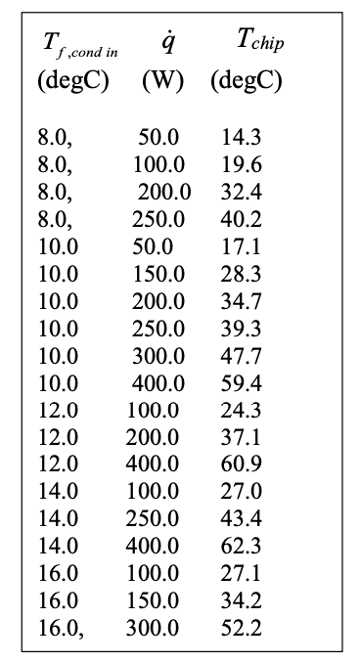

Appendix C2 - Python Implementation

# ============================================================
# Task 3 (a)
# ============================================================

import math

# ============================================================
# Evaporator conductance & condenser heat exchanger effectiveness
# ============================================================
UA_e = 12.7 # W/K
eps_c = 0.72 # (-)

# ============================================================
# Experimental data table (Tf_cond_in [°C], q_dot [W], Tchip_data [°C])
# ============================================================
data_rows = [
(8.0, 50.0, 14.3),
(8.0, 100.0, 19.6),
(8.0, 200.0, 32.4),
(8.0, 250.0, 40.2),
(10.0, 50.0, 17.1),
(10.0, 150.0, 28.3),
(10.0, 200.0, 34.7),
(10.0, 250.0, 39.3),
(10.0, 300.0, 47.7),
(10.0, 400.0, 59.4),
(12.0, 100.0, 24.3),
(12.0, 200.0, 37.1),
(12.0, 400.0, 60.9),
(14.0, 100.0, 27.0),
(14.0, 250.0, 43.4),
(14.0, 400.0, 62.3),
(16.0, 100.0, 27.1),
(16.0, 150.0, 34.2),
(16.0, 300.0, 52.2),
]

# ============================================================
# Choose ONE row (set index), OR loop all rows below
# ============================================================
row_i = 2 # <-- change this to pick a different row (0..len(data_rows)-1)
Tf_C, q_dot, Tchip_data_C = data_rows[row_i]

# ============================================================
# Task 1 code (model) starts here, but uses Tf_C, q_dot, UA_e, eps_c
# ============================================================

# (i) Geometry / wick
Dp = 0.015
Levap = 0.025
Ladiab = 0.30
Lcond = 0.025
Leff = Ladiab + 0.5 * Levap + 0.5 * Lcond

tw = 0.0025
Aw = (math.pi / 4.0) * (Dp**2 - (Dp - 2.0 * tw)**2)
Dv = Dp - 2.0 * tw
Av = (math.pi / 4.0) * (Dv**2)

rp_min = 0.000063
kappa = 2.3e-10
theta_deg = 10.0
re_min = rp_min / math.cos(math.radians(theta_deg))

# (ii) Condenser params
Tf_cond_in = Tf_C + 273.0
m_dot_c = 0.0080
cp_f = 4180.0

# (iii) T2 and P2
T2 = Tf_cond_in + q_dot / (m_dot_c * cp_f * eps_c)
C0, C1 = 25.73, -5266.0
P2 = math.exp(C0 + C1 / T2)

# (iv) Interpolation (water)
R = 461.5
Tc = 647.3

PA, PB, PC, PD = 1.71e3, 4.25e3, 9.59e3, 19.95e3

rhol15, rhol30, rhol45, rhol60 = 999.1, 995.6, 990.2, 983.2
rhov15, rhov30, rhov45, rhov60 = 1/77.875, 1/32.878, 1/15.252, 1/7.6672

mul15, mul30, mul45, mul60 = 1137.6e-6, 797.4e-6, 596.1e-6, 466.4e-6
muv15, muv30, muv45, muv60 = 9.59e-6, 10.01e-6, 10.46e-6, 10.93e-6

sig15, sig30, sig45, sig60 = 73.49e-3, 71.19e-3, 68.78e-3, 66.24e-3

hlv15 = (2528.33 - 62.98) * 1e3
hlv30 = (2555.55 - 125.73) * 1e3
hlv45 = (2582.43 - 188.43) * 1e3
hlv60 = (2608.83 - 251.18) * 1e3

WA = (P2 - PB) * (P2 - PC) * (P2 - PD) / ((PA - PB) * (PA - PC) * (PA - PD))
WB = (P2 - PA) * (P2 - PC) * (P2 - PD) / ((PB - PA) * (PB - PC) * (PB - PD))
WC = (P2 - PA) * (P2 - PB) * (P2 - PD) / ((PC - PA) * (PC - PB) * (PC - PD))
WD = (P2 - PA) * (P2 - PB) * (P2 - PC) / ((PD - PA) * (PD - PB) * (PD - PC))

rhov = WA*rhov15 + WB*rhov30 + WC*rhov45 + WD*rhov60
rhol = WA*rhol15 + WB*rhol30 + WC*rhol45 + WD*rhol60
muv = WA*muv15 + WB*muv30 + WC*muv45 + WD*muv60
mul = WA*mul15 + WB*mul30 + WC*mul45 + WD*mul60
sig = WA*sig15 + WB*sig30 + WC*sig45 + WD*sig60
hlv = WA*hlv15 + WB*hlv30 + WC*hlv45 + WD*hlv60

# (v) Vapor pressure drop -> P1
m_dot_v = q_dot / hlv
Vv = m_dot_v / (rhov * Av)
Re_v = (rhov * Vv * Dv) / muv
fv = 16.0 / Re_v
deltaP_v = 4.0 * fv * (Leff / Dv) * (rhov * Vv**2 / 2.0)
P1 = P2 + deltaP_v

# (vi) Liquid drop and P1-P4
deltaP_l = (mul * Leff * m_dot_v) / (kappa * rhol * Aw)
P1_minus_P4 = deltaP_v + deltaP_l

# (vii) Curved-interface -> T1
re = (2.0 * sig) / P1_minus_P4
C0_vii, C1_vii = 25.73, -5266.3
P0 = math.exp(C0_vii)
Nre = (2.0 * sig) / (re * rhol * R * Tc)
T1 = (C1_vii - Nre * Tc) / math.log(P1 / P0)

# (viii) Chip temperature + absolute error
Tchip_pred = T1 + q_dot / UA_e
Tchip_data = Tchip_data_C + 273.0
abs_diff = abs(Tchip_data - Tchip_pred)

print(f"Row {row_i}: Tf={Tf_C:.1f}°C, q={q_dot:.1f} W, Tchip,data={Tchip_data_C:.1f}°C")
print(f"Tchip,pred = {Tchip_pred - 273.0:.3f} °C")
print(f"|Tchip,data - Tchip,pred| = {abs_diff:.6f} K")

# ============================================================
# Task 3 (b)
# ============================================================
# Choose a specific row
row_i = 2
Tf_C, q_dot, Tchip_data_C = data_rows[row_i]

print(f"Row {row_i}: Tf={Tf_C:.1f} °C, q={q_dot:.1f} W, Tchip,data={Tchip_data_C:.1f} °C\n")

UA_vals = [6.0, 8.0, 10.0, 12.0, 15.0, 17.0] # (UA)e [W/K]
eps_vals = [0.25, 0.40, 0.55, 0.70, 0.85, 0.94] # eps_c [-]

print(f"{'UA_e (W/K)':>12} {'eps_c (-)':>12} {'|ΔT| (K)':>12}")

for UA_e in UA_vals:
for eps_c in eps_vals:

# ------------------------------------------------
# Run model once using the selected row values
# ------------------------------------------------
Tf_cond_in = Tf_C + 273.0
T2 = Tf_cond_in + q_dot / (m_dot_c * cp_f * eps_c)
P2 = math.exp(C0 + C1 / T2)

WA = (P2 - PB)*(P2 - PC)*(P2 - PD)/((PA - PB)*(PA - PC)*(PA - PD))
WB = (P2 - PA)*(P2 - PC)*(P2 - PD)/((PB - PA)*(PB - PC)*(PB - PD))
WC = (P2 - PA)*(P2 - PB)*(P2 - PD)/((PC - PA)*(PC - PB)*(PC - PD))
WD = (P2 - PA)*(P2 - PB)*(P2 - PC)/((PD - PA)*(PD - PB)*(PD - PC))

rhov = WA*rhov15 + WB*rhov30 + WC*rhov45 + WD*rhov60
rhol = WA*rhol15 + WB*rhol30 + WC*rhol45 + WD*rhol60
muv = WA*muv15 + WB*muv30 + WC*muv45 + WD*muv60
mul = WA*mul15 + WB*mul30 + WC*mul45 + WD*mul60
sig = WA*sig15 + WB*sig30 + WC*sig45 + WD*sig60
hlv = WA*hlv15 + WB*hlv30 + WC*hlv45 + WD*hlv60

m_dot_v = q_dot / hlv
Vv = m_dot_v / (rhov * Av)
Re_v = (rhov * Vv * Dv) / muv
fv = 16.0 / Re_v
deltaP_v = 4.0 * fv * (Leff / Dv) * (rhov * Vv**2 / 2.0)
P1 = P2 + deltaP_v

deltaP_l = (mul * Leff * m_dot_v) / (kappa * rhol * Aw)
P1_minus_P4 = deltaP_v + deltaP_l

re = (2.0 * sig) / P1_minus_P4
if re <= re_min:
continue # skip unphysical

Nre = (2.0 * sig) / (re * rhol * R * Tc)
T1 = (C1_vii - Nre * Tc) / math.log(P1 / P0)

Tchip_pred = T1 + q_dot / UA_e
Tchip_data = Tchip_data_C + 273.0
abs_diff = abs(Tchip_data - Tchip_pred)

print(f"{UA_e:12.2f} {eps_c:12.2f} {abs_diff:12.6f}")
# ============================================================
# Task 3 (b) - Surface plot
# ============================================================
import math
import numpy as np
import matplotlib.pyplot as plt

# ============================================================
# Pick ONE experimental operating point (row) to match
# ============================================================
row_i = 2
Tf_C, q_dot, Tchip_data_C = data_rows[row_i]
Tchip_data_K = Tchip_data_C + 273.0

print(f"Using row {row_i}: Tf={Tf_C:.1f} °C, q={q_dot:.1f} W, Tchip,data={Tchip_data_C:.1f} °C")

# ============================================================
# Model: compute |Tchip,data - Tchip,pred| for given (UA_e, eps_c)
# Assumes all constants from Task 1 are already defined above:
# m_dot_c, cp_f, C0, C1, C0_vii, C1_vii, P0, PA..PD, PB.. etc,
# Av, Dv, Leff, Aw, kappa, re_min, R, Tc, and anchor props arrays.
# ============================================================
def abs_Tchip_error(UA_e, eps_c):
# (ii)-(iii) condenser -> T2, P2
Tf_cond_in = Tf_C + 273.0
T2 = Tf_cond_in + q_dot / (m_dot_c * cp_f * eps_c)
P2 = math.exp(C0 + C1 / T2)

# (iv) Lagrange interpolation weights
WA = (P2 - PB)*(P2 - PC)*(P2 - PD)/((PA - PB)*(PA - PC)*(PA - PD))
WB = (P2 - PA)*(P2 - PC)*(P2 - PD)/((PB - PA)*(PB - PC)*(PB - PD))
WC = (P2 - PA)*(P2 - PB)*(P2 - PD)/((PC - PA)*(PC - PB)*(PC - PD))
WD = (P2 - PA)*(P2 - PB)*(P2 - PC)/((PD - PA)*(PD - PB)*(PD - PC))

# Interpolated fluid properties at P2
rhov = WA*rhov15 + WB*rhov30 + WC*rhov45 + WD*rhov60
rhol = WA*rhol15 + WB*rhol30 + WC*rhol45 + WD*rhol60
muv = WA*muv15 + WB*muv30 + WC*muv45 + WD*muv60
mul = WA*mul15 + WB*mul30 + WC*mul45 + WD*mul60
sig = WA*sig15 + WB*sig30 + WC*sig45 + WD*sig60
hlv = WA*hlv15 + WB*hlv30 + WC*hlv45 + WD*hlv60

# (v) vapor pressure drop -> P1
m_dot_v = q_dot / hlv
Vv = m_dot_v / (rhov * Av)
Re_v = (rhov * Vv * Dv) / muv
fv = 16.0 / Re_v
deltaP_v = 4.0 * fv * (Leff / Dv) * (rhov * Vv**2 / 2.0)
P1 = P2 + deltaP_v

# (vi) liquid pressure drop
deltaP_l = (mul * Leff * m_dot_v) / (kappa * rhol * Aw)
P1_minus_P4 = deltaP_v + deltaP_l

# (vii) capillary check + T1
re = (2.0 * sig) / P1_minus_P4
if re <= re_min:
return np.nan # capillary limit exceeded -> invalid

Nre = (2.0 * sig) / (re * rhol * R * Tc)
T1 = (C1_vii - Nre * Tc) / math.log(P1 / P0)

# (viii) chip temperature
Tchip_pred = T1 + q_dot / UA_e

return abs(Tchip_data_K - Tchip_pred)

# The 36 tested combinations
UA_vals = np.array([6.0, 8.0, 10.0, 12.0, 15.0, 17.0])
eps_vals = np.array([0.25, 0.40, 0.55, 0.70, 0.85, 0.94])

ERR36 = np.empty((len(eps_vals), len(UA_vals)), dtype=float)

for i, eps_c in enumerate(eps_vals):
for j, UA_e in enumerate(UA_vals):
ERR36[i, j] = abs_Tchip_error(UA_e, eps_c)

# Minimum among the 36 (ignore NaNs)
min_idx = np.nanargmin(ERR36)
i_min, j_min = np.unravel_index(min_idx, ERR36.shape)

UA_best_36 = UA_vals[j_min]
eps_best_36 = eps_vals[i_min]
err_best_36 = ERR36[i_min, j_min]

print("\n=== Minimum among the 36 tested points ===")
print(f"UA_e* = {UA_best_36:.6f} W/K")
print(f"eps_c* = {eps_best_36:.6f} (-)")
print(f"min |ΔT| = {err_best_36:.12f} K")

# Create mesh for plotting
UA_M, EPS_M = np.meshgrid(UA_vals, eps_vals)

plt.figure()
cs = plt.contourf(UA_M, EPS_M, ERR36, levels=20)
plt.colorbar(cs, label="|Tchip,data - Tchip,pred| (K)")

plt.scatter(UA_best_36, eps_best_36, marker="x", s=120, color="white")

plt.text(
UA_best_36, eps_best_36,
f" min\n UA_e={UA_best_36:.2f}\n eps_c={eps_best_36:.2f}\n |ΔT|={err_best_36:.6f} K",
verticalalignment="bottom",
color="white"
)

plt.xlabel("UA_e (W/K)")
plt.ylabel("eps_c (-)")
plt.title(f"|ΔT| surface for the 36 tested combinations (row {row_i}: Tf={Tf_C:.1f}°C, q={q_dot:.1f} W)")
plt.tight_layout()
plt.show()

print(abs_Tchip_error)

# -----------------------------
# Choose the experimental row
# -----------------------------
row_i = 2
Tf_C, q_dot, Tchip_data_C = data_rows[row_i]
Tchip_data_K = Tchip_data_C + 273.0

print(f"Row {row_i}: Tf={Tf_C:.1f} °C, q={q_dot:.1f} W, Tchip,data={Tchip_data_C:.1f} °C")

# ------------------------------------------------------------
# Model error function: returns |Tchip,data - Tchip,pred| (K)
# Returns NaN for unphysical (capillary limit exceeded) points
# ------------------------------------------------------------
def abs_Tchip_error(UA_e, eps_c):
Tf_cond_in = Tf_C + 273.0
T2 = Tf_cond_in + q_dot / (m_dot_c * cp_f * eps_c)
P2 = math.exp(C0 + C1 / T2)

WA = (P2 - PB) * (P2 - PC) * (P2 - PD) / ((PA - PB) * (PA - PC) * (PA - PD))
WB = (P2 - PA) * (P2 - PC) * (P2 - PD) / ((PB - PA) * (PB - PC) * (PB - PD))
WC = (P2 - PA) * (P2 - PB) * (P2 - PD) / ((PC - PA) * (PC - PB) * (PC - PD))
WD = (P2 - PA) * (P2 - PB) * (P2 - PC) / ((PD - PA) * (PD - PB) * (PD - PC))

rhov = WA * rhov15 + WB * rhov30 + WC * rhov45 + WD * rhov60
rhol = WA * rhol15 + WB * rhol30 + WC * rhol45 + WD * rhol60
muv = WA * muv15 + WB * muv30 + WC * muv45 + WD * muv60
mul = WA * mul15 + WB * mul30 + WC * mul45 + WD * mul60
sig = WA * sig15 + WB * sig30 + WC * sig45 + WD * sig60
hlv = WA * hlv15 + WB * hlv30 + WC * hlv45 + WD * hlv60

m_dot_v = q_dot / hlv
Vv = m_dot_v / (rhov * Av)
Re_v = (rhov * Vv * Dv) / muv
fv = 16.0 / Re_v
deltaP_v = 4.0 * fv * (Leff / Dv) * (rhov * Vv**2 / 2.0)
P1 = P2 + deltaP_v

deltaP_l = (mul * Leff * m_dot_v) / (kappa * rhol * Aw)
P1_minus_P4 = deltaP_v + deltaP_l

re = (2.0 * sig) / P1_minus_P4
if re <= re_min:
return np.nan

Nre = (2.0 * sig) / (re * rhol * R * Tc)
T1 = (C1_vii - Nre * Tc) / math.log(P1 / P0)

Tchip_pred = T1 + q_dot / UA_e
return abs(Tchip_data_K - Tchip_pred)

# ============================================================
# (A) Coarse grid over full required ranges
# ============================================================
UA_min, UA_max = 5.7, 17.7
eps_min, eps_max = 0.2, 0.95

n_UA_coarse = 81
n_eps_coarse = 81

UA_grid = np.linspace(UA_min, UA_max, n_UA_coarse)
eps_grid = np.linspace(eps_min, eps_max, n_eps_coarse)

ERR = np.empty((n_eps_coarse, n_UA_coarse), dtype=float)

for i, eps_c in enumerate(eps_grid):
for j, UA_e in enumerate(UA_grid):
ERR[i, j] = abs_Tchip_error(UA_e, eps_c)

i_min, j_min = np.unravel_index(np.nanargmin(ERR), ERR.shape)

UA_best_coarse = UA_grid[j_min]
eps_best_coarse = eps_grid[i_min]
err_best_coarse = ERR[i_min, j_min]

print("\n=== Coarse minimum ===")
print(f"UA_e* = {UA_best_coarse:.6f} W/K")
print(f"eps_c* = {eps_best_coarse:.6f} (-)")
print(f"min |ΔT| = {err_best_coarse:.12g} K")

# ============================================================
# (B) Refined grid around the coarse minimum
# ============================================================
UA_halfwidth = 1.0 # W/K
eps_halfwidth = 0.10 # (-)

UA_ref_min = max(UA_min, UA_best_coarse - UA_halfwidth)
UA_ref_max = min(UA_max, UA_best_coarse + UA_halfwidth)
eps_ref_min = max(eps_min, eps_best_coarse - eps_halfwidth)
eps_ref_max = min(eps_max, eps_best_coarse + eps_halfwidth)

n_UA_fine = 201
n_eps_fine = 201

UA_ref = np.linspace(UA_ref_min, UA_ref_max, n_UA_fine)
eps_ref = np.linspace(eps_ref_min, eps_ref_max, n_eps_fine)

ERR_ref = np.empty((n_eps_fine, n_UA_fine), dtype=float)

for i, eps_c in enumerate(eps_ref):
for j, UA_e in enumerate(UA_ref):
ERR_ref[i, j] = abs_Tchip_error(UA_e, eps_c)

i2, j2 = np.unravel_index(np.nanargmin(ERR_ref), ERR_ref.shape)

UA_best = UA_ref[j2]
eps_best = eps_ref[i2]
err_best = ERR_ref[i2, j2]

print("\n=== Refined minimum ===")
print(f"UA_e_best = {UA_best:.10f} W/K")
print(f"eps_c_best = {eps_best:.10f} (-)")
print(f"min |ΔT| = {err_best:.12g} K")

# ============================================================
# (C) Plot both surfaces
# ============================================================
fig, axes = plt.subplots(2, 1, figsize=(8, 12))

# --- 1) COARSE SURFACE ---
UA_M, EPS_M = np.meshgrid(UA_grid, eps_grid)

cs1 = axes[0].contourf(UA_M, EPS_M, ERR, levels=40)
fig.colorbar(cs1, ax=axes[0], label="|Tchip,data - Tchip,pred| (K)")

axes[0].scatter(
UA_best_coarse, eps_best_coarse,
marker="x", s=160, linewidths=2, color="white"
)

dUA1 = 0.04 * (UA_max - UA_min)
deps1 = 0.04 * (eps_max - eps_min)

axes[0].text(
UA_best_coarse + dUA1,
eps_best_coarse + deps1,
"Minimum:\n"
f"UA_e = {UA_best_coarse:.8f} W/K\n"
f"eps_c = {eps_best_coarse:.8f}\n"
f"|ΔT| = {err_best_coarse:.12g} K",
color="white",
fontsize=10,
bbox=dict(facecolor="black", alpha=0.7, edgecolor="none")
)

axes[0].set_xlabel("UA_e (W/K)")
axes[0].set_ylabel("eps_c (-)")
axes[0].set_title(f"Coarse |ΔT| Surface (row {row_i}: Tf={Tf_C:.1f}°C, q={q_dot:.1f} W)")

# --- 2) REFINED SURFACE ---
UA_M2, EPS_M2 = np.meshgrid(UA_ref, eps_ref)

cs2 = axes[1].contourf(UA_M2, EPS_M2, ERR_ref, levels=40)
fig.colorbar(cs2, ax=axes[1], label="|Tchip,data - Tchip,pred| (K)")

axes[1].scatter(
UA_best, eps_best,
marker="x", s=160, linewidths=2, color="white"
)

dUA2 = 0.04 * (UA_ref.max() - UA_ref.min())
deps2 = 0.04 * (eps_ref.max() - eps_ref.min())

axes[1].text(
UA_best + dUA2,
eps_best + deps2,
"Minimum:\n"
f"UA_e = {UA_best:.10f} W/K\n"
f"eps_c = {eps_best:.10f}\n"
f"|ΔT| = {err_best:.12g} K",
color="white",
fontsize=10,
bbox=dict(facecolor="black", alpha=0.7, edgecolor="none")
)

axes[1].set_xlabel("UA_e (W/K)")
axes[1].set_ylabel("eps_c (-)")
axes[1].set_title("Refined |ΔT| Surface near minimum")

plt.tight_layout()
plt.show()

Appendix D. Task 4

The Merit Number reference chart for commonly used fluids can be found below.

Given the methanol thermophysical properties table seen below. We modify the code from Task 1. Particular lines of code are screenshotted and appended below to elucidate this change. As well, the full modified code is pasted below.

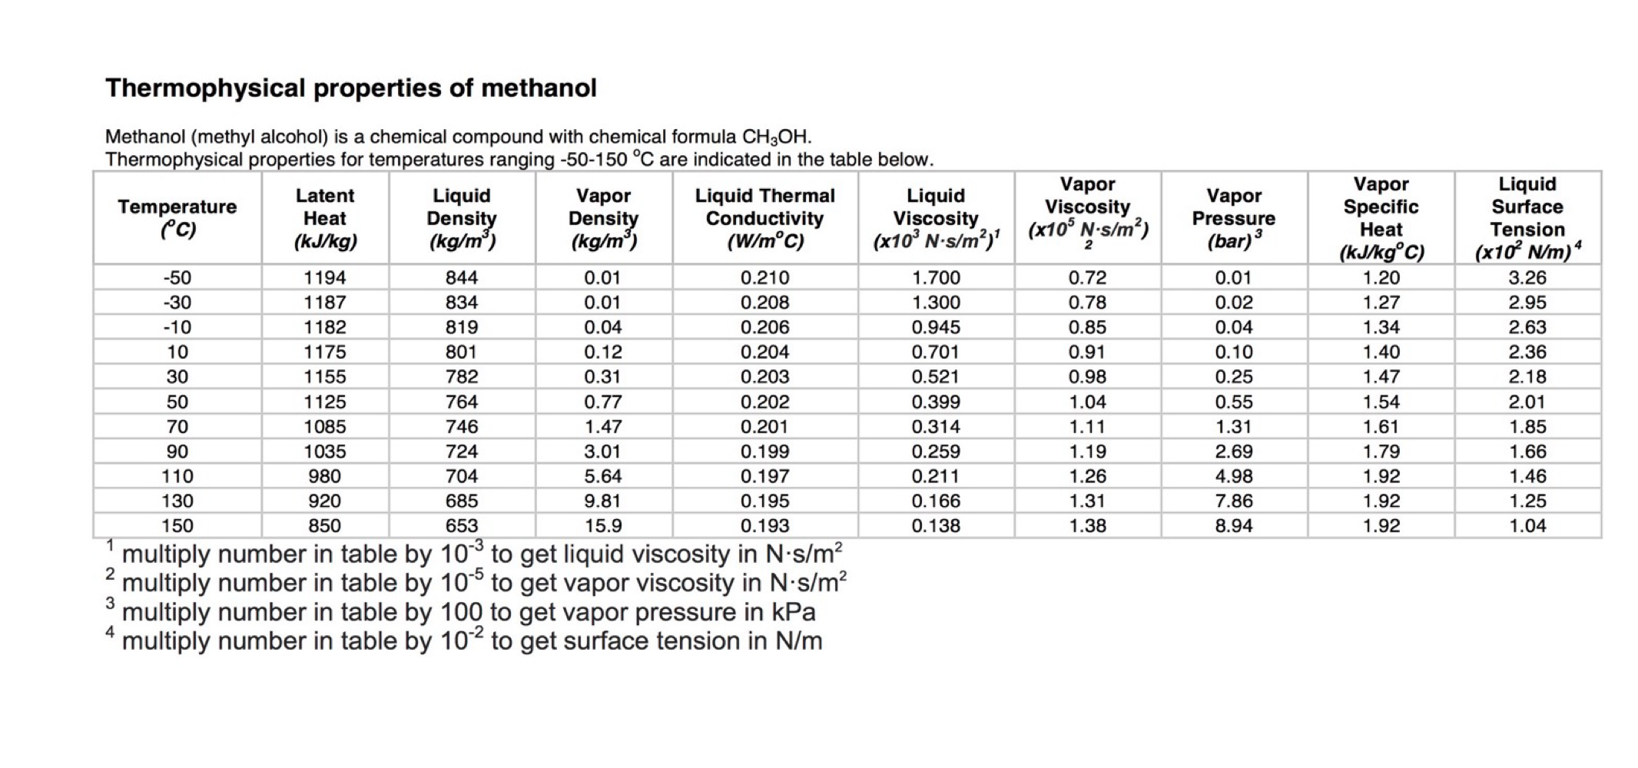
Note that the gas constant, R and critical temperature for methanol were found from the Engineering toolbox online and are as follows [3]:

R = 259.5 J/kgK
Tc = 513.4 K

As well, the C0 and C1 values were found by creating two equations and two unknowns given the saturation pressure and saturation temperature of methanol at 10 and 50 degrees Celsius taken from the table of methanol properties.

For methanol, the assignment brief provides the following relation:

$P = exp(C_{0}-\frac{C_{1}}{T})$

By substituting temperature and pressure values from the table we get:

$1. 10000 Pa= exp(C_{0}-\frac{C_{1}}{(10 + 273.15 K)})$

$2. 55000 Pa = exp(C_{0}-\frac{C_{1}}{(50 + 273.15 K)})$

Solving yields:
$C_{0}= 22.9826$ , $C_{1}= 3899.6080$
These values were inserted into the code.
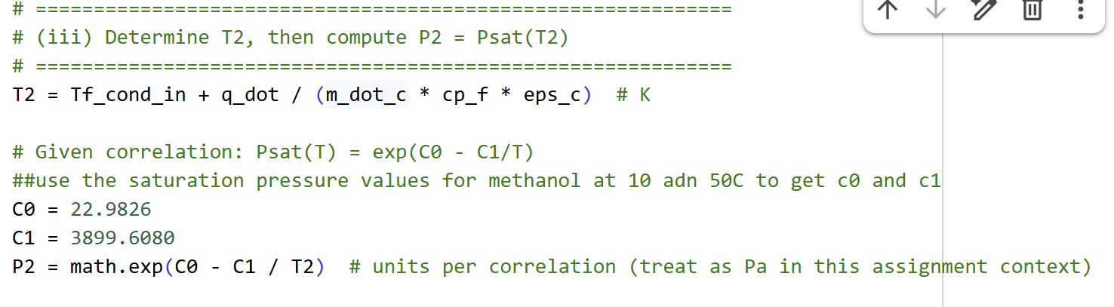
Then the following changes were made to the reference values and other methanol related parameters.
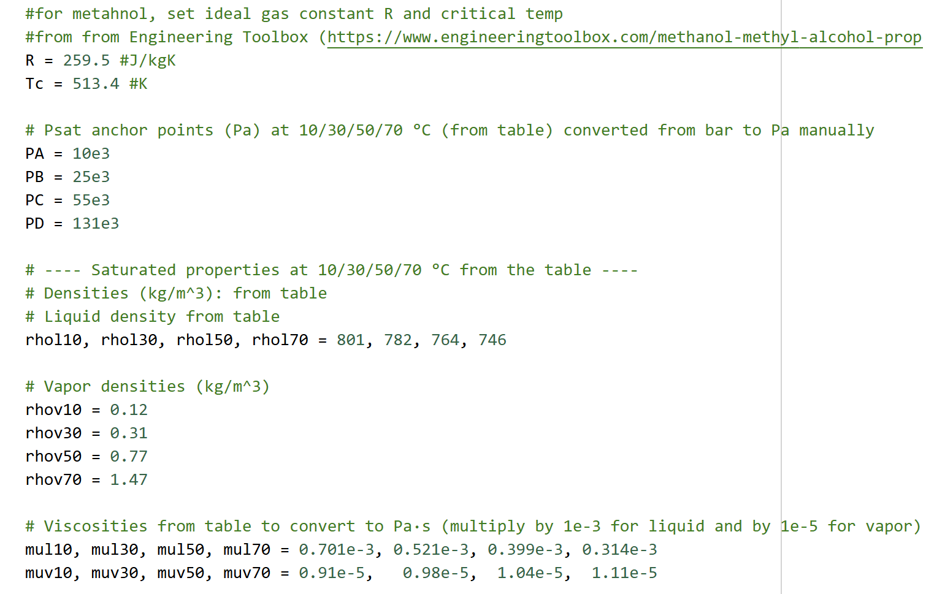
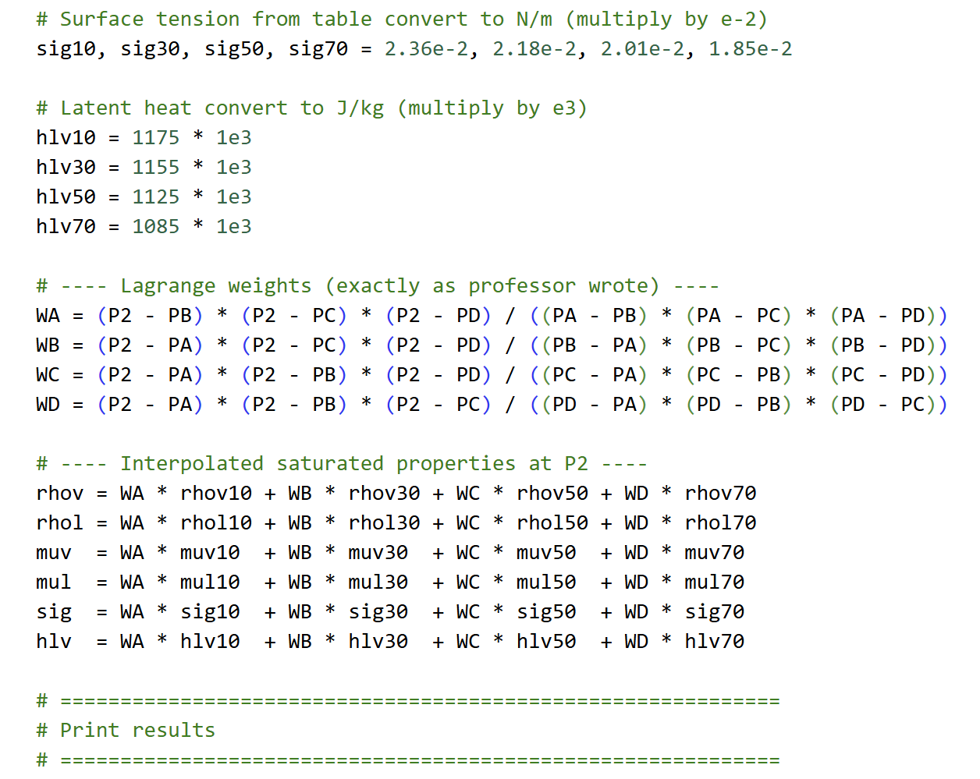

For Task 4(b):

The system was not at a stable steady state operational condition at 80 W with methanol as the working fluid, so we tried values of heat transfer rate between 30 and 80 W to find where the stable state condition would be met. The screenshot of the code below shows the trial and error process until we found 68 W as the value of heat transfer rate where the system can achieve a stable operating condition with methanol as its working fluid.
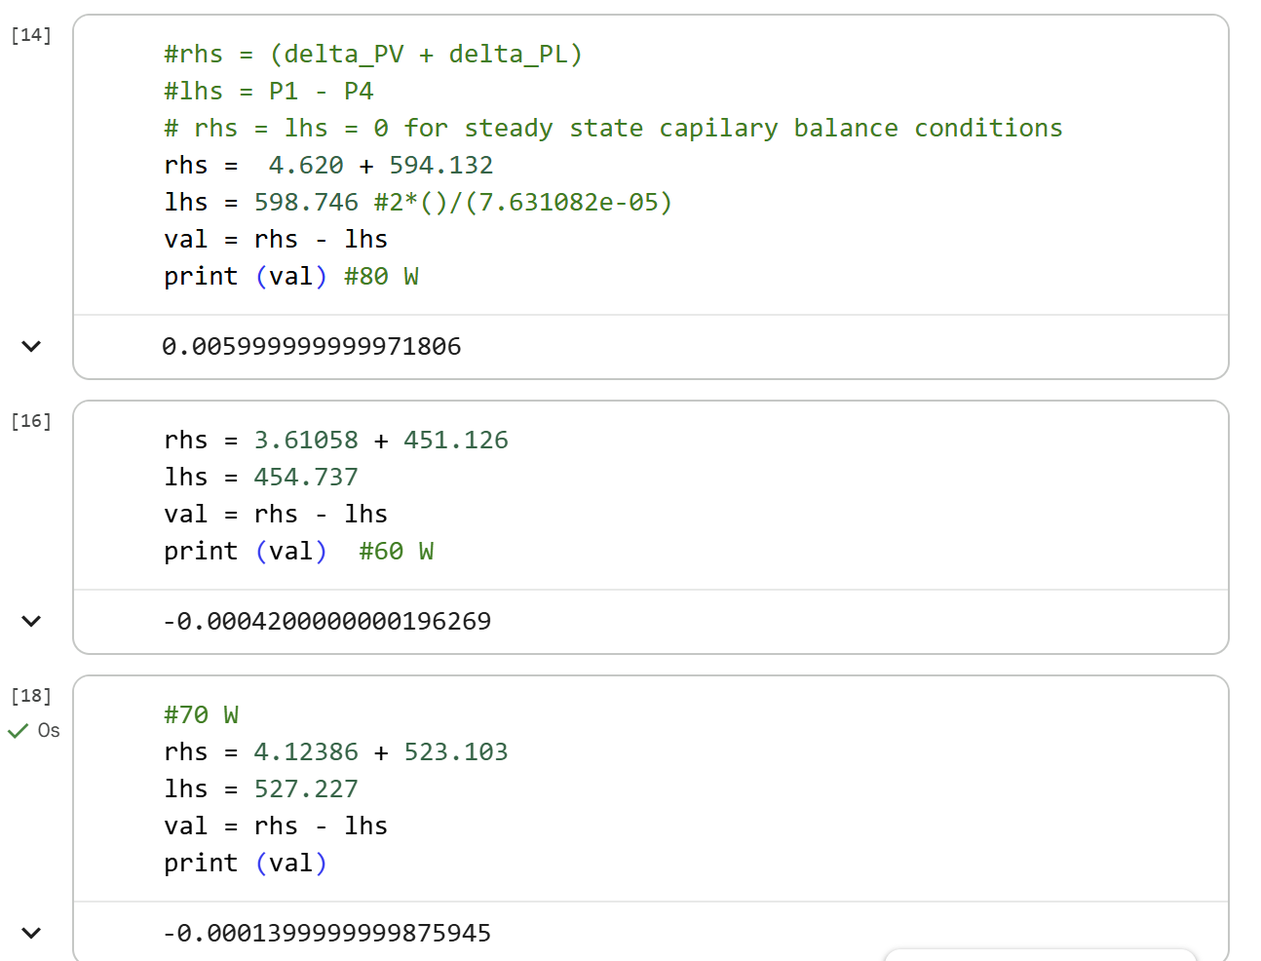
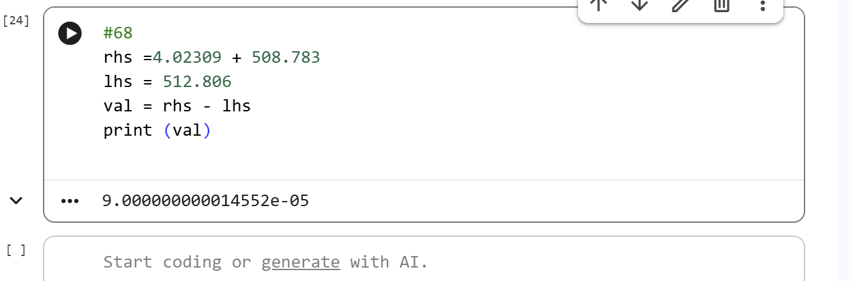

The code can be seen below:
# ============================================================
# Task 4 (a and b)
# ============================================================
import math
import numpy as np

# ============================================================
# (i) Heat pipe design + evaporator structure parameters
# ============================================================
Dp = 0.015 # m
Levap = 0.025 # m
Ladiab = 0.30 # m
Lcond = 0.025 # m

Leff = Ladiab + 0.5 * Levap + 0.5 * Lcond # m

tw = 0.0025 # m (wick thickness; multiple layers - mesh)
UA_e = 10.8 # W/K evaporator conductance

Aw = (math.pi / 4.0) * (Dp**2 - (Dp - 2.0 * tw)**2) # wick cross-sectional area, m^2
Dv = Dp - 2.0 * tw # vapor core diameter, m
Av = (math.pi / 4.0) * (Dv**2) # vapor core area, m^2

rp_min = 0.000045 # m minimum pore radius
kappa = 3e-10 # m^2 permeability
theta_deg = 10.0 # degrees
theta_rad = math.radians(theta_deg)
re_min = rp_min / math.cos(theta_rad) # m

# ============================================================
# (ii) Condenser design + operating parameters
# ============================================================
Tf_cond_in = 15.5 + 273.0 # K
q_dot = 80.0 # W
m_dot_c = 0.0080 # kg/s
eps_c = 0.6 # condenser heat exchanger effectiveness
cp_f = 4180.0 # J/(kg*K)

# ============================================================
# (iii) Determine T2, then compute P2 = Psat(T2)
# ============================================================
T2 = Tf_cond_in + q_dot / (m_dot_c * cp_f * eps_c) # K

# Given correlation: Psat(T) = exp(C0 - C1/T)
##use the saturation pressure values for methanol at 10 adn 50C to get c0 and c1
C0 = 22.9826
C1 = 3899.6080
P2 = math.exp(C0 - C1 / T2) # units per correlation (treat as Pa in this assignment context)

# ============================================================
# (iv) Lagrange interpolation in pressure-space using anchors
# Anchors are Psat at 10/30/50/70 C (given) and saturated
# properties at those temperatures (from your table page).
# ============================================================

#for metahnol, set ideal gas constant R and critical temp
#from from Engineering Toolbox (https://www.engineeringtoolbox.com/methanol-methyl-alcohol-properties-CH3OH-d_2031.html)
R = 259.5 #J/kgK
Tc = 513.4 #K

# Psat anchor points (Pa) at 10/30/50/70 °C (from table) converted from bar to Pa manually
PA = 10e3
PB = 25e3
PC = 55e3
PD = 131e3

# ---- Saturated properties at 10/30/50/70 °C from the table ----
# Densities (kg/m^3): from table
# Liquid density from table
rhol10, rhol30, rhol50, rhol70 = 801, 782, 764, 746

# Vapor densities (kg/m^3)
rhov10 = 0.12
rhov30 = 0.31
rhov50 = 0.77
rhov70 = 1.47

# Viscosities from table to convert to Pa·s (multiply by 1e-3 for liquid and by 1e-5 for vapor)
mul10, mul30, mul50, mul70 = 0.701e-3, 0.521e-3, 0.399e-3, 0.314e-3
muv10, muv30, muv50, muv70 = 0.91e-5, 0.98e-5, 1.04e-5, 1.11e-5

# Surface tension from table convert to N/m (multiply by e-2)
sig10, sig30, sig50, sig70 = 2.36e-2, 2.18e-2, 2.01e-2, 1.85e-2

# Latent heat convert to J/kg (multiply by e3)
hlv10 = 1175 * 1e3
hlv30 = 1155 * 1e3
hlv50 = 1125 * 1e3
hlv70 = 1085 * 1e3

# ---- Lagrange weights (exactly as professor wrote) ----
WA = (P2 - PB) * (P2 - PC) * (P2 - PD) / ((PA - PB) * (PA - PC) * (PA - PD))
WB = (P2 - PA) * (P2 - PC) * (P2 - PD) / ((PB - PA) * (PB - PC) * (PB - PD))
WC = (P2 - PA) * (P2 - PB) * (P2 - PD) / ((PC - PA) * (PC - PB) * (PC - PD))
WD = (P2 - PA) * (P2 - PB) * (P2 - PC) / ((PD - PA) * (PD - PB) * (PD - PC))

# ---- Interpolated saturated properties at P2 ----
rhov = WA * rhov10 + WB * rhov30 + WC * rhov50 + WD * rhov70
rhol = WA * rhol10 + WB * rhol30 + WC * rhol50 + WD * rhol70
muv = WA * muv10 + WB * muv30 + WC * muv50 + WD * muv70
mul = WA * mul10 + WB * mul30 + WC * mul50 + WD * mul70
sig = WA * sig10 + WB * sig30 + WC * sig50 + WD * sig70
hlv = WA * hlv10 + WB * hlv30 + WC * hlv50 + WD * hlv70

# ============================================================
# Print results
# ============================================================
print("=== (i) Geometry / Wick ===")
print(f"Leff = {Leff:.6f} m")
print(f"Aw = {Aw:.8e} m^2")
print(f"Dv = {Dv:.6f} m")
print(f"Av = {Av:.8e} m^2")
print(f"re_min = {re_min:.8e} m")

print("\n=== (iii) Condenser end state ===")
print(f"T2 = {T2:.6f} K")
print(f"P2 = {P2:.6e} (per Psat correlation)")

print("\n=== (iv) Lagrange weights ===")
print(f"WA, WB, WC, WD = {WA:.6g}, {WB:.6g}, {WC:.6g}, {WD:.6g}")
print(f"Sum weights = {(WA+WB+WC+WD):.6g}")

print("\n=== (iv) Saturated properties at P2 (interpolated) ===")
print(f"rhov = {rhov:.6g} kg/m^3")
print(f"rhol = {rhol:.6g} kg/m^3")
print(f"muv = {muv:.6g} Pa·s")
print(f"mul = {mul:.6g} Pa·s")
print(f"sig = {sig:.6g} N/m")
print(f"hlv = {hlv:.6g} J/kg")

# ============================================================
# (v) Vapor-flow pressure drop and P1
# ============================================================

# --- sanity checks (avoid silent crashes / nonsense) ---
if hlv <= 0:
raise ValueError(f"hlv must be > 0 (J/kg). Got {hlv}.")
if rhov <= 0:
raise ValueError(f"rhov must be > 0 (kg/m^3). Got {rhov}.")
if Av <= 0 or Dv <= 0:
raise ValueError(f"Av and Dv must be > 0. Got Av={Av}, Dv={Dv}.")
if muv <= 0:
raise ValueError(f"muv must be > 0 (Pa·s). Got {muv}.")
if Leff <= 0:
raise ValueError(f"Leff must be > 0 (m). Got {Leff}.")

# Mass flow rate of vapor (kg/s)
m_dot_v = q_dot / hlv

# Vapor average velocity (m/s)
Vv = m_dot_v / (rhov * Av)

# Vapor Reynolds number (-)
Re_v = (rhov * Vv * Dv) / muv

# Fanning friction factor (laminar) (-)
fv = 16.0 / Re_v

# Vapor pressure rise from condenser end (P2) to evaporator end (P1) due to flow (Pa)
deltaP_v = 4.0 * fv * (Leff / Dv) * (rhov * Vv**2 / 2.0)

# Pressure at evaporator end (Pa)
P1 = P2 + deltaP_v

print("\n=== (v) Vapor flow / pressure drop ===")
print(f"m_dot_v = {m_dot_v:.6g} kg/s")
print(f"Vv = {Vv:.6g} m/s")
print(f"Re_v = {Re_v:.6g} (-)")
print(f"f_v = {fv:.6g} (-)")
print(f"deltaP_v = {deltaP_v:.6g} Pa")
print(f"P1 = {P1:.6g} Pa")

# ============================================================
# (vi) Liquid flow pressure drop in porous wick (Darcy) and
# pressure difference across curved interface in evaporator
# ============================================================

# --- sanity checks ---
if mul <= 0:
raise ValueError(f"mul must be > 0 (Pa·s). Got {mul}.")
if kappa <= 0:
raise ValueError(f"kappa must be > 0 (m^2). Got {kappa}.")
if rhol <= 0:
raise ValueError(f"rhol must be > 0 (kg/m^3). Got {rhol}.")
if Aw <= 0:
raise ValueError(f"Aw must be > 0 (m^2). Got {Aw}.")
if m_dot_v <= 0:
raise ValueError(f"m_dot_v must be > 0 (kg/s). Got {m_dot_v}.")
if Leff <= 0:
raise ValueError(f"Leff must be > 0 (m). Got {Leff}.")

# Liquid flow pressure drop through wick (Pa)
# (m_dot is the same mass flow rate circulating: m_dot_v = q_dot/hlv)
deltaP_l = (mul * Leff * m_dot_v) / (kappa * rhol * Aw) # P3 - P4

# Total pressure difference from 1 to 4 (Pa)
# P2 = P3, so P1 - P4 = (P1 - P2) + (P3 - P4)
# From step (v): deltaP_v = P1 - P2
P1_minus_P4 = deltaP_v + deltaP_l

print("\n=== (vi) Wick (liquid) pressure drop + interface pressure difference ===")
print(f"deltaP_l (P3-P4) = {deltaP_l:.6g} Pa")
print(f"P1 - P4 = {P1_minus_P4:.6g} Pa")

# ============================================================
# (vii) Curved-interface equilibrium + saturation curve relation:

# Notes:
# - Uses sigma (N/m), re (m), rho_l (kg/m^3), R (J/kgK), Tc (K)
# - Requires P1 already computed in step (v), and deltaP_v/deltaP_l from (v)-(vi)
# ============================================================

# --- sanity checks ---
if sig <= 0:
raise ValueError(f"sig must be > 0 (N/m). Got {sig}.")
if P1_minus_P4 <= 0:
raise ValueError(f"P1_minus_P4 must be > 0 (Pa). Got {P1_minus_P4}.")
if rhol <= 0:
raise ValueError(f"rhol must be > 0 (kg/m^3). Got {rhol}.")
if R <= 0 or Tc <= 0:
raise ValueError(f"R and Tc must be > 0. Got R={R}, Tc={Tc}.")

# 1) Interface radius from pressure difference (m)
re = (2.0 * sig) / P1_minus_P4

# Enforce constraint re > re_min
if re <= re_min:
raise ValueError(
f"Computed re={re:.3e} m is <= re_min={re_min:.3e} m. "
"This violates the interface-radius constraint (capillary limit exceeded)."
)

# 2) Compute T1 using provided rearranged relation
# Constants from handout (note C1 slightly different from earlier step)
C0_vii = 25.73
C1_vii = -5266.3 # K

P0 = math.exp(C0_vii)

# Dimensionless Nre (uses Tc as in handout)
Nre = (2.0 * sig) / (re * rhol * R * Tc)

# Compute T1
ln_P1_over_P0 = math.log(P1 / P0)
if ln_P1_over_P0 == 0:
raise ValueError("ln(P1/P0) is zero; cannot compute T1.")

T1 = (C1_vii - Nre * Tc) / ln_P1_over_P0 # K

print("\n=== (vii) Curved-interface equilibrium ===")
print(f"re = {re:.6e} m")
print(f"re_min = {re_min:.6e} m")
print(f"Nre = {Nre:.6e} (-)")
print(f"P0 = {P0:.6e} (same pressure units as P1)")
print(f"ln(P1/P0) = {ln_P1_over_P0:.6e}")
print(f"T1 = {T1:.6f} K")

# ============================================================
# (viii) Chip temperature
# ============================================================

# --- sanity checks ---
if UA_e <= 0:
raise ValueError(f"UA_e must be > 0 (W/K). Got {UA_e}.")
if q_dot < 0:
raise ValueError(f"q_dot must be >= 0 (W). Got {q_dot}.")
if not math.isfinite(T1):
raise ValueError(f"T1 must be finite. Got {T1}.")
if not math.isfinite(re):
raise ValueError(f"re must be finite. Got {re}.")

T_chip = T1 + q_dot / UA_e # K

# Physical realism checks for interface radius
capillary_ok = (re > re_min) and math.isfinite(re)

print("\n=== (viii) Chip temperature + realism check ===")
print(f"T_chip = {T_chip:.6f} K")
print(f"T_chip (°C) = {T_chip - 273.15:.3f} °C")
print(f"re = {re:.6e} m")
print(f"re_min = {re_min:.6e} m")
print(f"capillary_ok = {capillary_ok}")

if not capillary_ok:
raise ValueError(
"Physically unrealistic operating point: re must be > re_min and finite. "
f"Got re={re:.3e}, re_min={re_min:.3e}."
)

# ============================================================
# Task 4 (c)
# ============================================================
import math
import numpy as np
import matplotlib.pyplot as plt
# ============================================================
# (i) Heat pipe design + evaporator structure parameters
# ============================================================
Dp = 0.015 # m
Levap = 0.025 # m
Ladiab = 0.30 # m
Lcond = 0.025 # m

Leff = Ladiab + 0.5 * Levap + 0.5 * Lcond # m

tw = 0.0025 # m (wick thickness; multiple layers - mesh)
UA_e = 10.8 # W/K evaporator conductance

Aw = (math.pi / 4.0) * (Dp**2 - (Dp - 2.0 * tw)**2) # wick cross-sectional area, m^2
Dv = Dp - 2.0 * tw # vapor core diameter, m
Av = (math.pi / 4.0) * (Dv**2) # vapor core area, m^2

rp_min = 0.000045 # m minimum pore radius
kappa = 3e-10 # m^2 permeability
theta_deg = 10.0 # degrees
theta_rad = math.radians(theta_deg)
re_min = rp_min / math.cos(theta_rad) # m

# ============================================================
# (ii) Condenser design + operating parameters
# ============================================================
Tf_cond_in = 15.5 + 273.0 # K
q_dot_array = [20.0, 30.0, 50.0, 60.0] # W
m_dot_c = 0.0080 # kg/s
eps_c = 0.6 # condenser heat exchanger effectiveness
cp_f = 4180.0 # J/(kg*K)

#initialize arrays to store the re and T_chip values in
re_array = []
T_chip_array = []

for q_dot in q_dot_array:
# ============================================================
# (iii) Determine T2, then compute P2 = Psat(T2)
# ============================================================
T2 = Tf_cond_in + q_dot / (m_dot_c * cp_f * eps_c) # K

# Given correlation: Psat(T) = exp(C0 - C1/T)
##use the saturation pressure values for methanol at 10 adn 50C to get c0 and c1
C0 = 22.9826
C1 = 3899.6080
P2 = math.exp(C0 - C1 / T2) # units per correlation (treat as Pa in this assignment context)

# ============================================================
# (iv) Lagrange interpolation in pressure-space using anchors
# Anchors are Psat at 10/30/50/70 C (given) and saturated
# properties at those temperatures (from your table page).
# ============================================================

#for metahnol, set ideal gas constant R and critical temp
#from from Engineering Toolbox (https://www.engineeringtoolbox.com/methanol-methyl-alcohol-properties-CH3OH-d_2031.html)
R = 259.5 #J/kgK
Tc = 513.4 #K

# Psat anchor points (Pa) at 10/30/50/70 °C (from table) converted from bar to Pa manually
PA = 10e3
PB = 25e3
PC = 55e3
PD = 131e3

# ---- Saturated properties at 10/30/50/70 °C from the table ----
# Densities (kg/m^3): from table
# Liquid density from table
rhol10, rhol30, rhol50, rhol70 = 801, 782, 764, 746

# Vapor densities (kg/m^3)
rhov10 = 0.12
rhov30 = 0.31
rhov50 = 0.77
rhov70 = 1.47

# Viscosities from table to convert to Pa·s (multiply by 1e-3 for liquid and by 1e-5 for vapor)
mul10, mul30, mul50, mul70 = 0.701e-3, 0.521e-3, 0.399e-3, 0.314e-3
muv10, muv30, muv50, muv70 = 0.91e-5, 0.98e-5, 1.04e-5, 1.11e-5

# Surface tension from table convert to N/m (multiply by e-2)
sig10, sig30, sig50, sig70 = 2.36e-2, 2.18e-2, 2.01e-2, 1.85e-2

# Latent heat convert to J/kg (multiply by e3)
hlv10 = 1175 * 1e3
hlv30 = 1155 * 1e3
hlv50 = 1125 * 1e3
hlv70 = 1085 * 1e3

# ---- Lagrange weights (exactly as professor wrote) ----
WA = (P2 - PB) * (P2 - PC) * (P2 - PD) / ((PA - PB) * (PA - PC) * (PA - PD))
WB = (P2 - PA) * (P2 - PC) * (P2 - PD) / ((PB - PA) * (PB - PC) * (PB - PD))
WC = (P2 - PA) * (P2 - PB) * (P2 - PD) / ((PC - PA) * (PC - PB) * (PC - PD))
WD = (P2 - PA) * (P2 - PB) * (P2 - PC) / ((PD - PA) * (PD - PB) * (PD - PC))

# ---- Interpolated saturated properties at P2 ----
rhov = WA * rhov10 + WB * rhov30 + WC * rhov50 + WD * rhov70
rhol = WA * rhol10 + WB * rhol30 + WC * rhol50 + WD * rhol70
muv = WA * muv10 + WB * muv30 + WC * muv50 + WD * muv70
mul = WA * mul10 + WB * mul30 + WC * mul50 + WD * mul70
sig = WA * sig10 + WB * sig30 + WC * sig50 + WD * sig70
hlv = WA * hlv10 + WB * hlv30 + WC * hlv50 + WD * hlv70

# ============================================================
# Print results
# ============================================================
print("=== (i) Geometry / Wick ===")
print(f"Leff = {Leff:.6f} m")
print(f"Aw = {Aw:.8e} m^2")
print(f"Dv = {Dv:.6f} m")
print(f"Av = {Av:.8e} m^2")
print(f"re_min = {re_min:.8e} m")

print("\n=== (iii) Condenser end state ===")
print(f"T2 = {T2:.6f} K")
print(f"P2 = {P2:.6e} (per Psat correlation)")

print("\n=== (iv) Lagrange weights ===")
print(f"WA, WB, WC, WD = {WA:.6g}, {WB:.6g}, {WC:.6g}, {WD:.6g}")
print(f"Sum weights = {(WA+WB+WC+WD):.6g}")

print("\n=== (iv) Saturated properties at P2 (interpolated) ===")
print(f"rhov = {rhov:.6g} kg/m^3")
print(f"rhol = {rhol:.6g} kg/m^3")
print(f"muv = {muv:.6g} Pa·s")
print(f"mul = {mul:.6g} Pa·s")
print(f"sig = {sig:.6g} N/m")
print(f"hlv = {hlv:.6g} J/kg")

# ============================================================
# (v) Vapor-flow pressure drop and P1
# ============================================================

# --- sanity checks (avoid silent crashes / nonsense) ---
if hlv <= 0:
raise ValueError(f"hlv must be > 0 (J/kg). Got {hlv}.")
if rhov <= 0:
raise ValueError(f"rhov must be > 0 (kg/m^3). Got {rhov}.")
if Av <= 0 or Dv <= 0:
raise ValueError(f"Av and Dv must be > 0. Got Av={Av}, Dv={Dv}.")
if muv <= 0:
raise ValueError(f"muv must be > 0 (Pa·s). Got {muv}.")
if Leff <= 0:
raise ValueError(f"Leff must be > 0 (m). Got {Leff}.")

# Mass flow rate of vapor (kg/s)
m_dot_v = q_dot / hlv

# Vapor average velocity (m/s)
Vv = m_dot_v / (rhov * Av)

# Vapor Reynolds number (-)
Re_v = (rhov * Vv * Dv) / muv

# Fanning friction factor (laminar) (-)
fv = 16.0 / Re_v

# Vapor pressure rise from condenser end (P2) to evaporator end (P1) due to flow (Pa)
deltaP_v = 4.0 * fv * (Leff / Dv) * (rhov * Vv**2 / 2.0)

# Pressure at evaporator end (Pa)
P1 = P2 + deltaP_v

print("\n=== (v) Vapor flow / pressure drop ===")
print(f"m_dot_v = {m_dot_v:.6g} kg/s")
print(f"Vv = {Vv:.6g} m/s")
print(f"Re_v = {Re_v:.6g} (-)")
print(f"f_v = {fv:.6g} (-)")
print(f"deltaP_v = {deltaP_v:.6g} Pa")
print(f"P1 = {P1:.6g} Pa")
#del_p = P1- P2
#print(f"P1 = {del_p:.6g} Pa")

# ============================================================
# (vi) Liquid flow pressure drop in porous wick (Darcy) and
# pressure difference across curved interface in evaporator
# ============================================================

# --- sanity checks ---
if mul <= 0:
raise ValueError(f"mul must be > 0 (Pa·s). Got {mul}.")
if kappa <= 0:
raise ValueError(f"kappa must be > 0 (m^2). Got {kappa}.")
if rhol <= 0:
raise ValueError(f"rhol must be > 0 (kg/m^3). Got {rhol}.")
if Aw <= 0:
raise ValueError(f"Aw must be > 0 (m^2). Got {Aw}.")
if m_dot_v <= 0:
raise ValueError(f"m_dot_v must be > 0 (kg/s). Got {m_dot_v}.")
if Leff <= 0:
raise ValueError(f"Leff must be > 0 (m). Got {Leff}.")

# Liquid flow pressure drop through wick (Pa)
# (m_dot is the same mass flow rate circulating: m_dot_v = q_dot/hlv)
deltaP_l = (mul * Leff * m_dot_v) / (kappa * rhol * Aw) # P3 - P4

# Total pressure difference from 1 to 4 (Pa)
# P2 = P3, so P1 - P4 = (P1 - P2) + (P3 - P4)
# From step (v): deltaP_v = P1 - P2
P1_minus_P4 = deltaP_v + deltaP_l

print("\n=== (vi) Wick (liquid) pressure drop + interface pressure difference ===")
print(f"deltaP_l (P3-P4) = {deltaP_l:.6g} Pa")
print(f"P1 - P4 = {P1_minus_P4:.6g} Pa")

# ============================================================
# (vii) Curved-interface equilibrium + saturation curve relation:

# Notes:
# - Uses sigma (N/m), re (m), rho_l (kg/m^3), R (J/kgK), Tc (K)
# - Requires P1 already computed in step (v), and deltaP_v/deltaP_l from (v)-(vi)
# ============================================================

# --- sanity checks ---
if sig <= 0:
raise ValueError(f"sig must be > 0 (N/m). Got {sig}.")
if P1_minus_P4 <= 0:
raise ValueError(f"P1_minus_P4 must be > 0 (Pa). Got {P1_minus_P4}.")
if rhol <= 0:
raise ValueError(f"rhol must be > 0 (kg/m^3). Got {rhol}.")
if R <= 0 or Tc <= 0:
raise ValueError(f"R and Tc must be > 0. Got R={R}, Tc={Tc}.")

# 1) Interface radius from pressure difference (m)
re = (2.0 * sig) / P1_minus_P4

# Enforce constraint re > re_min
if re <= re_min:
raise ValueError(
f"Computed re={re:.3e} m is <= re_min={re_min:.3e} m. "
"This violates the interface-radius constraint (capillary limit exceeded)."
)

# 2) Compute T1 using provided rearranged relation
# Constants from handout (note C1 slightly different from earlier step)
C0_vii = 25.73
C1_vii = -5266.3 # K

P0 = math.exp(C0_vii)

# Dimensionless Nre (uses Tc as in handout)
Nre = (2.0 * sig) / (re * rhol * R * Tc)

# Compute T1
ln_P1_over_P0 = math.log(P1 / P0)
if ln_P1_over_P0 == 0:
raise ValueError("ln(P1/P0) is zero; cannot compute T1.")

T1 = (C1_vii - Nre * Tc) / ln_P1_over_P0 # K

print("\n=== (vii) Curved-interface equilibrium ===")
print(f"re = {re:.6e} m")
print(f"re_min = {re_min:.6e} m")
print(f"Nre = {Nre:.6e} (-)")
print(f"P0 = {P0:.6e} (same pressure units as P1)")
print(f"ln(P1/P0) = {ln_P1_over_P0:.6e}")
print(f"T1 = {T1:.6f} K")

# ============================================================
# (viii) Chip temperature
# ============================================================

# --- sanity checks ---
if UA_e <= 0:
raise ValueError(f"UA_e must be > 0 (W/K). Got {UA_e}.")
if q_dot < 0:
raise ValueError(f"q_dot must be >= 0 (W). Got {q_dot}.")
if not math.isfinite(T1):
raise ValueError(f"T1 must be finite. Got {T1}.")
if not math.isfinite(re):
raise ValueError(f"re must be finite. Got {re}.")

T_chip = T1 + q_dot / UA_e # K

#append values of T_chip and re to the initialized arrays to store
T_chip_array.append(T_chip)
re_array.append(re)

# Physical realism checks for interface radius
capillary_ok = (re > re_min) and math.isfinite(re)

print("\n=== (viii) Chip temperature + realism check ===")
print(f"q_dot = {q_dot} W")
print(f"T_chip = {T_chip:.6f} K")
print(f"T_chip (°C) = {T_chip - 273.15:.3f} °C")
print(f"re = {re:.6e} m")
print(f"re_min = {re_min:.6e} m")
print(f"capillary_ok = {capillary_ok}")

if not capillary_ok:
raise ValueError(
"Physically unrealistic operating point: re must be > re_min and finite. "
f"Got re={re:.3e}, re_min={re_min:.3e}."
)

# ============================================================
# Is the system stable? (Capillary Limit Check)
# ============================================================
#rhs = (delta_PV + delta_PL)
#lhs = P1 - P4 = 2sigma/re_min
# rhs = lhs = 0 for steady state capilary balance conditions
rhs = deltaP_v + deltaP_l
lhs = (2*sig)/(re_min)
stability_val = rhs - lhs
print(f" Stability value = {stability_val}")

if rhs <= lhs:
print(f"The system is stable at {q_dot} W.")
else:
print(f"The system is NOT stable at {q_dot} W.")

#print the arrays that store the values of T_chip and re for the different q_dot iteration values
print(f"\n T_chip_array is as follows: {[f'{T- 273.15:.3f}' for T in T_chip_array]}")
print(f"\n re is as follows in micrometers: {[f'{r*1e6:.3f}' for r in re_array]}")

#make plots for the relations between T_chip and q_dot and re and q_dot

#create a figure with two subplots
fig, (ax1, ax2) = plt.subplots(2, 1, figsize=(10, 12))

#unit conversions for plotting
T_chip_array_C = []
for t in T_chip_array:
T_chip_array_C.append(t - 273.15)

re_array_micro = []
for r in re_array:
re_array_micro.append(r*1e6)

print (T_chip_array_C)
print(re_array_micro)
#plot 1: T_chip vs q_dot
ax1.plot(q_dot_array, T_chip_array_C, 'b-s', linewidth=3)
ax1.set_xlabel('Heat Transfer Rate, q_dot [W]')
ax1.set_ylabel('Chip Temperature [°C]')
ax1.set_title('Methanol: Chip Temperature vs. Heat Transfer Rate')
ax1.grid(True)

#plot 2: re vs q_dot
ax2.plot(q_dot_array, re_array_micro, 'r-o', linewidth=3)
ax2.axhline(y=re_min, linestyle='-.', label='re_min') #re_min reference
ax2.set_xlabel('Heat Transfer Rate (q_dot) [W]')
ax2.set_ylabel('Interface Radius (re) [micrometer]')
ax2.set_title('Methanol: Interface Radius vs. Heat Transfer Rate')
ax2.legend()
ax2.grid(True)

plt.tight_layout()
plt.show()

# ============================================================
# Task 4 (d)
# ============================================================
import math
import numpy as np
import matplotlib.pyplot as plt
# ============================================================
# (i) Heat pipe design + evaporator structure parameters
# ============================================================
Dp = 0.015 # m
Levap = 0.025 # m
Ladiab = 0.30 # m
Lcond = 0.025 # m

Leff = Ladiab + 0.5 * Levap + 0.5 * Lcond # m

tw = 0.0025 # m (wick thickness; multiple layers - mesh)
UA_e = 10.8 # W/K evaporator conductance

Aw = (math.pi / 4.0) * (Dp**2 - (Dp - 2.0 * tw)**2) # wick cross-sectional area, m^2
Dv = Dp - 2.0 * tw # vapor core diameter, m
Av = (math.pi / 4.0) * (Dv**2) # vapor core area, m^2

#rp_min = 0.00004 #m , decreased from 4.5e-5 to 3.5e-5 (increases capillary pressure)
#kappa = 8e-10 #m^2, increased from 3e-10 to 8e-10 (reduces pressure drop/friction)
rp_min = 0.000045 # m minimum pore radius OLD VALUES
kappa = 3e-10 # m^2 permeability OLD VALUES
theta_deg = 10.0 # degrees
theta_rad = math.radians(theta_deg)
re_min = rp_min / math.cos(theta_rad) # m

# ============================================================
# (ii) Condenser design + operating parameters
# ============================================================
Tf_cond_in = 15.5 + 273.0 # K
#test q_dot with 30% increase (60W*1.3 = 78W, let us test 78W)
q_dot_array = [20.0, 30.0, 50.0, 60.0, 78.0] # W
m_dot_c = 0.0080 # kg/s
eps_c = 0.6 # condenser heat exchanger effectiveness
cp_f = 4180.0 # J/(kg*K)

#initialize arrays to store the re and T_chip values in
re_array = []
T_chip_array = []

for q_dot in q_dot_array:
# ============================================================
# (iii) Determine T2, then compute P2 = Psat(T2)
# ============================================================
T2 = Tf_cond_in + q_dot / (m_dot_c * cp_f * eps_c) # K

# Given correlation: Psat(T) = exp(C0 - C1/T)
##use the saturation pressure values for methanol at 10 adn 50C to get c0 and c1
C0 = 22.9826
C1 = 3899.6080
P2 = math.exp(C0 - C1 / T2) # units per correlation (treat as Pa in this assignment context)

# ============================================================
# (iv) Lagrange interpolation in pressure-space using anchors
# Anchors are Psat at 10/30/50/70 C (given) and saturated
# properties at those temperatures (from your table page).
# ============================================================

#for metahnol, set ideal gas constant R and critical temp
#from from Engineering Toolbox (https://www.engineeringtoolbox.com/methanol-methyl-alcohol-properties-CH3OH-d_2031.html)
R = 259.5 #J/kgK
Tc = 513.4 #K

# Psat anchor points (Pa) at 10/30/50/70 °C (from table) converted from bar to Pa manually
PA = 10e3
PB = 25e3
PC = 55e3
PD = 131e3

# ---- Saturated properties at 10/30/50/70 °C from the table ----
# Densities (kg/m^3): from table
# Liquid density from table
rhol10, rhol30, rhol50, rhol70 = 801, 782, 764, 746

# Vapor densities (kg/m^3)
rhov10 = 0.12
rhov30 = 0.31
rhov50 = 0.77
rhov70 = 1.47

# Viscosities from table to convert to Pa·s (multiply by 1e-3 for liquid and by 1e-5 for vapor)
mul10, mul30, mul50, mul70 = 0.701e-3, 0.521e-3, 0.399e-3, 0.314e-3
muv10, muv30, muv50, muv70 = 0.91e-5, 0.98e-5, 1.04e-5, 1.11e-5

# Surface tension from table convert to N/m (multiply by e-2)
sig10, sig30, sig50, sig70 = 2.36e-2, 2.18e-2, 2.01e-2, 1.85e-2

# Latent heat convert to J/kg (multiply by e3)
hlv10 = 1175 * 1e3
hlv30 = 1155 * 1e3
hlv50 = 1125 * 1e3
hlv70 = 1085 * 1e3

# ---- Lagrange weights (exactly as professor wrote) ----
WA = (P2 - PB) * (P2 - PC) * (P2 - PD) / ((PA - PB) * (PA - PC) * (PA - PD))
WB = (P2 - PA) * (P2 - PC) * (P2 - PD) / ((PB - PA) * (PB - PC) * (PB - PD))
WC = (P2 - PA) * (P2 - PB) * (P2 - PD) / ((PC - PA) * (PC - PB) * (PC - PD))
WD = (P2 - PA) * (P2 - PB) * (P2 - PC) / ((PD - PA) * (PD - PB) * (PD - PC))

# ---- Interpolated saturated properties at P2 ----
rhov = WA * rhov10 + WB * rhov30 + WC * rhov50 + WD * rhov70
rhol = WA * rhol10 + WB * rhol30 + WC * rhol50 + WD * rhol70
muv = WA * muv10 + WB * muv30 + WC * muv50 + WD * muv70
mul = WA * mul10 + WB * mul30 + WC * mul50 + WD * mul70
sig = WA * sig10 + WB * sig30 + WC * sig50 + WD * sig70
hlv = WA * hlv10 + WB * hlv30 + WC * hlv50 + WD * hlv70

# ============================================================
# Print results
# ============================================================
print("=== (i) Geometry / Wick ===")
print(f"Leff = {Leff:.6f} m")
print(f"Aw = {Aw:.8e} m^2")
print(f"Dv = {Dv:.6f} m")
print(f"Av = {Av:.8e} m^2")
print(f"re_min = {re_min:.8e} m")

print("\n=== (iii) Condenser end state ===")
print(f"T2 = {T2:.6f} K")
print(f"P2 = {P2:.6e} (per Psat correlation)")

print("\n=== (iv) Lagrange weights ===")
print(f"WA, WB, WC, WD = {WA:.6g}, {WB:.6g}, {WC:.6g}, {WD:.6g}")
print(f"Sum weights = {(WA+WB+WC+WD):.6g}")

print("\n=== (iv) Saturated properties at P2 (interpolated) ===")
print(f"rhov = {rhov:.6g} kg/m^3")
print(f"rhol = {rhol:.6g} kg/m^3")
print(f"muv = {muv:.6g} Pa·s")
print(f"mul = {mul:.6g} Pa·s")
print(f"sig = {sig:.6g} N/m")
print(f"hlv = {hlv:.6g} J/kg")

# ============================================================
# (v) Vapor-flow pressure drop and P1
# ============================================================

# --- sanity checks (avoid silent crashes / nonsense) ---
if hlv <= 0:
raise ValueError(f"hlv must be > 0 (J/kg). Got {hlv}.")
if rhov <= 0:
raise ValueError(f"rhov must be > 0 (kg/m^3). Got {rhov}.")
if Av <= 0 or Dv <= 0:
raise ValueError(f"Av and Dv must be > 0. Got Av={Av}, Dv={Dv}.")
if muv <= 0:
raise ValueError(f"muv must be > 0 (Pa·s). Got {muv}.")
if Leff <= 0:
raise ValueError(f"Leff must be > 0 (m). Got {Leff}.")

# Mass flow rate of vapor (kg/s)
m_dot_v = q_dot / hlv

# Vapor average velocity (m/s)
Vv = m_dot_v / (rhov * Av)

# Vapor Reynolds number (-)
Re_v = (rhov * Vv * Dv) / muv

# Fanning friction factor (laminar) (-)
fv = 16.0 / Re_v

# Vapor pressure rise from condenser end (P2) to evaporator end (P1) due to flow (Pa)
deltaP_v = 4.0 * fv * (Leff / Dv) * (rhov * Vv**2 / 2.0)

# Pressure at evaporator end (Pa)
P1 = P2 + deltaP_v

print("\n=== (v) Vapor flow / pressure drop ===")
print(f"m_dot_v = {m_dot_v:.6g} kg/s")
print(f"Vv = {Vv:.6g} m/s")
print(f"Re_v = {Re_v:.6g} (-)")
print(f"f_v = {fv:.6g} (-)")
print(f"deltaP_v = {deltaP_v:.6g} Pa")
print(f"P1 = {P1:.6g} Pa")
#del_p = P1- P2
#print(f"P1 = {del_p:.6g} Pa")

# ============================================================
# (vi) Liquid flow pressure drop in porous wick (Darcy) and
# pressure difference across curved interface in evaporator
# ============================================================

# --- sanity checks ---
if mul <= 0:
raise ValueError(f"mul must be > 0 (Pa·s). Got {mul}.")
if kappa <= 0:
raise ValueError(f"kappa must be > 0 (m^2). Got {kappa}.")
if rhol <= 0:
raise ValueError(f"rhol must be > 0 (kg/m^3). Got {rhol}.")
if Aw <= 0:
raise ValueError(f"Aw must be > 0 (m^2). Got {Aw}.")
if m_dot_v <= 0:
raise ValueError(f"m_dot_v must be > 0 (kg/s). Got {m_dot_v}.")
if Leff <= 0:
raise ValueError(f"Leff must be > 0 (m). Got {Leff}.")

# Liquid flow pressure drop through wick (Pa)
# (m_dot is the same mass flow rate circulating: m_dot_v = q_dot/hlv)
deltaP_l = (mul * Leff * m_dot_v) / (kappa * rhol * Aw) # P3 - P4

# Total pressure difference from 1 to 4 (Pa)
# P2 = P3, so P1 - P4 = (P1 - P2) + (P3 - P4)
# From step (v): deltaP_v = P1 - P2
P1_minus_P4 = deltaP_v + deltaP_l

print("\n=== (vi) Wick (liquid) pressure drop + interface pressure difference ===")
print(f"deltaP_l (P3-P4) = {deltaP_l:.6g} Pa")
print(f"P1 - P4 = {P1_minus_P4:.6g} Pa")

# ============================================================
# (vii) Curved-interface equilibrium + saturation curve relation:

# Notes:
# - Uses sigma (N/m), re (m), rho_l (kg/m^3), R (J/kgK), Tc (K)
# - Requires P1 already computed in step (v), and deltaP_v/deltaP_l from (v)-(vi)
# ============================================================

# --- sanity checks ---
if sig <= 0:
raise ValueError(f"sig must be > 0 (N/m). Got {sig}.")
if P1_minus_P4 <= 0:
raise ValueError(f"P1_minus_P4 must be > 0 (Pa). Got {P1_minus_P4}.")
if rhol <= 0:
raise ValueError(f"rhol must be > 0 (kg/m^3). Got {rhol}.")
if R <= 0 or Tc <= 0:
raise ValueError(f"R and Tc must be > 0. Got R={R}, Tc={Tc}.")

# 1) Interface radius from pressure difference (m)
re = (2.0 * sig) / P1_minus_P4

# Enforce constraint re > re_min
if re <= re_min:
raise ValueError(
f"Computed re={re:.3e} m is <= re_min={re_min:.3e} m. "
"This violates the interface-radius constraint (capillary limit exceeded)."
)

# 2) Compute T1 using provided rearranged relation
# Constants from handout (note C1 slightly different from earlier step)
C0_vii = 25.73
C1_vii = -5266.3 # K

P0 = math.exp(C0_vii)

# Dimensionless Nre (uses Tc as in handout)
Nre = (2.0 * sig) / (re * rhol * R * Tc)

# Compute T1
ln_P1_over_P0 = math.log(P1 / P0)
if ln_P1_over_P0 == 0:
raise ValueError("ln(P1/P0) is zero; cannot compute T1.")

T1 = (C1_vii - Nre * Tc) / ln_P1_over_P0 # K

print("\n=== (vii) Curved-interface equilibrium ===")
print(f"re = {re:.6e} m")
print(f"re_min = {re_min:.6e} m")
print(f"rp_min = {rp_min:.6e} m")
print(f"kappa = {kappa:.6e} m^2")
print(f"Nre = {Nre:.6e} (-)")
print(f"P0 = {P0:.6e} (same pressure units as P1)")
print(f"ln(P1/P0) = {ln_P1_over_P0:.6e}")
print(f"T1 = {T1:.6f} K")

# ============================================================
# (viii) Chip temperature
# ============================================================

# --- sanity checks ---
if UA_e <= 0:
raise ValueError(f"UA_e must be > 0 (W/K). Got {UA_e}.")
if q_dot < 0:
raise ValueError(f"q_dot must be >= 0 (W). Got {q_dot}.")
if not math.isfinite(T1):
raise ValueError(f"T1 must be finite. Got {T1}.")
if not math.isfinite(re):
raise ValueError(f"re must be finite. Got {re}.")

T_chip = T1 + q_dot / UA_e # K

#append values of T_chip and re to the initialized arrays to store
T_chip_array.append(T_chip)
re_array.append(re)

# Physical realism checks for interface radius
capillary_ok = (re > re_min) and math.isfinite(re)

print("\n=== (viii) Chip temperature + realism check ===")
print(f"q_dot = {q_dot} W")
print(f"T_chip = {T_chip:.6f} K")
print(f"T_chip (°C) = {T_chip - 273.15:.3f} °C")
print(f"re = {re:.6e} m")
print(f"re_min = {re_min:.6e} m")
print(f"capillary_ok = {capillary_ok}")

if not capillary_ok:
raise ValueError(
"Physically unrealistic operating point: re must be > re_min and finite. "
f"Got re={re:.3e}, re_min={re_min:.3e}."
)

# ============================================================
# Is the system stable? (Capillary Limit Check)
# ============================================================
#rhs = (delta_PV + delta_PL)
#lhs = P1 - P4 = 2sigma/re_min
# rhs = lhs = 0 for steady state capilary balance conditions
rhs = deltaP_v + deltaP_l
lhs = (2*sig)/(re_min)
stability_val = rhs - lhs
#print(f" Stability value = {stability_val}")

if rhs <= lhs:
print(f"The system is stable at {q_dot} W.")
else:
print(f"The system is NOT stable at {q_dot} W.")

#print the arrays that store the values of T_chip and re for the different q_dot iteration values
print(f"\n T_chip_array is as follows: {[f'{T- 273.15:.3f}' for T in T_chip_array]}")
print(f"\n re is as follows in micrometers: {[f'{r*1e6:.3f}' for r in re_array]}")

#-------------------------------------------------------------

# Alter kappa and rp_min to increase heat transfer rate by 30%

#-------------------------------------------------------------
#increased_target_q = 60 * 1.3 = 78W
target_q = 78.0

#values to test for two parameters kappa and rp
kappa_range = [2e-10, 4e-10, 8e-10, 1e-9] #increase kappa
rp_range = [4.8e-5, 4.0e-5, 3.8e-5, 3.0e-5] #decrease rp

print(f"Look for 30% increase stability (at {target_q} W)")
print(f"{ 'q_dot [W]':<20}|{'kappa [m^2]':<20} | {'rp_min [m]':<20} | {'re_min [m]':<20} | {'re [m]':<20} | {'Status'}")

for k in kappa_range:
for rp in rp_range:
#find re_min
re_min_new = rp / math.cos(theta_rad)

#find max pressure diff with sig and properties from last loop
p_cap_max = (2.0 * sig) / re_min_new

#find the pressure drop
m_dot_v_new = target_q / hlv
dp_v_new = 4.0 * fv * (Leff / Dv) * (rhov * Vv**2 / 2.0)
dp_l_new = (mul * Leff * m_dot_v_new) / (k * rhol * Aw)
dp_test = dp_v_new + dp_l_new
re_new = (2.0 * sig) / dp_test

#to simplify finding the q_max now we assume a resistance value where
# R = diff_Pv /q_dot
R_v = deltaP_v / q_dot_array[-1] #vapour resistance at highest

#report a status for stability
status = "Stable" if dp_test < p_cap_max else "Not Stable"

print(f" {q_dot:<20.1e} | {k:<20.1e} | {rp:<20.1e} | {re_min_new:<20.1e} | {re_new:<20.1e} | {status}")

