Abstract
The present study conducted a secondary analysis of the experience sampling dataset collected by Aalbers et al. (2019), in which 125 undergraduate psychology students reported passive social media use (PSMU), active social media use (ASMU), depression symptoms, loneliness, and stress seven times daily over 14 days. Three research questions were investigated. First, we examined whether the day of the week was associated with depression symptoms and social media use. A repeated-measures mixed-effects model revealed a significant main effect of day and a significant Day x Variable interaction, indicating that scores varied across the week differentially depending on the variable. Follow-up linear mixed-effects models showed that concentration problems, stress, and hopelessness were significantly lower on weekends, while PSMU was higher on weekdays (Tuesday through Thursday) and ASMU was lower on Saturdays compared to the reference day. Second, we tested whether time of day moderated the network edges involving PSMU and ASMU, using mixed-effects regression models with a dichotomous moderator distinguishing daytime (≤17:59) from evening (≥18:00) beeps. Temporal moderation models (36 edges) yielded no significant interactions after Benjamini-Hochberg FDR correction, indicating that the lagged predictive relationships in the original temporal network of Aalbers et al. (2019) are statistically homogeneous across the day. Contemporaneous moderation models (34 edge-direction models) revealed three significant interactions: PSMU–Fatigue, Fatigue–PSMU, and PSMU–ASMU. Simple slopes showed that the PSMU–Fatigue co-occurrence was effectively absent during daytime (β ≈ −.005, p = .669) but emerged as a robust positive association in the evening (β ≈ .073, p < .001), constituting a meaningful refinement of the originally reported contemporaneous network. Third, an exploratory factor analysis of the seven depression items yielded a two-factor solution explaining 83% of total variance: an affective/cognitive factor (depressed mood, loneliness, inferiority, hopelessness) and a somatic/motivational factor (fatigue, concentration problems, loss of interest), supporting the construct validity of the Aalbers et al. (2019) questionnaire and consistent with the multidimensional conceptualisation of depression. Together, these findings extend the original network perspective by revealing temporal and contextual structure in the associations between social media use and depression symptoms that the pooled mlVAR estimates could not capture.

Introduction
Original study: Materials, Methods, and Results (Aalbers et al., 2018)
The dataset we used for our analyses came from the study conducted by Aalbers et al. (2018), “Social Media and Depression Symptoms: A Network Perspective”. In an online study, the participants were instructed to report social media use, depression symptoms, loneliness, and stress for two weeks. Their original sample consisted of 132 undergraduate psychology students who were recruited via an online study participation platform. They all received research credits required to complete their curriculum. Due to inclusion criteria, their final dataset consisted of 125 participants. The included participants (N = 125; 87 females, 38 males) had a mean age of 20.44 years (SD = 1.96).
Procedure
For 14 days in a row, seven times a day, the participants received prompts on their smartphone to complete a 12-item questionnaire. Using the LifeData Company’s RealLife Exp app, they were asked questions about their social media use, depression symptoms, loneliness, and stress. PSMU was defined as “You are using social media without commenting, posting, sharing, or chatting—that is, you are scrolling through the news feed, looking at photos, videos, and status updates shared by your social media contacts or public profiles that you follow.” Each item was assessed with a visual analog scale from 0 (not at all) to 100 (very much), and the following statement preceded the items: “Please indicate to what extent the following statements applied to you in the past 2 hours.”
Research objectives and data-analysis
Aalbers and colleagues were interested in whether PSMU may constitute a risk factor for depression. Using a network perspective, they assessed the link between PSMU and depression symptoms. Using their high-intensity time-series dataset, they estimated three types of network structures. First, a contemporaneous network was estimated to represent how variables were associated within the same time frame, after partialling out all other contemporaneous and temporal relationships. For example, a positive contemporaneous correlation between PSMU and fatigue indicated that, within the same timeframe of two hours, higher levels of PSMU co-occurred with feeling fatigued, after controlling for the influence of other variables. Second, a temporal network was estimated to indicate how a variable was predicted by the other variables at the previous timeframe. Lastly, they estimated a between-subjects network, where associations between variables represented correlations between mean levels of variables while controlling for all other variables. For example, a positive between-subjects correlation between PSMU and a depressed mood indicated that participants who spent, on average, more time on PSMU also tended to have a higher depressed mood.
Using the R package mlVAR, they estimated the three types of networks in two steps. In the first step, mlVAR estimated temporal and between-subject associations. This was done by estimating 10 multiple regression equations, one for each variable. In each equation, one variable was predicted by all other variables (including itself) at a previous time point (t − 1). For example, depressed mood at time point t was modelled as follows: depressed mood(t) = B0 + depressed mood(t − 1) × B1 + PSMU(t − 1) × B2 + loneliness(t − 1) × B3 + .... The weights in the equation represented the partial correlation between the explanatory variables at the previous time point (t − 1) and depressed mood at a subsequent time point (t). The intercept (B0) equaled the value of depressed mood at time t when all other variables at the previous time point were equal to zero. mlVAR also estimated random intercepts for each variable for each participant, which were equal to the mean value of a variable across the entire two-week period. These could then be used to calculate the between-subject correlations. The model did not fit the data perfectly. Therefore, in the second step, the residuals in the model were used to estimate the partial contemporaneous associations. mlVAR could do this by estimating how the residuals of one variable were predicted by all the residuals of all the other variables at the same timeframe.
Visualization of the networks was done using the R package qgraph. In the networks, the nodes represented the variables, while the edges represented the associations between the variables. They only included correlations with p values smaller than .05.
Results
First, Kolmogorov–Smirnov tests indicated that within-person mean levels for some variables were normally distributed, while for others they were not. The stationarity assumption was met since Kwiatkowski–Phillips–Schmidt–Shin unit root tests suggested stationary data for all variables in all participants.
The main results of the contemporaneous network showed that PSMU co-occurred with loss of interest, concentration problems, fatigue, and loneliness. Contrary to their hypothesis, the temporal network showed that engaging in PSMU did not predict depression symptoms or stress. Instead, previous fatigue and feelings of loneliness predicted social media use. Lastly, when controlling for all variables in the between-subject network, PSMU was unrelated to depression symptoms.
To conclude, the study conducted by Aalbers et al. (2018) was the first to apply a network perspective to investigate the relationship between social media and mental health. Besides these findings, their dataset invites further explanatory analyses into the link between social media and depression symptoms.
Research Questions
RQ1: “Does the day of the week have an effect on depression symptoms and social media usage?”
RQ2: “Does the time of day have an effect on the interaction between depression symptoms and social media usage?”
RQ3: “What latent factor structure underlies the depression items used by Aalbers et al. (2018)?”

RQ1: “Does the day of the week have an effect on depression symptoms and social media usage?”
The original study by Aalbers et al. (2018) examined a variety of depression symptoms, their internal connections, and their relationship with social media usage. For their network analysis, they partialed out temporal associations among the variables. However, depression symptoms and social media usage are not necessarily evenly distributed across the different days of the week.
Prior studies indicate that on the weekend there is a decrease in depression symptoms and negative affective experiences (Fritz et al., 2010; Luo et al., 2024). The participants reported less depressive feelings, more positive affective experiences and general increase in their overall mood. People do not have to work during the weekend (most of the time) and have time to recover and replenish their resources. Time off from work, which is a major stress factor for most people, and catching-up on sleep are both large contributors for the decrease in depressive symptoms during the weekend.
According to the research of You et al. (2023) and Reardon et al. (2022) there is an increase of social media usage in the weekend compared to weekdays. The samples of these studies consisted exclusively of adults thus these results might be partially explained by the tendency of adolescents to go to sleep at a later hour.
By exploring the temporal aspect of the variables, this study aims to confirm the decrease in depression symptoms (H1) and increase of social media usage (H2) during the weekend and to explore the pattern of the variables throughout the week.

RQ2 - “Does the time of day have an effect on the interaction between depression symptoms and social media usage?”
The link between social media usage in the evening and sleep disturbance has already been widely discussed in literature(Pirdehghan et al., 2021). But also higher levels for depressive symptoms related to social media use before bed have been reported (Lemola et al., 2015). When looking at the link between sleep quality and social media use, a differential relationship between use early in the day and later in the day could be found.
A limitation acknowledged by Aalbers et al. (2018) is that the mlVAR package is restricted to linear relationships and cannot capture higher-order interactions among variables. The present secondary analysis directly addresses this limitation by testing whether the strength of network edges involving PSMU and ASMU is moderated by the time of day at which a beep occurred that is, whether the structure of the depressive symptom - social media network differs between earlier (morning/afternoon) and later (evening/night) measurement occasions.
RQ3: Factor Analysis
Depression is often measured using self-report items that measure a range of affective, cognitive, and somatic symptoms. While these symptoms are often computed into a single score in traditional psychometric scales and models, Aalbers and colleagues (2018) used a network analysis to conceptualize the impact of PSMU on depression as a system of separate interacting symptoms. Using this network perspective the researchers treated individual depression symptoms as separate nodes in their analysis on the impact of PSMU. This approach assumes that each symptom represents a distinct observable element within a symptom network. However, psychometric research has shown that depressive symptoms often cluster into latent dimensions, suggesting that observed items may not be independent but instead reflect underlying common factors. Beck’s development of the Beck Depression Inventory (BDI) in 1961 (Beck et al., 1961) can be marked as one of the first major shifts by conceptualizing depression as a cluster of cognitive, affective, behavioural, and somatic symptoms. Later meta-analytic research found that the most used depression scales measure three different factors (Schafer, 2006). First, a ‘general depression’ or ‘negative affect’ factor reflecting symptoms such as depressed mood and sadness was identified. Second, they found that the depression scales also have a ‘somatic symptoms’ factor, including symptoms such as weight loss, fatigue, but also motivational problems. The last shared factor found in these questionnaires is the ‘positive affect’ factor, including items for ‘feeling happy’ and ‘enjoying things’.
Like previously mentioned, Aalbers and colleagues (2018) used an online questionnaire to conceptualize depression symptoms as independent nodes in network models. We were interested to see whether the items on this scale used by the researchers can also be seen as indicators of a smaller number of latent symptom dimensions or factors. To address this issue, the third objective of the current study was to re-examine the structure of the depression items used by Aalbers et al. using exploratory factor analysis.
Method, Analyses and Results
RQ1 - Method
Firstly, for analyzing the relationship between the different scores and the days of the week, a repeated measures mixed-effects model was fitted to confirm if the effect of the day of the week existed. The data was reshaped into a long format and the model was then fitted with the score (depression symptoms and social media usage) as the dependent variable.
We then proceeded to fit linear mixed-effects models for all the different scores individually: a separate linear model for all the depression symptoms and for the social media usage (passive and active). In each model, the score served as the dependent variable and the day of the week as the fixed effect. In order to account for the repeated measures within participants, a random intercept for participants was included.
The models were fitted using the lmer() function from the R package lme4.

RQ1: First Analysis: Does the day of the week have an impact on depression symptoms and social media usage?
To investigate this, a repeated measures mixed-effects model was fitted to determine whether there was an overall effect. After fitting the model, the Anova type III analysis revealed a significant main effect of ‘Day’, F(6, 86288) = 20.59, p<.001, which suggests that the scores (depression symptoms + social media usage) vary across different days. There also was a main effect of ‘Scores’, F(9, 86280) = 1613.79, p<.001, this is a logical result because the scores differ between the different symptoms and the social media usage. Most importantly, an interaction effect between ‘Day’ and ‘Scores’ was found, F(54, 86280) = 2.89, p<0.001, this indicates that the effect of the day differs across the different symptoms and social media usage.
After confirming these effects, they were further explored using separate linear mixed models for all the symptoms and social media usage. The p-values of these models were adjusted using the Benjamini-Hochberg procedure for correction after multiple testing (see Table 2). The model for concentration was very significant(p<.001), and small effects for weekend days were observed: scores were significantly lower on both Saturday (β = −2.68, p = .003) and Sunday (β = −2.22, p = .014). Simultaneously, the data also suggested lower stress scores in the weekend: Saturday (β = −1.72, p = .023) and Sunday (β = −1.73, p = .022), and less feelings of hopelessness: Saturday (β = −1.09, p = .040), Sunday (β = −1.46, p = .006).
Finally, the results indicate less active social media usage (ASMU) on the weekend, however, a significant result was only found for Saturday (β = −2.55, p = .002), and more passive social media usage throughout the week (except for Monday): Tuesday (β = 4.92, p < .001), Wednesday (β = 3.53, p <0.001), Thursday (β = 2.64, p = .010). The models not mentioned above were either non-significant, or did not have any (or too little) significant results (e.g., loneliness and loss of interest).
Figure 1
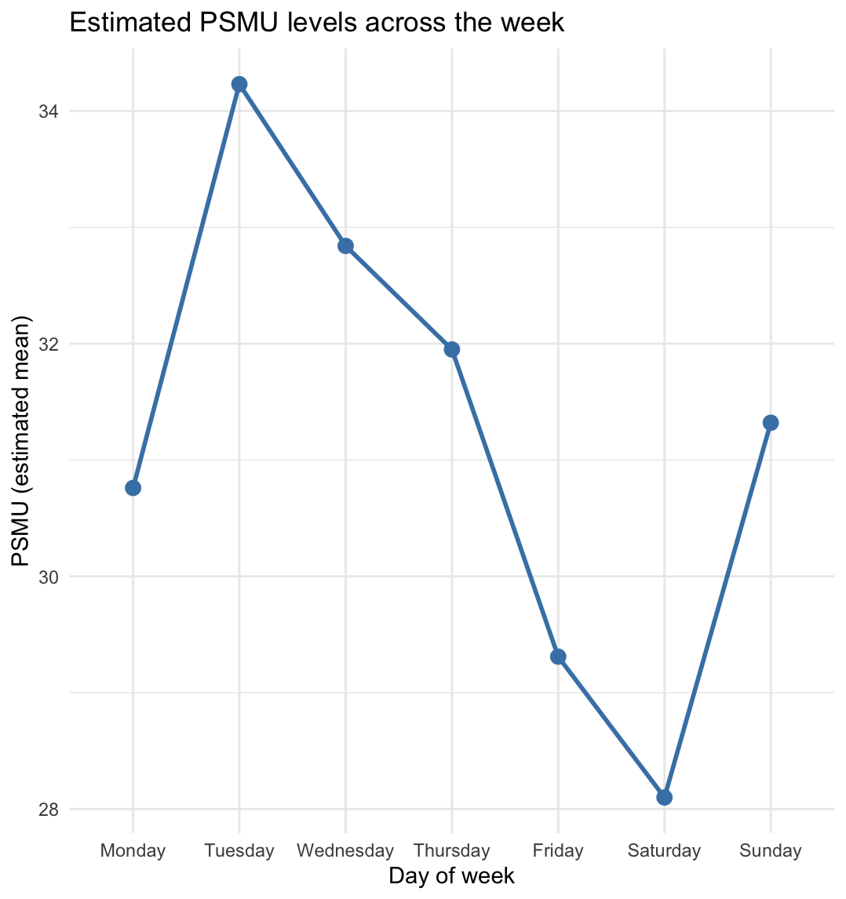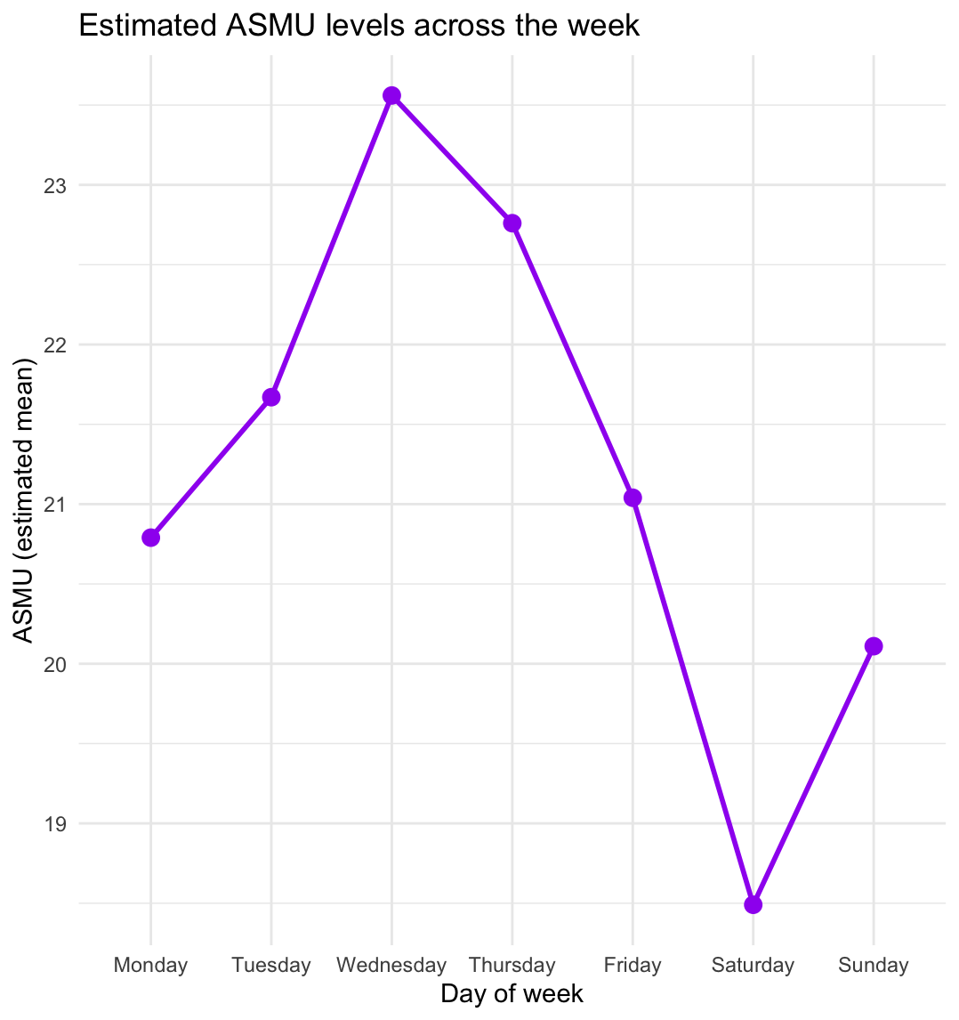
A B
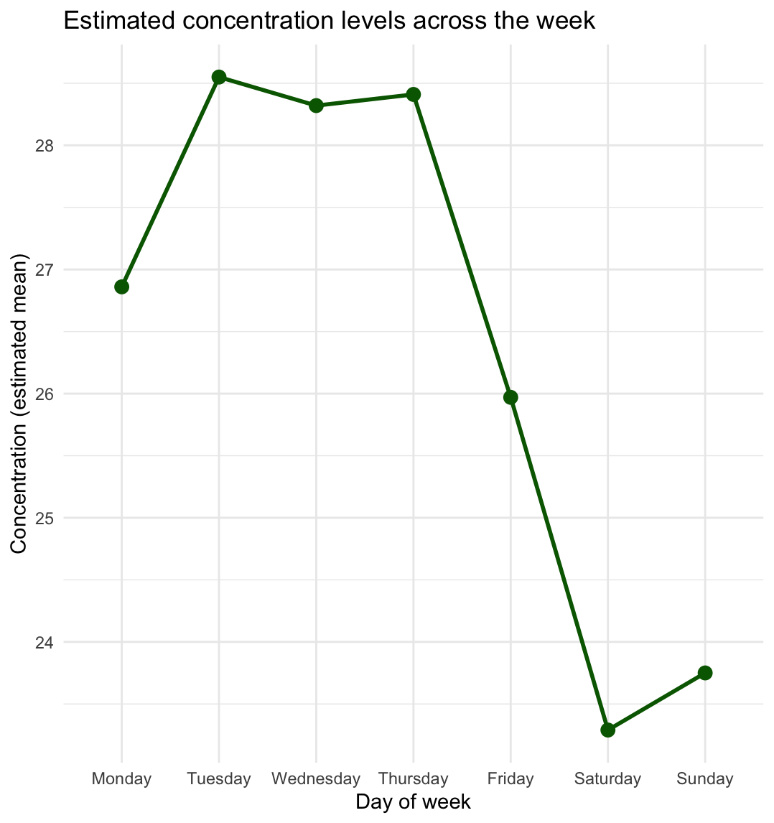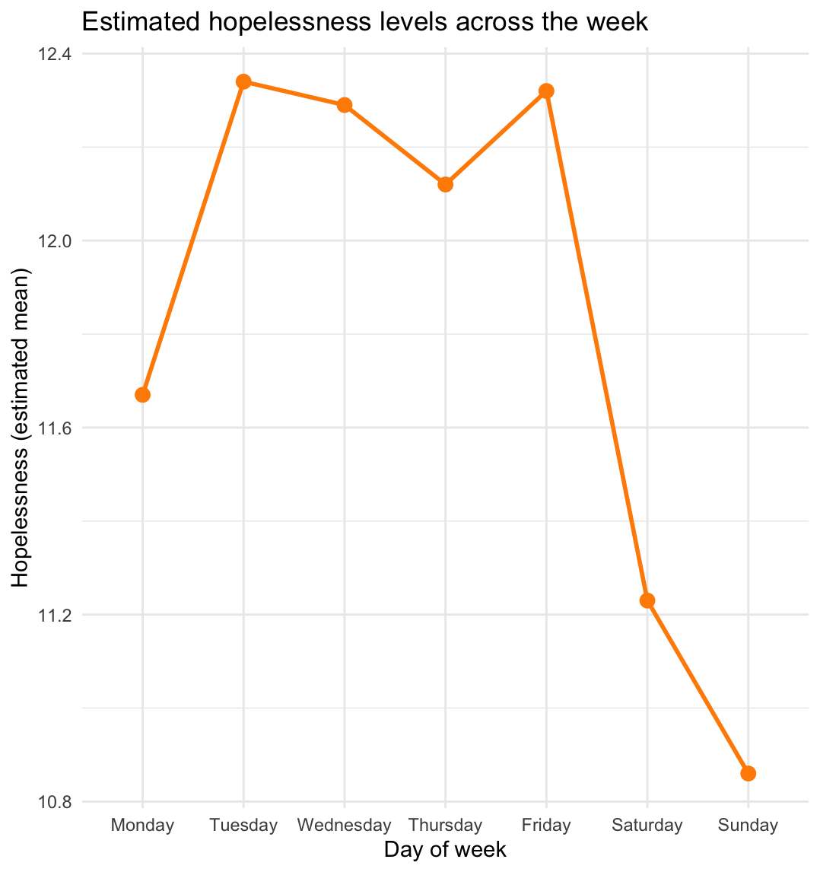
C D
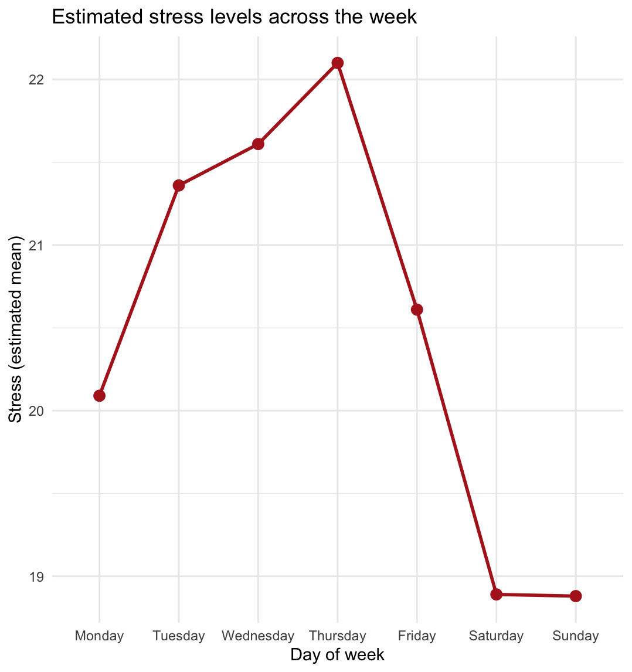
E
Table 2
Adjusted p-values for the linear mixed models after BH-correction
 | Adjusted P-values
Variable |  |  | p-value
Fatigue |  |  | 0.635
Depressed Mood |  |  | 0.201
Loneliness |  |  | 0.025*
Concentration |  |  | <.001***
Loss of Interest |  |  | 0.043*
Inferiority |  |  | 0.334
Hopelessness |  |  | 0.028*
Stress |  |  | <.001***
PSMU |  |  | <.001***
ASMU |  |  | <.001***

RQ2 - Moderation by time of day
Method:
To answer the question of whether time of day plays a role in the interaction between social media use and depression symptoms, the day was split in a dichotomous moderator with levels: daytime(t<=17:59) and evening (t=>18:00), resulting in 7009 early and 5236 late measurements.
To stay true to the analysis of the original paper, all variables were considered as both outcome and predictor variable. Where the original paper looked at all interactions between depressive symptoms and PSMU/ASMU, in the current analysis, the variables of interest were all in which PSMU or ASMU served as predictor or outcome, not looking at specific Because the mlVAR package used in the original study doesn’t support the inclusion of a moderating variable, the data was analysed by estimating mixed effect models by using the lme4 package in R with satterthwaite-corrected degrees of freedom and p-values.
Two network layers were analysed separately, being the contemporaneous and the temporal associations.
In the contemporaneous associations, predictor and outcome variable are compared by looking at the measurements taken at a same time interval (time predictor = time outcome).
With all correlations involving PSMU or ASMU and the 8 depression symptoms, being Depressed mood, concentration problems, stress, feelings of hopelessness, feeling inferior, loss of interest, loneliness and fatigue, this results in 34 models, also adding the predictive effect of PSMU on ASMU and ASMU on PSMU.
In the temporal condition the outcome variable would be predicted by a predictor that falls within one day of the outcome variable. (t-outcome=t predictor - (<=1day)). All computations result in 36 models, containing the same relations as in the contemporaneous associations, with addition of prediction of PSMU on subsequent PSMU and the same for ASMU.
All models contain a random intercept for each participant.
Effect sizes. Two complementary effect-sizes were computed for each interaction term. First, a standardised interaction coefficient (semi-partial β) was obtained by refitting the full model on z-scored continuous variables; this is directly comparable in scale and sign to mlVAR edge weights. Second, a partial R² for the interaction term was estimated as (R²full − R²reduced) / (1 − R²reduced), based on marginal R² from the performance package.

A false discovery rate Benjamini-Hochberg correction for multiple comparisons was done afterwards, to still account for confounding of other variables, as is done internally by the network analysis in the original study.
Simple slopes: all effects whose interaction term survived FDR correction, early and late simple slopes (with 95% asymptotic confidence intervals) were extracted using the emmeans package (emtrends function), permitting description of the direction and significance of the relationship within each time block.

Results:

Contemporaneous Moderation:
Thirty-four contemporaneous moderation models were fitted. After FDR correction, three interaction terms survived at q < .05 (see Table 3): PSMU - Fatigue (q = 5.99 × 10⁻⁵), PSMU - Active/ASMU (q = .004), and Fatigue - PSMU (q = .013). No other contemporaneous moderation terms survived correction. All remaining models returned qs ≥ .23.
Simple slopes were extracted for each significant interaction to characterise the direction and magnitude of the associations within each time block (see Table 4).
PSMU and Fatigue. During daytime, the contemporaneous association between PSMU and fatigue was effectively zero (β_early = −0.005, SE = 0.012, z = −0.43, p = .669). During late/evening beeps, a robust positive association emerged (β_late = 0.073, SE = 0.014, z = 5.12, p < .0001). An identical pattern appeared in the reverse regression direction (Fatigue -> PSMU): β_early = 0.006 (p = .652), β_late = 0.061 (p = .0001). The moderation interaction coefficient was β = 0.078 (β_std = 0.076, partial R² = .001) for the PSMU-predicting-Fatigue direction. These findings indicate that PSMU and fatigue co-occur specifically in the evening, with no detectable relationship during daytime assessment windows.
PSMU and ASMU. The positive contemporaneous association between PSMU and ASMU was significant in both time blocks (β_early = 0.274, p < .0001; β_late = 0.326, p < .0001), but was modestly amplified in the evening (interaction β = 0.052, β_std = 0.060, partial R² = .001). The association is therefore robust throughout the day, with a small but statistically reliable enhancement in the evening/night.
Table 3
Contemporaneous Moderation Results: Interaction of Predictor × Time Block (ordered by FDR-corrected q-value)
Predictor | Outcome | n | β | SE | t | p | q (FDR) | β_std | Partial R² | Sig.
PSMU | Fatigue | 8632 | .078 | .016 | 4.78 | < .001 | < .001 | .076 | .001 | x
PSMU | ASMU | 8632 | .052 | .014 | 3.68 | < .001 | .004 | .060 | .001 | x
Fatigue | PSMU | 8632 | .055 | .017 | 3.26 | .001 | .013 | .056 | < .001 | x
LossOfInt. | ASMU | 8632 | .035 | .016 | 2.21 | .027 | .230 | .036 | < .001 | 0
ASMU | LossOfInt. | 8632 | .033 | .016 | 2.10 | .036 | .245 | .032 | < .001 | 0
ASMU | Concentrat. | 8632 | −.028 | .016 | −1.70 | .090 | .340 | −.027 | < .001 | 0
PSMU | LossOfInt. | 8632 | .026 | .014 | 1.88 | .060 | .340 | .029 | < .001 | 0
ASMU | Inferior | 8632 | .015 | .008 | 1.79 | .074 | .340 | .024 | < .001 | 0
ASMU | PSMU | 8632 | .034 | .020 | 1.73 | .083 | .340 | .030 | < .001 | 0
Note. Only the nine models with the smallest q-values are shown; remaining 25 models all returned q ≥ .46. β = unstandardised interaction coefficient (Predictor × time_of_day_late); β_std = standardised interaction coefficient; Sig. = survived FDR correction (q < .05). LossOfInt. = loss of interest; Concentrat. = concentration problems; Inferior = feelings of inferiority.
Table 4
Simple Slopes for Significant Contemporaneous Moderation Effects
Edge | Time Block | Slope (β) | SE | z | 95% CI | p
PSMU → Fatigue | Early | −0.005 | 0.012 | −0.43 | [−0.029, 0.018] | .669
PSMU → Fatigue | Late | 0.073 | 0.014 | 5.12 | [0.045, 0.100] | < .001
PSMU → ASMU | Early | 0.274 | 0.010 | 27.53 | [0.254, 0.293] | < .001
PSMU → ASMU | Late | 0.326 | 0.012 | 27.58 | [0.302, 0.349] | < .001
Fatigue → PSMU | Early | 0.006 | 0.013 | 0.45 | [−0.020, 0.032] | .652
Fatigue → PSMU | Late | 0.061 | 0.015 | 4.03 | [0.032, 0.091] | < .001
Note. Slopes are unstandardised regression coefficients. Degrees of freedom were computed using asymptotic (z-based) inference due to sample size exceeding the pbkrtest and lmerTest limits (n = 8,632). CIs are asymptotic 95% confidence intervals.

Temporal Moderation:
Thirty-six temporal moderation models were fitted, covering all directed edges for which PSMU or ASMU was predictor or outcome. After Benjamini-Hochberg FDR correction, no interaction term survived (all qs = .99). Table 5 presents the full set of temporal moderation results. Raw p-values ranged from .041 (ASMU_lag1 -> ASMU effect) to .990, with the entire distribution shifted toward zero. Standardised interaction coefficients were small (|β_std| ≤ .040) and partial R² values were negligible (all < .001, many negative due to estimation noise around zero). The closest candidate, the autoregressive effect of ASMU (ASMU_lag1 -> Active, p = .041, q = .99, β_std = −.040), suggests that the carry-over of ASMU from one measurement to the next may be slightly attenuated in the evening relative to earlier in the day, but this did not withstand correction for multiple comparisons. None of the edges from the primary mlVAR temporal network showed evidence of time-of-day moderation.
Table 5
Temporal Moderation Results: Interaction of Predictor (Lag-1) × Time Block
Predictor | Outcome | n | β | SE | t | p | q (FDR) | β_std | Partial R²
PSMU | Fatigue | 6569 | .015 | .020 | 0.74 | .458 | .99 | .015 | < .001
ASMU | Fatigue | 6569 | −.022 | .023 | −0.96 | .339 | .99 | −.019 | < .001
PSMU | DeprMood | 6568 | .004 | .012 | 0.31 | .755 | .99 | .006 | < .001
ASMU | DeprMood | 6568 | .010 | .014 | 0.74 | .457 | .99 | .014 | < .001
PSMU | Loneliness | 6566 | .000 | .011 | −0.02 | .987 | .99 | .000 | < .001
ASMU | Loneliness | 6566 | .007 | .012 | 0.60 | .547 | .99 | .011 | < .001
PSMU | Concentrat. | 6564 | −.002 | .018 | −0.13 | .899 | .99 | −.003 | < .001
ASMU | Concentrat. | 6564 | −.005 | .021 | −0.25 | .800 | .99 | −.005 | < .001
PSMU | LossOfInt. | 6566 | .005 | .018 | 0.29 | .776 | .99 | .006 | < .001
ASMU | LossOfInt. | 6566 | −.016 | .021 | −0.76 | .448 | .99 | −.015 | < .001
PSMU | Inferior | 6566 | −.003 | .010 | −0.34 | .734 | .99 | −.006 | < .001
ASMU | Inferior | 6566 | −.005 | .011 | −0.50 | .614 | .99 | −.009 | < .001
PSMU | Hopeless | 6567 | −.004 | .011 | −0.38 | .702 | .99 | −.007 | < .001
ASMU | Hopeless | 6567 | −.009 | .012 | −0.74 | .462 | .99 | −.014 | < .001
PSMU | Stress | 6569 | .009 | .015 | 0.61 | .543 | .99 | .012 | < .001
ASMU | Stress | 6569 | −.018 | .018 | −1.02 | .306 | .99 | −.020 | < .001
PSMU | PSMU (AR) | 6567 | −.003 | .022 | −0.16 | .876 | .99 | −.003 | < .001
ASMU | PSMU | 6567 | −.003 | .025 | −0.13 | .900 | .99 | −.003 | < .001
PSMU | ASMU | 6566 | .026 | .017 | 1.51 | .132 | .99 | .030 | < .001
ASMU | ASMU (AR) | 6565 | −.040 | .020 | −2.04 | .041 | .99 | −.040 | < .001
Fatigue | PSMU | 6567 | .030 | .022 | 1.35 | .177 | .99 | .030 | < .001
DeprMood | PSMU | 6567 | −.001 | .035 | −0.03 | .972 | .99 | −.001 | < .001
Loneliness | PSMU | 6567 | .030 | .037 | 0.79 | .429 | .99 | .017 | < .001
Concentrat. | PSMU | 6567 | .000 | .025 | −0.01 | .990 | .99 | .000 | < .001
LossOfInt. | PSMU | 6567 | −.002 | .025 | −0.07 | .941 | .99 | −.002 | < .001
Stress | ASMU | 6566 | .042 | .022 | 1.91 | .056 | .99 | .038 | < .001
Fatigue | ASMU | 6566 | .016 | .017 | 0.95 | .342 | .99 | .019 | < .001
Loneliness | ASMU | 6566 | .031 | .029 | 1.06 | .289 | .99 | .021 | < .001
Note. β = unstandardised interaction coefficient (Predictor_lag1 × time_block_lag1late); β_std = standardised interaction coefficient; AR = autoregressive effect; Concentrat. = concentration problems; LossOfInt. = loss of interest; Inferior = feelings of inferiority; Hopeless = hopelessness; DeprMood = depressed mood. All q-values reflect Benjamini-Hochberg FDR correction within the temporal family. Partial R² values < .001 reflect estimation noise around zero.

RQ3 - Factor Analysis
To answer our third research question whether the items on the questionnaire could be structured into factors, the R-package ‘lavaan’ was used for an exploratory factor analysis (EFA).
Because measurements were collected at multiple timepoints, participant-level means were calculated for the seven items measuring depression symptoms: Depressed Mood, Fatigue, Loneliness, Inferiority, Concentration, Hopelessness, and Loss of Interest.
To check if the dataset was suitable for a factor analysis, a Kaiser-Meyer-Olkin (KMO) test in combination with a Bartlett’s test of sphericity was performed. The KMO measure tests the sampling adequacy by comparing simple correlations and partial correlations between the variables. Bartlett’s test of sphericity essentially tests whether the correlation matrix differs significantly enough from an identity matrix. A significant p-value indicates that the dataset is suitable to continue a factor analysis.
Parallel analysis was used to determine the number of factors to retain. After that, the maximum likelihood factor analysis with a cut-off point of .40 and the Kaiser’s criterion of eigenvalues greater than 1 was performed. Because the underlying psychological constructs were expected to be correlated, an oblique rotation was applied.
Results The seven items were subjected to an exploratory factor analysis (EFA) with promax rotation. The KMO measure verified the sampling adequacy for the analysis, KMO = 0.87. Bartlett’s test of sphericity χ2 (21) = 1021.38, p <.001, indicating that the correlation structure is adequate for factor analyses.
Firstly, the parallel analysis and inspection of the scree plot suggested the retaining of two factors (See Figure). The maximum likelihood factor analysis also pointed to a two-factor solution as the best fit for the data, accounting for 83.0% of the total variance. The results of this factor analysis are presented in Table 6.
Factor 1 had an eigenvalue of 3.52 and accounted for 50.2% of the variance. This factor was characterized by high loadings for the items measuring Depressed Mood (0.87), Loneliness (0.94), Inferiority (1), and Hopelessness (0.92). Factor 2 had an eigenvalue of 2.29 and accounted for 32.7% of the variance. This item was characterized by high loadings for the items measuring Fatigue (0.93), Concentration (0.86), and Loss of Interest (0.81).
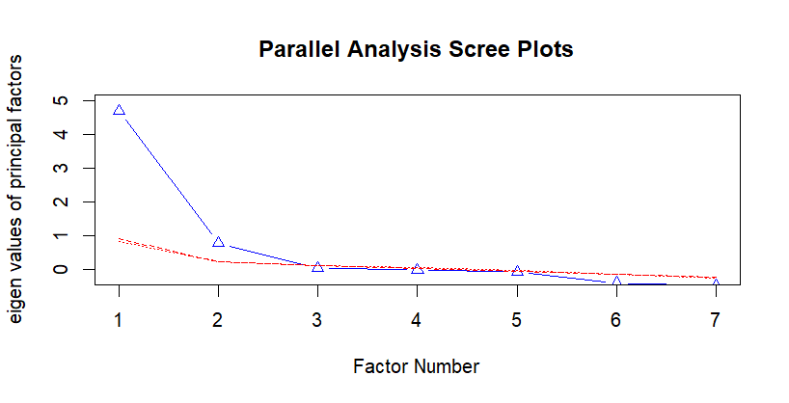
Figure
Parallel Analysis Scree Plot for Factor Retention

Variable | Factors
 | Factor 1 | Factor 2 | Uniqueness
Fatigue | -0.13 | 0.93 | 0.26
Depressed Mood | 0.87 | 0.14 | 0.08
Loneliness | 0.94 | 0 | 0.08
Concentration | 0 | 0.86 | 0.17
Loss of Interest | 0.10 | 0.81 | 0.24
Inferiority | 0.999 | -0.12 | 0.13
Hopelessness | 0.921 | 0 | 0.10

Table 6.
Factor Loadings and Uniqueness Values From the Exploratory Factor Analysis (EFA)

Discussion

RQ1(Day of the Week) We started with investigating the temporal aspects of the depression symptoms and social media usage. The repeated measures mixed-effects model suggested a main effect of the day of the week and an interaction effect between the scores (depression symptoms and social media usage) and the day of the week; this indicates that there are temporal differences in the data and that the scores can differ between days.
After fitting linear mixed models for all the variables separately, the results suggest a general decrease on the weekend. Significant results were found for concentration, stress, hopelessness, active and passive social media usage. These models share a similar trend: higher scores on week days and a decrease on weekend days. Not all the differences between the days are significant but the data clearly suggests a pattern and the differences are rather small. Although the models of loneliness and loss of interest were significant, they did not show any significant differences between days.
The decrease in depressive symptoms found in the research Fritz et al. (2010) and Luo et al. (2024) is further confirmed by our results (H1), but the the decrease in social media usage (passive and active) is not in accordance with the results of You et al. (2023) and Reardon et al. (2022) who found an increase on weekend days (H2). These contradictory findings cannot be explained by a difference in sample or measurement as they all used adolescents and self reported-measures, further research is necessary to explain these results.
RQ2 (Time of day moderation)
This secondary analysis of the Aalbers et al. (2018) dataset found that the temporal network of social media use and depression symptoms is statistically homogeneous across early and late periods of the day, replicating the robustness of the original findings. However, contemporaneous associations involving PSMU and fatigue were significantly moderated by time of day, emerging as a strong positive co-occurrence in the evening while being effectively absent during daytime. This evening specificity adds a meaningful refinement of the original contemporaneous network, with potential implications for understanding the contexts in which passive social media use and fatigue co-occur in daily life.
RQ3 (Factor Analysis) Our third objective was to investigate whether the items on the scale used by Aalbers et al. could be explained by fewer, underlying dimensions. Using factor analysis we found that the seven items measuring depression symptoms are best represented by a two-factor structure. The first factor appears to reflect an affective/cognitive dimension of depression, including depressed mood, loneliness, inferiority, and hopelessness. The second factor included fatigue, concentration problems and loss of interest and can be interpreted as a somatic/motivational dimension. The observation of these two factors aligns with previous research demonstrating that depressive symptomatology can be accurately explained by symptom domains or latent constructs (Beck et al 1961; Schafer 2006). Contrary to our findings, meta-analytic evidence (Schafer, 2006) suggests that besides the presence of a ‘General Depression’ / ‘Negative affect’ factor and a ‘Somatic’ factor, also a ‘Positive Affect’ factor exists. The absence of this third factor in current factor analysis can be explained through the fact that the online questionnaire of Aalbers et al. did not include any questions with regards to positive affect, or the lack of it (f.i. an item measuring ‘feeling happy’).
In sum, present findings support the evidence that depression is a multidimensional construct. Moreover, these findings support the construct validity of the questionnaire used by Aalbers et al. in their study.

Bibliography
Aalbers, G., McNally, R. J., Heeren, A., De Wit, S., & Fried, E. I. (2018). Social media and depression symptoms: A network perspective. Journal of Experimental Psychology General, 148(8), 1454–1462. https://doi.org/10.1037/xge0000528
Beck, A. T., Ward, C. H., Mendelson, M., Mock, J., & Erbaugh, J. (1961). An inventory for measuring depression. Archives of General Psychiatry, 4(6), 561–571. https://doi.org/10.1001/archpsyc.1961.01710120031004
Fritz, C., Sonnentag, S., Spector, P. E., & McInroe, J. A. (2010). The weekend matters: Relationships between stress recovery and affective experiences. Journal of Organizational Behavior, 31(8), 1137–1162. https://doi.org/10.1002/job.672
Lemola, S., Perkinson-Gloor, N., Brand, S., Dewald-Kaufmann, J. F., & Grob, A. (2015). Adolescents’ Electronic Media Use at Night, Sleep Disturbance, and Depressive Symptoms in the Smartphone Age. Journal of Youth and Adolescence, 44(2), 405-418. https://doi.org/10.1007/s10964-014-0176-x
Luo, Z., Wang, T., Wu, W., Yan, S., & Chen, L. (2024). Association between weekend catch-up sleep and depressive symptoms in American adults: Finding from NHANES 2017–2020. Journal of Affective Disorders, 354, 36–43. https://doi.org/10.1016/j.jad.2024.03.008
Pirdehghan, A., Khezmeh, E., & Panahi, S. (2021). Social Media Use and Sleep Disturbance among Adolescents: A Cross-Sectional Study. Iranian Journal of Psychiatry, 16(2), 137-145. https://doi.org/10.18502/ijps.v16i2.5814
Reardon, A., Lushington, K., & Agostini, A. (2022). Adolescent sleep, distress, and technology use: weekday versus weekend. Child and Adolescent Mental Health, 28(1), 108–116. https://doi.org/10.1111/camh.12616
Shafer, A. B. (2006). Meta-analysis of the factor structures of four depression questionnaires: Beck, CES-D, Hamilton, and Zung. Journal of Clinical Psychology, 62(1), 123–146. https://doi.org/10.1002/jclp.20213
You, Y., Yang-Huang, J., Raat, H., & Van Grieken, A. (2023). Factors of heavy social media use among 13-year-old adolescents on weekdays and weekends. World Journal of Pediatrics, 19(4), 378–389. https://doi.org/10.1007/s12519-023-00690-1

