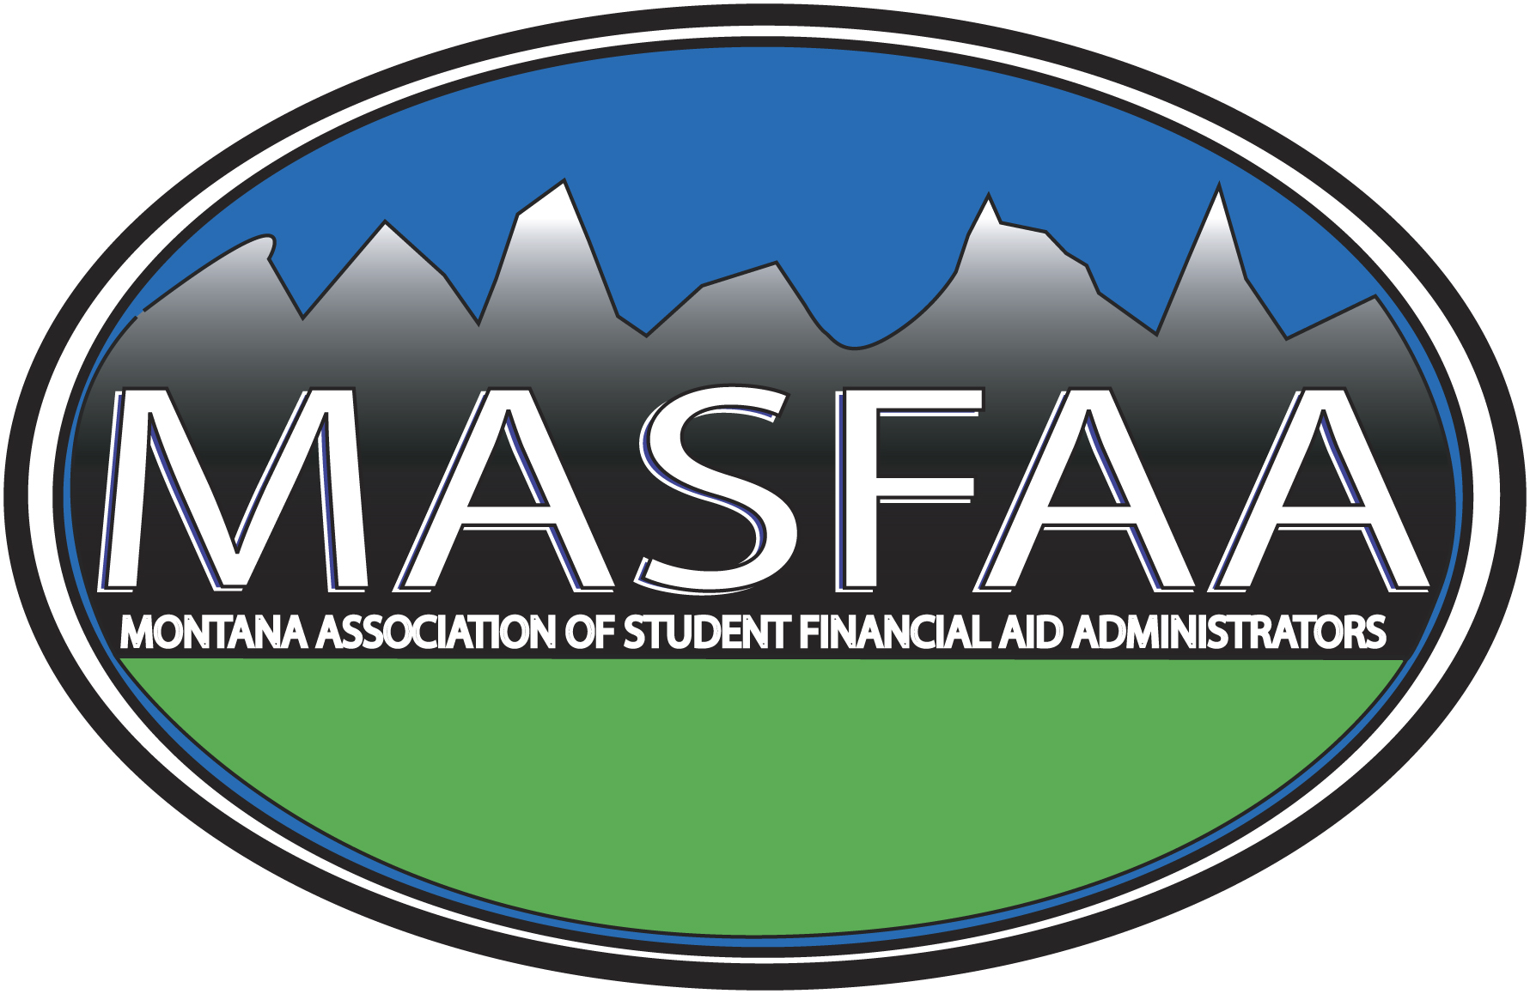

2018 ANNUAL MEMBERSHIP APPLICATION
ASSOCIATE MEMBERSHIP

Please provide the following information about your organization:

Organization Name__________________________________________________________________

Mailing Address_____________________________________________________________________

City, State, Zip______________________________________________________________________

Telephone Number__________________________________________________________________

FAX Number________________________________________________________________________

Organization's Web Address_________________________________________________________

Please list the names, titles, and e-mail addresses of the individuals of your organization who will be MASFAA associate members:

NAME TITLE E-MAIL

_____________________________________________________________________________________

_____________________________________________________________________________________

_____________________________________________________________________________________

_____________________________________________________________________________________

_____________________________________________________________________________________

________# of associate members @ $80 each TOTAL DUE $__________

Please return this application with the appropriate amount payable by March 1, 2018 to:

MASFAA
c/o Emily Linn
University of Providence
Financial Aid Office
1301 20th Street South
Great Falls, MT 59405
(406) 7915239
(406) 791-5209 FAX
Emily.Linn@uprovidence.edu

