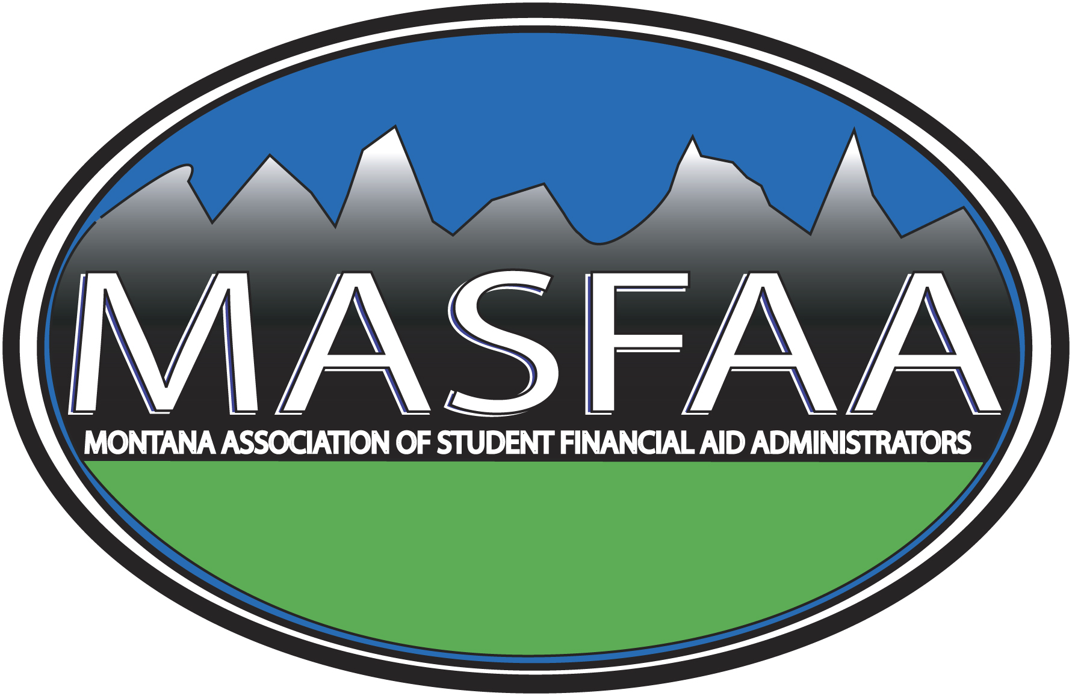
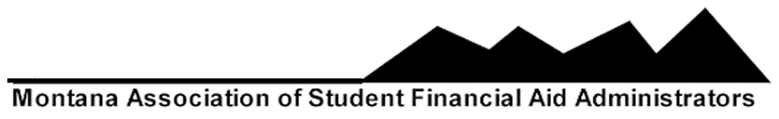
2017 ANNUAL MEMBERSHIP APPLICATION
ASSOCIATE MEMBERSHIP

Please provide the following information about your organization:

Organization Name__________________________________________________________________

Mailing Address_____________________________________________________________________

City, State, Zip______________________________________________________________________

Telephone Number__________________________________________________________________

FAX Number________________________________________________________________________

Organization's Web Address_________________________________________________________

Please list the names, titles, and e-mail addresses of the individuals of your organization who will be MASFAA associate members:

NAME TITLE E-MAIL

_____________________________________________________________________________________

_____________________________________________________________________________________

_____________________________________________________________________________________

_____________________________________________________________________________________

_____________________________________________________________________________________

________# of associate members @ $55 each TOTAL DUE $__________

Please return this application with the appropriate amount payable by March 1, 2017 to:

MASFAA
c/o Sandy Johnsrud
Montana State University-Northern
Financial Aid Department
PO Box 7751
Havre, MT 59501
(406) 265-3787
(406) 265-3519 FAX
sandy.johnsrud@msun.edu

