
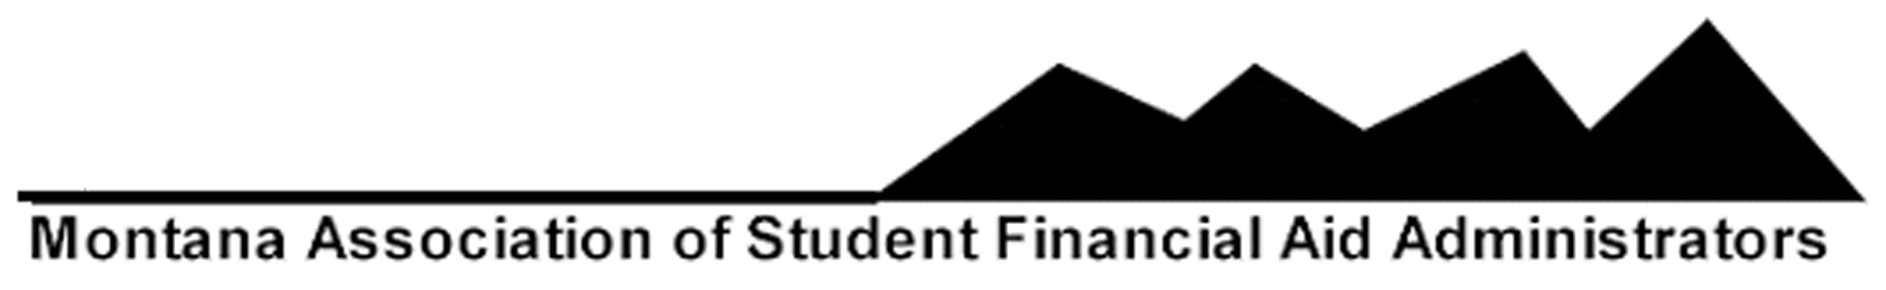
2017 ANNUAL MEMBERSHIP APPLICATION
INSTITUTIONAL MEMBERSHIP

Please provide the following information about your institution:

School Name________________________________________________________________________

Mailing Address_____________________________________________________________________

City, State, Zip______________________________________________________________________

Telephone Number__________________________________________________________________

FAX Number________________________________________________________________________

School's Web Address_______________________________________________________________

Please indicate the total unduplicated headcount of full and part-time students enrolled in 2015-2016. This number can be found on your 2015 FISAP, Part II, Section D, Line 7 A and B.

2015-2016 UNDUPLICATED HEADCOUNT___________________

Based on the number listed above, place an "X" before the appropriate category listed below, to determine the amount due in the last column:

CATEGORY AMOUNT DUE

_____Enrollment under 999 $ 30
_____Enrollment 1000-2999 $ 60
_____Enrollment 3000-4999 $ 90
_____Enrollment 5000-7499 $ 120
_____Enrollment over 7500 $ 150

AMOUNT DUE $ _____________

PLEASE COMPLETE THE BACK SIDE OF THIS APPLICATION!!!!!

2017 ANNUAL MEMBERSHIP APPLICATION
INSTITUTIONAL MEMBERSHIP

Please indicate or attach the name, title, telephone number, year MASFAA membership started and e-mail address of ALL your staff members:

NAME TITLE TELEPHONE E-MAIL YEAR MEMBERSHIP STARTED

_____________________________________________________________________________________

_____________________________________________________________________________________

_____________________________________________________________________________________

_____________________________________________________________________________________

_____________________________________________________________________________________

_____________________________________________________________________________________

_____________________________________________________________________________________

_____________________________________________________________________________________

_____________________________________________________________________________________

_____________________________________________________________________________________

Please complete BOTH SIDES of this application and return it with the appropriate amount payable by March 1, 2017 to:

MASFAA
c/o Sandy Johnsrud
Montana State University-Northern
Financial Aid Department
PO Box 7751
Havre, MT 59501
(406) 265-3787
(406) 265-3519 FAX
sandy.johnsrud@msun.edu

