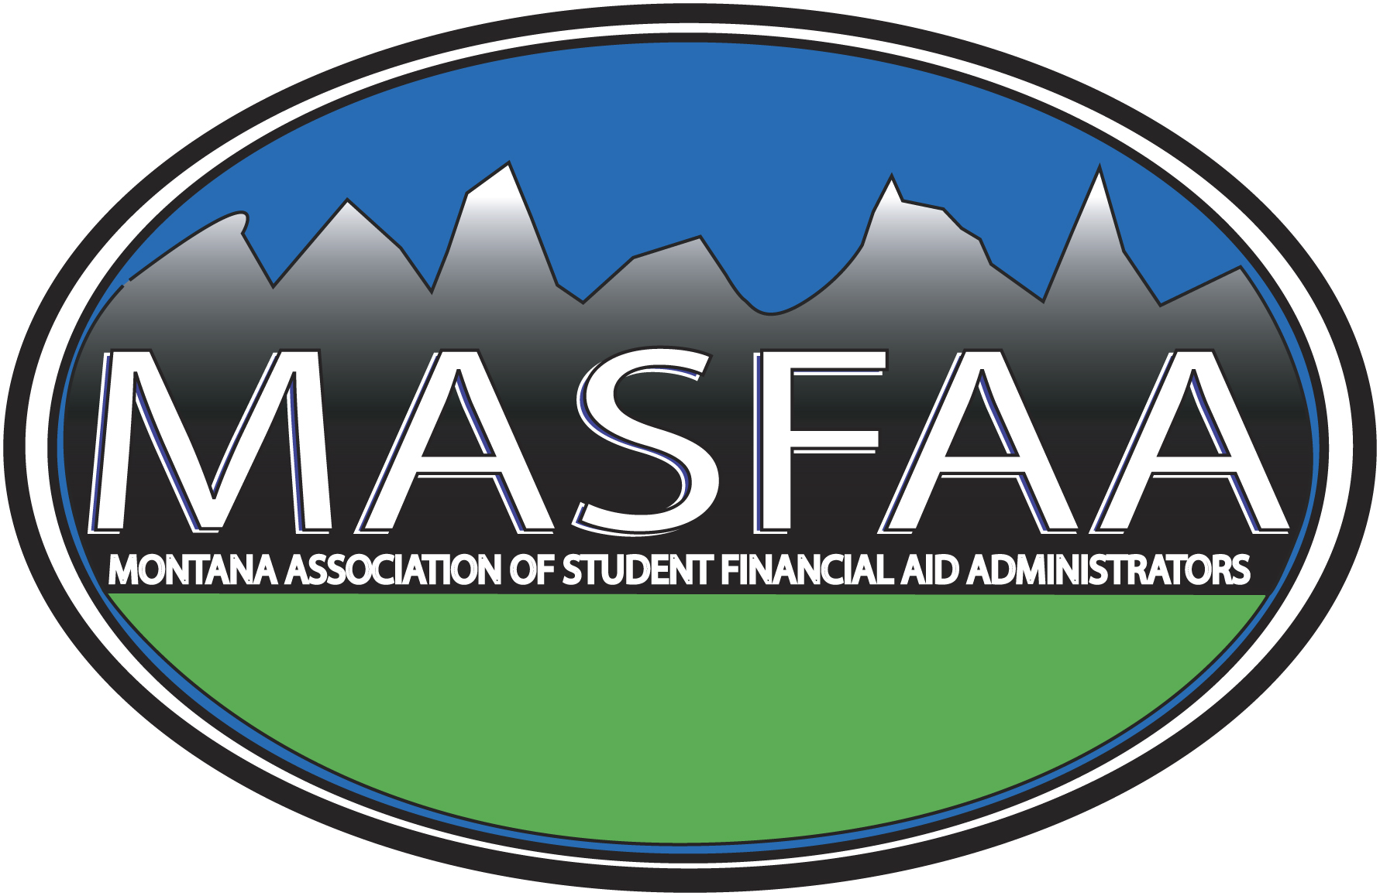
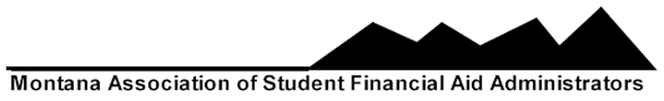

MASFAA Financial Aid Professional of the Year Award

The MASFAA By-laws state: The Financial Aid Professional of the Year – An award to recognize a professional who has contributed to the financial aid profession in Montana in ways that often go unnoticed but without their contribution our profession and service to our students would be severely impacted. Nominations will be solicited from the membership. The Financial Aid Professional of the Year will receive a plaque and the possibility to receive up to a $1000 professional development grant.

Recipients to date:

2006-2007 Janet Riis, Carroll College
2007-2008 Terri Gruba, The University of Montana
2008-2009 Leah Habel, Montana State University of Great Falls
2009-2010 Tina Wagner, Carroll College
2010-2011 Valerie Curtin, Helena College University of Montana
2011-2012 Ricki Jones, The University of Montana Western
2012-2013 Rita Larby, Montana State Univeristy-Bozeman
2013-2014 Leslie Olsen, Carroll College
2014-2015 Connie Bowman, University of Montana
2015-2016 Tom Steigers, University of Montana

