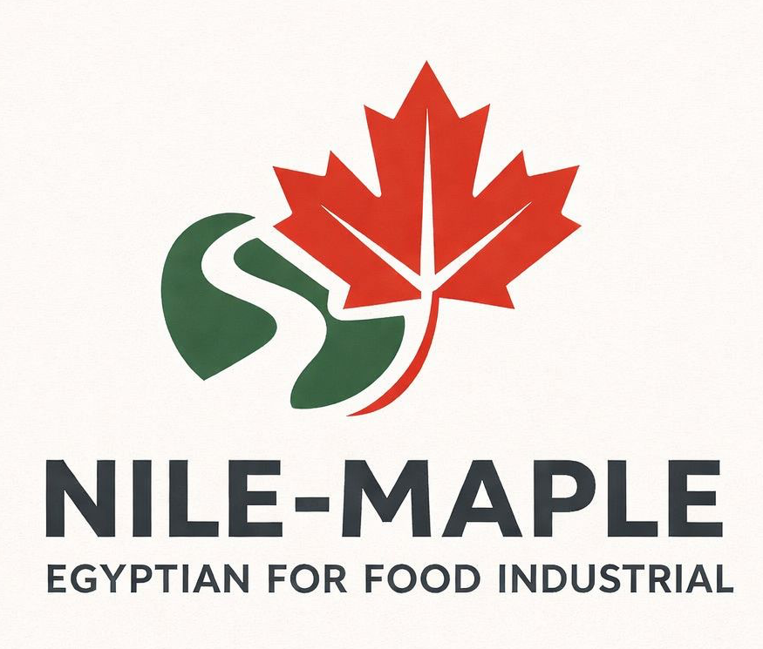
Company Profile
Egyptian Import and Export of Food and Agricultural Products
  Fresh Fruits | 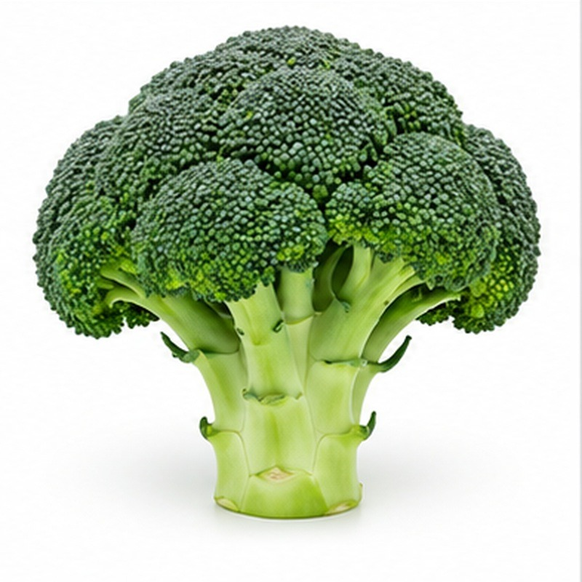  Fresh Vegetables
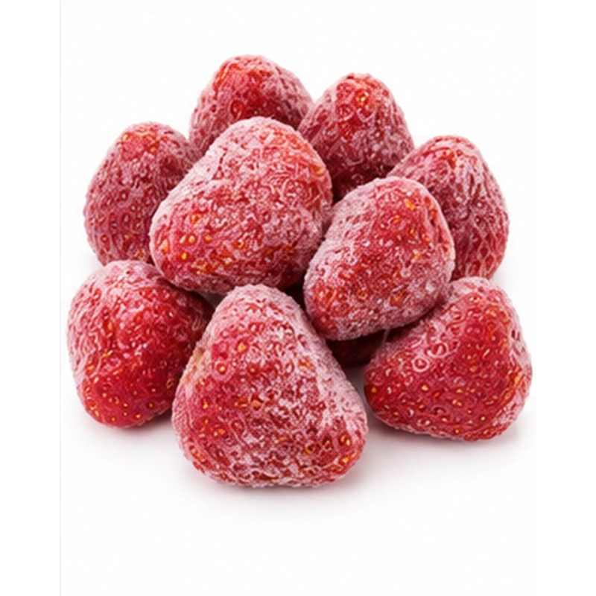  Frozen Products | 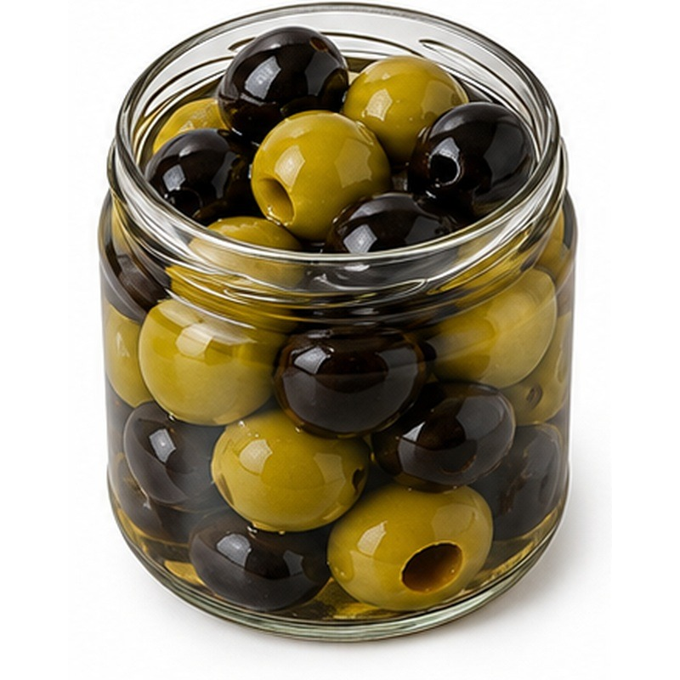  Processed and Canned Products
Flexible sourcing • Export-ready handling • Buyer-specific solutions

ABOUT US

A practical partner for international food trade
Nile-Maple is an Egyptian import and export company focused on food and agricultural products. We connect reliable sources with buyers seeking consistent products, practical commercial terms, flexible packaging and dependable shipment coordination.
Our portfolio covers fresh fruits, fresh vegetables, frozen products, and manufactured, processed and canned foods. This breadth allows buyers to work with one commercial partner across seasonal, temperature-controlled and shelf-stable product programmes.
We work closely with growers, packing facilities, processors, logistics providers and customers to align specifications before shipment. Product availability, grade, pack style, labelling, treatment and transport method are confirmed according to the destination market and the buyer's requirements. Products are supplied under the Nile-Maple name and label, while packaging and packing configurations can be customized upon request after feasibility and compliance review.

Our purpose
To make international sourcing straightforward by combining Egyptian supply capability with responsive commercial service, controlled product handling and clear export coordination.
One commercial partner  A coordinated point of contact from product selection and quotation through packing and shipment. | Flexible sourcing  Seasonal and buyer-specific sourcing across fresh, frozen and shelf-stable categories.
Export-focused execution  Attention to specifications, packing, documents, transport conditions and destination requirements. | Long-term relationships  Clear communication and practical solutions designed to support repeat business.

OUR HISTORY

From focused sourcing to a diversified export portfolio
Nile-Maple was established as a family-led trading business with a clear objective: to connect Egyptian food and agricultural production with international buyers through organised sourcing and dependable service.
The company's work developed from fresh produce opportunities into a broader portfolio. Fresh fruits and vegetables remain central to our identity, while frozen foods and manufactured, processed and canned products allow us to support year-round demand and a wider range of retail, wholesale and food-service requirements.
As the portfolio expanded, the operating model also became more structured. Product catalogues, specifications, packaging options, shipment planning and buyer communication are organised so that each enquiry can move from initial discussion to a clear commercial offer.

Our development
Stage | Development
Foundation | Family-led Egyptian trading and sourcing.
Portfolio growth | Expansion across four complementary food divisions.
Export readiness | Greater focus on specifications, packaging and documentation.
Market development | Building relationships with buyers, suppliers and logistics partners.

OUR WORK

Four product divisions built around buyer needs
Our product range is organised by handling method and supply chain. Each division is supported by product-specific selection, packing, storage and transport considerations.
Division | Typical product range | Primary handling focus
Fresh Fruits | Citrus, mangoes, grapes, pomegranates, strawberries, dates, melons, stone fruits and other seasonal lines. | Freshness, maturity, calibre, appearance and cold-chain planning.
Fresh Vegetables | Potatoes, onions, garlic, tomatoes, peppers, artichokes, leafy vegetables, legumes and specialty produce. | Harvest condition, sorting, ventilation, temperature and pack strength.
Frozen Products | IQF fruits, vegetables, herbs, mixed vegetables and buyer-specific blends. | Rapid freezing, stable frozen storage, product separation and uninterrupted cold chain.
Processed and Canned Products | Canned vegetables and fruits, pickles, olives, sauces, juices, jams, spreads and pantry products. | Recipe specification, fill weight, thermal processing, sealing, shelf life and labelling.

HOW WE WORK

A controlled path from enquiry to delivery
Each order begins with a clear understanding of the product, market and commercial requirements. We then coordinate the relevant supply, packing and logistics steps while keeping the buyer informed.
1 | Buyer enquiry | Product, quantity, destination, timing and required terms.
2 | Sourcing | Supplier availability, season, specification and packing capability.
3 | Offer confirmation | Price basis, pack format, lead time and shipment method.
4 | Product preparation | Sorting, processing, packing, labelling and agreed treatments.
5 | Quality review | Checks against the confirmed specification and packing requirements.
6 | Shipment coordination | Transport booking, export documents and delivery follow-up.

Commercial flexibility
Depending on the product and order programme, we can discuss customized packaging and packing, mixed-product container planning, air or sea freight, and retail or food-service packs. For ocean freight, the number of pallets follows the applicable standard container-loading plan and is not customizable. A requested container configuration or product mix must first be reviewed by Nile-Maple and remains subject to operational feasibility and availability.

QUALITY

Quality is managed through specification and product care
For Nile-Maple, quality is not a general promise; it is the result of clear specifications, appropriate handling and careful coordination at each stage. Requirements are agreed before supply is prepared so that the product, pack and shipment method are suitable for the destination and intended use.
Supplier and facility selection  We seek sources capable of meeting the product, hygiene, packing and traceability requirements of the order. | Product specification  Variety, grade, size, maturity, cut, recipe, net weight and tolerances are confirmed as applicable.
Handling controls  Temperature, ventilation, freezing, preservation and storage conditions are matched to the product. | Packing integrity  Packaging is selected to protect the product through handling, loading, transit and final delivery.
Pre-shipment review  Product and packing details are checked against the approved order before dispatch. | Clear records  Nile-Maple labels, packing information and shipment documents are prepared in line with the agreed commercial requirements.

Quality commitments
- Provide accurate product and packing information before order confirmation.
- Protect product condition through appropriate storage and transport planning.
- Communicate material changes in availability, specification or timing promptly.
- Work toward consistent supply and continuous improvement with every programme.

EXPORT CAPABILITY

Packaging logistics and documentation
International food trade depends on more than the product itself. Nile-Maple coordinates the practical details that help an order move efficiently from source to destination.

Packaging and presentation
- Export cartons, baskets, bags, trays, punnets, jars, cans, drums or bulk formats according to the product.
- All products are supplied under the Nile-Maple name and label.
- Packaging, packing or filling format, net weight, count and pack configuration can be customized upon customer request, subject to feasibility and destination requirements.
- For ocean freight, pallet numbers follow the applicable standard container-loading plan and are not customizable.
- Container loading configuration or product mix may be adapted only after Nile-Maple reviews the request and confirms operational feasibility and availability.

Logistics coordination
- Air freight for suitable high-value or time-sensitive fresh products.
- Sea freight for refrigerated, frozen and ambient container programmes.
- Temperature and ventilation planning appropriate to the commodity and transit period.
- Coordination with freight forwarders, carriers, packers and receiving parties.

Export documentation
- Commercial invoice and packing list.
- Certificate of origin and product-specific certificates when required and available.
- Transport documents and buyer-requested supporting information.
- Documentation requirements confirmed for the destination and agreed trade terms.

OUR PROGRESS

A growing platform built for repeat business
Nile-Maple's progress is reflected in the breadth and organisation of its offer.
The company now presents a structured portfolio across four product divisions. Product-specific information covers forms, handling, packing and storage.
This wider capability allows us to respond to different buyer profiles and purchasing cycles: seasonal fresh programmes, year-round frozen lines, and shelf-stable processed products. It also supports conversations with importers, distributors, wholesalers, retailers and food-service customers.
We measure good performance through responsiveness, accurate offers, realistic commitments, controlled product handling and the ability to develop lasting commercial relationships. Our focus is steady, responsible growth rather than claims that cannot be supported by the requirements of each individual shipment.

Why buyers work with Nile-Maple
Broad portfolio  Four complementary product divisions from fresh produce to shelf-stable foods. | Responsive service  Direct communication and quick clarification of specifications and commercial details.
Flexible solutions  Customer-requested packaging and packing options adapted to the programme after feasibility review. | Practical export knowledge  Attention to quantities, palletisation, trade terms, documents and destination needs.

CONTACT INFORMATION

Contact Nile-Maple
Buyers, distributors and commercial partners can contact Nile-Maple through the channels below for product availability, specifications, quotations, packaging options and export enquiries.
Company email | contact@nilemaple.com
Phone | +20 1515919135
Business WhatsApp | +20 1515919135
Instagram | @nilemaple2025
Facebook | Nile-Maple Facebook page

Website visibility requirement
The company email, telephone number and Business WhatsApp number must be visible in both the header and footer of every website page. Instagram and Facebook links must also appear in the footer and on the Contact page. Phone, WhatsApp, email and social icons should be clickable on desktop and mobile devices.
English logo |   Arabic logo

WEBSITE LANGUAGES

English Arabic and French content
A clearly visible language selector must appear at the top of every website page. The selector must allow visitors to switch between English, Arabic and French without returning to the home page.
English  Default left-to-right international version. | العربية  Full right-to-left Arabic version with suitable Arabic typography. | Français  Complete French version for French-speaking buyers and markets.

Multilingual content requirement
All core website content must be available in the three languages. This includes navigation, About Us, company history, quality information, FAQ, contact details, enquiry-form labels, confirmation messages and legal pages.
Every product must also be available in English, Arabic and French. Product names, descriptions, varieties or forms, handling information, packaging, storage guidance and relevant availability notes must be translated consistently.

Language selector requirements
- Position the selector in the main header where it remains visible on desktop and mobile.
- Use clear labels: English, العربية and Français.
- Keep visitors on the equivalent page when they change language.
- Apply right-to-left layout throughout the Arabic version.
- Use editable translation fields so product and page translations can be maintained separately.

WEBSITE STRUCTURE

Pages and navigation
The website should provide simple navigation for buyers while giving enough space to present the full Nile-Maple portfolio and export capabilities.
Page | Purpose
Home | Company introduction, product divisions, key strengths and direct enquiry actions.
About Us | Company story, leadership, work, quality approach, progress and vision.
Products | Main product hub divided into Fresh Fruits, Fresh Vegetables, Frozen Products, and Manufactured, Processed and Canned Products.
Product detail pages | Individual products with image, multilingual description, forms or varieties, handling, packaging and storage information.
Contact | Phone, WhatsApp, email, social links and the enquiry form.
FAQ | Common questions about products, quantities, Nile-Maple branding, packaging customization, payment, documents, freight and lead times.

Recommended supporting pages
- Quality and Handling
- Packaging and Logistics
- Seasonal Availability Calendar
- Export Documentation
- Privacy Policy
- Terms and Conditions

WEBSITE ENQUIRY FORM

Send us a message
The Contact page must include a professional message form. When a visitor submits the form successfully, the full enquiry must be delivered to contact@nilemaple.com.
Form field | Requirement
Full name | Required
Email address | Required and validated
Phone or WhatsApp | Optional
Company and country | Recommended
Subject | Required
Product of interest | Recommended selectable field
Message or enquiry details | Required
Consent checkbox | Required where applicable for privacy compliance

Submission and delivery requirements
- Use a clear Send Message or Get in Touch button.
- Send submissions securely through the website server or a trusted mail service to contact@nilemaple.com.
- Show a clear success confirmation after delivery and a useful error message if delivery fails.
- Use spam protection, field validation and rate limiting without making the form difficult for genuine buyers.
- Do not expose the company mailbox password or mail-service credentials in website code.
- Make the form fully responsive and available in English, Arabic and French.

LEADERSHIP AND VISION

Family leadership with an international outlook
Nile-Maple combines founder-led direction with hands-on commercial management. Decisions remain close to the customer, allowing enquiries, specifications and operational issues to be addressed directly and efficiently.
Eng. Issa Abousheloua  Founder and Owner | Provides the company's strategic direction and long-term commercial vision.
Eng. Omar Issa  Co-Founder and Executive Manager | Leads buyer communication, commercial development and day-to-day export coordination.

Our vision
To develop Nile-Maple into a trusted international trading partner recognised for reliable Egyptian sourcing, responsive service, consistent product care and commercially practical solutions.

Our direction
- Strengthen relationships with qualified producers, packers and processors.
- Expand access to international buyers and destination markets responsibly.
- Develop clearer product specifications and more efficient order coordination.
- Build repeat programmes based on consistency, transparency and mutual value.
NILE-MAPLE
Reliable products. Practical solutions. Long-term partnerships.

