NILE-MAPLE
FRESH FRUITS
Product & Export Handling Catalogue
Selected produce. Careful handling. Reliable global supply.

01 ORANGE
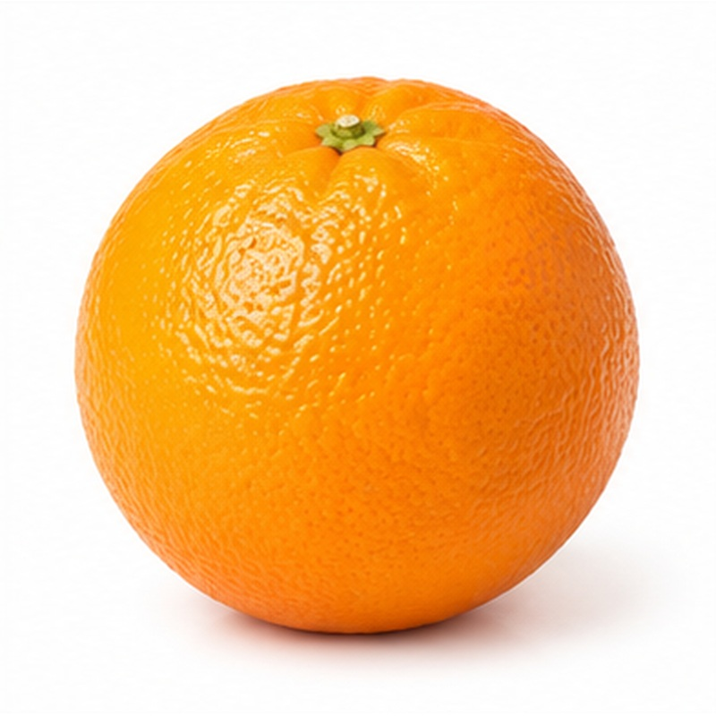 | Bright, juicy citrus selected for dependable eating quality and strong shelf presentation.  VARIETIES / TYPES Valencia, Navel, Baladi, Salustiana and Sukkari  EXPORT HANDLING Harvested at commercial maturity, field heat is removed promptly, then fruit is washed, graded by size and colour, and packed in ventilated cartons. Maintain a clean cold chain and protect from impact and moisture loss.  PACKING Ventilated cartons or telescopic boxes  COLD-CHAIN GUIDE Typically 3-8 C

02 MANDARIN / TANGERINE
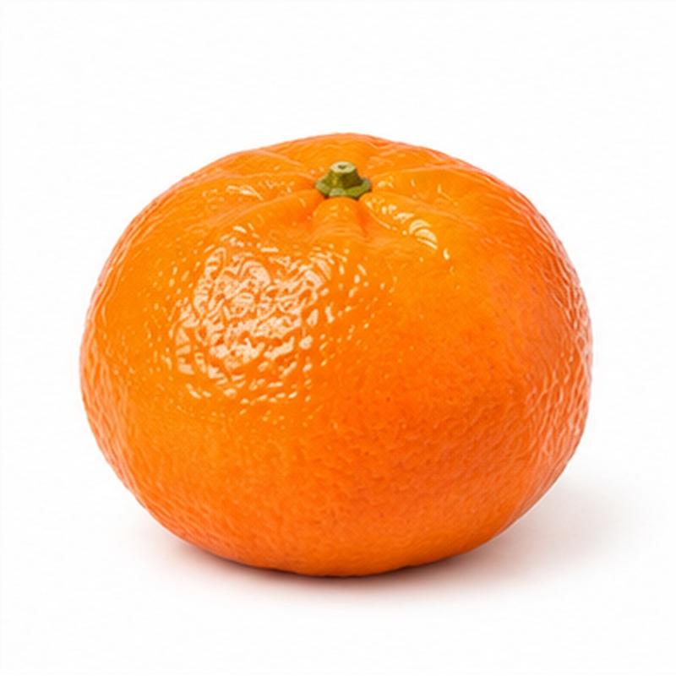 | Easy-peeling citrus with balanced sweetness, lively colour and excellent retail appeal.  VARIETIES / TYPES Fremont, Clementine, Merav, Tango, Murcott and W. Murcott  EXPORT HANDLING Fruit is clipped carefully to protect the rind, sorted for defects, calibrated, and packed to limit movement. Cool promptly and maintain airflow during refrigerated transport.  PACKING Open-top or telescopic cartons  COLD-CHAIN GUIDE Typically 4-8 C

03 SPANISH HONEY MURCOTT MANDARIN
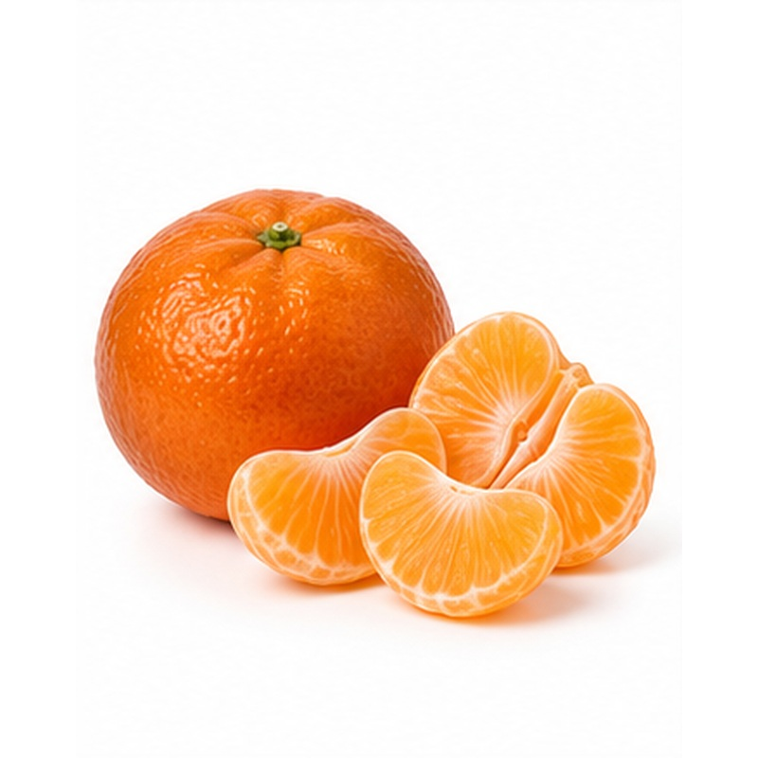 | A premium late-season mandarin valued for its rich honeyed flavour, juicy flesh and firm shipping character.  VARIETIES / TYPES Spanish Honey Murcott  EXPORT HANDLING Selected for colour, firmness and sound rind, then gently cleaned, sized and packed in ventilated cartons. Controlled cooling and careful stacking help preserve firmness and reduce compression during transit.  PACKING Ventilated cartons; loose or tray-packed  COLD-CHAIN GUIDE Typically 4-8 C

04 LEMON
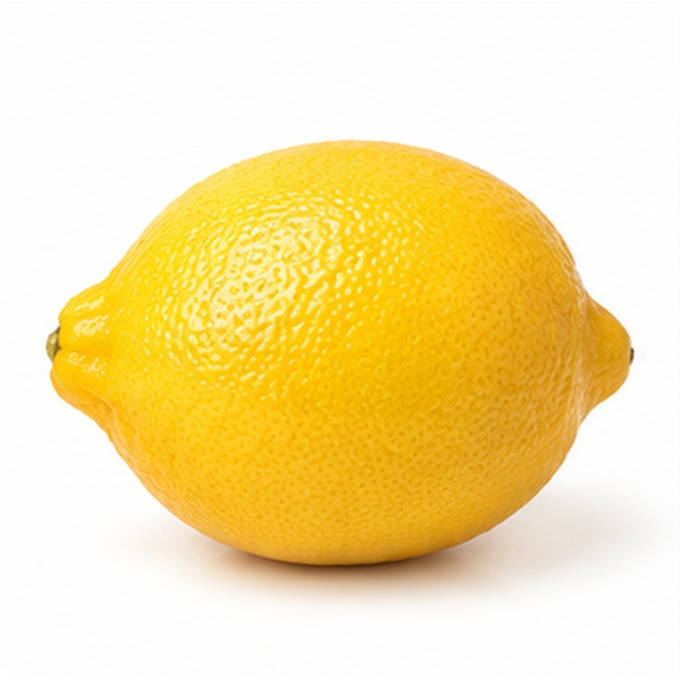 | Fresh aromatic lemons with strong colour, high juice content and versatile food-service use.  VARIETIES / TYPES Eureka, Adalia and Egyptian Baladi  EXPORT HANDLING Picked and handled gently to avoid oil spotting, then cleaned, graded and packed with good ventilation. Avoid excessive chilling and sudden temperature changes during storage and delivery.  PACKING Ventilated cartons or net packs  COLD-CHAIN GUIDE Typically 10-13 C

05 LIME
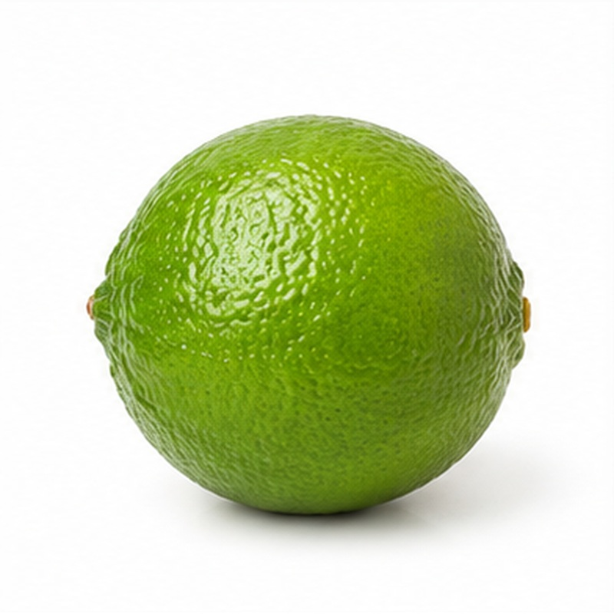 | Fragrant green limes selected for juice, acidity and a clean, uniform appearance.  VARIETIES / TYPES Egyptian / Baladi Lime  EXPORT HANDLING Harvested at the required green stage, sorted for skin quality and size, then packed in moisture-resistant ventilated cartons. Maintain moderate refrigeration to limit yellowing without causing chilling injury.  PACKING Ventilated cartons or consumer packs  COLD-CHAIN GUIDE Typically 9-12 C

06 GRAPEFRUIT
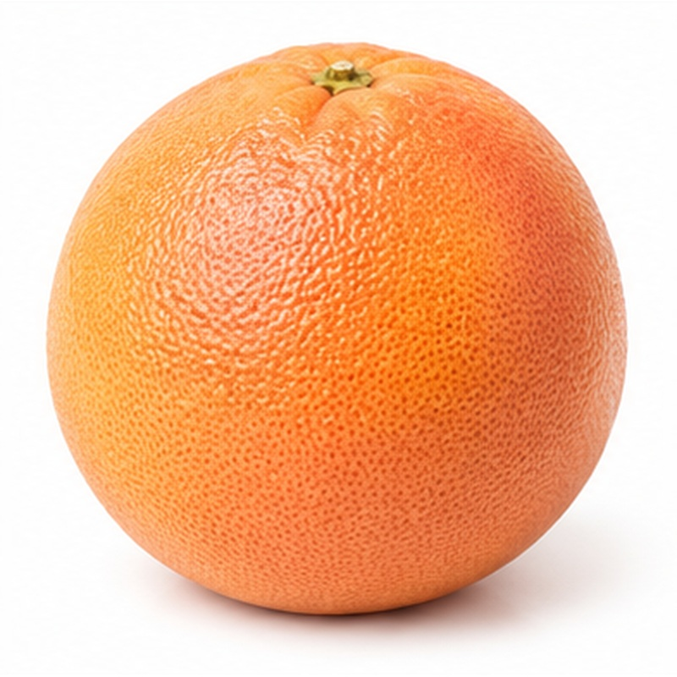 | Firm, refreshing citrus with attractive flesh colour and a distinctive sweet-tart profile.  VARIETIES / TYPES Star Ruby, Ruby Red and White Grapefruit  EXPORT HANDLING Fruit is cleaned, waxed where requested, graded by calibre and rind quality, and packed to prevent bruising. Consistent ventilation and moderate cooling support long-distance shipment.  PACKING Telescopic or open-top cartons  COLD-CHAIN GUIDE Typically 10-14 C

07 MANGO
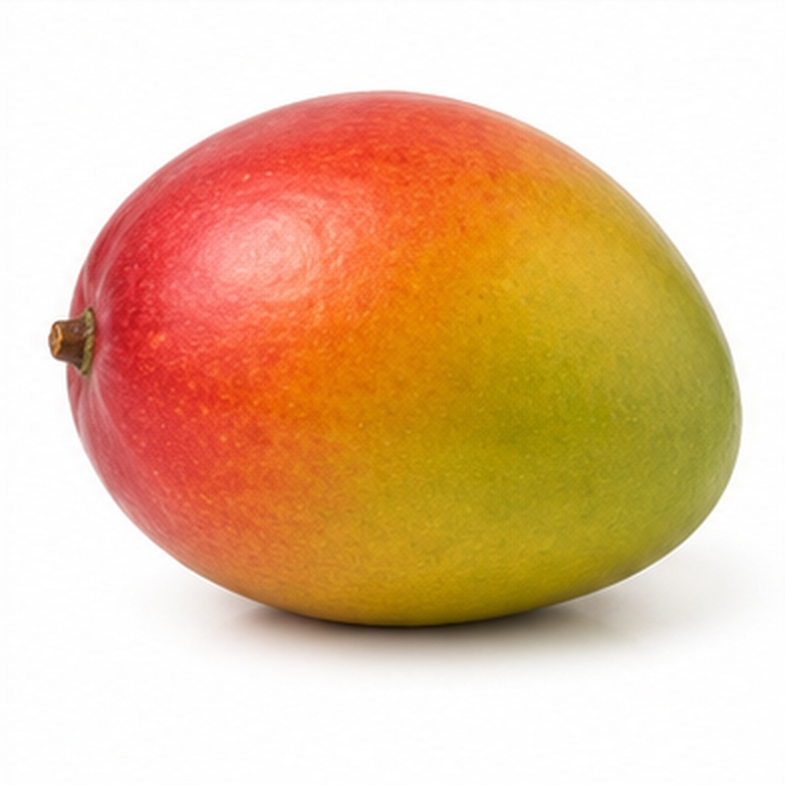 | A broad mango programme offering aromatic local favourites and firm export varieties for different markets.  VARIETIES / TYPES Owais, Alphonso, Keitt, Kent, Naomi, Zebda, Sukkari, Yasmina, Sideeka, Timor, Hindi, Tommy Atkins, Crimson, Maya / Aya and others  EXPORT HANDLING Mangoes are harvested at variety-specific maturity, de-sapped, cleaned, sorted and packed with protective inserts. Temperature and ripening are managed carefully; fruit is never compressed or exposed to chilling.  PACKING Single-layer or protected export cartons  COLD-CHAIN GUIDE Typically 10-13 C

08 GRAPES
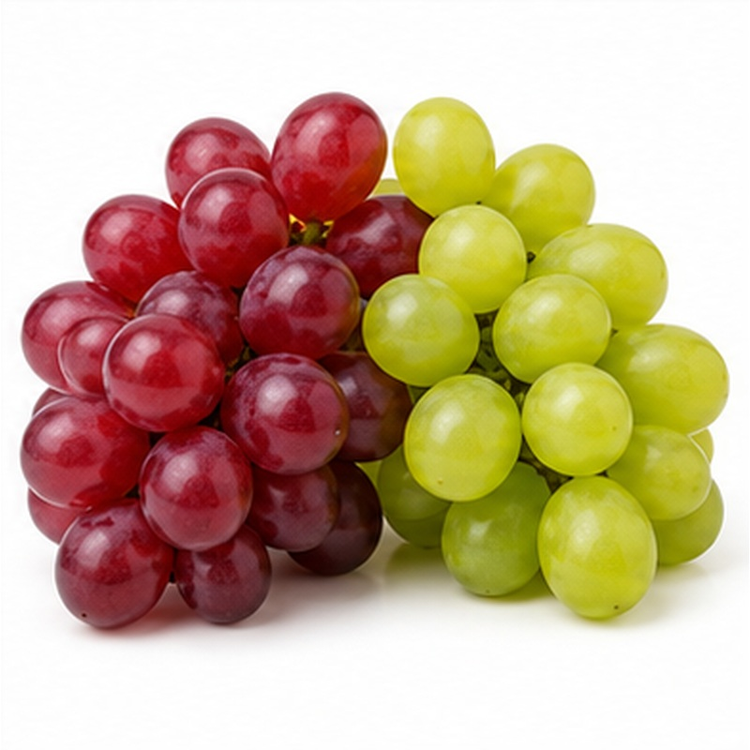 | Crisp table grapes supplied in green, red and black selections with strong bunch presentation.  VARIETIES / TYPES Superior Seedless, Early Sweet, Prime, Sugraone, Flame Seedless, Crimson Seedless, Red Globe, Autumn Royal and Black Magic  EXPORT HANDLING Bunches are hand-selected, trimmed and rapidly pre-cooled after harvest. They are packed in liners or punnets with controlled ventilation and maintained close to 0 C to preserve crispness and stem condition.  PACKING Cartons with liners, punnets or carry bags  COLD-CHAIN GUIDE Typically 0-1 C

09 POMEGRANATE
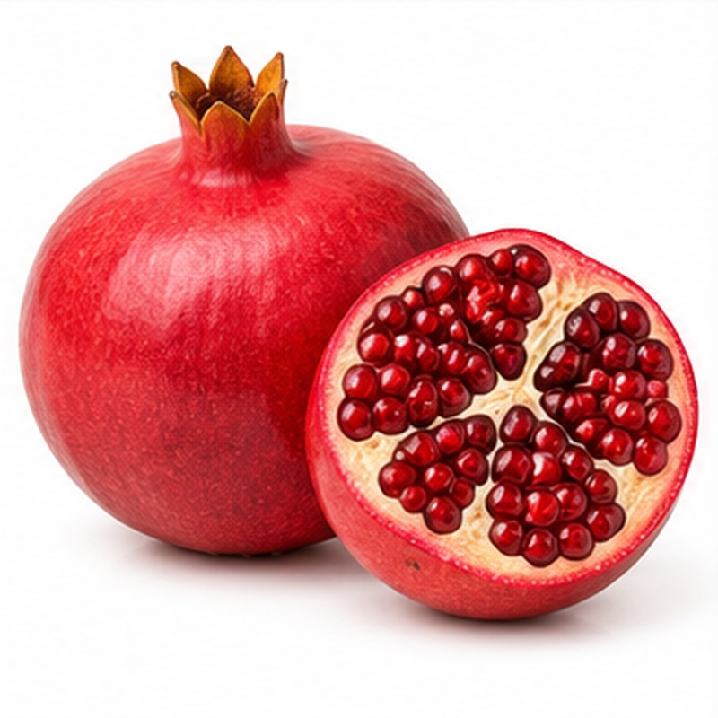 | Deep-coloured pomegranates chosen for sound skin, full arils and reliable export durability.  VARIETIES / TYPES Wonderful, Early 116, Manfaluti and Baladi  EXPORT HANDLING Fruit is clipped, cleaned, graded by weight, colour and external condition, then cushioned in cartons. Gentle handling, humidity control and stable refrigeration help prevent skin damage and dehydration.  PACKING Tray-packed or layered cartons  COLD-CHAIN GUIDE Typically 5-7 C

10 STRAWBERRY
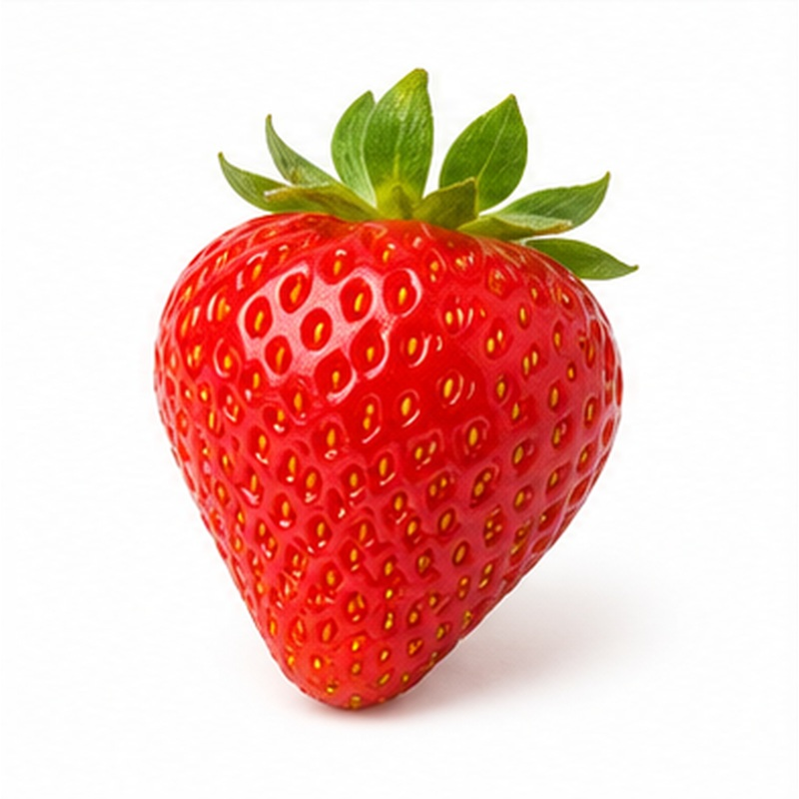 | Bright, flavourful berries selected for firmness, colour and premium fresh-market presentation.  VARIETIES / TYPES Festival, Fortuna, Sensation and Winter Star  EXPORT HANDLING Berries are picked in cool hours, handled minimally and pre-cooled immediately. They are packed directly into punnets, inspected for uniform ripeness, and moved through an uninterrupted cold chain.  PACKING Clamshell punnets in master cartons  COLD-CHAIN GUIDE Typically 0-2 C

11 FRESH DATES
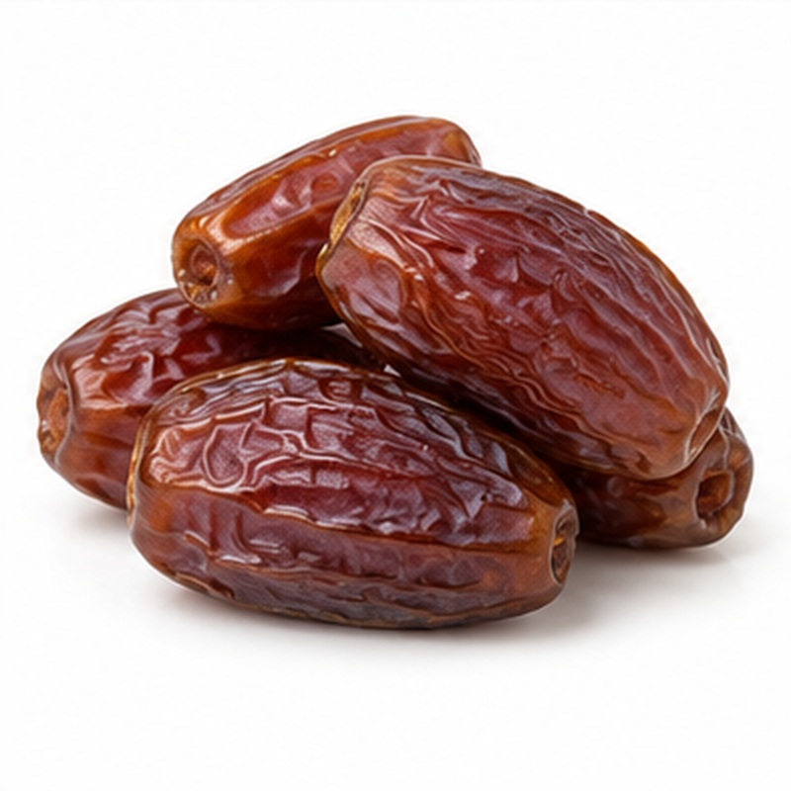 | Fresh dates supplied at the appropriate maturity stage, including premium yellow Barhi for a crisp, sweet bite.  VARIETIES / TYPES Barhi, Siwi, Medjool, Hayani and Zaghloul  EXPORT HANDLING Clusters or individual fruit are selected for maturity, colour and freedom from splits, then cooled and packed with gentle cushioning. Humidity and airflow are managed to reduce drying and condensation.  PACKING Punnets, trays or ventilated cartons  COLD-CHAIN GUIDE Typically 0-4 C

12 GUAVA
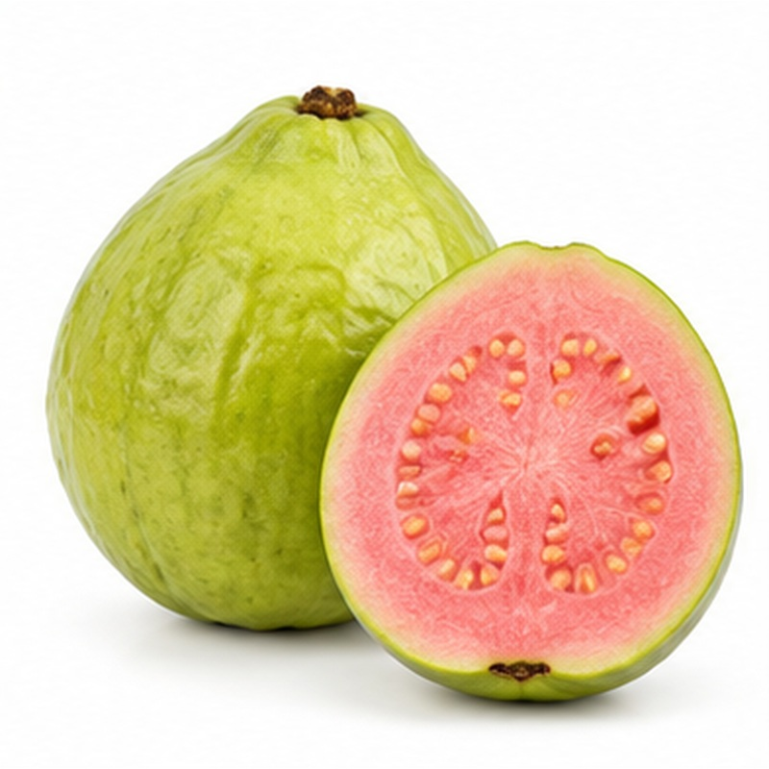 | Aromatic guava with fragrant flesh and a distinctive tropical flavour.  VARIETIES / TYPES Egyptian White and Pink Flesh  EXPORT HANDLING Fruit is harvested mature-firm, sorted for skin condition and packed in shallow, protective layers. Rapid cooling and careful temperature control are important because guava ripens quickly and bruises easily.  PACKING Shallow cartons with protective trays  COLD-CHAIN GUIDE Typically 8-10 C

13 FIG
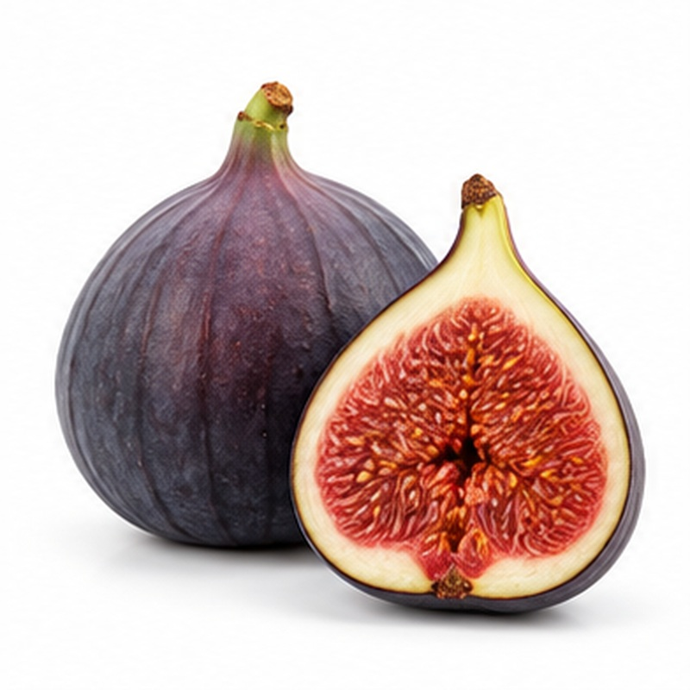 | Soft, naturally sweet figs selected for colour, intact skin and delicate flavour.  VARIETIES / TYPES Fresh Egyptian Figs  EXPORT HANDLING Figs are hand-picked, minimally handled and packed directly into shallow trays or punnets. Immediate pre-cooling and fast refrigerated distribution are essential because the fruit is highly perishable.  PACKING Single-layer punnets or trays  COLD-CHAIN GUIDE Typically 0-2 C

14 PEACH
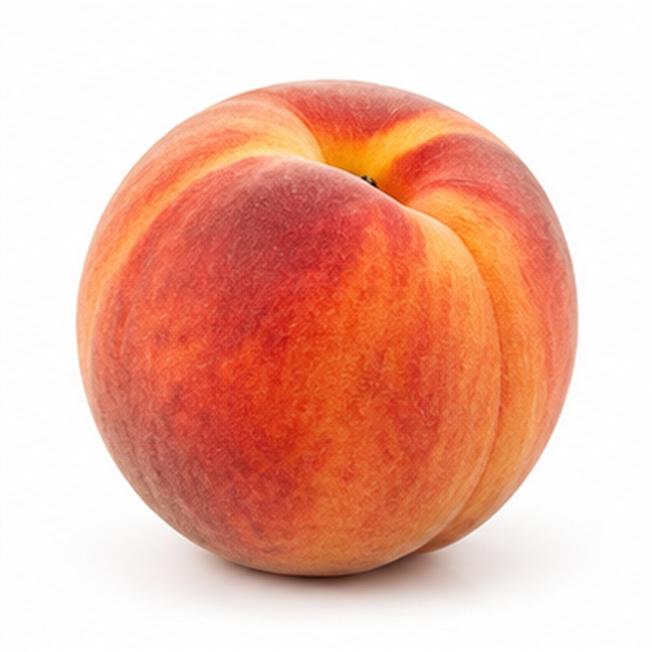 | Fragrant peaches offering juicy flesh, attractive colour and strong seasonal demand.  VARIETIES / TYPES White- and Yellow-Flesh Types  EXPORT HANDLING Harvested at firm maturity, pre-cooled quickly, graded for size and defects, and packed in trays that prevent rubbing. Maintain high humidity and a stable cold chain while avoiding compression.  PACKING Tray-packed telescopic cartons  COLD-CHAIN GUIDE Typically 0-1 C

15 NECTARINE
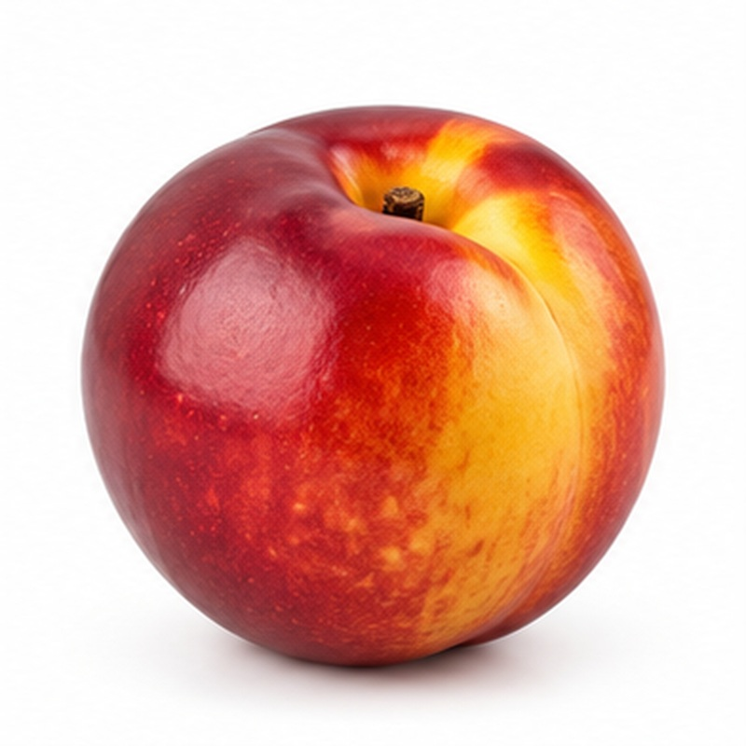 | Smooth-skinned stone fruit with crisp-to-juicy texture and bright, balanced flavour.  VARIETIES / TYPES White- and Yellow-Flesh Types  EXPORT HANDLING Fruit is picked firm, cooled rapidly and sorted for firmness, colour and calibre. Protective trays and careful palletisation reduce bruising and pressure marks during transport.  PACKING Tray-packed export cartons  COLD-CHAIN GUIDE Typically 0-1 C

16 APRICOT
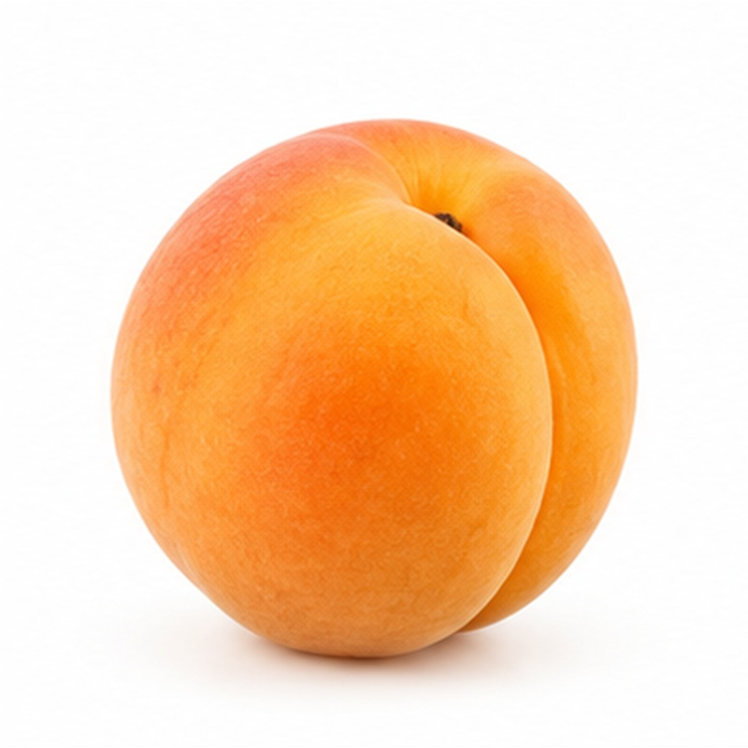 | Delicate golden fruit with aromatic flavour and an appealing soft texture when ripe.  VARIETIES / TYPES Selected Egyptian Varieties  EXPORT HANDLING Apricots are harvested at firm maturity, pre-cooled without delay and packed in shallow protective layers. Short handling times and strict temperature control preserve appearance and eating quality.  PACKING Punnets or tray-packed cartons  COLD-CHAIN GUIDE Typically 0-1 C

17 PLUM
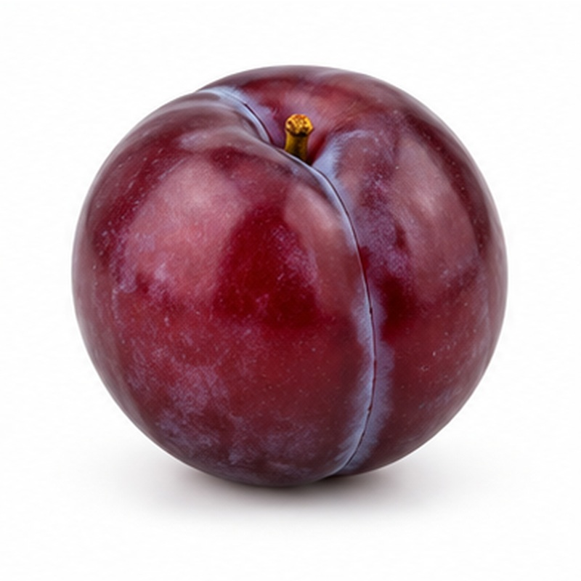 | Colourful plums selected for firmness, bloom and a balanced sweet-tart taste.  VARIETIES / TYPES Red, Black and Yellow Types  EXPORT HANDLING Fruit is graded gently to preserve its natural bloom, then pre-cooled and placed in trays or punnets. Stable low temperatures and careful stacking reduce softening and bruising.  PACKING Punnets or tray-packed cartons  COLD-CHAIN GUIDE Typically 0-1 C

18 CHERRY
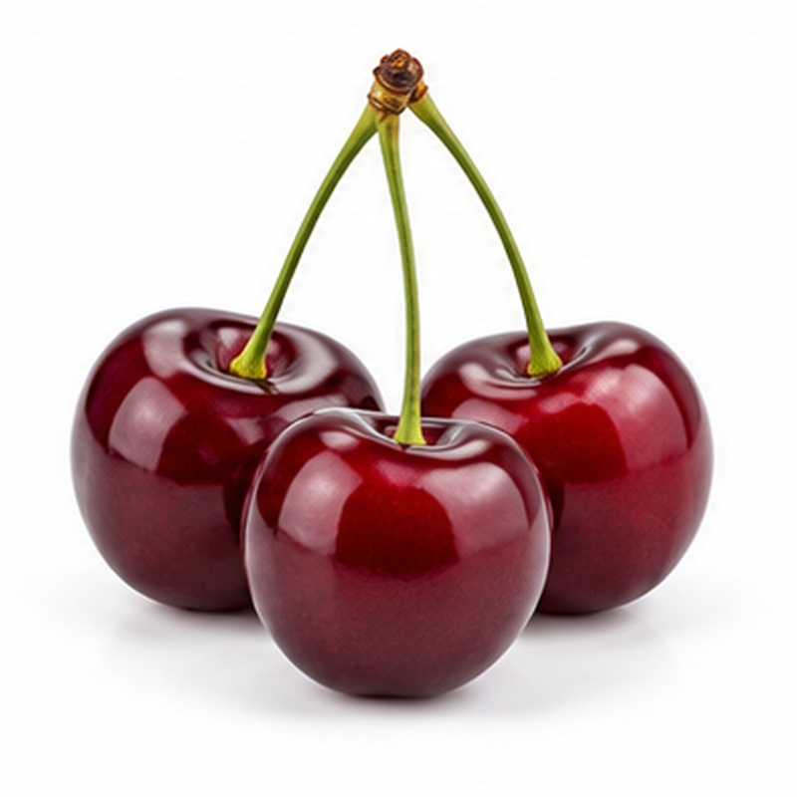 | Premium cherries chosen for deep colour, firm flesh and fresh green stems.  VARIETIES / TYPES Selected Varieties Subject to Availability  EXPORT HANDLING Cherries are harvested with stems, hydro-cooled or forced-air cooled promptly, sorted carefully, and packed in moisture-controlled formats. Continuous refrigeration is critical for firmness and stem freshness.  PACKING Punnets, bags or cartons with liners  COLD-CHAIN GUIDE Typically 0-1 C

19 WATERMELON
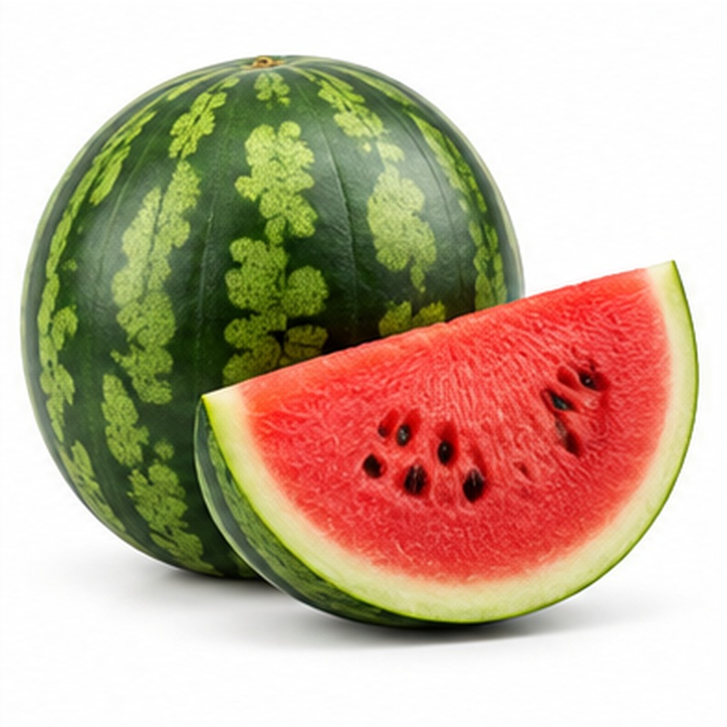 | Refreshing melons supplied for sweetness, sound rind and consistent internal quality.  VARIETIES / TYPES Crimson Sweet, Sugar Baby, Seedless and Egyptian Types  EXPORT HANDLING Each fruit is checked for maturity and rind condition, then handled to avoid drops and compression. Loads are secured with ventilation, kept dry, and protected from temperatures that can cause chilling injury.  PACKING Bulk bins, cartons or secured pallet loads  COLD-CHAIN GUIDE Typically 10-15 C

20 CANTALOUPE
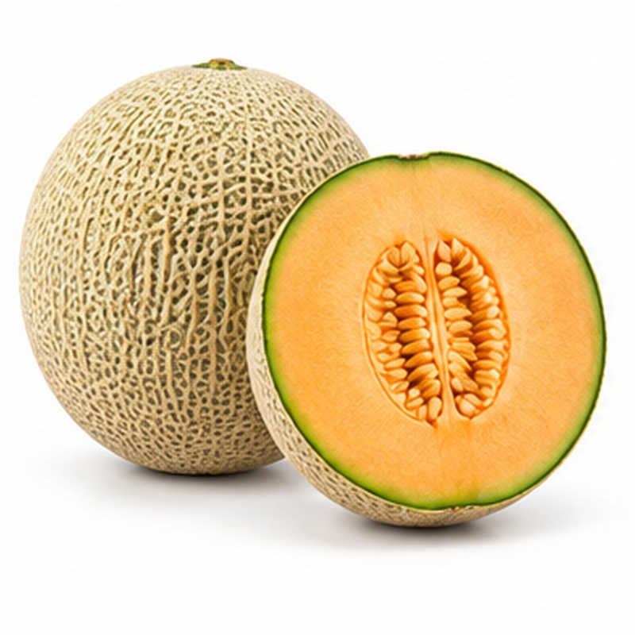 | Aromatic melons with netted rind, orange flesh and a sweet, refreshing profile.  VARIETIES / TYPES Selected Egyptian Varieties  EXPORT HANDLING Melons are harvested at the specified maturity, washed and sanitised where required, pre-cooled and graded. Ventilated cartons and controlled refrigeration help manage ripening and reduce decay.  PACKING Ventilated cartons with dividers  COLD-CHAIN GUIDE Typically 2-5 C

21 HONEYDEW MELON
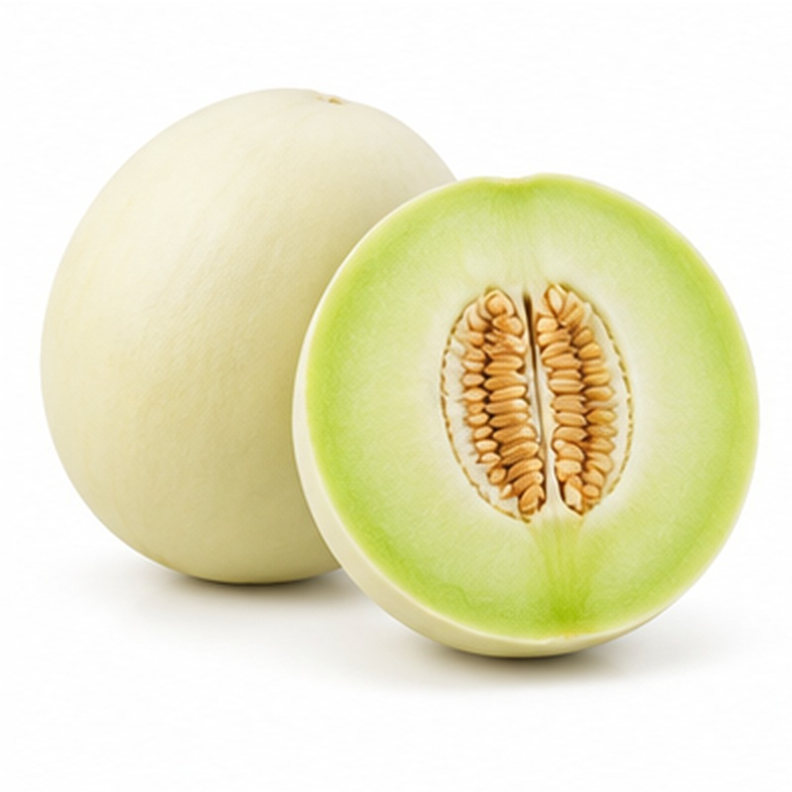 | Smooth-skinned melons valued for crisp, pale flesh and clean sweetness.  VARIETIES / TYPES Green- and Yellow-Skin Types  EXPORT HANDLING Fruit is selected for maturity and rind integrity, cleaned, cooled and packed with separators. Maintain ventilation and avoid rough handling or excessive chilling during storage and shipment.  PACKING Ventilated cartons or bins  COLD-CHAIN GUIDE Typically 7-10 C

22 CUSTARD APPLE
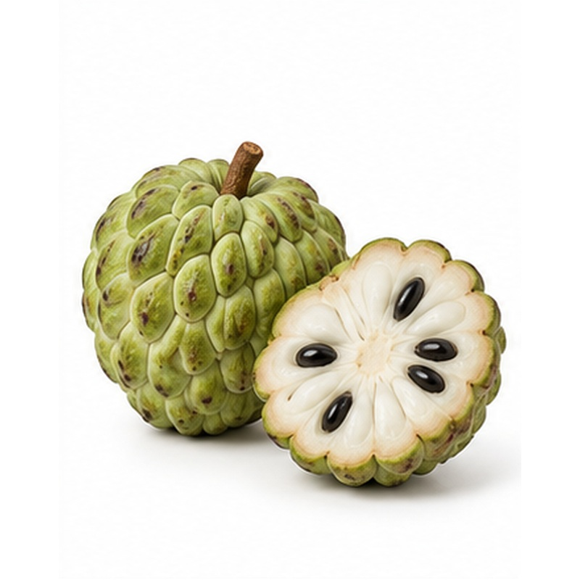 | A distinctive premium fruit with creamy, aromatic flesh and naturally sweet flavour.  VARIETIES / TYPES Selected Egyptian Varieties  EXPORT HANDLING Harvested mature-firm and handled individually because the skin marks easily. Fruit is cushioned in trays, kept at a moderate temperature and monitored closely as ripening progresses.  PACKING Single-layer trays or cushioned cartons  COLD-CHAIN GUIDE Typically 12-15 C

23 PERSIMMON / KAKI
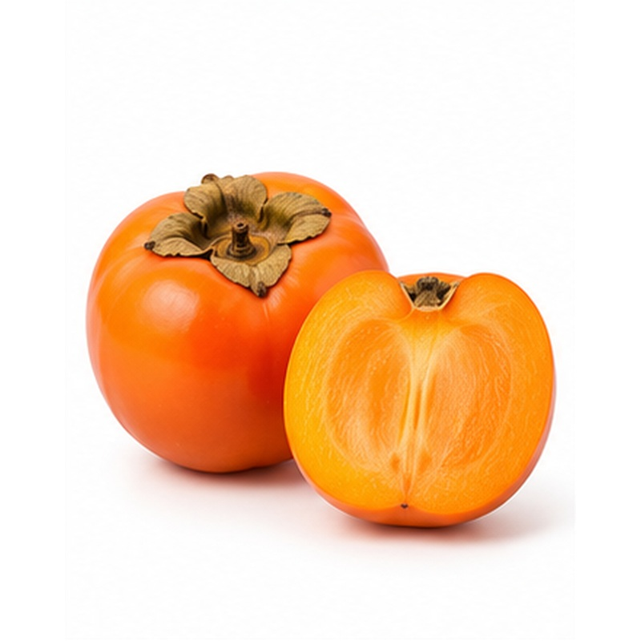 | Glossy orange fruit supplied in firm or ready-to-eat condition according to buyer requirements.  VARIETIES / TYPES Selected Seasonal Varieties  EXPORT HANDLING Fruit is clipped carefully, graded for colour and firmness, and placed in moulded trays. Temperature and ripening management are adjusted to the variety and requested eating stage.  PACKING Tray-packed export cartons  COLD-CHAIN GUIDE Typically 0-1 C

24 PRICKLY PEAR
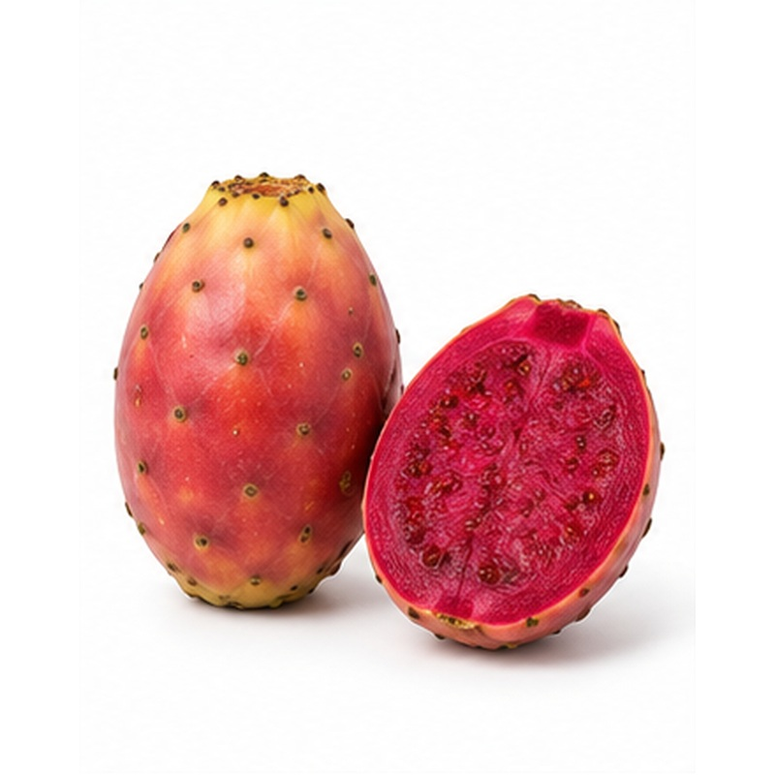 | Vibrant seasonal cactus fruit with juicy flesh and a refreshing, mildly sweet flavour.  VARIETIES / TYPES Selected Egyptian Varieties  EXPORT HANDLING Fruit is harvested carefully, de-spined using controlled handling, graded and packed to protect the skin. Cool, dry storage and gentle movement help maintain quality.  PACKING Punnets or protected cartons  COLD-CHAIN GUIDE Typically 5-8 C

25 LYCHEE
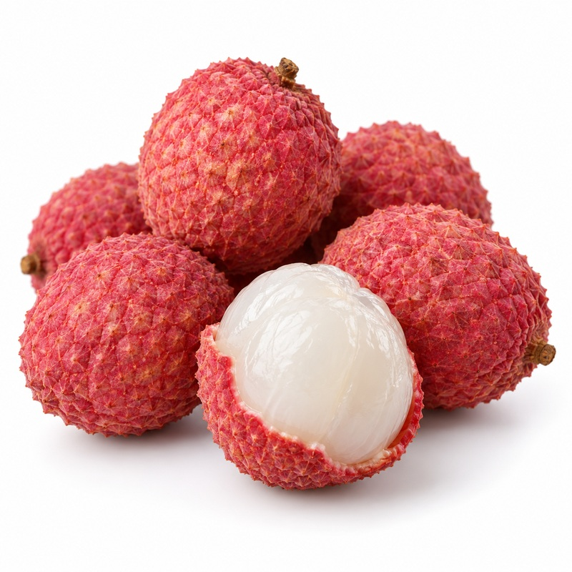 | Fragrant premium fruit with translucent flesh, floral sweetness and an attractive red-pink shell.  VARIETIES / TYPES Premium Fresh Lychee  EXPORT HANDLING Fruit is harvested in clusters, cooled promptly, sorted for colour and sound skin, and packed to limit moisture loss. High humidity and continuous refrigeration help control browning.  PACKING Punnets or lined ventilated cartons  COLD-CHAIN GUIDE Typically 2-5 C

26 APPLE
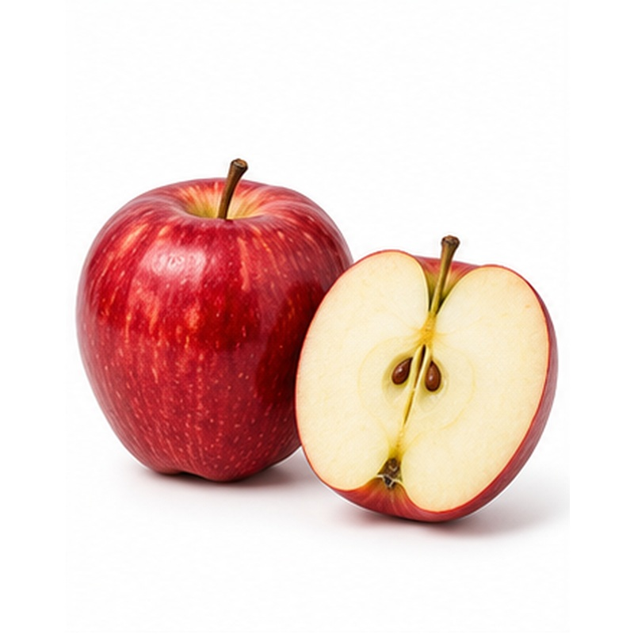 | Crisp apples sourced to match buyer requirements for colour, calibre, firmness and flavour.  VARIETIES / TYPES Red, Green and Golden Types  EXPORT HANDLING Fruit is washed, graded and packed in moulded trays or layers to prevent pressure damage. Refrigerated or controlled-atmosphere handling may be used according to variety and voyage length.  PACKING Tray-packed cartons or bushel-style boxes  COLD-CHAIN GUIDE Typically 0-4 C

27 PEAR
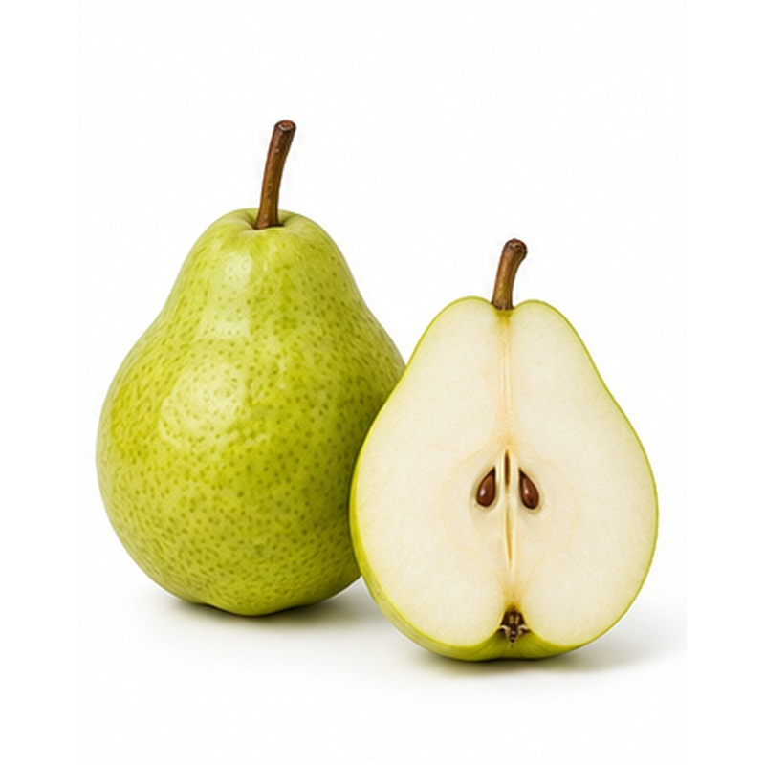 | Smooth, firm pears selected for consistent size and controlled ripening after delivery.  VARIETIES / TYPES Green and Red Types  EXPORT HANDLING Pears are harvested firm, cooled promptly and graded with minimal impact. Tray packing, high humidity and carefully managed temperatures protect against bruising and moisture loss.  PACKING Tray-packed cartons  COLD-CHAIN GUIDE Typically 0-1 C

28 KIWIFRUIT
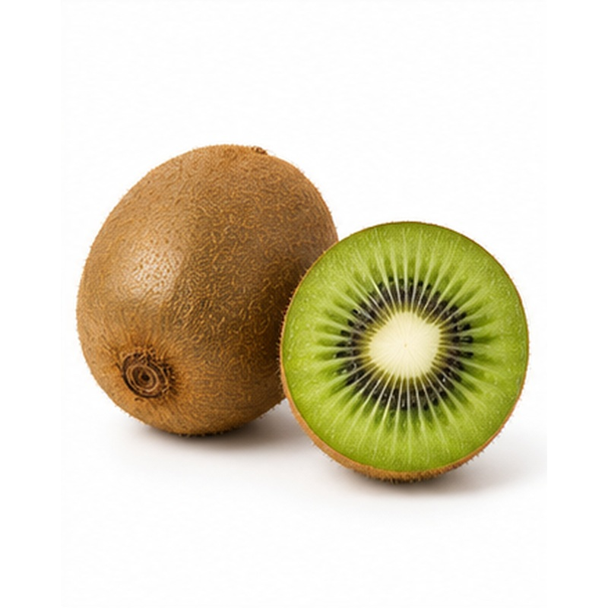 | Firm kiwifruit with bright flesh, refreshing acidity and reliable storage performance.  VARIETIES / TYPES Green and Gold  EXPORT HANDLING Fruit is selected by firmness and soluble solids, pre-cooled and packed in trays or punnets. It is kept away from ethylene-producing products unless ripening is intentionally required.  PACKING Trays, punnets or layered cartons  COLD-CHAIN GUIDE Typically 0-1 C

29 AVOCADO
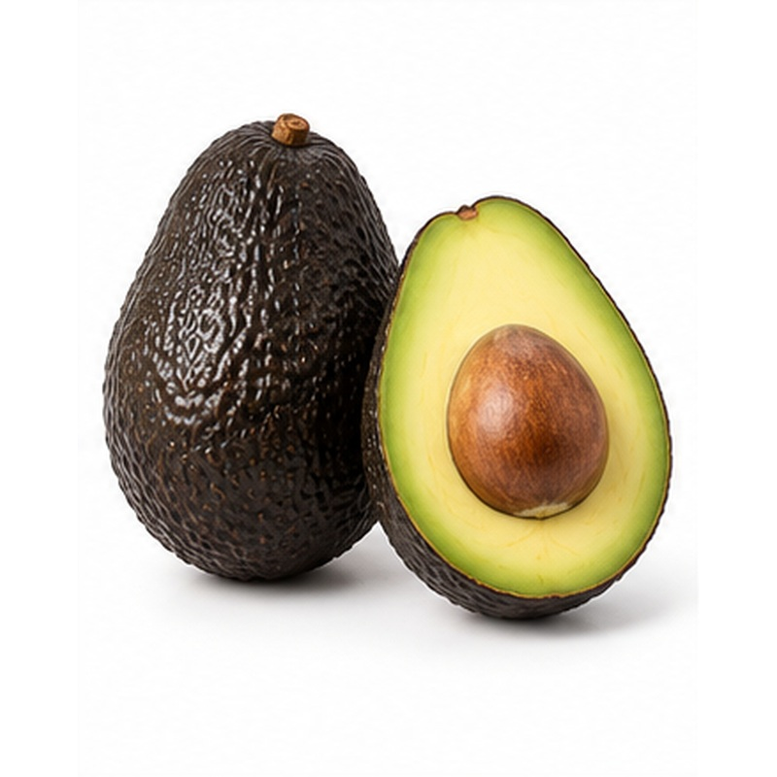 | Premium avocados offered at hard-green or programmed ripeness to suit retail and food-service needs.  VARIETIES / TYPES Hass and Fuerte  EXPORT HANDLING Fruit is clipped, cleaned, graded by size and dry-matter maturity, then protected in trays. Temperature is variety- and maturity-specific, with ethylene managed carefully during storage and ripening.  PACKING Tray-packed cartons  COLD-CHAIN GUIDE Typically 5-7 C

30 BANANA
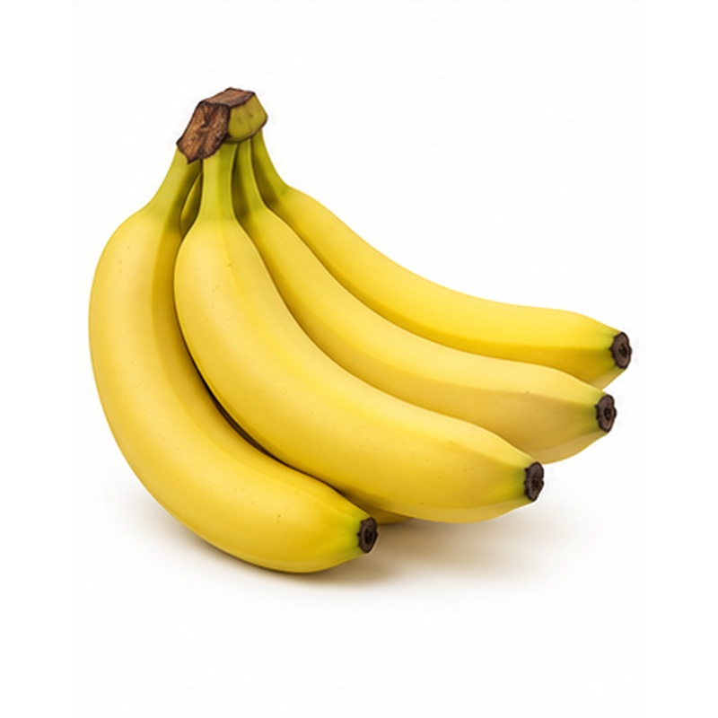 | Uniform green bananas sourced for controlled ripening, consistent colour and dependable retail quality.  VARIETIES / TYPES Cavendish and Other Selected Varieties  EXPORT HANDLING Hands are cleaned, graded and packed with liners that reduce abrasion and moisture loss. Fruit remains green under a stable cool chain and is protected from chilling until destination ripening.  PACKING Lined ventilated banana cartons  COLD-CHAIN GUIDE Typically 13-14 C

31 PINEAPPLE
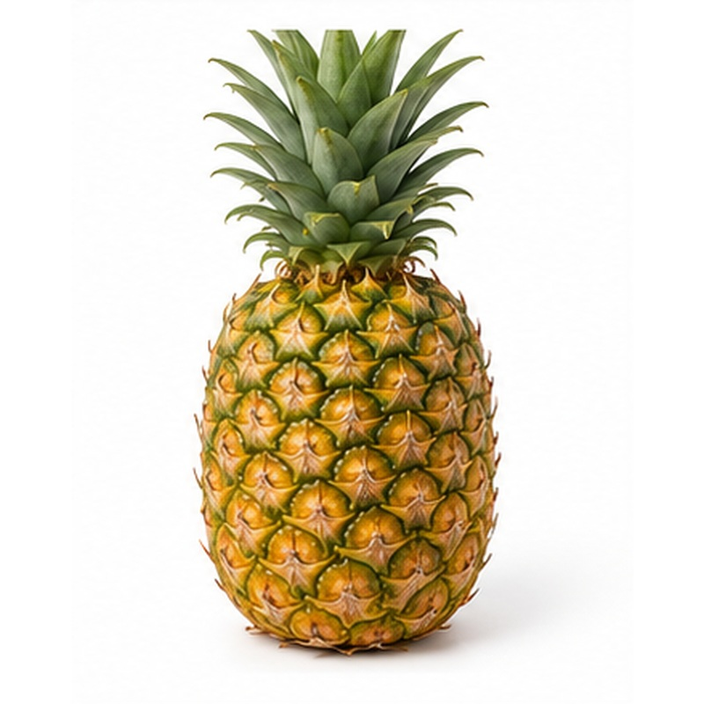 | Sweet tropical pineapple selected for crown condition, shell colour and internal maturity.  VARIETIES / TYPES Selected Varieties According to Source  EXPORT HANDLING Fruit is harvested at the agreed maturity, cleaned, graded and packed upright or securely layered. Ventilation, crown protection and moderate refrigeration reduce bruising, water loss and chilling risk.  PACKING Ventilated cartons with dividers  COLD-CHAIN GUIDE Typically 7-10 C

NILE-MAPLE
Flexible sourcing • Buyer-specific specifications • Export-ready handling
Packaging, calibre, maturity, treatment, temperature and shipment programmes are confirmed according to product, destination market and buyer requirements.

