NILE-MAPLE
FRESH VEGETABLES
Product & Export Handling Catalogue
Selected produce. Careful handling. Reliable global supply.

01 POTATO
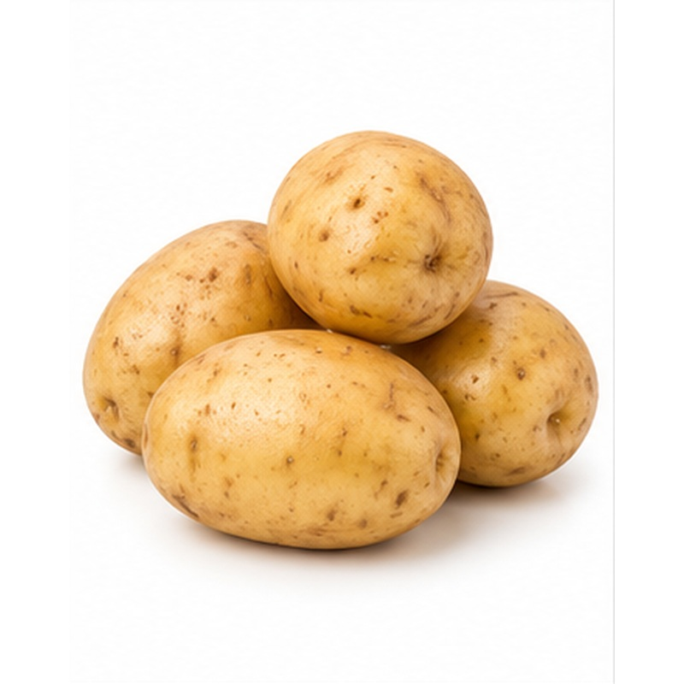 | Firm export potatoes selected for uniform shape, clean skin and dependable cooking or processing quality.  VARIETIES / TYPES Spunta, Nicola, Lady Rosetta, Hermes, Cara and Diamant  EXPORT HANDLING Tubers are cured where appropriate, dry-cleaned or washed to specification, graded by size and inspected for damage, greening and sprouting. Keep dark, dry and well ventilated.  PACKING Mesh bags, paper bags, cartons or jumbo bags  COLD-CHAIN GUIDE Typically 7-10 C for table stock

02 SWEET POTATO
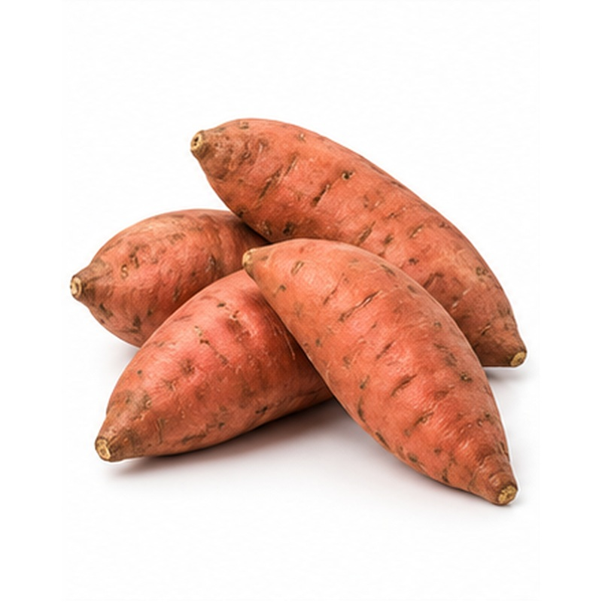 | Naturally sweet roots with attractive skin, rich flesh colour and strong retail appeal.  VARIETIES / TYPES Beauregard, Bellevue and selected Egyptian varieties  EXPORT HANDLING Roots are carefully lifted, cured to strengthen the skin, dry-cleaned, graded and packed to prevent abrasion. Avoid chilling, moisture condensation and excessive handling.  PACKING Cartons, crates or mesh bags  COLD-CHAIN GUIDE Typically 13-16 C

03 ONION
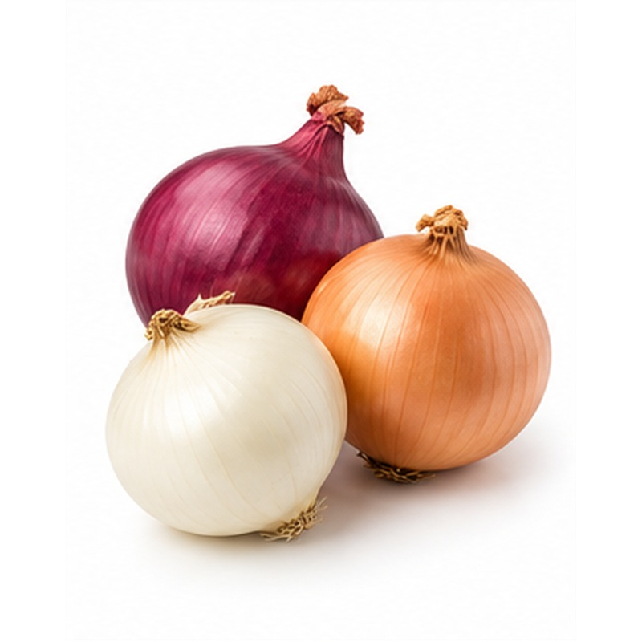 | Dry onions supplied with firm bulbs, sound skins and consistent colour for retail and food service.  VARIETIES / TYPES Red, golden/yellow and white onion  EXPORT HANDLING Bulbs are fully cured, topped, cleaned and graded by diameter. Dry ventilation, careful bagging and protection from moisture help control sprouting and decay.  PACKING Mesh bags, cartons or jumbo bags  COLD-CHAIN GUIDE Typically 0-2 C for long holding

04 SPRING ONION
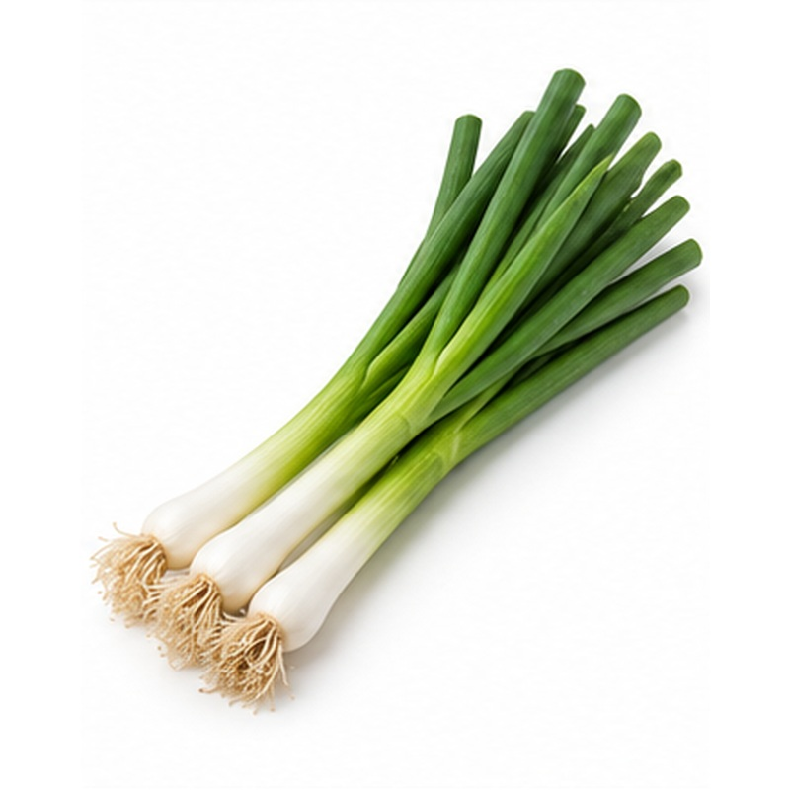 | Fresh spring onions with clean white shanks, upright green tops and a mild flavour.  VARIETIES / TYPES Green or bunching onion  EXPORT HANDLING Bunches are trimmed, washed, rapidly cooled and packed with high humidity protection. Gentle handling prevents crushing, yellowing and tip damage.  PACKING Bunched in lined cartons or crates  COLD-CHAIN GUIDE Typically 0-2 C

05 SHALLOT
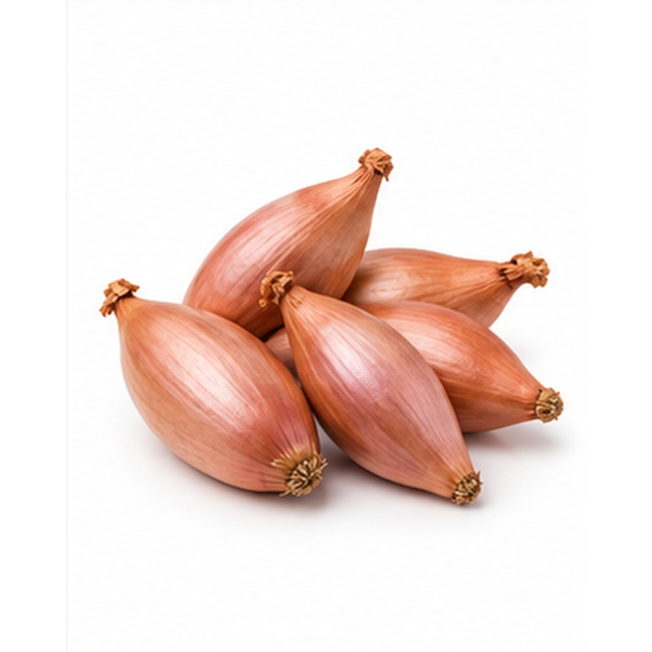 | Compact premium bulbs valued for firm texture, concentrated flavour and long storage potential.  VARIETIES / TYPES Red and golden shallots  EXPORT HANDLING Shallots are properly cured, cleaned and graded for size and skin integrity. Store dry with good airflow and avoid condensation inside the pack.  PACKING Mesh bags, punnets or cartons  COLD-CHAIN GUIDE Typically 0-2 C

06 GARLIC
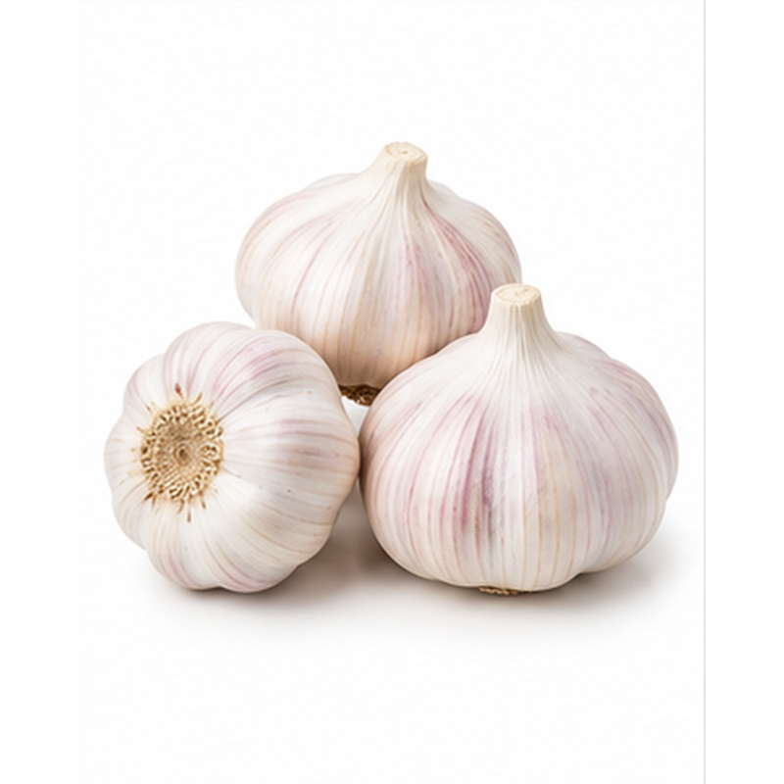 | Aromatic garlic bulbs selected for tight cloves, dry wrappers and strong commercial quality.  VARIETIES / TYPES White, red and Egyptian/Baladi garlic  EXPORT HANDLING Bulbs are cured thoroughly, roots and tops trimmed, then graded for diameter and freedom from mould or mechanical damage. Maintain dry, ventilated storage.  PACKING Mesh bags, cartons, nets or braids  COLD-CHAIN GUIDE Typically 0-2 C

07 LEEK
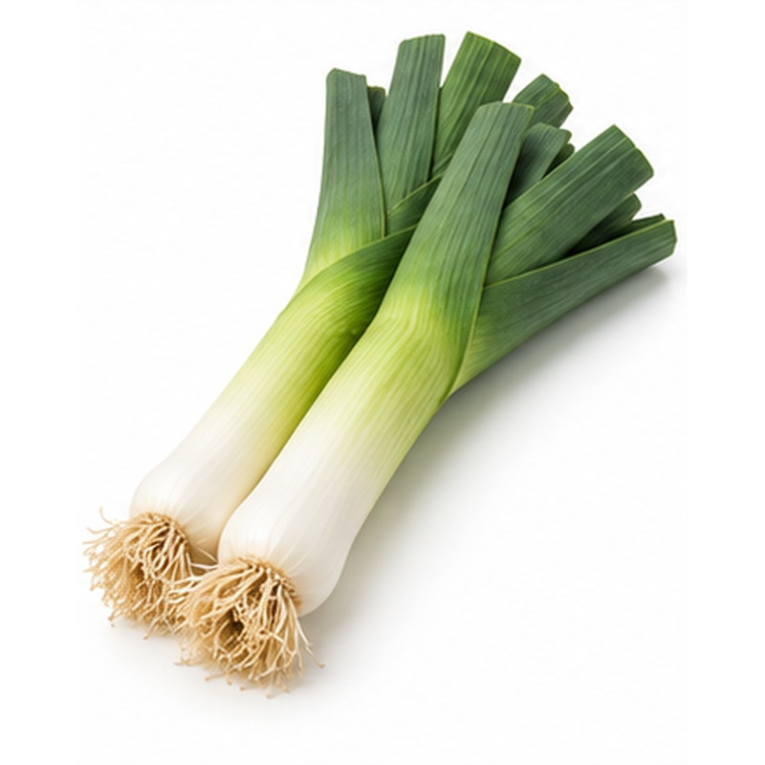 | Clean, firm leeks with long white shanks and fresh green leaves.  VARIETIES / TYPES Standard and baby leek  EXPORT HANDLING Leeks are lifted, trimmed, washed and rapidly pre-cooled. They are packed to retain humidity while allowing ventilation and are protected from crushing.  PACKING Lined cartons or reusable crates  COLD-CHAIN GUIDE Typically 0-2 C

08 CARROT
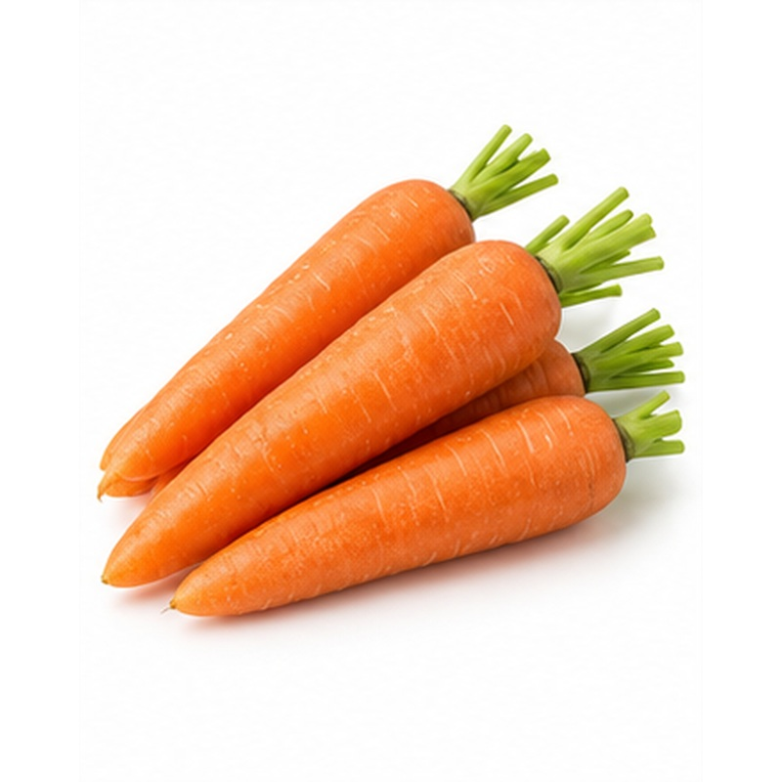 | Crisp carrots supplied with bright colour, smooth roots and consistent sizing.  VARIETIES / TYPES Standard orange and baby carrot  EXPORT HANDLING Roots are topped, washed, hydro-cooled or forced-air cooled, graded and packed quickly. High humidity limits wilting while careful handling prevents breakage.  PACKING Bags, cartons or lined crates  COLD-CHAIN GUIDE Typically 0-2 C

09 BEETROOT
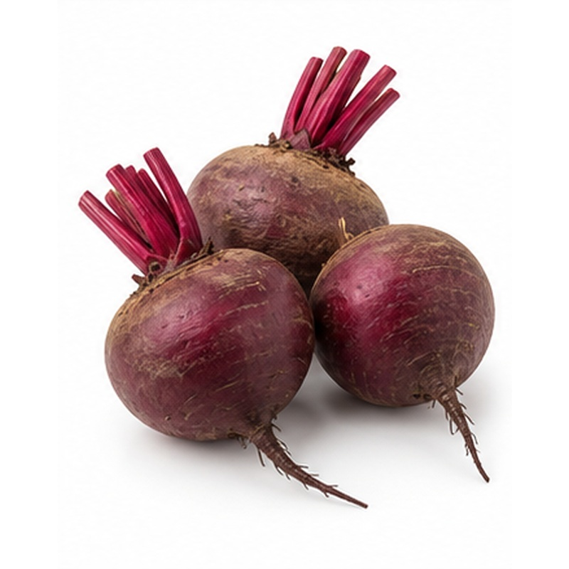 | Deep-coloured beetroot selected for firm roots, smooth skin and uniform calibre.  VARIETIES / TYPES Red beetroot  EXPORT HANDLING Roots are trimmed without damaging the crown, washed, graded and cooled. Moisture loss is controlled with liners or suitable consumer packaging.  PACKING Mesh bags, cartons or punnets  COLD-CHAIN GUIDE Typically 0-2 C

10 RADISH
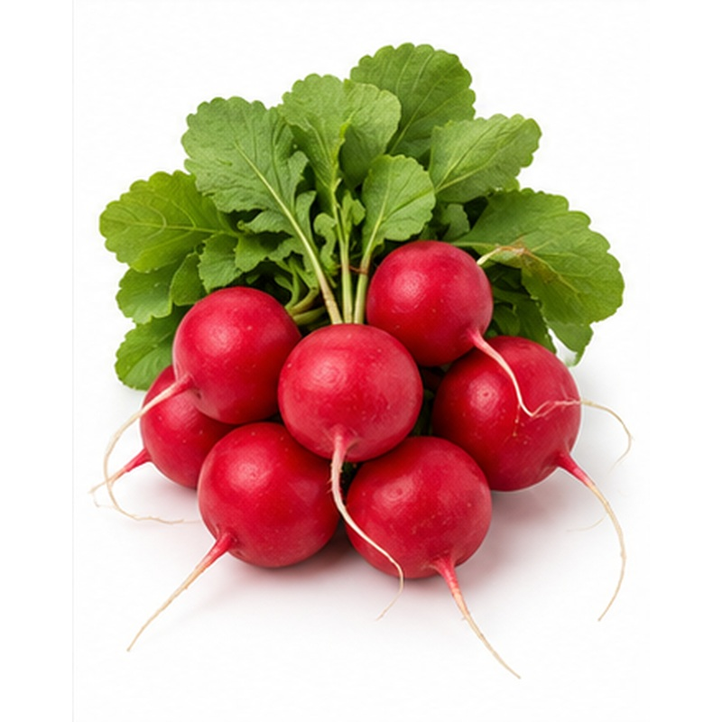 | Crisp radishes with bright colour, clean roots and a fresh peppery character.  VARIETIES / TYPES Red and white radish  EXPORT HANDLING Radishes are harvested young, washed, cooled immediately and packed at high humidity. Tops may be retained or removed according to buyer specification.  PACKING Bunches, bags or lined cartons  COLD-CHAIN GUIDE Typically 0-2 C

11 TURNIP
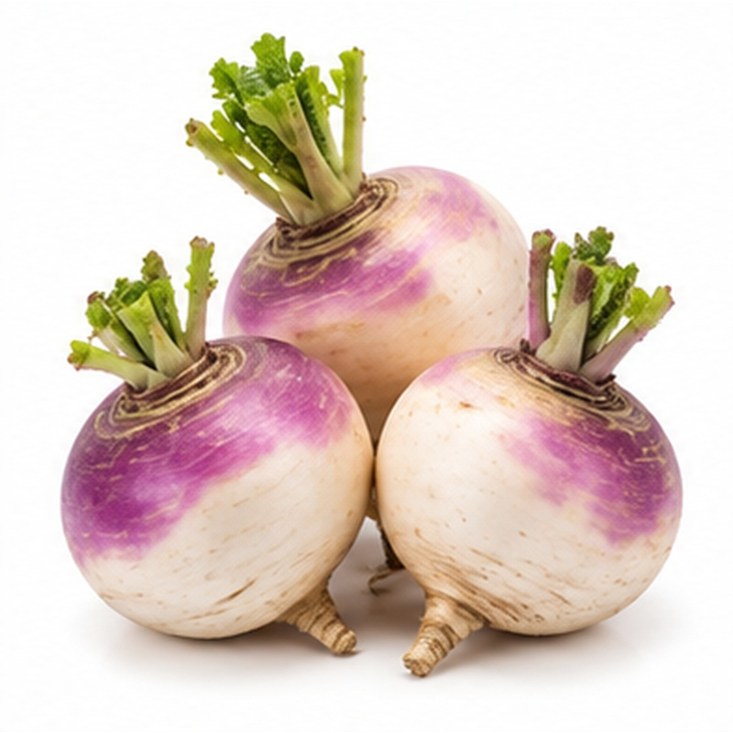 | Firm, clean turnips with mild flavour and consistent root development.  VARIETIES / TYPES White and purple-top turnip  EXPORT HANDLING Roots are topped, washed, graded and rapidly cooled. High humidity and protective packing reduce shrivelling and surface damage.  PACKING Mesh bags, cartons or crates  COLD-CHAIN GUIDE Typically 0-2 C

12 TOMATO
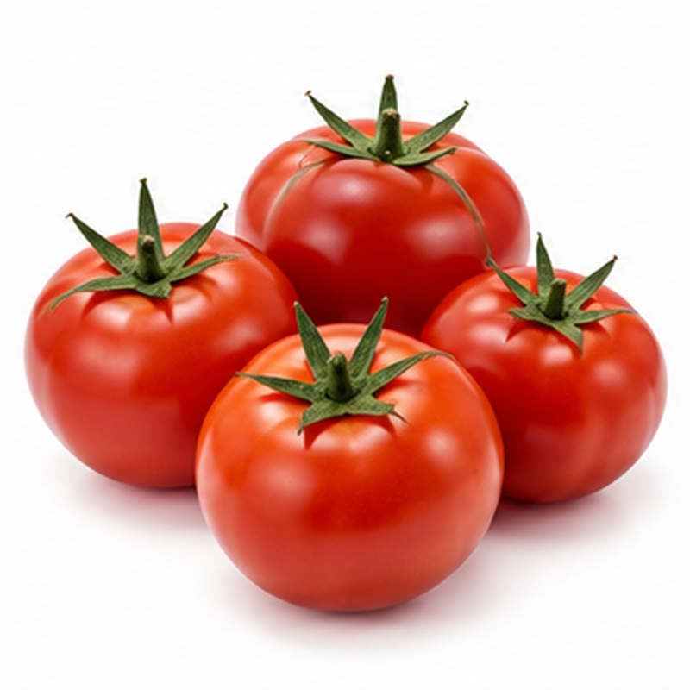 | Fresh tomatoes supplied at buyer-specified colour and maturity for retail, wholesale or food service.  VARIETIES / TYPES Round, beef and plum/Roma tomato  EXPORT HANDLING Fruit is hand-picked, graded for size, firmness and colour, then packed in shallow layers. Temperature is matched to maturity to manage ripening and avoid chilling injury.  PACKING Open-top, telescopic or tray-packed cartons  COLD-CHAIN GUIDE Typically 10-13 C

13 CHERRY TOMATO
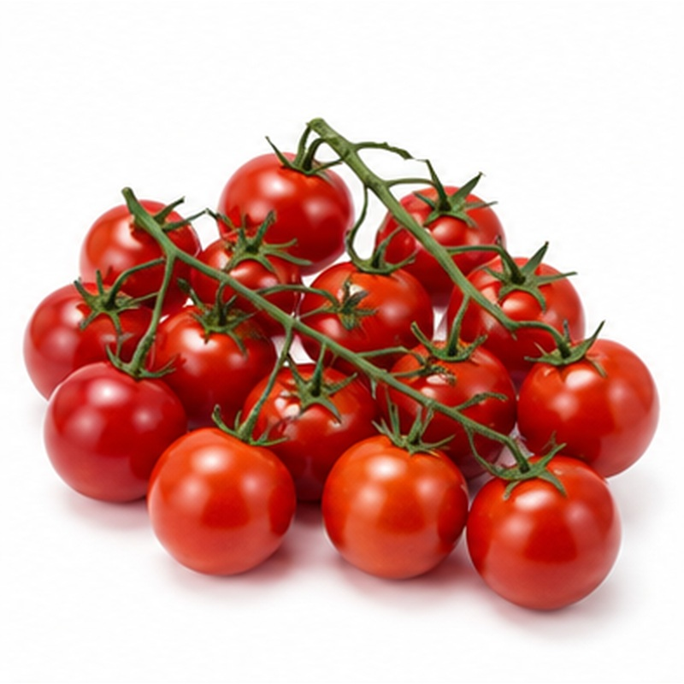 | Sweet bite-sized tomatoes with bright colour and premium pack presentation.  VARIETIES / TYPES Red, yellow and mixed cherry tomato  EXPORT HANDLING Clusters or loose fruit are selected for firmness and uniform ripeness, cooled moderately and packed in ventilated punnets. Rough handling and condensation are avoided.  PACKING Clamshell punnets or flow-wrapped trays  COLD-CHAIN GUIDE Typically 10-12 C

14 BELL PEPPER / CAPSICUM
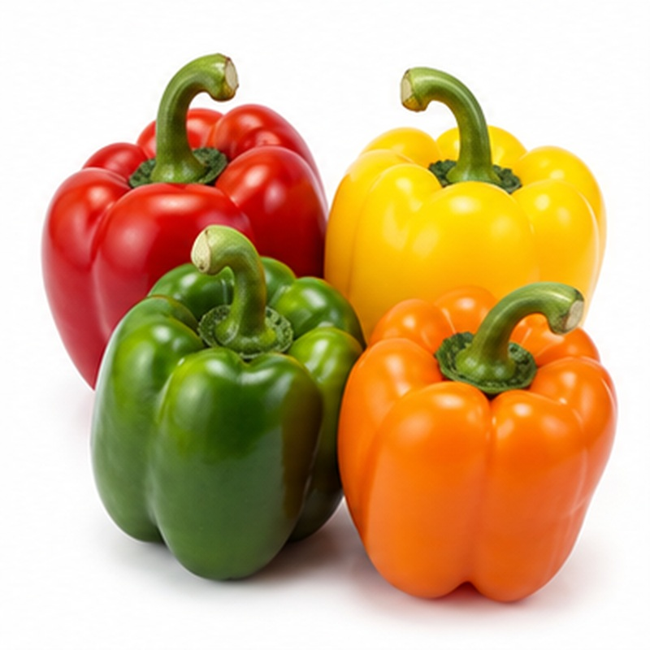 | Glossy sweet peppers selected for firm walls, vivid colour and sound stems.  VARIETIES / TYPES Green, red, yellow and orange  EXPORT HANDLING Peppers are clipped, cleaned, graded by colour and size, and packed to prevent rubbing. Moderate cooling preserves firmness without causing chilling injury.  PACKING Cartons, trays or consumer packs  COLD-CHAIN GUIDE Typically 7-10 C

15 CHILI PEPPER
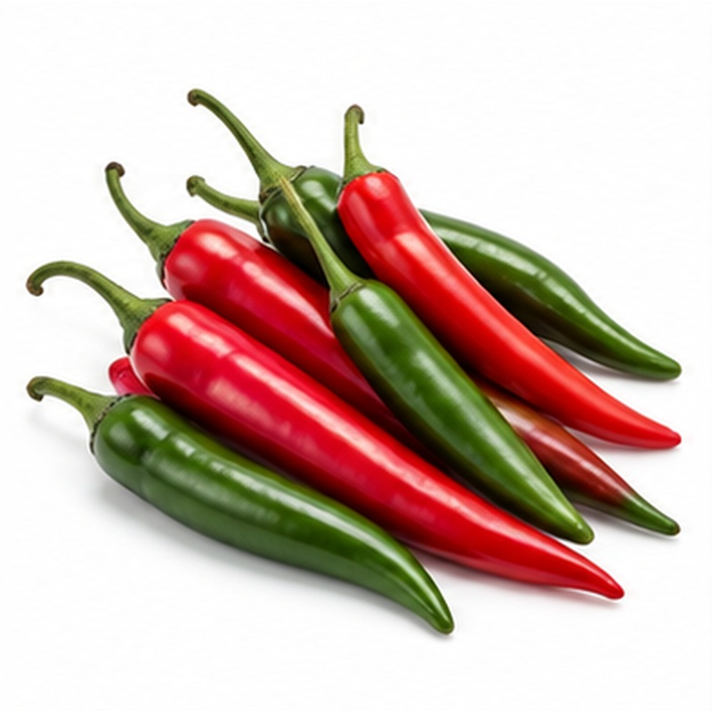 | Fresh chilies offering strong colour, firm texture and heat levels suited to buyer requirements.  VARIETIES / TYPES Green, red and selected hot varieties  EXPORT HANDLING Pods are harvested with sound stems, sorted for colour and defects, cooled and packed in ventilated formats. Prevent compression, dehydration and excess condensation.  PACKING Punnets, bags or ventilated cartons  COLD-CHAIN GUIDE Typically 7-10 C

16 CUCUMBER
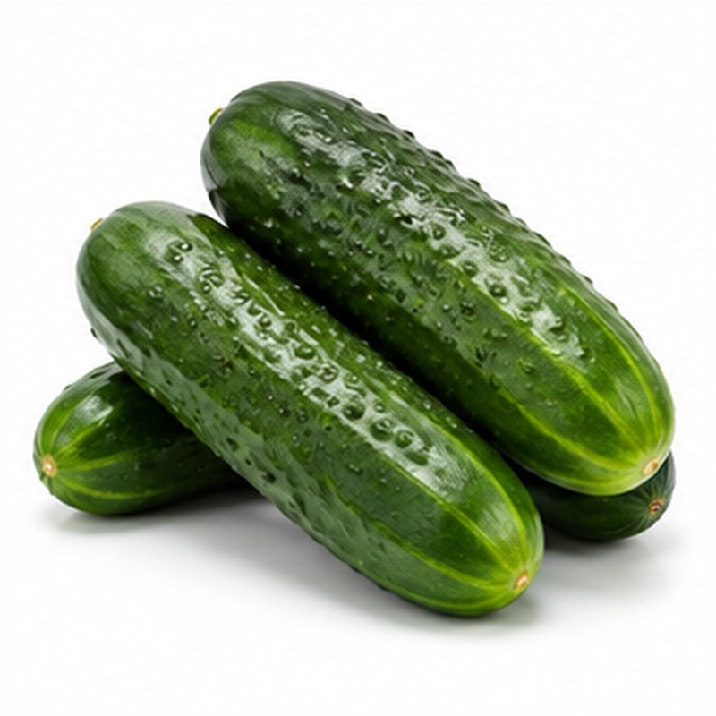 | Crisp cucumbers selected for straight shape, fresh colour and uniform size.  VARIETIES / TYPES English, mini and standard cucumber  EXPORT HANDLING Fruit is harvested before over-maturity, graded carefully and packed with moisture protection. Moderate temperatures reduce water loss while avoiding chilling damage.  PACKING Cartons, trays or shrink-wrapped packs  COLD-CHAIN GUIDE Typically 10-12 C

17 ZUCCHINI / COURGETTE
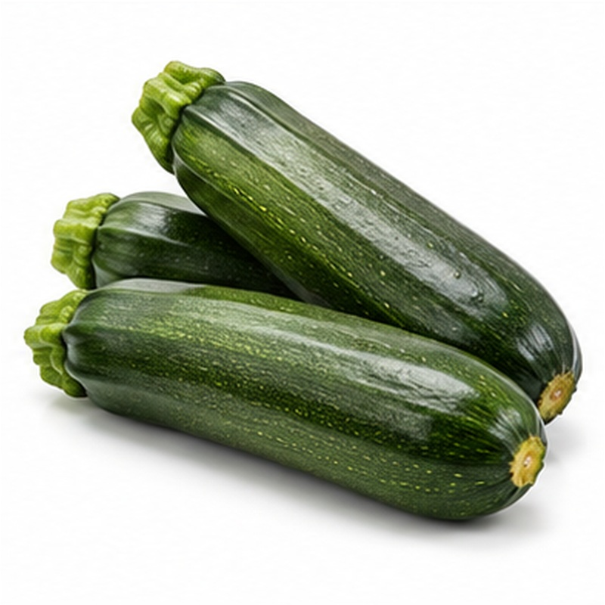 | Tender courgettes with glossy skin, firm flesh and consistent export sizing.  VARIETIES / TYPES Green and yellow zucchini  EXPORT HANDLING Fruit is picked young, handled gently, pre-cooled and graded for length and diameter. Packs are ventilated and protected from abrasion and chilling.  PACKING Cartons, trays or crates  COLD-CHAIN GUIDE Typically 7-10 C

18 EGGPLANT / AUBERGINE
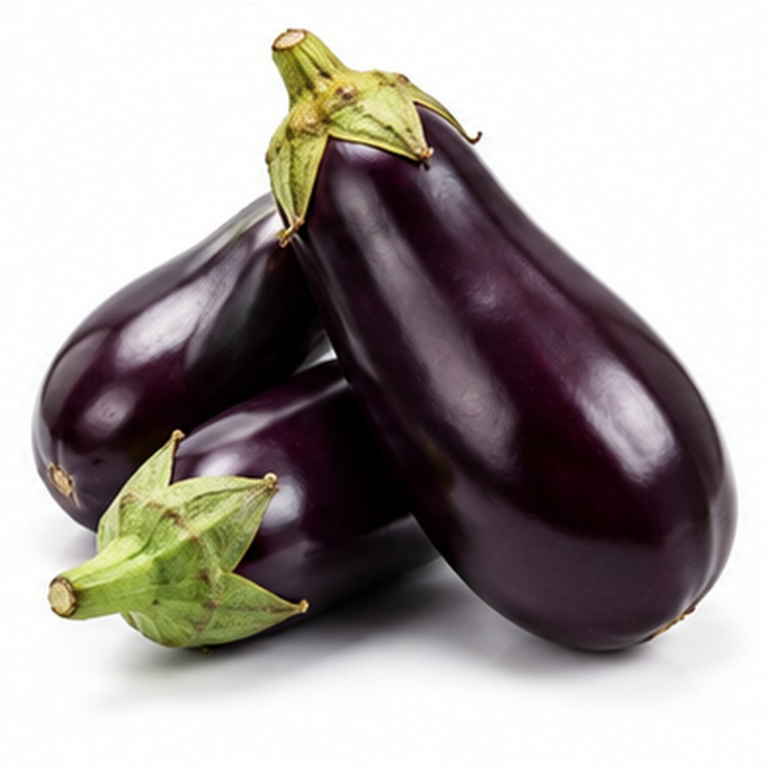 | Glossy aubergines selected for rich colour, firm flesh and fresh green caps.  VARIETIES / TYPES Black, white and long eggplant  EXPORT HANDLING Fruit is clipped carefully, graded and packed with separators to prevent scuffing. Moderate cooling and high humidity help preserve shine and firmness.  PACKING Tray-packed or layered cartons  COLD-CHAIN GUIDE Typically 10-12 C

19 OKRA
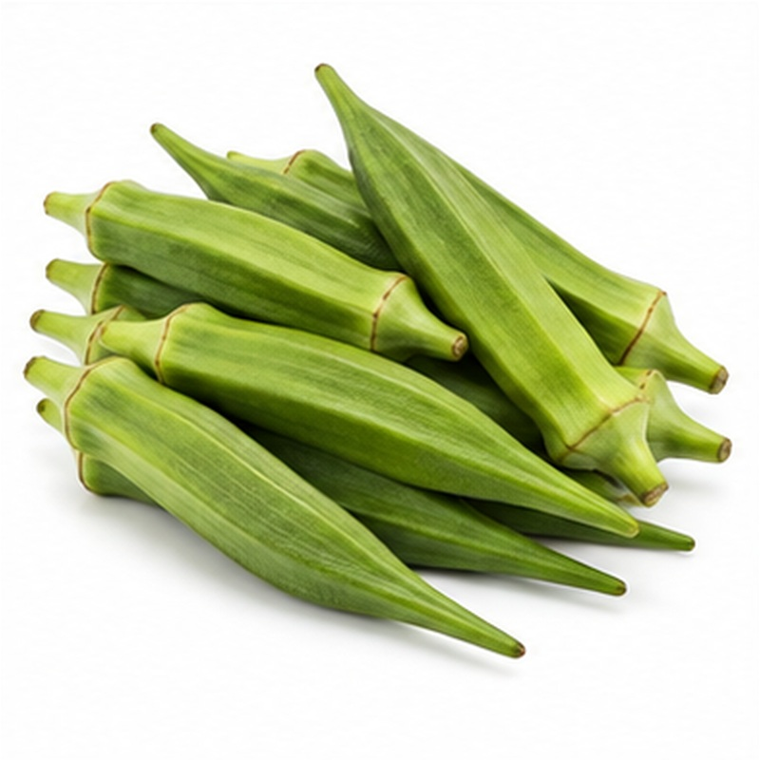 | Tender green okra pods chosen for fresh colour, clean shape and minimal fibre.  VARIETIES / TYPES Fine, medium and selected Egyptian varieties  EXPORT HANDLING Pods are harvested young, shaded and cooled promptly, then graded by length and packed with moisture control. Avoid bruising, wet packs and excessive chilling.  PACKING Punnets or ventilated cartons  COLD-CHAIN GUIDE Typically 7-10 C

20 SWEET CORN
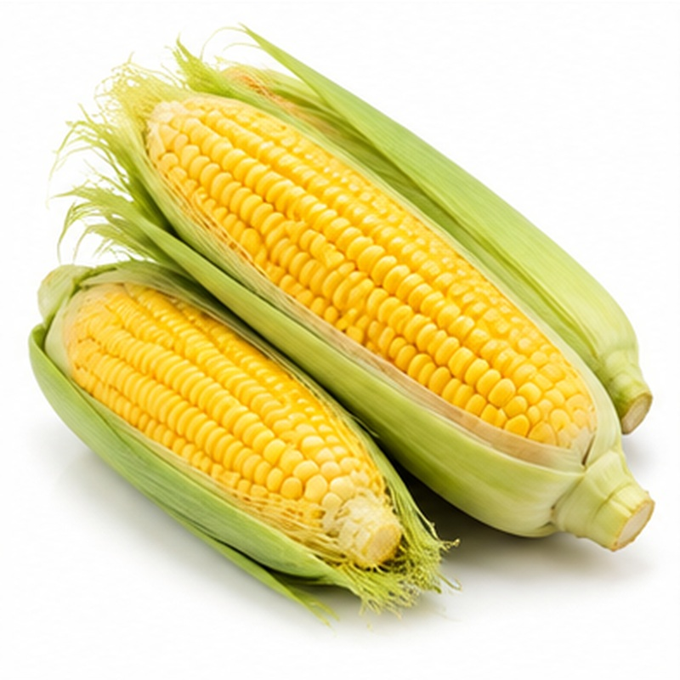 | Sweet corn supplied with plump kernels, fresh husks and strong eating quality.  VARIETIES / TYPES Fresh corn on the cob  EXPORT HANDLING Cobs are harvested at peak sweetness and cooled immediately to slow sugar loss. Husks are retained where required and cartons are kept continuously refrigerated.  PACKING Cartons, crates or consumer packs  COLD-CHAIN GUIDE Typically 0-2 C

21 GREEN BEANS
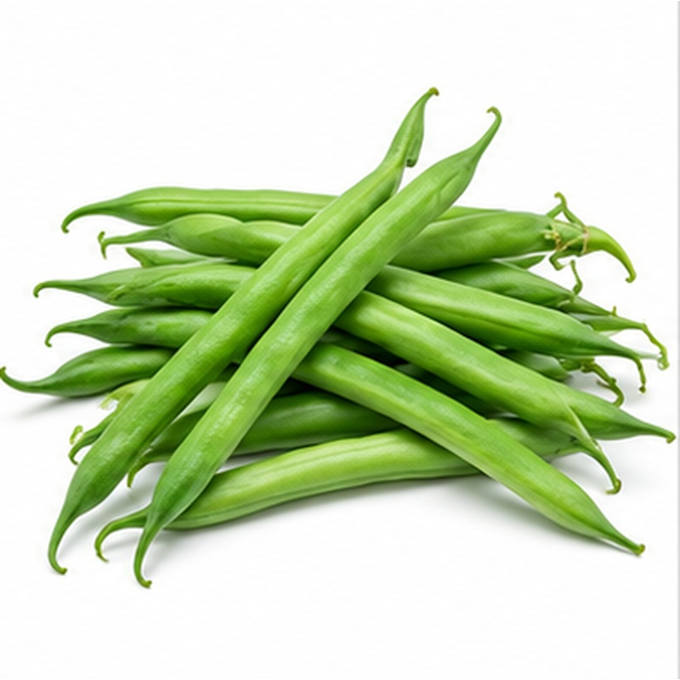 | Fresh green beans selected for straight pods, crisp snap and uniform green colour.  VARIETIES / TYPES Fine, extra-fine and standard beans  EXPORT HANDLING Beans are hand-picked, sorted by length and diameter, pre-cooled and packed with ventilation. Moisture and temperature are balanced to limit wilting and chilling injury.  PACKING Lined cartons, bags or punnets  COLD-CHAIN GUIDE Typically 5-7 C

22 GREEN PEAS
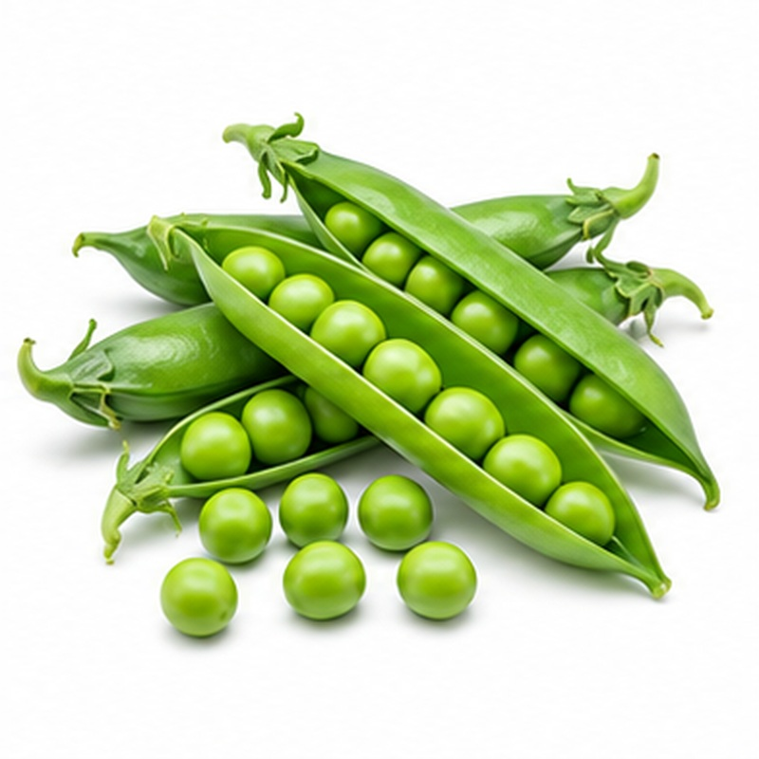 | Sweet green peas supplied in fresh, well-filled pods with bright colour and tender texture.  VARIETIES / TYPES Fresh garden peas  EXPORT HANDLING Pods are harvested young, cooled immediately and graded for fill and appearance. High humidity and fast refrigerated distribution protect sweetness and freshness.  PACKING Punnets, bags or lined cartons  COLD-CHAIN GUIDE Typically 0-2 C

23 SNOW PEAS / MANGETOUT
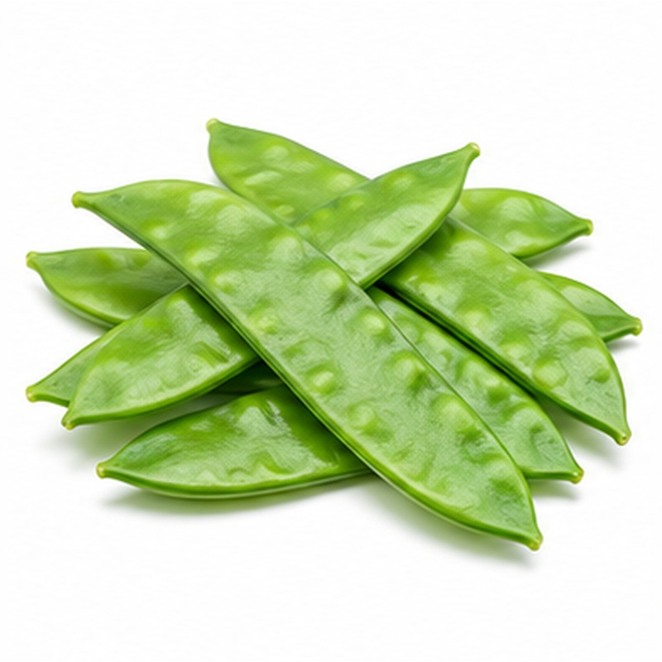 | Delicate flat pods valued for crisp texture, vivid colour and premium culinary use.  VARIETIES / TYPES Flat edible-pod peas  EXPORT HANDLING Pods are hand-picked, sorted for tenderness and freedom from blemishes, then rapidly cooled. Moisture-protective packs reduce wilting during distribution.  PACKING Punnets or lined cartons  COLD-CHAIN GUIDE Typically 0-2 C

24 SUGAR SNAP PEAS
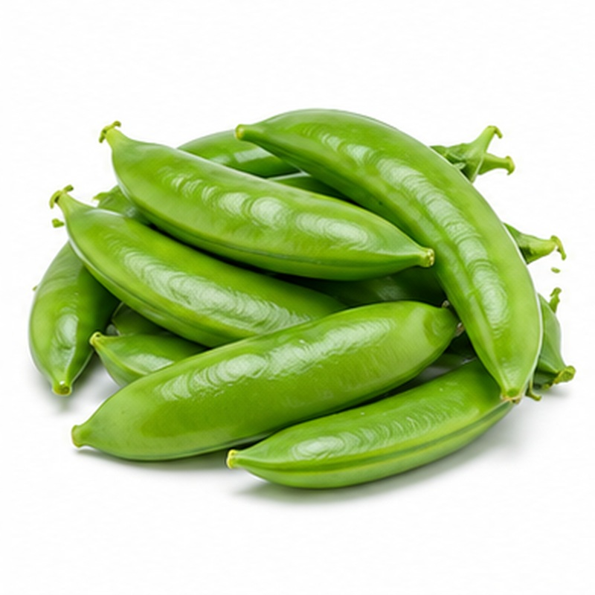 | Plump, crisp pods combining clean sweetness with convenient whole-pod use.  VARIETIES / TYPES Fresh edible-pod sugar snap peas  EXPORT HANDLING Peas are harvested at the required fill, cooled promptly, graded and packed in small ventilated units. Maintain high humidity without free moisture.  PACKING Punnets, bags or lined cartons  COLD-CHAIN GUIDE Typically 0-2 C

25 BROAD BEANS
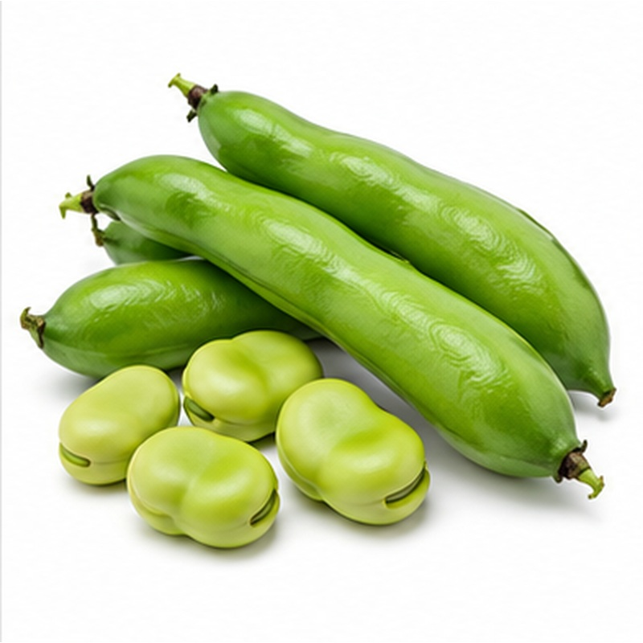 | Fresh broad beans supplied in full green pods with tender, well-developed seeds.  VARIETIES / TYPES Fresh fava beans  EXPORT HANDLING Pods are harvested before fibrous maturity, shaded and cooled quickly, then graded for fill and colour. Refrigerated handling limits yellowing and moisture loss.  PACKING Ventilated cartons, crates or bags  COLD-CHAIN GUIDE Typically 0-2 C

26 BROCCOLI
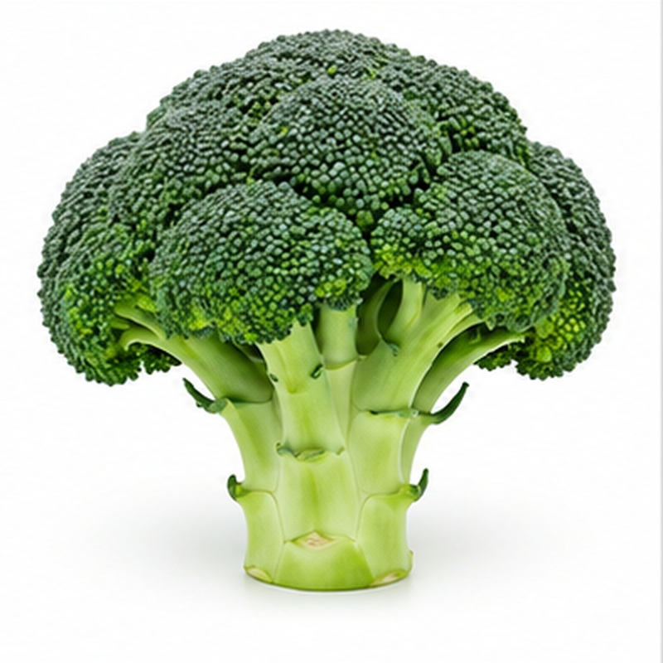 | Dense green broccoli with compact florets, fresh-cut stems and strong visual quality.  VARIETIES / TYPES Standard heads and tenderstem/baby broccoli  EXPORT HANDLING Heads are cut, trimmed and cooled immediately, commonly by hydrocooling or forced air. Continuous refrigeration and high humidity prevent yellowing and wilting.  PACKING Lined cartons, crates or retail packs  COLD-CHAIN GUIDE Typically 0-2 C

27 CAULIFLOWER
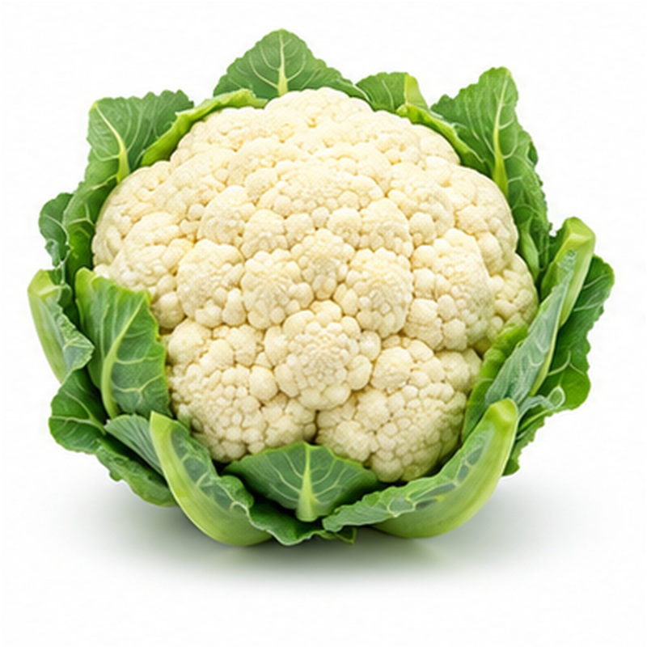 | Compact white curds protected by fresh wrapper leaves and selected for uniform size.  VARIETIES / TYPES White cauliflower  EXPORT HANDLING Heads are trimmed, graded and rapidly pre-cooled. Protective leaves or liners reduce bruising, yellowing and moisture loss during refrigerated transport.  PACKING Lined cartons or crates  COLD-CHAIN GUIDE Typically 0-2 C

28 CABBAGE
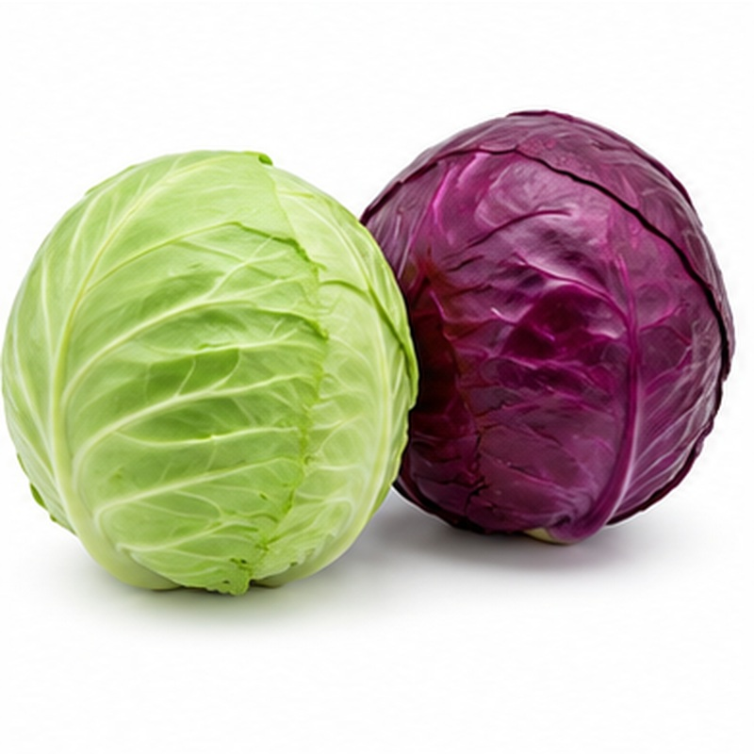 | Firm cabbage heads selected for compact structure, fresh leaves and consistent weight.  VARIETIES / TYPES White/green and red cabbage  EXPORT HANDLING Outer damaged leaves are removed, stems trimmed and heads graded. Cool, humid storage and secure stacking preserve crispness and limit dehydration.  PACKING Cartons, crates, bags or bulk bins  COLD-CHAIN GUIDE Typically 0-2 C

29 BRUSSELS SPROUTS
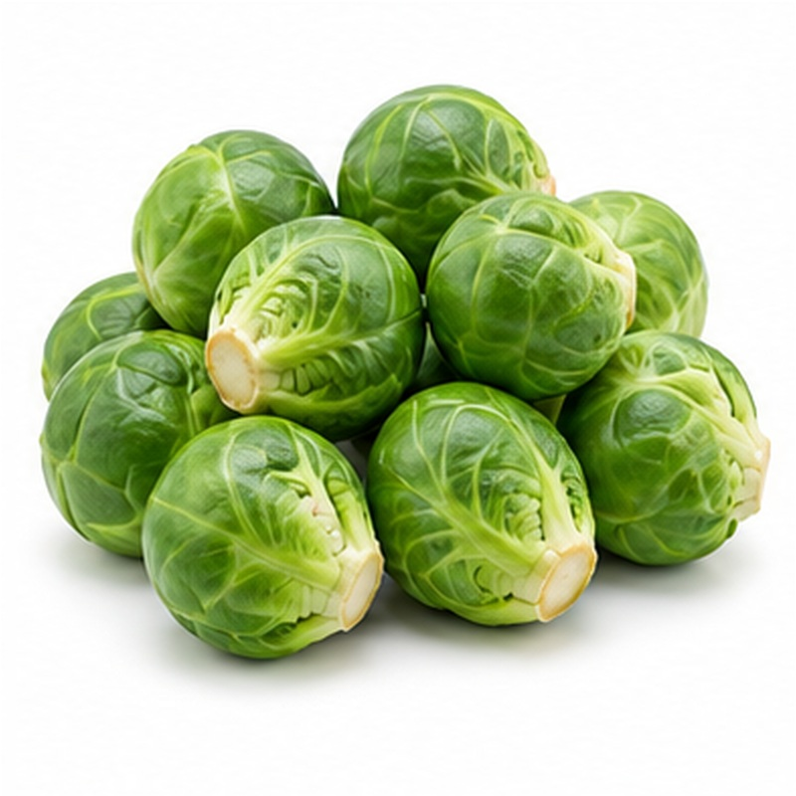 | Compact green sprouts supplied with tight leaves and consistent small calibre.  VARIETIES / TYPES Selected seasonal varieties  EXPORT HANDLING Sprouts are trimmed, sorted and cooled immediately after harvest. High humidity and continuous refrigeration slow yellowing and leaf separation.  PACKING Punnets, bags or lined cartons  COLD-CHAIN GUIDE Typically 0-2 C

30 ICEBERG LETTUCE
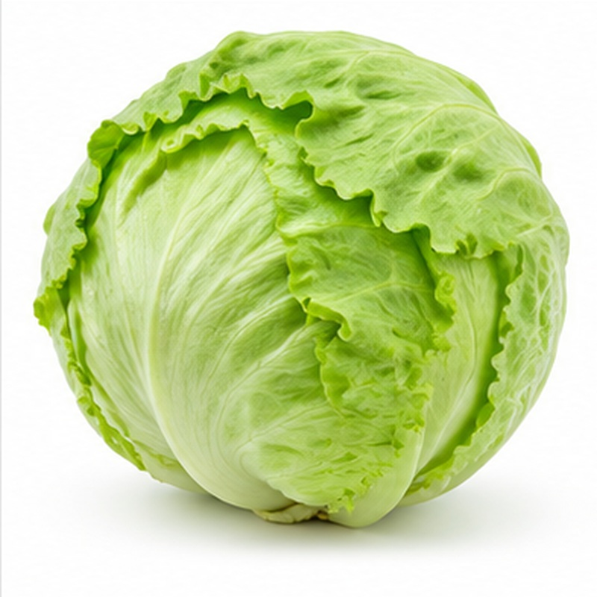 | Crisp compact lettuce with fresh wrapper leaves and dependable retail presentation.  VARIETIES / TYPES Standard iceberg  EXPORT HANDLING Heads are cut, trimmed, vacuum- or forced-air cooled promptly and packed to prevent compression. An uninterrupted high-humidity cold chain is essential.  PACKING Lined cartons or crates  COLD-CHAIN GUIDE Typically 0-2 C

31 ROMAINE LETTUCE
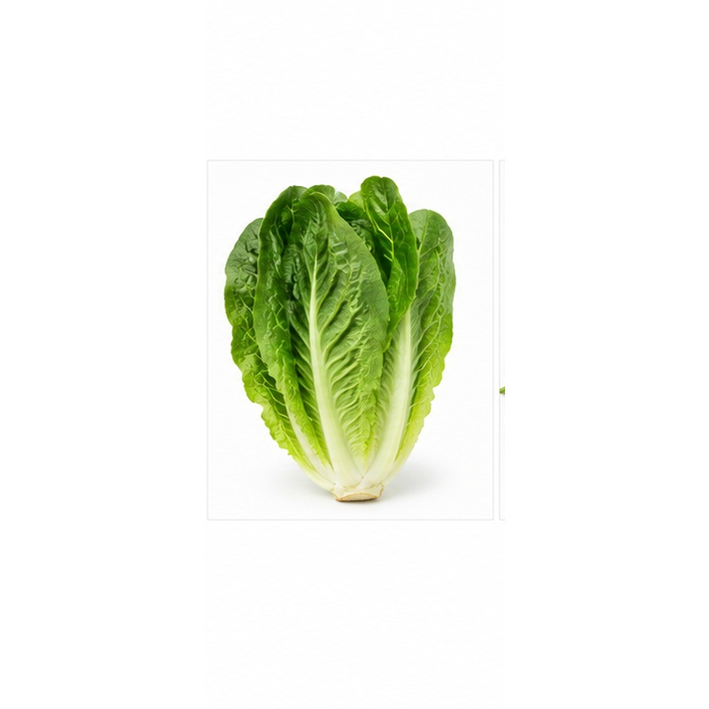 | Upright romaine lettuce with crisp ribs, fresh green leaves and clean flavour.  VARIETIES / TYPES Standard and baby romaine  EXPORT HANDLING Heads are trimmed, washed where required, cooled immediately and packed upright or layered. Protect from crushing, dehydration and ethylene exposure.  PACKING Lined cartons, crates or retail packs  COLD-CHAIN GUIDE Typically 0-2 C

32 SPINACH
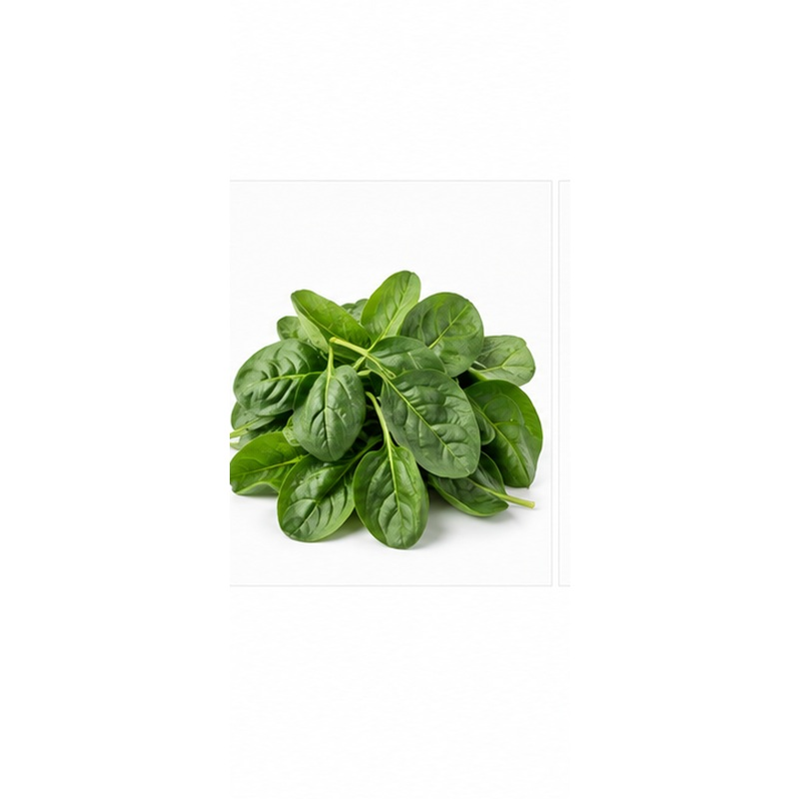 | Tender green spinach selected for leaf colour, freshness and freedom from yellowing.  VARIETIES / TYPES Bunched and baby spinach  EXPORT HANDLING Leaves are harvested in cool conditions, washed where specified, dried, rapidly cooled and packed with controlled ventilation. Strict refrigeration supports short shelf life.  PACKING Bags, punnets or lined cartons  COLD-CHAIN GUIDE Typically 0-2 C

33 CELERY
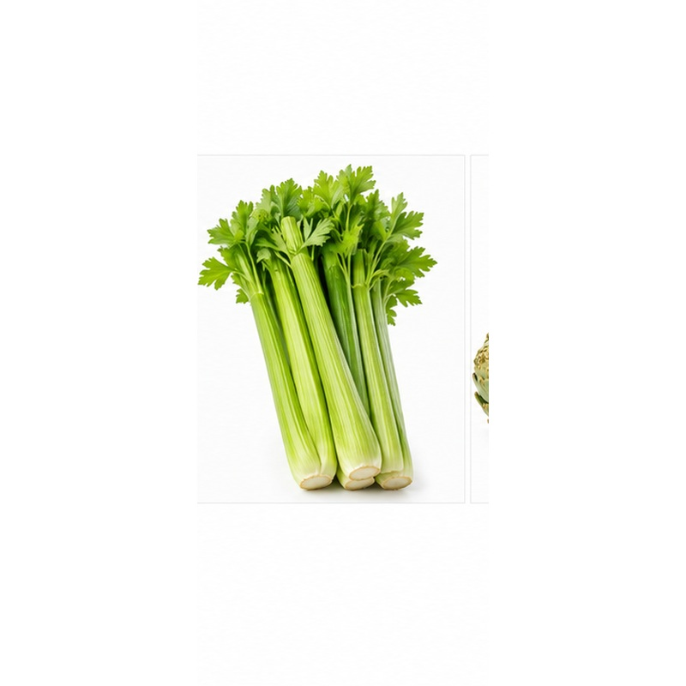 | Crisp celery with firm stalks, fresh leaves and uniform bunch formation.  VARIETIES / TYPES Standard celery  EXPORT HANDLING Plants are trimmed, washed and cooled quickly, then sleeved or lined to retain moisture. Careful stacking prevents splitting and crushing.  PACKING Sleeved bunches in cartons or crates  COLD-CHAIN GUIDE Typically 0-2 C

34 ARTICHOKE
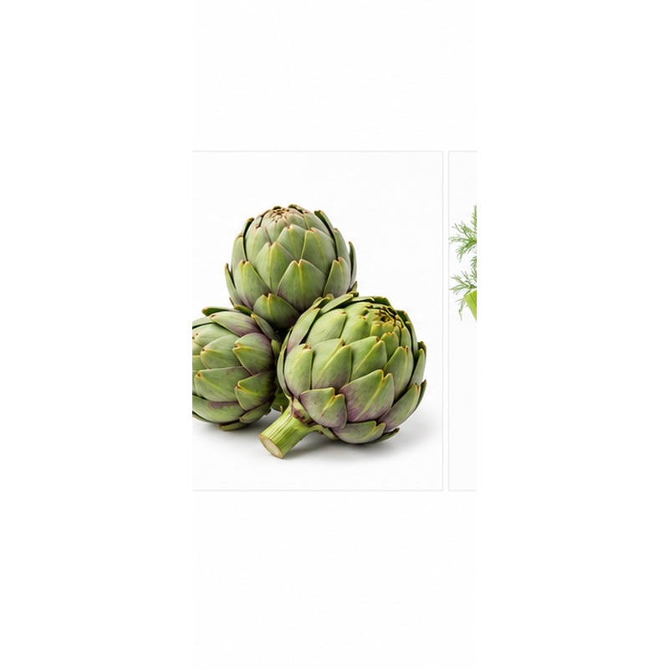 | Premium flower buds selected for compact scales, fresh colour and firm stems.  VARIETIES / TYPES Globe artichoke  EXPORT HANDLING Buds are clipped, graded by diameter and cooled promptly. High humidity and protective cartons reduce wilting, browning and mechanical damage.  PACKING Layered cartons or crates  COLD-CHAIN GUIDE Typically 0-2 C

35 FENNEL
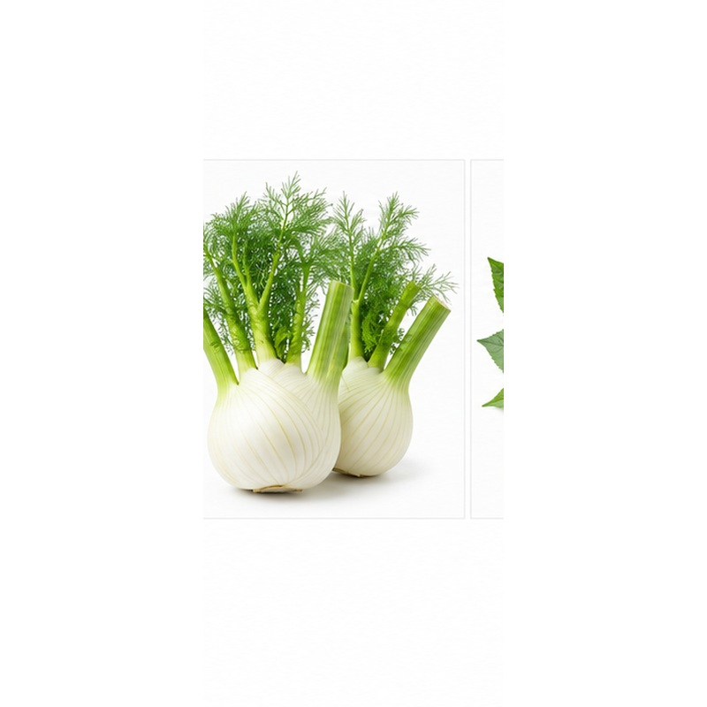 | Clean white fennel bulbs with crisp texture, green tops and a mild aromatic flavour.  VARIETIES / TYPES Florence fennel  EXPORT HANDLING Bulbs are trimmed, washed, graded and rapidly cooled. Lined packs and high humidity protect against dehydration while allowing ventilation.  PACKING Lined cartons, crates or consumer packs  COLD-CHAIN GUIDE Typically 0-2 C

36 FRESH MOLOKHIA / JUTE MALLOW
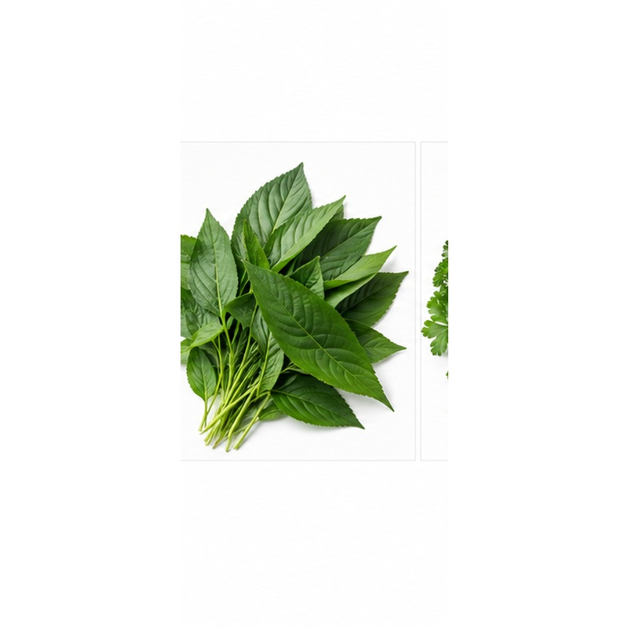 | Tender Egyptian molokhia leaves valued for vibrant colour and traditional culinary use.  VARIETIES / TYPES Fresh whole leaves or trimmed bunches  EXPORT HANDLING Leaves are harvested young, shaded immediately, sorted and cooled promptly. They are packed lightly to avoid crushing, heat build-up and rapid moisture loss.  PACKING Bunches, perforated bags or lined cartons  COLD-CHAIN GUIDE Typically 5-8 C

37 FRESH HERBS
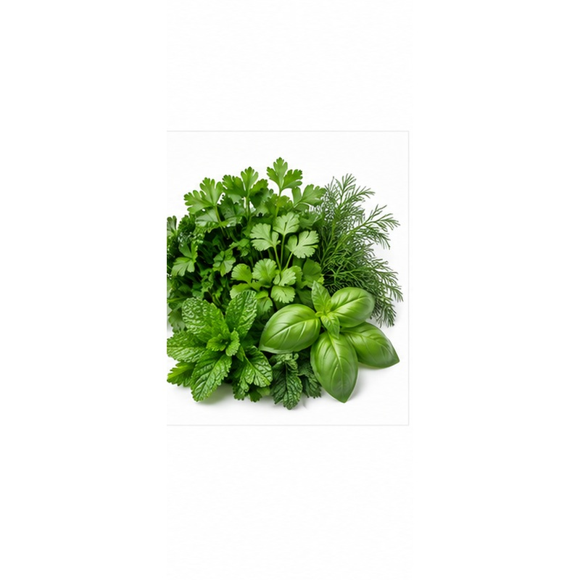 | A versatile herb range supplied for fresh aroma, vivid colour and clean bunch presentation.  VARIETIES / TYPES Parsley, coriander/cilantro, dill, mint and basil  EXPORT HANDLING Herbs are harvested in cool hours, trimmed, washed where specified and cooled quickly. Moisture, ventilation and temperature are adjusted by herb type to prevent wilting or chilling.  PACKING Bunches, punnets or lined cartons  COLD-CHAIN GUIDE Typically 2-8 C depending on herb

NILE-MAPLE
Flexible sourcing • Buyer-specific specifications • Export-ready handling
Packaging, calibre, maturity, treatment, temperature and shipment programmes are confirmed according to product, destination market and buyer requirements.

