NILE-MAPLE
FROZEN PRODUCTS
IQF Product & Export Handling Catalogue
Selected produce. Rapid freezing. Reliable global supply.

01 FROZEN OKRA
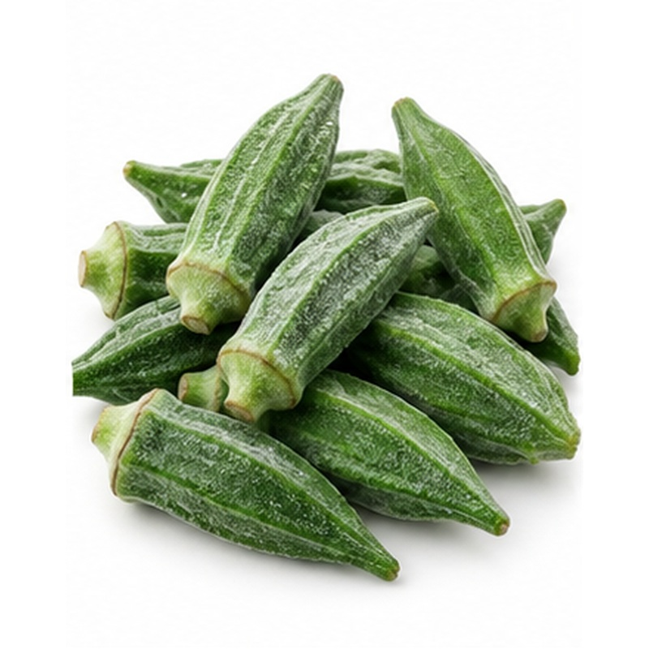 | Tender Egyptian okra preserved for year-round colour, flavour and convenient preparation.  AVAILABLE FORMS Whole, cut, zero, extra and fine grades  PROCESSING & HANDLING Selected young pods are washed, trimmed, graded and individually quick frozen. Product remains free-flowing and is protected from thawing or temperature fluctuation.  PACKING Retail pouches, food-service bags or lined bulk cartons  FROZEN-CHAIN GUIDE Keep frozen at -18 C or below

02 FROZEN MOLOKHIA
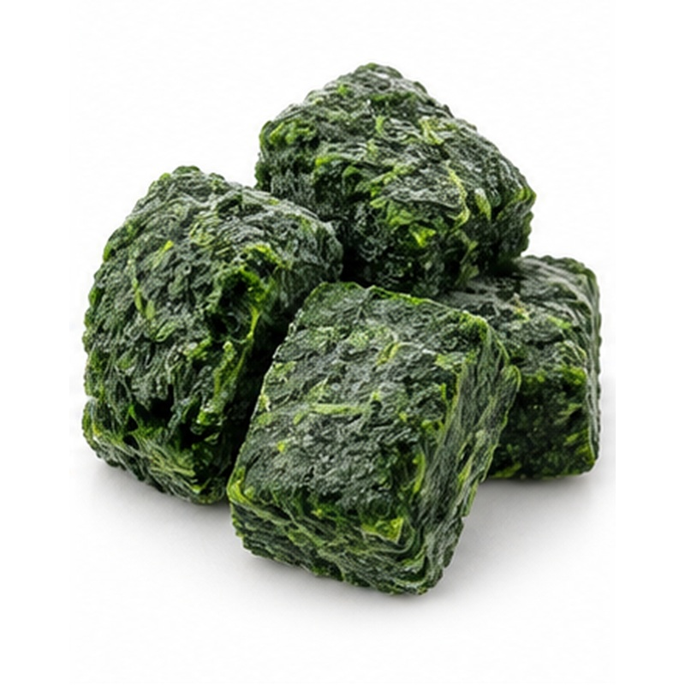 | A traditional Egyptian leafy product frozen soon after preparation to preserve its characteristic colour and flavour.  AVAILABLE FORMS Minced portions or whole leaves  PROCESSING & HANDLING Fresh leaves are inspected, washed and either minced or kept whole before rapid freezing. Hygienic processing and an uninterrupted frozen chain protect quality.  PACKING Retail blocks, pouches or bulk cartons  FROZEN-CHAIN GUIDE Keep frozen at -18 C or below

03 FROZEN GREEN PEAS
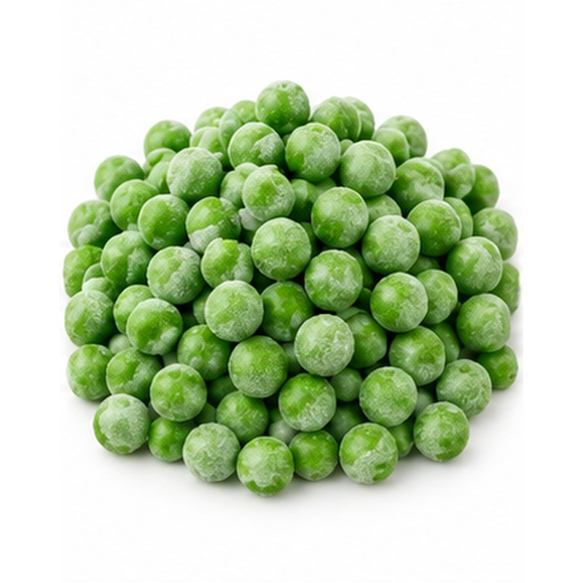 | Sweet green peas with uniform colour, tenderness and reliable year-round availability.  AVAILABLE FORMS Standard and premium grades  PROCESSING & HANDLING Peas are shelled, washed, blanched, cooled and IQF frozen shortly after harvest. Careful grading maintains uniform size and free-flowing condition.  PACKING Retail pouches, food-service bags or bulk cartons  FROZEN-CHAIN GUIDE Keep frozen at -18 C or below

04 FROZEN GREEN BEANS
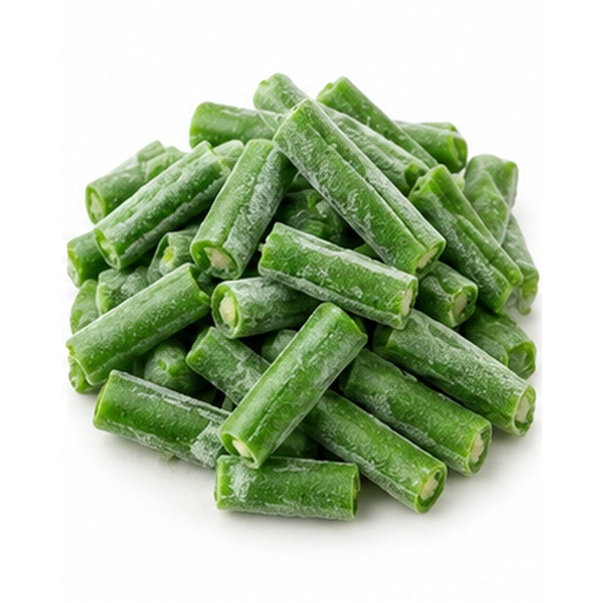 | Crisp green beans prepared in convenient formats for retail, catering and industrial buyers.  AVAILABLE FORMS Whole, cut and fine beans  PROCESSING & HANDLING Fresh pods are sorted, topped, washed, cut where required, blanched and IQF frozen. Size and cut length are agreed with the buyer.  PACKING Retail pouches, food-service bags or bulk cartons  FROZEN-CHAIN GUIDE Keep frozen at -18 C or below

05 FROZEN CARROTS
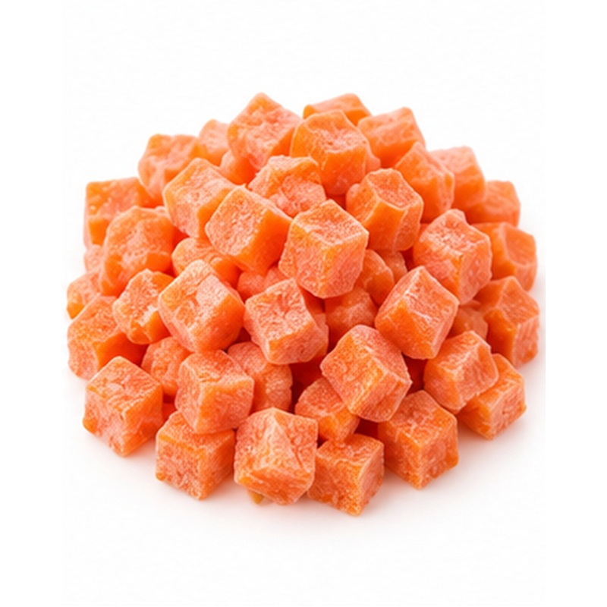 | Bright frozen carrots offering consistent colour, sizing and preparation convenience.  AVAILABLE FORMS Diced, sliced, strips or baby carrots  PROCESSING & HANDLING Roots are washed, peeled, cut, blanched and rapidly frozen. Pieces are graded to the requested dimensions and maintained free-flowing.  PACKING Retail pouches, food-service bags or bulk cartons  FROZEN-CHAIN GUIDE Keep frozen at -18 C or below

06 FROZEN PEAS & CARROTS
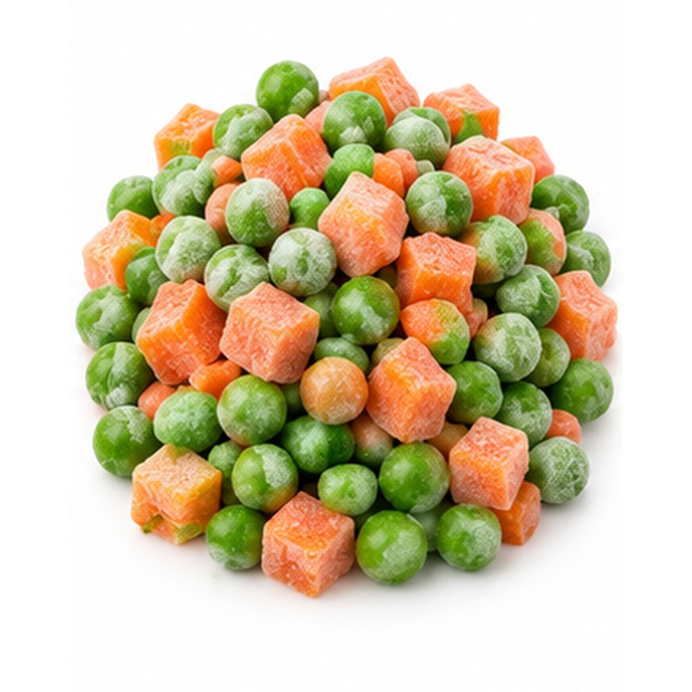 | A practical two-way vegetable blend with balanced colour, texture and portion consistency.  AVAILABLE FORMS Green peas with diced carrots  PROCESSING & HANDLING Each component is prepared and frozen before controlled blending. Ratios, dice size and grade can be aligned with the buyer specification.  PACKING Retail pouches, food-service bags or bulk cartons  FROZEN-CHAIN GUIDE Keep frozen at -18 C or below

07 FROZEN MIXED VEGETABLES
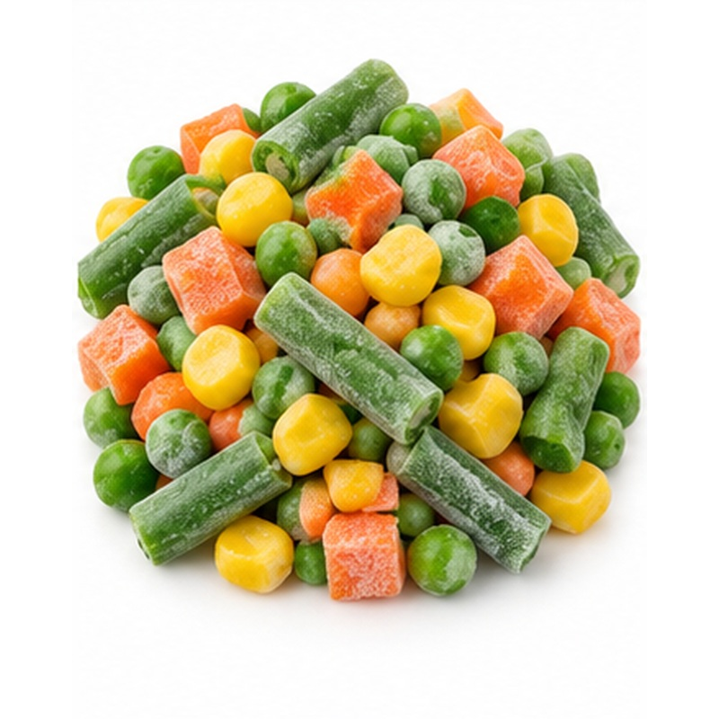 | A colourful four-way blend designed for convenient retail, food-service and ingredient use.  AVAILABLE FORMS Peas, carrots, yellow corn and green beans  PROCESSING & HANDLING Individually prepared vegetables are IQF frozen and blended to controlled proportions. Uniform cuts support even cooking and presentation.  PACKING Retail pouches, food-service bags or bulk cartons  FROZEN-CHAIN GUIDE Keep frozen at -18 C or below

08 FROZEN SPINACH
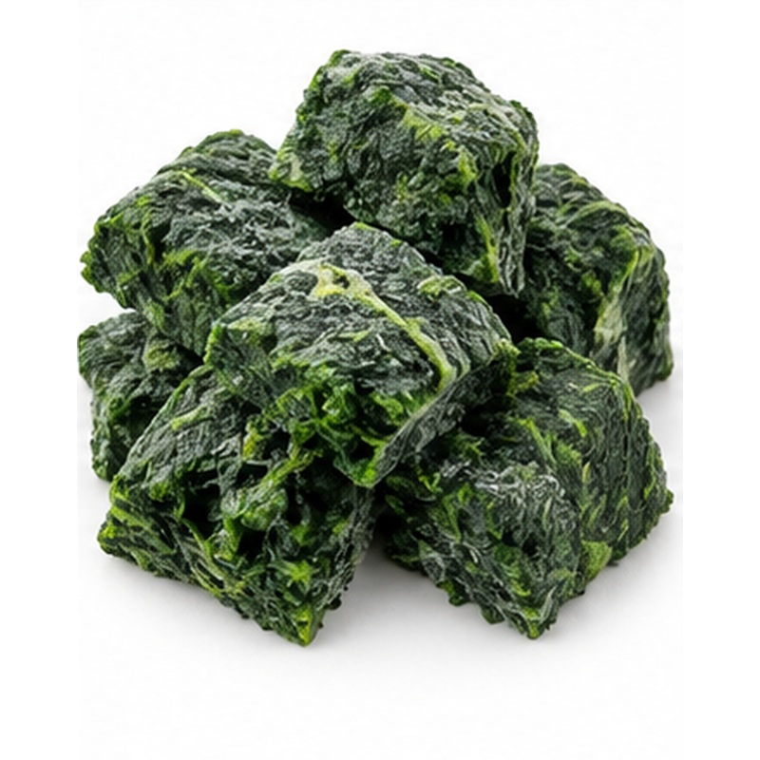 | Prepared spinach frozen for dependable colour, flavour and convenient portioning.  AVAILABLE FORMS Chopped, minced, leaf or portion blocks  PROCESSING & HANDLING Leaves are sorted, washed, blanched where specified, chopped or portioned and rapidly frozen. The product is protected from dehydration and thawing.  PACKING Retail blocks, pouches or bulk cartons  FROZEN-CHAIN GUIDE Keep frozen at -18 C or below

09 FROZEN BROCCOLI
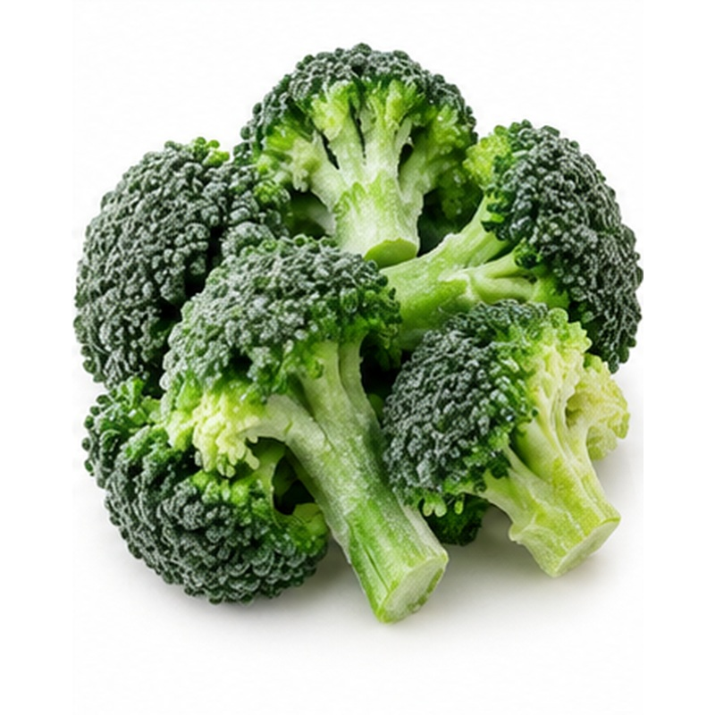 | Green broccoli florets supplied in uniform cuts for retail, catering and manufacturing.  AVAILABLE FORMS IQF florets in selected size ranges  PROCESSING & HANDLING Heads are trimmed into florets, inspected, washed, blanched, cooled and IQF frozen. Floret size and stem allowance follow buyer requirements.  PACKING Retail pouches, food-service bags or bulk cartons  FROZEN-CHAIN GUIDE Keep frozen at -18 C or below

10 FROZEN CAULIFLOWER
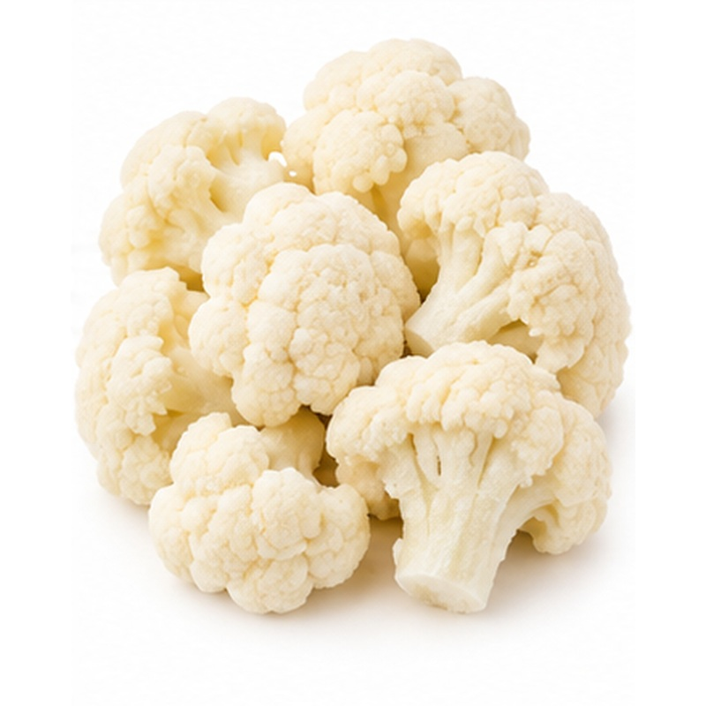 | Clean white cauliflower florets with consistent sizing and convenient year-round use.  AVAILABLE FORMS IQF florets in selected size ranges  PROCESSING & HANDLING Curds are trimmed, washed, divided into florets, blanched, cooled and IQF frozen. Grading removes discoloured or damaged pieces.  PACKING Retail pouches, food-service bags or bulk cartons  FROZEN-CHAIN GUIDE Keep frozen at -18 C or below

11 FROZEN ARTICHOKE
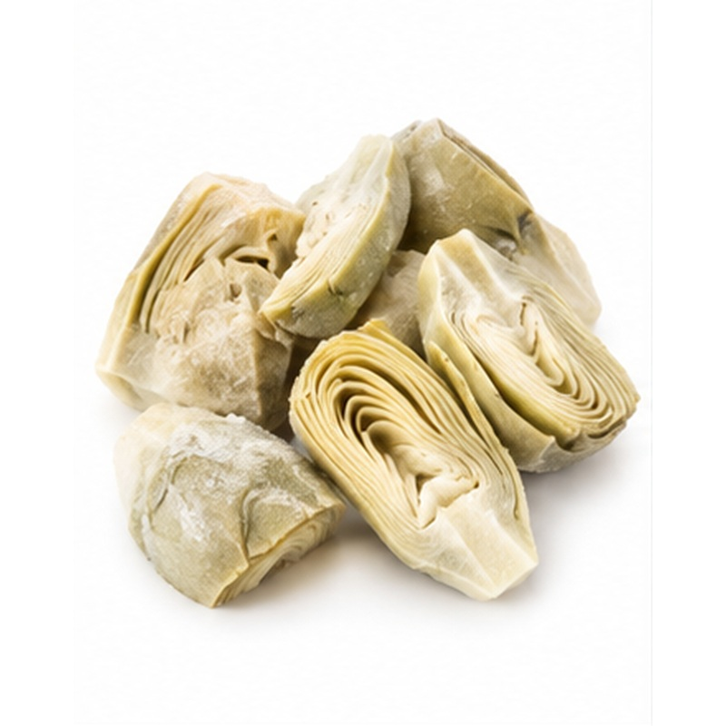 | Premium artichoke portions prepared for easy use in retail, catering and ingredient applications.  AVAILABLE FORMS Hearts, bottoms, quarters or segments  PROCESSING & HANDLING Fresh buds are trimmed, peeled, cut to specification, treated to limit browning and rapidly frozen. Piece size and trim level are buyer-defined.  PACKING Retail pouches, food-service bags or bulk cartons  FROZEN-CHAIN GUIDE Keep frozen at -18 C or below

12 FROZEN YELLOW SWEET CORN
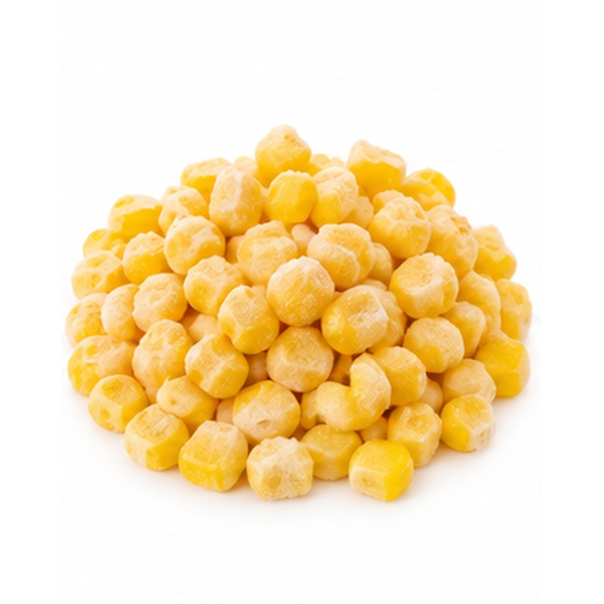 | Sweet yellow corn preserved close to harvest for bright colour and clean flavour.  AVAILABLE FORMS Kernels or corn-on-the-cob portions  PROCESSING & HANDLING Cobs are husked and cleaned; kernels are removed where required, then blanched, cooled and IQF frozen. Product is graded for colour and tenderness.  PACKING Retail pouches, food-service bags or bulk cartons  FROZEN-CHAIN GUIDE Keep frozen at -18 C or below

13 FROZEN BROAD BEANS
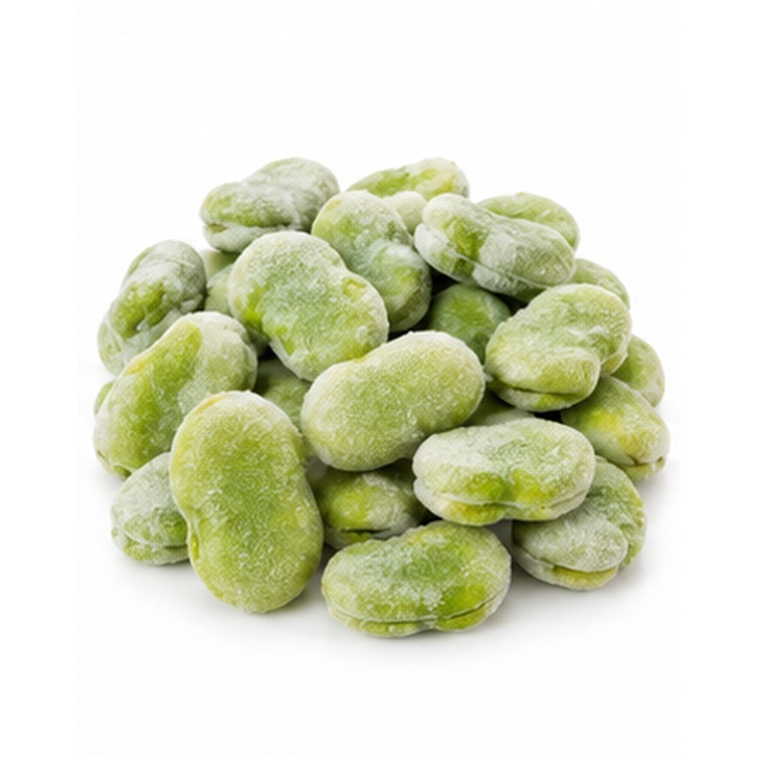 | Tender broad beans supplied for traditional dishes, food service and industrial preparation.  AVAILABLE FORMS Peeled or unpeeled fava beans  PROCESSING & HANDLING Beans are shelled, sorted, washed, blanched and rapidly frozen. Peeled formats may be produced according to buyer specification.  PACKING Retail pouches, food-service bags or bulk cartons  FROZEN-CHAIN GUIDE Keep frozen at -18 C or below

14 FROZEN TARO CUBES
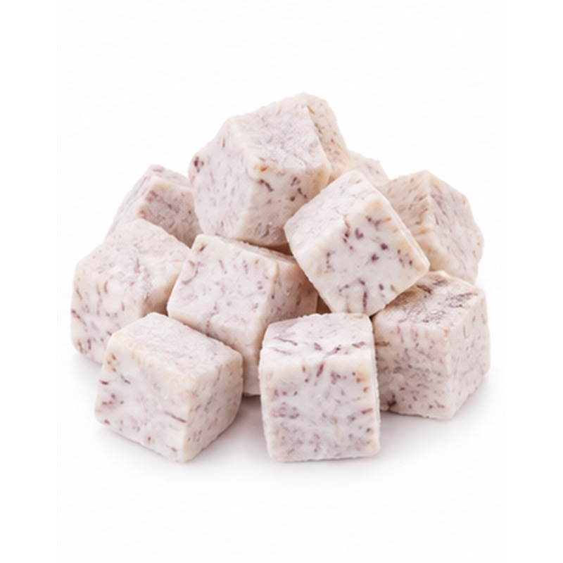 | Prepared taro supplied in uniform frozen cubes for convenient cooking and portion control.  AVAILABLE FORMS Peeled cubes or selected cut pieces  PROCESSING & HANDLING Roots are washed, peeled, trimmed and cut to controlled dimensions before rapid freezing. Pieces are inspected for colour and defects.  PACKING Retail pouches, food-service bags or bulk cartons  FROZEN-CHAIN GUIDE Keep frozen at -18 C or below

15 FROZEN FRENCH FRIES & POTATO PRODUCTS
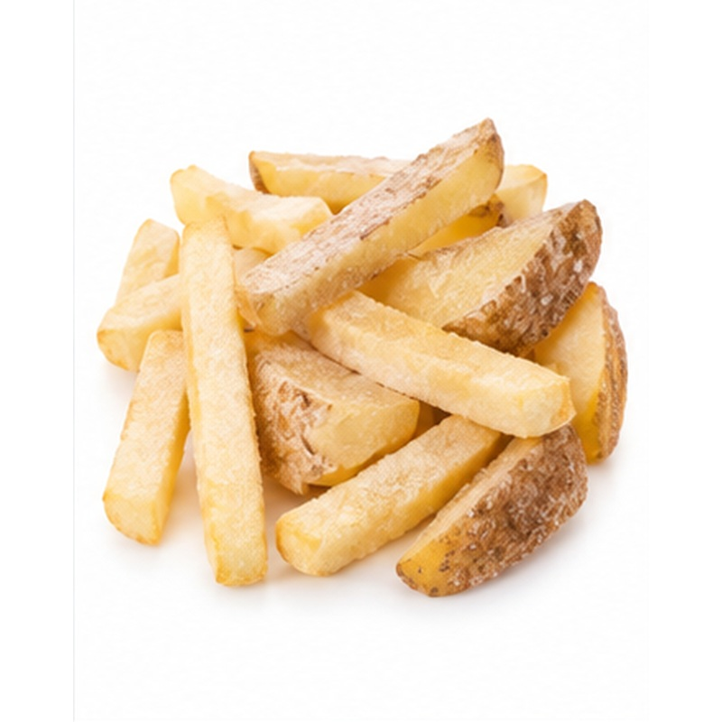 | Convenient frozen potato formats produced for retail, catering and quick-service applications.  AVAILABLE FORMS French fries, wedges and potato cubes  PROCESSING & HANDLING Potatoes are washed, peeled, cut, blanched and frozen; fries may be partially fried according to specification. Cut, coating and cooking performance are buyer-defined.  PACKING Retail bags, food-service bags or bulk cartons  FROZEN-CHAIN GUIDE Keep frozen at -18 C or below

16 FROZEN ONION
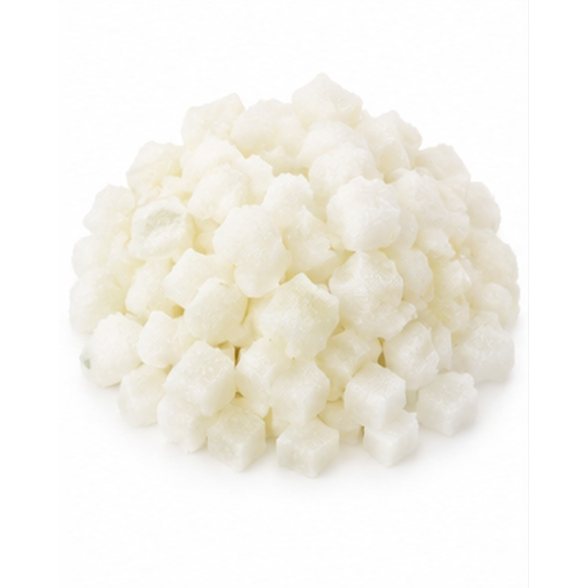 | Prepared onion delivering consistent cuts and convenient year-round ingredient supply.  AVAILABLE FORMS Diced, sliced, strips or whole baby onion  PROCESSING & HANDLING Bulbs are peeled, washed, cut to specification and rapidly frozen. Pieces are screened for size, colour and foreign material.  PACKING Retail pouches, food-service bags or bulk cartons  FROZEN-CHAIN GUIDE Keep frozen at -18 C or below

17 FROZEN BELL PEPPER
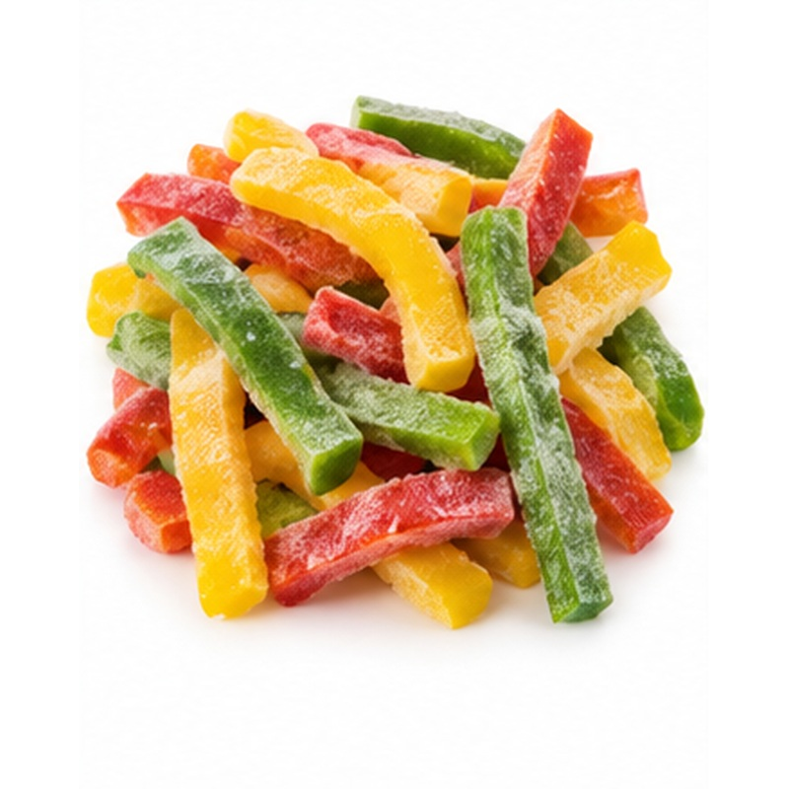 | Colourful frozen peppers prepared for cooking, food service and manufacturing applications.  AVAILABLE FORMS Strips, diced pieces or mixed colours  PROCESSING & HANDLING Peppers are washed, cored, deseeded, cut and IQF frozen. Green, red, yellow and mixed-colour programmes can be supplied.  PACKING Retail pouches, food-service bags or bulk cartons  FROZEN-CHAIN GUIDE Keep frozen at -18 C or below

18 FROZEN ZUCCHINI
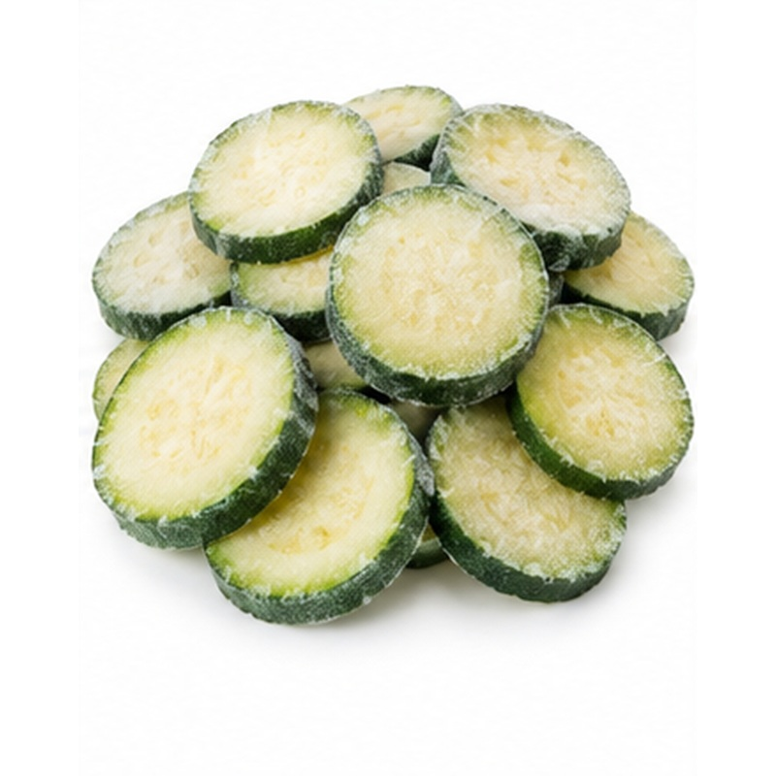 | Tender zucchini supplied in uniform frozen cuts for convenient recipe preparation.  AVAILABLE FORMS Slices, half-slices or diced  PROCESSING & HANDLING Courgettes are washed, trimmed, cut, blanched where required and rapidly frozen. Cut size and skin specification follow buyer requirements.  PACKING Retail pouches, food-service bags or bulk cartons  FROZEN-CHAIN GUIDE Keep frozen at -18 C or below

19 FROZEN GRILLED EGGPLANT
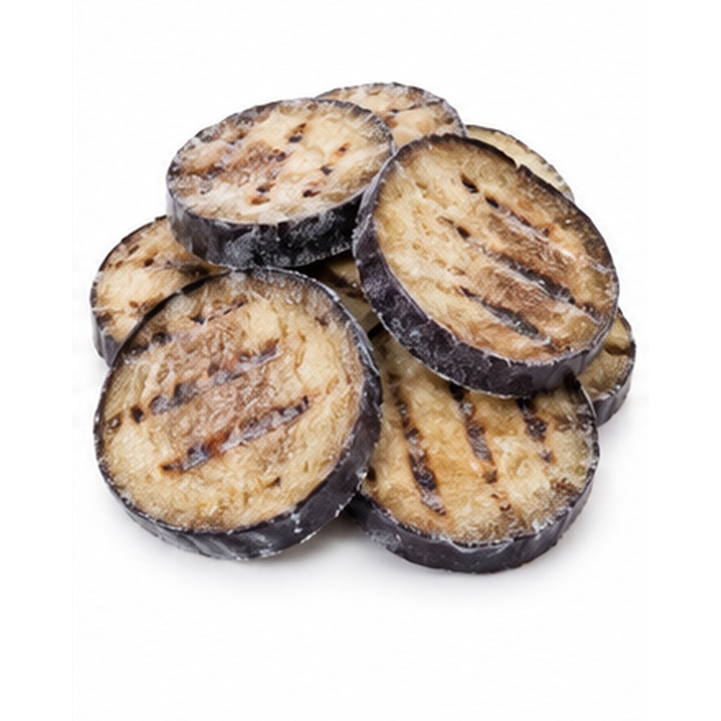 | Prepared aubergine with convenient formats for Mediterranean dishes and food-service use.  AVAILABLE FORMS Grilled slices, cubes or peeled pieces  PROCESSING & HANDLING Fruit is washed, trimmed and cut; selected formats are grilled before rapid freezing. Thickness, peel and grill level can be customised.  PACKING Retail pouches, food-service bags or bulk cartons  FROZEN-CHAIN GUIDE Keep frozen at -18 C or below

20 FROZEN STRAWBERRY
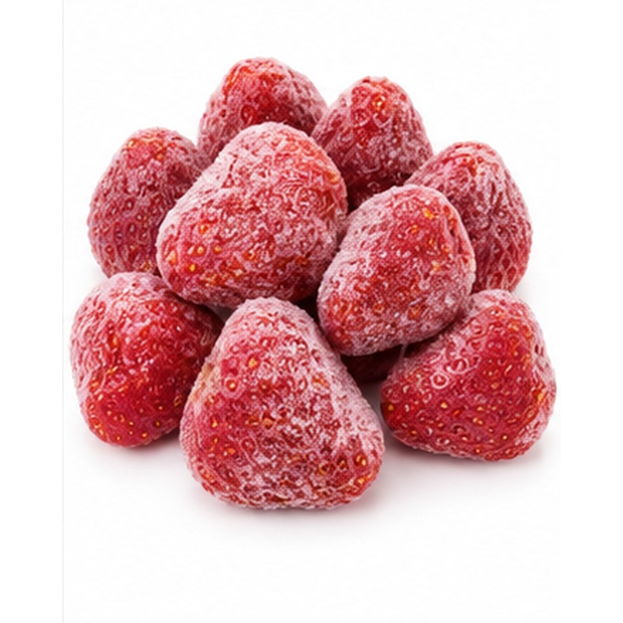 | A flagship Egyptian frozen fruit valued for vivid colour, natural flavour and broad industrial use.  AVAILABLE FORMS Whole, halves, slices or diced  PROCESSING & HANDLING Berries are selected, washed, hulled, graded and IQF frozen soon after harvest. Size, Brix range and cut format are agreed by specification.  PACKING Retail pouches, food-service bags or lined bulk cartons  FROZEN-CHAIN GUIDE Keep frozen at -18 C or below

21 FROZEN MANGO
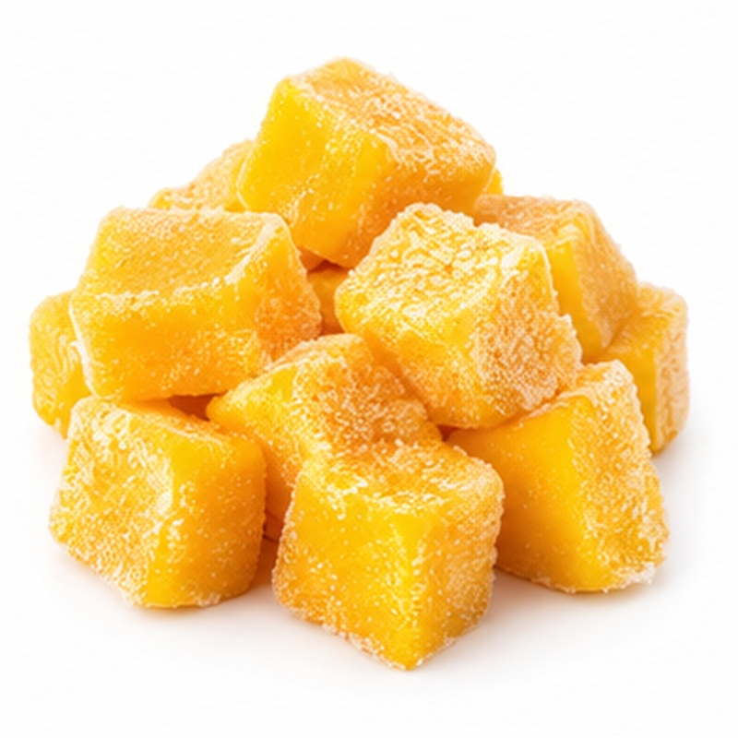 | Aromatic mango pieces offering tropical colour and flavour throughout the year.  AVAILABLE FORMS Chunks, slices or cubes  PROCESSING & HANDLING Ripe sound fruit is washed, peeled, destoned, cut and rapidly frozen. Variety, ripeness, cube size and Brix may be selected for the application.  PACKING Retail pouches, food-service bags or lined bulk cartons  FROZEN-CHAIN GUIDE Keep frozen at -18 C or below

22 FROZEN GUAVA
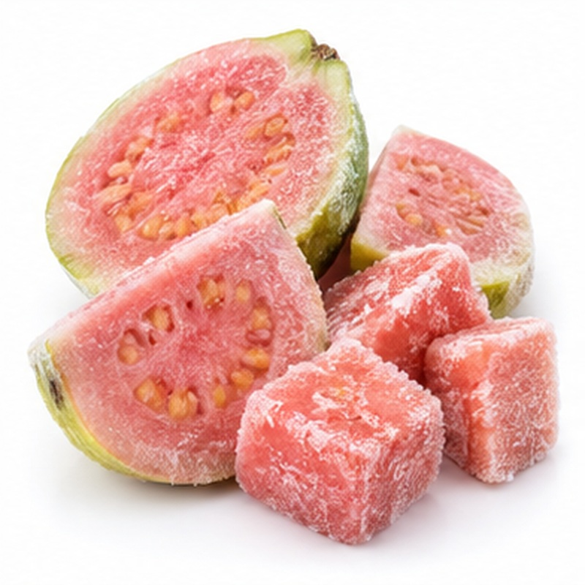 | Fragrant guava prepared for beverages, desserts, food service and ingredient manufacturing.  AVAILABLE FORMS Halves, slices, cubes or pulp  PROCESSING & HANDLING Fruit is washed, trimmed and cut or pulped before rapid freezing. Seed level, colour, cut size and ripeness are controlled to specification.  PACKING Retail pouches, food-service bags or lined bulk cartons  FROZEN-CHAIN GUIDE Keep frozen at -18 C or below

23 FROZEN POMEGRANATE ARILS
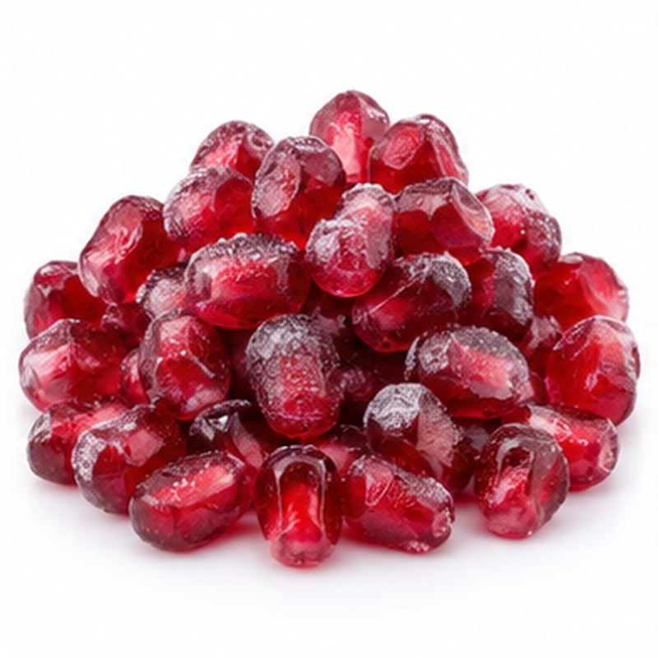 | Bright pomegranate arils offering convenient use without peeling or preparation waste.  AVAILABLE FORMS Individually frozen arils  PROCESSING & HANDLING Sound fruit is opened hygienically, arils are separated, inspected and IQF frozen. Gentle handling helps maintain colour and minimise broken arils.  PACKING Retail pouches, food-service bags or lined bulk cartons  FROZEN-CHAIN GUIDE Keep frozen at -18 C or below

24 FROZEN FIG
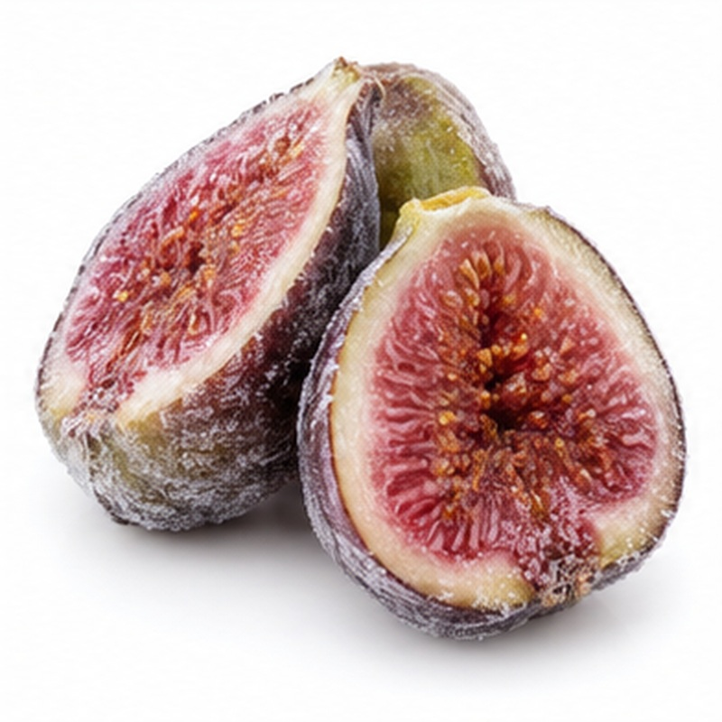 | Naturally sweet figs prepared in practical frozen formats for desserts and processing.  AVAILABLE FORMS Whole, halves or quarters  PROCESSING & HANDLING Fruit is selected for maturity, washed, trimmed, cut where required and rapidly frozen. Pieces are protected from crushing and thawing.  PACKING Retail pouches, food-service bags or lined bulk cartons  FROZEN-CHAIN GUIDE Keep frozen at -18 C or below

25 FROZEN APRICOT
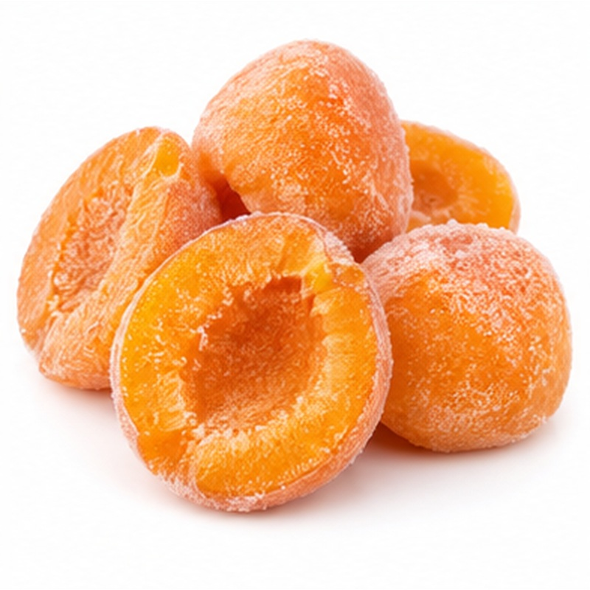 | Golden apricot pieces offering balanced sweetness, acidity and convenient seasonal continuity.  AVAILABLE FORMS Halves, slices or diced  PROCESSING & HANDLING Fruit is washed, halved, destoned, cut to specification and rapidly frozen. Colour-protection treatment may be applied where agreed.  PACKING Retail pouches, food-service bags or lined bulk cartons  FROZEN-CHAIN GUIDE Keep frozen at -18 C or below

26 FROZEN PEACH
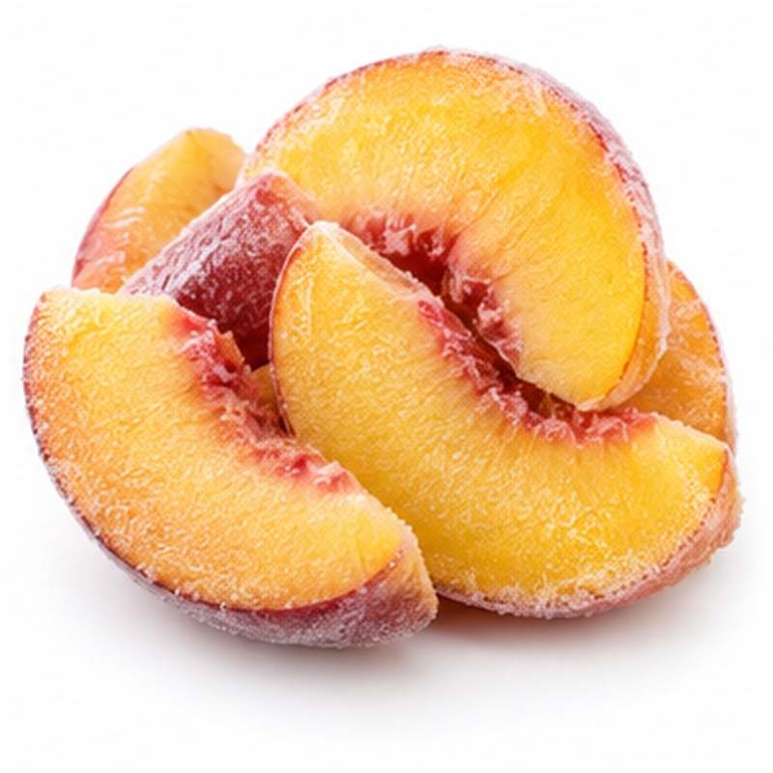 | Juicy peach pieces prepared for desserts, bakery, smoothies and industrial applications.  AVAILABLE FORMS Halves, slices or diced  PROCESSING & HANDLING Fruit is washed, peeled where required, destoned, cut and rapidly frozen. Ripeness, cut dimensions and colour are controlled.  PACKING Retail pouches, food-service bags or lined bulk cartons  FROZEN-CHAIN GUIDE Keep frozen at -18 C or below

27 FROZEN GRAPES
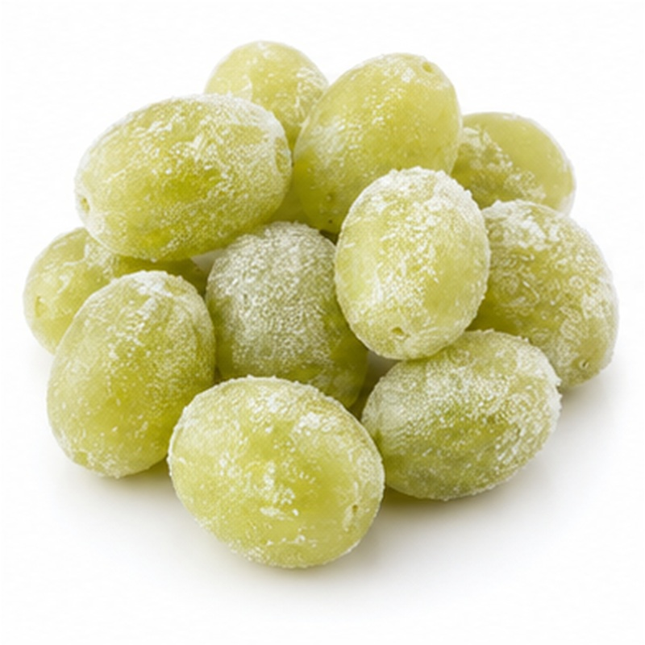 | Naturally sweet whole grapes frozen for snacks, desserts and beverage applications.  AVAILABLE FORMS Whole seedless grapes  PROCESSING & HANDLING Sound seedless berries are removed from stems, washed, inspected and IQF frozen. Product is handled gently to minimise splitting.  PACKING Retail pouches, food-service bags or lined bulk cartons  FROZEN-CHAIN GUIDE Keep frozen at -18 C or below

28 FROZEN BLUEBERRY
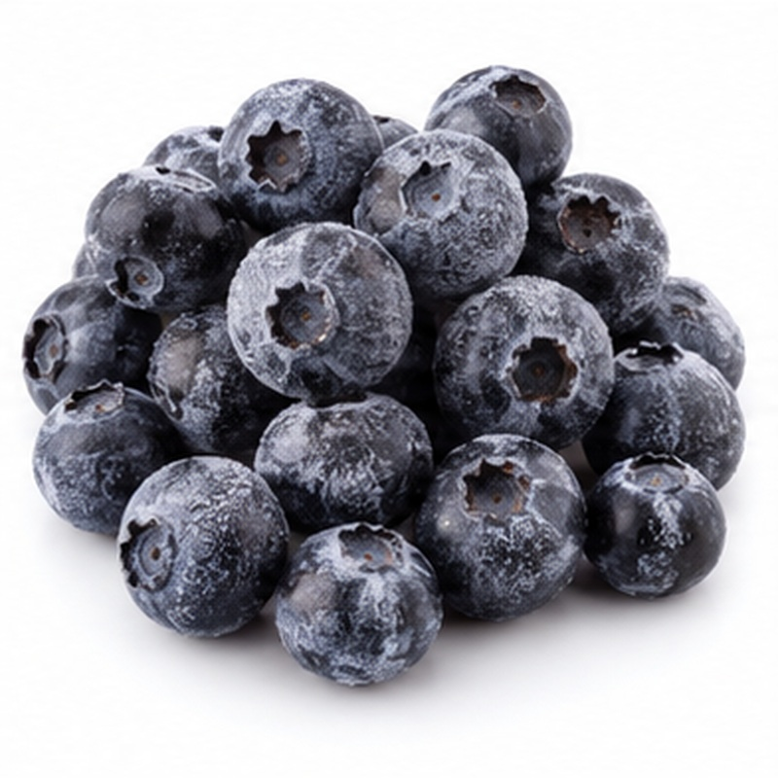 | Free-flowing blueberries with deep colour and convenient year-round availability.  AVAILABLE FORMS Whole IQF berries  PROCESSING & HANDLING Berries are cleaned, graded, inspected and IQF frozen. Size, firmness and foreign-material controls follow the agreed specification.  PACKING Retail pouches, food-service bags or lined bulk cartons  FROZEN-CHAIN GUIDE Keep frozen at -18 C or below

29 FROZEN RASPBERRY
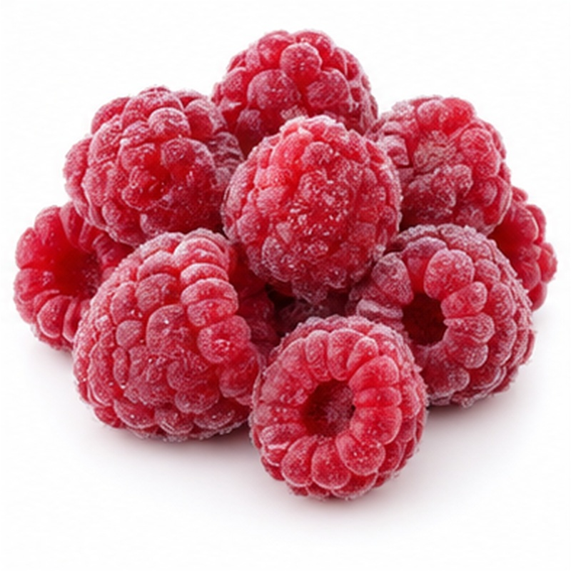 | Bright raspberries supplied for bakery, desserts, smoothies and ingredient use.  AVAILABLE FORMS Whole and broken fruit grades  PROCESSING & HANDLING Delicate berries are inspected and frozen rapidly with minimal handling. Whole and crumble grades are separated according to buyer needs.  PACKING Retail pouches, food-service bags or lined bulk cartons  FROZEN-CHAIN GUIDE Keep frozen at -18 C or below

30 FROZEN BLACKBERRY
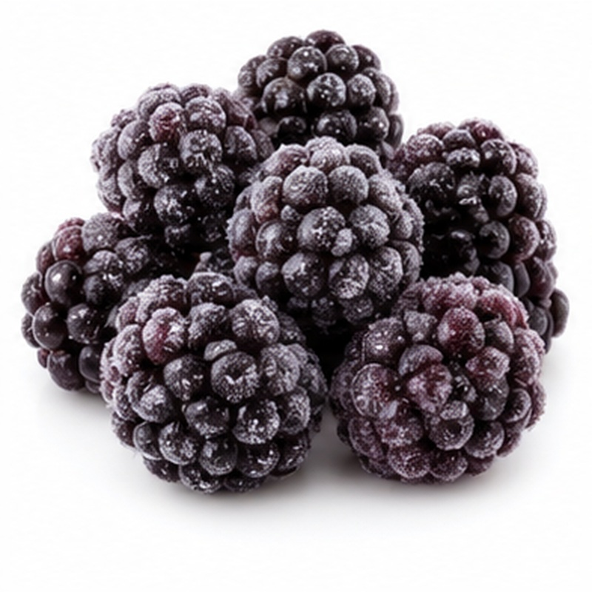 | Dark, flavourful blackberries supplied for desserts, beverages and food manufacturing.  AVAILABLE FORMS Whole IQF berries  PROCESSING & HANDLING Berries are selected, cleaned, graded and rapidly frozen. Packs are handled carefully to limit breakage and thaw damage.  PACKING Retail pouches, food-service bags or lined bulk cartons  FROZEN-CHAIN GUIDE Keep frozen at -18 C or below

31 FROZEN PINEAPPLE
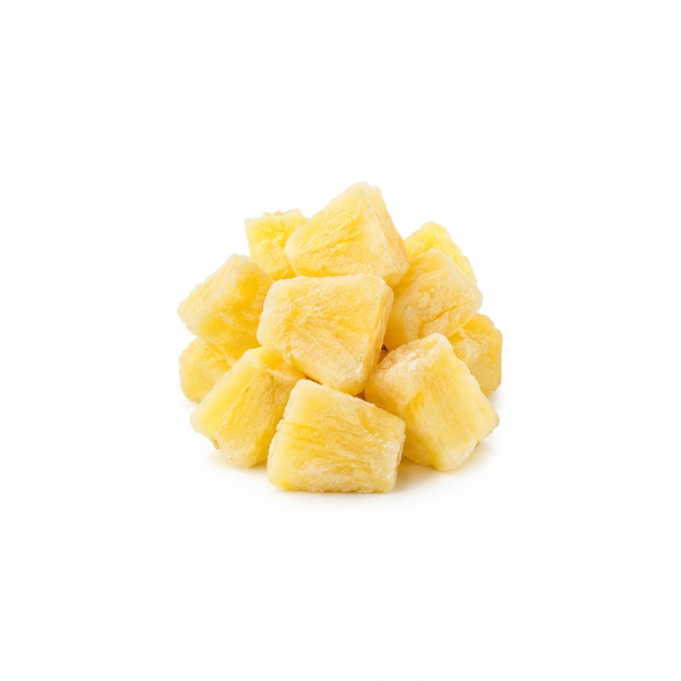 | Sweet pineapple pieces prepared in consistent cuts for retail, catering and industrial use.  AVAILABLE FORMS Chunks, rings or diced  PROCESSING & HANDLING Fruit is peeled, cored, cut to specification, inspected and rapidly frozen. Maturity, Brix and piece dimensions can be buyer-defined.  PACKING Retail pouches, food-service bags or lined bulk cartons  FROZEN-CHAIN GUIDE Keep frozen at -18 C or below

32 FROZEN MIXED BERRIES
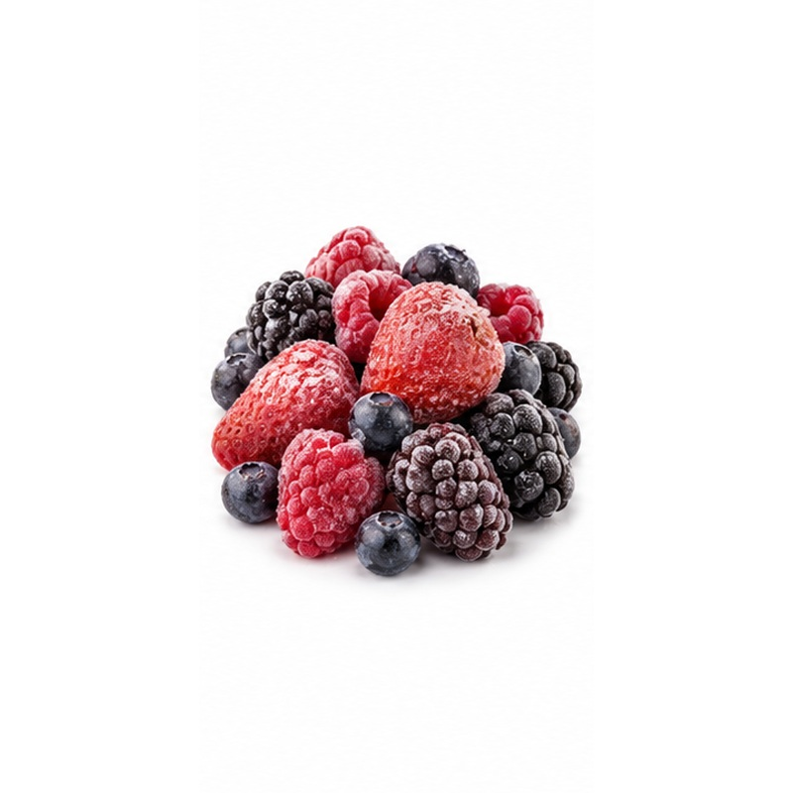 | A colourful berry blend for smoothies, desserts, bakery and retail convenience.  AVAILABLE FORMS Strawberry, blueberry, raspberry and blackberry  PROCESSING & HANDLING IQF berries are blended under controlled conditions to agreed ratios. Whole-fruit content and broken-fruit tolerance are specification-based.  PACKING Retail pouches, food-service bags or lined bulk cartons  FROZEN-CHAIN GUIDE Keep frozen at -18 C or below

33 FROZEN TROPICAL FRUIT MIX
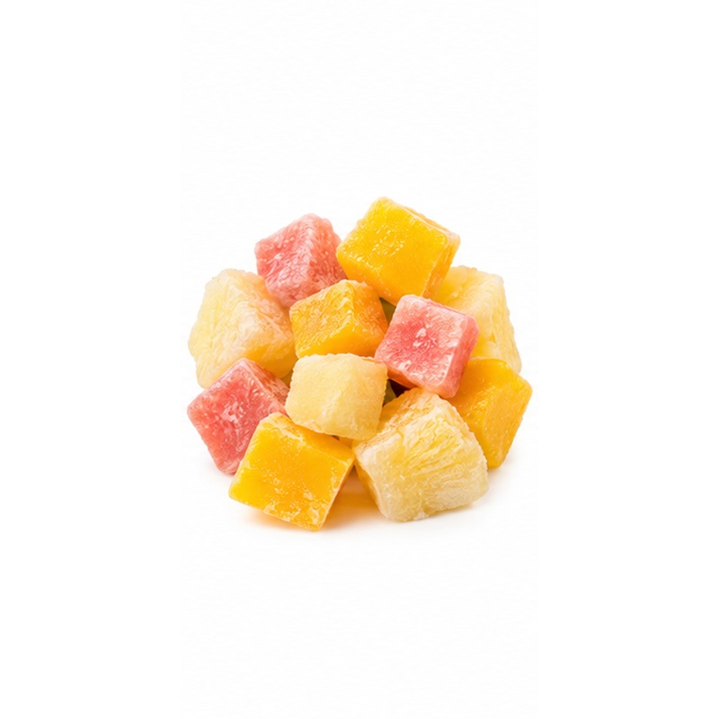 | A bright tropical blend offering balanced flavour and convenient multi-fruit preparation.  AVAILABLE FORMS Mango, pineapple and guava  PROCESSING & HANDLING Individually frozen fruit pieces are combined to controlled ratios and cut sizes. Custom recipes may be produced for retail or food service.  PACKING Retail pouches, food-service bags or lined bulk cartons  FROZEN-CHAIN GUIDE Keep frozen at -18 C or below

34 FROZEN MEDITERRANEAN VEGETABLE MIX
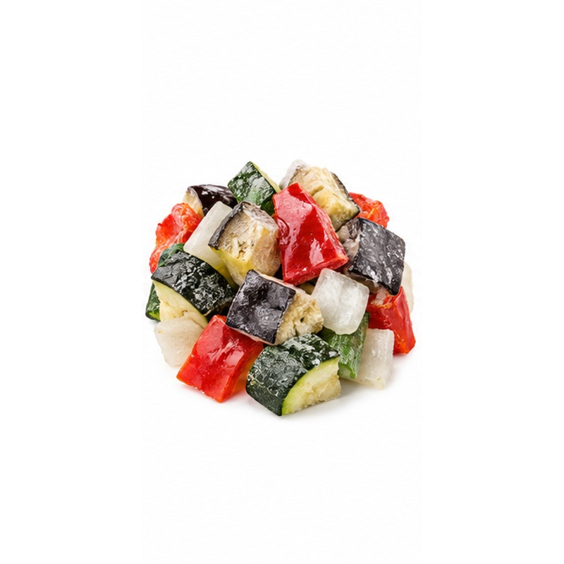 | A versatile vegetable blend designed for roasting, grilling and Mediterranean recipes.  AVAILABLE FORMS Zucchini, eggplant, peppers and onion  PROCESSING & HANDLING Prepared IQF components are blended to agreed ratios and dimensions. Grilled or ungrilled formats may be developed by specification.  PACKING Retail pouches, food-service bags or lined bulk cartons  FROZEN-CHAIN GUIDE Keep frozen at -18 C or below

35 FROZEN STIR-FRY VEGETABLE MIX
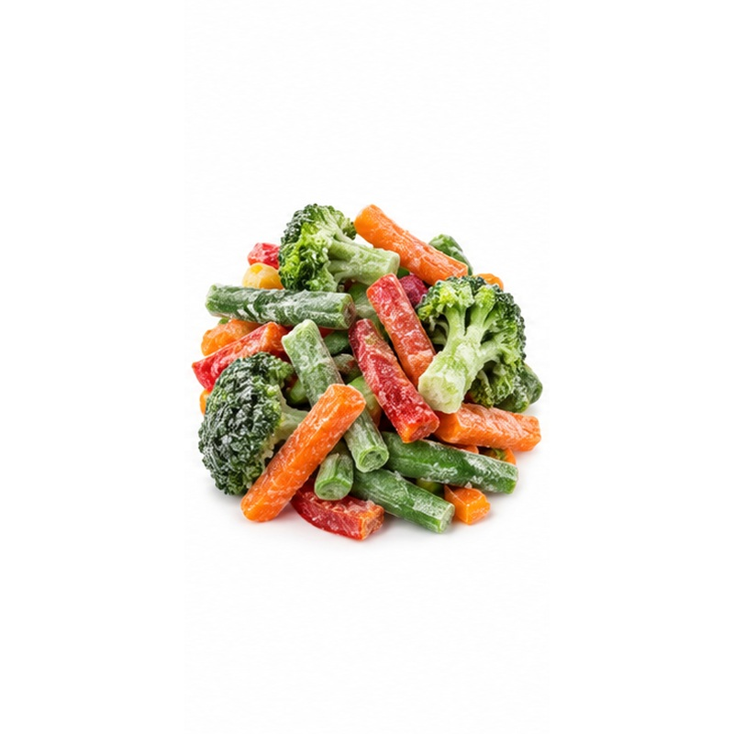 | A colourful ready-to-cook blend with varied textures and consistent portioning.  AVAILABLE FORMS Broccoli, peppers, beans and carrots  PROCESSING & HANDLING IQF vegetables are combined after individual preparation and grading. Component choice, ratios and cut sizes are customisable.  PACKING Retail pouches, food-service bags or lined bulk cartons  FROZEN-CHAIN GUIDE Keep frozen at -18 C or below

36 CUSTOM FROZEN MIXES
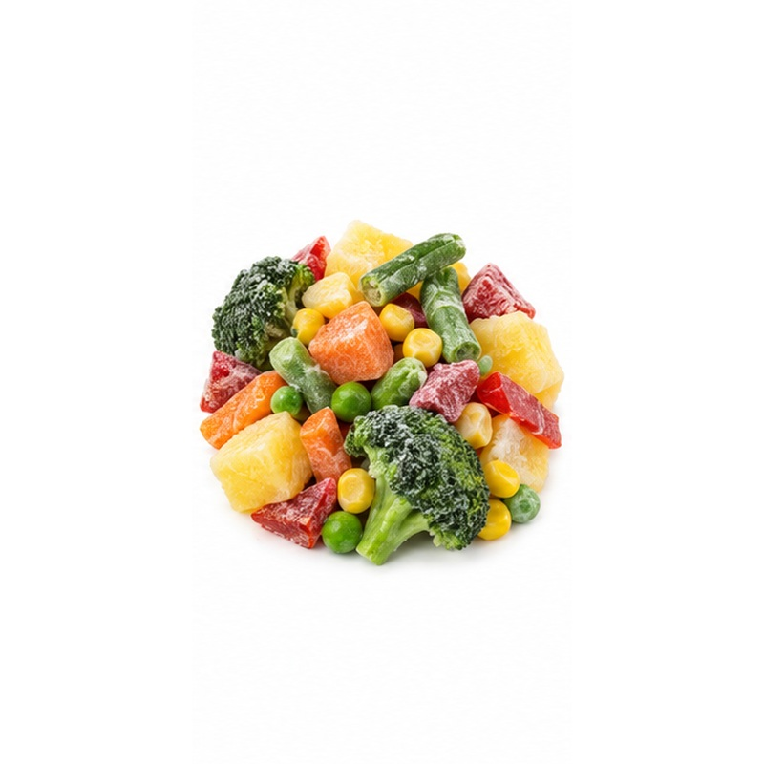 | Buyer-specific frozen blends developed for retail, food service or industrial programmes.  AVAILABLE FORMS Fruit, vegetable or combined recipes  PROCESSING & HANDLING Approved IQF components are blended to the agreed recipe, cut, grade and tolerance requirements. Final specifications are confirmed before production.  PACKING Private-label retail, food-service or bulk formats  FROZEN-CHAIN GUIDE Keep frozen at -18 C or below

NILE-MAPLE
IQF supply • Buyer-specific formats • Uninterrupted frozen chain
Product cut, grade, recipe, treatment, packaging and shipment specifications are confirmed according to production capability, destination market and buyer requirements.

