NILE-MAPLE
MANUFACTURED, PROCESSED
& CANNED PRODUCTS
Product & Export Handling Catalogue
Flexible formats. Buyer-specific recipes. Reliable global supply.

01 CANNED FAVA BEANS
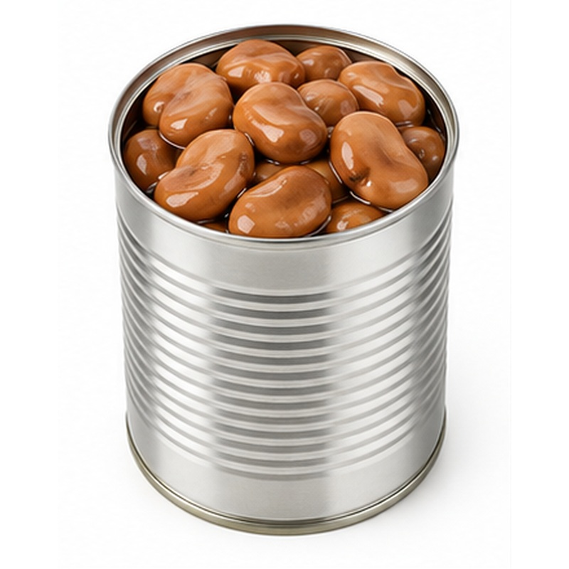 | Ready-to-eat Egyptian fava beans offered in classic and seasoned recipes.  AVAILABLE FORMS Plain, peeled, tomato sauce, tahini, chili or Lebanese recipe  PROCESSING & HANDLING Ingredients are sorted, washed and prepared, filled into containers, sealed and thermally processed under a validated product specification.  PACKING Retail cans, glass jars or food-service cans; private label subject to agreement  STORAGE GUIDE Store unopened in a cool, dry place away from direct sunlight. Refrigerate after opening and follow the final label instructions.

02 CANNED CHICKPEAS
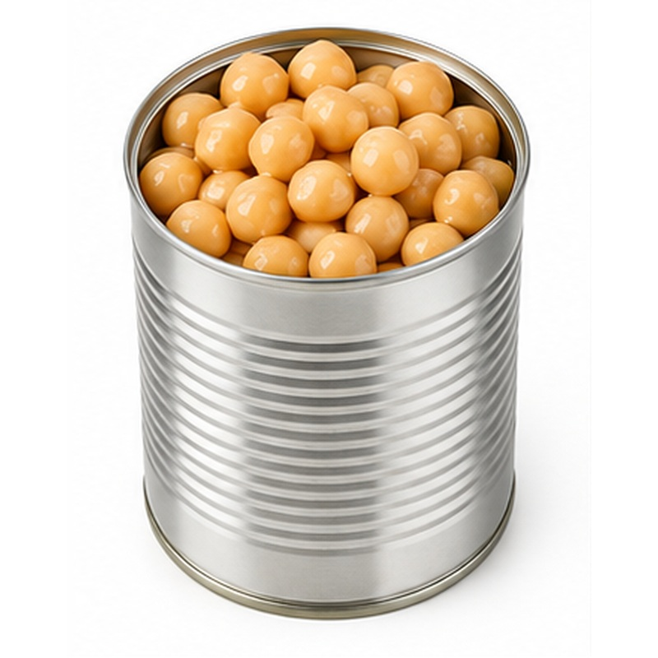 | Tender chickpeas prepared for retail, catering and ingredient applications.  AVAILABLE FORMS Plain or seasoned  PROCESSING & HANDLING Ingredients are sorted, washed and prepared, filled into containers, sealed and thermally processed under a validated product specification.  PACKING Retail cans, glass jars or food-service cans; private label subject to agreement  STORAGE GUIDE Store unopened in a cool, dry place away from direct sunlight. Refrigerate after opening and follow the final label instructions.

03 CANNED WHITE BEANS
 | Creamy white beans supplied plain or in a rich tomato sauce.  AVAILABLE FORMS Plain or in tomato sauce  PROCESSING & HANDLING Ingredients are sorted, washed and prepared, filled into containers, sealed and thermally processed under a validated product specification.  PACKING Retail cans, glass jars or food-service cans; private label subject to agreement  STORAGE GUIDE Store unopened in a cool, dry place away from direct sunlight. Refrigerate after opening and follow the final label instructions.

04 CANNED RED KIDNEY BEANS
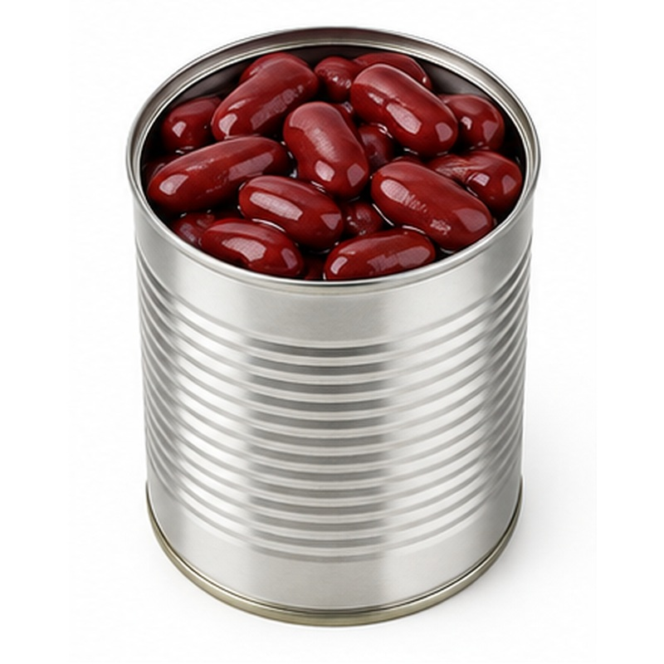 | Firm red kidney beans with consistent colour and convenient preparation.  AVAILABLE FORMS Plain or in sauce  PROCESSING & HANDLING Ingredients are sorted, washed and prepared, filled into containers, sealed and thermally processed under a validated product specification.  PACKING Retail cans, glass jars or food-service cans; private label subject to agreement  STORAGE GUIDE Store unopened in a cool, dry place away from direct sunlight. Refrigerate after opening and follow the final label instructions.

05 CANNED GREEN PEAS
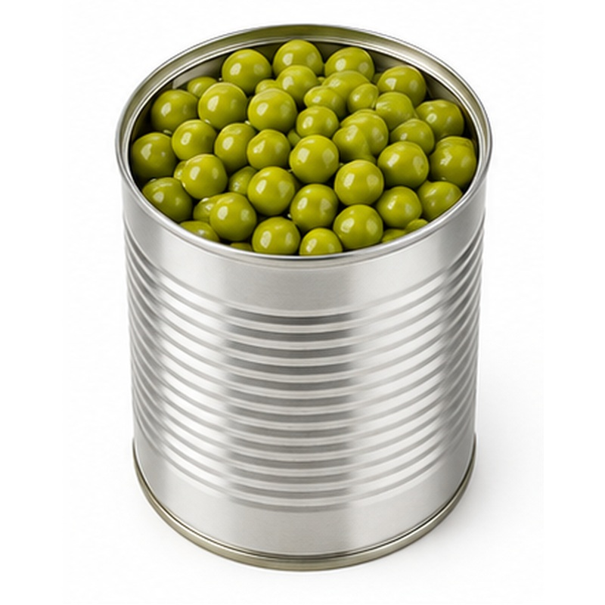 | Tender green peas preserved for convenient year-round use.  AVAILABLE FORMS Plain or with carrots  PROCESSING & HANDLING Ingredients are sorted, washed and prepared, filled into containers, sealed and thermally processed under a validated product specification.  PACKING Retail cans, glass jars or food-service cans; private label subject to agreement  STORAGE GUIDE Store unopened in a cool, dry place away from direct sunlight. Refrigerate after opening and follow the final label instructions.

06 CANNED SWEET CORN
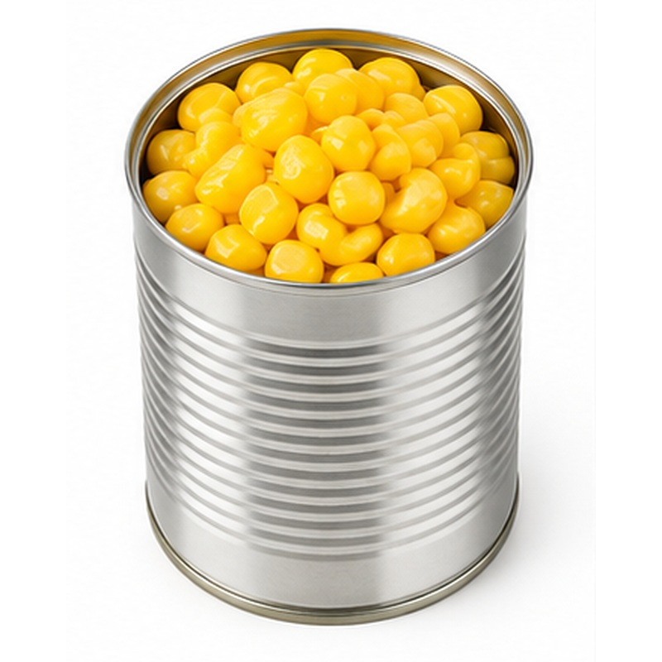 | Bright sweet corn kernels with consistent tenderness and colour.  AVAILABLE FORMS Whole-kernel yellow sweet corn  PROCESSING & HANDLING Ingredients are sorted, washed and prepared, filled into containers, sealed and thermally processed under a validated product specification.  PACKING Retail cans, glass jars or food-service cans; private label subject to agreement  STORAGE GUIDE Store unopened in a cool, dry place away from direct sunlight. Refrigerate after opening and follow the final label instructions.

07 CANNED GREEN BEANS
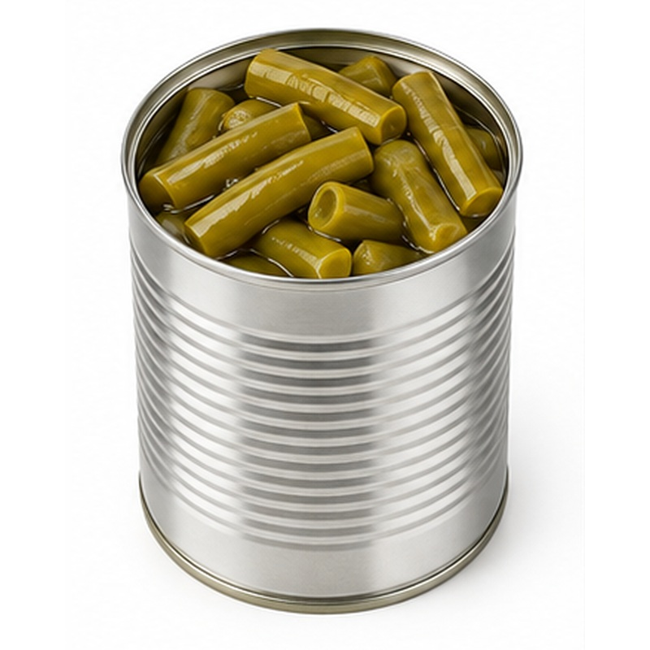 | Prepared green beans offered in uniform whole or cut formats.  AVAILABLE FORMS Whole or cut  PROCESSING & HANDLING Ingredients are sorted, washed and prepared, filled into containers, sealed and thermally processed under a validated product specification.  PACKING Retail cans, glass jars or food-service cans; private label subject to agreement  STORAGE GUIDE Store unopened in a cool, dry place away from direct sunlight. Refrigerate after opening and follow the final label instructions.

08 CANNED MIXED VEGETABLES
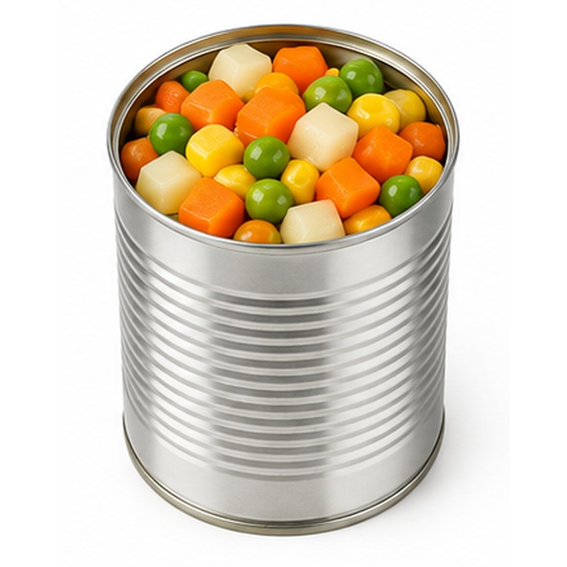 | A colourful vegetable blend for retail and food-service convenience.  AVAILABLE FORMS Peas, carrots, corn and beans  PROCESSING & HANDLING Ingredients are sorted, washed and prepared, filled into containers, sealed and thermally processed under a validated product specification.  PACKING Retail cans, glass jars or food-service cans; private label subject to agreement  STORAGE GUIDE Store unopened in a cool, dry place away from direct sunlight. Refrigerate after opening and follow the final label instructions.

09 CANNED ARTICHOKES
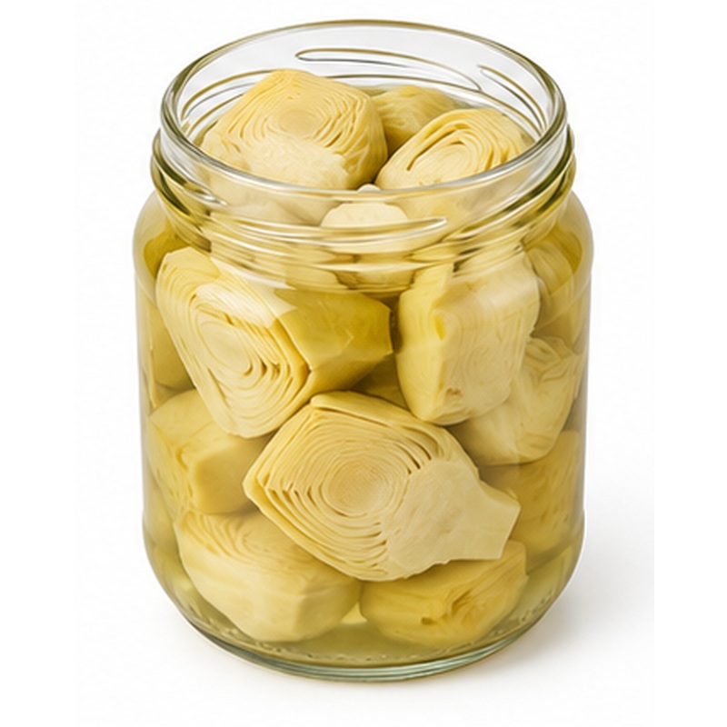 | Tender artichoke portions prepared for salads, cooking and food service.  AVAILABLE FORMS Hearts, bottoms, quarters or slices  PROCESSING & HANDLING Ingredients are sorted, washed and prepared, filled into containers, sealed and thermally processed under a validated product specification.  PACKING Retail cans, glass jars or food-service cans; private label subject to agreement  STORAGE GUIDE Store unopened in a cool, dry place away from direct sunlight. Refrigerate after opening and follow the final label instructions.

10 CANNED GRAPE LEAVES
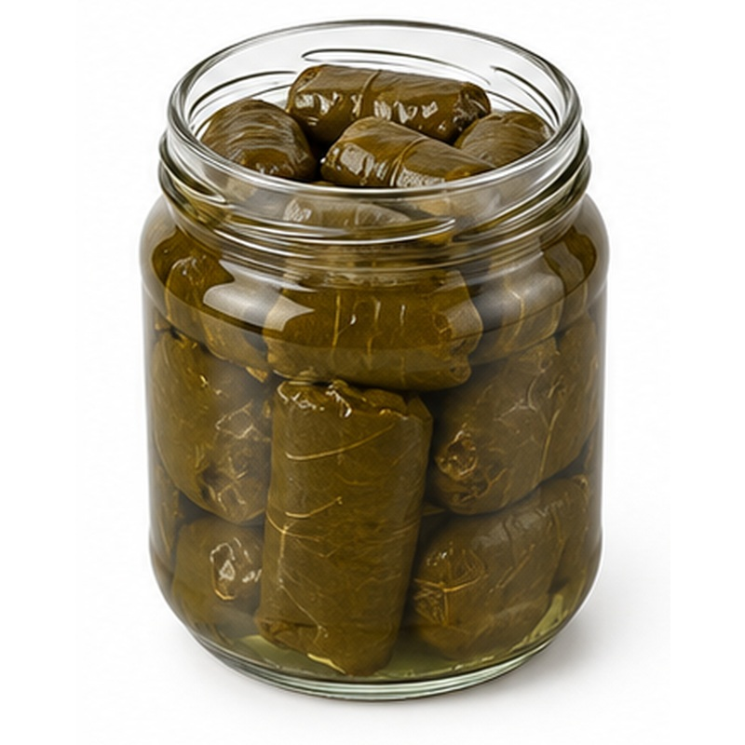 | Selected grape leaves preserved for traditional stuffed-leaf recipes.  AVAILABLE FORMS Plain, layered or ready for stuffing  PROCESSING & HANDLING Ingredients are sorted, washed and prepared, filled into containers, sealed and thermally processed under a validated product specification.  PACKING Retail cans, glass jars or food-service cans; private label subject to agreement  STORAGE GUIDE Store unopened in a cool, dry place away from direct sunlight. Refrigerate after opening and follow the final label instructions.

11 CANNED WHOLE TOMATOES
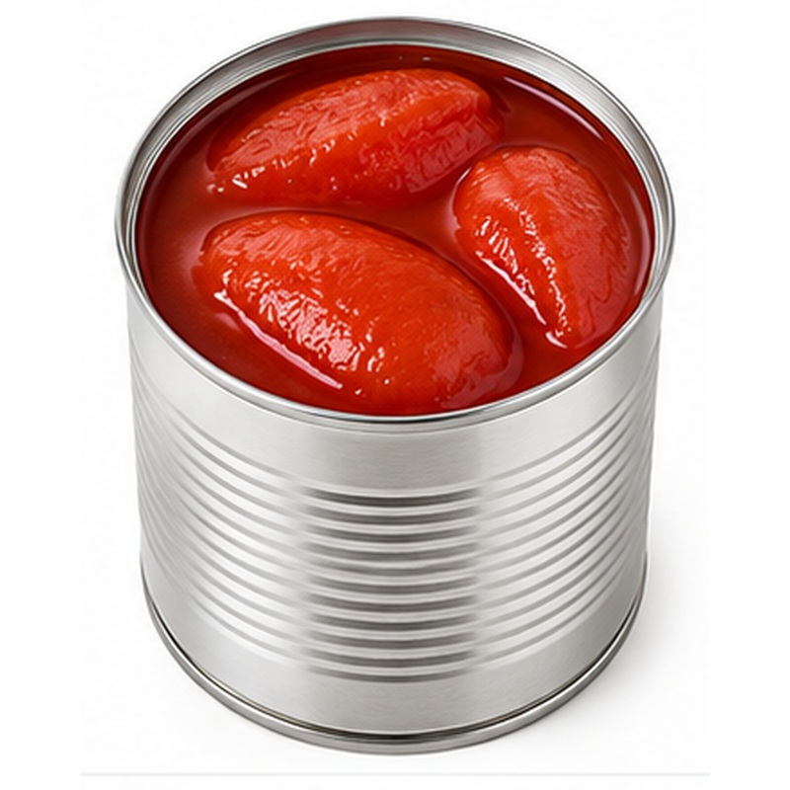 | Ripe peeled tomatoes preserved whole for sauces and professional kitchens.  AVAILABLE FORMS Whole peeled tomatoes  PROCESSING & HANDLING Ingredients are sorted, washed and prepared, filled into containers, sealed and thermally processed under a validated product specification.  PACKING Retail cans, glass jars or food-service cans; private label subject to agreement  STORAGE GUIDE Store unopened in a cool, dry place away from direct sunlight. Refrigerate after opening and follow the final label instructions.

12 CANNED DICED TOMATOES
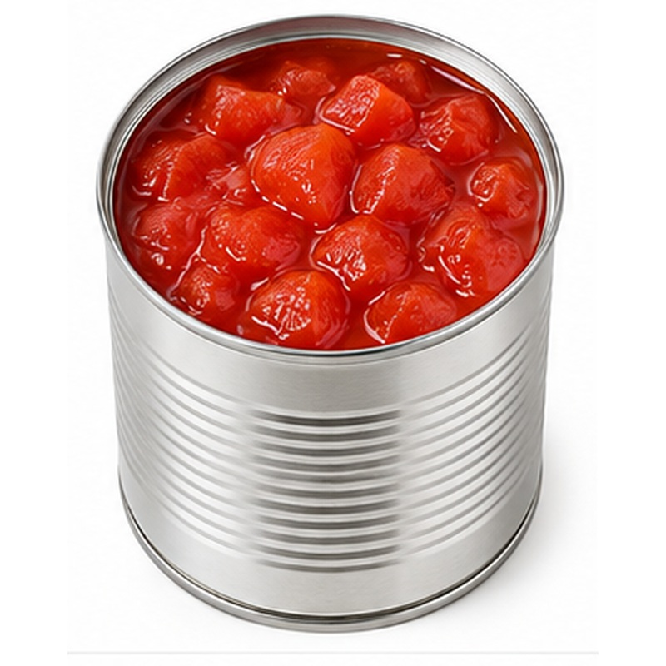 | Prepared tomato pieces offering consistent colour, texture and convenience.  AVAILABLE FORMS Diced or crushed tomatoes  PROCESSING & HANDLING Ingredients are sorted, washed and prepared, filled into containers, sealed and thermally processed under a validated product specification.  PACKING Retail cans, glass jars or food-service cans; private label subject to agreement  STORAGE GUIDE Store unopened in a cool, dry place away from direct sunlight. Refrigerate after opening and follow the final label instructions.

13 CANNED MUSHROOMS
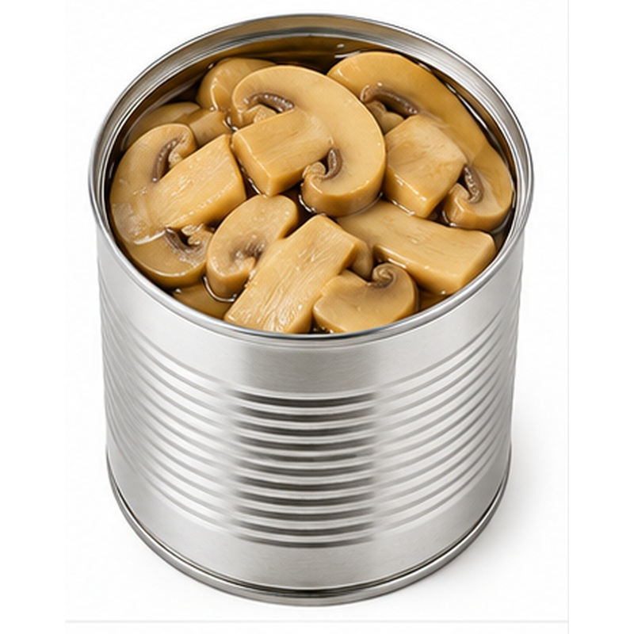 | Cultivated mushrooms preserved whole or sliced for dependable ingredient use.  AVAILABLE FORMS Whole or sliced  PROCESSING & HANDLING Ingredients are sorted, washed and prepared, filled into containers, sealed and thermally processed under a validated product specification.  PACKING Retail cans, glass jars or food-service cans; private label subject to agreement  STORAGE GUIDE Store unopened in a cool, dry place away from direct sunlight. Refrigerate after opening and follow the final label instructions.

14 CANNED FRUIT COCKTAIL
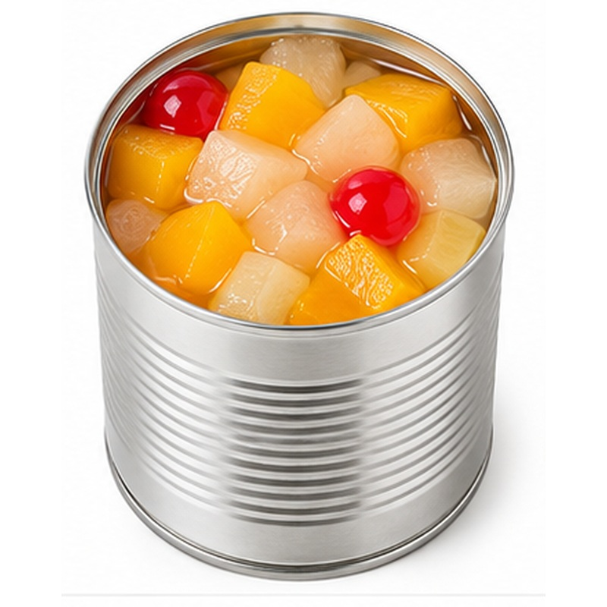 | A colourful selection of prepared fruits packed together in syrup.  AVAILABLE FORMS Mixed fruits in light or standard syrup  PROCESSING & HANDLING Ingredients are sorted, washed and prepared, filled into containers, sealed and thermally processed under a validated product specification.  PACKING Retail cans, glass jars or food-service cans; private label subject to agreement  STORAGE GUIDE Store unopened in a cool, dry place away from direct sunlight. Refrigerate after opening and follow the final label instructions.

15 CANNED PINEAPPLE
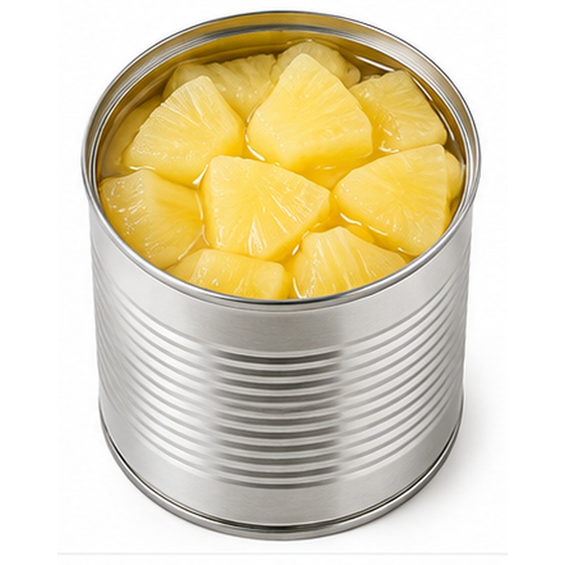 | Sweet pineapple prepared in consistent formats for desserts and catering.  AVAILABLE FORMS Rings, slices or chunks  PROCESSING & HANDLING Ingredients are sorted, washed and prepared, filled into containers, sealed and thermally processed under a validated product specification.  PACKING Retail cans, glass jars or food-service cans; private label subject to agreement  STORAGE GUIDE Store unopened in a cool, dry place away from direct sunlight. Refrigerate after opening and follow the final label instructions.

16 CANNED PEACHES
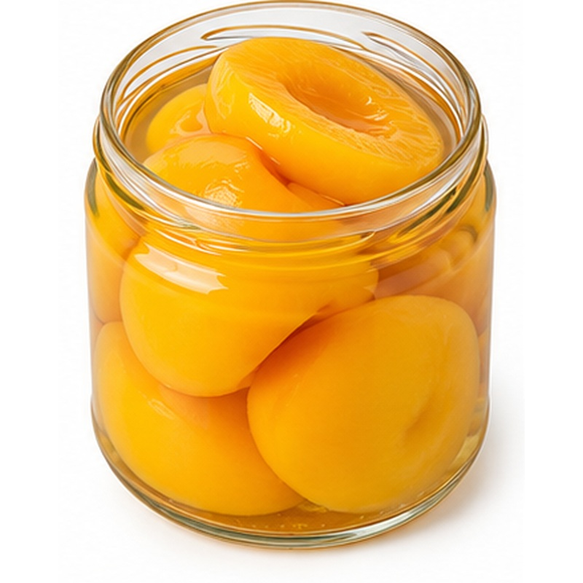 | Golden peach halves or slices with a soft, attractive texture.  AVAILABLE FORMS Halves or slices in syrup  PROCESSING & HANDLING Ingredients are sorted, washed and prepared, filled into containers, sealed and thermally processed under a validated product specification.  PACKING Retail cans, glass jars or food-service cans; private label subject to agreement  STORAGE GUIDE Store unopened in a cool, dry place away from direct sunlight. Refrigerate after opening and follow the final label instructions.

17 TABLE OLIVES
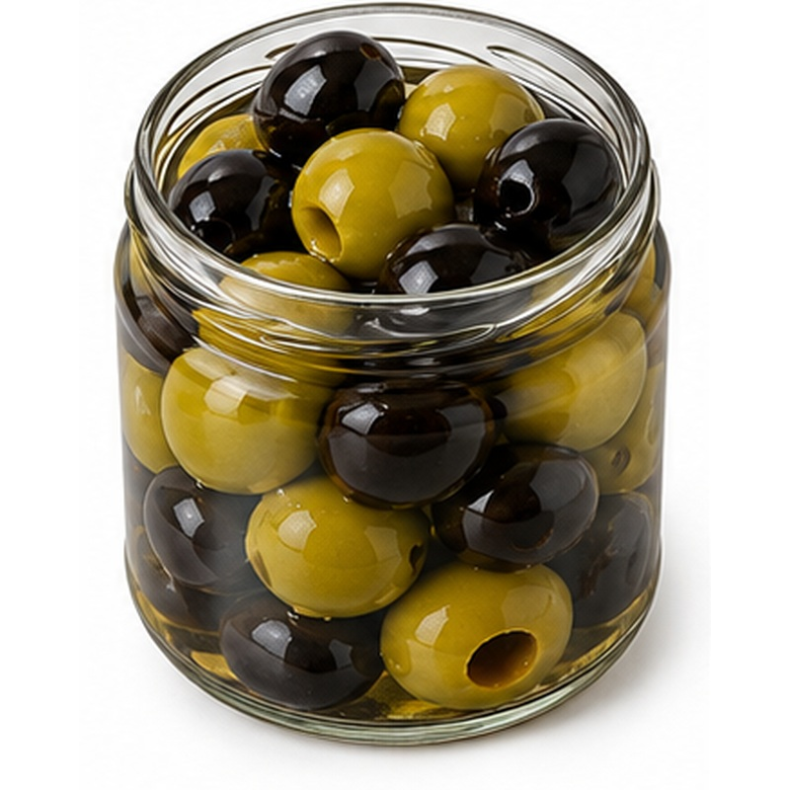 | Selected table olives supplied in multiple colours, sizes and presentations.  AVAILABLE FORMS Green, black, Kalamata-style, whole, pitted or sliced  PROCESSING & HANDLING Produce is sorted, prepared and packed in a controlled brine or marinade. Salt, acidity, recipe and cut are confirmed to buyer specification.  PACKING Glass jars, PET jars, cans or food-service containers  STORAGE GUIDE Store unopened in a cool, dry place away from direct sunlight. Refrigerate after opening and follow the final label instructions.

18 STUFFED GREEN OLIVES
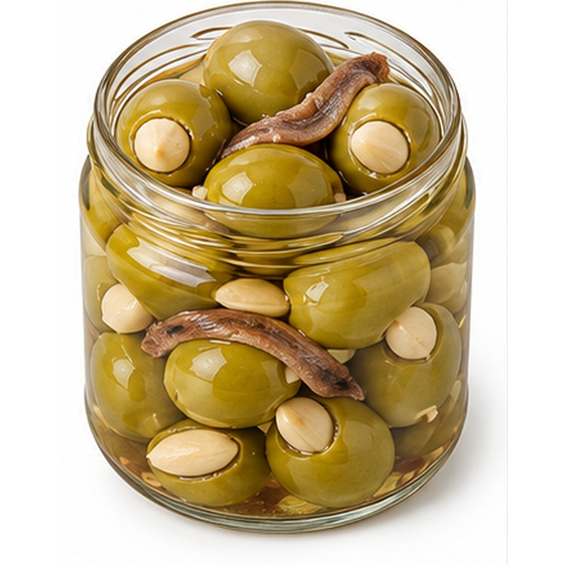 | Premium green olives filled with almond or anchovy for speciality retail ranges.  AVAILABLE FORMS Almond-stuffed or anchovy-stuffed  PROCESSING & HANDLING Produce is sorted, prepared and packed in a controlled brine or marinade. Salt, acidity, recipe and cut are confirmed to buyer specification.  PACKING Glass jars, PET jars, cans or food-service containers  STORAGE GUIDE Store unopened in a cool, dry place away from direct sunlight. Refrigerate after opening and follow the final label instructions.

19 PICKLED CUCUMBERS / GHERKINS
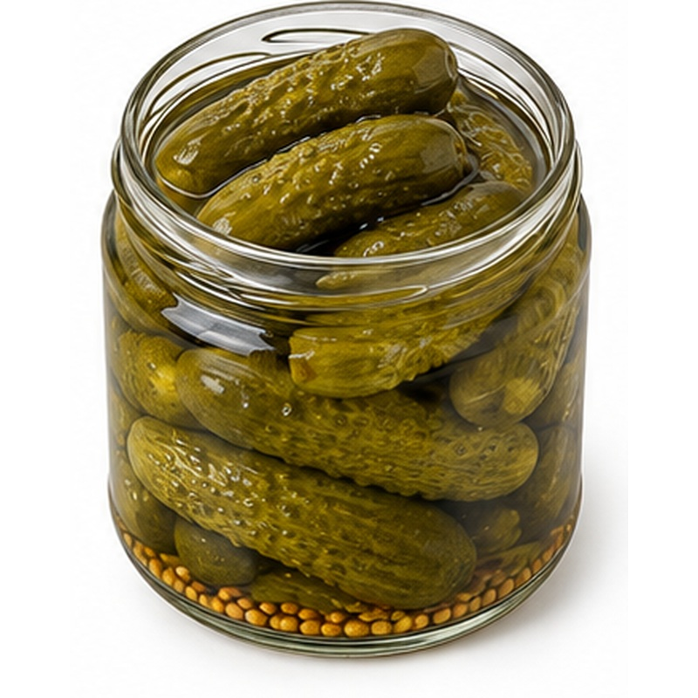 | Crisp cucumbers preserved in seasoned brine for snacks and food service.  AVAILABLE FORMS Whole, sliced or baby gherkins  PROCESSING & HANDLING Produce is sorted, prepared and packed in a controlled brine or marinade. Salt, acidity, recipe and cut are confirmed to buyer specification.  PACKING Glass jars, PET jars, cans or food-service containers  STORAGE GUIDE Store unopened in a cool, dry place away from direct sunlight. Refrigerate after opening and follow the final label instructions.

20 PICKLED ONIONS
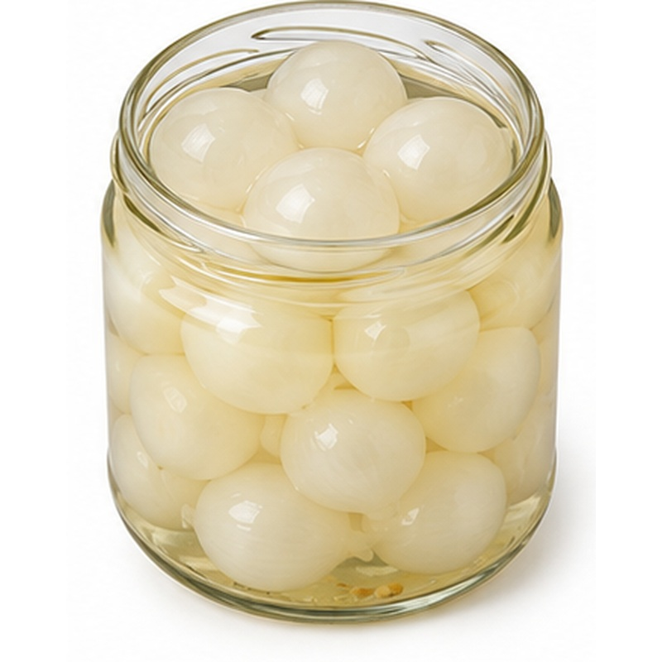 | Firm onions pickled for a balanced sharp flavour and attractive appearance.  AVAILABLE FORMS White, red or baby onions  PROCESSING & HANDLING Produce is sorted, prepared and packed in a controlled brine or marinade. Salt, acidity, recipe and cut are confirmed to buyer specification.  PACKING Glass jars, PET jars, cans or food-service containers  STORAGE GUIDE Store unopened in a cool, dry place away from direct sunlight. Refrigerate after opening and follow the final label instructions.

21 PICKLED PEPPERS
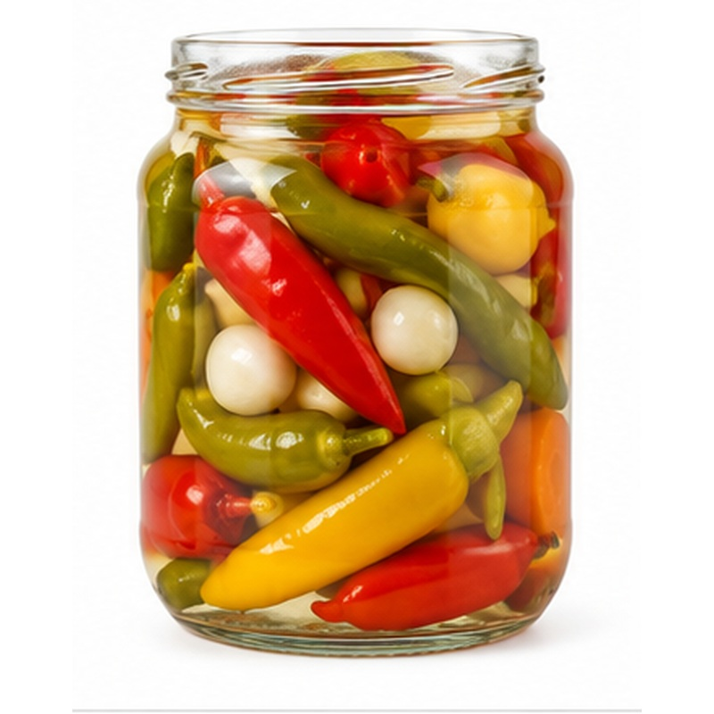 | Colourful peppers preserved in brine with buyer-selected heat levels.  AVAILABLE FORMS Green, red, chili or mixed peppers  PROCESSING & HANDLING Produce is sorted, prepared and packed in a controlled brine or marinade. Salt, acidity, recipe and cut are confirmed to buyer specification.  PACKING Glass jars, PET jars, cans or food-service containers  STORAGE GUIDE Store unopened in a cool, dry place away from direct sunlight. Refrigerate after opening and follow the final label instructions.

22 PICKLED JALAPENOS
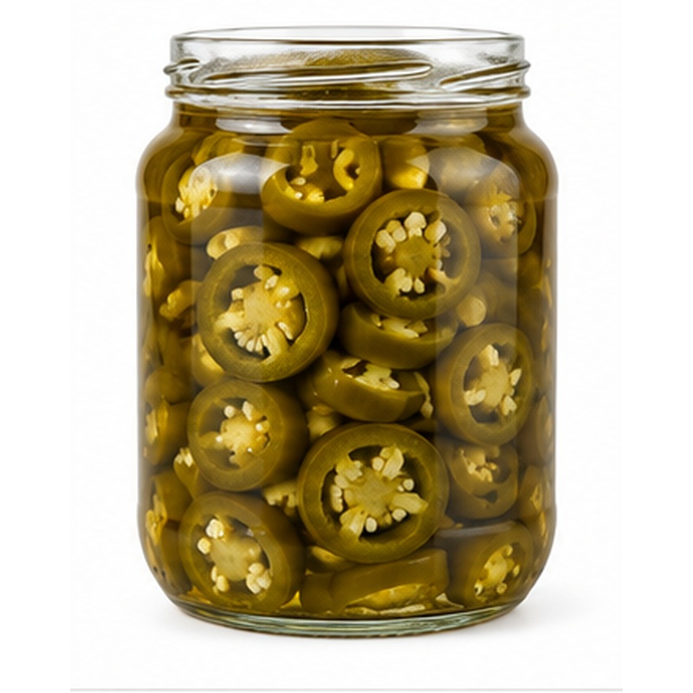 | Tangy jalapenos supplied whole or sliced for retail and food-service use.  AVAILABLE FORMS Whole or sliced  PROCESSING & HANDLING Produce is sorted, prepared and packed in a controlled brine or marinade. Salt, acidity, recipe and cut are confirmed to buyer specification.  PACKING Glass jars, PET jars, cans or food-service containers  STORAGE GUIDE Store unopened in a cool, dry place away from direct sunlight. Refrigerate after opening and follow the final label instructions.

23 PICKLED LEMONS WITH SAFFLOWER
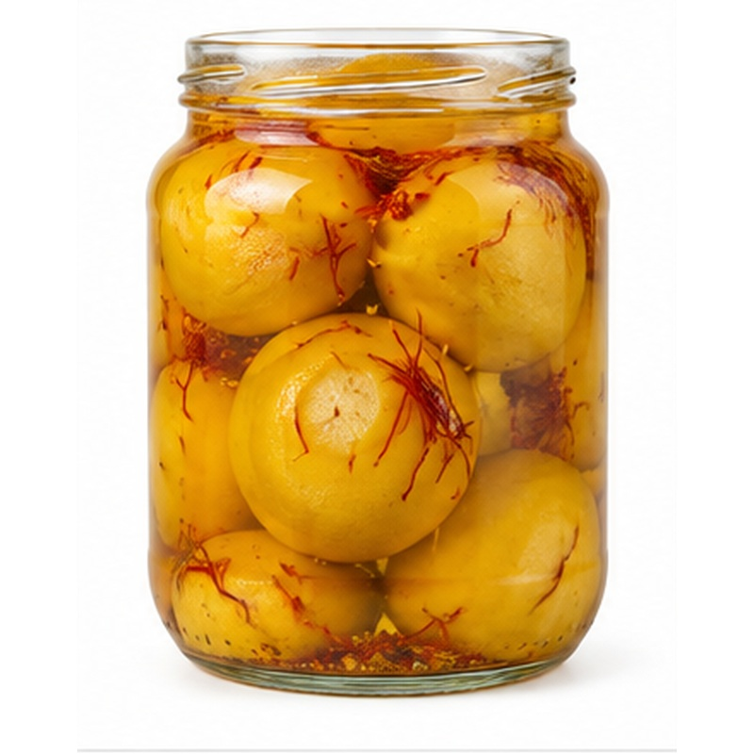 | Traditional pickled lemons seasoned with safflower for a distinctive Egyptian profile.  AVAILABLE FORMS Whole or quartered Egyptian-style lemons  PROCESSING & HANDLING Produce is sorted, prepared and packed in a controlled brine or marinade. Salt, acidity, recipe and cut are confirmed to buyer specification.  PACKING Glass jars, PET jars, cans or food-service containers  STORAGE GUIDE Store unopened in a cool, dry place away from direct sunlight. Refrigerate after opening and follow the final label instructions.

24 PICKLED TURNIPS
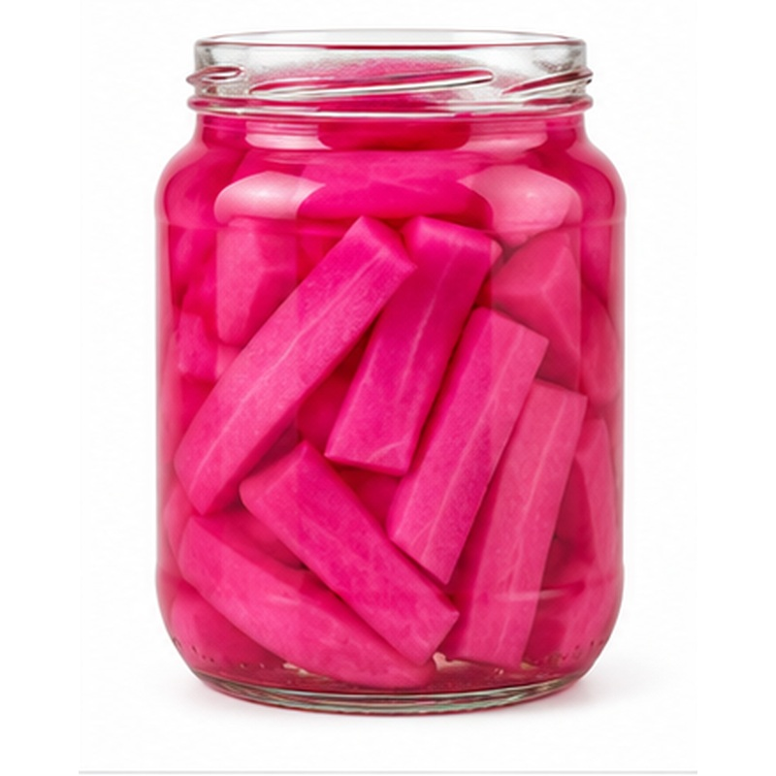 | Crisp turnip pieces offered natural or with their familiar bright pink colour.  AVAILABLE FORMS Natural or beet-coloured  PROCESSING & HANDLING Produce is sorted, prepared and packed in a controlled brine or marinade. Salt, acidity, recipe and cut are confirmed to buyer specification.  PACKING Glass jars, PET jars, cans or food-service containers  STORAGE GUIDE Store unopened in a cool, dry place away from direct sunlight. Refrigerate after opening and follow the final label instructions.

25 PICKLED CARROTS
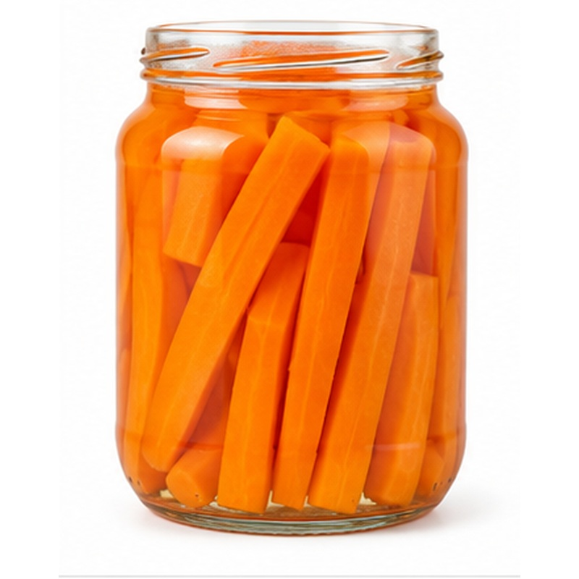 | Firm carrot pieces preserved in a balanced seasoned brine.  AVAILABLE FORMS Slices, sticks or mixed formats  PROCESSING & HANDLING Produce is sorted, prepared and packed in a controlled brine or marinade. Salt, acidity, recipe and cut are confirmed to buyer specification.  PACKING Glass jars, PET jars, cans or food-service containers  STORAGE GUIDE Store unopened in a cool, dry place away from direct sunlight. Refrigerate after opening and follow the final label instructions.

26 PICKLED MIXED VEGETABLES
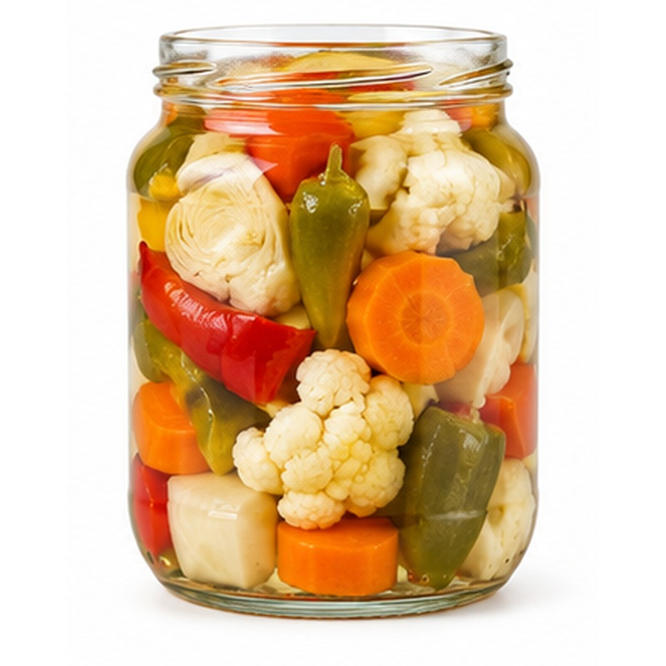 | A colourful brined selection combining vegetables to the requested recipe.  AVAILABLE FORMS Buyer-selected vegetable combination  PROCESSING & HANDLING Produce is sorted, prepared and packed in a controlled brine or marinade. Salt, acidity, recipe and cut are confirmed to buyer specification.  PACKING Glass jars, PET jars, cans or food-service containers  STORAGE GUIDE Store unopened in a cool, dry place away from direct sunlight. Refrigerate after opening and follow the final label instructions.

27 ARTICHOKES IN BRINE
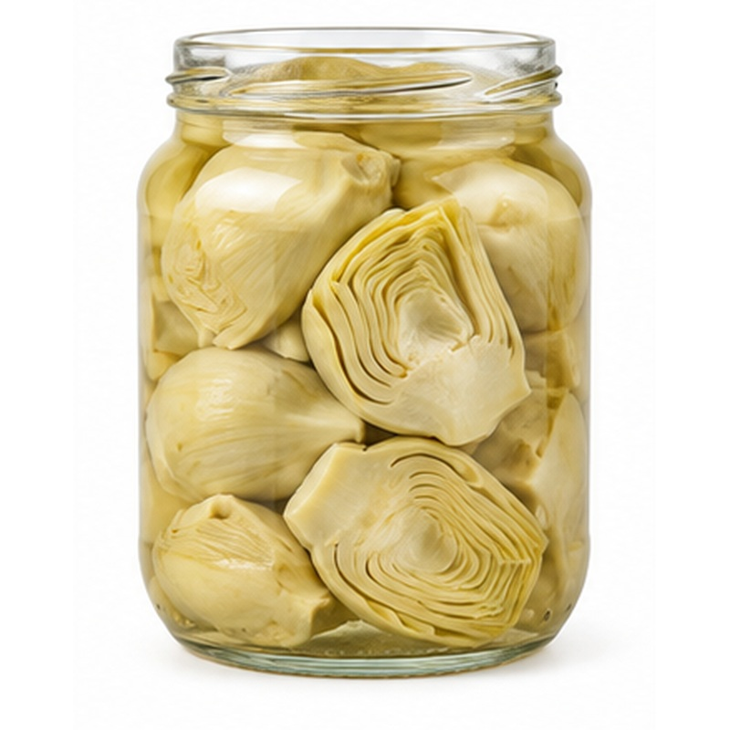 | Prepared artichokes held in brine for convenient culinary use.  AVAILABLE FORMS Hearts, bottoms, quarters or slices  PROCESSING & HANDLING Produce is sorted, prepared and packed in a controlled brine or marinade. Salt, acidity, recipe and cut are confirmed to buyer specification.  PACKING Glass jars, PET jars, cans or food-service containers  STORAGE GUIDE Store unopened in a cool, dry place away from direct sunlight. Refrigerate after opening and follow the final label instructions.

28 ROASTED RED PEPPERS
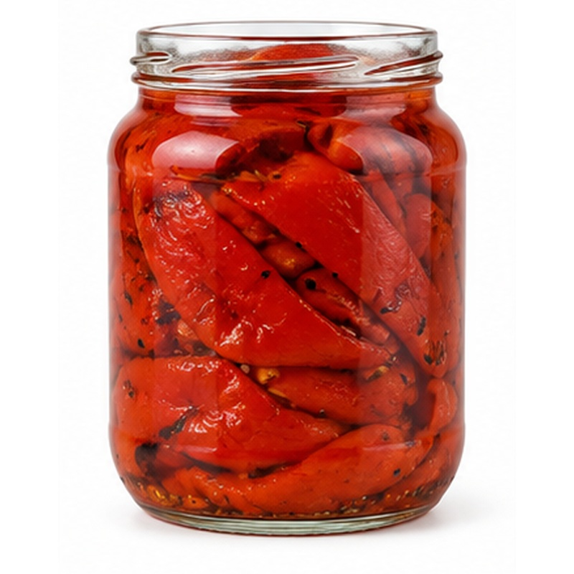 | Sweet roasted peppers with peeled flesh and a rich cooked flavour.  AVAILABLE FORMS Whole, strips or pieces  PROCESSING & HANDLING Produce is sorted, prepared and packed in a controlled brine or marinade. Salt, acidity, recipe and cut are confirmed to buyer specification.  PACKING Glass jars, PET jars, cans or food-service containers  STORAGE GUIDE Store unopened in a cool, dry place away from direct sunlight. Refrigerate after opening and follow the final label instructions.

29 EGGPLANT MAKDOUS
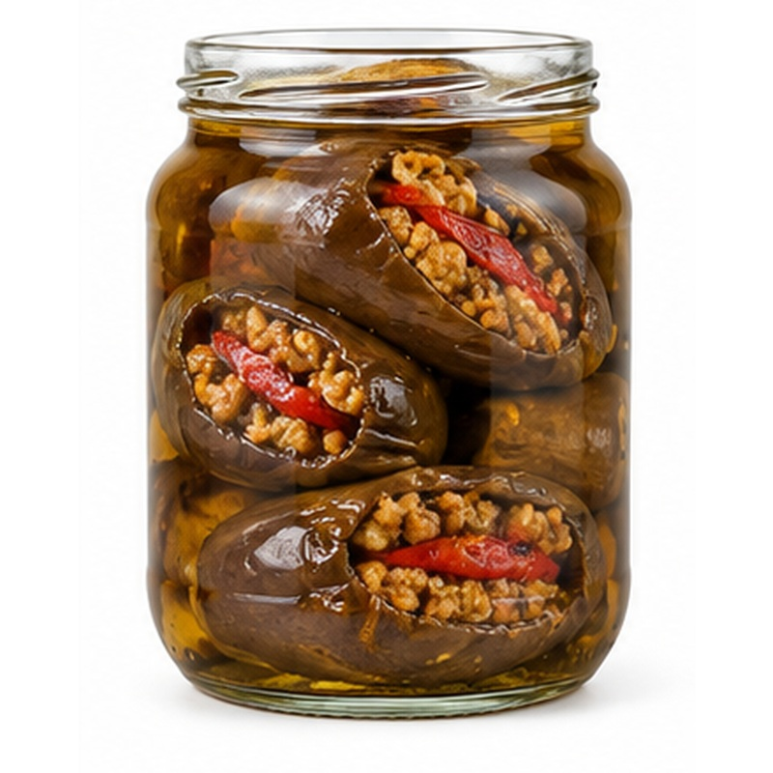 | Traditional preserved baby eggplant filled with a seasoned savoury mixture.  AVAILABLE FORMS Stuffed baby eggplant  PROCESSING & HANDLING Produce is sorted, prepared and packed in a controlled brine or marinade. Salt, acidity, recipe and cut are confirmed to buyer specification.  PACKING Glass jars, PET jars, cans or food-service containers  STORAGE GUIDE Store unopened in a cool, dry place away from direct sunlight. Refrigerate after opening and follow the final label instructions.

30 GRILLED EGGPLANT
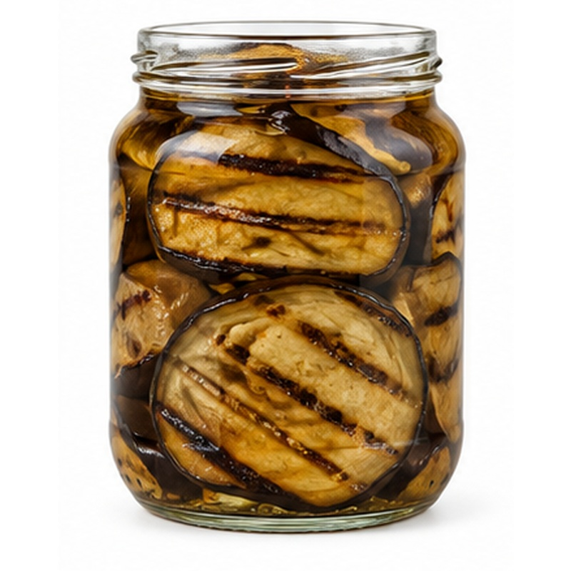 | Smoky grilled eggplant prepared for appetisers, dips and ready-meal production.  AVAILABLE FORMS Grilled slices, pieces or pulp  PROCESSING & HANDLING Produce is sorted, prepared and packed in a controlled brine or marinade. Salt, acidity, recipe and cut are confirmed to buyer specification.  PACKING Glass jars, PET jars, cans or food-service containers  STORAGE GUIDE Store unopened in a cool, dry place away from direct sunlight. Refrigerate after opening and follow the final label instructions.

31 TOMATO PASTE
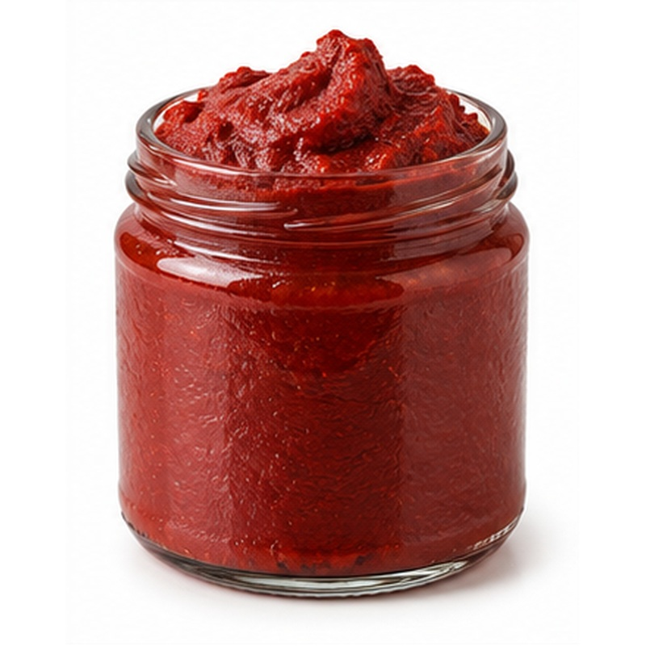 | Concentrated tomato paste offering deep colour and consistent solids.  AVAILABLE FORMS 22-24 or 28-30 Brix and buyer-specific grades  PROCESSING & HANDLING Ingredients are processed, blended and concentrated to the agreed recipe, then hot-filled or aseptically packed as applicable.  PACKING Glass jars, cans, pouches, bottles or aseptic bulk  STORAGE GUIDE Store unopened in a cool, dry place away from direct sunlight. Refrigerate after opening and follow the final label instructions.

32 TOMATO SAUCE
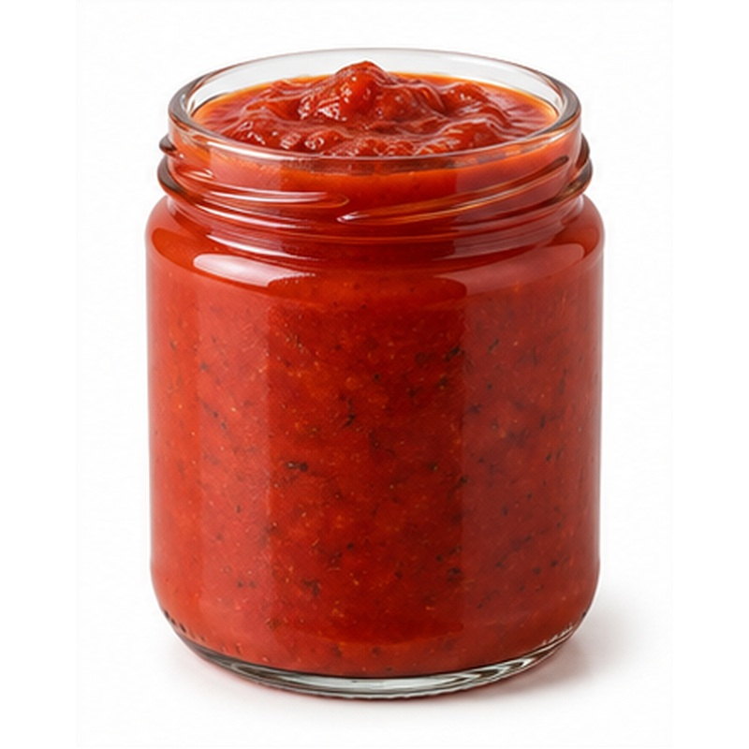 | Smooth tomato sauce prepared for retail, catering and recipe manufacturing.  AVAILABLE FORMS Plain or seasoned  PROCESSING & HANDLING Ingredients are processed, blended and concentrated to the agreed recipe, then hot-filled or aseptically packed as applicable.  PACKING Glass jars, cans, pouches, bottles or aseptic bulk  STORAGE GUIDE Store unopened in a cool, dry place away from direct sunlight. Refrigerate after opening and follow the final label instructions.

33 TOMATO PASSATA
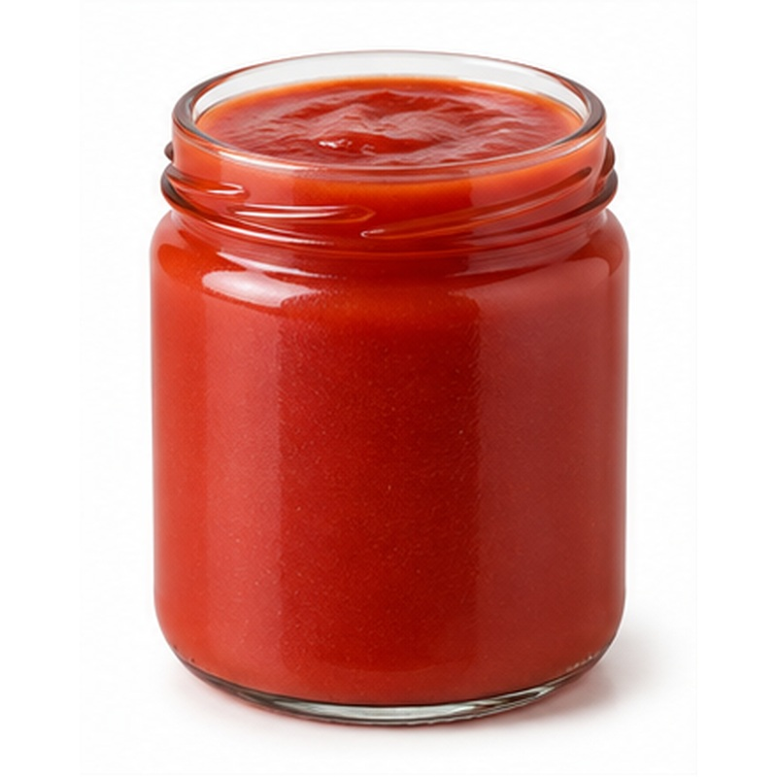 | Fine strained tomato passata with a clean texture and natural tomato character.  AVAILABLE FORMS Smooth strained tomatoes  PROCESSING & HANDLING Ingredients are processed, blended and concentrated to the agreed recipe, then hot-filled or aseptically packed as applicable.  PACKING Glass jars, cans, pouches, bottles or aseptic bulk  STORAGE GUIDE Store unopened in a cool, dry place away from direct sunlight. Refrigerate after opening and follow the final label instructions.

34 PIZZA SAUCE
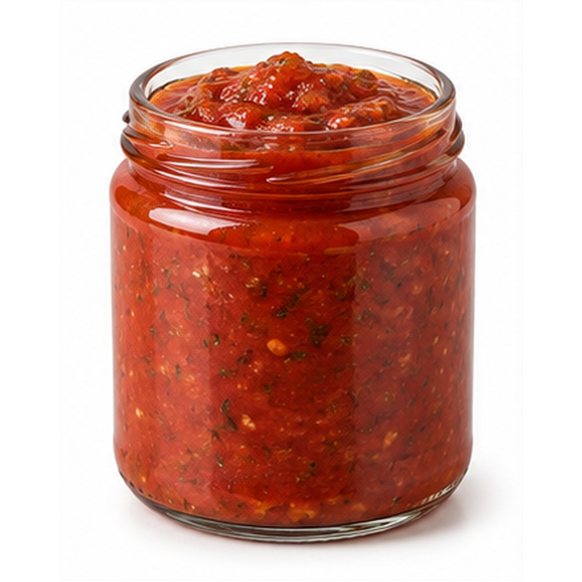 | A ready-to-use tomato base developed for pizza and bakery applications.  AVAILABLE FORMS Ready-seasoned or buyer-specific recipe  PROCESSING & HANDLING Ingredients are processed, blended and concentrated to the agreed recipe, then hot-filled or aseptically packed as applicable.  PACKING Glass jars, cans, pouches, bottles or aseptic bulk  STORAGE GUIDE Store unopened in a cool, dry place away from direct sunlight. Refrigerate after opening and follow the final label instructions.

35 TOMATO KETCHUP
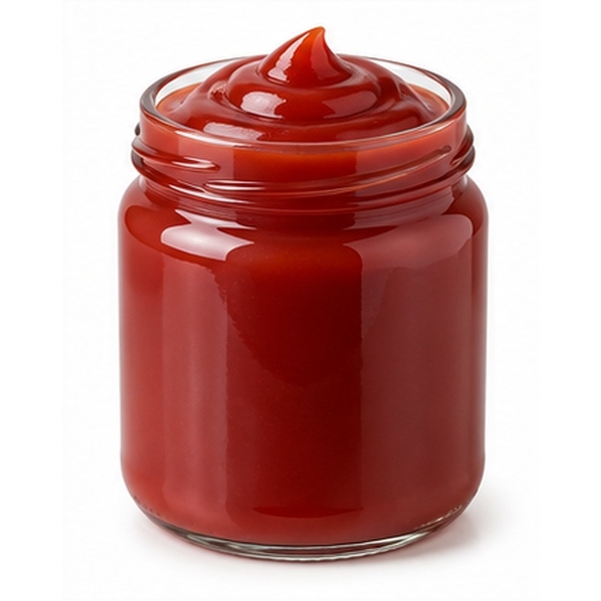 | Smooth tomato ketchup with buyer-selected sweetness, acidity and consistency.  AVAILABLE FORMS Retail or food-service recipe  PROCESSING & HANDLING Ingredients are processed, blended and concentrated to the agreed recipe, then hot-filled or aseptically packed as applicable.  PACKING Glass jars, cans, pouches, bottles or aseptic bulk  STORAGE GUIDE Store unopened in a cool, dry place away from direct sunlight. Refrigerate after opening and follow the final label instructions.

36 CHILI PASTE / HARISSA
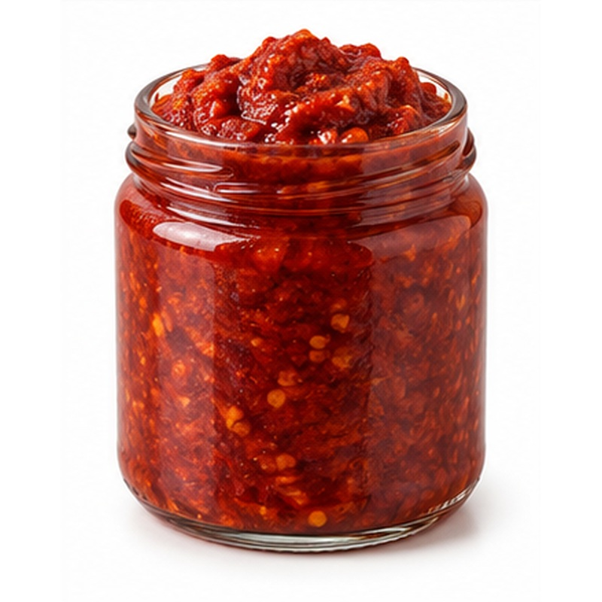 | Concentrated chili paste supplying colour, aroma and controlled heat.  AVAILABLE FORMS Mild, medium or hot  PROCESSING & HANDLING Ingredients are processed, blended and concentrated to the agreed recipe, then hot-filled or aseptically packed as applicable.  PACKING Glass jars, cans, pouches, bottles or aseptic bulk  STORAGE GUIDE Store unopened in a cool, dry place away from direct sunlight. Refrigerate after opening and follow the final label instructions.

37 HOT SAUCE
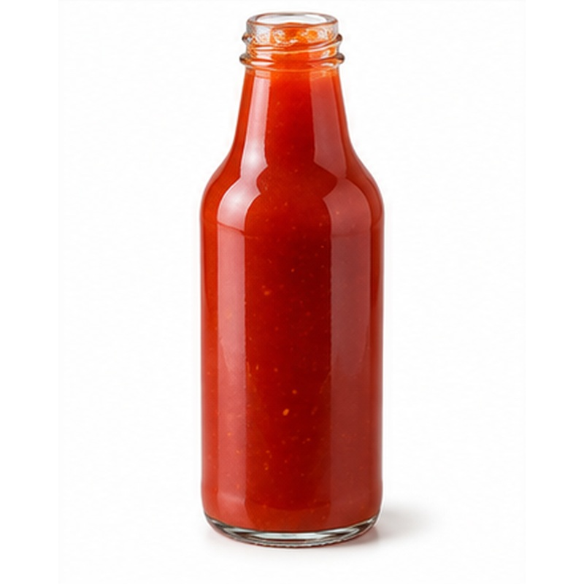 | Pourable pepper sauce developed to the required heat and flavour profile.  AVAILABLE FORMS Multiple heat levels and recipes  PROCESSING & HANDLING Ingredients are processed, blended and concentrated to the agreed recipe, then hot-filled or aseptically packed as applicable.  PACKING Glass jars, cans, pouches, bottles or aseptic bulk  STORAGE GUIDE Store unopened in a cool, dry place away from direct sunlight. Refrigerate after opening and follow the final label instructions.

38 FRUIT JAM
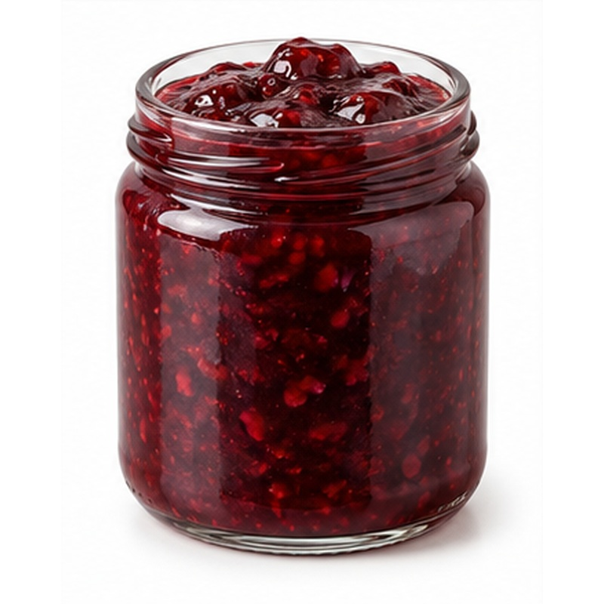 | Fruit-rich jam offered in classic Egyptian and international flavours.  AVAILABLE FORMS Strawberry, apricot, fig, mango, guava, blackberry or raspberry  PROCESSING & HANDLING Ingredients are cleaned, cooked or blended to the agreed solids and sweetness, then hygienically hot-filled and sealed.  PACKING Glass jars, plastic tubs, buckets or bulk formats  STORAGE GUIDE Store unopened in a cool, dry place away from direct sunlight. Refrigerate after opening and follow the final label instructions.

39 ORANGE MARMALADE
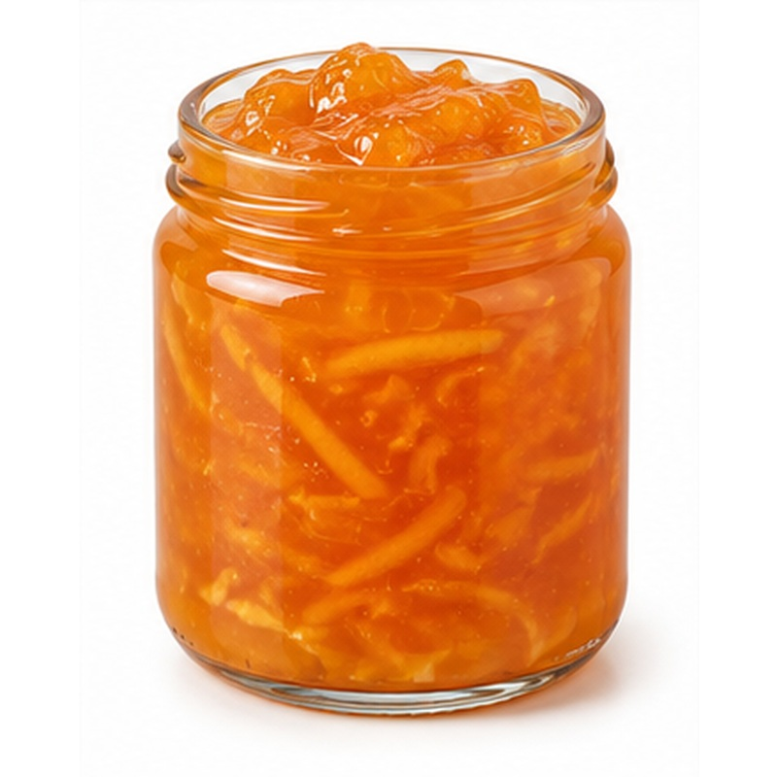 | Bright citrus marmalade with adjustable peel content and sweetness.  AVAILABLE FORMS Smooth or peel-rich  PROCESSING & HANDLING Ingredients are cleaned, cooked or blended to the agreed solids and sweetness, then hygienically hot-filled and sealed.  PACKING Glass jars, plastic tubs, buckets or bulk formats  STORAGE GUIDE Store unopened in a cool, dry place away from direct sunlight. Refrigerate after opening and follow the final label instructions.

40 DATE JAM
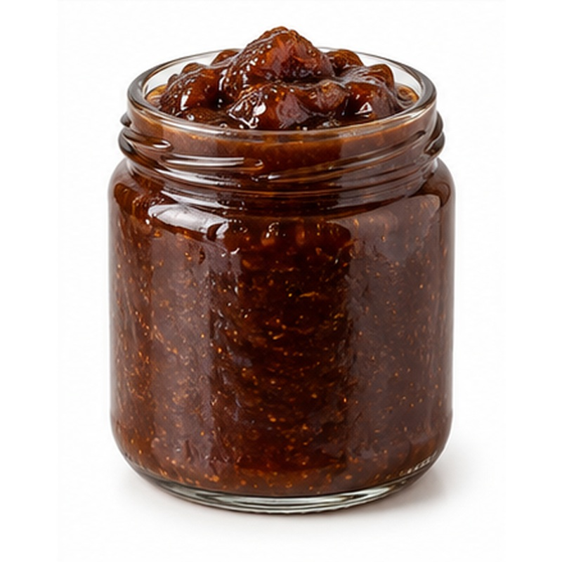 | Rich naturally dark date spread with a smooth, full-bodied character.  AVAILABLE FORMS Plain or flavoured  PROCESSING & HANDLING Ingredients are cleaned, cooked or blended to the agreed solids and sweetness, then hygienically hot-filled and sealed.  PACKING Glass jars, plastic tubs, buckets or bulk formats  STORAGE GUIDE Store unopened in a cool, dry place away from direct sunlight. Refrigerate after opening and follow the final label instructions.

41 PRICKLY PEAR JAM
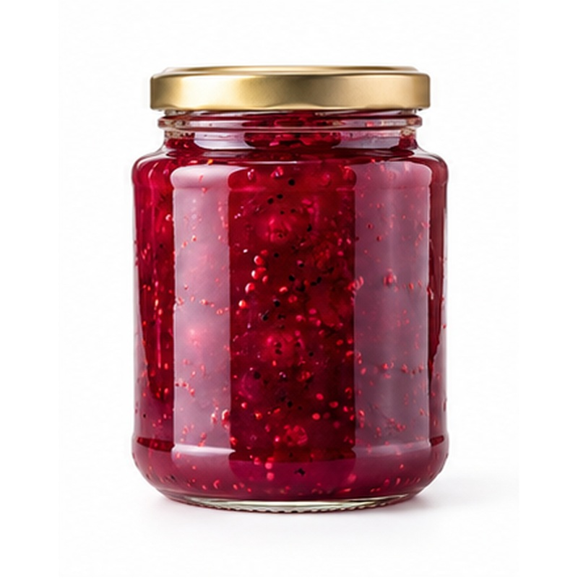 | A distinctive speciality jam made from colourful prickly pear fruit.  AVAILABLE FORMS Seasonal speciality  PROCESSING & HANDLING Ingredients are cleaned, cooked or blended to the agreed solids and sweetness, then hygienically hot-filled and sealed.  PACKING Glass jars, plastic tubs, buckets or bulk formats  STORAGE GUIDE Store unopened in a cool, dry place away from direct sunlight. Refrigerate after opening and follow the final label instructions.

42 BLACK MOLASSES
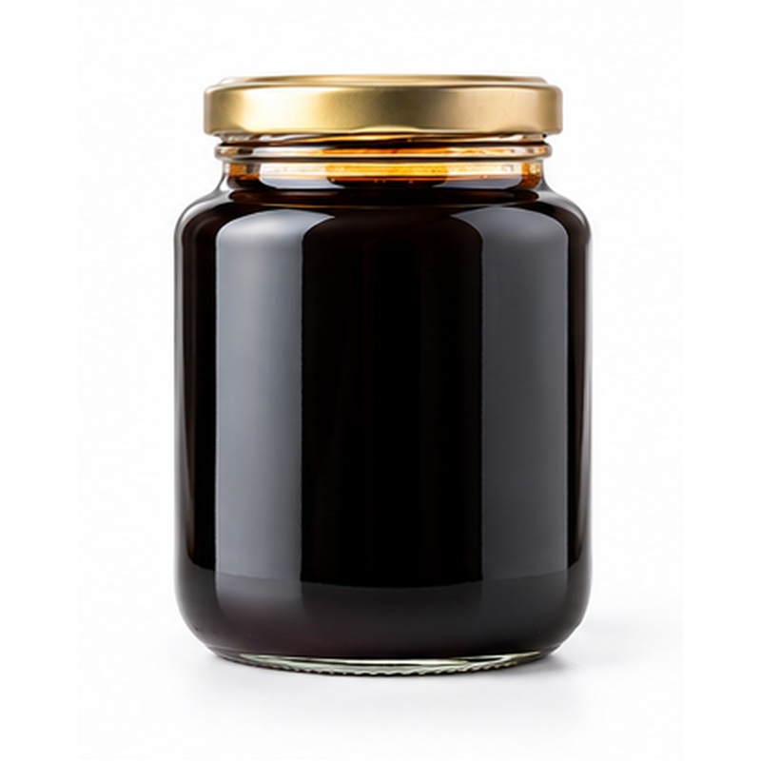 | Dense sugarcane molasses with a deep colour and characteristic robust flavour.  AVAILABLE FORMS Retail or bulk  PROCESSING & HANDLING Ingredients are cleaned, cooked or blended to the agreed solids and sweetness, then hygienically hot-filled and sealed.  PACKING Glass jars, plastic tubs, buckets or bulk formats  STORAGE GUIDE Store unopened in a cool, dry place away from direct sunlight. Refrigerate after opening and follow the final label instructions.

43 NATURAL HONEY
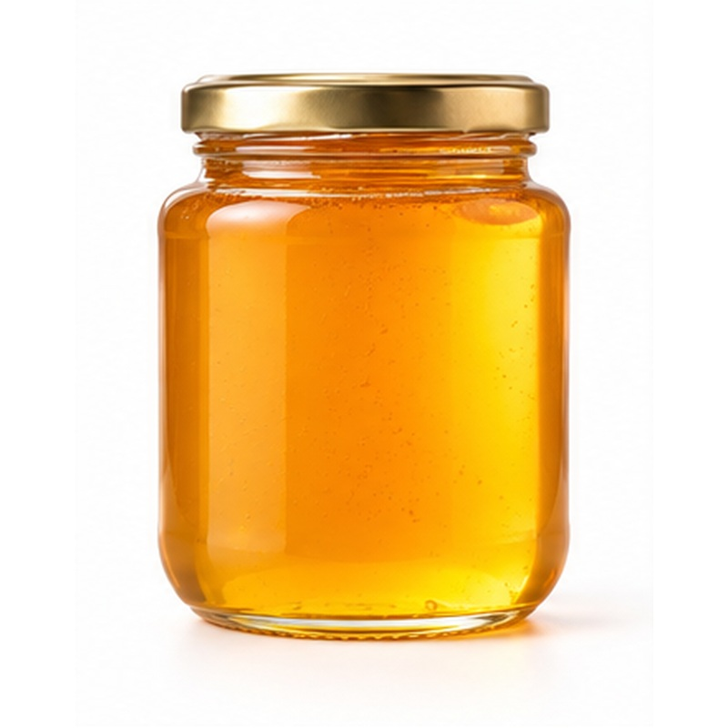 | Natural Egyptian honey selected by floral source and buyer requirements.  AVAILABLE FORMS Clover, citrus or multifloral  PROCESSING & HANDLING Ingredients are cleaned, cooked or blended to the agreed solids and sweetness, then hygienically hot-filled and sealed.  PACKING Glass jars, plastic tubs, buckets or bulk formats  STORAGE GUIDE Store unopened in a cool, dry place away from direct sunlight. Refrigerate after opening and follow the final label instructions.

44 FRUIT JUICE
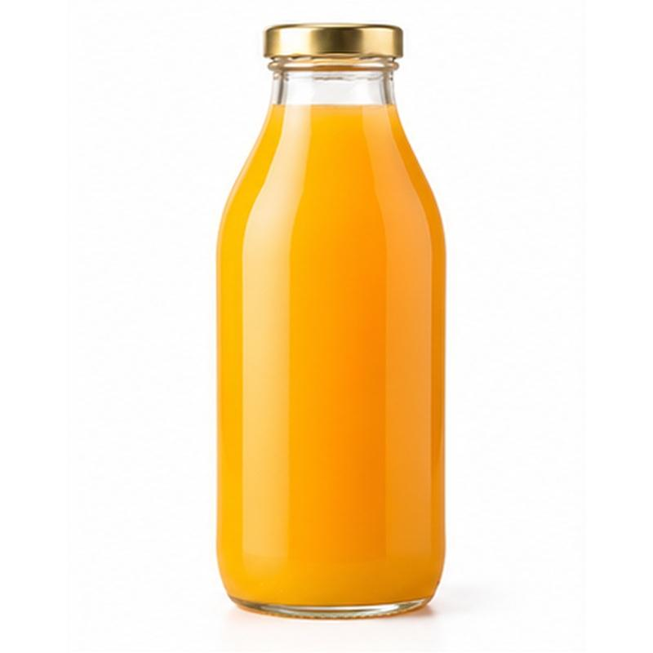 | Fruit juice supplied in popular single-fruit flavours and export pack sizes.  AVAILABLE FORMS Orange, lemon, apple, grape or pomegranate  PROCESSING & HANDLING Raw material is extracted or pulped, standardised to specification, pasteurised and hygienically filled in the selected format.  PACKING Glass, PET, cans, cartons or aseptic bulk  STORAGE GUIDE Store unopened in a cool, dry place away from direct sunlight. Refrigerate after opening and follow the final label instructions.

45 FRUIT NECTAR
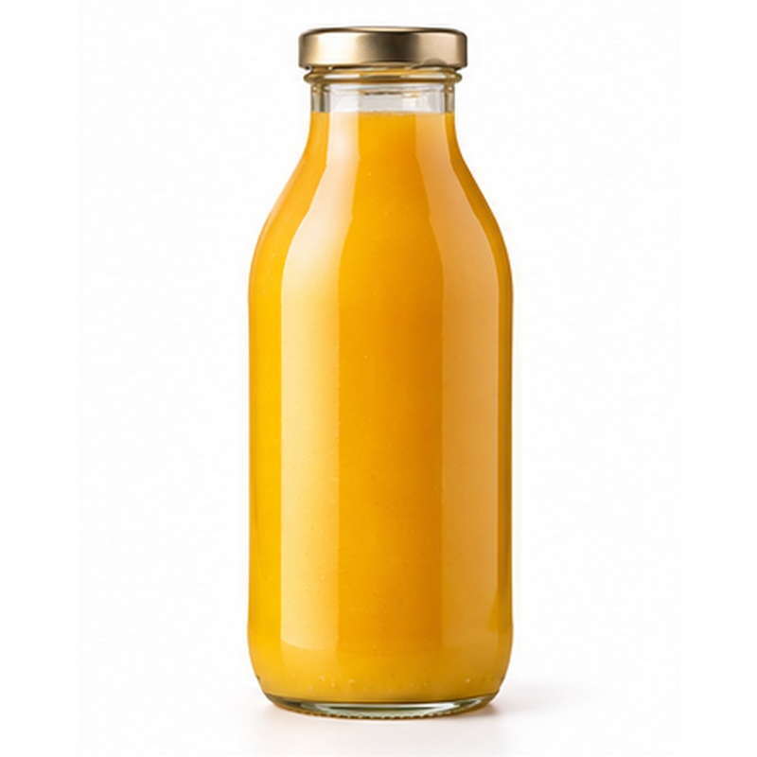 | Smooth fruit nectar balancing pulp, sweetness and drinkable consistency.  AVAILABLE FORMS Mango, guava, peach or cocktail  PROCESSING & HANDLING Raw material is extracted or pulped, standardised to specification, pasteurised and hygienically filled in the selected format.  PACKING Glass, PET, cans, cartons or aseptic bulk  STORAGE GUIDE Store unopened in a cool, dry place away from direct sunlight. Refrigerate after opening and follow the final label instructions.

46 FRUIT CONCENTRATES
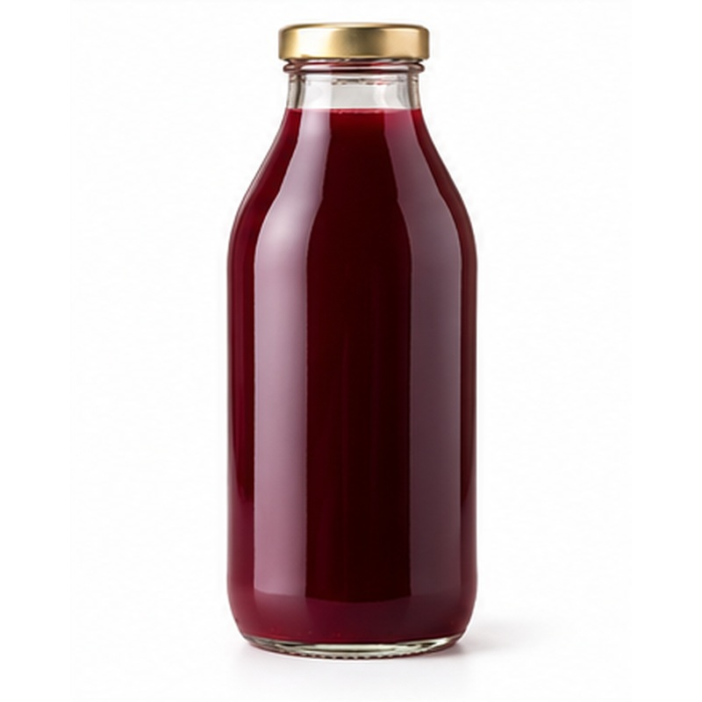 | Concentrated fruit ingredients for beverage, dairy and food manufacturing.  AVAILABLE FORMS Orange, lemon, grape or pomegranate  PROCESSING & HANDLING Raw material is extracted or pulped, standardised to specification, pasteurised and hygienically filled in the selected format.  PACKING Glass, PET, cans, cartons or aseptic bulk  STORAGE GUIDE Store unopened in a cool, dry place away from direct sunlight. Refrigerate after opening and follow the final label instructions.

47 FRUIT PUREES / PULPS
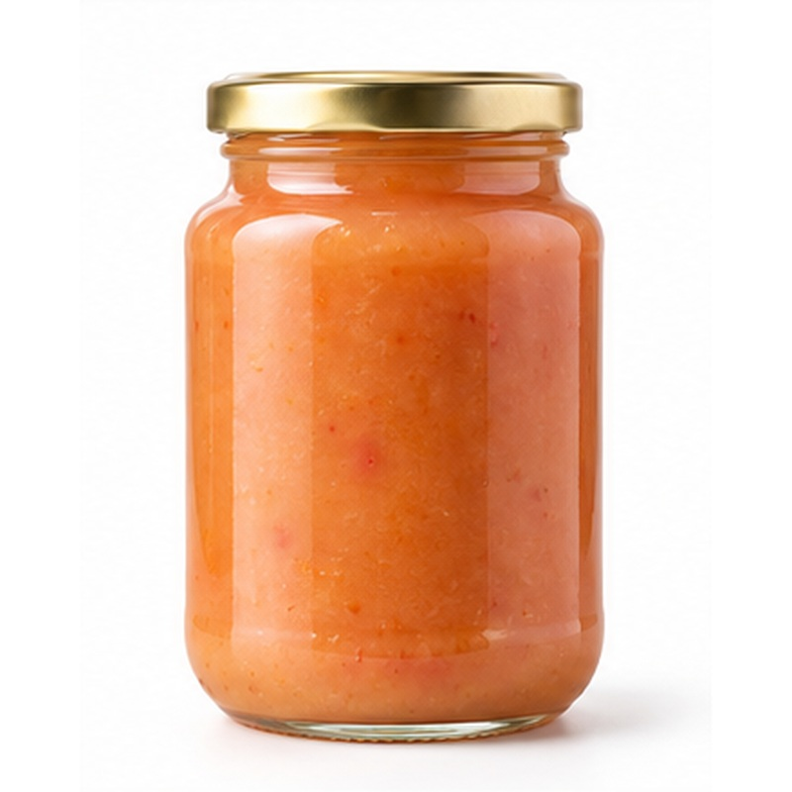 | Prepared fruit pulp offering consistent colour, flavour and processing convenience.  AVAILABLE FORMS Mango, guava, strawberry, peach or apricot  PROCESSING & HANDLING Raw material is extracted or pulped, standardised to specification, pasteurised and hygienically filled in the selected format.  PACKING Glass, PET, cans, cartons or aseptic bulk  STORAGE GUIDE Store unopened in a cool, dry place away from direct sunlight. Refrigerate after opening and follow the final label instructions.

48 TOMATO JUICE
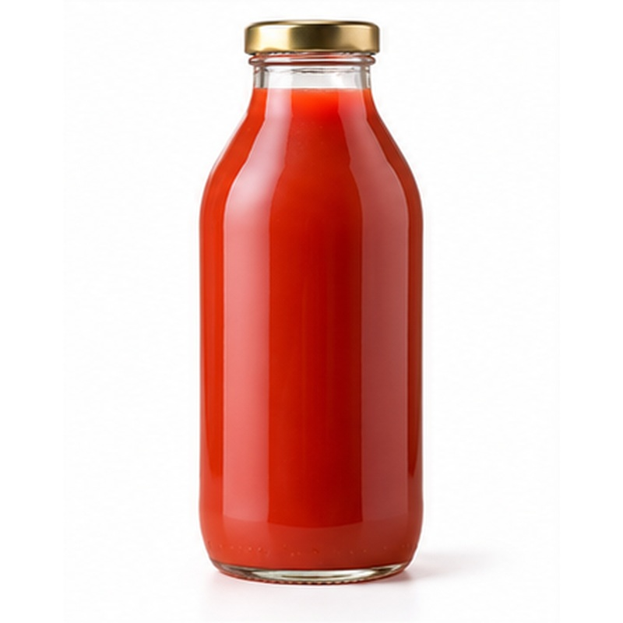 | Smooth tomato juice supplied for retail, catering and beverage programmes.  AVAILABLE FORMS Natural or seasoned  PROCESSING & HANDLING Raw material is extracted or pulped, standardised to specification, pasteurised and hygienically filled in the selected format.  PACKING Glass, PET, cans, cartons or aseptic bulk  STORAGE GUIDE Store unopened in a cool, dry place away from direct sunlight. Refrigerate after opening and follow the final label instructions.

49 FRUIT COCKTAIL DRINK
A refreshing mixed-fruit drink developed to the required flavour and sweetness.
AVAILABLE FORMS Mixed-fruit flavours
PROCESSING & HANDLING Raw material is extracted or pulped, standardised to specification, pasteurised and hygienically filled in the selected format.
PACKING Glass, PET, cans, cartons or aseptic bulk
STORAGE GUIDE Store unopened in a cool, dry place away from direct sunlight. Refrigerate after opening and follow the final label instructions.

50 OLIVE OIL
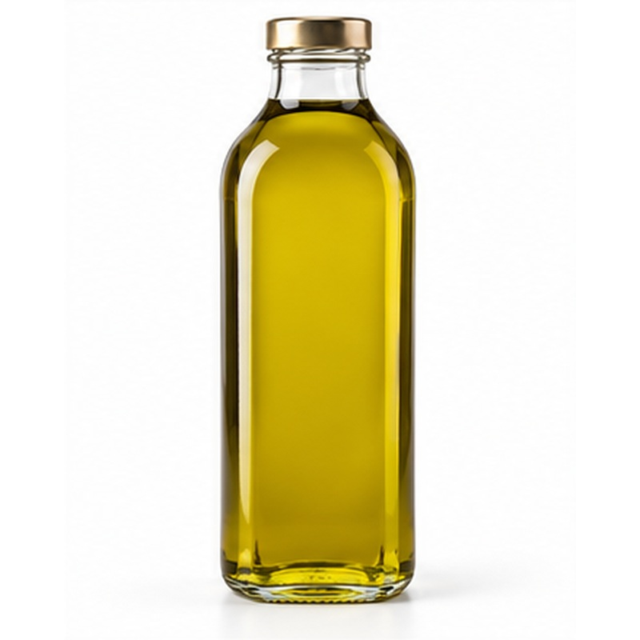 | Egyptian olive oil supplied in retail and bulk formats according to grade.  AVAILABLE FORMS Extra virgin, virgin or refined  PROCESSING & HANDLING Olives are processed and the oil is filtered or settled according to grade, then protected from heat, oxygen and light during filling.  PACKING Dark glass, PET, tins or bulk containers  STORAGE GUIDE Store unopened in a cool, dry place away from direct sunlight. Refrigerate after opening and follow the final label instructions.

51 TAHINI
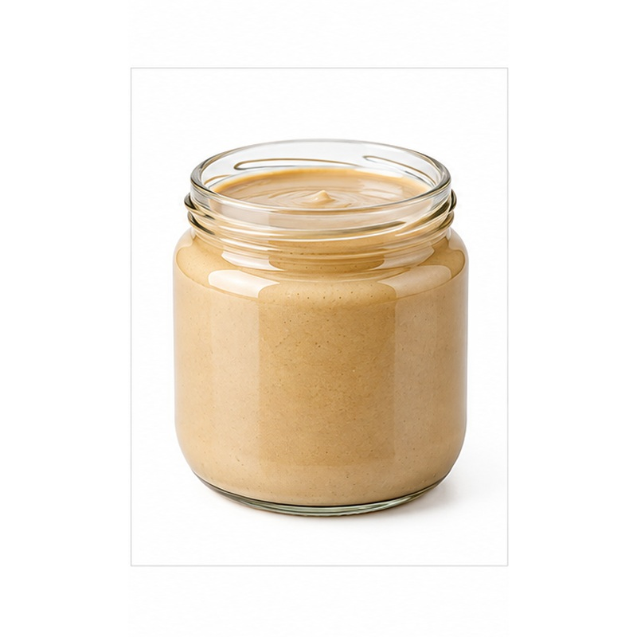 | Smooth sesame paste with a rich roasted flavour and consistent texture.  AVAILABLE FORMS Natural sesame paste  PROCESSING & HANDLING Ingredients are prepared and blended under controlled hygienic conditions, then filled and sealed in the buyer-selected format.  PACKING Glass jars, tubs, cans or food-service containers  STORAGE GUIDE Store unopened in a cool, dry place away from direct sunlight. Refrigerate after opening and follow the final label instructions.

52 HALVA
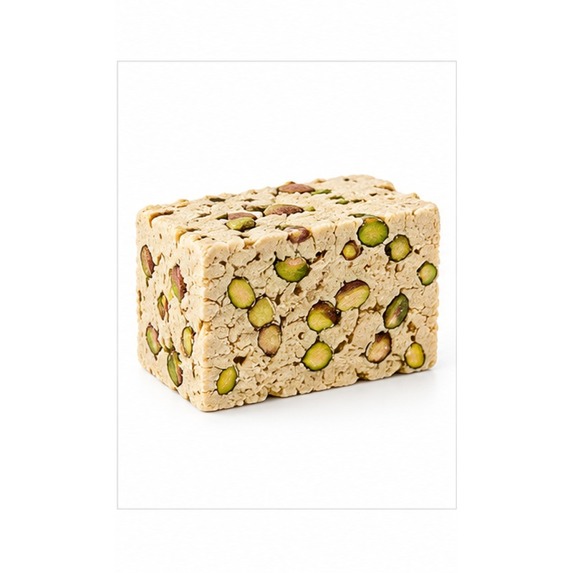 | Traditional sesame halva with a light, crumbly texture and optional nuts.  AVAILABLE FORMS Plain, pistachio or mixed nuts  PROCESSING & HANDLING Ingredients are prepared and blended under controlled hygienic conditions, then filled and sealed in the buyer-selected format.  PACKING Glass jars, tubs, cans or food-service containers  STORAGE GUIDE Store unopened in a cool, dry place away from direct sunlight. Refrigerate after opening and follow the final label instructions.

53 HUMMUS
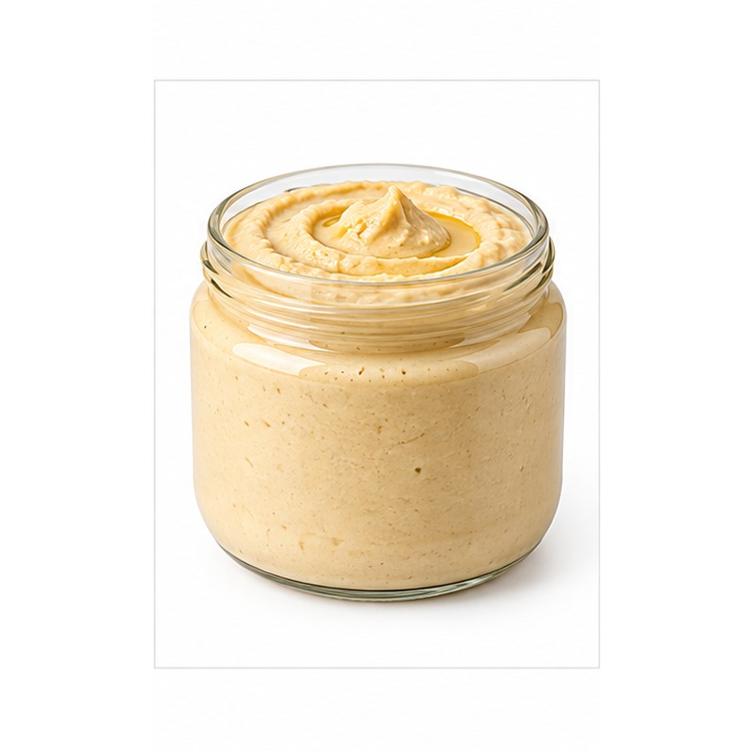 | Ready-to-eat chickpea and tahini spread with a smooth savoury profile.  AVAILABLE FORMS Plain or flavoured  PROCESSING & HANDLING Ingredients are prepared and blended under controlled hygienic conditions, then filled and sealed in the buyer-selected format.  PACKING Glass jars, tubs, cans or food-service containers  STORAGE GUIDE Store unopened in a cool, dry place away from direct sunlight. Refrigerate after opening and follow the final label instructions.

54 BABA GHANOUSH
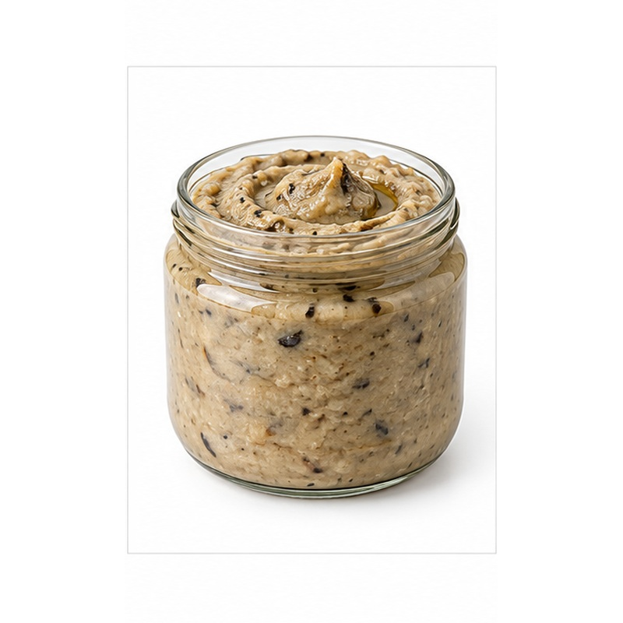 | Smoky eggplant dip prepared for retail and food-service appetiser ranges.  AVAILABLE FORMS Classic or buyer-specific recipe  PROCESSING & HANDLING Ingredients are prepared and blended under controlled hygienic conditions, then filled and sealed in the buyer-selected format.  PACKING Glass jars, tubs, cans or food-service containers  STORAGE GUIDE Store unopened in a cool, dry place away from direct sunlight. Refrigerate after opening and follow the final label instructions.

55 NATURAL VINEGAR
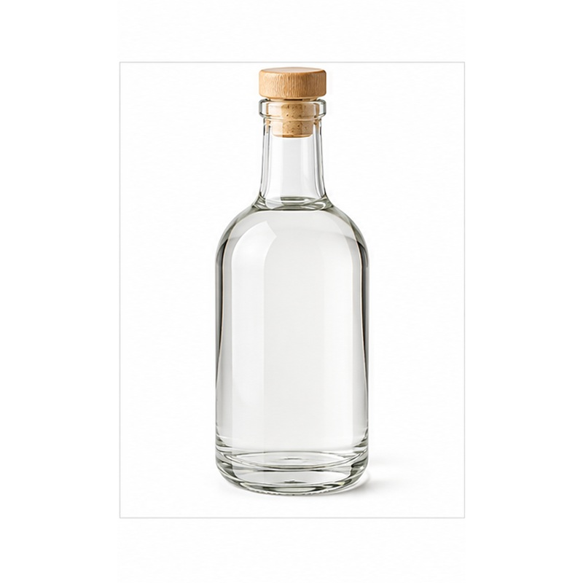 | Clear culinary vinegar supplied in multiple types and acidity specifications.  AVAILABLE FORMS White, apple or other natural varieties  PROCESSING & HANDLING Ingredients are prepared and blended under controlled hygienic conditions, then filled and sealed in the buyer-selected format.  PACKING Glass jars, tubs, cans or food-service containers  STORAGE GUIDE Store unopened in a cool, dry place away from direct sunlight. Refrigerate after opening and follow the final label instructions.

NILE-MAPLE
Flexible recipes • Export packaging • Private-label capability
Ingredients, recipes, net weights, treatments, shelf life, labelling and packaging are confirmed with the approved manufacturer according to the destination market and buyer requirements.

