**

**UNIVERSITY-BANGLADESH**

Choose an item.

**Report Cover Sheet**

|  |  |  |  |  |
| --- | --- | --- | --- | --- |
| Assignment Title: | Merto rail connecting commertial area to residential area | | | |
| Assignment No: | **Click here to enter text.** | | Date of Submission: | 26 December 2023 |
| Course Title: | COMPUTER GRAPHICS | | | |
| Course Code: | **Click here to enter text.** | | Section: | [A] |
| Semester: | Fall | 2023-2024 | Course Teacher: | **ANEEM AL AHSAN RUPAI** |

**Declaration and Statement of Authorship:**

1. I/we hold a copy of this Assignment/Case-Study, which can be produced if the original is lost/damaged.
2. This Assignment/Case-Study is my/our original work and no part of it has been copied from any other student’s work or from any other source except where due acknowledgement is made.
3. No part of this Assignment/Case-Study has been written for me/us by any other person except where such collaborationhas been authorized by the concerned teacher and is clearly acknowledged in the assignment.
4. I/we have not previously submitted or currently submitting this work for any other course/unit.
5. This work may be reproduced, communicated, compared and archived for the purpose of detecting plagiarism.
6. I/we give permission for a copy of my/our marked work to be retained by the Faculty for review and comparison, including review by external examiners.
7. I/we understand thatPlagiarism is the presentation of the work, idea or creation of another person as though it is your own. It is a formofcheatingandisaveryseriousacademicoffencethatmayleadtoexpulsionfromtheUniversity. Plagiarized material can be drawn from, and presented in, written, graphic and visual form, including electronic data, and oral presentations. Plagiarism occurs when the origin of them arterial used is not appropriately cited.
8. I/we also understand that enabling plagiarism is the act of assisting or allowing another person to plagiarize or to copy my/our work.

*\* Student(s) must complete all details except the faculty use part.*

** Please submit all assignments to your course teacher or the office of the concerned teacher.

|  |  |
| --- | --- |
| Group Name/No.: | 06 |

|  |  |  |  |  |  |  |
| --- | --- | --- | --- | --- | --- | --- |
| **No** | **Name** | **ID** | | **Program** | | **Signature** |
| 1 | Zafir Ken Zaman | 20-44041-2 | | BSc [CSE] | |  |
| 2 | Moazzen Hossain | 20-43014-1 | | BSc [CSE] | |  |
| 3 | Mahadi Hasan Emon | 20-43099-1 | | BSc [CSE] | |  |
| 4 | Md Al Masud Or Rashid | 20-43014-1 | | BSc [CSE] | |  |
| ***Faculty use only*** | | | | | | | |
| FACULTYCOMMENTS | | | **Marks Obtained** | |  | | |
|  | | |  | |  | | |
|  | | |  | |  | | |
|  | | | **Total Marks** | |  | | |
|  | | |  | |  | | |

The following sections must be included in your project report-

1. Title Page
2. Table of Contents
3. Introduction (Give a description of your project. Also discuss about the technologies you have used)

"MetroConnect" is an engaging graphics OpenGL project that envisions a dynamic metro rail network seamlessly connecting commercial and residential zones within a virtual urban landscape. Through realistic simulations and interactive features, the project explores the impact of efficient transportation on urban connectivity, offering a glimpse into a more integrated and sustainable future for city dwellers. Join us on a visual journey to experience the potential of a well-designed metro system in fostering vibrant, interconnected urban spaces.

1. Project Graph – This part will you look at the project design. Also it will guide with coordinates with which you will be working.

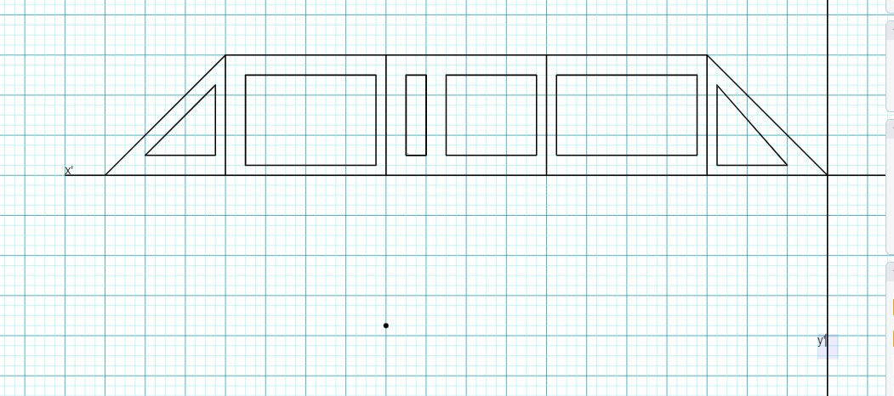

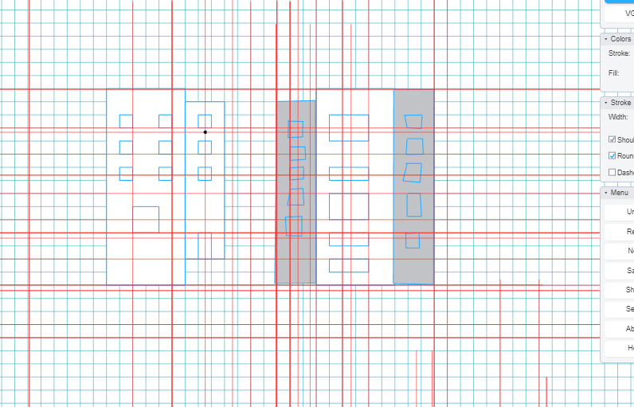

1. List of objects assigning an object ID – Make a list of the objects that will be included in your project. MUST follow the following listing pattern.

|  |  |  |
| --- | --- | --- |
| SL# | Object ID | Object Name |
| 1 | Sky | Sky |
| 2 | Sun 1 | Sun |
| 3 | Sun2 | Sun |
| 4 | Plane | Plane |
| 5 | River | River |
| 6 | Moon | Moon |
| 7 | Building 1 | Building |
| 8 | Building 2 | Building |
| 9 | Building3 | Building |
| 10 | Building 4 | building |
| 11 | Building5 | Building |
| 12 | Bakery | Bakery |
| 13 | StationRB | Station roof |
| 14 | StationFP | Station pillar |
| 15 | Train | Train |
| 16 | redlights | Redlights |
| 17 | Road | road |
| 18 | Accelerator | Escalator |
| 19 | Car | Car |
| 20 | Car2 | Car |
| 21 | Tyre 2nd | Tire |
| 22 | Tyre | Tire |
| 23 | tyreM | Tire |
| 24 | Secondcartire | Tire |
| 25 | Secondcartire3 | Tire |
| 26 | Secondcartire2 | Tire |
| 27 | Busstop | Bustop |
| 28 | Bus | Bus |
| 29 | Bustyre1 | Tire |
| 30 | Bustyre2 | Tire |
| 31 | Bustyre3 | tire |
| 32 | humany | Human |
| 33 | streetlights | Streetlights |
| 34 | streetlight | Streetlights |
| 35 | stationroad | Stationroad |
| 36 | Streetlights1 | streetlights |
| 37 | Station | Metro station |
| 38 | Ship | Ship |
| 39 | Boat1 | Boat |
| 40 | Mosque | mosque |
| 41 | House3 | House |
| 42 | House2 | House |
| 43 | House1 | House |
| 44 | House | House |
| 45 | House4 | House |
| 46 | Nightsky | Sky |
| 47 | Cloud | Cloud |
| 48 | Star | Star |
| 49 | Nightriver | River |
| 50 | earth | Ground |
| 51 | Earthnight | Ground |
| 52 | Footballground | Footballground |
| 53 | Goalpost | Goalpost |
| 54 | goalposts | Goalposts |
| 55 | Football | Football |
| 56 | Player | Player |
| 57 | players | Player |
| 58 | Ground | Football ground |

1. List of Functions To Represent Objects- Each object must be represented by a function. MUST follow the following listing pattern-

|  |  |  |  |  |
| --- | --- | --- | --- | --- |
| SL# | Object name | Function name | Object Name | Function name |
| 1 | Sky | Sky () | Sky | Sky |
| 2 | Sun | Sun 1 () | Sun 1 | Sun |
| 3 | Sun | Sun2 () | Sun2 | Sun |
| 4 | Plane | Plane() | Plane | Plane |
| 5 | River | River () | River | River |
| 6 | Moon | Moon () | Moon | Moon |
| 7 | Building | Building 1() | Building 1 | Building |
| 8 | Building | Building 2() | Building 2 | Building |
| 9 | Building | Building3 () | Building3 | Building |
| 10 | building | Building 4() | Building 4 | building |
| 11 | Building | Building5 () | Building5 | Building |
| 12 | Bakery | Bakery() | Bakery | Bakery |
| 13 | Station roof | StationRB() | StationRB | Station roof |
| 14 | Station pillar | StationFP() | StationFP | Station pillar |
| 15 | Train | Train() | Train | Train |
| 16 | Redlights | redlights() | redlights | Redlights |
| 17 | road | Road () | Road | road |
| 18 | Escalator | Accelerator() | Accelerator | Escalator |
| 19 | Car | Car () | Car | Car |
| 20 | Car | Car2() | Car2 | Car |
| 21 | Tire | Tyre 2nd() | Tyre 2nd | Tire |
| 22 | Tire | Tyre () | Tyre | Tire |
| 23 | Tire | tyreM () | tyreM | Tire |
| 24 | Tire | Secondcartire () | Secondcartire | Tire |
| 25 | Tire | Secondcartire3() | Secondcartire3 | Tire |
| 26 | Tire | Secondcartire2() | Secondcartire2 | Tire |
| 27 | Bustop | Busstop() | Busstop | Bustop |
| 28 | Bus | Bus() | Bus | Bus |
| 29 | Tire | Bustyre1() | Bustyre1 | Tire |
| 30 | Tire | Bustyre2() | Bustyre2 | Tire |
| 31 | tire | Bustyre3() | Bustyre3 | tire |
| 32 | Human | humany() | humany | Human |
| 33 | Streetlights | streetlights() | streetlights | Streetlights |
| 34 | Streetlights | streetlight() | streetlight | Streetlights |
| 35 | Stationroad | stationroad() | stationroad | Stationroad |
| 36 | streetlights | Streetlights1() | Streetlights1 | streetlights |
| 37 | Metro station | Station() | Station | Metro station |
| 38 | Ship | Ship() | Ship | Ship |
| 39 | Boat | Boat1() | Boat1 | Boat |
| 40 | mosque | Mosque() | Mosque | mosque |
| 41 | House | House3() | House3 | House |
| 42 | House | House2() | House2 | House |
| 43 | House | House1() | House1 | House |
| 44 | House | House () | House | House |
| 45 | House | House4() | House4 | House |
| 46 | Sky | Nightsky() | Nightsky | Sky |
| 47 | Cloud | Cloud() | Cloud | Cloud |
| 48 | Star | Star() | Star | Star |
| 49 | River | Nightriver() | Nightriver | River |
| 50 | Ground | Earth() | earth | Ground |
| 51 | Ground | Earthnight() | Earthnight | Ground |
| 52 | Footballground | Footballground() | Footballground | Footballground |
| 53 | Goalpost | Goalpost() | Goalpost | Goalpost |
| 54 | Goalposts | Goalposts() | goalposts | Goalposts |
| 55 | Football | Football() | Football | Football |
| 56 | Player | Player() | Player | Player |
| 57 | Player | Players() | players | Player |
| 58 | Football ground | Ground() | Ground | Football ground |

1. List of Animation Functions with ID – These should be functions that are used to add animations like- object movement, mouse, and keyboard interaction, change of scenarios and so on. MUST follow the following listing pattern-

|  |  |  |  |
| --- | --- | --- | --- |
| SL# | Animation Function ID | Animation Function | Object/Scene |
| 1 | Sun | Update() | Sun |
| 2 | Moon | Update() | Moon |
| 3 | Ship | Update() | Ship |
| 4 | Train | Update() | Train |
| 5 | Boat | Update() | Boat |
| 6 | Plane | Update() | Plane |
| 7 | Bus | Update() | Bus |
| 8 | Car 1 | Update() | Car 1 |
| 9 | Car 2 | Update() | Car 2 |
| 10 | Cloud | Update() | Cloud |
| 11 | Players | Update() | Players |
| 12 | Football | Update() | Football |

1. Contribution – This part will list the contribution of each member. MUST follow the following listing pattern-

|  |  |  |  |
| --- | --- | --- | --- |
| Member Name | Implemented Functions | Implemented Animation Functions | Percentage of Contribution |
| Moazzen Hossain | Stationrb() , stationfp(), train(), redlights(), railline(), accelerator() , station light (), stationroad(), station(), stars(), earth(), earthnight() | Update() | 25% |
| Zafir ken Zaman | Building1(),Building2(),Building3(),Building4(),Building5(), mosque(), bakery(), footballground(), goalpost(), goalposts(), football(), player(), players() | Update() | 25% |
| Mahadi Hasan Emon | Sky(), sun1(),sun2(), plane(), moon(),ship(),boat1(), mosque(),house1(),house2(),house3(),house4(),house(),nightsky(), cloud(), nightriver(). | Update() | 25% |
| Md Al Masud Or Rashid | River(), road(), car(), tyre2nd(), tyre(), tyreM(), car2(), secondcartyre(),secondcartyre2(),secondcartyre3(), bustop(), bus(), bustyre1(),bustyre2(),bustyre3(), streetlights(),streetlights1() | Update() | 25% |

1. **Conclusion:** **To sum up, our graphics project did well in showing off design skills and technical know-how. Even though we faced challenges, the team worked together to make a visually impressive final product. Overall, this project taught us a lot and will help with future graphic design work.**

***Add the IDs as a comment at the start of each function. This will help you to search the functions easily.***