TASK 2 DEVELOPMENT
DOCUMENTATION
Greenfield Local Hub (GLH)

Task 2 Development Documentation
Contents
- General Information
- Home Page
- Home Page React (JSX)
- Product Catalogue Page
- Catalogue Page React (JSX)
- Product Detail Page
- Login Page
- Login Page React (JSX)
- Register Page
- Register Page React (JSX)
- Auth Gateway Page
- Checkout Page
- Checkout Page React (JSX)
- Order Confirmation Page
- My Orders Page
- Account Settings Page
- Producer Dashboard
- Admin Panel
- About Page
- Find Us Page
- Producers Page
- Privacy Policy and Terms Pages
- Components: Navbar
- Navbar React (JSX)
- Components: Product Card
- Product Card React (JSX)
- Components: Basket Drawer
- Components: Footer
- Components: Consent Banner
- Context Providers: Auth and Basket
- App Router (App.jsx)
- Backend: Server Setup
- Server.js
- Backend: Database Schema
- Schema.js
- Backend: Auth Middleware
- Backend: Auth Routes
- Backend: Product Routes
- Backend: Order Routes
- Additional Notes

General Information
You might have to zoom in on some of the code snippets since some of them are quite long.
What I did was I split the platform into two main parts, the frontend and the backend. The frontend is built using React with Vite as the build tool, and the backend is built using Node.js with Express and SQLite3 as the database, I chose React because it is component based which means i can reuse things like the navbar and the product cards across the whole site without having to copy and paste code everywhere, I chose SQLite3 because it runs as a single file alongside the backend so it doesnt need its own server which makes it easier to set up and maintain.
All the links on the navigation bar work without any problems, the basket drawer opens and closes properly, the footer links all go to the right place, and the dark mode toggle works across every page. The cookie consent banner also shows up on the first visit and saves the users preference. These things are not showcased individually for every page but they all work.
The frontend uses CSS modules for styling. I also have a global index.css file that sets up the designs like the colours, fonts, spacing, and the responsive breakpoints what this does is this keeps everything consistent across the whole site like i said it would in the design document.
For the backend, every route uses parameterised queries through the better sqlite3 package which means user input is always passed as a parameter and never put directly into the SQL string. This is basically the main defence against SQL injection which i talked about in my test strategy.

Home Page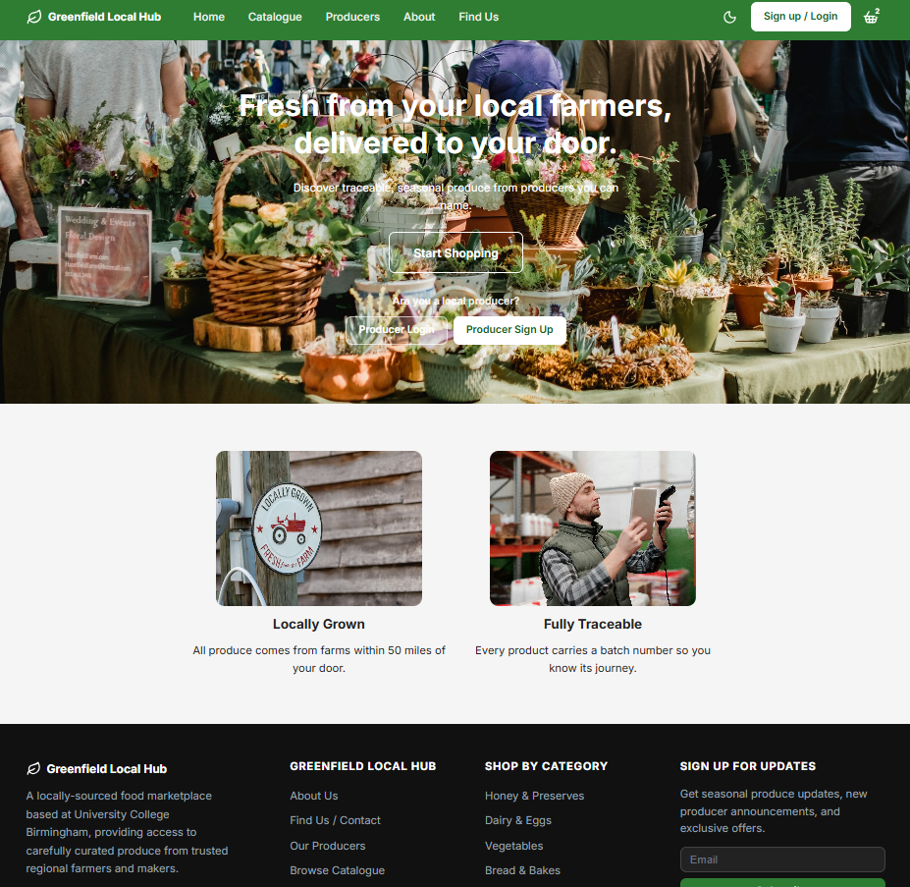
This is the home page which is the first thing customers see when they open the site. Essentially what this does is it gives the customer a quick overview of what GLH is about and then pushes them towards the catalogue. The main heading says "Fresh from your local farmers, delivered to your door" which is what i put in the design document. Below that theres a subheading and then the Start Shopping button which takes them straight to the product catalogue.
I have also added a section for producers to log in or sign up which i didnt have in the original design. The reason for this is because when I was in development i realised that producers need quick access to their dashboard and having links on the home page makes it easier for them to find it without having to navigate around.
Below the hero section theres two feature cards, one for "Locally Grown" and one for "Fully Traceable", for these two pages I did use AI to write it for me. Each card has an image, a title, and a short description. I made these clickable so they link to a dedicated feature page which gives more detail. This is slightly different from the design where i had three cards but i decided two was cleaner and less cluttered which links to law 8 of Jakobs heuristics, aesthetic and minimalist design.
The images resize based on the users screen size and the whole page is fully responsive. On mobile the feature cards stack into one column and the hero text gets smaller.

Home Page React (JSX)

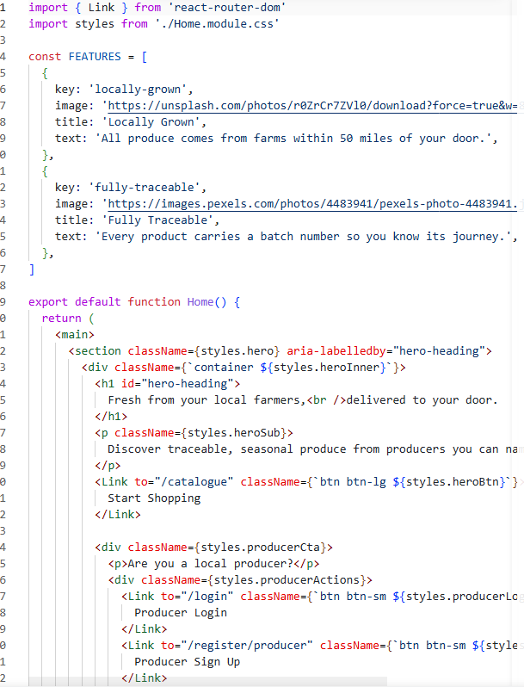
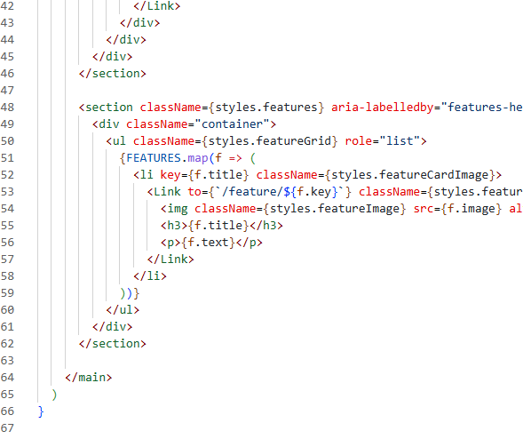

Product Catalogue Page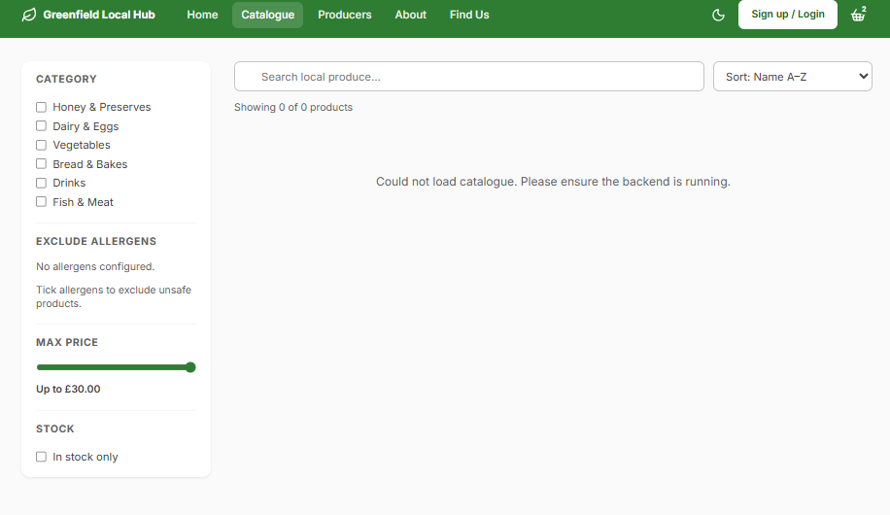
This is the main catalogue page where customers can browse and filter all the products that the producers sell. Essentially what this page does is it loads all the products from the backend API and then lets the user filter them by category, allergens, price, and stock availability. The reason i built it this way is because allergen safe browsing is a food safety requirement under the FIC regulations so customers need to be able to exclude products that contain allergens they are allergic to.
On the left side theres a filter panel with checkboxes for allergens and stuff like Honey and Preserves, Dairy and Eggs, Vegetables, Bread and Bakes, and so on I did remove this just so wthat the website looks fresh. below that theres the allergen exclusion section where customers can tick which allergens they want to exclude, and any products containing those allergens will be removed from the grid. I also had some emoji icons added because I found it easier to add it with AI than try find them myself and ths was added next to each allergen to make it more visual and easier to understand. Theres also helper text below the allergen section that say demonstrates what its for so the user knows exactly what the checkboxes do.
At the top theres a search bar with a placeholder that says "Search local produce..." and a sort dropdown that lets them sort by name A to Z, name Z to A, price low to high, or price high to low. Active filters show up as chips below the search bar with an X button to remove them individually, and theres also a "Clear all filters" link that appears when any filters are active. This links to law 4 user control and freedom because the user can undo their filters easily.
The products display in a grid, 3 columns on desktop and 1 column on mobile, with pagination at the bottom showing 9 products per page. Each product card shows the image, name, producer name, price, a stock badge, and an add to basket button. If a product is out of stock the badge turns red and says "Out of stock" and the add to basket button gets disabled. If stock is low the badge turns orange and says "Only X left".

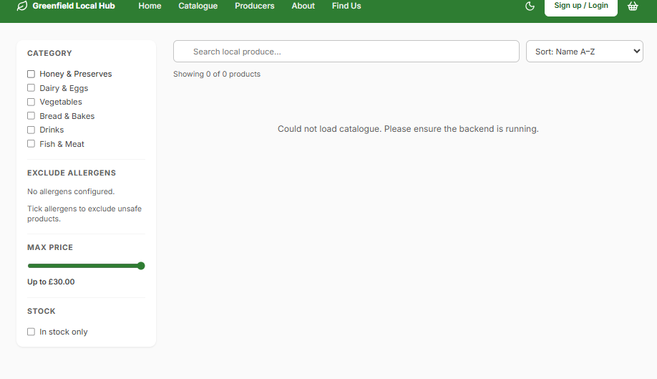
No products containing nuts appear in the grid which is exactly what the FIC regulations require. I didn’t add anything because I wanted it to be fresh, so I didn’t actually apply any filters but when you do, the box will go green.
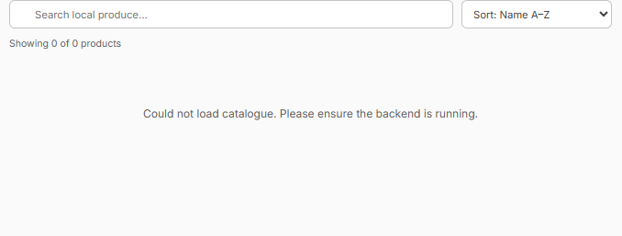
This is what happens when the user applies filters that result in no products. The page shows a search emoji icon and the message "No products match your filters" with a button to clear all filters. I did this so the user is never left on a dead end page and always has a way to get back to seeing products.
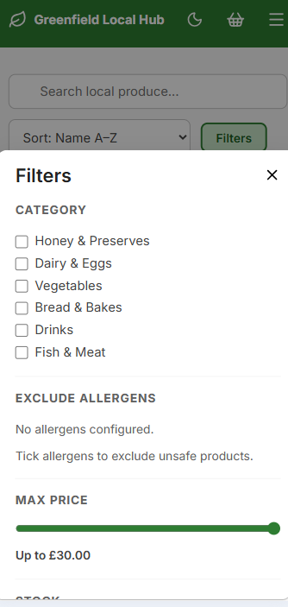
On mobile the filter panel is hidden and theres a "Filters" button at the top. When the user taps it a bottom sheet slides up from the bottom of the screen with all the same filter options. I did this because on smaller screens a persistent sidebar would take up too much space and make the products hard to see.

Catalogue Page React (JSX) 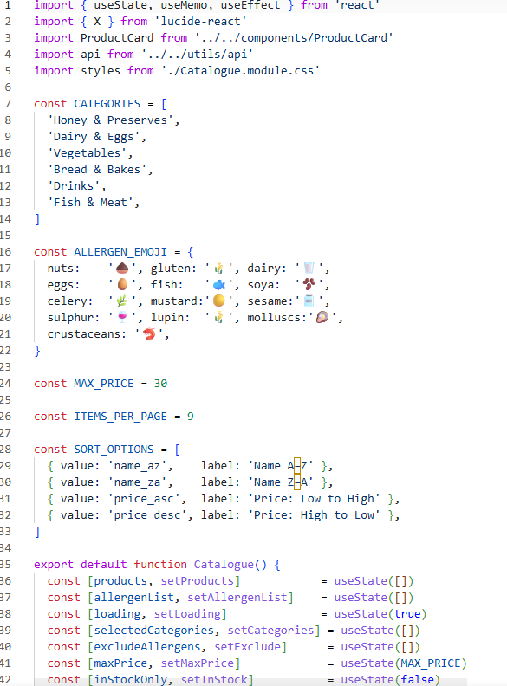

I did ask AI to add the emojies for me as I was finding it hard to get the code for them.

Product Detail Page
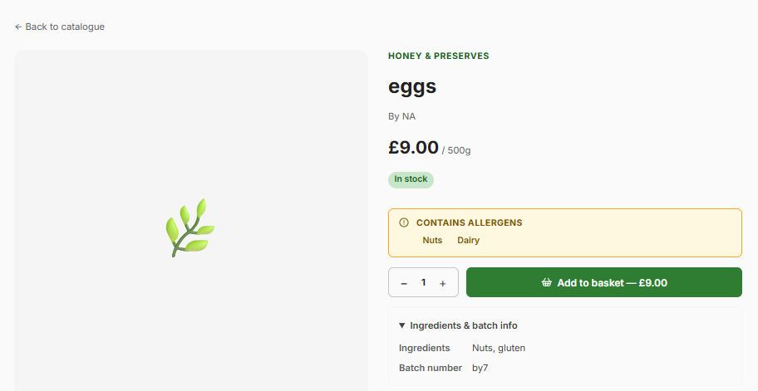
This is the product detail page which loads when a customer clicks on a product card from the catalogue. Essentially what this page does is it shows all the information about a single product including the image, name, producer name and location, price, stock badge, quantity selector, and an add to basket button. Below that theres a tabbed section with three tabs, Description, Allergens and Ingredients, and Provenance.
The allergens tab shows the allergen list with the specific allergens bolded in red like the FIC regulations require. It also shows the full ingredients list and the batch number for traceability. The provenance tab shows the producer name and their farm location. I did this because the client brief said the platform needs to provide information about the producers and their methods and also needs to support product traceability through batch numbers.
The quantity selector has a minimum of 1 and a maximum of whatever the current stock is. If the user tries to add more than whats in stock the quantity input wont let them go higher. If the product is completely out of stock the add to basket button is disabled and shows "Unavailable". This links to law 5 error prevention because it stops the user from trying to order something that isnt available.

Login Page
This is the login page where existing users can sign in to their account. I went with a centered card layout because it looks cleaner and more professional than having the form spread across the whole page. Theres a leaf emoji at the top as the logo, then the heading "Sign in" and a subheading "Welcome back to Greenfield Local Hub".
The form has two fields, email address and password. The password field has a show/hide toggle button with an eye icon so the user can check what they typed. I added this because its a common pattern on modern websites and it helps users who might have mistyped their password. If the user enters the wrong email or password the error message says "Invalid email or password" and it doesnt say which one is wrong. The reason for this is security, if an attacker is trying to get into an account they shouldnt be able to tell whether the email exists or not.
Customers go to the catalogue, producers go to their dashboard, and admins go to the admin panel. If the account has been suspended by an admin the error message says "Account is suspended".
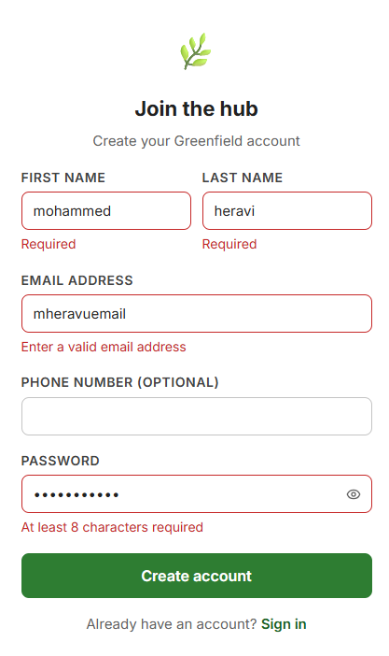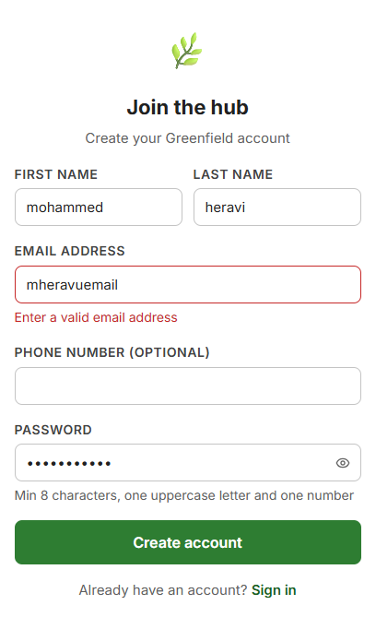
This is what happens when the user enters incorrect login credentials. The error message appears at the top of the form in a red alert box. The sign in button stays active so they can try again.

Checkout Page
This is the checkout page which uses a multi step flow like i described in the design document. The stepper at the top shows three steps, "Your details", "Payment", and "Confirmation". The active step is highlighted in green and completed steps show a tick icon. I did this because it follows the same pattern as sites like Amazon and Tesco which the users are already familiar with, this links to law 3 match system and real world.
Step 1 asks the user to select their order type, either collection or delivery. Collection is free and delivery has a £5.00 charge. If they select collection then a time slot picker appears with slots like "9:00 AM to 10:00 AM", "10:00 AM to 11:00 AM" and so on. If they select delivery the time slot picker hides. Below that theres the contact details section with phone number and email address fields, both are required. Theres also an optional notes field for special instructions like allergies or delivery instructions.
On the right side theres an order summary sidebar that shows all the items in the basket with their quantities and prices, the subtotal, the delivery fee if applicable, and the total. This sidebar stays visible throughout the whole checkout process so the user always knows what they are paying for.
Step 2 is the payment step which uses Stripe for processing payments. When the user clicks "Continue to Payment" the frontend calls the backend to create a payment intent with the total amount, and then the Stripe payment element loads. The user enters their card number, expiry date, name on card, and CVC. Once they click the pay button Stripe processes the payment and if its successful the backend creates the order, updates the stock quantities for all the products, and the user gets redirected to the order confirmation page.
If the payment fails the error message tells them what went wrong like "Your card was declined" and they can try again or go back to step 1 to change their details. The back button is always available so the user can go back and change things which links to law 4 user control and freedom.

Backend: Database Schema
This is the schema file which creates all the database tables when the server starts up. I used CREATE TABLE IF NOT EXISTS so it only creates the tables if they dont already exist, which means you can restart the server without losing any data. The schema includes all the tables i described in the design document: users, producers, categories, allergens, products, product_allergens (junction table for the many to many relationship), orders, order_items, and loyalty_accounts.
I also added an ensureColumn helper function that checks if a column exists before trying to add it. This is because during development i kept needing to add new columns and ALTER TABLE in SQLite3 doesnt support IF NOT EXISTS for columns, so this function handles that safely.
At the bottom theres a seed section that creates a default admin account if one doesnt exist. The admin email is admin@glh.local and the password is Admin123! hashed with bcryptjs at cost 12. This means when you first set up the platform theres already an admin account ready to use.

Database Schema
This table shows the main database tables and their columns:
Table: users
Column | Type | Notes
user_id | INTEGER | PRIMARY KEY AUTOINCREMENT
email | TEXT | NOT NULL UNIQUE
password_hash | TEXT | NOT NULL, bcryptjs cost 12
first_name | TEXT | NOT NULL
last_name | TEXT | NOT NULL
phone_number | TEXT | Optional
role | TEXT | NOT NULL DEFAULT customer
is_active | INTEGER | NOT NULL DEFAULT 1, 0 means suspended
created_at | TEXT | NOT NULL DEFAULT datetime now

Table: products
Column | Type | Notes
product_id | INTEGER | PRIMARY KEY AUTOINCREMENT
producer_id | INTEGER | NOT NULL REFERENCES producers
category_id | INTEGER | REFERENCES categories
name | TEXT | NOT NULL
description | TEXT | Optional
price | REAL | NOT NULL CHECK price > 0
unit | TEXT | NOT NULL
stock_quantity | INTEGER | NOT NULL DEFAULT 0 CHECK >= 0
batch_number | TEXT | NOT NULL, for traceability
ingredients | TEXT | NOT NULL, FIC regulation
image_url | TEXT | Optional
is_active | INTEGER | NOT NULL DEFAULT 1

Table: orders
Column | Type | Notes
order_id | INTEGER | PRIMARY KEY AUTOINCREMENT
order_ref | TEXT | NOT NULL UNIQUE, format GLH XXXXX
customer_id | INTEGER | NOT NULL REFERENCES users
order_type | TEXT | NOT NULL, collection or delivery
status | TEXT | NOT NULL DEFAULT placed
subtotal | REAL | NOT NULL
delivery_fee | REAL | NOT NULL DEFAULT 0.00
loyalty_discount | REAL | NOT NULL DEFAULT 0.00
total_amount | REAL | NOT NULL

Backend: Auth Middleware
This is the auth middleware which protects the API routes that need authentication. Essentially what it does is it checks if the request has a valid JWT token in the Authorization header. If it does then it decodes the token to get the user ID and role and attaches it to the request object so the route handler can use it. If the token is missing, invalid, or expired it returns a 401 Unauthorised response.
The requireRole function is a second middleware that checks if the authenticated user has the right role. For example if a route needs admin access it uses requireRole("admin") and any user who isnt an admin will get a 403 Forbidden response. I use this on the admin panel routes, the producer dashboard routes, and anywhere else where only specific roles should have access.

Backend: Auth Routes
This is the auth routes file which handles all the authentication related API endpoints. It covers registration, login, getting account details, updating profile, changing password, deleting account, and all the admin account management endpoints.
The register endpoint validates all the input fields, checks if the email already exists, hashes the password with bcryptjs at cost 12, creates the user in the database, and if the role is producer it also creates a producer profile. If the role is customer it creates a loyalty account. All the inputs are normalised using helper functions that trim whitespace and convert emails to lowercase.
The login endpoint checks the email against the database, verifies the password hash with bcrypt.compare, checks if the account is active, and if everything passes it creates a JWT token that expires in 24 hours. The error message for wrong credentials is intentionally generic ("Invalid email or password") so attackers cant tell whether the email exists or not.
The delete account endpoint uses a transaction to safely remove all the users data including their orders, order items, products (if producer), product allergens, loyalty accounts, and finally the user record itself. If anything fails the transaction rolls back so the database stays consistent.

auth.js (routes)
const express = require('express')
const bcrypt = require('bcryptjs')
const jwt = require('jsonwebtoken')
const db = require('../db')
const { requireAuth, requireRole } = require('../middleware/auth')

const JWT_SECRET = process.env.JWT_SECRET || 'glh-local-dev-secret'

const router = express.Router()
const emailRegex = /^[^\s@]+@[^\s@]+\.[^\s@]+$/
const phoneRegex = /^[0-9+()\-\s]{7,20}$/

function normalizeText(value) {
return value?.toString().trim()
}

function normalizeEmail(value) {
return value?.toString().toLowerCase().trim()
}

function normalizePhone(value) {
const trimmed = normalizeText(value)
return trimmed || null
}

function validatePassword(password) {
if (!password || password.length < 8) {
return 'Password must be at least 8 characters'
}
if (!/[A-Z]/.test(password)) {
return 'Password must include an uppercase letter'
}
if (!/[0-9]/.test(password)) {
return 'Password must include a number'
}
// Reject suspicious SQL/script patterns
if (/['";\\()[\]{}*?+|&^%$#@!~`]/.test(password.slice(0, 3))) {
return 'Password cannot start with special characters'
}
return null
}

async function getAccountRow(userId) {
return db.getAsync(
`SELECT u.user_id, u.email, u.first_name, u.last_name, u.phone_number, u.role, u.is_active, u.created_at,
p.producer_id, p.farm_name, p.description, p.location, p.contact_email, p.contact_phone, p.logo_url
FROM users u
LEFT JOIN producers p ON p.user_id = u.user_id
WHERE u.user_id = ?`,
[userId]
)
}

function formatAccount(row) {
if (!row) return null

return {
user_id: row.user_id,
email: row.email,
first_name: row.first_name,
last_name: row.last_name,
name: `${row.first_name} ${row.last_name}`.trim(),
phone_number: row.phone_number || '',
role: row.role,
is_active: row.is_active,
created_at: row.created_at,
producer: row.producer_id
? {
producer_id: row.producer_id,
farm_name: row.farm_name || '',
description: row.description || '',
location: row.location || '',
contact_email: row.contact_email || '',
contact_phone: row.contact_phone || '',
logo_url: row.logo_url || '',
}
: null,
}
}

async function deleteUserData(userId) {
const account = await getAccountRow(userId)
if (!account) return false

await db.execAsync('BEGIN TRANSACTION')
try {
const customerOrders = await db.allAsync('SELECT order_id FROM orders WHERE customer_id = ?', [userId])
for (const order of customerOrders) {
await db.runAsync('DELETE FROM order_items WHERE order_id = ?', [order.order_id])
}
await db.runAsync('DELETE FROM orders WHERE customer_id = ?', [userId])

if (account.producer_id) {
const producerProducts = await db.allAsync(
'SELECT product_id FROM products WHERE producer_id = ?',
[account.producer_id]
)

for (const product of producerProducts) {
const linkedOrders = await db.allAsync('SELECT DISTINCT order_id FROM order_items WHERE product_id = ?', [product.product_id])
await db.runAsync('DELETE FROM order_items WHERE product_id = ?', [product.product_id])
await db.runAsync('DELETE FROM product_allergens WHERE product_id = ?', [product.product_id])
await db.runAsync('DELETE FROM products WHERE product_id = ?', [product.product_id])

for (const order of linkedOrders) {
const remaining = await db.getAsync('SELECT COUNT(*) AS count FROM order_items WHERE order_id = ?', [order.order_id])
if (!remaining?.count) {
await db.runAsync('DELETE FROM orders WHERE order_id = ?', [order.order_id])
}
}
}

await db.runAsync('DELETE FROM producers WHERE user_id = ?', [userId])
}

await db.runAsync('DELETE FROM loyalty_accounts WHERE user_id = ?', [userId])
await db.runAsync('DELETE FROM users WHERE user_id = ?', [userId])
await db.execAsync('COMMIT')
return true
} catch (err) {
await db.execAsync('ROLLBACK').catch(() => {})
throw err
}
}

router.post('/register', async (req, res) => {
try {
let {
email,
password,
first_name,
last_name,
phone_number,
role,
farm_name,
description,
location,
contact_email,
contact_phone,
} = req.body

email = normalizeEmail(email)
password = password?.toString()
first_name = normalizeText(first_name)
last_name = normalizeText(last_name)
phone_number = normalizePhone(phone_number)
farm_name = normalizeText(farm_name)
description = normalizeText(description)
location = normalizeText(location)
contact_email = normalizeEmail(contact_email)
contact_phone = normalizePhone(contact_phone)

if (!email || !password || !first_name || !last_name) {
return res.status(400).json({ error: 'All fields are required' })
}
if (first_name.length > 50 || last_name.length > 50 || email.length > 100) {
return res.status(400).json({ error: 'Input too long' })
}
if (!emailRegex.test(email)) {
return res.status(400).json({ error: 'Invalid email format' })
}
if (phone_number && !phoneRegex.test(phone_number)) {
return res.status(400).json({ error: 'Invalid phone number format' })
}

const passwordError = validatePassword(password)
if (passwordError) {
return res.status(400).json({ error: passwordError })
}

const assignedRole = role === 'producer' ? 'producer' : 'customer'
if (assignedRole === 'producer' && !farm_name) {
return res.status(400).json({ error: 'Farm name is required for producer accounts' })
}
if (assignedRole === 'producer' && farm_name.length > 100) {
return res.status(400).json({ error: 'Farm name too long' })
}
if (contact_email && !emailRegex.test(contact_email)) {
return res.status(400).json({ error: 'Invalid producer contact email format' })
}
if (contact_phone && !phoneRegex.test(contact_phone)) {
return res.status(400).json({ error: 'Invalid producer contact phone format' })
}

const existing = await db.getAsync('SELECT user_id FROM users WHERE email = ?', [email])
if (existing) {
return res.status(400).json({ error: 'An account already exists with this email' })
}

const passwordHash = await bcrypt.hash(password, 12)
const result = await db.runAsync(
`INSERT INTO users (email, password_hash, first_name, last_name, phone_number, role)
VALUES (?, ?, ?, ?, ?, ?)`,
[email, passwordHash, first_name, last_name, phone_number, assignedRole]
)

const userId = result.lastInsertRowid

if (assignedRole === 'producer') {
await db.runAsync(
`INSERT INTO producers (user_id, farm_name, description, location, contact_email, contact_phone)
VALUES (?, ?, ?, ?, ?, ?)`,
[userId, farm_name, description || '', location || '', contact_email || email, contact_phone || phone_number]
)
} else {
await db.runAsync('INSERT INTO loyalty_accounts (user_id) VALUES (?)', [userId])
}

res.status(201).json({ message: 'Account created successfully' })
} catch (err) {
console.error('Register error:', err)
res.status(500).json({ error: 'Server error. Please try again.' })
}
})

router.post('/login', async (req, res) => {
try {
let { email, password } = req.body
email = normalizeEmail(email)
password = password?.toString()

if (!email || !password) {
return res.status(400).json({ error: 'Email and password are required' })
}

const user = await db.getAsync('SELECT * FROM users WHERE email = ?', [email])
if (!user) {
return res.status(401).json({ error: 'Invalid email or password' })
}
if (!user.is_active) {
return res.status(401).json({ error: 'Account is suspended' })
}

const valid = await bcrypt.compare(password, user.password_hash)
if (!valid) {
return res.status(401).json({ error: 'Invalid email or password' })
}

const token = jwt.sign(
{ userId: user.user_id, role: user.role, name: user.first_name },
JWT_SECRET,
{ expiresIn: '24h' }
)

res.json({ token, role: user.role, name: user.first_name })
} catch (err) {
console.error('Login error:', err)
res.status(500).json({ error: 'Server error. Please try again.' })
}
})

router.get('/me', requireAuth, async (req, res) => {
try {
const account = await getAccountRow(req.user.userId)
if (!account) {
return res.status(404).json({ error: 'Account not found' })
}
res.json(formatAccount(account))
} catch (err) {
console.error('GET /me error:', err)
res.status(500).json({ error: 'Server error' })
}
})

router.patch('/me', requireAuth, async (req, res) => {
try {
const existing = await getAccountRow(req.user.userId)
if (!existing) {
return res.status(404).json({ error: 'Account not found' })
}

let { first_name, last_name, email, phone_number, farm_name, description, location, contact_email, contact_phone, logo_url } = req.body
first_name = normalizeText(first_name)
last_name = normalizeText(last_name)
email = normalizeEmail(email)
phone_number = normalizePhone(phone_number)
farm_name = normalizeText(farm_name)
description = normalizeText(description)
location = normalizeText(location)
contact_email = normalizeEmail(contact_email)
contact_phone = normalizePhone(contact_phone)
logo_url = normalizeText(logo_url)

if (!first_name || !last_name || !email) {
return res.status(400).json({ error: 'first_name, last_name and email are required' })
}
if (!emailRegex.test(email)) {
return res.status(400).json({ error: 'Invalid email format' })
}
if (phone_number && !phoneRegex.test(phone_number)) {
return res.status(400).json({ error: 'Invalid phone number format' })
}
if (contact_email && !emailRegex.test(contact_email)) {
return res.status(400).json({ error: 'Invalid producer contact email format' })
}
if (contact_phone && !phoneRegex.test(contact_phone)) {
return res.status(400).json({ error: 'Invalid producer contact phone format' })
}

const conflict = await db.getAsync(
'SELECT user_id FROM users WHERE email = ? AND user_id != ?',
[email, req.user.userId]
)
if (conflict) {
return res.status(400).json({ error: 'Email already in use by another account' })
}

await db.runAsync(
'UPDATE users SET first_name = ?, last_name = ?, email = ?, phone_number = ? WHERE user_id = ?',
[first_name, last_name, email, phone_number, req.user.userId]
)

if (existing.role === 'producer') {
if (!farm_name) {
return res.status(400).json({ error: 'Farm name is required for producer accounts' })
}
await db.runAsync(
`UPDATE producers
SET farm_name = ?, description = ?, location = ?, contact_email = ?, contact_phone = ?, logo_url = ?
WHERE user_id = ?`,
[farm_name, description || '', location || '', contact_email || email, contact_phone || phone_number, logo_url || null, req.user.userId]
)
}

const updated = await getAccountRow(req.user.userId)
res.json({ message: 'Account updated', account: formatAccount(updated) })
} catch (err) {
console.error('PATCH /me error:', err)
res.status(500).json({ error: 'Server error' })
}
})

router.patch('/me/password', requireAuth, async (req, res) => {
try {
const currentPassword = req.body.current_password?.toString()
const newPassword = req.body.new_password?.toString()
if (!currentPassword || !newPassword) {
return res.status(400).json({ error: 'current_password and new_password are required' })
}

const passwordError = validatePassword(newPassword)
if (passwordError) {
return res.status(400).json({ error: passwordError })
}

const user = await db.getAsync('SELECT password_hash FROM users WHERE user_id = ?', [req.user.userId])
const valid = await bcrypt.compare(currentPassword, user.password_hash)
if (!valid) {
return res.status(400).json({ error: 'Current password is incorrect' })
}

const nextHash = await bcrypt.hash(newPassword, 12)
await db.runAsync('UPDATE users SET password_hash = ? WHERE user_id = ?', [nextHash, req.user.userId])
res.json({ message: 'Password updated' })
} catch (err) {
console.error('PATCH /me/password error:', err)
res.status(500).json({ error: 'Server error' })
}
})

router.delete('/me', requireAuth, async (req, res) => {
try {
const deleted = await deleteUserData(req.user.userId)
if (!deleted) {
return res.status(404).json({ error: 'Account not found' })
}
res.json({ message: 'Account deleted' })
} catch (err) {
console.error('DELETE /me error:', err)
res.status(500).json({ error: 'Server error' })
}
})

router.post('/manage/accounts', requireAuth, requireRole('admin'), async (req, res) => {
try {
let {
email,
password,
first_name,
last_name,
phone_number,
role,
farm_name,
description,
location,
contact_email,
contact_phone,
} = req.body

email = normalizeEmail(email)
password = password?.toString()
first_name = normalizeText(first_name)
last_name = normalizeText(last_name)
phone_number = normalizePhone(phone_number)
farm_name = normalizeText(farm_name)
description = normalizeText(description)
location = normalizeText(location)
contact_email = normalizeEmail(contact_email)
contact_phone = normalizePhone(contact_phone)

if (!email || !password || !first_name || !last_name) {
return res.status(400).json({ error: 'All fields are required' })
}
if (first_name.length > 50 || last_name.length > 50 || email.length > 100) {
return res.status(400).json({ error: 'Input too long' })
}
if (!emailRegex.test(email)) {
return res.status(400).json({ error: 'Invalid email format' })
}
if (phone_number && !phoneRegex.test(phone_number)) {
return res.status(400).json({ error: 'Invalid phone number format' })
}

const passwordError = validatePassword(password)
if (passwordError) {
return res.status(400).json({ error: passwordError })
}

const assignedRole = ['customer', 'producer', 'admin'].includes(role) ? role : 'customer'
if (assignedRole === 'producer' && !farm_name) {
return res.status(400).json({ error: 'Farm name is required for producer accounts' })
}
if (assignedRole === 'producer' && farm_name.length > 100) {
return res.status(400).json({ error: 'Farm name too long' })
}
if (contact_email && !emailRegex.test(contact_email)) {
return res.status(400).json({ error: 'Invalid producer contact email format' })
}
if (contact_phone && !phoneRegex.test(contact_phone)) {
return res.status(400).json({ error: 'Invalid producer contact phone format' })
}

const existing = await db.getAsync('SELECT user_id FROM users WHERE email = ?', [email])
if (existing) {
return res.status(400).json({ error: 'An account already exists with this email' })
}

const passwordHash = await bcrypt.hash(password, 12)
const result = await db.runAsync(
`INSERT INTO users (email, password_hash, first_name, last_name, phone_number, role)
VALUES (?, ?, ?, ?, ?, ?)`,
[email, passwordHash, first_name, last_name, phone_number, assignedRole]
)

const userId = result.lastInsertRowid

if (assignedRole === 'producer') {
await db.runAsync(
`INSERT INTO producers (user_id, farm_name, description, location, contact_email, contact_phone)
VALUES (?, ?, ?, ?, ?, ?)`,
[userId, farm_name, description || '', location || '', contact_email || email, contact_phone || phone_number]
)
}

res.status(201).json({ message: 'Account created successfully' })
} catch (err) {
console.error('POST /manage/accounts error:', err)
res.status(500).json({ error: 'Server error' })
}
})

router.get('/manage/accounts', requireAuth, requireRole('admin'), async (_req, res) => {
try {
const rows = await db.allAsync(
`SELECT u.user_id, u.email, u.first_name, u.last_name, u.phone_number, u.role, u.is_active, u.created_at,
p.producer_id, p.farm_name, p.description, p.location, p.contact_email, p.contact_phone
FROM users u
LEFT JOIN producers p ON p.user_id = u.user_id
ORDER BY u.created_at DESC`
)
res.json(rows.map(formatAccount))
} catch (err) {
console.error('GET /manage/accounts error:', err)
res.status(500).json({ error: 'Server error' })
}
})

router.patch('/manage/accounts/:id/status', requireAuth, requireRole('admin'), async (req, res) => {
try {
const userId = Number(req.params.id)
const isActive = Number(req.body.is_active)
if (!Number.isInteger(userId) || ![0, 1].includes(isActive)) {
return res.status(400).json({ error: 'Invalid payload' })
}
await db.runAsync('UPDATE users SET is_active = ? WHERE user_id = ?', [isActive, userId])
res.json({ message: 'Account status updated' })
} catch (err) {
console.error('PATCH /manage/accounts/:id/status error:', err)
res.status(500).json({ error: 'Server error' })
}
})

router.patch('/manage/accounts/:id', requireAuth, requireRole('admin'), async (req, res) => {
try {
const userId = Number(req.params.id)
if (!Number.isInteger(userId)) {
return res.status(400).json({ error: 'Invalid user id' })
}

const existing = await getAccountRow(userId)
if (!existing) {
return res.status(404).json({ error: 'Account not found' })
}

let { first_name, last_name, email, phone_number, farm_name, description, location, contact_email, contact_phone, logo_url } = req.body
first_name = normalizeText(first_name)
last_name = normalizeText(last_name)
email = normalizeEmail(email)
phone_number = normalizePhone(phone_number)
farm_name = normalizeText(farm_name)
description = normalizeText(description)
location = normalizeText(location)
contact_email = normalizeEmail(contact_email)
contact_phone = normalizePhone(contact_phone)
logo_url = normalizeText(logo_url)

if (!first_name || !last_name || !email) {
return res.status(400).json({ error: 'first_name, last_name and email are required' })
}
if (!emailRegex.test(email)) {
return res.status(400).json({ error: 'Invalid email format' })
}
if (phone_number && !phoneRegex.test(phone_number)) {
return res.status(400).json({ error: 'Invalid phone number format' })
}
if (contact_email && !emailRegex.test(contact_email)) {
return res.status(400).json({ error: 'Invalid producer contact email format' })
}
if (contact_phone && !phoneRegex.test(contact_phone)) {
return res.status(400).json({ error: 'Invalid producer contact phone format' })
}

const conflict = await db.getAsync('SELECT user_id FROM users WHERE email = ? AND user_id != ?', [email, userId])
if (conflict) {
return res.status(400).json({ error: 'Email already in use by another account' })
}

await db.runAsync(
'UPDATE users SET first_name = ?, last_name = ?, email = ?, phone_number = ? WHERE user_id = ?',
[first_name, last_name, email, phone_number, userId]
)

if (existing.role === 'producer') {
if (!farm_name) {
return res.status(400).json({ error: 'Farm name is required for producer accounts' })
}
await db.runAsync(
`UPDATE producers
SET farm_name = ?, description = ?, location = ?, contact_email = ?, contact_phone = ?, logo_url = ?
WHERE user_id = ?`,
[farm_name, description || '', location || '', contact_email || email, contact_phone || phone_number, logo_url || null, userId]
)
}

res.json({ message: 'Account updated', account: formatAccount(await getAccountRow(userId)) })
} catch (err) {
console.error('PATCH /manage/accounts/:id error:', err)
res.status(500).json({ error: 'Server error' })
}
})

router.patch('/manage/accounts/:id/password', requireAuth, requireRole('admin'), async (req, res) => {
try {
const userId = Number(req.params.id)
const newPassword = req.body.new_password?.toString()
if (!Number.isInteger(userId)) {
return res.status(400).json({ error: 'Invalid user id' })
}

const passwordError = validatePassword(newPassword)
if (passwordError) {
return res.status(400).json({ error: passwordError })
}

const nextHash = await bcrypt.hash(newPassword, 12)
await db.runAsync('UPDATE users SET password_hash = ? WHERE user_id = ?', [nextHash, userId])
res.json({ message: 'Password reset' })
} catch (err) {
console.error('PATCH /manage/accounts/:id/password error:', err)
res.status(500).json({ error: 'Server error' })
}
})

router.delete('/manage/accounts/:id', requireAuth, requireRole('admin'), async (req, res) => {
try {
const userId = Number(req.params.id)
if (!Number.isInteger(userId)) {
return res.status(400).json({ error: 'Invalid user id' })
}

const deleted = await deleteUserData(userId)
if (!deleted) {
return res.status(404).json({ error: 'Account not found' })
}

res.json({ message: 'Account deleted' })
} catch (err) {
console.error('DELETE /manage/accounts/:id error:', err)
res.status(500).json({ error: 'Server error' })
}
})

module.exports = router

Backend: Product Routes
This is the product routes file which handles all the product related API endpoints. The public GET endpoint returns all active products with their category name, farm name, and allergens. The producer endpoints let authenticated producers create, update, and delete their own products. The admin endpoints let admins manage all products across all producers.
The allergen syncing is handled by the syncProductAllergens function which first deletes all existing allergens for the product and then re inserts the new ones. If an allergen doesnt exist in the allergens table yet it creates it automatically with the first letter capitalised. This makes it easy for producers to add custom allergens without the admin having to set them up first.
I also added a producer analytics endpoint that returns revenue data, weekly order counts, top selling products, revenue trends for the last 7 days, and stock statistics. All of these are calculated using SQL queries with JOINs and aggregate functions which keeps the logic on the database side where it runs faster.

products.js (routes)
const express = require('express')
const router = express.Router()
const db = require('../db')
const { requireAuth, requireRole } = require('../middleware/auth')

const isProducer = [requireAuth, requireRole('producer')]
const isAdmin = [requireAuth, requireRole('admin')]

async function resolveCategoryId(categoryId, categoryName) {
if (categoryId) return categoryId
if (!categoryName?.trim()) return null

const name = categoryName.trim()
const existing = await db.getAsync('SELECT category_id FROM categories WHERE name = ?', [name])
if (existing) return existing.category_id

const created = await db.runAsync('INSERT INTO categories (name) VALUES (?)', [name])
return created.lastInsertRowid
}

function normalizeAllergenNames(input) {
if (!input) return []
const values = Array.isArray(input) ? input : String(input).split(',')
const cleaned = values
.map(v => String(v || '').trim().toLowerCase())
.filter(v => v.length > 0 && v.length <= 50)
return Array.from(new Set(cleaned))
}

async function syncProductAllergens(productId, allergenNames) {
await db.runAsync('DELETE FROM product_allergens WHERE product_id = ?', [productId])

for (const name of allergenNames) {
const existing = await db.getAsync('SELECT allergen_id FROM allergens WHERE lower(name) = ?', [name])
let allergenId = existing?.allergen_id

if (!allergenId) {
const prettyName = name.charAt(0).toUpperCase() + name.slice(1)
const created = await db.runAsync('INSERT INTO allergens (name) VALUES (?)', [prettyName])
allergenId = created.lastInsertRowid
}

await db.runAsync(
'INSERT OR IGNORE INTO product_allergens (product_id, allergen_id) VALUES (?, ?)',
[productId, allergenId]
)
}
}

function formatAllergens(list) {
if (!list) return []
return Array.from(new Set(String(list).split(',').map(a => a.trim()).filter(Boolean)))
}

async function ownedProduct(productId, userId) {
return db.getAsync(
`SELECT p.product_id FROM products p
JOIN producers pr ON p.producer_id = pr.producer_id
WHERE p.product_id = ? AND pr.user_id = ?`,
[productId, userId]
)
}

router.get('/producers', async (_req, res) => {
try {
const rows = await db.allAsync(
`SELECT pr.producer_id, pr.user_id, pr.farm_name, pr.description, pr.location,
pr.contact_email, pr.contact_phone, pr.logo_url,
COUNT(DISTINCT p.product_id) AS product_count
FROM producers pr
LEFT JOIN products p ON pr.producer_id = p.producer_id AND p.is_active = 1
GROUP BY pr.producer_id
ORDER BY pr.farm_name`
)
res.json(rows)
} catch (err) {
console.error('GET /producers error:', err)
res.status(500).json({ error: 'Server error' })
}
})

router.get('/mine', ...isProducer, async (req, res) => {
try {
const rows = await db.allAsync(
`SELECT p.*, c.name AS category_name,
GROUP_CONCAT(a.name) AS allergens
FROM products p
LEFT JOIN categories c ON p.category_id = c.category_id
JOIN producers pr ON p.producer_id = pr.producer_id
LEFT JOIN product_allergens pa ON p.product_id = pa.product_id
LEFT JOIN allergens a ON pa.allergen_id = a.allergen_id
WHERE pr.user_id = ?
GROUP BY p.product_id
ORDER BY p.created_at DESC`,
[req.user.userId]
)
res.json(rows.map(r => ({ ...r, allergens: formatAllergens(r.allergens) })))
} catch (err) {
console.error('GET /mine error:', err)
res.status(500).json({ error: 'Server error' })
}
})

router.get('/', async (_req, res) => {
try {
const rows = await db.allAsync(
`SELECT p.*, c.name AS category_name, pr.farm_name,
GROUP_CONCAT(a.name) AS allergens
FROM products p
JOIN producers pr ON p.producer_id = pr.producer_id
LEFT JOIN categories c ON p.category_id = c.category_id
LEFT JOIN product_allergens pa ON p.product_id = pa.product_id
LEFT JOIN allergens a ON pa.allergen_id = a.allergen_id
WHERE p.is_active = 1
GROUP BY p.product_id
ORDER BY p.created_at DESC`
)

const products = rows.map(r => ({
...r,
allergens: formatAllergens(r.allergens),
}))

res.json(products)
} catch (err) {
console.error('GET / error:', err)
res.status(500).json({ error: 'Server error' })
}
})

router.post('/', ...isProducer, async (req, res) => {
try {
const { name, description, price, unit, stock_quantity, low_stock_threshold,
batch_number, ingredients, category_id, category_name, image_url, is_active, allergens } = req.body

if (!name?.trim() || !price || !unit?.trim() || !batch_number?.trim() || !ingredients?.trim()) {
return res.status(400).json({ error: 'name, price, unit, batch_number and ingredients are required' })
}
if (price <= 0) return res.status(400).json({ error: 'Price must be greater than 0' })

const producer = await db.getAsync(
'SELECT producer_id FROM producers WHERE user_id = ?', [req.user.userId]
)
if (!producer) return res.status(400).json({ error: 'Producer profile not found' })

const resolvedCategoryId = await resolveCategoryId(category_id, category_name)

const result = await db.runAsync(
`INSERT INTO products
(producer_id, category_id, name, description, price, unit,
stock_quantity, low_stock_threshold, batch_number, ingredients, image_url, is_active)
VALUES (?, ?, ?, ?, ?, ?, ?, ?, ?, ?, ?, ?)`,
[
producer.producer_id,
resolvedCategoryId,
name.trim(),
description?.trim() || '',
price,
unit.trim(),
stock_quantity ?? 0,
low_stock_threshold ?? 5,
batch_number.trim(),
ingredients.trim(),
image_url?.trim() || null,
is_active !== undefined ? (is_active ? 1 : 0) : 1,
]
)
await syncProductAllergens(result.lastInsertRowid, normalizeAllergenNames(allergens))
res.status(201).json({ product_id: result.lastInsertRowid, message: 'Product created' })
} catch (err) {
console.error('POST / error:', err)
res.status(500).json({ error: 'Server error' })
}
})

router.put('/:id', ...isProducer, async (req, res) => {
try {
const product = await ownedProduct(req.params.id, req.user.userId)
if (!product) return res.status(404).json({ error: 'Product not found' })

const { name, description, price, unit, low_stock_threshold,
batch_number, ingredients, category_id, category_name, image_url, is_active, allergens } = req.body

if (!name?.trim() || !price || !unit?.trim() || !batch_number?.trim() || !ingredients?.trim()) {
return res.status(400).json({ error: 'name, price, unit, batch_number and ingredients are required' })
}
if (price <= 0) return res.status(400).json({ error: 'Price must be greater than 0' })

const resolvedCategoryId = await resolveCategoryId(category_id, category_name)

await db.runAsync(
`UPDATE products SET name=?, description=?, price=?, unit=?,
low_stock_threshold=?, batch_number=?, ingredients=?, image_url=?, category_id=?, is_active=?
WHERE product_id = ?`,
[
name.trim(), description?.trim() || '', price, unit.trim(),
low_stock_threshold ?? 5, batch_number.trim(), ingredients.trim(), image_url?.trim() || null,
resolvedCategoryId, is_active !== undefined ? (is_active ? 1 : 0) : 1,
req.params.id,
]
)
await syncProductAllergens(req.params.id, normalizeAllergenNames(allergens))
res.json({ message: 'Product updated' })
} catch (err) {
console.error('PUT /:id error:', err)
res.status(500).json({ error: 'Server error' })
}
})

router.patch('/:id/stock', ...isProducer, async (req, res) => {
try {
const product = await ownedProduct(req.params.id, req.user.userId)
if (!product) return res.status(404).json({ error: 'Product not found' })

const qty = parseInt(req.body.stock_quantity, 10)
if (isNaN(qty) || qty < 0) {
return res.status(400).json({ error: 'stock_quantity must be a non-negative integer' })
}

await db.runAsync(
'UPDATE products SET stock_quantity = ? WHERE product_id = ?',
[qty, req.params.id]
)
res.json({ message: 'Stock updated' })
} catch (err) {
console.error('PATCH /:id/stock error:', err)
res.status(500).json({ error: 'Server error' })
}
})

router.delete('/:id', ...isProducer, async (req, res) => {
try {
const product = await ownedProduct(req.params.id, req.user.userId)
if (!product) return res.status(404).json({ error: 'Product not found' })

await db.runAsync('DELETE FROM products WHERE product_id = ?', [req.params.id])
res.json({ message: 'Product deleted' })
} catch (err) {
console.error('DELETE /:id error:', err)
res.status(500).json({ error: 'Server error' })
}
})

router.get('/admin/all', ...isAdmin, async (_req, res) => {
try {
const rows = await db.allAsync(
`SELECT p.*, c.name AS category_name, pr.farm_name,
GROUP_CONCAT(a.name) AS allergens
FROM products p
JOIN producers pr ON p.producer_id = pr.producer_id
LEFT JOIN categories c ON p.category_id = c.category_id
LEFT JOIN product_allergens pa ON p.product_id = pa.product_id
LEFT JOIN allergens a ON pa.allergen_id = a.allergen_id
GROUP BY p.product_id
ORDER BY p.created_at DESC`
)
res.json(rows.map(r => ({ ...r, allergens: formatAllergens(r.allergens) })))
} catch (err) {
console.error('GET /admin/all error:', err)
res.status(500).json({ error: 'Server error' })
}
})

router.put('/admin/:id', ...isAdmin, async (req, res) => {
try {
const product = await db.getAsync('SELECT product_id FROM products WHERE product_id = ?', [req.params.id])
if (!product) return res.status(404).json({ error: 'Product not found' })

const { name, description, price, unit, low_stock_threshold, stock_quantity,
batch_number, ingredients, category_id, category_name, image_url, is_active, allergens } = req.body

if (!name?.trim() || !price || !unit?.trim() || !batch_number?.trim() || !ingredients?.trim()) {
return res.status(400).json({ error: 'name, price, unit, batch_number and ingredients are required' })
}
if (Number(price) <= 0) return res.status(400).json({ error: 'Price must be greater than 0' })

const resolvedCategoryId = await resolveCategoryId(category_id, category_name)

await db.runAsync(
`UPDATE products SET name=?, description=?, price=?, unit=?, stock_quantity=?,
low_stock_threshold=?, batch_number=?, ingredients=?, image_url=?, category_id=?, is_active=?
WHERE product_id = ?`,
[
name.trim(), description?.trim() || '', Number(price), unit.trim(),
Number(stock_quantity) || 0, Number(low_stock_threshold) || 5,
batch_number.trim(), ingredients.trim(), image_url?.trim() || null,
resolvedCategoryId, is_active !== undefined ? (is_active ? 1 : 0) : 1,
req.params.id,
]
)
await syncProductAllergens(req.params.id, normalizeAllergenNames(allergens))
res.json({ message: 'Product updated' })
} catch (err) {
console.error('PUT /admin/:id error:', err)
res.status(500).json({ error: 'Server error' })
}
})

router.patch('/admin/:id/toggle', ...isAdmin, async (req, res) => {
try {
const product = await db.getAsync(
'SELECT product_id, is_active FROM products WHERE product_id = ?', [req.params.id]
)
if (!product) return res.status(404).json({ error: 'Product not found' })
const next = product.is_active ? 0 : 1
await db.runAsync('UPDATE products SET is_active = ? WHERE product_id = ?', [next, req.params.id])
res.json({ message: next ? 'Product activated' : 'Product deactivated', is_active: next })
} catch (err) {
console.error('PATCH /admin/:id/toggle error:', err)
res.status(500).json({ error: 'Server error' })
}
})

router.delete('/admin/:id', ...isAdmin, async (req, res) => {
try {
const product = await db.getAsync('SELECT product_id FROM products WHERE product_id = ?', [req.params.id])
if (!product) return res.status(404).json({ error: 'Product not found' })
await db.runAsync('DELETE FROM product_allergens WHERE product_id = ?', [req.params.id])
await db.runAsync('DELETE FROM products WHERE product_id = ?', [req.params.id])
res.json({ message: 'Product deleted' })
} catch (err) {
console.error('DELETE /admin/:id error:', err)
res.status(500).json({ error: 'Server error' })
}
})

router.get('/analytics', ...isProducer, async (req, res) => {
try {
const producer = await db.getAsync(
'SELECT producer_id FROM producers WHERE user_id = ?', [req.user.userId]
)
if (!producer) return res.status(400).json({ error: 'Producer profile not found' })

const pid = producer.producer_id

const [revenueRow, weekOrdersRow, topProducts, revenueTrend, stockStats] = await Promise.all([
db.getAsync(
`SELECT COALESCE(SUM(oi.line_total), 0) AS total_revenue
FROM order_items oi
JOIN products p ON oi.product_id = p.product_id
WHERE p.producer_id = ?`,
[pid]
),
db.getAsync(
`SELECT COUNT(DISTINCT oi.order_id) AS order_count
FROM order_items oi
JOIN products p ON oi.product_id = p.product_id
JOIN orders o ON oi.order_id = o.order_id
WHERE p.producer_id = ? AND o.created_at >= datetime('now', '-7 days')`,
[pid]
),
db.allAsync(
`SELECT p.name,
COALESCE(SUM(oi.line_total), 0) AS revenue,
COALESCE(SUM(oi.quantity), 0) AS units_sold
FROM products p
LEFT JOIN order_items oi ON p.product_id = oi.product_id
WHERE p.producer_id = ?
GROUP BY p.product_id
ORDER BY revenue DESC
LIMIT 5`,
[pid]
),
db.allAsync(
`SELECT date(o.created_at) AS day,
COALESCE(SUM(oi.line_total), 0) AS revenue
FROM orders o
JOIN order_items oi ON o.order_id = oi.order_id
JOIN products p ON oi.product_id = p.product_id
WHERE p.producer_id = ? AND o.created_at >= datetime('now', '-7 days')
GROUP BY day ORDER BY day`,
[pid]
),
db.getAsync(
`SELECT
COUNT(*) AS total,
SUM(CASE WHEN stock_quantity = 0 THEN 1 ELSE 0 END) AS out_of_stock,
SUM(CASE WHEN stock_quantity > 0 AND stock_quantity <= low_stock_threshold THEN 1 ELSE 0 END) AS low_stock,
SUM(CASE WHEN stock_quantity > low_stock_threshold THEN 1 ELSE 0 END) AS in_stock
FROM products WHERE producer_id = ?`,
[pid]
),
])

res.json({
totalRevenue: revenueRow.total_revenue,
weeklyOrders: weekOrdersRow.order_count,
topProducts,
revenueTrend,
stockStats,
})
} catch (err) {
console.error('GET /analytics error:', err)
res.status(500).json({ error: 'Server error' })
}
})

module.exports = router

Backend: Order Routes
This is the order routes file which handles all the order related API endpoints. The most important endpoint is POST /orders which creates a new order. Essentially what it does is it takes the basket items from the frontend, validates them against the database to check the products exist and have enough stock, calculates the totals with rounding to avoid floating point issues, creates the order and order items, decrements the stock for each product, and returns the order reference.
The whole thing runs inside a database transaction so if any part fails (like a product being out of stock) everything gets rolled back and no data is changed. This prevents the race condition where two customers might try to buy the last item at the same time because the stock check and the stock update happen within the same transaction.
Each order item stores a product_snapshot which is a JSON string containing the product name, producer name, and batch number at the time of purchase. The reason for this is so that even if the product gets deleted or updated later the order history still has the correct information about what the customer actually bought.
The traceability endpoint lets admins search by batch number and find all affected products and orders. This is critical for food safety because if theres a product recall the admin needs to quickly identify every customer who purchased the affected product.

orders.js (routes)
const express = require('express')
const router = express.Router()
const db = require('../db')
const { requireAuth, requireRole } = require('../middleware/auth')

const DELIVERY_FEE = 5.0
const VALID_ORDER_TYPES = new Set(['collection', 'delivery'])
const VALID_ORDER_STATUSES = new Set(['placed', 'confirmed', 'ready', 'collected', 'delivered', 'cancelled'])

function parseSnapshot(snapshot) {
try {
return JSON.parse(snapshot)
} catch {
return null
}
}

function safeRound(value) {
return Math.round((Number(value) + Number.EPSILON) * 100) / 100
}

router.get('/', requireAuth, async (req, res) => {
try {
const userId = req.user.userId
const orders = await db.allAsync(
`SELECT order_id, order_ref, status, order_type, subtotal, delivery_fee,
loyalty_discount, total_amount, created_at
FROM orders
WHERE customer_id = ?
ORDER BY created_at DESC`,
[userId]
)

const enrichedOrders = await Promise.all(
orders.map(async (order) => {
const items = await db.allAsync(
`SELECT item_id, product_id, product_snapshot, quantity, unit_price, line_total
FROM order_items
WHERE order_id = ?`,
[order.order_id]
)

const normalizedItems = items.map((item) => {
const snapshot = parseSnapshot(item.product_snapshot)
return {
item_id: item.item_id,
product_id: item.product_id,
name: snapshot?.name || 'Product',
quantity: item.quantity,
unit_price: item.unit_price,
line_total: item.line_total,
}
})

return { ...order, items: normalizedItems }
})
)

res.json(enrichedOrders)
} catch (err) {
console.error('GET / error:', err)
res.status(500).json({ error: 'Server error' })
}
})

router.post('/', requireAuth, async (req, res) => {
try {
const userId = req.user.userId
const { items, order_type, contact_phone, contact_email, collection_time, notes } = req.body

if (!Array.isArray(items) || items.length === 0) {
return res.status(400).json({ error: 'Order must contain at least one item' })
}

if (!VALID_ORDER_TYPES.has(order_type)) {
return res.status(400).json({ error: 'Invalid order type' })
}

await db.execAsync('BEGIN TRANSACTION')

const checkedItems = []

for (const raw of items) {
const productId = Number(raw.product_id)
const quantity = Number(raw.quantity)

if (!Number.isInteger(productId) || !Number.isInteger(quantity) || quantity <= 0) {
await db.execAsync('ROLLBACK')
return res.status(400).json({ error: 'Invalid item payload' })
}

const product = await db.getAsync(
`SELECT p.product_id, p.name, p.price, p.stock_quantity, p.is_active,
p.producer_id, pr.farm_name, p.batch_number
FROM products p
JOIN producers pr ON p.producer_id = pr.producer_id
WHERE p.product_id = ?`,
[productId]
)

if (!product || !product.is_active) {
await db.execAsync('ROLLBACK')
return res.status(400).json({ error: 'One or more products are unavailable' })
}

if (quantity > product.stock_quantity) {
await db.execAsync('ROLLBACK')
return res.status(400).json({ error: `Insufficient stock for ${product.name}` })
}

checkedItems.push({
product_id: product.product_id,
quantity,
unit_price: Number(product.price),
name: product.name,
producer_id: product.producer_id,
farm_name: product.farm_name,
batch_number: product.batch_number,
})
}

const subtotal = safeRound(
checkedItems.reduce((sum, item) => sum + item.unit_price * item.quantity, 0)
)
const deliveryFee = order_type === 'delivery' ? DELIVERY_FEE : 0
const loyaltyDiscount = 0
const total = safeRound(subtotal + deliveryFee - loyaltyDiscount)

if (total <= 0) {
await db.execAsync('ROLLBACK')
return res.status(400).json({ error: 'Invalid order total' })
}

const orderRef = `GLH-${Date.now().toString(36).toUpperCase()}`
const orderResult = await db.runAsync(
`INSERT INTO orders
(order_ref, customer_id, order_type, status, subtotal, delivery_fee, loyalty_discount, total_amount,
contact_phone, contact_email, collection_time, notes)
VALUES (?, ?, ?, 'placed', ?, ?, ?, ?, ?, ?, ?, ?)`,
[orderRef, userId, order_type, subtotal, deliveryFee, loyaltyDiscount, total,
contact_phone || null, contact_email || null, collection_time || null, notes || null]
)

const orderId = orderResult.lastInsertRowid

for (const item of checkedItems) {
const lineTotal = safeRound(item.unit_price * item.quantity)

await db.runAsync(
`INSERT INTO order_items
(order_id, product_id, product_snapshot, quantity, unit_price, line_total)
VALUES (?, ?, ?, ?, ?, ?)`,
[
orderId,
item.product_id,
JSON.stringify({
product_id: item.product_id,
name: item.name,
producer_id: item.producer_id,
farm_name: item.farm_name,
batch_number: item.batch_number,
}),
item.quantity,
item.unit_price,
lineTotal,
]
)

await db.runAsync(
'UPDATE products SET stock_quantity = stock_quantity - ? WHERE product_id = ?',
[item.quantity, item.product_id]
)
}

await db.execAsync('COMMIT')
res.status(201).json({ order_id: orderId, order_ref: orderRef, total_amount: total })
} catch (err) {
await db.execAsync('ROLLBACK').catch(() => {})
console.error('POST / error:', err)
res.status(500).json({ error: 'Server error' })
}
})

router.get('/producer', requireAuth, requireRole('producer'), async (req, res) => {
try {
const producer = await db.getAsync(
'SELECT producer_id FROM producers WHERE user_id = ?',
[req.user.userId]
)

if (!producer) return res.status(400).json({ error: 'Producer profile not found' })

const rows = await db.allAsync(
`SELECT DISTINCT o.order_id, o.order_ref, o.status, o.order_type, o.total_amount, o.created_at,
u.first_name || ' ' || u.last_name AS customer_name, u.email AS customer_email
FROM orders o
JOIN users u ON o.customer_id = u.user_id
JOIN order_items oi ON o.order_id = oi.order_id
JOIN products p ON oi.product_id = p.product_id
WHERE p.producer_id = ?
ORDER BY o.created_at DESC`,
[producer.producer_id]
)

const orders = await Promise.all(
rows.map(async (order) => {
const items = await db.allAsync(
`SELECT oi.item_id, oi.product_id, oi.quantity, oi.unit_price, oi.line_total,
p.name AS product_name, p.batch_number
FROM order_items oi
JOIN products p ON oi.product_id = p.product_id
WHERE oi.order_id = ? AND p.producer_id = ?`,
[order.order_id, producer.producer_id]
)

return { ...order, items }
})
)

res.json(orders)
} catch (err) {
console.error('GET /producer error:', err)
res.status(500).json({ error: 'Server error' })
}
})

router.patch('/producer/:orderId/status', requireAuth, requireRole('producer'), async (req, res) => {
try {
const orderId = Number(req.params.orderId)
const status = String(req.body.status || '').trim().toLowerCase()

if (!Number.isInteger(orderId)) {
return res.status(400).json({ error: 'Invalid order id' })
}

if (!VALID_ORDER_STATUSES.has(status)) {
return res.status(400).json({ error: 'Invalid order status' })
}

const producer = await db.getAsync(
'SELECT producer_id FROM producers WHERE user_id = ?',
[req.user.userId]
)

if (!producer) return res.status(400).json({ error: 'Producer profile not found' })

const linked = await db.getAsync(
`SELECT o.order_id
FROM orders o
JOIN order_items oi ON o.order_id = oi.order_id
JOIN products p ON oi.product_id = p.product_id
WHERE o.order_id = ? AND p.producer_id = ?`,
[orderId, producer.producer_id]
)

if (!linked) return res.status(404).json({ error: 'Order not found' })

await db.runAsync('UPDATE orders SET status = ? WHERE order_id = ?', [status, orderId])
res.json({ message: 'Order status updated' })
} catch (err) {
console.error('PATCH /producer/:orderId/status error:', err)
res.status(500).json({ error: 'Server error' })
}
})

router.get('/admin/all', requireAuth, requireRole('admin'), async (_req, res) => {
try {
const orders = await db.allAsync(
`SELECT o.order_id, o.order_ref, o.status, o.order_type, o.subtotal,
o.delivery_fee, o.total_amount, o.created_at,
u.first_name || ' ' || u.last_name AS customer_name, u.email
FROM orders o
JOIN users u ON o.customer_id = u.user_id
ORDER BY o.created_at DESC`
)
res.json(orders)
} catch (err) {
console.error('GET /admin/all error:', err)
res.status(500).json({ error: 'Server error' })
}
})

router.get('/admin/traceability', async (req, res) => {
try {
const batch = req.query.batch?.trim()
if (!batch) return res.status(400).json({ error: 'batch parameter is required' })

const products = await db.allAsync(
`SELECT p.product_id, p.name, p.batch_number, p.stock_quantity,
pr.farm_name AS producer_name
FROM products p
JOIN producers pr ON p.producer_id = pr.producer_id
WHERE p.batch_number = ?`,
[batch]
)

const productIds = products.map(p => p.product_id)
let orders = []

if (productIds.length > 0) {
const placeholders = productIds.map(() => '?').join(',')
orders = await db.allAsync(
`SELECT DISTINCT o.order_id, o.order_ref, o.status, o.created_at,
u.first_name || ' ' || u.last_name AS customer_name,
oi.product_id
FROM orders o
JOIN users u ON o.customer_id = u.user_id
JOIN order_items oi ON o.order_id = oi.order_id
WHERE oi.product_id IN (${placeholders})
ORDER BY o.created_at DESC`,
productIds
)
}

res.json({ batch, products, orders })
} catch (err) {
console.error('GET /admin/traceability error:', err)
res.status(500).json({ error: 'Server error' })
}
})

module.exports = router

Additional Notes
The frontend uses Vite as the build tool which is much faster than webpack for development. Hot module replacement works so when i change a file the browser updates instantly without a full page reload.
For the icons i used lucide react which is an open source icon library. All the icons are on a consistent 24px grid and decorative icons have aria-hidden="true" so screen readers skip them.
The CSS uses custom properties (CSS variables) throughout for the design tokens like colours, fonts, and spacing. This means i can change a colour in one place and it updates everywhere. The dark mode toggle works by adding a data-theme="dark" attribute to the html element which overrides the CSS variables with dark mode values.
For the deployment i have the frontend running on a Vite dev server and the backend on Express with port 5001. The frontend proxies API requests to the backend through the Vite config. In production you would build the frontend with vite build and serve the static files from the Express server.
All of the security features i mentioned in my test strategy are implemented: JWT authentication with 24 hour expiry, bcryptjs password hashing at cost 12, parameterised SQL queries to prevent injection, role based access control on both frontend and backend, input validation and sanitisation on every endpoint, CORS headers, and generic error messages for failed logins.

