Documentation
play-arduino-with-tflite

0. Tools
0.1. Hardware
+ Arduino Uno SMD, Memory: 32 kB, RAM: 2 kB and Processor 16 MHz

0.2. Tested Software
+ TensorFlow Lite C++ API
+ Arduino IDE 1.8.13
+ Arduino programming language

0.3. Link Penting
Arduino
+ Official website: https://www.arduino.cc/en/Main/ArduinoBoardUnoSMD
+ Arduino software: https://www.arduino.cc/en/Main/Software
+ Bahasa pemograman: https://www.arduino.cc/reference/en/
+ Tutorial Arduino: https://www.arduino.cc/en/Tutorial/HomePage/

TFLite
+ TensorFlow Lite for Microcontrollers: https://www.tensorflow.org/lite/microcontrollers

0.4. Architecture

1. Instalasi Arduino Uno
URL: https://www.arduino.cc/en/Guide/Linux/
+ Download sofware disini https://www.arduino.cc/en/Main/Software kemudian ekstrak file arduino-1.8.13-linux64.tar.xz.

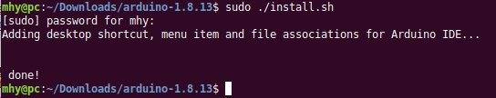
Lihat didesktop, kemudian klik icon arduino, tampilannya akan seperti ini:

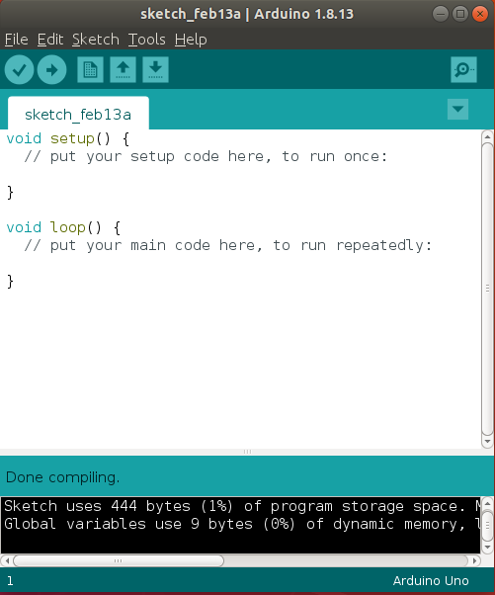
+ Introduction Arduino: https://www.arduino.cc/en/Guide/Introduction/
Arduino programming language (based on Wiring (http://wiring.org.co/)), and the Arduino Software (IDE), based on Processing (https://processing.org/).

+ Arduino IDE: https://www.arduino.cc/en/Guide/Environment/
Program ditulis di Arduino IDE disebut sketches.

+ Arduino Uno using C++:
https://www.youtube.com/watch?v=0TM_AbK3Epc

2. Contoh implementasi TF Lite ke Arduino
2.1. AI Magic Wand with TensorFlow Lite for Microcontrollers and Arduino: https://codelabs.developers.google.com/codelabs/ai-magicwand/#0

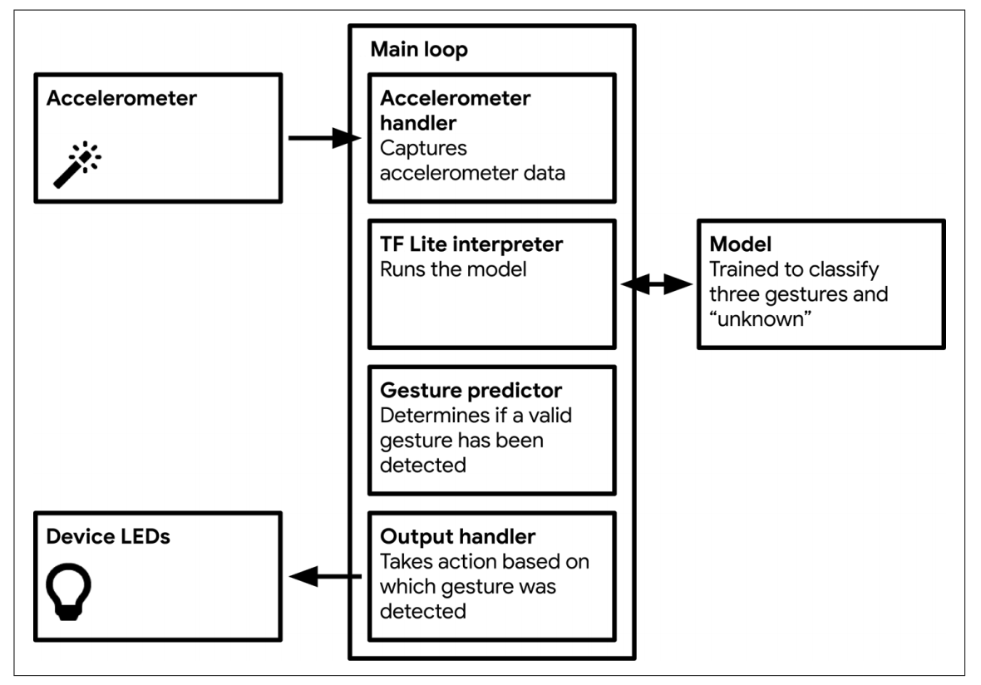
Pengaturan Arduino
Tools > Board: “Arduino Uno”

Setup Port
Tools -> Port: /dev/ttyACM0 (Arduino Uno)

Check Board Connection
Tools -> Get Board Info

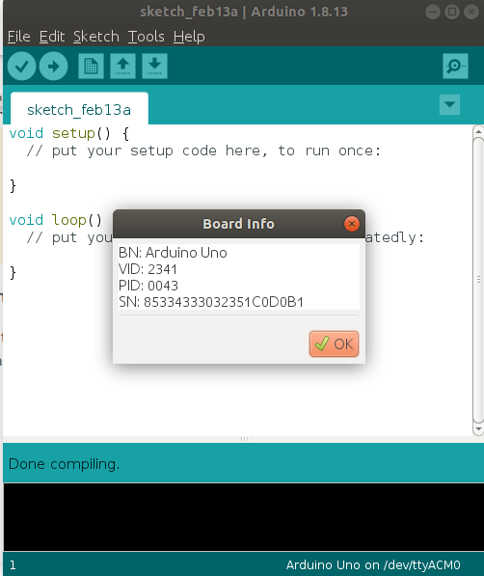

2.2. Instal library
2.2.1. Install TensorFlow Arduino Library
+ Download: https://bit.ly/2HVMKJm

+ kemudian di menu arduino pilih
Sketch -> Include Library -> Add .ZIP Library…

+ kemudian tambahkan TensorFlow Arduino Library .zip yang sudah didiwnload.

2.2.2. Instal LSM9DS1 Arduino Library

+ From the Arduino menu, select Sketch -> Include -> Manage Libraries…
+ Cari dan install "Arduino_LSM9DS1".

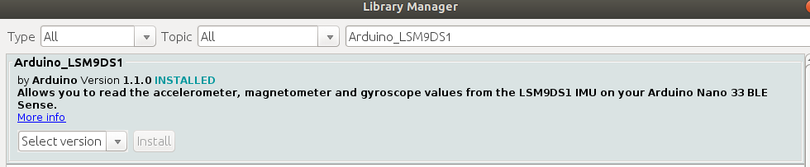
+ Kemudian dari menu arduino pilih File > Examples bisa dilihat menu Arduino_LSM9DS1 and Arduino_TensorFlowLite. Jika tidak ada maka ulangi langkah-langkah diatas.

3. Meload dan Build contoh
3.1. Load contoh yang sudah ada

+ Dari menu arduino pilih File -> Examples -> Arduino_TensorFlowLite -> magic_wand untuk meload kode contoh.
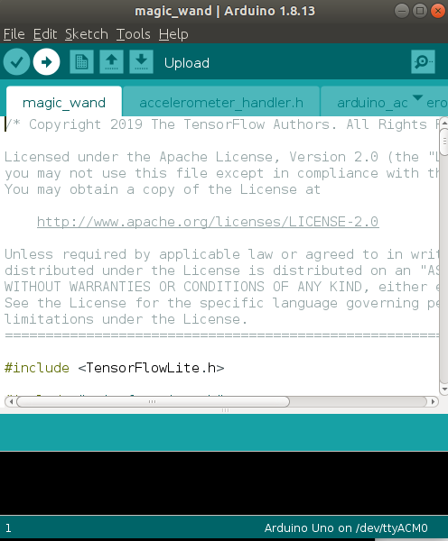
3.2. Build contoh
+ Klik Upload di sketch window.
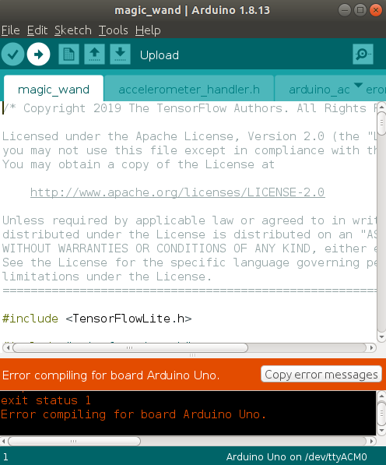

Karena terjadi error ketika compiling,

Arduino: 1.8.13 (Linux), Board: "Arduino Uno"

In file included from /home/mhy/Arduino/libraries/tensorflow_lite/src/tensorflow/lite/micro/micro_error_reporter.h:18:0,
from sketch/accelerometer_handler.h:22,
from /home/mhy/Arduino/libraries/tensorflow_lite/examples/magic_wand/magic_wand.ino:20:
/home/mhy/Arduino/libraries/tensorflow_lite/src/tensorflow/lite/core/api/error_reporter.h:18:10: fatal error: cstdarg: No such file or directory
#include <cstdarg>
^~~~~~~~~
compilation terminated.
exit status 1
Error compiling for board Arduino Uno.

This report would have more information with
"Show verbose output during compilation"
option enabled in File -> Preferences.

Maka selesaikan permasalahan dengan
URL: https://www.arduino.cc/en/Tutorial/BuiltInExamples/

