Documentation
DetectorPi

0. Tools
0.1. Hardware
+ RasberryPi 4 Model B (RPi)
+ microSD Card 15 GB
+ Google Edge TPU USB Accelerator. Datasheet: https://coral.ai/docs/accelerator/datasheet/
+ 5M USB Retractable Clip 120 Degrees WebCam Web Wide-angle Camera Laptop U7 Mini or Raspi Camera

0.2. Tested Software
+ OS Raspbian 10 (Buster), install on RPi
+ PyTorch
+ Python min. ver. 3.5
.
1. Install PyTorch for RaspberryPi
1.1. Percobaan Install PyTorch pertama kali
Isu: https://discuss.pytorch.org/t/pytorch-inference-on-raspberry-pi/87967
PyTorch packages for ARM64 http://mathinf.com/pytorch/arm64/
Get Started: https://pytorch.org/get-started/locally/

$ sudo apt install python3-numpy python3-wheel python3-setuptools python3-future python3-yaml python3-six python3-requests python3-pip python3-pillow

+ Download torch dan torchvision versi 1
torch-1.7.0a0-cp37-cp37m-linux_aarch64.whl: http://mathinf.com/pytorch/arm64/torch-1.7.0a0-cp37-cp37m-linux_aarch64.whl (git tag v1.7.0) 67MB last updated 2020-10-28

torchvision-0.8.0a0+45f960c-cp37-cp37m-linux_aarch64.whl http://mathinf.com/pytorch/arm64/torchvision-0.8.0a0+45f960c-cp37-cp37m-linux_aarch64.whl (git tag v0.8.1) 17MB last updated 2020-10-28

pi@raspberrypi:~ $ cd Downloads/
pi@raspberrypi:~/Downloads $ sudo pip3 install torch-1.7.0a0-cp37-cp37m-linux_aarch64.whl torchvision-0.8.0a0+45f960c-cp37-cp37m-linux_aarch64.whl

+ Kendala:
Ternyata tidak support dengan RaspberryPi4 dengan OS raspbian v10

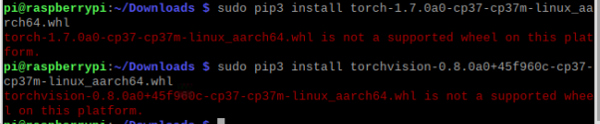
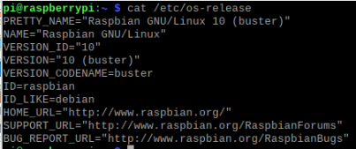
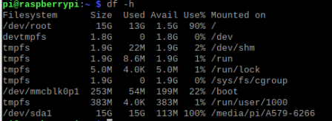

1.2. Percobaan Install Kedua
URL:
+ A Step by Step guide to installing PyTorch in Raspberry Pi: https://medium.com/secure-and-private-ai-writing-challenge/a-step-by-step-guide-to-installing-pytorch-in-raspberry-pi-a1491bb80531 [2019-08-17]
+ Quick setup instructions for installing PyTorch and fastai on Raspberry Pi 4: https://medium.com/analytics-vidhya/quick-setup-instructions-for-installing-pytorch-and-fastai-on-raspberry-pi-4-5ffbe45e0ae3 [2020-03-04]

